**Macrium - Reflect.exe - CLONE your HD - The best way to clone a hard drive**

[**https://www.ghacks.net/2015/08/29/the-best-way-to-clone-a-hard-drive-least-time-consuming-error-prone/**](https://www.ghacks.net/2015/08/29/the-best-way-to-clone-a-hard-drive-least-time-consuming-error-prone/)

by [Martin Brinkmann](https://www.ghacks.net/author/martin/) on August 29, 2015 in [Tutorials](https://www.ghacks.net/category/tutorials-basic/) - [66 comments](https://www.ghacks.net/2015/08/29/the-best-way-to-clone-a-hard-drive-least-time-consuming-error-prone/#comments)

The boot drive of my main PC has been a 128 Gigabyte Crucial m4 Solid State Drive for a long time. While that worked out well up until now, I always had to fight bloat on the drive to prevent it from being filled to the brim and slowing down the computer as a whole in the process.

Windows updates, Chrome downloads, software installations or the creation of DVDs are just some of the events that had an impact on the drive's free storage space. While I managed to slim down the drive every time it hit the magical 15 Gigabyte mark of free space, it meant that I had to monitor the drive constantly to make sure I did not miss events that filled it.

I made the decision to get a larger drive. A Solid State Drive of course because it improves loading time significantly. The [Crucial BX100 250 Gigabyte SSD](https://www.amazon.com/gp/product/B00RQA6TEI/ref=as_li_tl?ie=UTF8&camp=1789&creative=390957&creativeASIN=B00RQA6TEI&linkCode=as2&tag=windowsnews-20&linkId=6GXT4PT453BSXXDN) was just what I needed.

Since I did not want to set up the system anew, the decision was made to clone the current drive instead so that I could replace it with the new one.

There are plenty of programs that let you clone drives but when you run some of them, you will notice huge differences in handling and usability.

For instance, some programs clone a hard drive while Windows is running while others require that you reboot the computer to perform the operation before Windows starts.

**What you need**

1. A hard drive that you want to clone.
2. A new hard drive that you want to copy the contents of the old one to.
3. [Macrium Reflect Free](http://www.macrium.com/reflectfree.aspx)

**The process**

[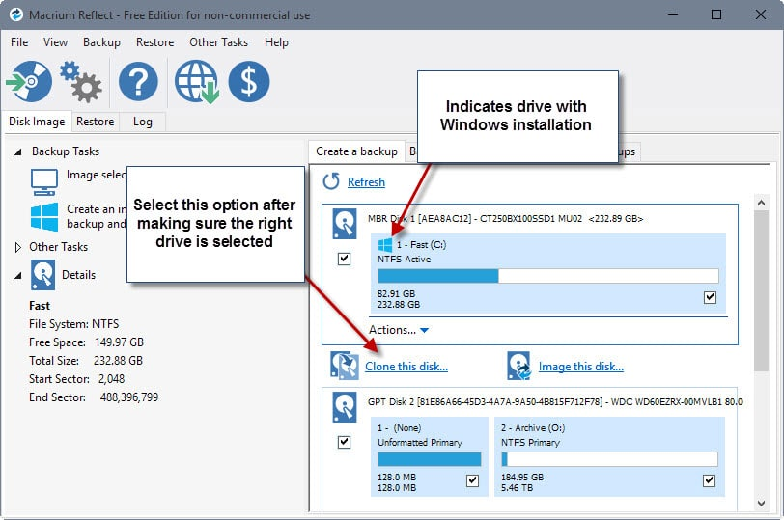](https://cdn.ghacks.net/wp-content/uploads/2015/08/macrium-reflect.jpg)

First thing you need to do is connect both hard drives to the computer. Make sure you have enough a spare power connector and SATA data cable as you need those to connect the new hard drive.

If you don't, you may use existing cables instead, for instance by disconnecting an optical drive temporarily (works only if you don't plan to use the old drive as well).

Install and run Macrium Reflect afterwards.

1. Macrium Reflect Free displays all drives in its interface on start. If that is not the case for you, make sure the Disk Image tab is activated.
2. Select the hard drive that you want to clone. The main hard drive with Windows is listed with a small Windows-icon in front of its name and drive letter.
3. You find the "clone this disk" option below the drive once it has been selected. This copies all contents of that drive to the destination drive.
4. Click on "select a disk to clone to" on the next screen, and pick the new drive. You need to make sure you don't pick a drive that is already in use as all contents of it will be overwritten during the process.
5. Make sure you adjust the size of the cloned partition in the next step. This is especially important if the destination is larger than the source. If you don't do that, you end up with a single partition that contains the cloned data of the source drive, and unused disk space that you need to partition and format. One easy way of making the right adjustment here is to click on the "maximum size" button.
6. Macrium Reflect will then start the cloning process which it does while Windows is running. It took 22 minutes to clone the old 128 Gigabyte SDD to the new 256 Gigabyte Solid State Drive.

One easy way to check that the operation completed successfully is to restart the PC and change the boot order in BIOS/UEFI. Select the new drive as the first boot device and check if Windows loads fine. If that is the case you may disconnect the old drive or use it for storage purposes.

**Tips**

[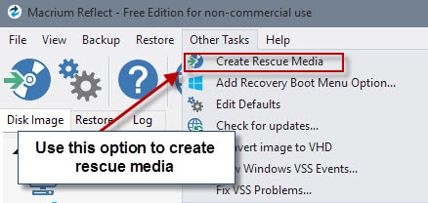](https://cdn.ghacks.net/wp-content/uploads/2015/08/rescue-media.jpg)

1. Macrium Reflect works well with encrypted drives as it does not need to run operations before Windows loads.
2. You may want to create rescue media before you run the operation. You may boot from a rescue disc if things go wrong to correct issues found.
3. I'd create a backup of the original drive as well just to be on the safe side.
4. You can always go back to using the old drive as it is not modified by the process (or re-run the cloning at a later point in time).
5. Macrium Reflect is an excellent backup program which means that you can create disk images easily using similar mechanics.

Summary

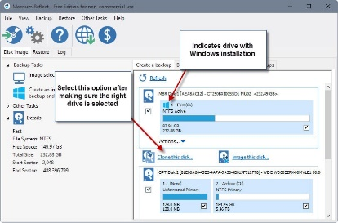

Article Name

The best way to clone a hard drive (least time-consuming, error-prone)

Description

The tutorial walks you through the process of replacing a hard drive by cloning it so that data is not lost in the process.

Author

Martin Briinkmann

**We need your help**

Advertising revenue is falling fast across the Internet, and independently-run sites like Ghacks are hit hardest by it. The advertising model in its current form is coming to an end, and we have to find other ways to continue operating this site.

We are committed to keeping our content free and independent, which means no paywalls, no sponsored posts, no annoying ad formats (video ads) or subscription fees.

If you like our content, and would like to help, please consider making a contribution:

[Donate via PayPal](https://paypal.me/ghacks)

**About Martin Brinkmann**

Martin Brinkmann is a journalist from Germany who founded Ghacks Technology News Back in 2005. He is passionate about all things tech and knows the Internet and computers like the back of his hand.You can follow Martin on [Facebook](https://www.facebook.com/ghacks), [Twitter](https://twitter.com/ghacks) or [Google+](https://plus.google.com/115604903045061277330?rel=author)

[View all posts by Martin Brinkmann →](https://www.ghacks.net/author/martin/)

**Comments**

1. **Pants** said on August 29, 2015 at 6:35 pm

[Reply](https://www.ghacks.net/2015/08/29/the-best-way-to-clone-a-hard-drive-least-time-consuming-error-prone/#comment-3559718)

I have more than 1 physical drive. What I do is my boot c drive contains the OS and about 5 programs installed (Office, PS, Skyrim) (and some other minor stuff like flash, f.lux). Nothing really changes. I do windows updates 6 monthly – and I take a new clone image each time. All personal data and 400+ portable programs are stored on other drives.

I use Clonezilla to clone c drive to an image on d drive. I then back this up to an external. All personal data and portable software etc is also backed up.

If C drive dies, or I replace it – I just clonezilla back from the image on d to c (and maybe have to update flash)  
If D drive dies, I replace it, and copy back from my externals etc.

I wouldn’t say clonezilla is uber user friendly, and you can’t exactly open the image and retrieve individual files (you can but its done via a virtual image and you have to allot the same drive space as the original drive!). But for simple one off images I find it works perfectly – especially as I separate OS from Software from Personal Data.

* 1. **Rustam** said on June 15, 2016 at 9:10 am

[Reply](https://www.ghacks.net/2015/08/29/the-best-way-to-clone-a-hard-drive-least-time-consuming-error-prone/#comment-3921349)

Dear Sir

i have have a machine hard drive IDE 40 Gb machine software is working Good I Want to clone the software of Hard drive .when i attached the Hard Drive with laptop it s show in disk management unallocated and not show in drives acronics not working and cant copy.does any body know which software i use to backup/restore or tell me the way how can i do this work. i try many softwares but i am still finding solution

thanks in Advance

* 1. **Anonymous** said on June 30, 2016 at 7:22 pm

[Reply](https://www.ghacks.net/2015/08/29/the-best-way-to-clone-a-hard-drive-least-time-consuming-error-prone/#comment-3931382)

I tried everything does not work with me. Unstable program. Not recommended.

* 1. **Carlindo Sousa** said on June 30, 2016 at 7:26 pm

[Reply](https://www.ghacks.net/2015/08/29/the-best-way-to-clone-a-hard-drive-least-time-consuming-error-prone/#comment-3931384)

Whatever program that does not work perfectly after installation, its not stable, not recommended, period. I tried every single fix, would get stuck on creating volume snapshot every time. Excuses about something wrong with the system is ridiculous. So thank you, but no thank you. Not recommending, not buying, Macrium it’s a waste of time.

* + 1. **A different Martin** said on June 30, 2016 at 8:12 pm

[Reply](https://www.ghacks.net/2015/08/29/the-best-way-to-clone-a-hard-drive-least-time-consuming-error-prone/#comment-3931400)

You should email Macrium some useful feedback about your problem — key details about your system and drives, and the like — so they can try to fix it. (Unless you’re a paid user, it will take a little work and imagination to find a suitable contact form on their site. Do they have a forum where you could post? I don’t remember.)

I’ve used Macrium Reflect on a bunch of Windows 7 systems, with both BIOSes and UEFIs, with both MBR and GPT drives, and with both internally mounted drives and external USB-mounted drives, and I haven’t run into any problems yet (that I can recall, and I probably would if I had). However, the vast majority of what I’ve done has been cloning, not imaging, so I’m not a reliable judge of Macrium Reflect’s imaging performance.

1. **seeprime** said on August 29, 2015 at 6:39 pm

[Reply](https://www.ghacks.net/2015/08/29/the-best-way-to-clone-a-hard-drive-least-time-consuming-error-prone/#comment-3559730)

Macrium Reflect is a great program. Good tip to post.

1. **CJ Earner** said on August 29, 2015 at 6:51 pm

[Reply](https://www.ghacks.net/2015/08/29/the-best-way-to-clone-a-hard-drive-least-time-consuming-error-prone/#comment-3559761)

Macrium Reflect has never let me down once in the many years I’ve been using it.

1. **Tim** said on August 29, 2015 at 6:55 pm

[Reply](https://www.ghacks.net/2015/08/29/the-best-way-to-clone-a-hard-drive-least-time-consuming-error-prone/#comment-3559765)

DriveImage XML = Free, lightweight, bulletproof and easy to use.

<http://www.runtime.org/dixml.htm>

I have cloned 2 SSD’s by plugging into a USB2.0 drive enclosure and they will boot from an AHCI enabled system.  
Usually can’t boot AHCI when I use a USB 2.0 plugin to setup a drive.

1. **Robert** said on August 29, 2015 at 7:13 pm

[Reply](https://www.ghacks.net/2015/08/29/the-best-way-to-clone-a-hard-drive-least-time-consuming-error-prone/#comment-3559795)

Looks great and it’s free to use for personal use. I currently use Terabyte Unlimited for my clones. It can clone both Linux and Windows partitions as well as make complete image backups for both formats. It’s not free but it is cheap.

* 1. **Rustam** said on June 15, 2016 at 9:08 am

[Reply](https://www.ghacks.net/2015/08/29/the-best-way-to-clone-a-hard-drive-least-time-consuming-error-prone/#comment-3921348)

dear sir

i have have a machine hard drive IDE 40 Gb machine software is working Good I Want to clone the software of Hard drive .when i attached the Hard Drive with laptop it s show in disk management unallocated and not show in drives acronics not working and cant copy.does any body know which software i use to backup/restore or tell me the way how can i do this work.

thanks in Advance