Maps of The Ancient Sea Kings - Charles Hapgood
http://www.goldenageproject.org.uk/seakings.php
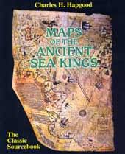
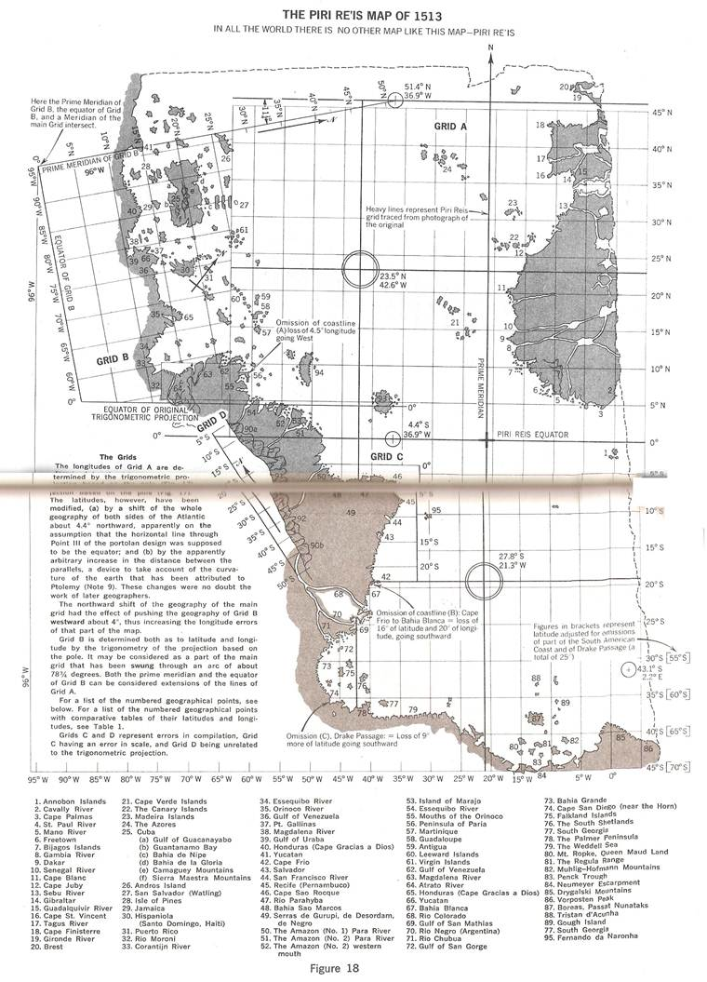
Rare and ancient maps reveal a new history of mankind in Charles Hapgood’s classic - back in print after more than twenty years.
In this fascinating and provocative book Charles Hapgood uses ancient maps as evidence for the existence, many thousands of years ago, of an advanced worldwide civilisation. The maps, long known to scholars, include the Piri Reis Map that shows Antarctica, the Hadji Ahmed map, the Oronteus Finaeus and other remarkable maps and charts. According to Hapgood, the mapmakers responsible for the earliest maps must in some ways have been more technically advanced than sixteenth-century Europe and the ancient civilisations of Greece, Egypt and Babylonia.Not only did they produce fantastically detailed maps, they also appear to have mapped every continent. The Americas were mapped thousands of years before Columbus and Antarctica was mapped when its coasts were free of ice. From the evidence it seems that these people must have lived when the ice age had not yet ended in the Northern Hemisphere and when Alaska was still connected to Siberia by the Pleistocene, ice age “land bridge”, that is, thousands of years before the heyday of the ancient Egyptians.
ANTARCTICA
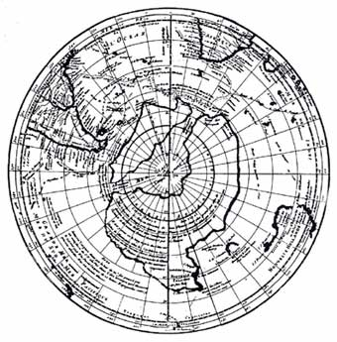
The Philippe Buache map of Antarctica, made in Paris in 1737, a century before Antarctica was discovered. Evidently copied frm maps surviving from ancient times, it shows Antarctica as two separate land masses, a fact no established until the Geophysical Year of 1958 through ice soundings, but evidently known to navigators of prehistory, who may have visited Antarctica before it was covered by ice.
From Mysteries of Forgotten Worlds by Charles Berlitz

ANTARCTICA WITHOUT THE ICECAP
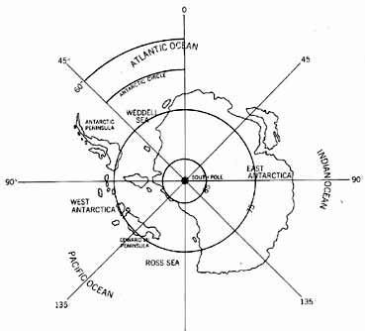
Sketch map of Antarctica as it would appear without the icecap, now more than two miles thick. The Antarctic continent, without the ice, would not be one land mass but two, separated by water.
From Mysteries of Forgotten Worlds by Charles Berlitz

THE ORONTEUS FINAEUS MAP OF ANTARCTICA
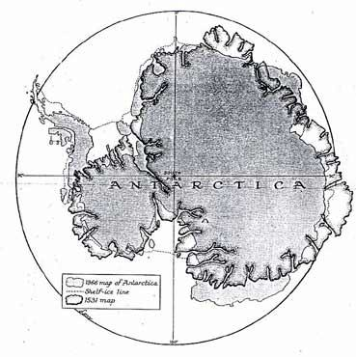
The Oronteus Finaeus Map of Antarctica redrawn on the modern equidistant azimuthal polar projection, compared with the modern map of Antarctica on the same projection (Christian Science Monitor)
A comparison of the Oronteus Finaeus Map with the map of the subglacial land surfaces of Antarctica produced by survey teams or various nations during the International Geophysical Year (1958) seems to explain some of the apparent short-comings of the Oronteus Finaeus Map, and at the same time throws some light on the question of the probable extent of glacial conditions when the original maps were drawn.
From Maps of the Ancient Sea Kings by Charles Hapgood

ANCIENT TECHNOLOGY - MAPPING CLUES
- CHANNEL ISLANDS
The Channel Islands pictured are, from left, Guernsey, Herm, Sark and Jersey.
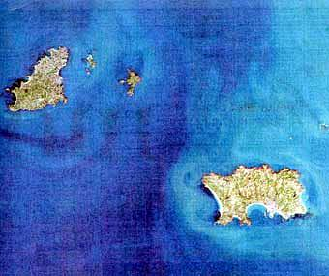
This overhead photograph of the Channel Islands picks out clearly the beautiful coastline shapes created by the erosion of the land by the sea over time.
On the Ptolemy map below we see the crude attempts to survey the Mediterranean coastlines, yet on the much earlier Portalano (port to port), the Piri Re'is, and the Oronteus Finaeus maps we find exceptional detail.
Looking at the many practical problems of making accurate coastline surveys, this would suggest that these earlier maps could only have been created from airial surveys and high technology equipment.
On the Oronteus Finaeus map of the Antarctic, where both coastline detail and the overlying ice cover are accurately recorded, this would explain how the maps were created in relatively modern holocene times.
In isolation, Professor Hapgood's thesis within Maps of The Ancient Sea Kings is a difficult one to accept.
However when taken with Professor Stechini's observations of ancient land surveys, and the raft of supporting evidence of an advanced world wide civilisation, his case is made.
Golden Age Project Comments

NORDENSKIÖLD'S COMPARISON OF PTOLEMY'S MAP OF THE MEDITERRANEAN WITH THE DULCERT PORTOLANO
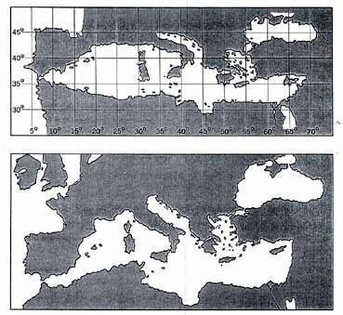
Nordenskiold’s comparison of Ptolemy’s Map of the Mediterranean (top) with the Dulcert Portolano.
After comparing the two, he found that the portolanos were much better than Ptolemy’s maps. He compared Ptolemy’s map of the Mediterranean and the Black Seas with the Dulcert Portolano (Fig. 3) and found that the superiority of the portolano was evident.
Let us stop to consider, for a moment, what this means. Ptolemy is the most famous geographer of the ancient world. He worked in Alexandria in the 2nd century A.D., in the greatest library of the ancient world. He had at his command all the accumulated geographical information of that world. He was acquainted with mathematics. He shows, in his great work, the Geographia (168), a modern scientific mentality. Can we lightly assume that medieval sailors of the fourteenth century, without any of this knowledge, and without modern instruments except a rudimentary compass – and without mathematics – could produce a more scientific product?
From Maps of the Ancient Sea Kings by Charles Hapgood

EGYPTIAN WISDOM
In an essay written some years ago, entitled Astronomical Theory and Historical Data, Dr Livio C. Stecchini demonstrated that the Egyptians could measure latitude and longitude accurately, a technique not developed by our society until the eighteenth century. Dr Stecchini; a professor of ancient history at William Patterson College in New Jersey, gives almost reluctant confirmation of Egyptian’s superior geographical and mathematical skill.
In a set of documents, known to Egyptologists but not hitherto regarded as out of the ordinary, he found date to prove that, as early as 3000 B.C., they had already recorded the latitude and longitude of the main points of the Nile, from the Equator right down to the Mediterranean. Further data was found by Dr Stecchini which showed survey measurements of points encompassing most of the Old World – some even extending to Norway and Russia.
Discomfited by this revelation, he desperately searched for errors. The calculation, however, proved to be uncannily accurate and he was never able to establish more than a minute of error in latitude, or more than five minutes of error in ten degrees of longitude. It does seem as if there may be some substance to the old tradition which says that initiates from Atlantis brought technical skills into ancient Egypt.
The Lion motif, which figures strongly in Egypt, may be another indication of the time of the initiates’ entry. It prompts the deduction that the Lion is representative of the Age of Leo. The relic of ancient Egypt, the Denderah Zodiac, has baffled archaeologists for years. Originally part of the ceiling of the 4000 B.C. temple at Menes, it now reposes in the Louvre, in Paris. The zodiacal signs are arranged in a circle, but the Lion is set at the point of the vernal equinox, suggesting that it may have been constructed in the time that it was meant to represent, the Age of Leo.
From Giants – The Vanqished Race of Mighty Men by Roy Norvill

MAP OF THE TRACKS OF YU THE GREAT
The Yu Chi Fu, or map of the Tracks of Yu the Great was carved in stone 1137. It is known to have been in use for an indefinite period before that. Like the portalanos of the West the real date of origin is unknown. A comparison of the river system shown on this map with that on a modern map of China shows a remarkable accuracy (see Figs. 77 and 78). This map was evidently drawn with excellent information as to longitudes, such as we find on the portalanos, but do not find on the classical maps of Greece and Rome, and which was certainly not typical of the cartography of medieval China or Japan.
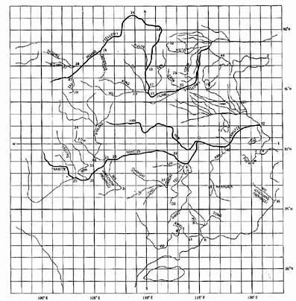
The Yu Chi Fu with oblong grid constructed empirically from the geography.
As a further test of the grid I had drawn for the map, I listed separately all the northernmost and southernmost places identified on the map and averaged their errors in latitude. I also listed all the easternmost and westernmost places and and averaged their errors in longitude (Tables 10b and 10c). The average error of latitude on the north was less than one-half of one degree (or 30 miles!), and the average error on the south balanced out to zero (with four localities 1¹ too far south and four 1.2¹ too far north). So far as longitude was concerned, the error both on the east and on the west balanced out to zero. There was no indication, therefore that the grid constructed for the map was seriously in error.
From Maps of the Ancient Sea Kings by Charles H. Hapgood

MODERN MAP OF CHINA
It seems to me that the evidence of this map points to the existence in very ancient times of a worldwide civilization, the mapmakers of which mapped virtually the entire globe with a uniform general level of technology, with similar methods, equal knowledge of mathematics, and probably the same sorts of instruments. I regard this Chinese map as the capstone of the structure I have erected in this book. For me it settles the question as to whether the ancient culture that penetrated Antarctica, and originated all the ancient western maps, was indeed worldwide (see also 135a).
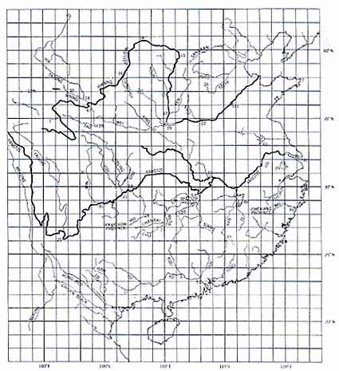
From Maps of the Ancient Sea Kings by Charles H. Hapgood

==============================================================================================================

http://www.astraltraveler.com/mysteres/oronteus-finaeus.html

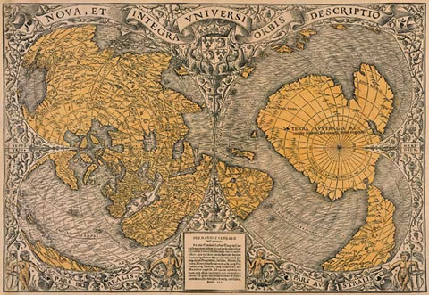
Oronce Finé (also known as Oronteus Finaeus) was a renowned French mathematician and cartographer who lived between 1494 and 1555. He is famous for his map of 1531, which was discovered in the Library of Congress in Washington DC in 1960 by Professor Charles H. Hapgood.
Although this map has been copied from earlier sources, what's interesting about it is that it shows non-glacial conditions of the costal regions of Antarctica, notably Queen Maud Land, Enderby Land, Wilkes Land, Victoria Land (the east coast of Ross Sea), and Marie Byrd Land.
The continent of Antarctica was discovered in 1818, and in 1949 the actual landmass was mapped as a result of a comprehensive seismic survey conducted by a joint British-Swedish scientific reconnaissance team. According to geological evidence, Queen Maud Land was last ice-free in 4000 BC. There is no civilization known to orthodox history that had the capability of surveying the Antarctic coastline in 4000 BC.
Charles Hapgood and his team converted this map from its original projection method into a modern projection method. See the results below.
This first image is simply the map as it was drawn by Oronteus Finaeus.
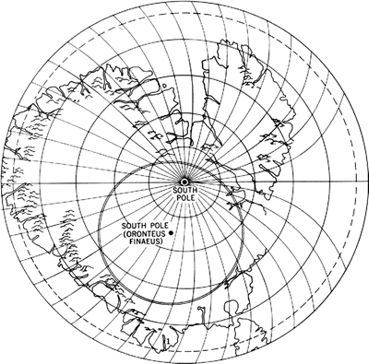
Next they converted it to a modern projection method as shown below.
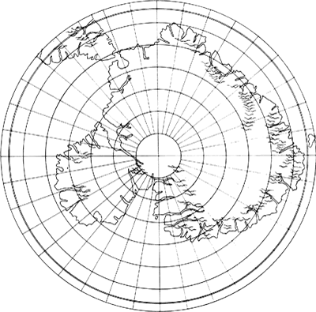
Compare the first two images with a modern map of Antarctica to see just how close they were.
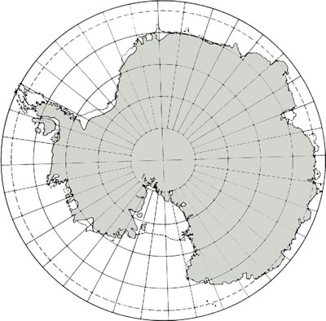
Regardless of some of the theories as to how such a map could exist, the Oronteus Finaeus Map remains a mystery.

