

caduceus.jamesmuir.com/ caduceus_work_in_progress.html

Caduceus . . . Work in Progress
Now Complete

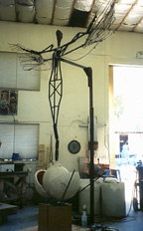  "CADUCEUS"  trial armature stage  @10 feet | "CADUCEUS"  trial armature stage  @10 feet
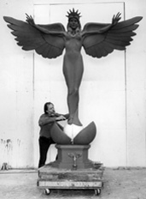  "CADUCEUS"  will have  fountain capabilities | 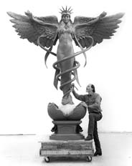  "CADUCEUS"  Clay in progress
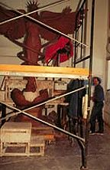  "CADUCEUS"  Scaffolding | 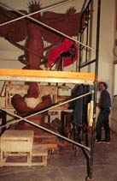  "CADUCEUS"  Scaffolding
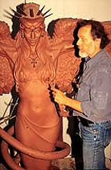 | 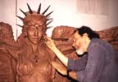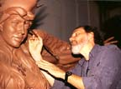
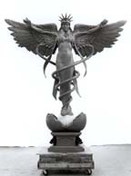 | 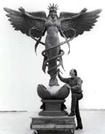

"My goal is to see these "Seven Ladies on Seven Continents" transcending individual differences to become a unifying symbol for the universal kinship of humanity and all creation in a physical metaphor representing the spiritual connection between all things. To help bring the healing power of love into the earth, ushering in a new era of Peace."
James Nathan Muir


New Sculpture of Caduceus
Honors SLU's Medical Mission

www.slu.edu/publications/ gc/v5-3/news_25.shtml

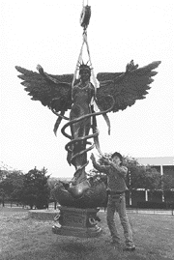
The traditional symbol of medicine, enhanced in a sculpture by James Muir, is the latest piece to join Saint Louis University's outdoor collection.
Caduceus, symbolizing the angel of healing, has been positioned on the Frost campus lawn at the corner of Grand Boulevard and Laclede Avenue. The piece was purchased for the University by an anonymous donor.
The sculpture is one of a trilogy of pieces designed by Muir to depict Spirit, Truth and Healing. The second piece, Quo Vadis, is on display at the Pere Marquette Gallery, and the third sculpture, Justice, is located in the newly completed atrium of the School of Law.
"It is particularly fitting for Saint Louis University to display a piece depicting healing," said University President Lawrence Biondi, SJ. "An important part of the University's Catholic, Jesuit mission continues to be the education of physicians, nurses and other health care professionals who help in the healing of both body and spirit."
Caduceus is 12 feet high and nine feet wide. James Muir is recognized as one of America's foremost historical/symbolic sculptors and is exploring new frontiers in "allegorical art." His studio is in Phoenix.

Richard Sanker, M.A., Assistant Director
www.slu.edu/colleges/ AS/phs/HomePage.html
3840 Lindell Blvd. ... St. Louis, MO 63108 ... 314-977-2840

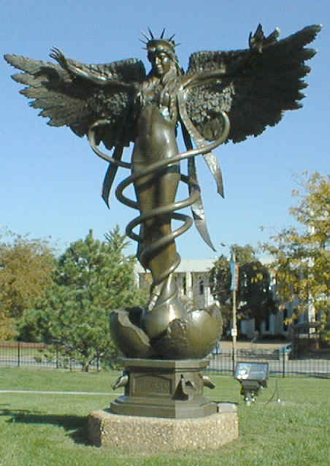
Preprofessional Health Studies is a special program dedicated to the advising of students preparing for careers in medicine, dentistry, optometry, podiatry, veterinary sciences and pharmacy. Although the program is administratively within the College of Arts and Sciences, it serves all pre-health professions students at Saint Louis University.
Well defined programs of study are designed for preprofessional health students who aspire to enter professional schools of medicine, dentistry, optometry, podiatry, veterinary medicine, and pharmacy. Saint Louis University's program is not rigid in the sense that every student's classes are the same. One important aspect of the premedical program at SLU is the effort to tailor your work load to fit college admission test scores, high school science background and class rank. If your personal schedule is demanding, alternatives are provided.

