# 27 incredible lighthouses that stood the test of time

http://brightside.me/wonder-places/27-incredible-lighthouses-that-stood-the-test-of-time-126755/

**Whiteford Lighthouse, England**

[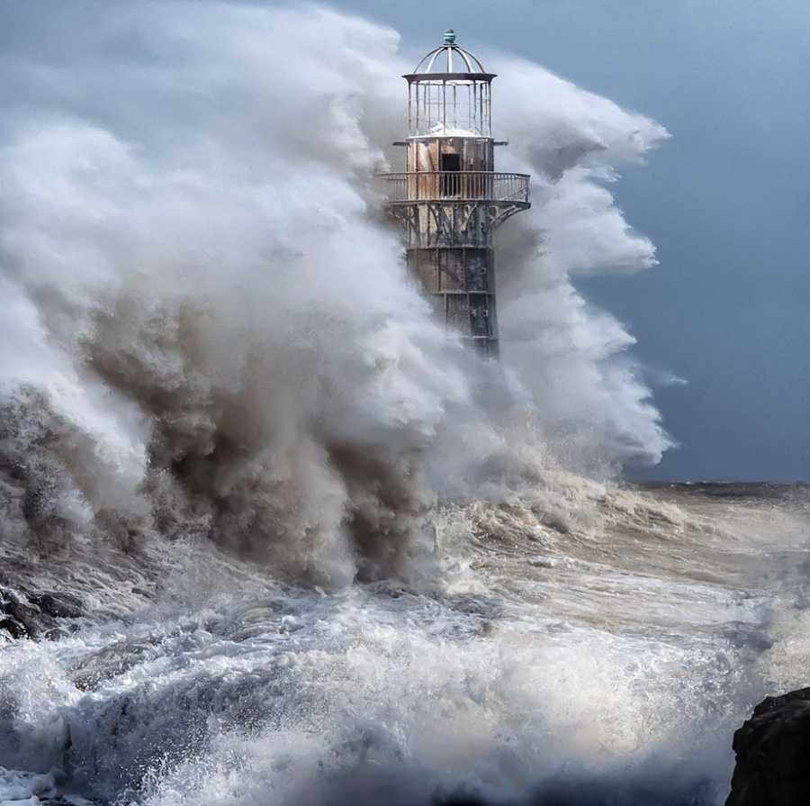](http://brightside.me/wonder-places/27-incredible-lighthouses-that-stood-the-test-of-time-126755/#image881555)

[© Matthew Jones](http://500px.com/photo/53361462/storm-rage-by-matthew-jones)

**Brest, France**

[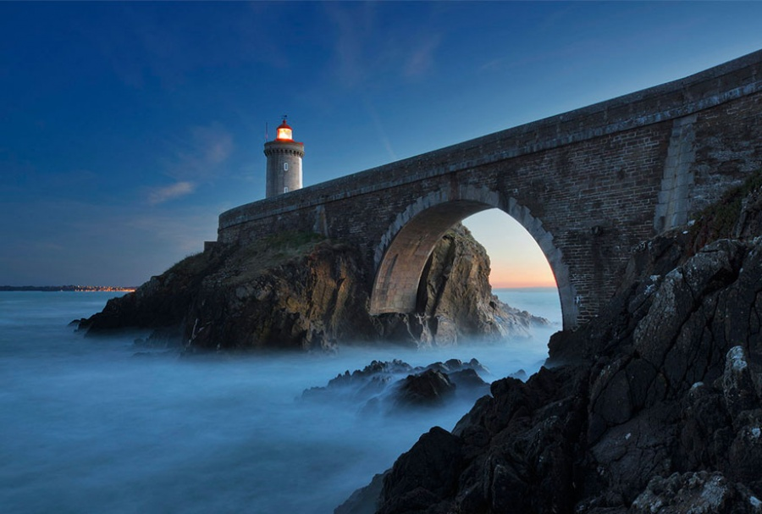](http://brightside.me/wonder-places/27-incredible-lighthouses-that-stood-the-test-of-time-126755/#image881605)

[© Alexander Riek](http://500px.com/photo/64302309/when-the-night-sets-in-by-alexander-riek)

**Michigan, United States**

[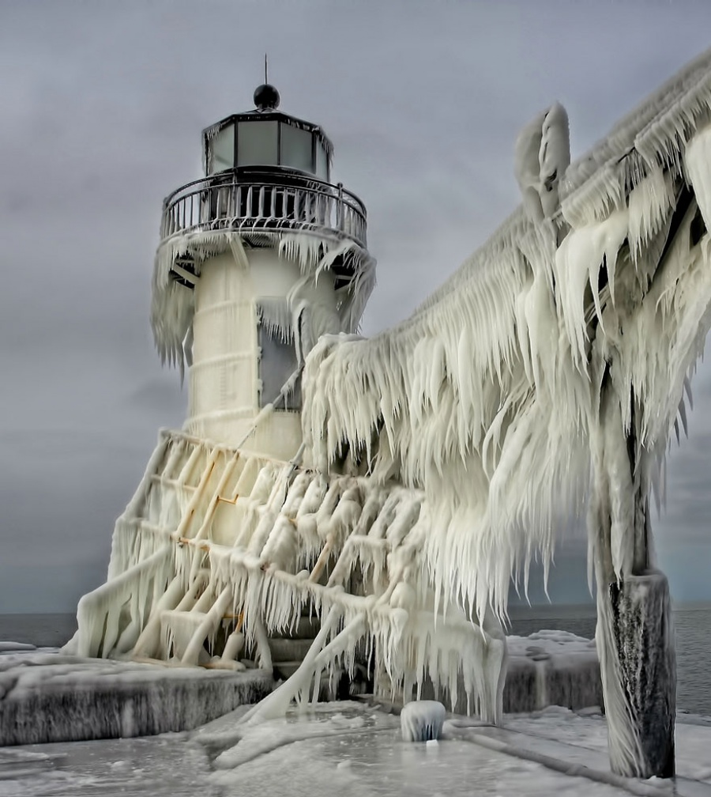](http://brightside.me/wonder-places/27-incredible-lighthouses-that-stood-the-test-of-time-126755/#image881655)

[© Thomas Zakowski](http://500px.com/ThomasZakowski)

**Porto, Portugal**

[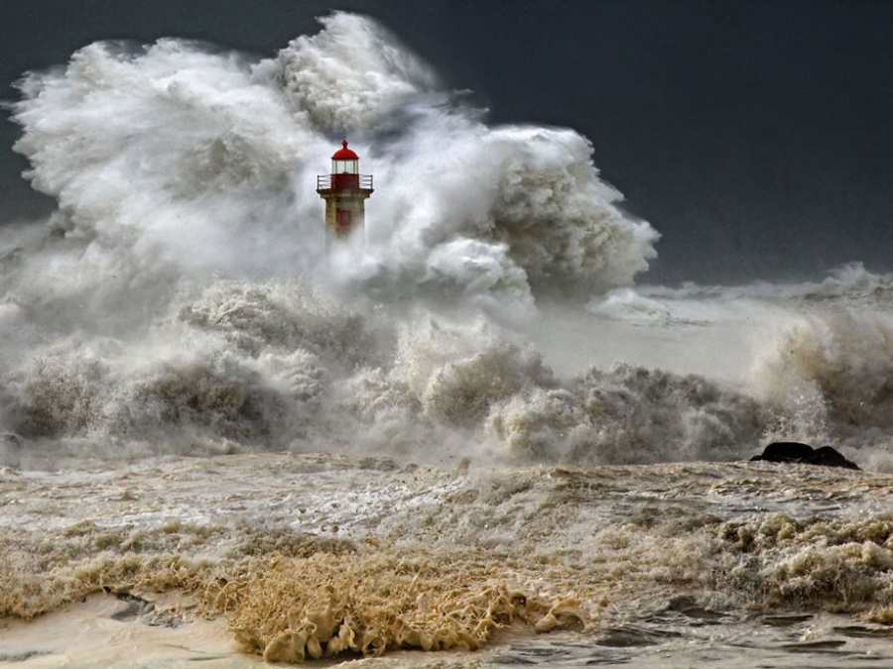](http://brightside.me/wonder-places/27-incredible-lighthouses-that-stood-the-test-of-time-126755/#image881705)

[©Veselin Malinov](http://photography.nationalgeographic.com/photography/photo-of-the-day/stormy-seas-portugal/)

**California, United States**

[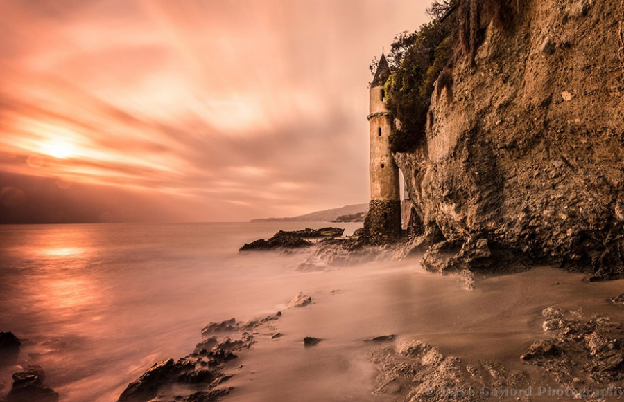](http://brightside.me/wonder-places/27-incredible-lighthouses-that-stood-the-test-of-time-126755/#image881755)

[© Dave Gaylord](http://500px.com/photo/36981594/victoria-lighthouse-by-dave-gaylord)

**Asturias, Spain**

[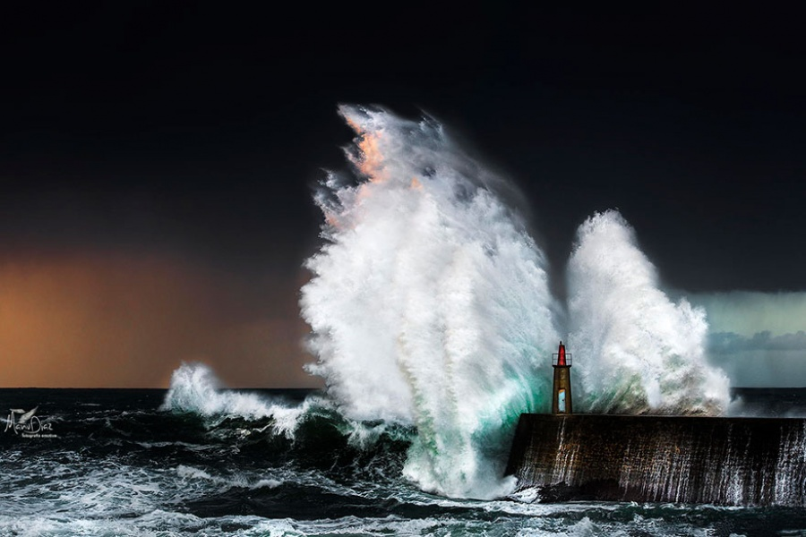](http://brightside.me/wonder-places/27-incredible-lighthouses-that-stood-the-test-of-time-126755/#image881805)

[© Manu Díaz](http://500px.com/photo/56841448/perfect-storm-by-manu-d%C3%ADaz)

**Schleswig-Holstein, Germany**

[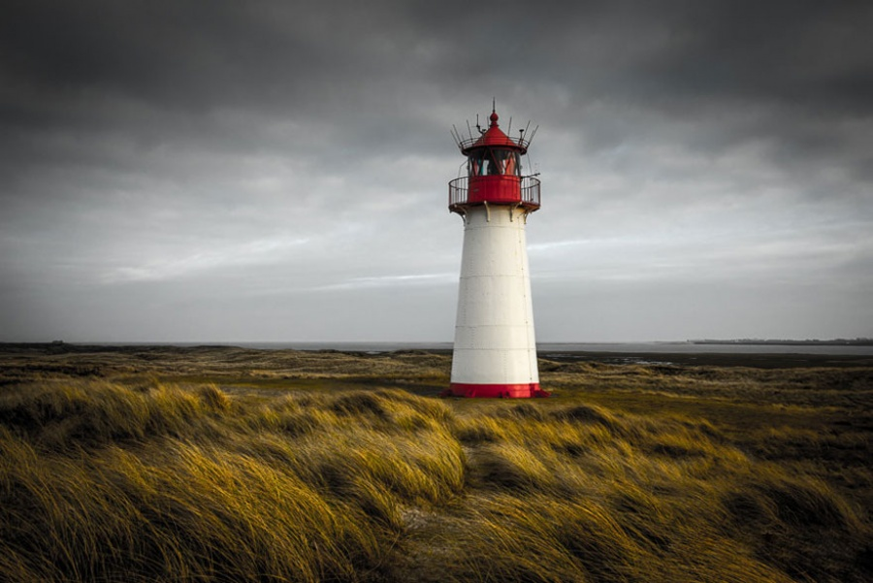](http://brightside.me/wonder-places/27-incredible-lighthouses-that-stood-the-test-of-time-126755/#image881855)

[© Holger Schmitt](http://500px.com/photo/64712375/sylt-lighthouse-by-holger-schmitt-)

**Wales, United Kingdom**

[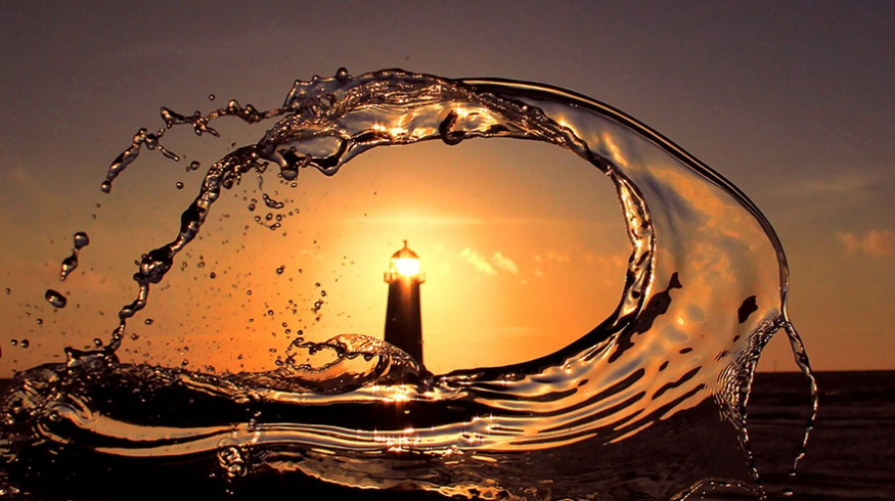](http://brightside.me/wonder-places/27-incredible-lighthouses-that-stood-the-test-of-time-126755/#image881905)

[© Iain McConnell](http://500px.com/photo/75041019/lighthouse-by-iain-mcconnell)

**Andros, Greece**

[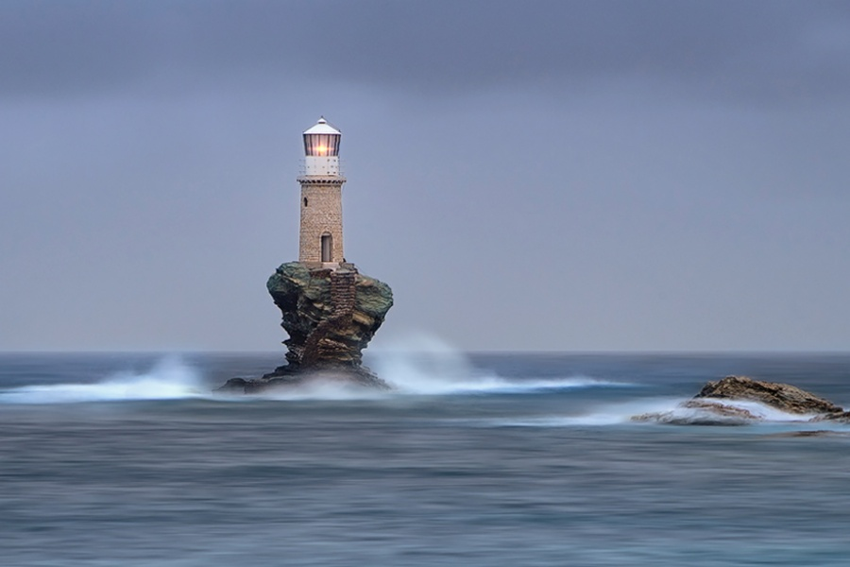](http://brightside.me/wonder-places/27-incredible-lighthouses-that-stood-the-test-of-time-126755/#image881955)

[© Mary Kay](http://500px.com/photo/16546225/light-at-the-end-of-the-world-by-mary-kay)

**San Esteban de Pravia, Spain**

[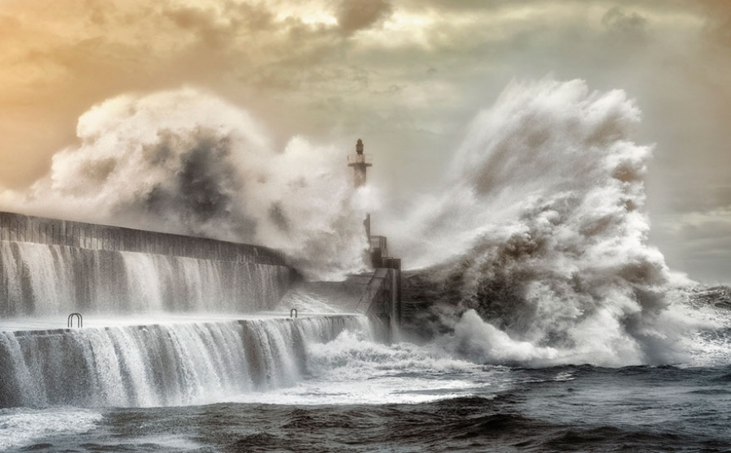](http://brightside.me/wonder-places/27-incredible-lighthouses-that-stood-the-test-of-time-126755/#image882005)

[© Saghani](http://500px.com/photo/8837964/explosions-by-saghani-)

**Wales, United Kingdom**

[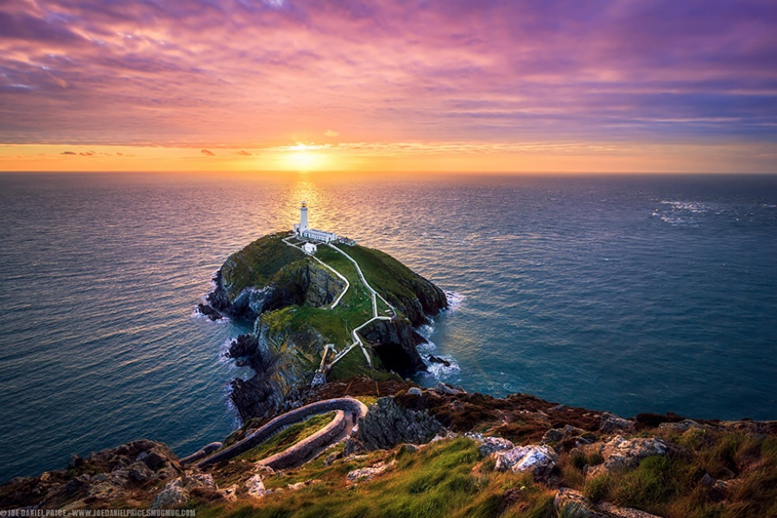](http://brightside.me/wonder-places/27-incredible-lighthouses-that-stood-the-test-of-time-126755/#image882055)

[© Joe Daniel Price](http://500px.com/photo/40718946/the-south-stack-near-holyhead-anglesey-wales-by-joe-daniel-price?from=editors&only=Landscapes)

**Beagle Channel, Argentina**

[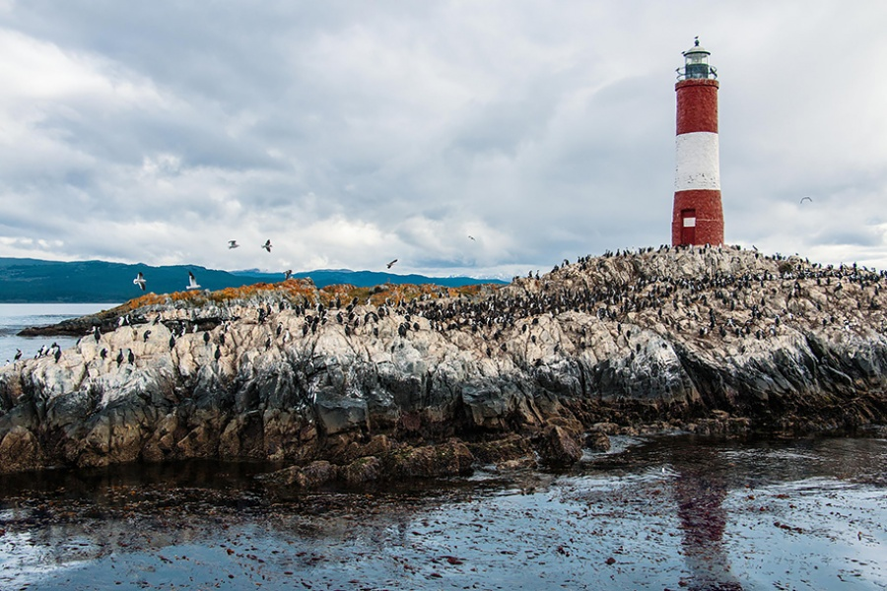](http://brightside.me/wonder-places/27-incredible-lighthouses-that-stood-the-test-of-time-126755/#image882105)

[© Skel Shizuko](http://500px.com/photo/62946667/south-american-tern-flying-over-imperial-shags-by-skel-shizuko)

**Cork, the Republic of Ireland**

[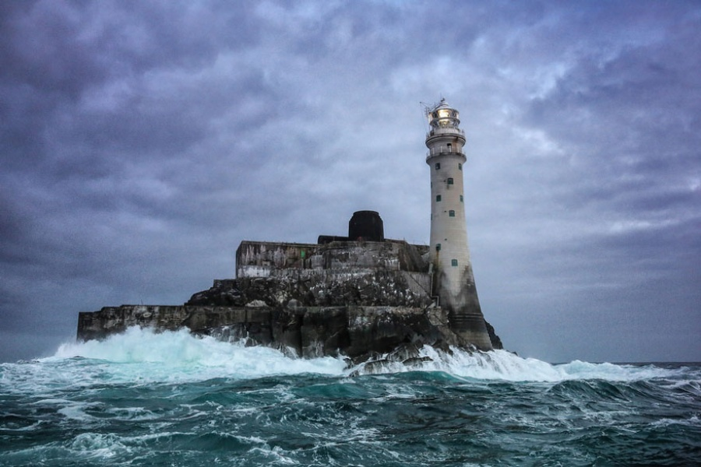](http://brightside.me/wonder-places/27-incredible-lighthouses-that-stood-the-test-of-time-126755/#image882155)

[© Fergal O’Callaghan](https://www.flickr.com/photos/48839047@N07/9615186309)

**Ostend, Belgium**

[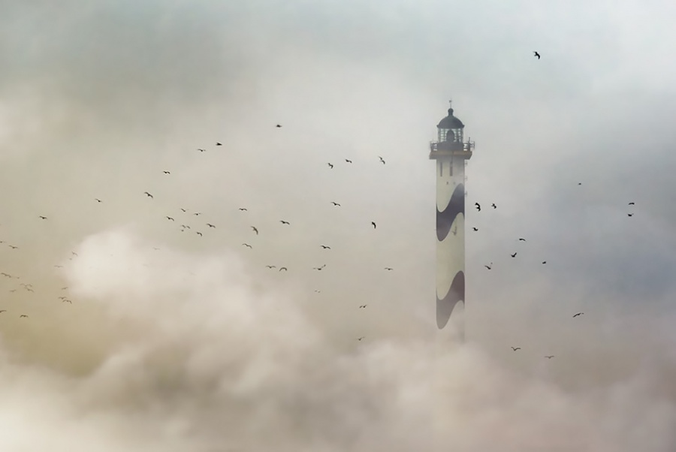](http://brightside.me/wonder-places/27-incredible-lighthouses-that-stood-the-test-of-time-126755/#image882205)

[© Piet Flour](http://500px.com/photo/334846/the-lighthouse-by-piet-flour?from=editors&only=Landscapes)

**Wisconsin, United States**

[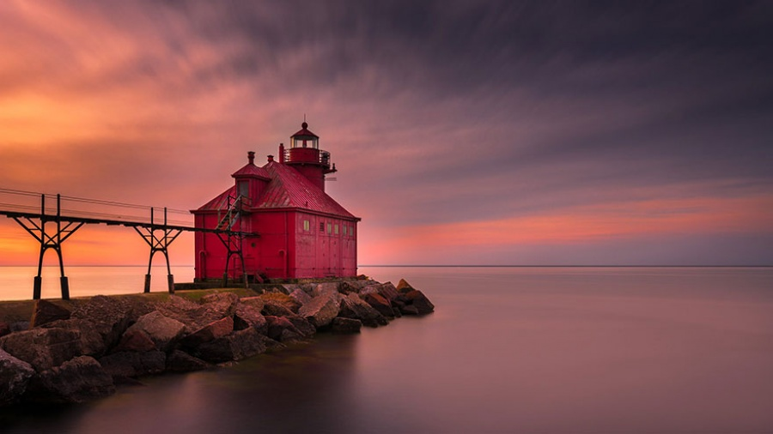](http://brightside.me/wonder-places/27-incredible-lighthouses-that-stood-the-test-of-time-126755/#image882255)

[© Ratul Maiti](http://500px.com/photo/70122241/sunrise-at-sturgeon-bay-by-ratul-maiti)

**Cantabria, Spain**

[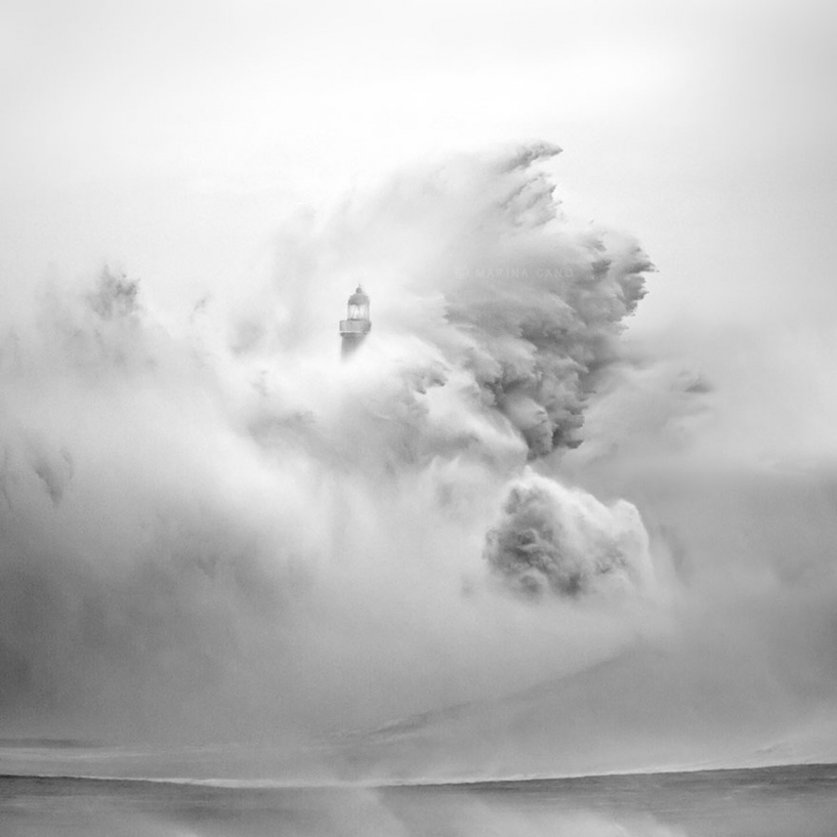](http://brightside.me/wonder-places/27-incredible-lighthouses-that-stood-the-test-of-time-126755/#image882305)

[© Marina Cano](http://500px.com/photo/25292313/in-love-with-the-sea-by-marina-cano)

**Lysekil, Sweden**

[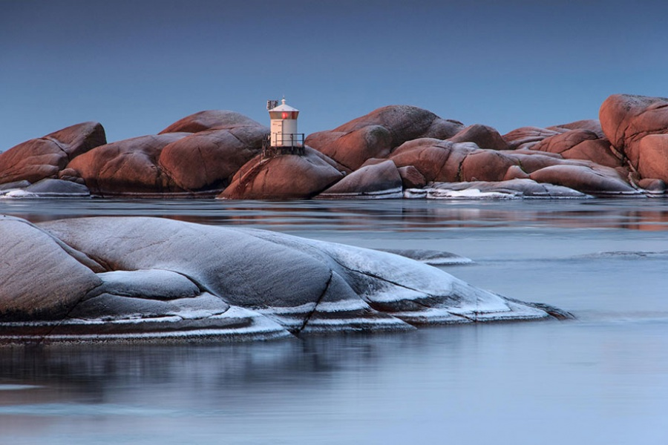](http://brightside.me/wonder-places/27-incredible-lighthouses-that-stood-the-test-of-time-126755/#image882355)

[© Henrik Aleborg](http://500px.com/photo/56036298/at-pinneviken-by-henrik-aleborg)

**Bait Island, UK**

[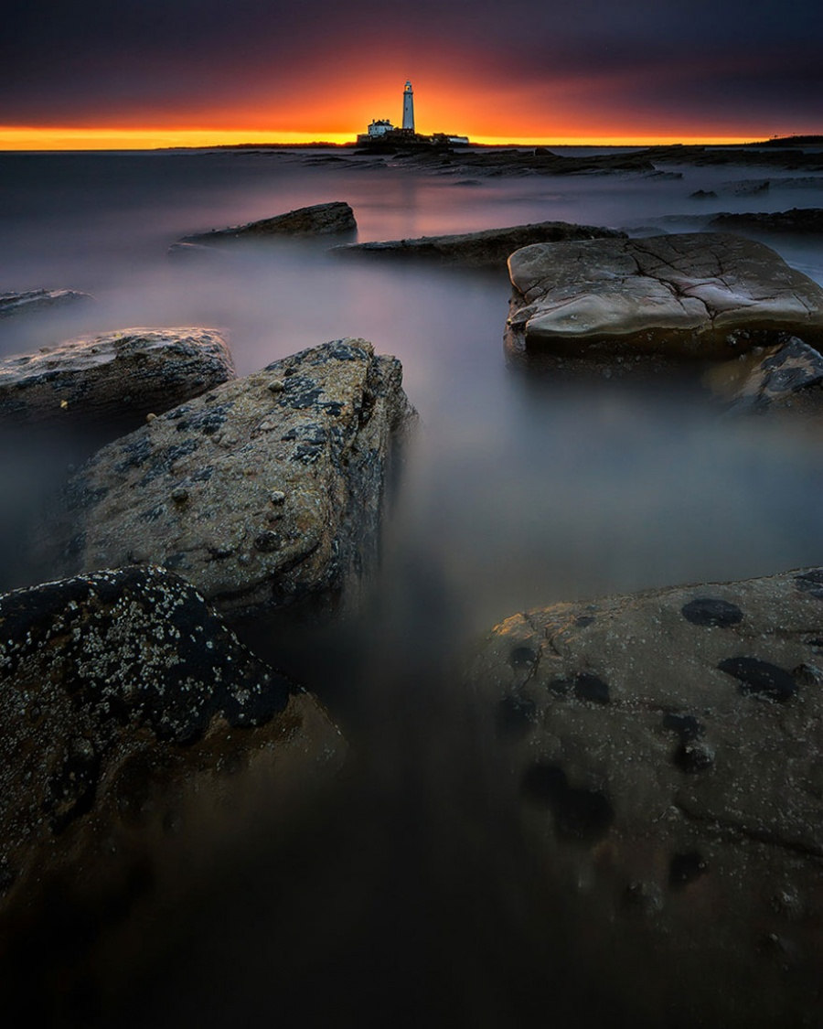](http://brightside.me/wonder-places/27-incredible-lighthouses-that-stood-the-test-of-time-126755/#image882405)

[© Steven Walden](http://500px.com/photo/50807554/radiation-by-steven-walden)

**Bretagne, France**

[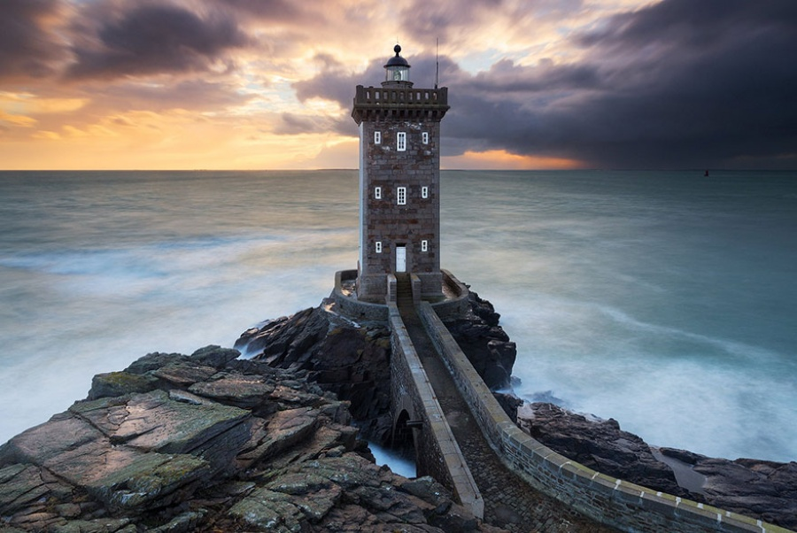](http://brightside.me/wonder-places/27-incredible-lighthouses-that-stood-the-test-of-time-126755/#image882455)

[© Nicolas Rottiers](http://500px.com/photo/63472683/braver-les-temp%C3%AAtes-by-nicolas-rottiers)

**East Sussex, England**

[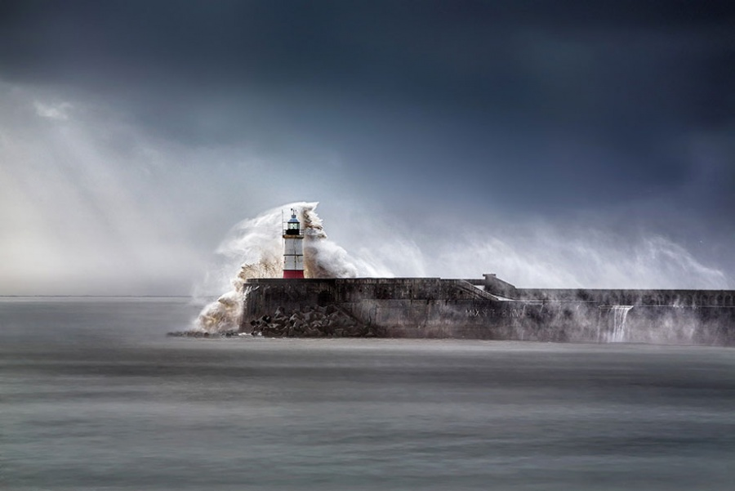](http://brightside.me/wonder-places/27-incredible-lighthouses-that-stood-the-test-of-time-126755/#image882505)

[© Peter](http://500px.com/photo/60519076/wrath-of-poseidon-by-peter-)

**Maine, USA**

[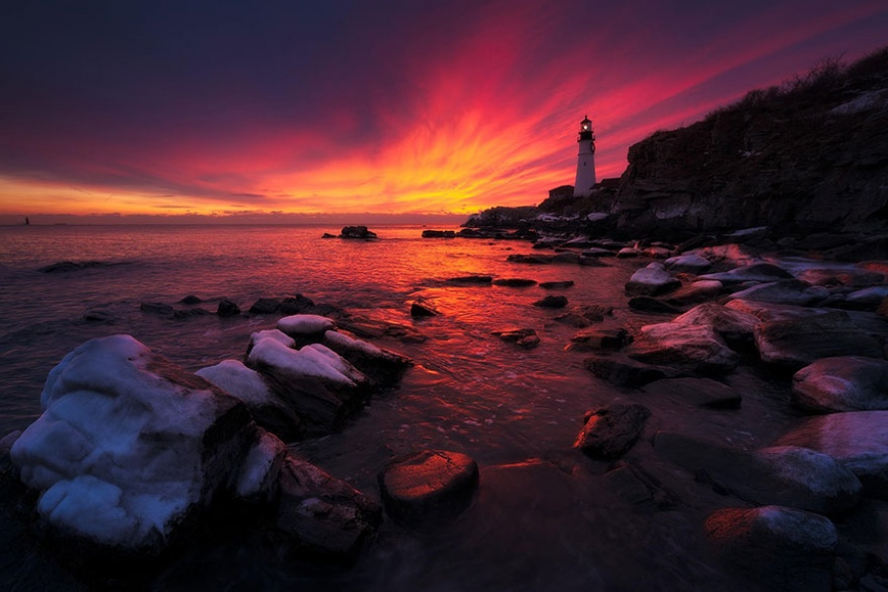](http://brightside.me/wonder-places/27-incredible-lighthouses-that-stood-the-test-of-time-126755/#image882555)

[©Yegor Malinovskii](http://500px.com/photo/74664897/burn-brighter-by-yegor-malinovskii)

**Mouro Island, Spain**

[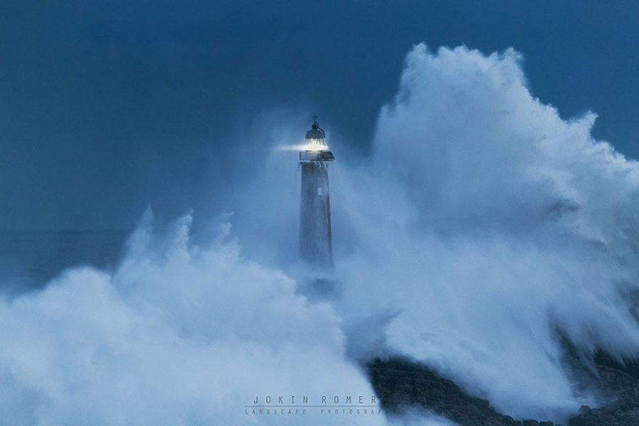](http://brightside.me/wonder-places/27-incredible-lighthouses-that-stood-the-test-of-time-126755/#image882605)

[© Jokin Romero](http://500px.com/photo/60045898/poseidon-vs-cyclops-by-jokin-romero)

**Brest, France**

[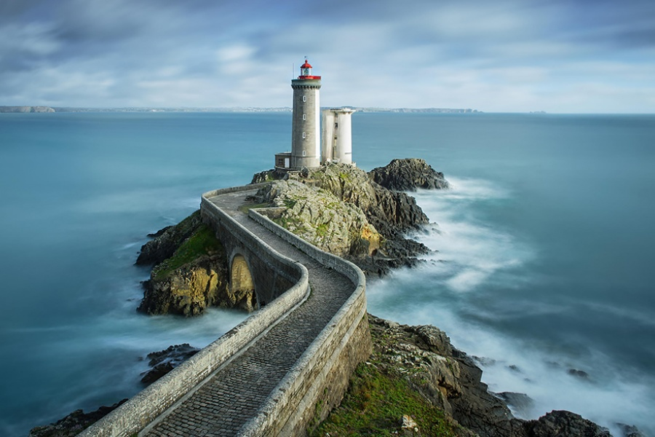](http://brightside.me/wonder-places/27-incredible-lighthouses-that-stood-the-test-of-time-126755/#image882655)

[© Stefan Cruysberghs](http://500px.com/photo/70110473/phare-du-petit-minou-by-stefan-cruysberghs?from=editors&only=Landscapes)

**Norway**

[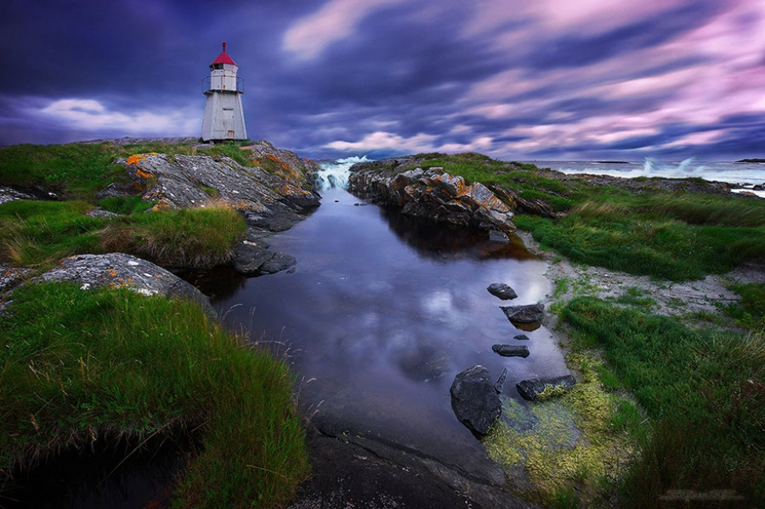](http://brightside.me/wonder-places/27-incredible-lighthouses-that-stood-the-test-of-time-126755/#image882705)

[© freeezzzz](http://500px.com/photo/60457536/molnes-by-freeezzzz-)

**Massachusetts, United States**

[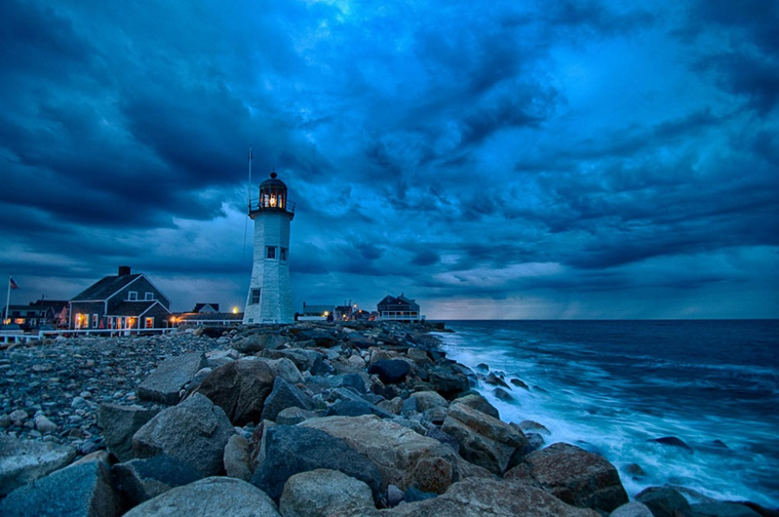](http://brightside.me/wonder-places/27-incredible-lighthouses-that-stood-the-test-of-time-126755/#image882755)

[© Francisco Marty](http://500px.com/photo/72224503/scituate-blues%21-by-francisco-marty)

**Nazaré, Portugal**

[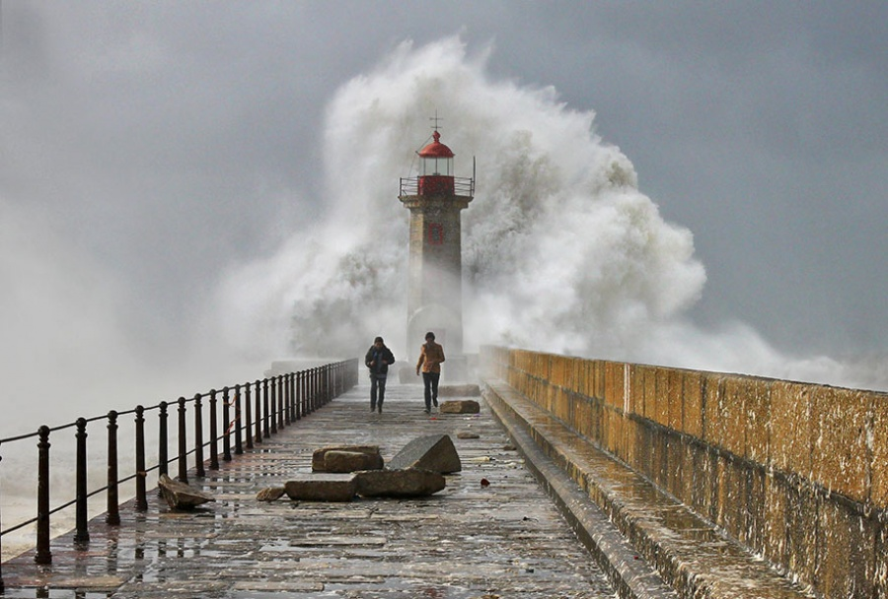](http://brightside.me/wonder-places/27-incredible-lighthouses-that-stood-the-test-of-time-126755/#image882805)

[© Veselin Malinov](http://500px.com/photo/58516312/hard-times-by-veselin-malinov)

**Iceland**

[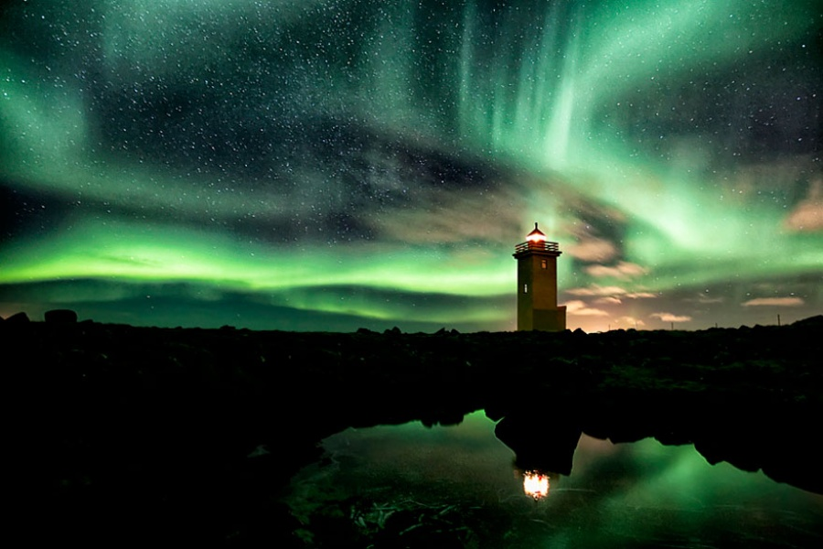](http://brightside.me/wonder-places/27-incredible-lighthouses-that-stood-the-test-of-time-126755/#image882855)

[© Gunnar Gestur](http://500px.com/photo/29376317/before-the-storm-iceland-by-gunnar-gestur-?from=user)

**France**

[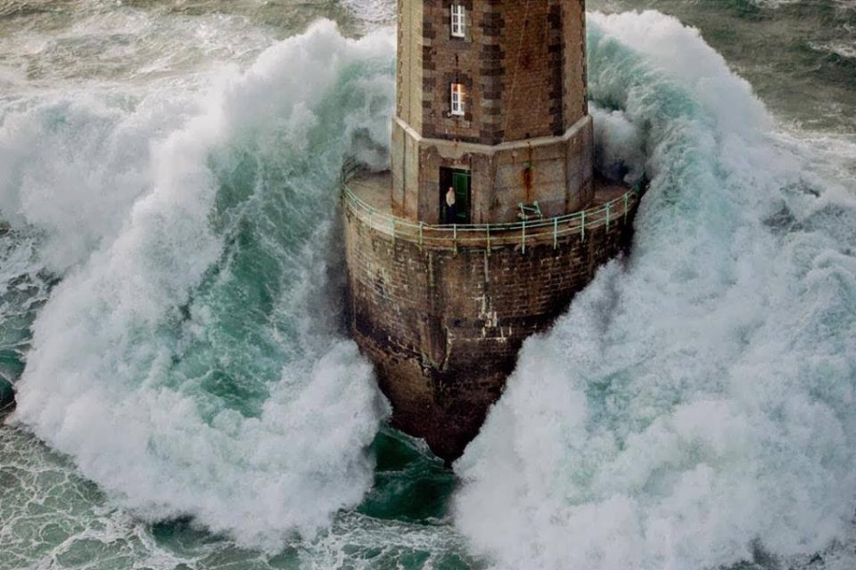](http://brightside.me/wonder-places/27-incredible-lighthouses-that-stood-the-test-of-time-126755/#image882905)

© Jean Guichard