# 20 perfect photographs that reveal the true beauty of our world in all its glory

http://brightside.me/article/20-perfect-photographs-that-reveal-the-true-beauty-of-our-world-in-all-its-glory-46355/

**Yunnan, China**

[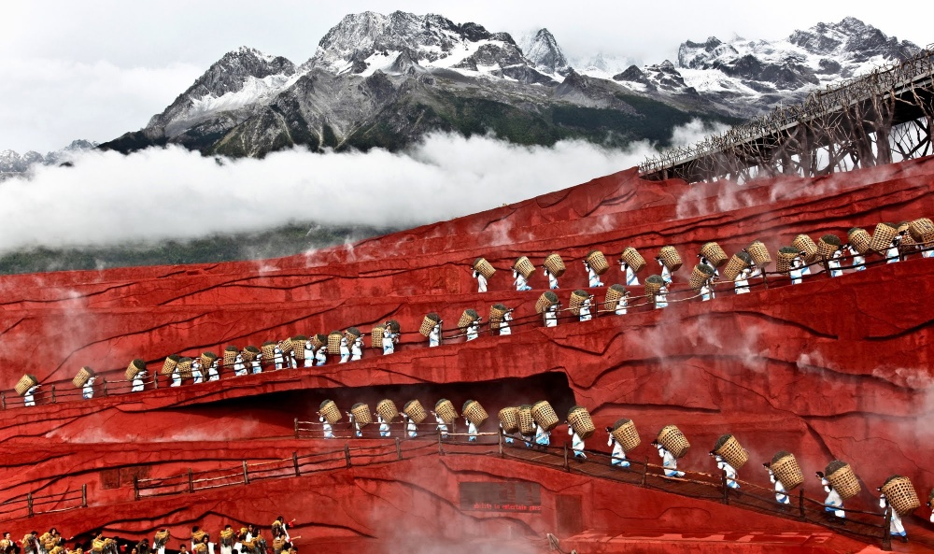](http://brightside.me/article/20-perfect-photographs-that-reveal-the-true-beauty-of-our-world-in-all-its-glory-46355/#image194905)

[ytimg](http://i.ytimg.com/vi/fCQswmM98U4/maxresdefault.jpg)

**Olympic National Park, USA**

[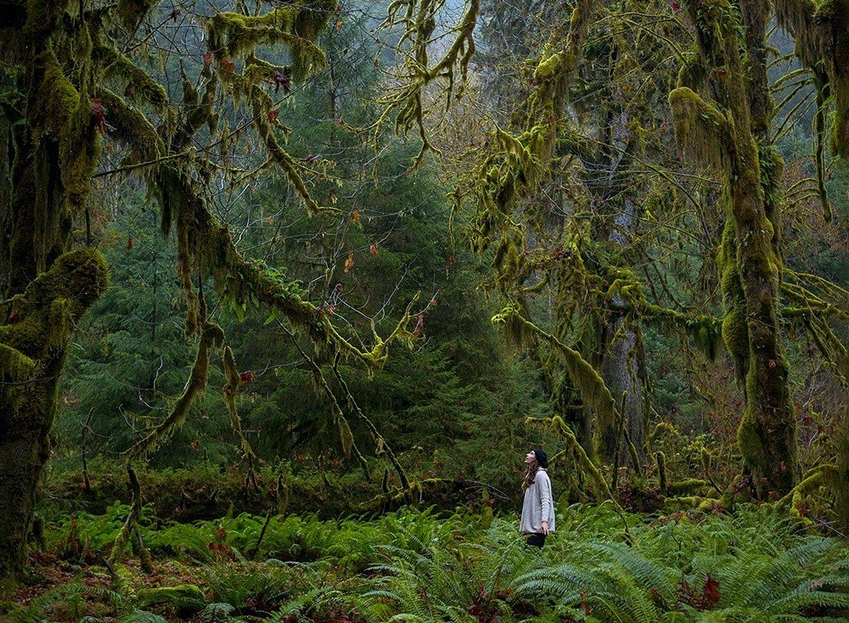](http://brightside.me/article/20-perfect-photographs-that-reveal-the-true-beauty-of-our-world-in-all-its-glory-46355/#image194255)

[© Justin Jung](http://justinchungstudio.com/)

**Hotaru Ika firefly squids, Japan**

[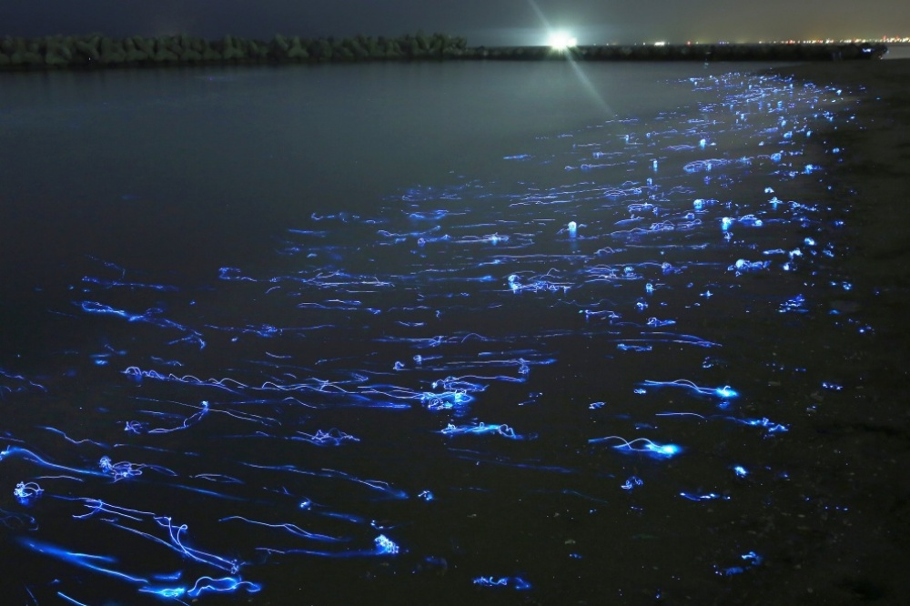](http://brightside.me/article/20-perfect-photographs-that-reveal-the-true-beauty-of-our-world-in-all-its-glory-46355/#image194855)

[© Takehito Miyatake](http://www.take-miyatake.com/)

**Sunset on Pensacola beach, USA**

[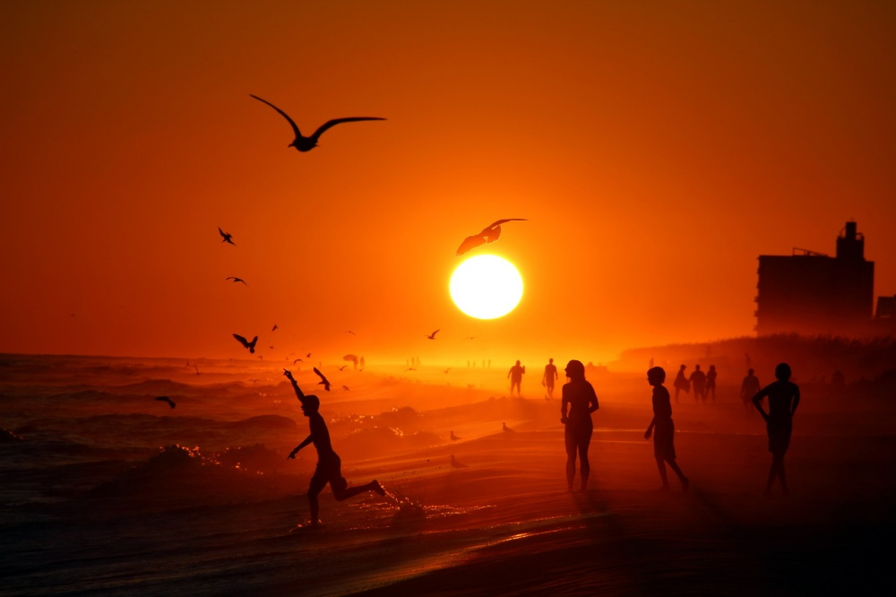](http://brightside.me/article/20-perfect-photographs-that-reveal-the-true-beauty-of-our-world-in-all-its-glory-46355/#image193705)

[© Anthony DellaCroce](https://www.facebook.com/AnthonyDellacrocePhotographyAdphotos)

**Blue Pond, Hokkaido, Japan**

[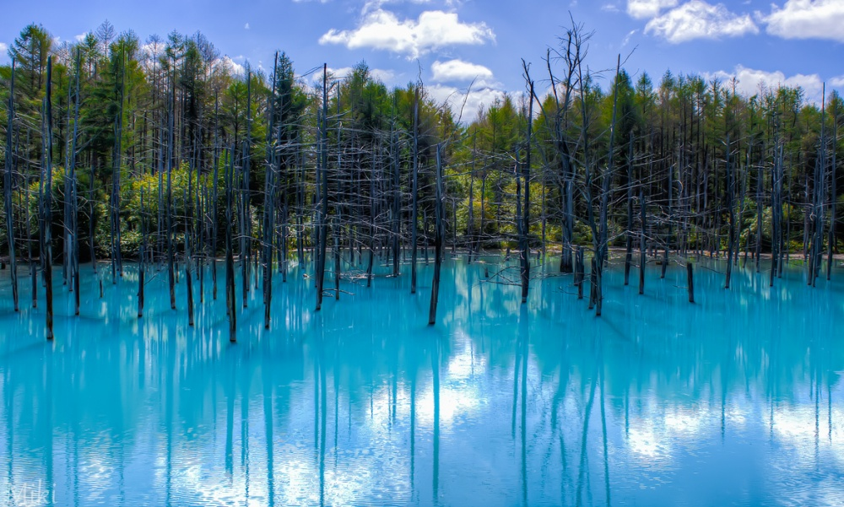](http://brightside.me/article/20-perfect-photographs-that-reveal-the-true-beauty-of-our-world-in-all-its-glory-46355/#image193655)

[© Miki Asai](http://500px.com/photo/12989637/aoi-ike-by-miki-asai)

**The Namib Desert, Africa**

[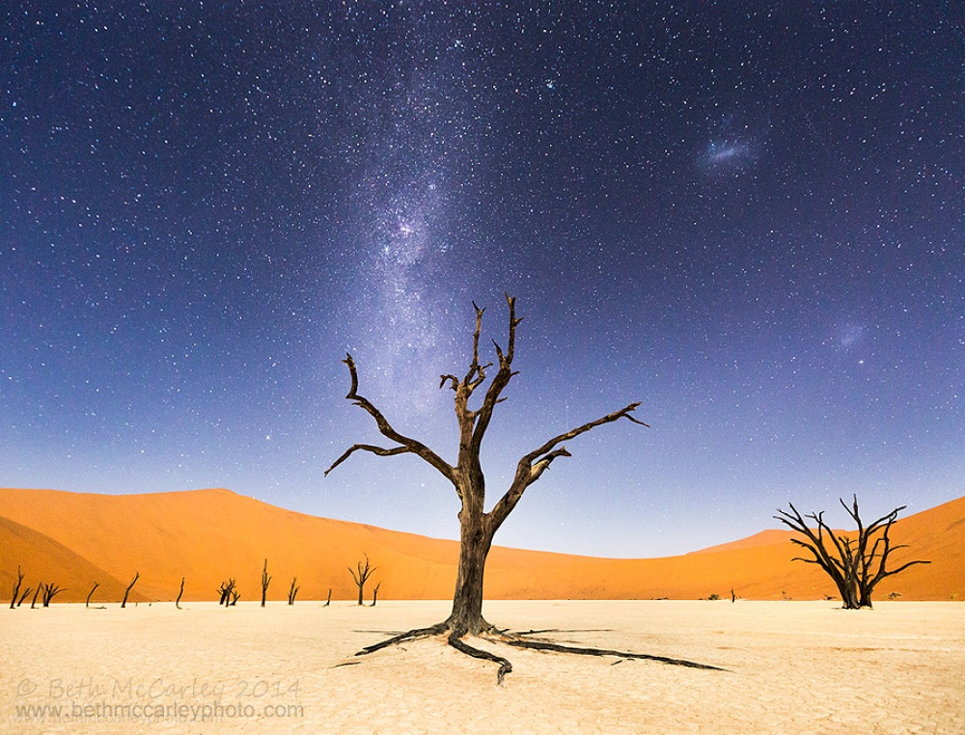](http://brightside.me/article/20-perfect-photographs-that-reveal-the-true-beauty-of-our-world-in-all-its-glory-46355/#image195005)

[© Beth McCarley](http://bethmccarleyphoto.com/)

**Daigo-ji temple, Japan**

[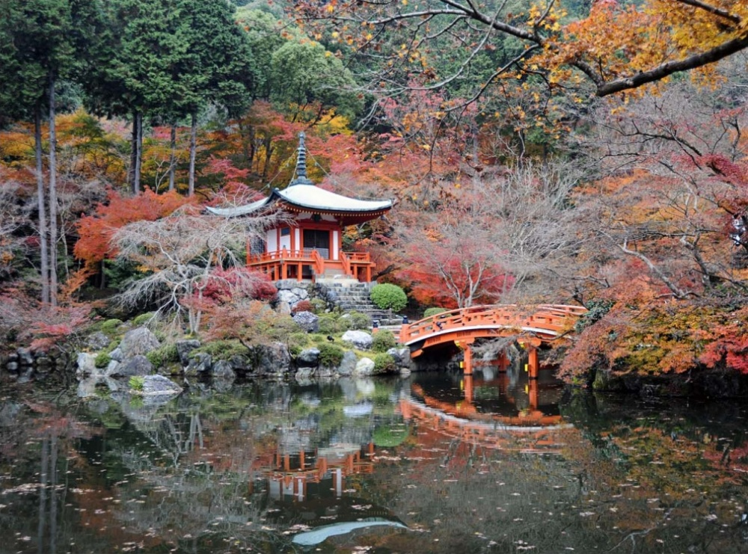](http://brightside.me/article/20-perfect-photographs-that-reveal-the-true-beauty-of-our-world-in-all-its-glory-46355/#image195055)

[© Aleksei Mole](https://www.facebook.com/alexey.kruglov.90)

**Volcanic lightning, Japan**

[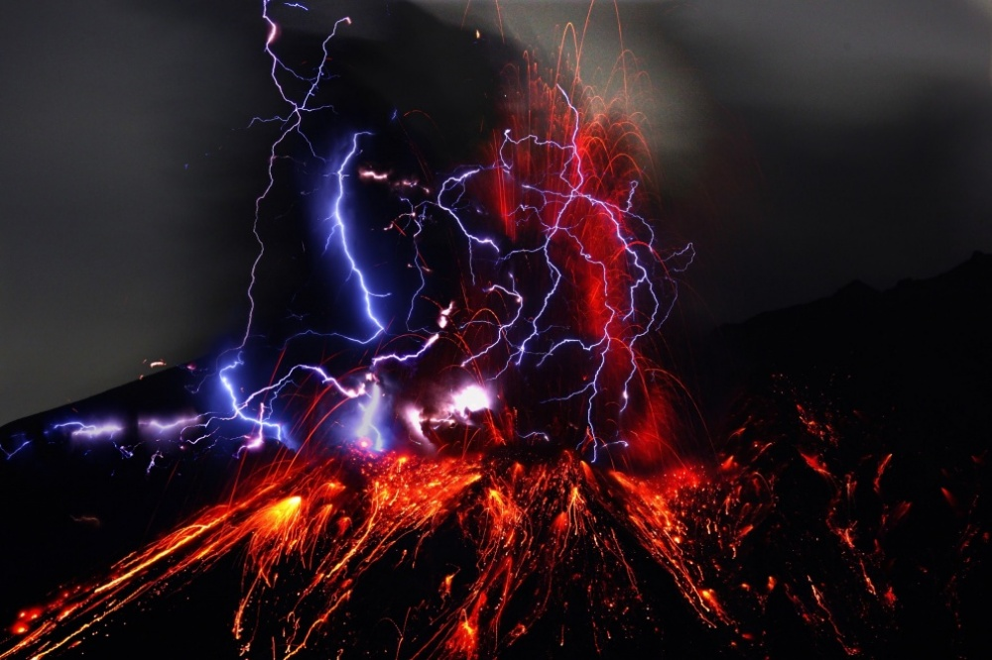](http://brightside.me/article/20-perfect-photographs-that-reveal-the-true-beauty-of-our-world-in-all-its-glory-46355/#image194955)

[© Takehito Miyatake](http://www.take-miyatake.com/)

**Lake Natron, Tanzania**

[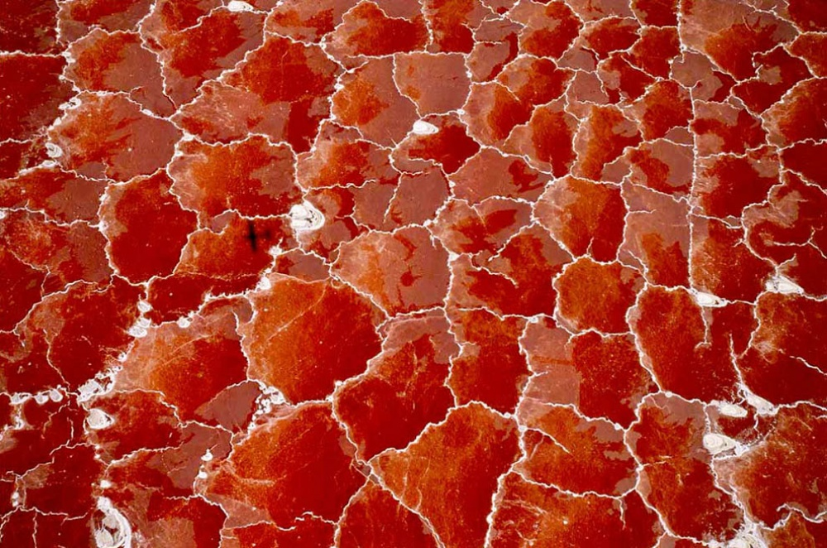](http://brightside.me/article/20-perfect-photographs-that-reveal-the-true-beauty-of-our-world-in-all-its-glory-46355/#image193455)

[greentooth](http://www.greentooth.net/aerial-view-on-lake-natron-tanzania/)

**The 15 mile-long shadow of Fujiyama Mountain, Japan**

[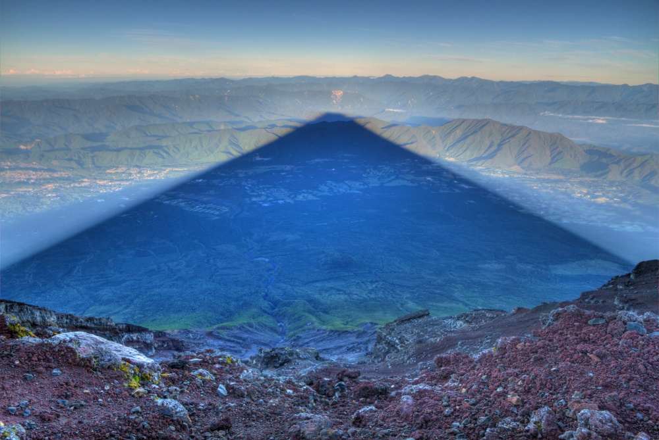](http://brightside.me/article/20-perfect-photographs-that-reveal-the-true-beauty-of-our-world-in-all-its-glory-46355/#image193805)

[© Kris Boorman](http://www.kjbphotographics.com/)

**Forests without end, Russia**

[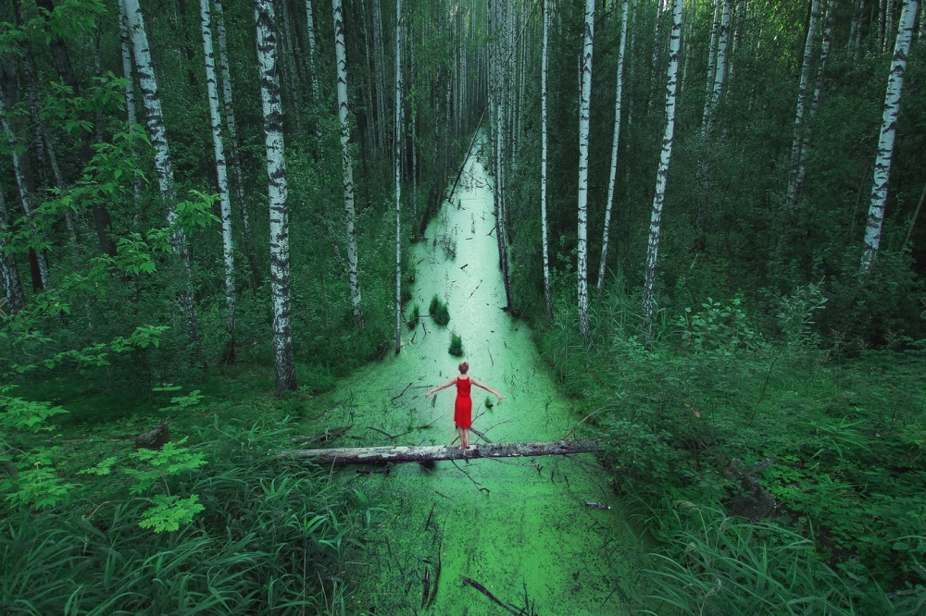](http://brightside.me/article/20-perfect-photographs-that-reveal-the-true-beauty-of-our-world-in-all-its-glory-46355/#image193905)

[© Ivan Letokhin](http://letohin.livejournal.com/)

**The place where the Namib Desert meets the sea**

[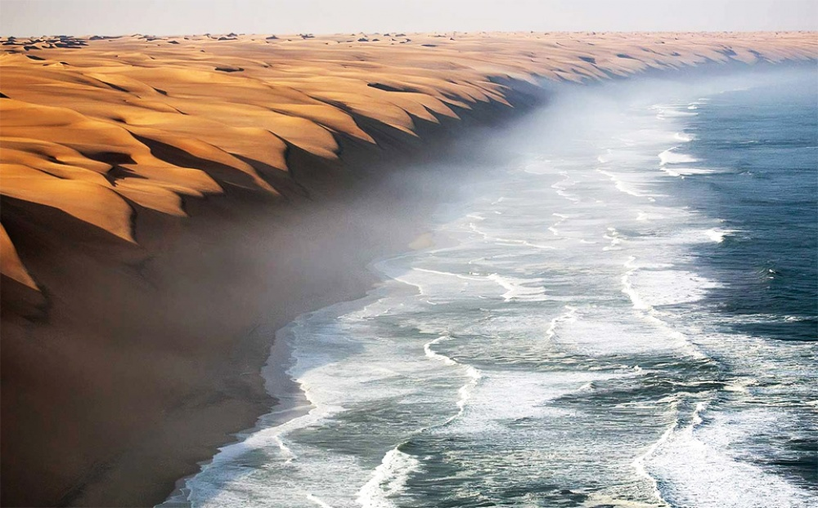](http://brightside.me/article/20-perfect-photographs-that-reveal-the-true-beauty-of-our-world-in-all-its-glory-46355/#image193855)

[© Roberto Sysa Moiola](https://500px.com/sysaworld)

**Rapeseed fields in Luoping, China**

[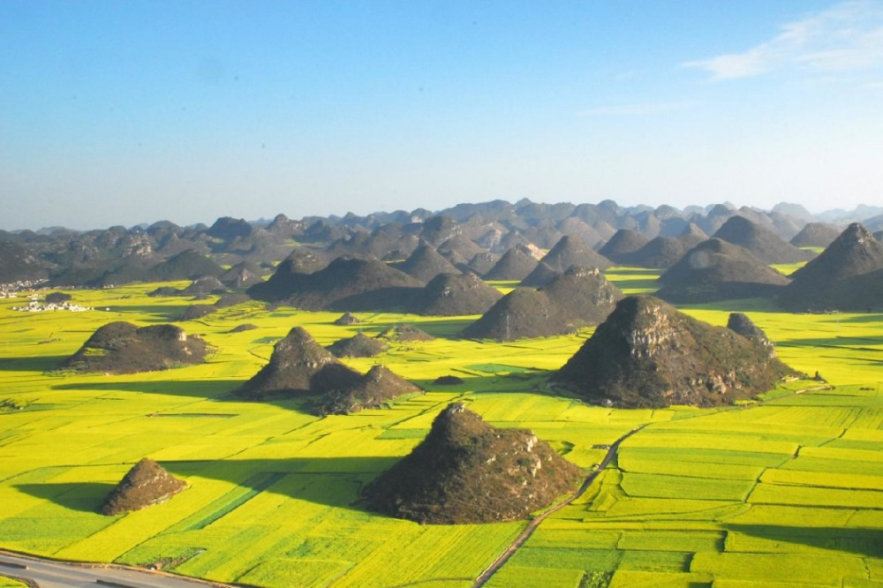](http://brightside.me/article/20-perfect-photographs-that-reveal-the-true-beauty-of-our-world-in-all-its-glory-46355/#image193305)

[© bbs](http://bbs.hsw.cn/)

**Dog-sledding in Greenland**

[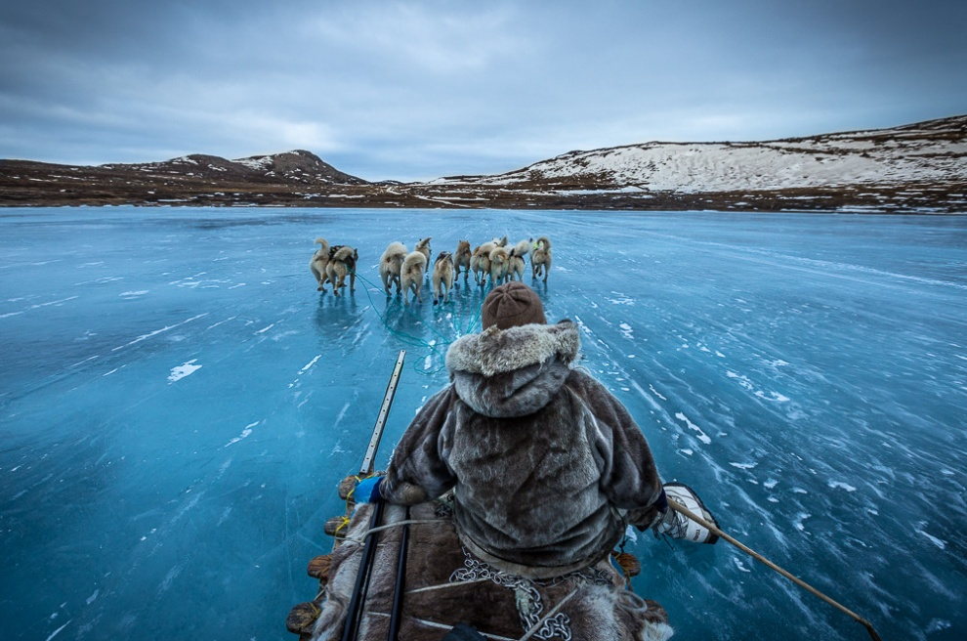](http://brightside.me/article/20-perfect-photographs-that-reveal-the-true-beauty-of-our-world-in-all-its-glory-46355/#image193005)

[© Joe Capra](https://500px.com/scientifantastic)

**Kazbegi, Georgia**

[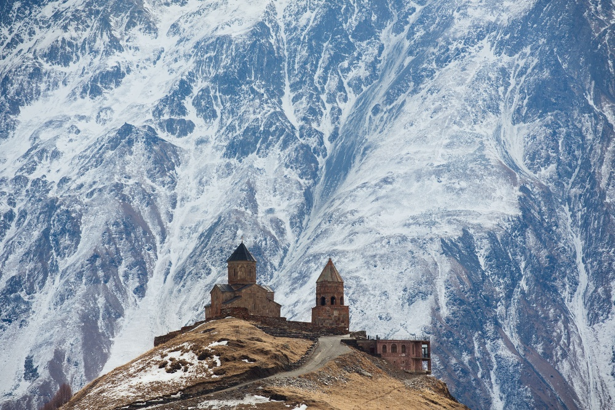](http://brightside.me/article/20-perfect-photographs-that-reveal-the-true-beauty-of-our-world-in-all-its-glory-46355/#image193155)

[© Alexandra Mednaya](http://www.mednaya.com/travel/)

**The place where the North Sea and the Baltic Sea meet**

[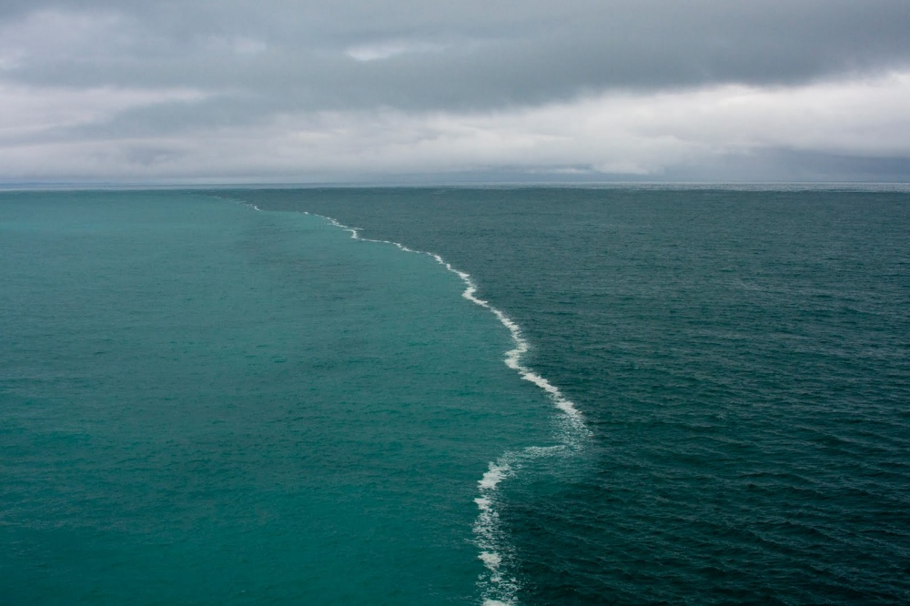](http://brightside.me/article/20-perfect-photographs-that-reveal-the-true-beauty-of-our-world-in-all-its-glory-46355/#image195105)

[img-fotki](http://img-fotki.yandex.ru/get/6423/137106206.197/0_99533_74279de0_orig)

**A farmer, Vietnam**

[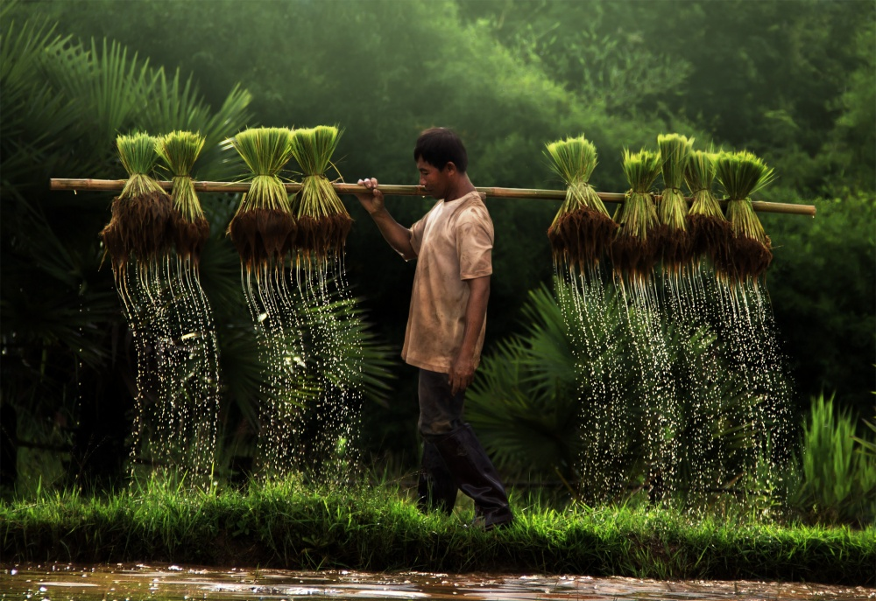](http://brightside.me/article/20-perfect-photographs-that-reveal-the-true-beauty-of-our-world-in-all-its-glory-46355/#image195155)

[© Yothin Insuk](https://500px.com/photo/107264629/a-farmer-and-water-dripping-by-yothin-insuk?utm_campaign=may3_12PM_a-farmer-and-water-dripping-by-yothin-insuk&utm_medium=social&utm_source=500px)

**A curious seal, USA**

[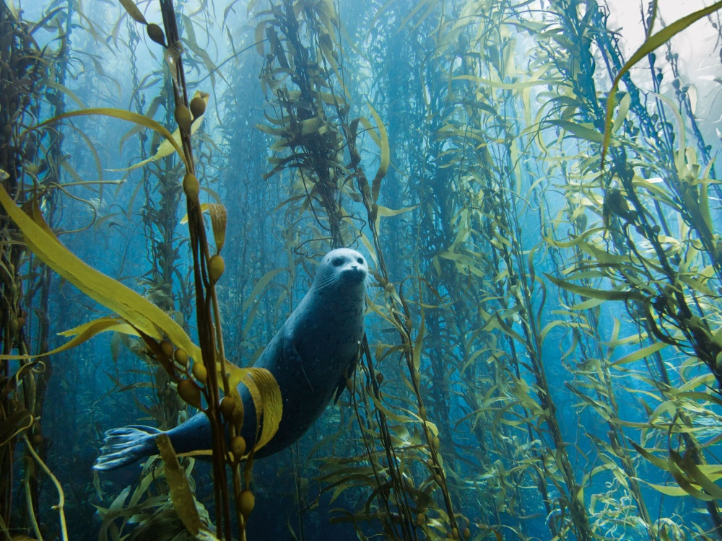](http://brightside.me/article/20-perfect-photographs-that-reveal-the-true-beauty-of-our-world-in-all-its-glory-46355/#image193755)

[© Kyle McBurnie](http://kylemcburnie.com/bio/)

**Winter in Kamchatka, Russia**

[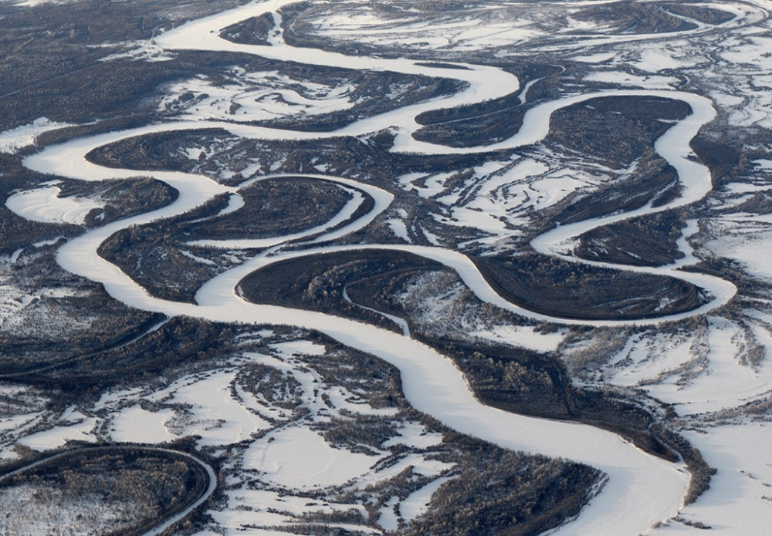](http://brightside.me/article/20-perfect-photographs-that-reveal-the-true-beauty-of-our-world-in-all-its-glory-46355/#image193505)

[*© Igor Shpilenok*](http://shpilenok.livejournal.com/)

**Lake Retba, Senegal**

[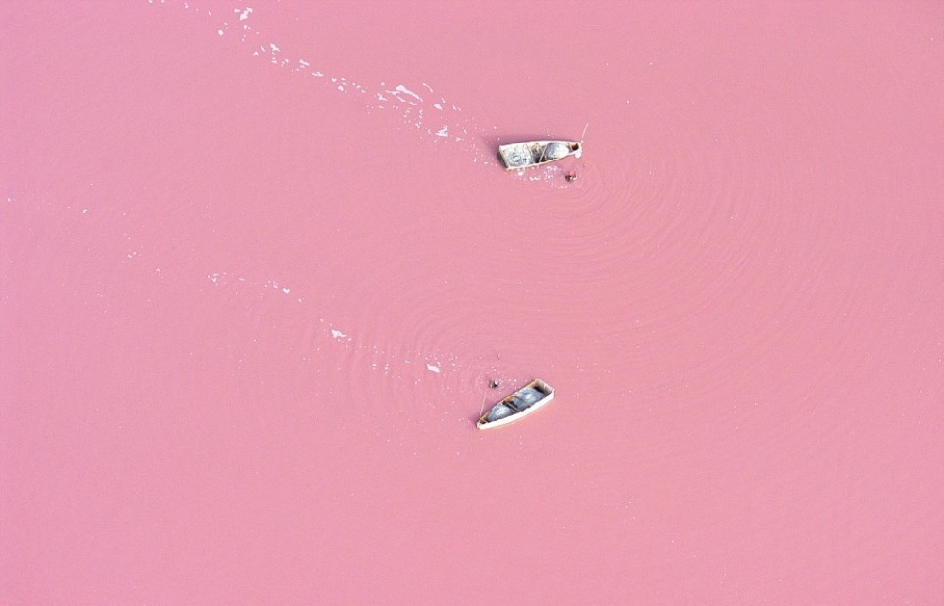](http://brightside.me/article/20-perfect-photographs-that-reveal-the-true-beauty-of-our-world-in-all-its-glory-46355/#image193405)

[*bioindustry*](http://www.bioindustry.cn/info/view/17373)