# 18 truly impressive photos we’ve never seen before

**http://brightside.me/creativity-photography/18-truly-impressive-photos-weve-never-seen-before-126955/**

**The size of a comet compared to Los Angeles**

[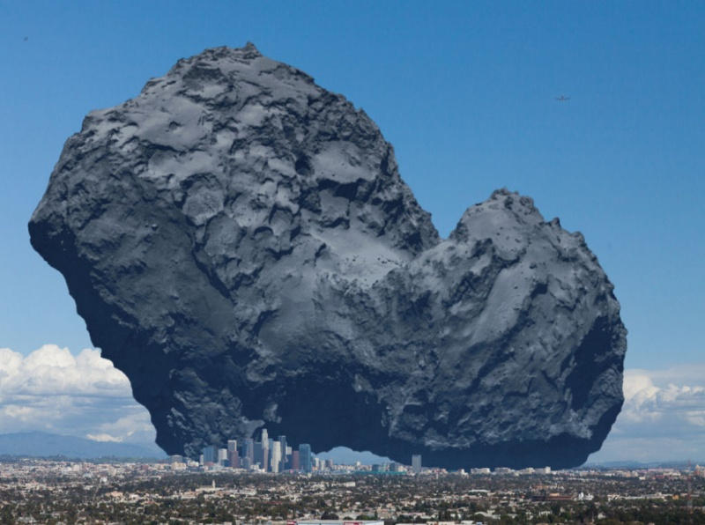](http://brightside.me/creativity-photography/18-truly-impressive-photos-weve-never-seen-before-126955/#image889005)

[imgur.com](http://i.imgur.com/BEZBAKB.jpg)

**An armadillo in ’sleep mode’**

[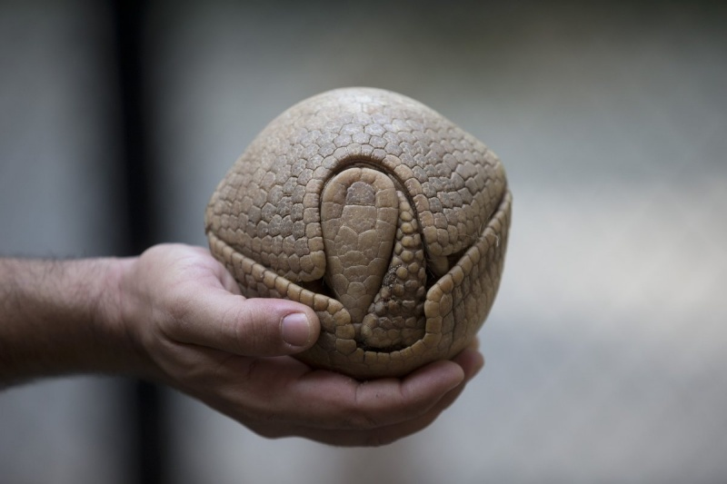](http://brightside.me/creativity-photography/18-truly-impressive-photos-weve-never-seen-before-126955/#image889055)

[diply.com](http://diply.com/and/woah-would-you-look-at-that/146560/5)

**High-tech parking. Volkswagen factory, Wolfsburg**

[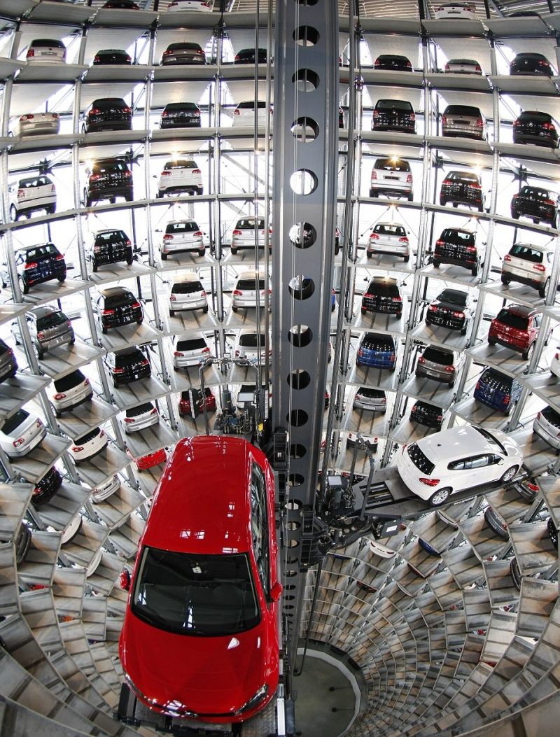](http://brightside.me/creativity-photography/18-truly-impressive-photos-weve-never-seen-before-126955/#image889105)

[acidcow.com](http://acidcow.com/pics/63753-very-interesting-photos-part-47-18-pics.html)

**A honeycomb**

[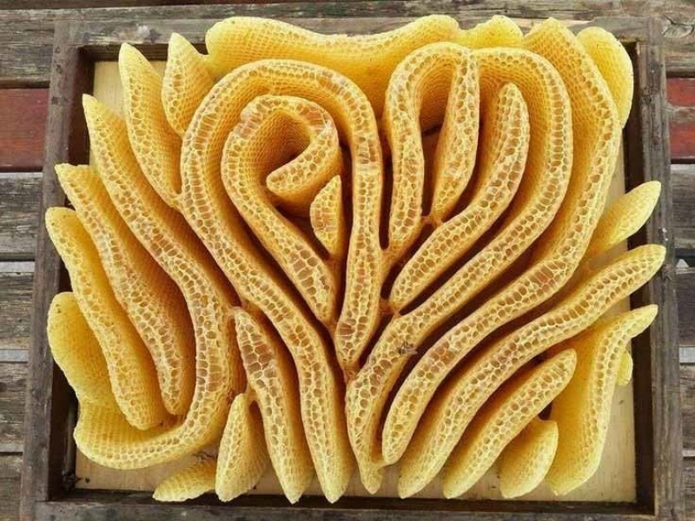](http://brightside.me/creativity-photography/18-truly-impressive-photos-weve-never-seen-before-126955/#image889155)

[imgur.com](http://i.imgur.com/HQht0af.jpg)

**A 360º rainbow**

[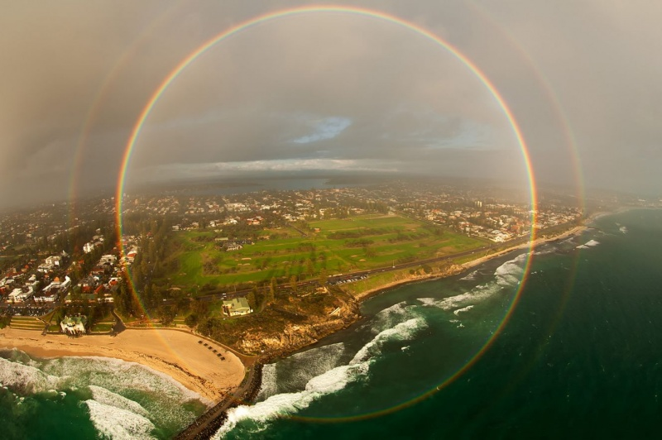](http://brightside.me/creativity-photography/18-truly-impressive-photos-weve-never-seen-before-126955/#image889205)

[circoviral.com](http://circoviral.com/28-fotos-impactantes-percepcion-del-mundo/)

**Two trees that share one branch**

[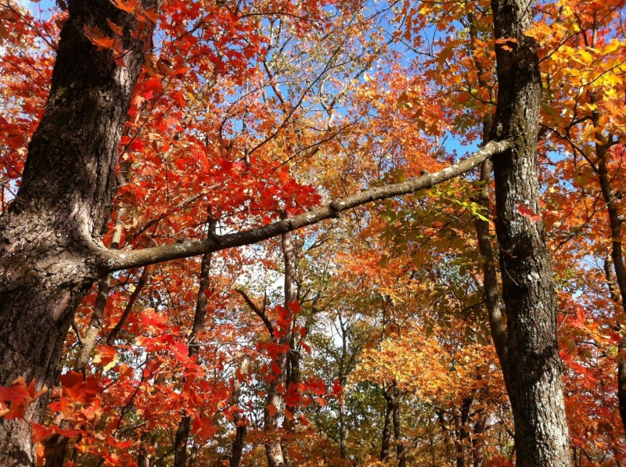](http://brightside.me/creativity-photography/18-truly-impressive-photos-weve-never-seen-before-126955/#image889255)

[imgur.com](http://i.imgur.com/p0zwW.jpg)

**Farmers’ fields in Saudi Arabia**

[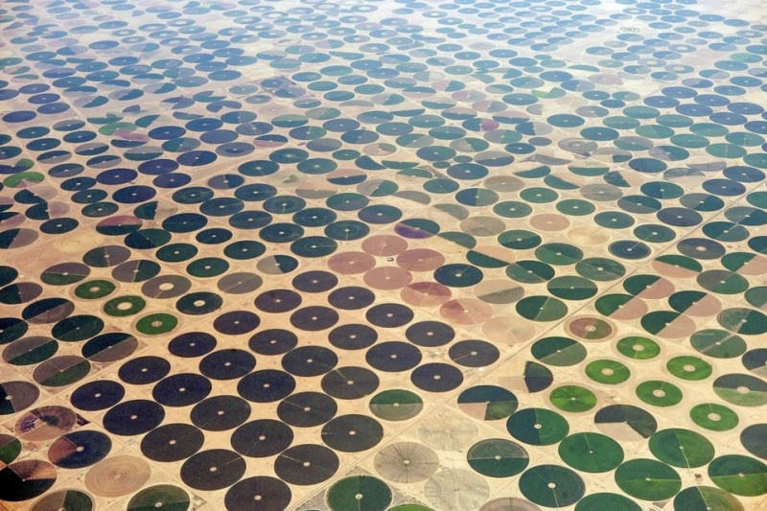](http://brightside.me/creativity-photography/18-truly-impressive-photos-weve-never-seen-before-126955/#image889305)

[imgur.com](http://imgur.com/Kb1IOwm)

**Wheat vs. Lavender**

[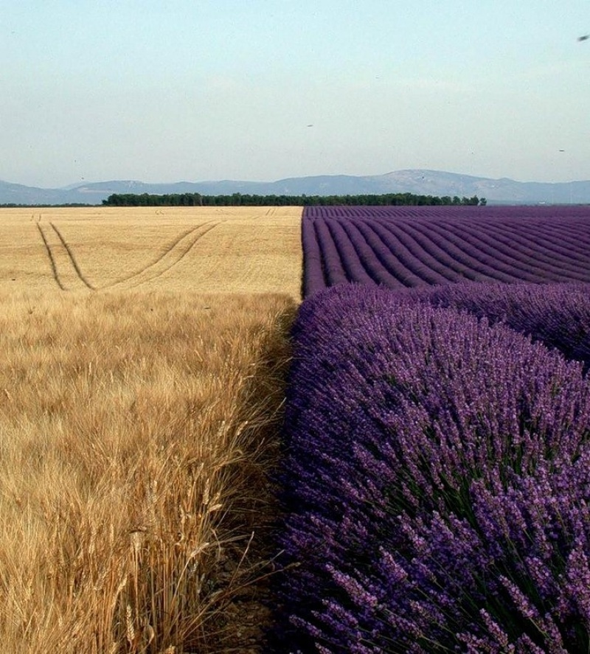](http://brightside.me/creativity-photography/18-truly-impressive-photos-weve-never-seen-before-126955/#image889355)

[imgur.com](http://i.imgur.com/hwZZTyV.jpg)

**Earth viewed from Mars, and Mars viewed from Earth**

[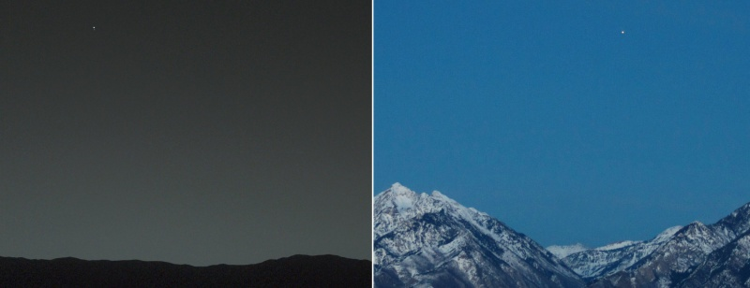](http://brightside.me/creativity-photography/18-truly-impressive-photos-weve-never-seen-before-126955/#image889405)

[es-static.us](http://en.es-static.us/upl/2014/02/earth-mars-2014.jpg)

**A cornea transplant**

[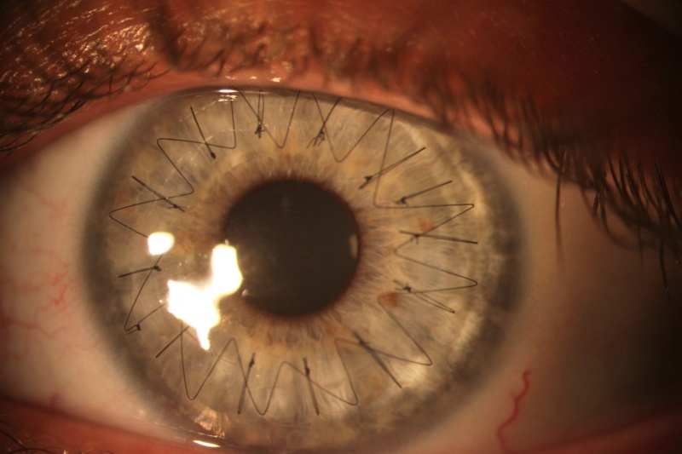](http://brightside.me/creativity-photography/18-truly-impressive-photos-weve-never-seen-before-126955/#image889455)

[imgur.com](http://imgur.com/jFyo0)

**Graphene aerogel — the lightest material ever made**

[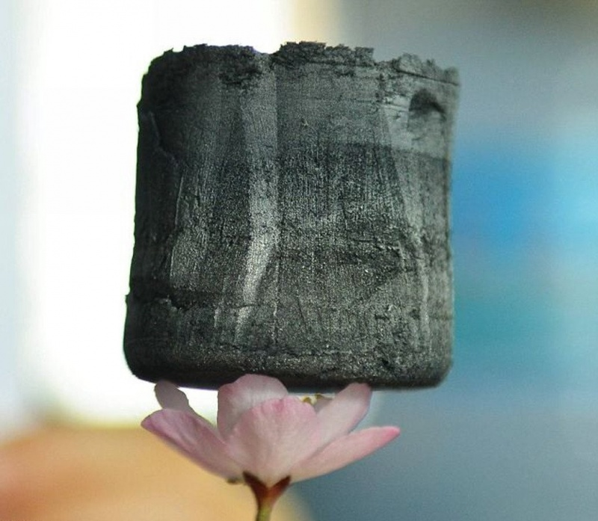](http://brightside.me/creativity-photography/18-truly-impressive-photos-weve-never-seen-before-126955/#image889505)

[galleryhip.com](http://galleryhip.com/carbon-aerogel-lightest-material.html)

**The Magdeburg Water Bridge in Germany**

[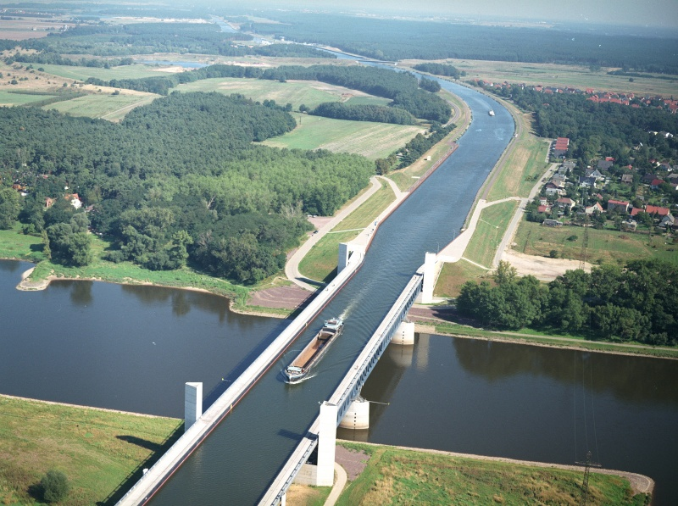](http://brightside.me/creativity-photography/18-truly-impressive-photos-weve-never-seen-before-126955/#image889555)

[megalife.com.ua](http://megalife.com.ua/uploads/posts/2013-03/1363431161_waterbridges01.jpg)

**A rainbow and lightning seen together**

[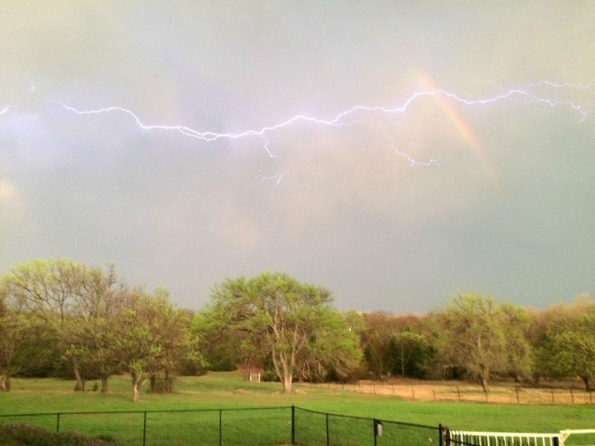](http://brightside.me/creativity-photography/18-truly-impressive-photos-weve-never-seen-before-126955/#image889605)

[reddit.com](https://www.reddit.com/r/pics/comments/30bpy9/rainbowlightning_combo/)

**In the heart of the sea**

[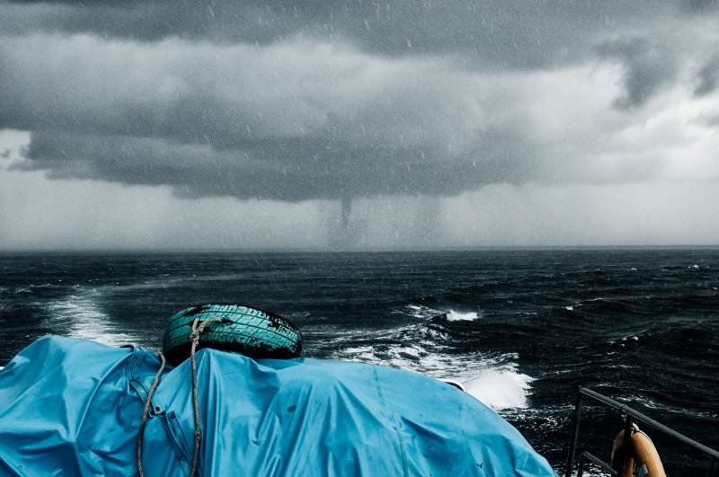](http://brightside.me/creativity-photography/18-truly-impressive-photos-weve-never-seen-before-126955/#image889655)

[Spreng Ben](https://www.flickr.com/photos/sprengben/9664416778/in/photostream/)

**Some velcro put under the microscope**

[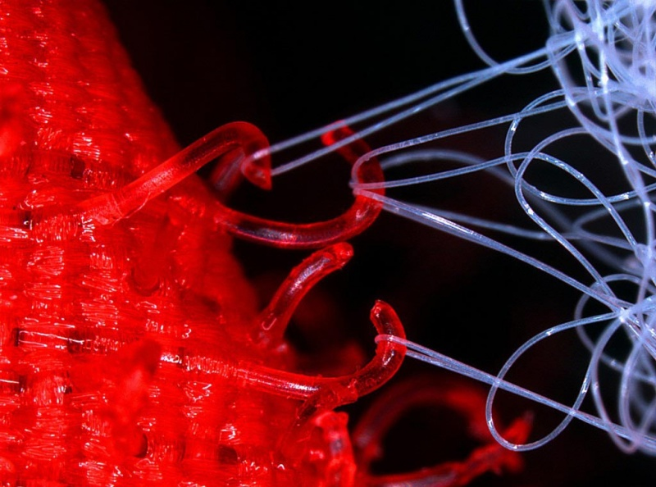](http://brightside.me/creativity-photography/18-truly-impressive-photos-weve-never-seen-before-126955/#image889705)

[imgur.com](http://imgur.com/JQfU796)

**A transparent acrylic car**

[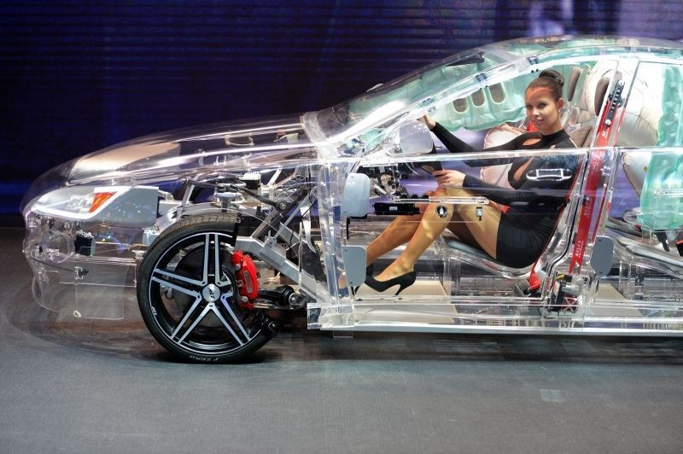](http://brightside.me/creativity-photography/18-truly-impressive-photos-weve-never-seen-before-126955/#image889755)

[avtovolop.ru](http://avtovolop.ru/news/prozrachnyj_avtomobil_iz_akrila_na_vystavke_vo_frankfurte/2013-10-06-1131)

**How genetics work: take a close look at the newlywed’s relatives**

[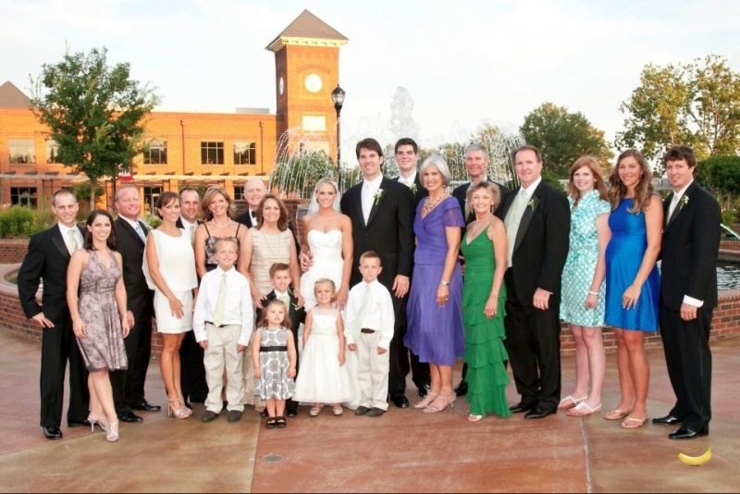](http://brightside.me/creativity-photography/18-truly-impressive-photos-weve-never-seen-before-126955/#image889805)

[reddit.com](http://www.reddit.com/r/pics/comments/1th0rc/genetics_from_rtall/)

**The Great Wall of China ends right here**

[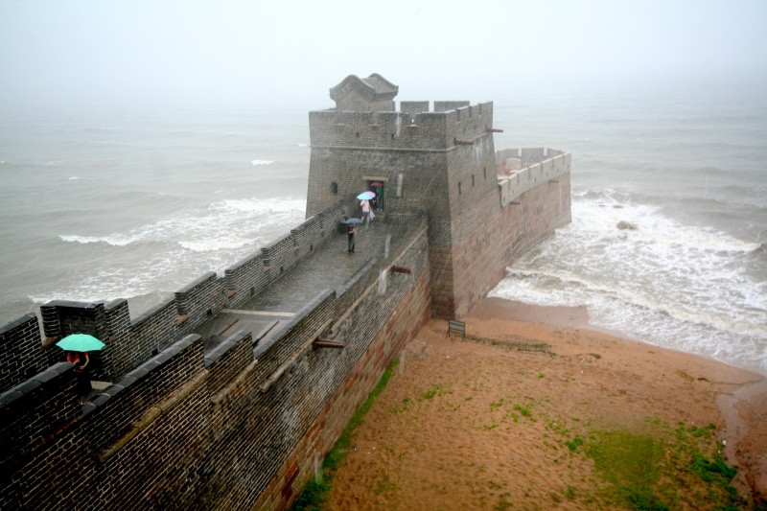](http://brightside.me/creativity-photography/18-truly-impressive-photos-weve-never-seen-before-126955/#image889855)

[circoviral.com](http://circoviral.com/28-fotos-impactantes-percepcion-del-mundo/)