Occult Symbols
Twilit Grotto Esoteric Archives
http://www.esotericarchives.com/gifs/gifs.htm#alchemy

Alchemy
Ounce | Dram | Gold | Tin | Silver | Copper | Iron | Lead | Mercury
aqua | aer | ignis | terra
Note, formulae given in apothacary symbols have the following meaning: "Roman numerals (lower case) are always used following a symbol to designate the number of units read, but if the abbreviation is used, Arabic numerals are used and preceed the abbreviation; for example 3iv or 4dr. For less that one unit, ½ may be designated by "ss" following the symbol, but other fractions must be designated by Arabic numeral fractions." [Merck Index, and Encyclopedia of Chemicals and Drugs, Merck & Co., Inc., New Jersey, 10th Edition, 1983, p. MISC-71.]
Angels
Seals of the angels
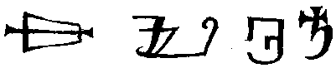 | of Saturn
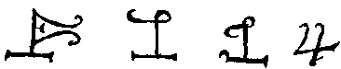 | of Jupiter
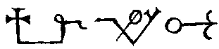 | of Mars
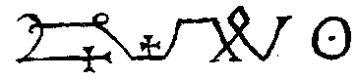 | of the Sun
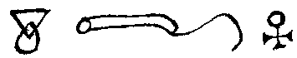 | of Venus
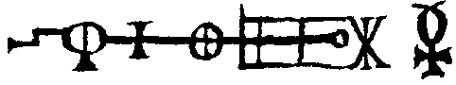 | of Mercury
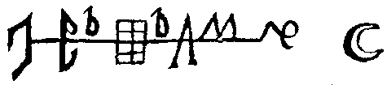 | of the Moon
Astrology
Planets
Saturn. | Jupiter. | Mars. | Sol. | Venus. | Mercury. | Luna.
 | 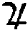 |  | 
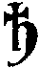 | 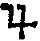 | 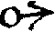 | 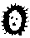 |  |  | 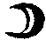

The five Planetary Aspects.
Conjunction. | Sextile. | Quadrat. | Trine. | Opposition.

Signs of the Zodiac.
Aries. | Taurus. | Gemini. | Cancer. | Leo. | Virgo.
Libra. | Scorpio. | Sagittarius. | Capricornus. | Aquarius. | Pisces.
Goetic:
Bael | Agares | Vassago | Gamigin | Marbas
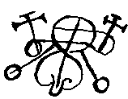 | 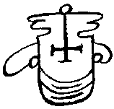 | 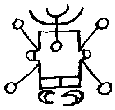 | 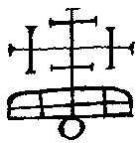 | 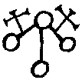
Magic
 | 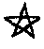
Triangle | Pentacle

Sigils of the seven planets (Magical calendar, A.D 1620)
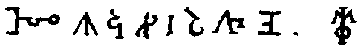
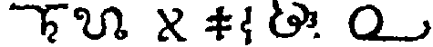
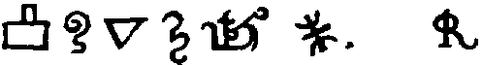
Runes
From Sloane MS. 3854 (From Charles Burnett, Magic and Divination in the Middle Ages,Variorum, 1996, p. 426.
Latin  letter | Constellation  name (first  occurrence) | Sign of  zodiac | Constellation  name (2nd  and 3rd  occurrence) | Rune name | Rune figure | Rune nature | Old Norse  rune name
a | Salmadys |  | Salmadys | Ay |  |  | ár
b |  |  |  | Bietke |  |  | bjarkan
c | Lachlym |  | Lachlim | Kon |  |  | (kaun)
d |  |  |  | Gostarigen |  |  | Týr stunginn
e | Celech |  | Scecelech | Ystingen |  |  | iss stunginn
f |  |  |  | Forpa |  |  | fé
g | Rohos |  | Rops | Luen (Iuen) | 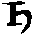 |  | kaun stunginn
h |  |  |  | Hagel |  |  | hagall
i | Ayheyl |  | Eyleyl | Lis (Iis) |  |  | íss
k |  |  |  | Barke |  |  | kaun
l | Alpos |  | Lyale | Lâg |  |  | logr
m |  |  |  | Mâg |  |  | maðr
n | Affoguil |  | Affoguil | Noch |  |  | nauð
o |  |  |  | Och |  |  | óss
p | Kalcharie |  | Alcharie | Bierbe stuncken |  |  | bjarkan stunginn
q |  |  |  | Bierbe blesena |  |  | (bjarkan ...)
r | Harapel |  | Hanape | Rether | 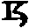 |  | reið
s |  |  |  | Sol |  |  | sól
t | Hahoel |  | Allioes | Tyr |  |  | Týr
u |  |  |  | Ue |  |  | úr
x | Gariofel |  | Fariopel | Xere | 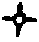
y |  |  |  | Yois
z | Nimbel |  | Rymbel / Kicubel | Zaziyr / Zatzir | 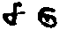
Woodcuts
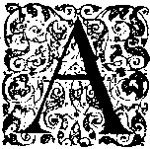 | 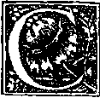 | 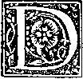 | 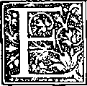
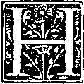 | 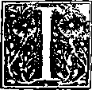 | 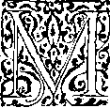 | 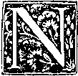
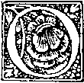 | 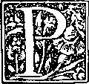 | 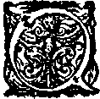 | 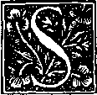
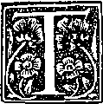 | 