BIDATA

Program for beekeeping and queen breeding
Version 6.0 for windows 98/NT/2000/XP

Developed by Jorn Johanesson

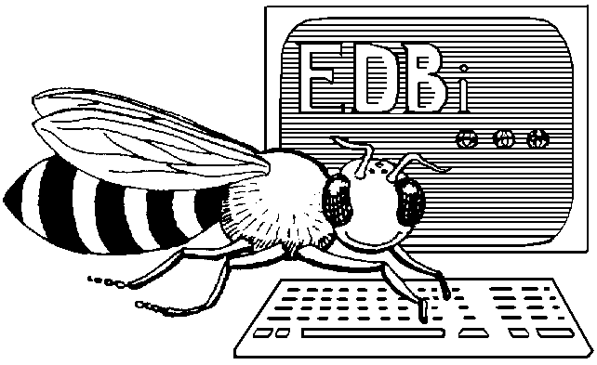

March 2003

18. March 2003

Bidata © copyright 1992/03 by the EDBi Foundation and Jorn Johanesson.
Manual © 2003 Jorn Johanesson and Ken Morris.

Program Jorn Johanesson Solsortevej 27, Assens DK-9550 Mariager Phone. (+45) 98 58 40 61

Software download HTTP://apimo.dk/download1.htm

The Bidata software will behave differently, depending on the registration:
- The Normal software, allows 40 bee colonies.
- Expanded software, allows unlimited queen entries.
- Demo software, which has all the facilities of the expanded program, except that it is limited to ten hives.

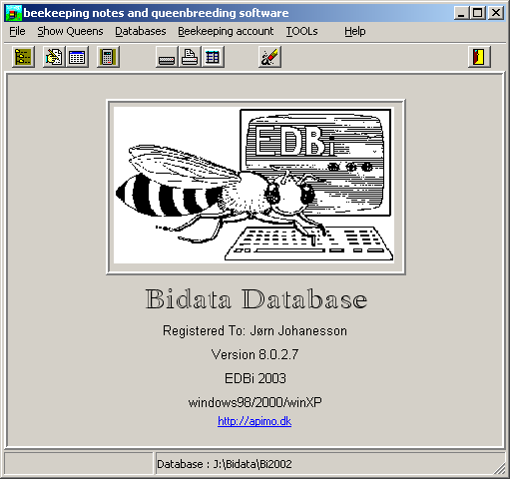

PREFACE
The first beekeeping software for maintaining hive notes was offered to the Danish beekeeper society in 1987. Since then the software has been extensively redeveloped, thanks to the help I have received from the Beekeeper Society in Denmark and feedback from the software users. Criticism has always been welcome and I have listened to it with great interest, because the software is intended to meet the needs of beekeepers.
Thank you to all who have contributed with criticism, suggestions and ideas. I hope that users of the software will continue to forward their ideas and suggestions to me, so that the software can be as useful as possible.
Bidata is a DATABASE PROGRAM specifically developed for use in beekeeping, for both normal hive note use and queen breeding.
The purpose of the software is to make hive note writing simple and efficient, and to assist the beekeeper in judging the various qualities of the queens, based on notes taken throughout the bee year. The Program makes use of the judgement scale from the Danish Beekeeper Foundation and is inspired by the Official Hive Note card distributed in 1990 by DBF.
INTRODUCTION
Bidata is a program that can run by itself (No runtime module is needed). The database is a Borland Paradox database and it is possible to make an SQL search in the various databases. The software is multilingual and the language can be changed from the Tool menu. The default language is English. The Bidata program, when run for the first time, will ask you to select a language for the software.
Bidata is a database containing records that can be seen as electronic Hive Notes containing data entered after visiting the beeyard.
The Bidata database can be seen as a card file with predefined index cards.
Each new bee year a new card file is generated. The card file is in two parts; daily hive notes, and calculated index cards.
The Bidata software is complex in its functions. Although considerable effort has gone into making the interface as simple as possible, it is strongly recommended that you read the manual in its entirety.

Bidata enables you to:
- Enter, read, edit and delete Hive Notes.
- Calculate the INDEX of the queens within bee yards.
- Print the last notes you made as a work sheet for use in the bee yard.
- Search the database by using a SQL builder, showing only the data you wish to check. You can customise the SQL search to suit your particular needs.
- Compare queen sisters within a bee yard. It also makes it possible to compare sisters placed in different bee yards.
- Move hives from one bee yard to another or move a whole bee yard to another location.
- Display graphic representation of Index calculated data and a lot more which you may not require yet, but is available as the need arises.

System requirements:

Bidata is developed for use on an IBM or IBM Compatible PC running Microsoft WindowsTM . The software might run on other computers but it is required that Microsoft WindowsTM is installed or that the platform is compatible with the Microsoft Windows TM platform.
It is recommended that the computer is provided with at least an Intel 386dx processor. An Intel 486dx 100 or better is preferable. Memory requirement is 4 Mb or better.

INSTALLATION of the WIN-98/NT/2000/XP software

The software package comes on a CD-ROM for registered users.
Insert CD-ROM. The CD-ROM should load an Autorun routine. If the Autorun does not show up then navigate to the directory with “setup.exe” in it or use “Install/remove” software from the control panel. The “setup.exe” file is found on the CD-ROM in directory “EDBi/WIN95/Bidatawin95_98/Cdrom/DISK1/”
The set-up will ask several questions suggesting defaults: It is recommended to use default directories.
If you have purchased the software you will have received the registration.
If you got the software from a friend, or have received the Demo software, just enter what you like as a serial number. All inputs are accepted, but only the correct registration number will turn the software into registered software.

You will be offered three kinds of installation:

typical which will install both the Bidata software and the Pollen database and all language files. This will use 10 Mb of your hard drive.

compact which is recommended for normal use. Only the necessary files needed for running the program are installed and only Danish and English language files will be installed. (Use Selective installation to install other language’s.)

Selective here you have a custom installation and install only the components you need.
It is highly recommended that you choose to reboot the computer. This will ensure that the computer will launch all necessary files and enable newly installed files.

Running the software for the first time:

When you launch the software for the first time you will be presented with some information screens. Please read these in their entirety. They give information about program behaviour, limitations, addresses and so on. Some Bidata software packages contain incorrect registration fee information. The registration fee is DKr 650.00 (Danish Crooner), which is approximately US $100.00 for a full registration, or DKr 275 (Danish Crooner), which is approximately US $45 for a 40-hive registration

When you have passed the information screens, you will be asked to enter details in a personal form, comprising two input fields. One is for your initials, which are used for naming the queens. The queen name is constructed from your initial and the hive number. This is the Buckfast method of naming queens.

The second input field is a password used to protect your data. There is no password stored in the data files, it is used if you want to create a new database, empty a database and some other functions involving potential loss of data.

You will also be shown a form from which you can choose to let Bidata act as queen breeder software or just as normal hivenote software.

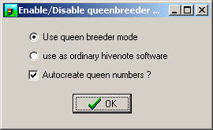

I suggest that you keep Auto create queen numbers checked, even if you are not a queen breeder. The queen number is very like a civil registration number. This assures a unique identification of the queen. This is needed when I add a family tree to the software. The queen number is combined from your initials, the year the queen in introduced, the race of queen, a serial number and a number of the hive where the queen is introduced. If you decide to uncheck this, then only your initials will be used as queen number.
If you have registered the software by now, the program should appear as registered, otherwise you will find a menu item enabling you to register the software package.

Entering data into the database.

This is the most important part of getting your program to perform to your requirements. A database program is only as useful as the quality of input data allows it to be! You must discipline yourself to input all the necessary data with care and accuracy.

Make your hive notes in the bee yard and then enter the data at your earliest opportunity. To help you in collecting data the ‘quick entry’ screen and the work list printout have the same layout. As you enter hive details in the database the hives will appear in the bee yard work list. The work list is meant to be taken with you to the bee yard, where it is used to update your data. It shows the last entries made, so that you need only input the changes since the last entry. There is also an opportunity to make a printout of a big hive note card, which you can configure to your needs.

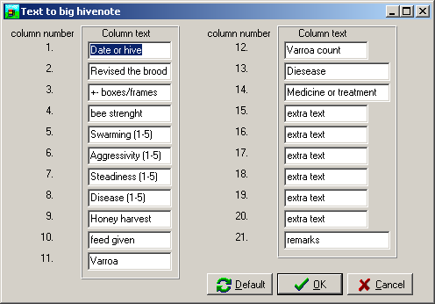

Quick entry screen

The spreadsheet style entry screen is named quick entry screen. Although it looks like a spreadsheet, it does not function in that way. It is just an interface to enter routine data quickly and easily
If there are no hive notes present in the database, then you will be presented with a hive add request form. The following is the no queen breeder screen.

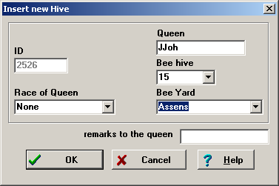

Queen Field.
In the Queen field you enter the queen identification name. It is preferable that you use your initials and the hive number like this: JJ0010, but you can enter whatever you like.
If you have chosen to use auto generation of queen numbers, then this was already filled out with this new specific number like here in the queen breeder mode screen:

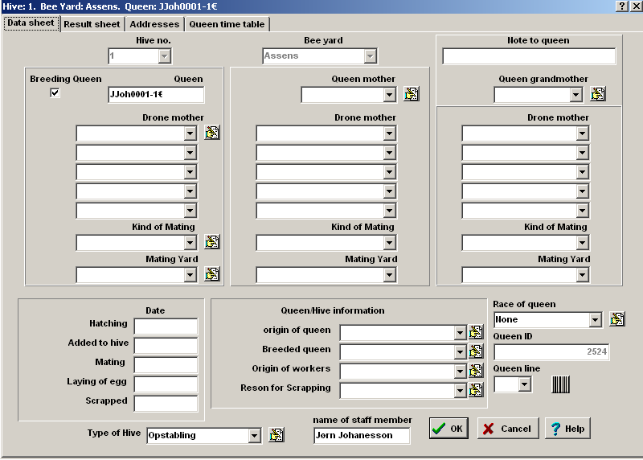

The edit buttons indicates that you can edit the dropdown lists to suit your needs.

Queen Mother Field. (Buckfast - Queen breeder mode)
In the Queen Mother field you enter the identification name of the queen, which produced the egg from which the current queen developed. If you don’t know it leave it blank, an unknown entry is better than just putting in a name. This is important for the bee family tree function that I am developing. It is a program which monitors the success or otherwise of queen breeding activities.

Drone Mother Field. (Buckfast -Queen breeder mode)
In the Drone Mother field you only enter data if the drone mother is known. If you know the drone source, which normally only queen breeders using artificial insemination do, then you enter the drone mother identification.

Hive Number field.
In the BeeHive number field you will enter the hive number where the queen is placed. This is the only field that must be unique on each new hive. The Bidata program will complain if you don’t follow this rule but try to duplicate a hive number. The reason is that the hive number is used as an internal key in the Bidata program. The field is a dropdown list from which a spare hive can be selected or a new hive can be established.

Beeyard field.
In the Beeyard field you will enter the name of the bee yard in which the hive is placed. You will preferably use the name of the location where the bee yard is placed. If you already have bee yards set up then the dropdown list can be used to select the bee yard.

When you have entered the data into the New Beehive Add Form and press the OK button, you will be presented with the calendar, where you can select the date for the actual hive note.

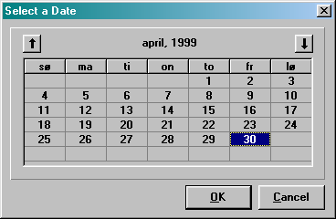

When you have selected the date, the next step will be to enter the hive note data into the database. This is done in the input form, which will pop up next.

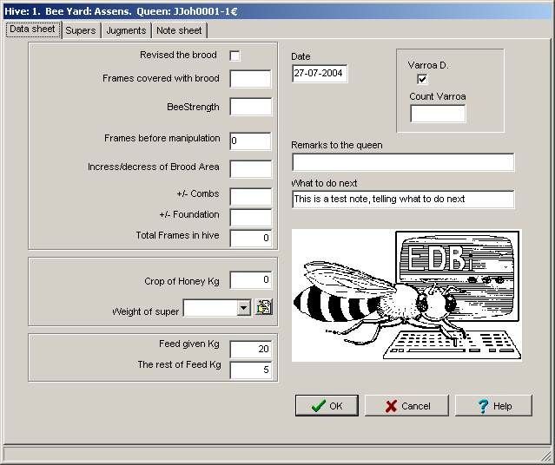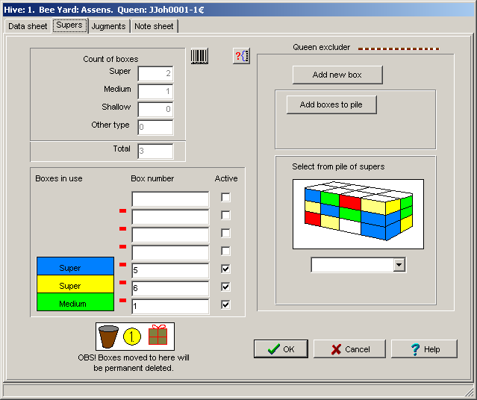

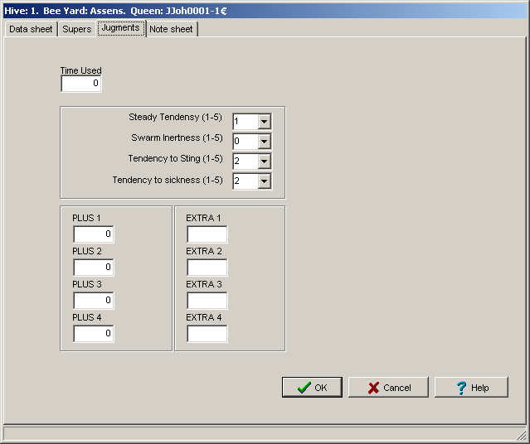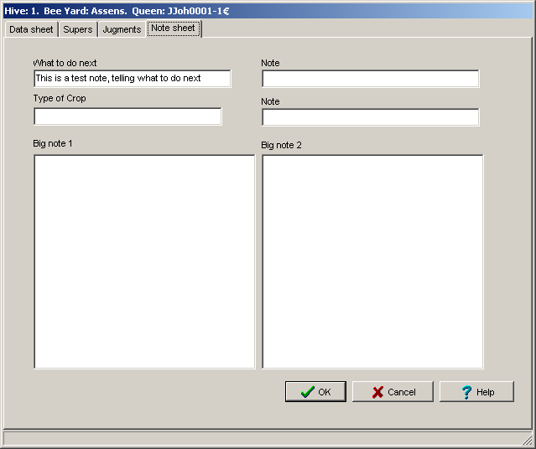

As you can see from the picture, the input form is grouped together with relevant data. The first group is about the most common notes. The second group is about the food and the third group is about the index criteria, which is the absolute power of this software, and distinguishes it from other hive note software on the market. Those groups need a little more explanation. Generally when you are visiting the hive you have a feeling of what is going on. Is the hive easy to work with? Is it going to swarm? Are the bees bumping at you? And so on. A lot of this behaviour is genetic in nature, and by careful selection among the queens that produce bees with behaviour you like, you can increase the joy of beekeeping, and also get much better results, not only in honey harvest but also in handling the bees. I have to mention that you don't have to judge all of it every time you open a hive. You can limit this judging to what actually is up. The group is judged by numbers from 1 to 5 where five is the best and 1 is the condition where you have to do something about it, mainly replacing the queen with a new queen with better genetic traits.

The Steady tendency is the behaviour of the bees when you open the hive, and maybe want to study the queen. Number 5 is where the bees stay in the hive and only a few bees lift off into the air. The queen is easy to study; because she continues to do her job and the bees will not try to escape the comb, even if the comb is lifted out. You can keep the bees under control just by spraying them with a little water. and it is easy to shuttle off the bees. Number 1 is given if you are getting a lot of bees into the air, the queen is trying to escape, and when you lift a comb out the bees will try to escape maybe building a lump of bees on the button stick of the frame and then fall off. It is impossible to study the queen even if she is marked, because she will run away as far as she can, and maybe run out of the hive too. Your judgement here is what you feel about the situation.

Here are the Judging definitions:

5. Very quiet, the bees are moving quietly around on the combs, even if provoked. They are easy to shuttle off the combs. They don’t go into the air even if you shuttle them off.

4. Quiet. The bees a little disturbed on the combs (don’t lift off, but lift off if shuttled). Or they are difficult to shuttle off the combs.

3. Nervous. The bees are rushing around on the combs and few bees lift off unprovoked.

2. Disturbed. The bees run off the combs. A lot of bees lift off unprovoked

1. Very disturbed. A lot of bees in the air.

The Swarm Inertness is important because it can be very time consuming to catch swarms and to try to eliminate swarming which is practically impossible to stop when it gets going: The bees have made swarm cells and they have started to seal those. Some queens are more up to swarming than others, and the swarm tendency is a genetic trait. You can limit the swarming physically by taking care of keeping the balance in the hive. A normal colony is around 30.000 individuals, with 200 drones. If the hive population increases significantly over that point the colony will think it is strong enough for a natural splitting of the hive. So by doing a split into two colonies , and giving the split a new mated queen, will have the effect, that the hive is going back to normal and you can use the swarm catching time better by taking care of those new colonies. The swarming can also be triggered by a heavy honey flow filling each empty cell up with nectar, and thereby blocking the egg production of the queen. Be aware that a good queen can produce around 2000 eggs a day. If she is restricted in this by too little room, the pheromones she produces will lower and thereby trigger the swarming. A factor is also that the nurse bees will have little to do, and the balance in the hive is out of order. The ideal situation is where there is room in the broad chamber for both egg production and the nectar flow. There is work for the building bees as well for the nurse bees. If these conditions are met some queens will just continue working and the bees will replace the queen when the time comes (silent queen exchange), but some will swarm at every change given, maybe even swarm more than once in a year.

5. No swarm cells with eggs or larvae.

4. Swarm cells with eggs, but no swarming, and no effort made to stop swarming.

3. Swarm cells with eggs. One action taken, to stop swarming.

2. Swarm cells with eggs and feed larvae. More than one action taken to stop swarming.

1. Swarming, despite all attempts to stop it.

Tendency to sting or Aggressiveness is an important issue to face. Mainly because of the extra workload and discomfort from working aggressive bees gives, but also to point out that bee poison is poison and it is wise to limit the stings received from the bees to a minimum, because one can develop an allergic reaction, and thereby be forced to give up beekeeping. Some bees are very aggressive and some are very gentle to work with. The ideal is not to receive one single non-provoked sting. With very aggressive bees one may have to dress for full protection whilst still 50 meters away from the beeyard.

5. Don’t sting. Can be handled without use of smoke

4. Don’t sting if moderate smoke is used

3. 1–3 stings unprovoked.

2. 4-10 stings unprovoked

1. Very aggressive. Are very willing to sting. .

Tendency to Sickness is also important to watch out for, because it is also genetically influenced. This criteria judges how effective the bees are in keeping the brood chamber free of sick brood. Some bees are able to keep the most common bee diseases away by quickly removing sick or dead brood while other colonies break down.

5. You never see any sign of sickness

4. You see some nosema or chalk brood and the like but they handle it themselves.

3. You see evidence of tracheal mites or American Foulbrood in action (No medication given)

2. You have to treat the bees to keep them alive.

1. The colony will not recover.

The right side of the input form is available for you to use if needed. The varroa checkbox is normally kept checked, at least if you are living in Europe. The varroa count is to be given the daily fall down of varroa mites, because this is important to know for the treatment of varroa. A guideline for the varroa count is two hundred times the count, to get a picture of the varroa attachments. Even as little as 2 daily counts will demand a treatment in one or another way or you will lose the colony, either by breaking down or in a swarm where all bees will leave the hive in an attempt to get rid of the varroa mites. The Indian bee handles the varroa situation in this way, and it is genetically built into many normal colonies. The treatments you use can be tracked in the sickness database, where you can enter the treatment used for different diseases.

The plus and extra fields are for creative use. The plus fields work in this way. Numbers added will be accumulated when an index calculation is done while the Diff field will be subtracted. The difference field is not of practical use, at least I have not found a practical use for it. It is up to you if you use it or not. You can change the labels of these fields, and here is a suggestion for the plus field labels.

Plus1 change to larvae means larvae used for raising queens.
Plus2 change to queen’s means larvae accepted and fed up to queens and hatched.
Plus3 change to mated means queens hatched and succeeded in mating.
Plus4 change to Used means used for nucleus hives or sold.

This way you can keep track of success in queen breeding for each hive used for this purpose.

The extra fields can be similarly relabelled, and can be used for private judgement of the colony in other points than the points meant for index calculation.

You will also find three short notes. Note 1 will come out as a print in worksheet (the field worksheet that is printed when you press the button with the printer from the front), and can be used for what to do next. The other two can be short notes about weather, temperature or the like.

The two big notes are big notes, because you have 65000 chars available in each note. I doubt you ever will need more notes taken when visiting the hive.

When you press the OK button, you will find the hive added into the database, shown in both the upper half of the screen and in the lower half. The upper half will always contain the last entered hive note and the lower part will contain all hive notes entered for that beehive.

Explanation of the buttons

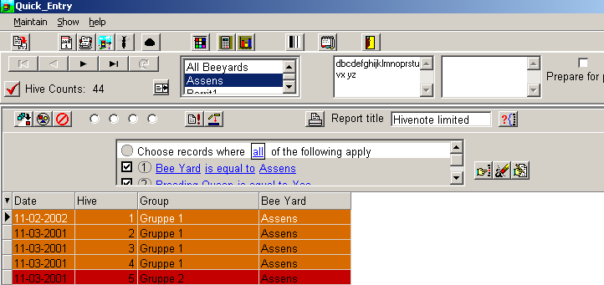

The navigator buttons are used to navigate through the hive notes and to accept or cancel changes made to hive notes. The Button Panel functions are (from left):

- Import queens from previous bee year to current bee year, (It is only visible if you have a database from the previous bee year).

- Add new hive note for the current beehive.

- Add a new beehive to the database.

- Auto create hives.

- Edit the queen.

- Activate the disease database for the actual beehive.

- Group and colour hives.

- Graphical display of the index cards, (only shown if you have calculated an index for your bee yards).

- Generate and print barcodes for the hive.

- Calculate Index for your apiaries

- General notebook for the apiary

- Close Quick entry

- Update the counts of hives shown in grid.

- Update the bee yard list. Must be done if you change language.

- Bee yard list. Shows the names of the bee yards you have entered into the database and is used to limit the show of hive notes to a specific bee yard.

- The two note boxes. Each showing Big notes. The note box can contain up to 65000 characters in all. I think this is more than you will ever need to enter. There is a total of five note fields available, but they are only available from the Input data screen. If you click those then a bigger screen will popup. You can here edit the notes.

- Prepare for Palm. If you check this then only the hives in grid will be transferred to the palm handheld. This checkbox is only visible if you have installed the Palm support.

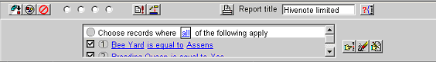

The above shown picture shows the two panels that can be hidden from the show menu item.
- Select all the hives in grid.
- Select grouped hives.
- Undo selection.

The round radio buttons are a quick filtering option.

The first radio button cancels the radio button filtering.

The second radio button shows those hives you have grouped.

The third radio button selects the hives not yet grouped.

The fourth radio button selects your breeding queens.

The update button simply updates the hives shown in grid.

The repair database button will repair the database if you get a key violation. This should not happen in this new software.

The print button will print out the grid in report form with the title in the edit books as heading.
The search button will bring you to the search engine.

The filter panel allows you to put an effective filtering on the hives in your database. This is especially useful if you want to filter hives for manipulation such as multi add hive notes for a group of hives or if you want to transfer the hives to the Palm Handheld if you have one.

The finger button activates the filtering defined in filter part.
The erase button clears the filtering and the edit button allows you to edit the filtering conditions.

if you do not need the above facilities you can turn those off by selecting the show menu item

Special features of the Quick Hivenote Entry screen :

Pop Up Menu

Pressing the Right Mouse button will launch a pop up menu at the mouse pointer position. In addition to the push button panel functions, you can set the chart data you want displayed. This function is limited to displays that are useful and practical.

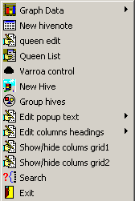
As you can see nearly all functions are at your fingertips. You can show and hide columns, edit the column headings, search the database and a lot more.

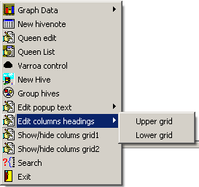

The search engine is totally new!

If you click the search item then you will get to a new very powerful search screen, but before you get there you will be asked about creating a new search template. Just type in a name and you will then be placed in the search screen.

The new engine does not require you to know anything about my database layout. When you have built your query you click the blitz button, and the result is shown in the grid.

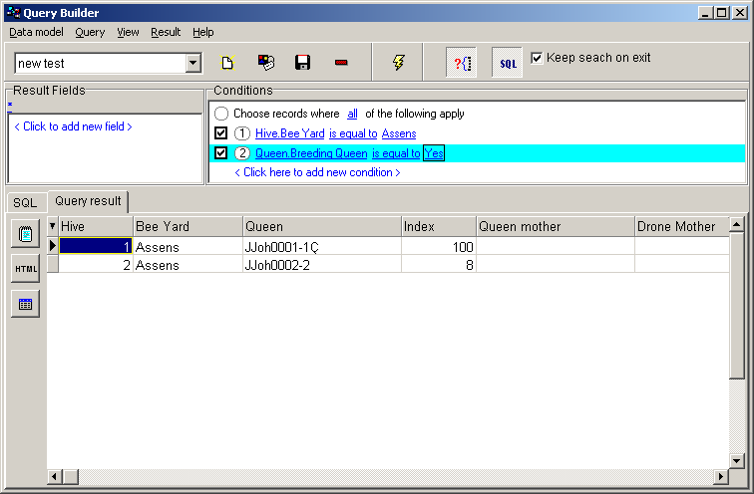

You now have the capability to export the data to text, Html and Dbase format. Those exports allow you to import into Access, Excel and FrontPage. If you check the “Keep Search” on exit then the quick entry will adopt the search result. Use the Data model menu to get access to e.g. configuration. This though is a complicated task, and I suggest you refrain from this if you are not familiar with building queries. It is however, safe to change group names and reorganize the fields into other groups. If you want to change the group names then be aware that you cannot use double clicks on the group names. Use click to mark it then click again to edit. You cannot use spaces in group names. A trick is to write the group name with spaces in notepad, then copy this group name to clipboard, and then paste into the group name edit.

The following shows a Chart result shown as pie charts.

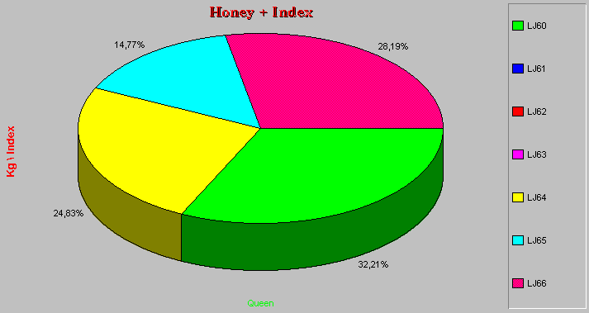

The Index calculation

The index calculation feature distinguishes Bidata software from other hive note programs on the market and is at the core of Bidata design. Index calculation makes it possible to directly compare queens within a bee yard and even queens from different bee yards, normally not possible. Accordingly, it is relevant to search for queens with a specific index in all bee yards. You create a new search template in the search engine set up for this purpose.

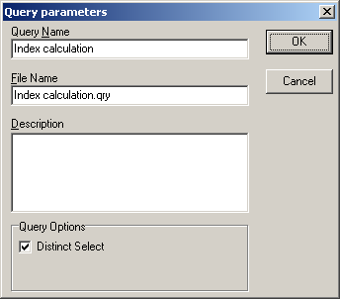

In the search select the index and set the value between what you want. e.g. index bigger than 97 and index less than 100.

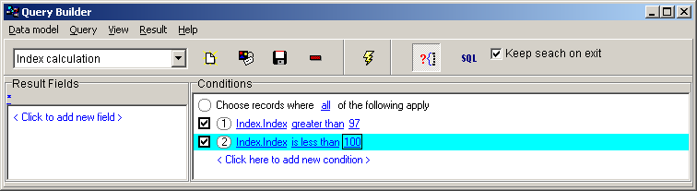

Clicking the blitz button will then show the queens that apply to those criteria selection.

Remember to get this into play you must have calculated index for the hives.

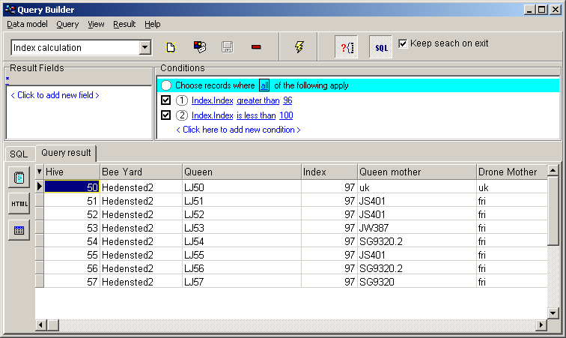

About multi selection!

To make it easy to maintain the database it is possible to make use of multi selection in some functions!

You can multi select by holding down the Ctrl key and then click on the hives you want to select. This allows you to e.g. add a hive note to all selected just by filling out one note. The same goes for the disease screen, or selecting for grouping or barcode printout. You can also move and delete multi selected hives.

It means that if you have treated a bee yard with Apistan then you can multi select the hives in the yard and then add a disease treatment to all of the hives.

Palm support! 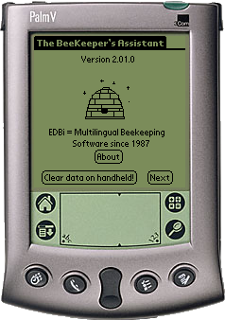 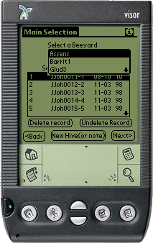

It is possible to use a Palm based OS handheld computer in conjunction with the Bidata software. All versions of Palm OS can be used.

Palm Support is not installed by default. You have to install this option. When the install loads, you get the following screen:

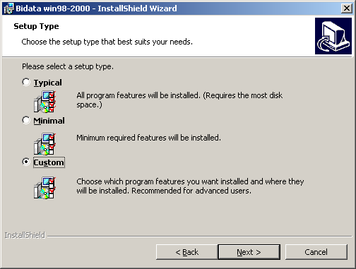

Select the Custom install and activate the items you want installed.

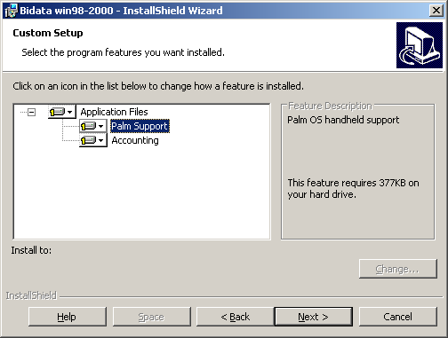

After the installation is complete, you will have to download the Palm Bidata to the handheld. This MUST be done from the ALL Programs\ Apimo Programs\ Palm Support\ Install to handheld Icon:

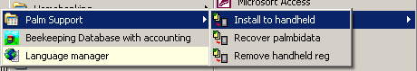

It is important that the Bidata Palm is installed to the handheld this way, because the Hotsynch manager needs an entry to be able to connect to Bidata.

How does it work?

If you have data on the Handheld, then this data will be transferred to the PC Bidata when you make a hotsynch and the Updated database in Bidata PC will then be transferred to the Handheld. Otherwise the data from the Bidata PC will be transferred to the Handheld Bidata Palm. Bidata PC must be up running for this to happen. By default all data from Bidata PC will be transferred to the Palm, but having maybe 5000 hives configured will not be easy to handle on the Palm. This is due to the limitation in available memory on the Palm. Instead, you can search or filter out those hives you have in mind to handle during the day. This is done from the quick entry screen. You will find a check box that you can check when you have the hives you want to handle present in the upper grid. When you check the box then those hives present will be transferred to the Palm Bidata.

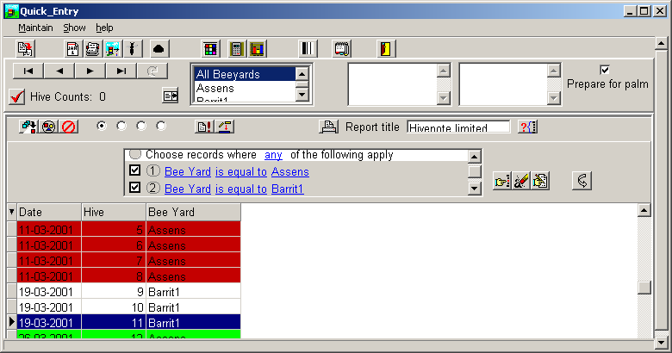

You can also make a search, by activating the Button, for the hives you want to work with.

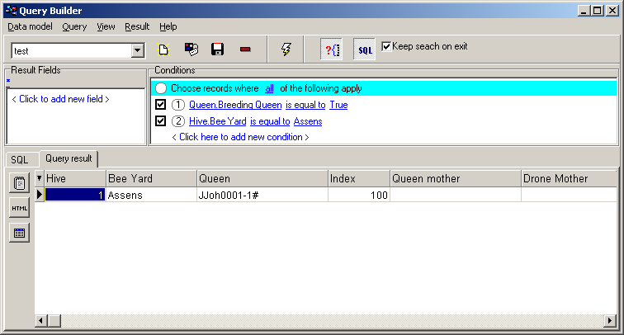

Palm OS based scanner and barcode support.

If you have a Palm OS based scanner then you can take advantage of the Bidata program’s ability to create barcodes. It works so that if you print out barcodes for hives then a barcode is generated and stored in the database. Now when a hotsynch is generated this barcode entry is transferred to the handheld. You can now scan the printed barcode, and the Palm Bidata will find the hive in the Palm bidata database and you are placed directly in the correct record, ready for editing.

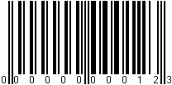 Scanning this will place you immediately on the record for hive nr. 12

Here is a Picture of the Symbol 1550 palm based scanner I am using!
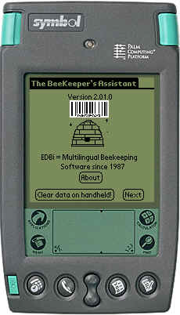

I know this might seem an expensive solution but it will be of big help if you have hundreds of hives. The scanner can of course also be used for other purposes such as stock registration. A Visor handheld can also be equipped with a scanner, and for other handhelds there will be an add-on available. Search the web for Palm and scanners.

How to use the Language manager.

In your programs open the Language manager

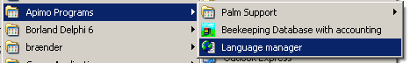

It will bring up the following screen:

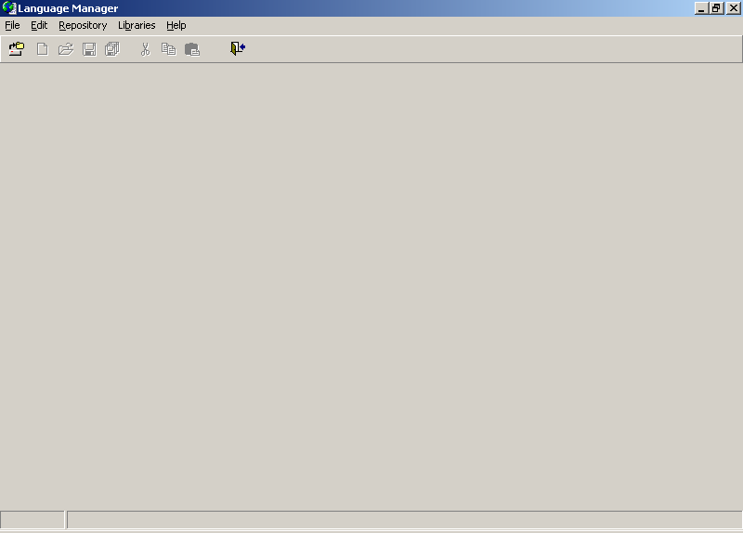

Now in file open an existing project:

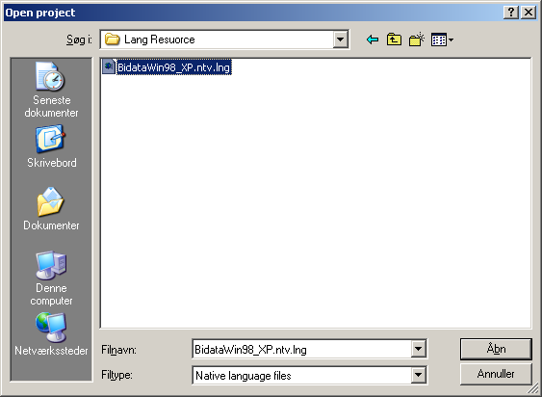

You will now be asked to open a defined language file

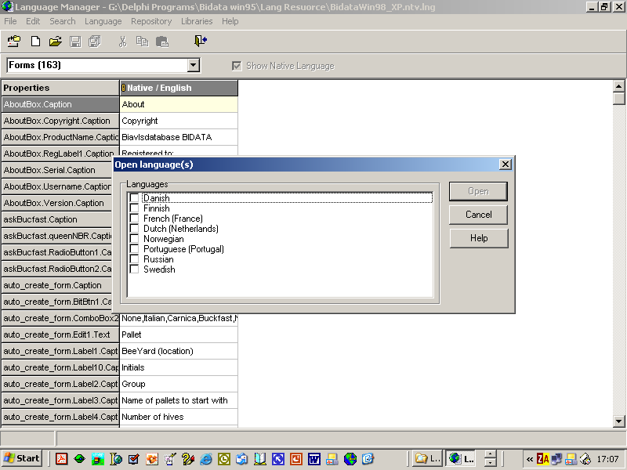

You can cancel this and then create your own language file based on an open languagefile

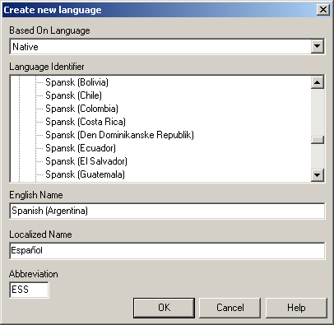

Use the help button to get further explanations.
Here I have created a Spanish (Argentina) language file.

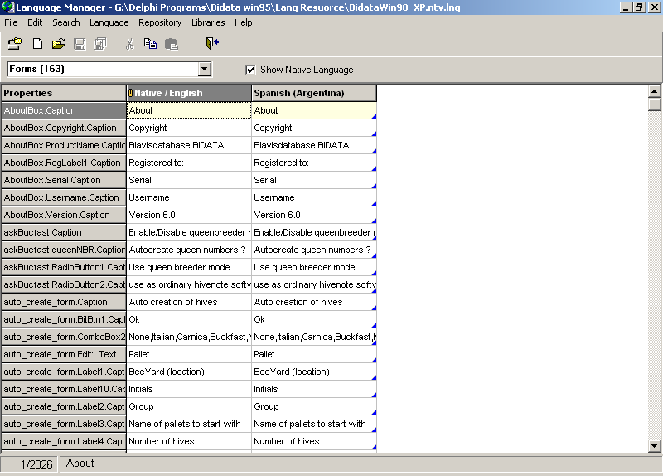
You can now from the language menu item sort the language in ascending order and you will now find the items sorted so that equal items are listed together. This have the benefit that if you translate an item all equal items are translated at once.

E.g. if you translate the first occurrence of Continue UnRegistered ??, then the remaining equal strings will be translated too.

It might seems a bit heavy to go through all but doing this kind of work helping me out will not take that time it at first seems to do. I think it can be done within a few days. And the benefit of this translations tool is that you can translate the software into the deep of it.

You have two sections to translate:

The Section of form’s and unit’s.

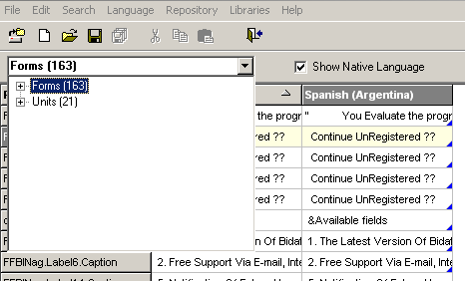

You will find some items like this :

Equal=is equal to
NotEqual=is not equal to
LessThan=is less than
LessOrEqual=is less than or equal to
GreaterThan=greater than
GreaterOrEqual=greater than or equal to
IsNull=is null
InList=is in list
StartsWith=starts with
NotStartsWith=does not start with
Contains=contains
NotContains=does not contain
Between=is between

When you meet those only translate what is after the =

also be care full here not to delete the @ because it is placeholders.

[Query Panel] do not translate it is a place mark.
ttlFilter=Choose records where @ of the following apply
ttlBracket=@ of the following apply
ttlAll=all
ttlAny=any

If you meet a & then this means that the letter following is a hotkey letter

In one place you will find && this is not an error and must stay.

%Something should not be translated.

I hope for your cooperation in this for me and other users of my software important task.

When you have finished translation the only thing you have to do is to send the translated file to me. It will have a name of

BidataWin98_Xp.XXX.lng where the XXX stands for your language abbreviation. E.g. ES for Spanish, FR for French and so on.

Best regards Jorn Johanesson (Jørn Johanesson)

