Eckhart Tolle 1948-

http://en.wikipedia.org/wiki/Eckhart_Tolle

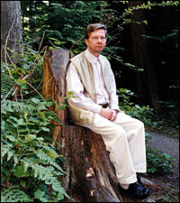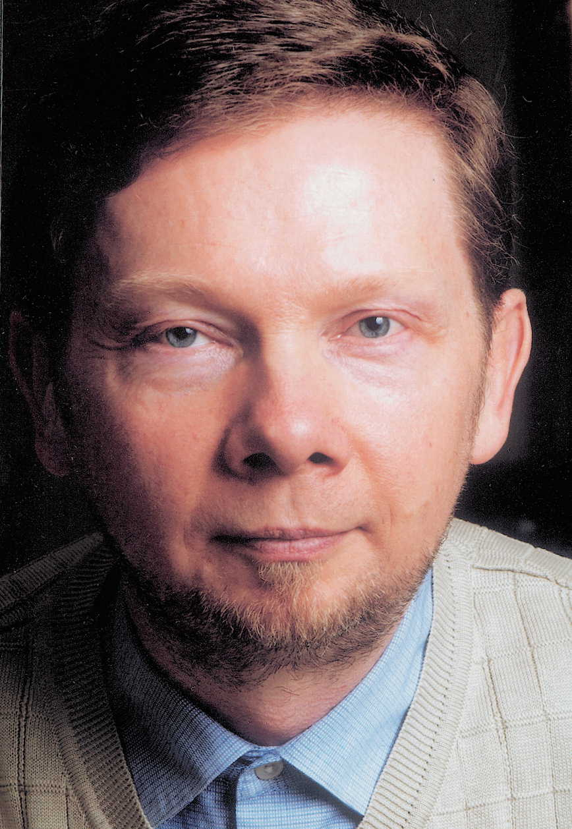

Eckhart Tolle, (born Germany, 1948 as Ulrich Tolle) is a contemporary spiritual teacher and writer on spirituality.

Contents
[hide]
- 1 Teaching
- 2 Further Biographical Aspects
- 3 Quotations
- 4 Works
  - 4.1 Books
  - 4.2 Audio tapes
- 5 External links

[] Teaching
His non-fiction bestseller, The Power of Now, describes his experience of enlightenment at the age of 29 after suffering long periods of depression, dissolving his old identity and radically changing the course of his life. This book emphasizes the importance of focusing on the present moment and the futility of dwelling on the bygone past or fearing the imagined future. In Tolle's view, the present moment is all that one really has (as past & future are merely thoughts in the mind), and being consciously present in the now is the best way to realize the immense potential of the future. "Being in the now" also brings about an awareness that is beyond the mind. This awareness helps in transcending "the painbody" that is created by the identification of the mind and ego with the body. His later book, A New Earth further explores the structure of the human ego and how this acts to distract people from their present experience of the world.
The aim of Tolle's teachings is the transformation of individual and collective human consciousness - a global spiritual awakening.
Core teachings that appear to arise from his works are:
1. You are not your thoughts. You are the awareness behind the thoughts. Thoughts are often negative and painful, yearning for or fearing something in the future, complaining about something in the present or fearing a matter from the past. However, the thoughts are not you; they are a construct of the ego. Awareness of your thoughts without being caught up in them is the first step to freedom.
2. Only the present moment exists. That is where life is (indeed it is the only place life can truly be found). Becoming aware of the 'now' has the added benefit that it will draw your attention away from your (negative) thoughts. Use mindfulness techniques to fully appreciate your surroundings and everything you are experiencing. Look and listen intently. Give full attention to the smallest details.
3. Accept the present moment. It is resistance to the present moment that creates most of the difficulties in your life. However, acceptance does not mean that you cannot take action to rectify the situation you are in. What is important is to drop resistance so that you let the moment be, and that any action arises from deeper awareness rather than from resistance. The vast majority of pain in a person's life comes from resistance to what is.
4. Observe the Painbody. Years of conditioned thought patterns, individually and collectively, have resulted in habitual emotional reactions with an apparent personality of their own. During 'painbody attacks' we become completely identified with this 'pain identity' and respond from its agenda - which is to create more pain for ourselves and others. Observing the painbody is awareness itself arising - as it allows humans to separate from this unconscious identification with pain.
Eckhart Tolle is not aligned with any particular religion or tradition.
Influences which are alluded to in The Power of Now are the writings of Meister Eckhart, Advaita Vedanta, A Course in Miracles and Zen Buddhism's Lin-chi (Rinzai) school. The book also interprets sayings of Jesus from the Bible.
Some disciples of the Australian teacher Barry Long see Long's influence in Tolle's writings as well. Tolle attended Long's seminars in London in the mid-1980s, some years after his own self-described awakening. Tolle himself mentions briefly in an interview with John Parker [1] that by listening to and having some conversation with Barry Long, he understood things more deeply. However, too much should not be read into this statement. In the same interview Tolle also mentions the influence of the Western-born Buddhist monk, Achan Sumedo, and also speaks passionately of his appreciation of the teachings of Jiddu Krishnamurti and Ramana Maharshi. He sees his own teaching as enabling the respective messages of the two latter to merge as one.

[] Further Biographical Aspects
Tolle was educated at the Universities of London and Cambridge. He was born in Germany but lived with his father in Spain from about age 13 until he moved to England in his early 20s. He did not attend formal schooling after age 13, but rather did language and other courses. He attended night colleges to obtain the necessary entrance requirements for University in England.
At the age of twenty-nine, he experienced a spiritual transformation that marked the beginning of an intense inward journey and the beginning of his career as a counselor and spiritual teacher.
He now lives in Vancouver, British Columbia, Canada.
The name change from Ulrich to Eckhart seems to be a reference to German mystic Meister Eckhart.

[] Quotations
- “All forms are Impermanent.”
- “Compassion is the awareness of a deep bond between yourself and all creatures.”
- “True salvation is freedom from negativity, and above all from past and future as a psychological need.”
- “Is suffering really necessary? Yes and no. If you had not suffered as you have, there would be no depth to you, no humility, no compassion.”
- “Enlightenment means choosing to dwell in the state of presence rather than in time. It means saying yes to what is.”
- “As you go about your life, don’t give 100 percent of your attention to the external world and to your mind. Keep some within. Feel the inner body even when engaged in everyday activities, especially when you are relating with nature. Feel the stillness deep inside it. Keep the portal open.”

[] Works
The first of his four books was The Power of Now, a #1 New York Times best-seller that has been translated into over 30 languages. (See Book section below.) He has also recorded numerous audio interviews and a video.

[] Books
- The Power of Now: A Guide to Spiritual Enlightenment, New World Library, October, 1999 ISBN 1-57731-152-3 (HC) ISBN 1-57731-480-8 (PB)
- Practicing the Power of Now: Essential Teachings, Mations, and Exercises from The Power of Now, New World Library, October 10, 2001 ISBN 1-57731-195-7 (HC)
- Stillness Speaks, New World Library, August, 2003 ISBN 1-57731-400-X
- A New Earth: Awakening to Your Life's Purpose, Dutton, October 11, 2005 ISBN 0-525-94802-3

[] Audio tapes
- What is Mation?
- Practising the Power of Now
- Companion to the Power of Now: A Guide to Spiritual Enlightenment, June 2001
- Living the Liberated Life and Dealing With the Pain Body, October 2001
- The Realization of Being: A Guide to Experiencing Your True Identity, October 2001
- Know That "I Am", January 1, 2002
- Even the Sun Will Die: An Interview With Eckhart Tolle, July 2002
- The Eckhart Tolle Audio Collection, September 2002
- The Essence of Now, 2002
- Choose to Awaken Now, 2002
- In the Presence of a Great Mystery, 2002
- Realizing the Power of Now: An In-Depth Retreat With Eckhart Tolle, June 2003
- Entering the Now, August 2003
- Gateways to Now, September 1, 2003
- Whispers, January 1, 2004
- The Flowering of Human Consciousness, May 2004
- Living a Life of Inner Peace, October 10, 2004
- Practicing Presence: A Guide for the Spiritual Teacher and Health Practitioner, November 1, 2004
- Eckhart Tolle's Findhorn Retreat: Stillness Amidst the World, October 10, 2005
- Through the Open Door: Journey to the Vastness of Your True Being, January 30, 2006

[] External links
- Eckhart Tolle's official website
- The Power of Now
- Eckhart Tolle: a fan site - includes quotes and excerpts, interviews, articles and photos.
- Now-For-You A forum to discuss the teachings of Eckhart Tolle
- www.eckharttolle.eu European online store for Eckhart Tolle Books, CDs, Audiobooks, Cards and other products
==========================================================================================================================
END

