**William R. Corliss 1926-2011 Wikipedia Oct 14 2014**

**http://en.wikipedia.org/wiki/William_R._Corliss**

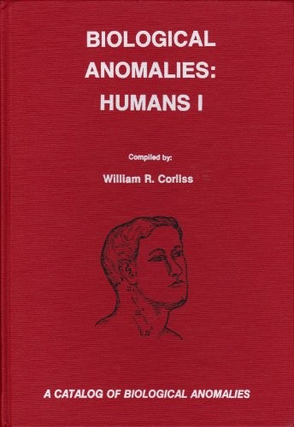 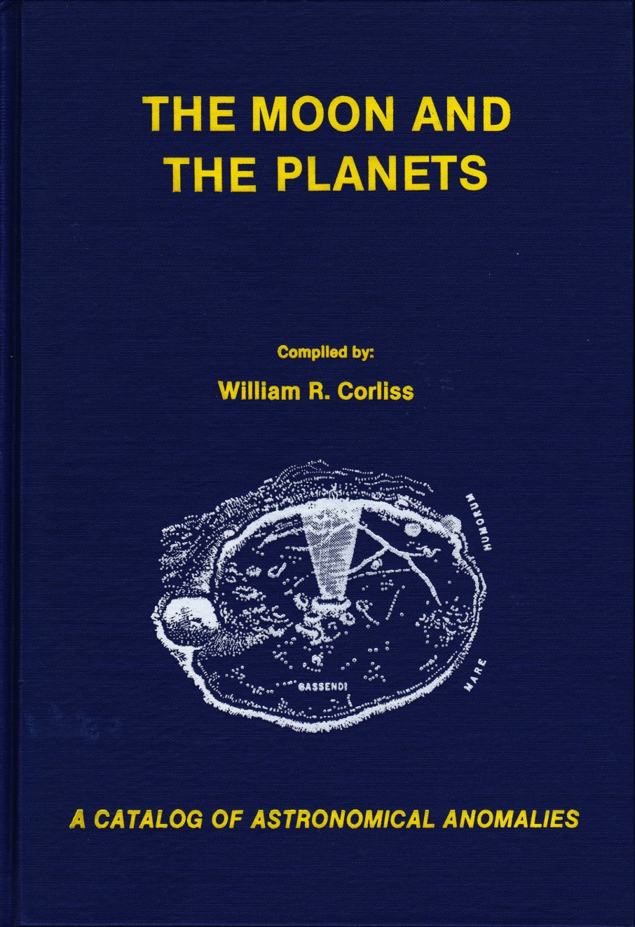 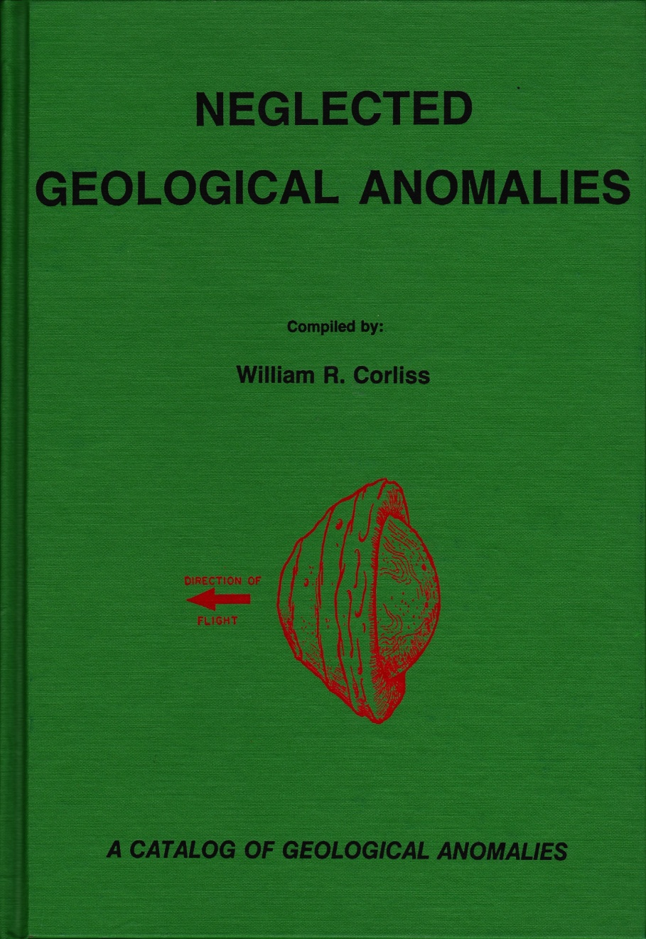

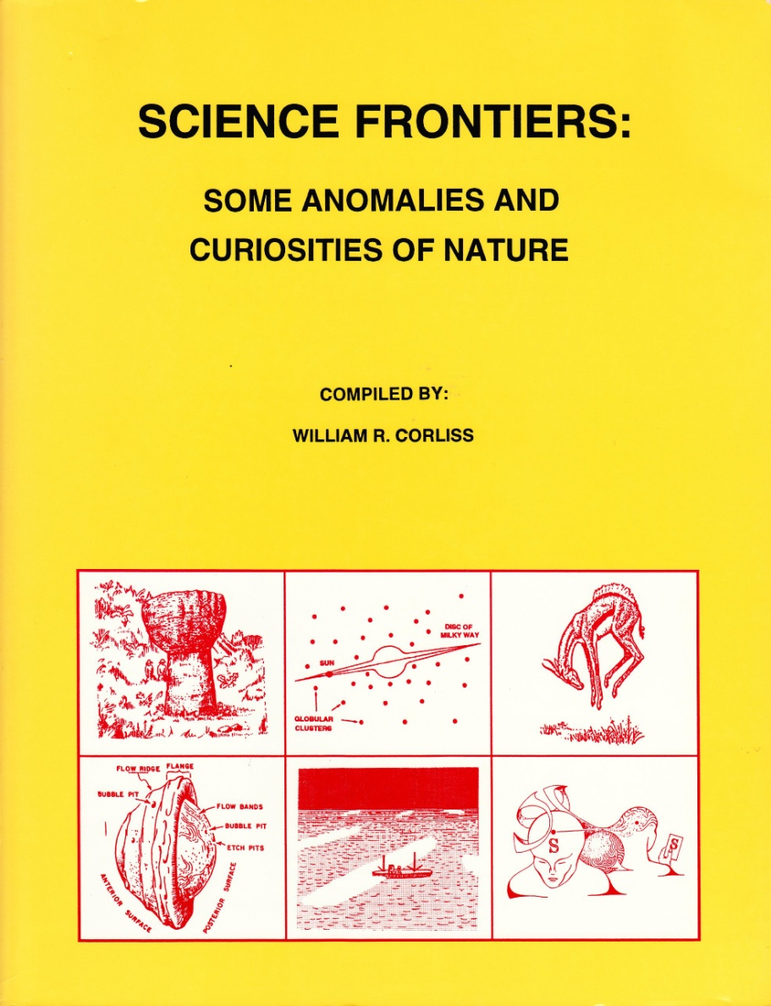 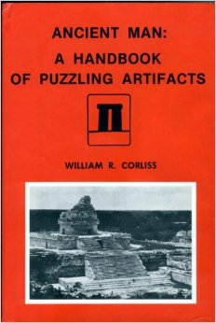 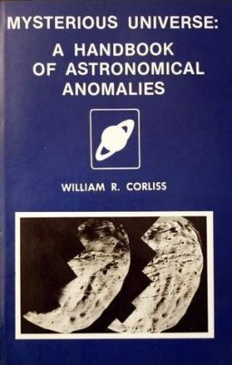 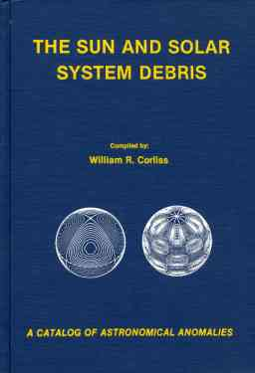

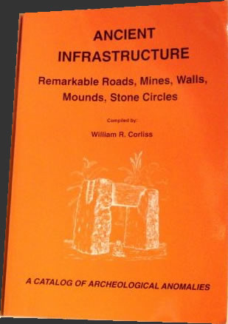 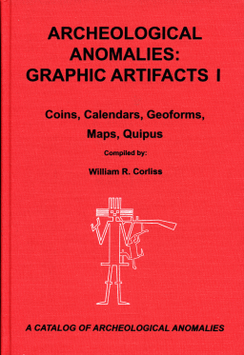

**William R. Corliss**

|  |  |  |
| --- | --- | --- |
| |  |  | | --- | --- | | [Ancient Infrastructure: Remarkable Roads, Mines, Walls, Mounds, Stone Circles](http://divorcenewsnetwork.tv/wp-content/es/Ancient-Infrastructure-Remarkable-Roads-Mines-Walls-Mounds-Stone-Circles-free-books/PDF-1608456904/) | [**Ancient Infrastructure: Remarkable Roads, Mines, Walls, Mounds, Stone Circles**](http://divorcenewsnetwork.tv/wp-content/es/Ancient-Infrastructure-Remarkable-Roads-Mines-Walls-Mounds-Stone-Circles-free-books/PDF-1608456904/)  William R. Corliss  Hardcover, no jacket issued, in white- & black-stamped boards as shown. Some spots on front cover, minor soiling on bottom pp-edg... | |
| |  |  | | --- | --- | | [Biological Anomalies: Humans II (Catalog of Biological Anomalies Series)](http://divorcenewsnetwork.tv/wp-content/es/Biological-Anomalies-Humans-II-Catalog-of-Biological-Anomalies-Series-free-books/PDF-1432091530/) | [**Biological Anomalies: Humans II (Catalog of Biological Anomalies Series)**](http://divorcenewsnetwork.tv/wp-content/es/Biological-Anomalies-Humans-II-Catalog-of-Biological-Anomalies-Series-free-books/PDF-1432091530/)  William R. Corliss  BIOLOGICAL ANOMALIES - HUMANS II is one of 22 volumes in the Catalog of Anomalies published by The Sourcebook Project. The catalo... | |
| |  |  | | --- | --- | | [Lightning, Auroras, Nocturnal Lights, and Related Luminous Phenomena: A Catalog of Geophysical Anomalies](http://divorcenewsnetwork.tv/wp-content/es/Lightning-Auroras-Nocturnal-Lights-and-Related-Luminous-Phenomena-A-Catalog-of-Geophysical-Anomalies-free-books/PDF-1145487594/) | [**Lightning, Auroras, Nocturnal Lights, and Related Luminous Phenomena: A Catalog of Geophysical Anomalies**](http://divorcenewsnetwork.tv/wp-content/es/Lightning-Auroras-Nocturnal-Lights-and-Related-Luminous-Phenomena-A-Catalog-of-Geophysical-Anomalies-free-books/PDF-1145487594/)  William R. Corliss  Lightning, Auroras, Nocturnal Lights, and Related Luminous Phenomena: A Catalog of Geophysical Anomalies... | |
| |  |  | | --- | --- | | [Biological Anomalies: Humans (Catalog of Biological Anomalies)](http://divorcenewsnetwork.tv/wp-content/es/Biological-Anomalies-Humans-Catalog-of-Biological-Anomalies-free-books/PDF-1048470523/) | [**Biological Anomalies: Humans (Catalog of Biological Anomalies)**](http://divorcenewsnetwork.tv/wp-content/es/Biological-Anomalies-Humans-Catalog-of-Biological-Anomalies-free-books/PDF-1048470523/)  William R. Corliss  BIOLOGICAL ANOMALIES - HUMANS I is one of 22 volumes in the Catalog of Anomalies published by The Sourcebook Project. The catalog... | |

From Wikipedia, the free encyclopedia

|  |  |
| --- | --- |
| **William R. Corliss** | |
| **Born** | August 28, 1926 [Stamford, Connecticut](http://en.wikipedia.org/wiki/Stamford,_Connecticut) |
| **Died** | July 8, 2011 (aged 84) |
| **Education** | Physics, Bsc (Rensselaer Polytechnic Institute, 1950), Physics, M. Sc (University of Colorado, 1953). |
| **Occupation** | Writer Anomalistics |
| **Organization** | AAAS |

**William Roger Corliss** (August 28, 1926 – July 8, 2011)[[1]](http://en.wikipedia.org/wiki/William_R._Corliss#cite_note-Contemp-1) was an American physicist and writer who was known[[2]](http://en.wikipedia.org/wiki/William_R._Corliss#cite_note-2) for his interest in collecting data regarding [anomalous phenomena](http://en.wikipedia.org/wiki/Anomaly_%28Forteana%29). [Arthur C. Clarke](http://en.wikipedia.org/wiki/Arthur_C._Clarke) described him as "[Fort](http://en.wikipedia.org/wiki/Charles_Fort)'s latter-day - and much more scientific - successor."[[3]](http://en.wikipedia.org/wiki/William_R._Corliss#cite_note-clarke110-3)

**Contents**

* [1 Biography](http://en.wikipedia.org/wiki/William_R._Corliss#Biography)
* [2 Bibliography](http://en.wikipedia.org/wiki/William_R._Corliss#Bibliography)
* [3 References](http://en.wikipedia.org/wiki/William_R._Corliss#References)
* [4 External links](http://en.wikipedia.org/wiki/William_R._Corliss#External_links)

**Biography**

Starting in 1974, Corliss published a number of works in the "Sourcebook Project". Each volume was devoted to a scientific field ([archeology](http://en.wikipedia.org/wiki/Archeology), [astronomy](http://en.wikipedia.org/wiki/Astronomy), [geology](http://en.wikipedia.org/wiki/Geology), et cetera) and featured articles culled almost exclusively from [scientific journals](http://en.wikipedia.org/wiki/Scientific_journal). Corliss was inspired by [Charles Fort](http://en.wikipedia.org/wiki/Charles_Fort), who decades earlier also collected reports of unusual phenomena. Unlike Fort, Corliss offered little in the way of his own opinions or editorial comments, preferring to let the articles speak for themselves. Corliss quoted all relevant parts of articles (often reprinting entire articles or stories, including illustrations). Many of the articles in Corliss's works were earlier mentioned in Charles Fort's works.

In his book *Unexplained!*, [Jerome Clark](http://en.wikipedia.org/wiki/Jerome_Clark) describes Corliss as "essentially conservative in outlook". He explains, "Corliss [is] more interested in unusual weather, ball lighting, geophysical oddities, extraordinary mirages, and the like — in short, anomalies that, while important in their own right, are far less likely to outrage mainstream scientists than those that delighted Fort, such as UFOs, monstrous creatures, or other sorts of extraordinary events and entities."[[4]](http://en.wikipedia.org/wiki/William_R._Corliss#cite_note-4) Arthur C. Clarke said:

|  |  |  |
| --- | --- | --- |
| **“** | Unlike Fort, Corliss selected his material almost exclusively from scientific journals like *Nature* and *Science*, not newspapers, so it has already been subjected to a filtering process which would have removed most hoaxes and reports from obvious cranks. Nevertheless, there is much that is quite baffling in some of these reports from highly reputable sources.[[3]](http://en.wikipedia.org/wiki/William_R._Corliss#cite_note-clarke110-3) | **”** |

Corliss wrote many other books and articles, notably including 13 educational books about astronomy, outer space and space travel for [NASA](http://en.wikipedia.org/wiki/NASA) and a similar number for the [Atomic Energy Commission](http://en.wikipedia.org/wiki/United_States_Atomic_Energy_Commission) and the [National Science Foundation](http://en.wikipedia.org/wiki/National_Science_Foundation).[[5]](http://en.wikipedia.org/wiki/William_R._Corliss#cite_note-newscientist1-5)

**Bibliography**

Books published include:[[1]](http://en.wikipedia.org/wiki/William_R._Corliss#cite_note-Contemp-1)

* *Propulsion Systems for Spaceflight* (1960)
* *Radioisotopic Power Generation* (with [D.G. Harvey](http://en.wikipedia.org/w/index.php?title=D.G._Harvey&action=edit&redlink=1); 1964)
* *Space Probes and Planetary Exploration* (1965)
* *Scientific Satellites* (1967)
* *Mysteries of the Universe* (1967)
* *Teleoperator Controls* (with [E.G. Johnsen](http://en.wikipedia.org/w/index.php?title=E.G._Johnsen&action=edit&redlink=1); 1968)
* *Mysteries Beneath the Sea* (1970)
* *Human Factors Applications in Teleoperator Design and Operation* (with Johnsen; 1971)
* *History of NASA Sounding Rockets* (1971)
* *Man and Atom* (with [Glenn T. Seaborg](http://en.wikipedia.org/wiki/Glenn_T._Seaborg); 1971)
* *History of the Goddard Networks* (1972)
* *The Interplanetary Pioneers* (1972)
* *Strange Phenomena: A Sourcebook of Unusual Natural Phenomena* (1974)
* *Strange Artifacts: A Sourcebook on Ancient Man* (1974)
* *The Unexplained* (1976)
* *Strange Life* (1976)
* *Strange Minds* (1976)
* *Strange Universe* (1977)
* *Handbook of Unusual Natural Phenomena* (1977)
* *Strange Planet* (1978)
* *Ancient Man: A Handbook of Puzzling Artifacts* (1978)
* *Mysterious Universe: A Handbook of Astronomical Anomalies* (1979)
* *Unknown Earth: A Handbook of Geological Enigmas* (1980)
* *Wind Tunnels of NASA* (1981)
* *Incredible Life: A Handbook of Biological Mysteries* (1981)
* *The Unfathomed Mind: A Handbook of Unusual Mental Phenomena* (1982)
* *Lightning, Auroras, Nocturnal Lights, and Related Luminous Phenomena* (1982)
* *Tornados, Dark Days, Anomalous Precipitation, and Related Weather Phenomena* (1983)
* *Earthquakes, Tides, Unidentified Sounds, and Related Phenomena* (1983)
* *Rare Halos, Mirages, Anomalous Rainbows, and Related Electromagnetic Phenomena* (1984)
* *The Moon and the Planets* (1985)
* *The Sun and Solar System Debris* (1986)
* *Stars, Galaxies, Cosmos* (1987)
* *Carolina Bays, Mima Mounds, Submarine Canyons* (1988)
* *Anomalies in Geology: Physical, Chemical, Biological* (1989)
* *Neglected Geological Anomalies* (1990)
* *Inner Earth: A Search for Anomalies* (1991)
* *Biological Anomalies: Humans I* (1992)
* *Biological Anomalies: Humans II* (1993)
* *Biological Anomalies: Humans III* (1994)
* *Science Frontiers: Some Anomalies and Curiosities of Nature* (1994)
* *Biological Anomalies: Mammals I* (1995)
* *Biological Anomalies: Mammals II* (1996)
* *Biological Anomalies: Birds* (1998)
* *Ancient Infrastructure: Remarkable Roads, Mines, Walls, Mounds, Stone Circles: A Catalog of Archeological Anomalies* (1999)
* *Ancient Structures: Remarkable Pyramids, Forts, Towers, Stone Chambers, Cities, Complexes: A Catalog of Archeological Anomalies* (2001)
* *Remarkable Luminous Phenomena in Nature: A Catalog of Geophysical Anomalies* (2001)
* *Scientific Anomalies and other Provocative Phenomena* (2003)
* *Archeological Anomalies: Small Artifacts* (2003)
* *Archeological Anomalies: Graphic Artifacts I* (2005)

**References**

* 1. "William R(oger) Corliss". *Contemporary Authors Online*. Gale. July 3, 2002. Retrieved on August 6, 2008.
  2. William J. Broad. "The science corps wants a few more good heretics". *The New York Times*. October 16, 1983. A18.
  3. Clarke, Arthur C. (1990) *Astounding Days: A Science Fictional Autobiography*. Gollancz. Page 110
  4. Jerome Clark. "Sourcebook Project" *Unexplained!*. Detroit: Visible Ink Press, 466-7.
  5. Adrian Hope. "Finding a Home for Stray Fact". *New Scientist*. July 14, 1977. 83.

**External links**

* [The Sourcebook Project homepage](http://www.science-frontiers.com/sourcebk.htm)
* [Unofficial Sourcebook discussion group](http://groups.yahoo.com/group/sourcebookdiscussion/)
* [A Search for Anomalies](http://www.scientificexploration.org/jse/abstracts/v16n3a6.php), by William R. Corliss, Journal for Scientific Exploration, Volume 16: Number 3: Article 6 (2002)
* [Works by or about William R. Corliss](http://worldcat.org/identities/lccn-n80-57226) in libraries ([WorldCat](http://en.wikipedia.org/wiki/WorldCat" \o "WorldCat) catalog)
* [William Roger Corliss Obituary](http://www.legacy.com/obituaries/baltimoresun/obituary.aspx?n=william-roger-corliss&pid=152523465), Baltimore Sun, July 13, 2011