**the Oregon Petition**

31,487 American scientists have signed this petition,  
including 9,029 with PhDs

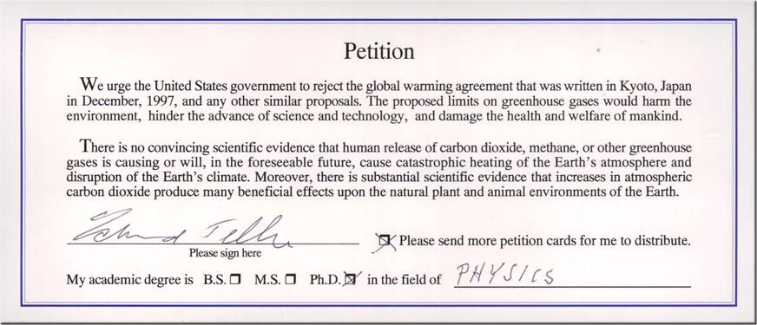

**THE OREGON PETITION**

31,486 scientists have signed a document called **the Oregon Petition**

lambasting the shoddy research behind global warming, stating quite simply that “. . . any

human contribution to climate change has not been demonstrated.”

This is not a gang of political hacks, or George Soros–funded “activists.” No, the signatories

include 3,667 atmospheric, environmental and Earth scientists; 4,796 chemists; 2,924 biologists

and agricultural scientists; 903 math and computer scientists; and 9,992 in engineering and

general science.

Of these, 9,029 have PhDs.

The petition states that there is no convincing scientific evidence that the human release of

carbon dioxide or other greenhouse gases is causing or will cause global warming.

It goes on to say that there is substantial scientific evidence demonstrating that atmospheric

carbon dioxide produces countless beneficial effects on the plant and animal populations of

Earth. (In one of Mother Nature’s most spectacular touches of environmental magic, plants

convert carbon dioxide and sunlight into oxygen—you know, the stuff we breathe.)