**Is Global Warming Real?**

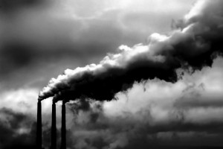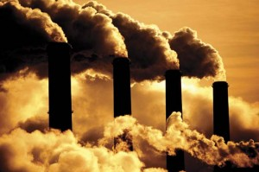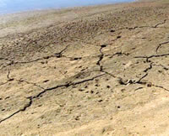

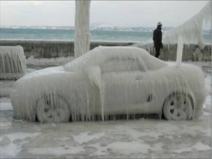

Why are the “nay-Sayers” so adamant in denying that there is a problem? Money, for the most part.

By Citizen Correspondent Jurgen Ankenbrand

Date Posted: 10/15/07

**Reader Rating:**

Social issues always have a "moral" aspect and who is to say who should do what? Unfortunately the powerful and economic strong nations will do that to often or mostly serve their own interests. Is this wrong? You must ask yourself this question.

Before I start today’s reply I need to make a short statement. Is there “FREEDOM OF THE PRESS & OR SPEECH” in the US?

As a national and international published freelance photojournalist, I have tried to “sell” my work to many magazines in the past. Usually, I wrote about “social issues.” like the one at discussion here. Replies from editors: I (we) like your article and mostly agree with your viewpoint, but I can’t print it or I lose advertisers. Bottom line, it’s almost always about money and power, and not about freedom of speech.

With this in mind, I write today’s story. How can I be so sure? As a European immigrant and Green-Card holder, I have lived in the US for over 40 years and have seen how the Government operates by “manipulating” the news and trying to pull the wool over peoples eyes. Unfortunately ,too many people are “buying” the Government’s stories because of either ignorance, lack of interest or knowledge. Either way, it’s a very sad situation.

A British High Court judge ruled Gore’s climate change film, *An Inconvenient Truth*, contained “nine scientific errors” and could be shown in U.K. schools only if teachers pointed out the nine disputed and controversial sections.

Why should that not surprise anybody? Seen how the British Government “blindly” followed Bushes lead with Iraq and provides lip service n many other issues how can they take another stance on this?

The fact that ex-vice president Gore received the Nobel Piece Price can’t make Bush very happy, since he now cannot continue to “deny” the Global Warming issue as a “hoax” as he has helped to promote all this time.

Have you publicly doubted the basis of a human-caused climate disaster? Has the Climate debacle been caused by the human race? I would think that by now there can’t or should not be any doubt about it. The answer should be a resounding YES. Why has the Bush Government constantly tried to deny this? Simply for the same reason/s they have lied to the entire world and nation about why they went to war in Iraq.

This decision about going to war had already been made well before Bush ever “stole” the Presidency. Bush needed to be President so he could “force” the issue and have “ his” war, no matter what anybody say at home or anywhere in the entire world. He saw too many opportunities for his cronies and the powerful corporate world to get rich in the process and that is why we have a war that will cost the US and the world much in human life and money for a very long time to come. So much for honesty in Government. Who runs the Government anyway?

My opinion is this: A few powerful and ruthless people in the Government, equally powerful, ruthless and greedy corporations and a very “biased (for the most part anyway) press who tries to “manipulate” the public. By airing and printing what they and the Government “thinks” the public ought to know (whether it’s true or not) and they are doing a pretty good job of it.

Remember the saying, the Government must keep enough people ignorant, misinformed and in the dark so they can get away with pretty much anything as is the case certainly in the US.

Are you convinced “climate change deniers” are leading us to our demise? Why are the “nay-Sayers” so adamant in denying that there is a problem?

Money, for the most part. To make the changes that might make a difference will cost a fortune and those holding the purse strings and are “obliged” to the corporate stockholders are not about ready to dole out the big bucks required.

Certain corporations are paying certain organizations and individuals to speak out against the problem of global climate change, trying to sway public opinion.

There is also a “moral” issue at stake. Other and less developed countries are saying we are behind in our development and don’t have, nor can spend the money required for the industrial changes needed. Issues like this always pit the “haves” against the “don’t haves” of the globe. Who is to say who and what is the “correct” and “proper” way to go? Again it is about money. Those who have power and money are not willing to part with any of it “just to help” the poorer nations. Sounds cold and cruel, but that is the reality of the world, now and perhaps more so in the future.  
What will the future hold?

If “global warming” will have the effect on the world, Ex-President Gore and many millions the world over are saying then maybe we won’t have to worry about it. Perhaps not in our life time but maybe in a generation or two. Too may officials, Government and big Corporations seem to care very little what kind of world they will leave behind for generations to come, which is pretty much the way many Americans seem to live their lives. Entitlement to all is what their life-style reflects so who has time nor cares what the distant future brings?

Should Al Gore run for President?

I personally do not think so. I don’t detect the fire in him nor enough enthusiasm. I believe he can do more for the cause, the US and the world in general by working for the issue at stake. Besides, call me crazy but if he would run, I am sure the Republicans will find a way to “steal” the election from Al Gore, no matter how and what it takes and who wants to see that again?

==============================================================================================================================================