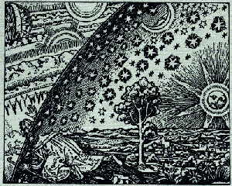 | Sacred-Texts: Fortean  http://www.sacred-texts.com/fort/index.htm
Charles Fort was a crank in the best sense of the word. Lovecraft and the X-files can't begin to compete with the spooky stuff he uncovered. In the early twentieth century he put together great quantities of exhaustively documented 'puzzling evidence' (in the words of David Byrne), data which science is unable or unwilling to explain. Forts' books gave me nightmares when I read them when I was seven. Strange items drop from the sky, bizarre artifacts turn up in unexpected places, stars violate the laws of astronomy, giant clouds blot out the moon and the sun trembles in the sky. Is the world inside out? Is it flat? Or maybe shaped like a giant spindle?
What does it all mean? He drops cryptic, breathless hints such as "I think we're property." and "I think that we're fished for. It may be that we're highly esteemed by super-epicures somewhere." Whatever you think about this information, you will at some point while reading Forts' books feel like the foundations of your reality are slipping slightly to the south...
Consider yourself warned!

For more Fortean texts you must visit Mr. X's web site http://www.resologist.net/index.htm. The mysterious Mr. X is in the process of producing high quality etexts all of Fort's books.

Note on Copyrights
According to Mr. X (personal communication):
"...way back in 1973, I conducted my own search of the U.S. Copyright Office records. I discovered that the original copyrights on Fort's books lapsed at the end of their original 28-year period, as the copyrights were not renewed. Both Fort and his widow had died, and apparently, no one bothered to renew the copyrights or knew their value, (these would have been distributed in the estate of Fort's widow). I also discovered, many years later, that Fort directed that his notes and papers were to be made available to Fortean researchers. Simply put, all of Fort's work is in the Public Domain."

