
Using the Desktop
What you will do:
- Choose a desktop style
- Work in Web style
- Create shortcuts to save time
- Bring Web content to your desktop
- Make the computer more accessible for people with disabilities
- Create user profiles for each student
One of the most exciting features of Windows 98 is its ability to integrate your computer with the Internet. Imagine the possibilities. Not only does this make navigating through your files and folders quicker and easier, but you can search the World Wide Web in the same window where you are browsing your hard drive, have news and other information delivered to you automatically, and view educational programming on your computer screen.
Before you Begin
Many of the activities in this section require a network or modem connection to the Internet. See your network administrator or technology coordinator for help with this if necessary.
A Desktop to Fit Your Style
In Windows 98 there are three ways to view your desktop and browse through files and folders.
- Classic style—much like Windows 95 desktop view. You double-click items to open them and each item appears in a new window.
- Web style—in this view you can browse your desktop and folders like you browse Web pages, by single-clicking items and using back and forward buttons. Items open in the same window rather than in separate windows.
- Custom style—allows you to choose the options which make your computer easiest for you to use.

To select your desktop style
- Click the Start button to open the Start menu and point to Settings.
- Click Folder Options. The Folder Options dialog box opens.
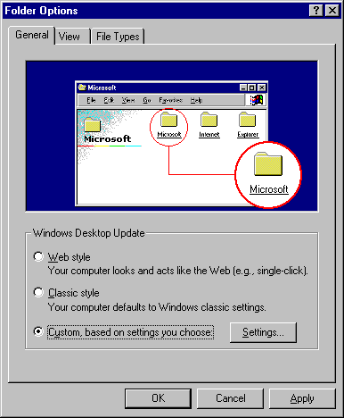

- Click Web Style, or Classic Style and click OK. Or, click Custom and then click the Settings button. Select the options you want and then click OK.
When you turn on Web style you will notice a few things that are new to the Windows operating system. First, files and folders appear as underlined hot links (look at your desktop shortcuts). When you point to them your cursor changes to a pointing hand indicating that you can jump to that item, just like hotlinks on the Web. Most Web style folder windows will look different too. To try out Web style, open the My Computer folder and point to the C drive icon. You should see a description of that object (the C drive) under the My Computer title. And if you point to a graphic file, you see a thumbnail, or miniature, of the picture.

Browsing is Simple
You can display customizable toolbars at the top of a window to make browsing your computer and the Internet simple. Windows 98 automatically knows which toolbar buttons to display based on the kind of information in the window. The following table explains the available toolbars.

Toolbar | Use to
Standard | Display buttons for common commands such as copying, pasting and deleting, changing views, and moving back and forward.
Address Bar | Open Web pages, programs, folders, and documents. The address bar usually shows your current location (the path or Web page URL). You can change location by typing in a new path or URL.
Links | Create custom links to frequently used Web pages.
Desktop (taskbar only) | Put your desktop shortcuts on the taskbar.
Quick Launch (taskbar only) | Contains buttons to open frequently used programs such as Internet Explorer and Outlook Express. Add your own shortcuts here as well.

To show toolbars
- To show the Standard, Address and Links toolbars, click the My Computer icon.
- Click the View menu.
- Point to Toolbars. Click the toolbar you want to show. A checkmark appears next to a toolbar that is displayed. To hide a toolbar, click it to clear the checkmark.
Many programs, like Microsoft Word, will also have their own toolbars that will appear under the Menu bar in the program window. These toolbars are usually shown by selecting them from the View menu.
You can also customize the taskbar by adding toolbars.
- To show the Address, Links, Desktop, or Quick Launch toolbars on the taskbar, right-click a blank area of the taskbar. The taskbar shortcut menu appears.
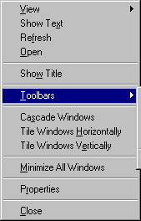 | 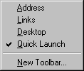

- Point to Toolbars. A checkmark appears next to the name of a toolbar that is displayed. To hide a toolbar, click on its name to clear the checkmark.
- Click anywhere outside the menu to cancel or close it.
Some toolbars may be quite long, if, for example, if you have a lot of desktop shortcuts. To scroll through items on the toolbar, click the arrows. To show more of a toolbar on the task bar, point to the sizing bar. When the pointer becomes a double arrow, drag the sizing bar to show more or less of the toolbar. The following illustration shows the Desktop toolbar.
Sizing bar
Shortcut icon
Arrow
Indicates additional shortcuts exist.
Finding What You Need When You Need It
Your computer should help you teach better, not take up time that you could be using to plan lessons and interact with students. Is there a program or accessory that you use frequently but is inconveniently buried in three tiers of cascading menus? Or maybe there’s a file you open all the time, like an electronic gradebook that you could open directly from your desktop. In the following activities you will learn how to create shortcuts on the desktop and on the Start menu for the programs and other files that you use the most.

Customizing the Start menu
The Start menu is one of the most accessible places on your desktop. You use it all the time, and the Start button is almost always visible no matter what else you are doing. You can customize your Start menu by moving program icons or personal files or folders onto it.
Pick a program or accessory from your Programs menu. For example, perhaps you use the Calculator accessory several times a day and would like to get to it with only a click. Position the mouse pointer over the program icon and click and hold down the left mouse button. Drag the program to the Start menu. When you drag the pointer you will see a gray box called a ghost which represents the program icon. As you move the pointer on the Start menu, you will see a black locator bar that shows you where the program will be placed if you release the left mouse button. Release the mouse button at a convenient place on the Start menu. Once you move a program or accessory to the Start menu, it no longer appears in your Programs or Accessory menus. Click anywhere on the desktop to close the Start menu.

Creating Shortcuts to Files and Folders


If you are using a Microsoft suite of programs like Microsoft Office, you might already have a shortcut bar on your desktop with buttons to some of your programs.
You can create a shortcut to any program, file, or folder. You may want to create a shortcut for the word processing program you use, or for a folder that you use frequently. These shortcuts can be placed on your desktop or Start menu for easy accessibility.

To create a shortcut
- To move a file or folder to the desktop or Start menu, first open Windows Explorer (do not maximize the window).

You can easily arrange the shortcuts on your desktop. Right-click a blank spot on the desktop to display the desktop shortcut menu and then point to Arrange Icons and click an option.
- Right-click the file or folder and, holding down the right mouse button, drag the file or folder to the desktop or to a convenient location on the Start menu.
- Release the mouse button. A shortcut menu appears.
- Click Create Shortcut Here. An icon to the file or folder will appear.
You can also create a shortcut to a program on your desktop. Pick a program that you would like to create a shortcut for. Click Start and point to Programs. Position the mouse pointer over the program icon that you would like to place on the desktop. Press and hold down the left mouse button. Drag the program or accessory icon to a blank place on the desktop and release the mouse button.

To remove a shortcut
- Right-click on the shortcut icon that you want to delete. A shortcut menu is displayed.
- Click Delete. A message asking you to confirm the deletion opens.
- Click Yes to move the shortcut to the recycle bin.

To rename a shortcut on the Start menu
- Click the Start button to display the Start menu.
- On the Start menu point to Settings, and then click Taskbar & Start Menu. The Taskbar properties dialog box appears.
- Click the Start Menu Programs tab, and then click the Advanced button. The Exploring Start Menu window opens.
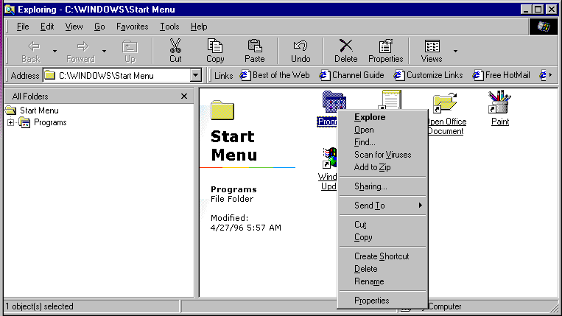

- The Start menu is selected in the left pane and the shortcut icons are displayed in the right pane. Right-click the shortcut you want to rename. A shortcut menu opens.
- Click Rename. A box appears around the object name and the text is highlighted. Type the new name and press Enter. Click the Close button to close the window.
- In the Taskbar Properties dialog box, click OK.
To rename a shortcut icon on the desktop, right-click on the shortcut icon to open a shortcut menu. Click Rename and type the new name under the shortcut icon.

Starting Programs Automatically
You can have your computer automatically run programs whenever Windows starts when you put a shortcut for that program in the StartUp menu. Maybe you have virus checking software that you want to scan your computer every time it starts, or you want your Outlook Express email to open first thing every morning when you turn on your computer. Be aware, though, that too many programs running at startup can slow your computer's performance.

To add a shortcut to your StartUp folder
- Move the pointer over the shortcut icon and press and hold the left mouse button.
- Drag the icon to the StartUp menu and release the mouse button.
- To remove a shortcut from the StartUp menu, simply drag it to the Recycle Bin, or right-click the shortcut icon and then click Delete from the shortcut menu.
You might want to restart Windows 98 to test your new StartUp shortcut.
Favorites
Sometimes you can have too many things out on your desk. Likewise, you might find that having a lot of shortcuts on your desktop starts to seem “cluttered.” On the Start menu you will find a command for Favorites. You can add four kinds of objects to this menu for quick and easy retrieval: files, folders, cascading menus and Web pages.

To add a file or folder to the Favorites menu
You can easily move a file or folder directly onto the Favorites menu:
- Find the file or folder using My Computer or Windows Explorer.
- Click the file or folder in the My Computer or Exploring window and, holding down the left mouse button, drag it to the Favorites submenu. (While you are dragging the file, point to the Start button and then to Favorites to open the Favorites submenu.)
- The locating bar shows you where the shortcut to the file or folder will be displayed. Release the mouse button to place the shortcut on the Favorites submenu.
There is another easy way to add a shortcut to a file or folder from Windows Explorer:
- Select the file or folder (if you are in Web view, don’t click the item, just move the pointer over it until it is highlighted).
- Click Favorites on the Explorer menu bar.
- Click Add to Favorites. The Add Favorite dialog box opens.
- Click OK to add the item directly onto the menu. Or, you can place it in a folder in the Favorites menu.
- To place the item in a folder, click Create in and then click one of the existing folders.
You can also create a new folder in which to place the favorite item:
- Repeat steps 1 through 4 above to add a shortcut from Windows Explorer.
- Click New Folder. The Create New Folder dialog box opens.
- Type a name for the folder and click OK.
- Make sure the new folder is selected and then click OK to place a shortcut to the item in that folder on the Favorites menu.
Changing Display Settings
Previously you adjusted settings for the mouse to make it comfortable for your use. You can also change your display settings to fit your needs and your personality.
Play Better!
Find a picture on the Web that you really like? You can easily make it your desktop wallpaper. Right click on the picture and then click Set as Wallpaper.

To change the display settings
- On the Start menu point to Settings.
- Click Control Panel and then click Display.
The Display Properties dialog box opens.
- Click a tab to change the settings in that tab. The following tabs are available:
- Background—choose an HTML document or picture for your desktop background. Several options are available automatically, or you can create your own.
- Screen Saver—choose a screen saver and add password protection. Also set energy saving options for your monitor. Your school, district, or college or university may have rules about using password protection and you probably have some of your own. Remember to discuss with students the “hazards” of locking the instructor out of the computer system.
- Appearance—choose a color scheme for your windows and desktop. Choose a high contrast color scheme for greater accessibility for those with visual impairments.
- Effects—change the look and size of desktop icons.
- Web—add active content items to the desktop. For more information about the Active Desktop and active content, see the section “Getting Connected.”
- Settings—choose your color settings. Also add another monitor and view your desktop across both.
Many of the optional display settings are designed to make the computer more accessible for persons with disabilities. Be aware that you can enlarge icons and screen fonts and use high-contrast colors for those with visual impairments.
Organizing Files and Customizing Folders
You can organize files and documents on your computer just as you would in a filing cabinet. It is easy to create new folders to store your files or documents in and it is easy to move items from folder to folder.


To learn more about using spreadsheets in education, see In and Out of the Classroom with Microsoft Office. In and Out of the Classroom is a series of free self-paced workbooks designed to help educators learn and use Microsoft software applications in the classroom and also as personal productivity tools. To view available titles and download individual workbooks, go to: http://www.microsoft.com/
education/k12/learn.htm
For example, you have created a spreadsheet of grades for each of your students and you would like to put them all in the same folder on your hard drive.

To create a new folder
- Open Windows Explorer.
Make sure the hard drive (usually C:) is selected. Click File, point to New and click Folder.
A new folder will appear in the right side of the window with the title New Folder selected.
- Type in a new title such as “Grades.” In Windows 98, you can use spaces, symbols, and numbers in your file and folder names.

To move several files at the same time that are listed consecutively, click the first file you want to move and then, holding down the shift key, click the last file you want to move. All of the files in between will be selected and you can drag them all to the new location.

If you want to move more than one file, but they are not listed consecutively, hold down the CTRL key while you select the files, then drag them to the new location.
- Click View and then click Refresh.
Your new folder will appear in the left side of the window.
- You are now ready to move the individual spreadsheets into the “grades” folder. Right now they are stored in the My Documents folder.
- In the left side of the window, click the folder where the files or documents are currently stored. The individual documents will appear in the right side of the window.
- Click on a document, and then holding down the left mouse button, drag the document to the new folder and release the mouse button.
There are four ways to view the files in the right side of the Explorer window: as large icons, as small icons, as a list, or as a list with details including file size, type, and last date modified. You can select how you view files in Explorer from the View menu. You can also sort files by date, type, or size.

To sort files
- In a folder window, such as in Windows Explorer, click Views and select Details. This will display the files in the folder in a list with the file name, size, type, and last date modified.
Views button

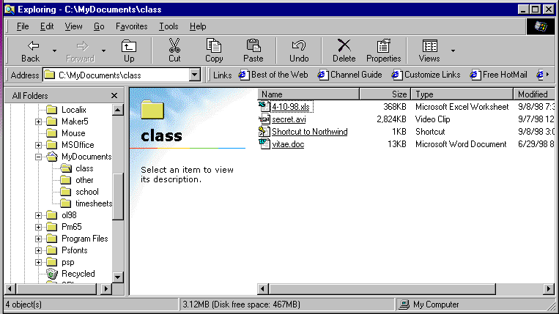
Address bar
Shows the path to the file.
Left pane
Shows the folders on the selected drive. The “class” subfolder of the My Documents folder is open.
Sorting buttons
Scroll bar

- Sort files by clicking the buttons at the top of the details columns. (The default arrangement is by name.)
- Click Name to sort files in alphabetical order by name.
- Click Size to sort files by file size, smallest to largest.
- Click Type to sort files by type such as Application, Microsoft Word Document, or Video Clip. Files will be organized first by type in alphabetical order. Next, all files of a type will be listed together in alphabetical order by file name.
- Click Modified to sort files by the date they were last saved, from most recent to oldest.
Eventually you may want to create a folder for each student’s grades. You can do this the same way you created the Grades folder. If you want each student folder to be a subfolder within the Grades folder, click the Grades folder in the Explorer window and then click File, point to New and click Folder to create a new student subfolder.
Adding Programs to the Taskbar
The Windows 98 taskbar includes a Quick Launch toolbar with buttons that start frequently used programs. The default toolbar has four buttons: Show Desktop, Launch Outlook Express, Launch Internet Explorer Browser, and View Channels. To save even more of your valuable time, in Windows 98 you can add additional buttons to the taskbar. Maybe you use the calculator accessory several times throughout the day. You can add a button for the calculator to the Quick Launch toolbar.

To add the calculator to the taskbar
- Click the Start button to display the Start menu.
- Point to Programs, point to Accessories, and then point to Calculator.
- Right-drag Calculator to the Quick Launch toolbar on the task bar. A locator bar appears.
- Release the right mouse button when the locator bar is where you want the Calculator button to appear. A shortcut menu appears.
- Click Create Shortcut Here.
- Drag the toolbar separator to the right if you cannot see all of the Quick Launch buttons.
Creating User Profiles
Many classroom teachers only have one computer in the classroom or use a computer lab that is shared with others in the school. With Windows 98 you can create profiles that are unique to each user. When that user logs on to the computer, the computer can bring up the following customized settings:
- Desktop colors, backgrounds, and screen savers
- Favorites
- My Documents folder settings
- Accessibility features
And you can create a password to protect personal settings and documents from other users. Remember though that allowing students to use passwords can create complications.

To create a user profile
- Click the Start button, point to Settings, and then click Control Panel. The Control Panel window opens.
- Click the Users icon. The Enable Multi-User dialog box appears.
- Type your name and click Next. Each user will be identified by a different name.
- In the password box, type a password, press TAB, and type the password again. You can add a password for only yourself if you do not want others to use passwords.
- Click Next. The Personal Items settings box appears. Select one or more items to personalize.
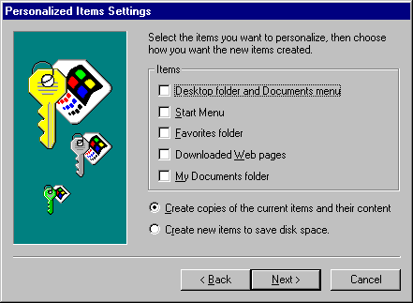

- Click the Create New Items To Save Disk Space option, and then Next.
- Click Finish. You will be prompted to restart your computer. The new profile will not take effect until you restart the computer.
- Click Yes to restart the computer. From now on, when you turn on the computer, you will be prompted to type your username and password.
- Repeat these steps to create profiles for students, groups of students, or others who use the computer.
Accessibility Features
Microsoft is committed to increasing accessibility to computers and their uses for all people including those with disabilities. In order to enable many of the Windows 98 accessibility options, you must use the Windows 98 CD-ROM to install the Accessibility Wizard.

To install the Accessibility Wizard
- Insert the Windows 98 CD-ROM into the CD-ROM drive.
- Click the Start button, point to Settings, and then click Control Panel. The Control Panel window opens.
- Click the Add/Remove Programs icon. The Add/Remove Programs Properties dialog box appears.
- Click the Windows Setup tab. A list of available programs is displayed.
- Select the Accessibility check box and click OK.
- You will be prompted to restart your computer. Click Yes. Your computer will restart and the new settings will take effect.
After you install the Accessibility Wizard, you will find it on the Accessories submenu of your Programs menu. To start the Accessibility Wizard, click Start, point to Programs, point to Accessories, and then point to Accessibility.
Click Accessibility Wizard. The Accessibility Wizard dialog box opens and guides you through the process of making the computer more accessible for users with disabilities.
Run the Accessibility Wizard from the Control Panel to enable any of the following features:
Feature: | If you want to:
StickyKeys | Use SHIFT, CTRL, or ALT by pressing one key at a time instead of in combination with other keys to perform a task.
FilterKeys | Have Windows ignore brief or repeated keystrokes.
ToggleKeys | Hear tones when pressing the CAPS LOCK, NUM LOCK, and SCROLL LOCK keys.
SoundSentry | See visual warnings when your computer makes a sound.
ShowSounds | Have programs display captions for the speech and sounds they make.
High Contrast | Have programs change color scheme to a high contrast scheme.
MouseKeys | Control the mouse pointer with the numeric keypad on the keyboard.
SerialKey Devices | Use an alternate input device for access to keyboard and mouse features.

Putting it Together
Now that you have discovered the features of the Windows 98 based desktop, you can try the following ideas and activities in and out of the classroom:
- Create folders for each of the subjects or class periods you teach. Each folder can contain:
- Microsoft Excel spreadsheet for grades.
- Seating chart.
- Assignments, worksheets, and tests.
- Calendar of classroom activities and assignment due dates.
- Test forms and answer sheets.
- Create folders for each student to keep track of:
- Contact with parents.
- Records of conferences that have been held.
- Records of turned-in assignments, or late and missing assignments.
- Grades for each subject.
- Use the scientific calculator. Create quizzes for students to take online using the calculator or scientific calculator. To open the scientific calculator, open the calculator from the Accessories menu and then click View and select Scientific. Refer to the online Help for instructions for using the scientific calculator.
- Create shortcuts for programs that you or your students use frequently and place the shortcuts on the desktop, in the Start menu, or on the Quick Launch toolbar.
- Allow students to create their own user profiles and personal folder:
- Install the Accessibility Wizard from the Windows 98 CD-ROM so you can enable accessibility features for students with special needs.

