Working Better in Windows 98
What you will do:
- Work with the mouse
- Work with menus and commands
- Work with windows
- Work with Help and Windows Explorer

This section will show you some concepts of Windows 98 and Windows based software programs including how to use the mouse and how to work with windows. If you are already familiar with using Windows 95, you may want to simply review this section, concentrating on the Teach Better! ideas. If you are new to the Windows operating system or are upgrading from Windows 3.1, you may want to supplement this section with the Discover Windows 98 online tutorial and the Getting Started guide that came with your Windows 98 software. And if at any time you want more information about a topic, remember to use the Windows Help system. For more information about using Help, see the end of this section.
Getting Started
Windows 98 will help you work better by making your computer run faster and more reliably. Windows 98 supports the latest multimedia and communications technologies. With a fully Web integrated user interface, it brings the global community to your classroom.
It might seem ironic, but one of the first things to know about Windows 98 is how to exit Windows and shut down the computer when you are finished using it. Your shut down options are available from the Start menu. Depending on how your computer is set up you may have the following options:
- Log Off—choose Log off if you want the computer to remain on but don’t want other users to have access to your personal user profile.
- Shut Down—choose Shut down when you want to completely turn off power to your computer.
- Stand by—an option available with computers that have Advanced Power Manager (APM) or ACPI built in. Stand by saves energy and lets you come right back to where you were working.
- Restart—choose Restart when it is necessary to exit Windows, but when you want to keep using the computer. For example, when you install new hardware or programs, you will often be prompted to restart the computer for certain settings to take effect.
- Restart in MS-DOS Mode—choose this option if you want to use MS-DOS® based software that will not run with the Windows operating system. Sometimes it is also necessary to reboot in MS-DOS mode to troubleshoot system problems.

Exiting Windows and shutting down the computer
- Save any documents you have been working in and then close any programs that are running. (If you are using Stand by, save your documents, but you can leave your programs running.)
- Click the Start button to open the Start menu.
- Click Shut Down to turn off or restart the computer. Or, click Log Off if you want the computer to remain on but don’t want other users to have access to your personal user profile. (For more information about user profiles, see section two, “Introducing the Windows 98 Desktop.”) The Shut Down Windows dialog box opens.


If the computer is not shut down properly, Windows 98 will automatically run the ScanDisk program at the next startup to help prevent hard drive errors. For more information about ScanDisk, see the section “Multimedia and Other Tools.”
- Choose Stand by, Shut down, Restart, or Restart in MS-DOS Mode, and then click OK.
- If you chose Stand by, the computer will appear to shut off.
If you chose Shut down, wait for Windows to show the message “It is now safe to turn off your computer,” then you can turn off the computer.
If you chose Restart or Restart in MS-DOS mode, Windows will exit and then automatically start again. You may be prompted to log in again if that is part of your system’s configuration.
Sometimes, due to system or program errors, your computer might “hang,” that is, it will be running but you will not be able to use any commands, you might not even be able to use the mouse pointer. If this happens and you are unable to shut down Windows as explained above, try pressing Ctrl + Alt + Delete. This will open a dialog box that can help you shut down the program that is causing the error, or shut down the computer if necessary. Be careful, by shutting down the computer in this way, you can lose any unsaved information your were working on. This should only be done if you are unable to shut down Windows from the Start menu.
Exploring Windows 98
As an educator, you might believe that sometimes the best way to learn something is to explore. As you are getting to know the Windows 98 operating system, feel free to do just that. The following pages explain some of the things you will find in Windows 98.

The Desktop
In Windows 98, the main screen is called the desktop. This is your work area. Just like the top of a real desk, this one changes depending on what you are doing. You can also customize it to fit your needs and personality (more about this in the section, "Using the Windows 98 Desktop”). The following illustration shows the Windows 98 desktop.
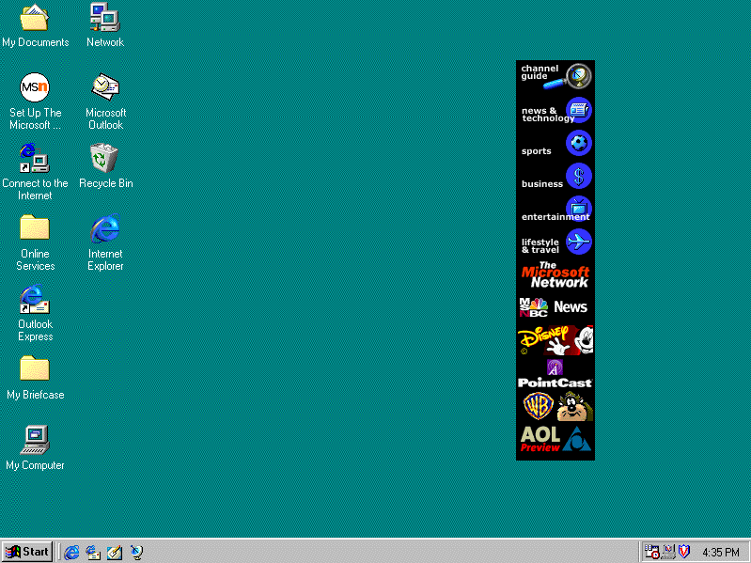
Time Clock
Displays the current time set in the computer. Change the time and date by double-clicking here.
Start button Click to open the Start menu, your one-stop access to many of the features of Windows 98.
Channel Bar Obtain instant access to any of more than 3,000 active Web pages with this active channel “remote control."
Icons
Double-click one of these icons, or shortcuts, to open a program or folder.
Quick Launch toolbar
Use these icons to start Internet Explorer, start Outlook Express, minimize all open windows, or view channels.
Taskbar
When a window is open but not active, an icon for the window appears here. Quickly switch between open windows using the icons.

Windows
When you open something on your computer like a program, a document, or a Web browser, it appears on your desktop inside a window. There are two types of windows—program windows which contain a program, such as Microsoft Word, and document windows which contain documents inside a program window. You can have several documents open in one program window, for example you can have more than one Microsoft PowerPoint presentation file open at a time within the PowerPoint program window. The following illustration shows the parts of a typical window.
Title bar
Changes color when the window is active.

Menu bar
Contains menus for the program. Click on the menu names to display the menus and their commands.
Minimize button
Window becomes an icon on the taskbar

Maximize button
Window fills the entire desktop

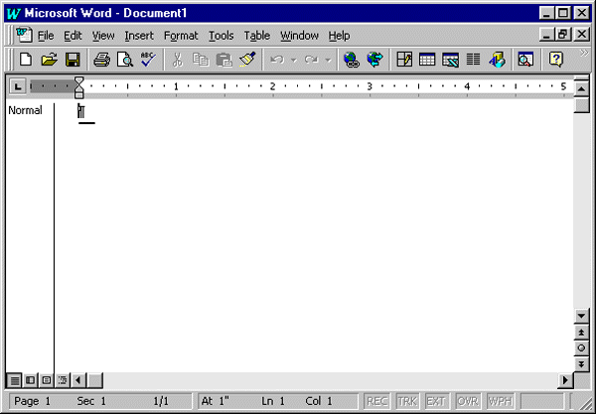
Status bar
Shows you information about the document
Toolbar
Available buttons depend on the program you are using
Document window
Scroll arrow
Click to move through the document
Restore button
Smaller than maximized but not minimized
Close button
Closes document, or quits program
Scroll box
Drag the box left or right (up or down on the vertical bar) to see information which doesn't fit in the window.
Horizontal Scroll bar
Click at a point in the scroll bar to move the scroll box, instead of dragging the scroll box.
Horizontal Scroll bar
Click at a point in the scroll bar to move the scroll box, instead of dragging the scroll box
Scroll box
Drag the box left or right (up or down on the vertical bar) to see information which doesn’t fit in the window.
Corner
Resize the window by dragging from the corner.

Moving, Sizing, and Organizing Windows
Once you are familiar with the parts of a window, it is easy to use several windows at once so that you can accomplish more than one thing at a time. You can search the Internet and import text or pictures into a Word document; or, you can figure grades with an Excel spreadsheet, and write memos in Word Pad all while you are reading your e-mail. The following are some tips for moving, sizing, and organizing windows that you have open on your desktop at the same time:
- Move—Use the Title Bar to move a window around on the desktop. Click on the title bar, and while holding down the mouse button, drag the window to a new location on the desktop. This is helpful when you are using more than one program at a time and need to see them both simultaneously, such as when you are editing a picture in Paint and then want to import the picture into a Word document.

Don’t forget about the Desktop button on the Quick Launch toolbar. If you have several windows open and can’t see the desktop, but you want to open something from a desktop shortcut, click this button to minimize all of your open windows and show the desktop.
- Resize—Customize the size of a window with the resize pointers. You can drag the window’s borders to make the window larger or smaller. To try this, open Notepad from the Accessories submenu (on the Programs menu). Move the pointer over to the right edge of the window. The pointer will change to a resize pointer, a short line with arrows at both ends. Hold down the left mouse button and drag any part of the window's edge to make the window wider. Or, drag the window from the corner to resize the height and width at the same time.
- Organize—When you right-click on the taskbar, a menu appears. This handy menu contains commands for cascading and tiling windows, and for minimizing all open windows. To try out these features, open a few accessory programs such as Word Pad, the calculator, and Paint, and then right-click an open space on the taskbar and choose Cascade Windows or Tile Windows Horizontally.

Dialog Boxes
Dialog boxes pop up on your screen when Windows or a Windows based program needs information, requires you to confirm an action (such as deleting), or has an alert or other information. Dialog boxes look a bit like windows, but don’t have all the features of windows. For example, they have title bars, but not toolbars. You can move them but not resize them. You can close them but not minimize them. Most dialog boxes are intuitive, usually asking for a simple Yes, No, or OK. Some are more complicated, especially those used for changing settings.
Several Windows 98 dialog boxes you use to change system settings are subdivided into tabbed categories, like a "real" file folder or card file. This allows you to make multiple changes from a centralized location on your computer. Each tab has a heading which categorizes the information on that tab. Click on the tab to change from one to another. The following illustration shows the Date/Time Properties dialog box.
Help
Changes the pointer into a question mark. Click on an object for an explanation of it.
Close
Title bar
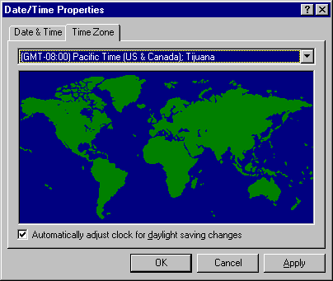
Drop down list
Click the arrow to open a list of options to select from.
Tabs
Cancel button
Click to close the dialog box without changing any settings.
Apply button
Click to change setting but not close dialog box.
Checkbox
Selected when checked. Click to check or to clear check mark.
OK button
Click to close the dialog box and change settings as indicated.

Identifying File Box Features
Another typical dialog box is the file box. This box opens when you choose the Open or Save As command on the File menu of most Windows programs.
File View Buttons
Allows easy access to folders or functions. Buttons vary depending on which dialog box is open.
Folder tree
Click the arrow to browse folders and select one.
Up one level button
Click to go to the folder one level higher than the current one.

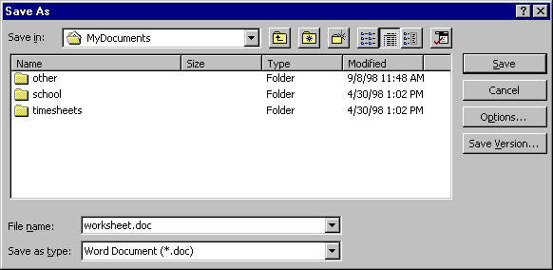
Document type field
Shows the file format in which the document will be saved (Save as dialog box) or of the documents displayed (Open dialog box).
File name field
Use this field to select or type a name of a file you are saving (Save as dialog box) or want to open (Open dialog box).

Pointing and Clicking
In Windows 98, the mouse is the tool you will most often use to navigate through the operating system and perform tasks. There are five basic actions you perform with the mouse: point, click, double-click, right-click, and drag.
To point the mouse, simply position the on-screen mouse pointer over an object. Sometimes when you point to an object and “hover” over it, a small box called a tool tip will appear that contains a description of the object. When you point to some objects, the mouse pointer changes shape, alerting you to the fact that you can perform some kind of command. For example, when the pointer turns into a hand with a pointing finger, you are pointing to a clickable item such as a hyperlink. A hyperlink is text or a picture that you can click to jump to another location. A two-headed arrow allows you to resize an object.
Click means to press the left (primary) mouse button. When you click an object you make it active. Double-click means to press the left mouse button twice quickly. Right-click means to press the right (secondary) mouse button. To drag an object with the mouse pointer, point to the object and press and hold down the left mouse button. When you have moved the object to where you want it, release the mouse button to “drop” the object.
To make the mouse comfortable for you and your students to use, you can adjust the speed of the mouse pointer, adjust the mouse for left-handed users, and make the pointers larger or smaller. You can also show the trail of the pointer, which is helpful if you are using the computer with a projection device. For those who cannot use a mouse, keyboard alternatives are available through the Accessibility Wizard.

To Adjust Mouse Settings
- Click Start to display the Start menu.
- Point to Settings and then click Control Panel from the submenu.

- Double-click the Mouse icon to open the Mouse Properties dialog box.
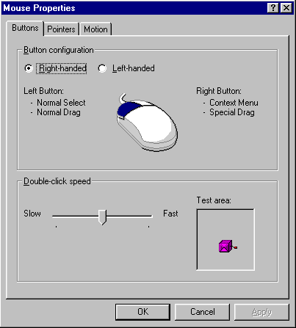
Pointers tab
Change the look of pointers. Make them larger for easier visibility.
Button configuration
Change settings for left-handed users.
Slider
Click on the speed indicator and, while holding down the mouse button, drag it to the left or right.
Motion tab
Show pointer trails and adjust tracking speed.
Test area
Handle on the box demonstrates the double-click speed

- Click either the Buttons tab, Pointers tab, or Motion tab. Adjust the settings and then click Apply.
- Click OK to close the dialog box.
Working with Menus and Commands
A menu is a list of commands or instructions that tell your computer to perform an action (such as opening a program or saving a document). The main menu associated with Windows 98 is the Start menu. Most software programs will have their own menus that you will become familiar with as you use the program. You will usually find these menus at the top of the program window in an area called the menu bar. In Windows 98 you will use menus, cascading menus, submenus, and shortcut menus. The following illustrations show some of the kinds of menus and their parts.

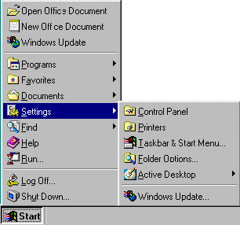
If an arrow follows a command on a menu, pointing to that command opens another menu called a cascading menu.
Start button
Click to open the Start menu.

You can cancel any menu (close it without choosing a command) by clicking anywhere outside of the menu.

Later in this book you will learn how to add items to the Start menu, such as other programs or documents you use every day. The following are descriptions of the commands on the default Start menu:
- Run—opens the Run dialog box. You can type in the name of a program, folder, document, or Internet resource and Windows 98 will open it for you. There is also a Browse button to help you find what you want to open.
- Settings—opens a cascading menu with commands to open the Control Panel folder, Printers folder, Taskbar Properties dialog box, Folder Options dialog box, and Active Desktop commands.
- Documents—quick access to the last 15 files that you have opened, as well as a shortcut to the My Documents folder.
- Favorites—opens a cascading menu, which helps you quickly access your Web page subscriptions, Active Channel subscriptions, and My Documents folder.
- Programs—opens the Programs menu which contains shortcuts to the software programs on your computer or that are available on your computer network including Windows Explorer and the Windows 98 Accessories.
For information about the Shut Down command, see the beginning of this section. For information about the Find command and the Help command, see the end of this section. Depending on what other types of programs you have on your computer or network, you might have additional commands on the Start menu.
There are some other symbols, called indicators, that you will sometimes find on menus. The following is an illustration of the View menu in Microsoft Word 97 showing the kinds of indicators you will find on program menus.
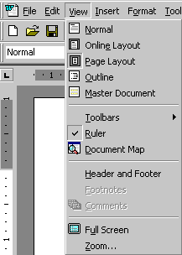
Button
Indicates which of several related options is selected
Checkbox
Indicates that a command is selected.
Unavailable
Commands that appear “grayed out” are not available for the task you are doing.
Ellipses
Indicates that a dialogue box opens and additional information is required before the command is executed.
Menu bar
Click on the menu name to display the menu.

In Windows 98 and software programs that run on the Windows operating system, there are also shortcut menus which you open by right-clicking an object or area on the desktop or in a program window. The commands available on a shortcut menu depend on the location of the pointer when it is clicked. For example, the Windows 98 desktop shortcut menu allows you to create shortcuts and arrange shortcut icons as well as customize your Active Desktop.

Benefiting from Help and Windows Explorer
Windows 98 includes several tools to help you find things you need on the computer and an excellent online Help system that has information for all levels of users, from those exploring Windows for the first time, to those who need access to detailed technical support.

Using Find
If you need a file or program located on your computer or network, but you cannot remember its name or location, use the Find File command. Click the Start button, point to Find, and then click Files or Folders. When you choose this command from the Start menu, the Find dialog box opens.
From this dialog box, you can find the file or program based on several types of search criteria, such as the file format (type), a partial file name, or words in a file. The more specific you can make the search, the faster the search results are displayed. For example, if you know the document you are looking for is a Microsoft Word document, it contains the word "vitae," and it is on your computer, you could choose "*.doc" from the dropdown list for the Named field, type "vitae" in the Containing text field, and select your hard drive in the Look in field before pressing Find Now to start the search. When the search is completed, a list of files and folders matching your criteria appears in the field at the bottom of the Find dialog box:
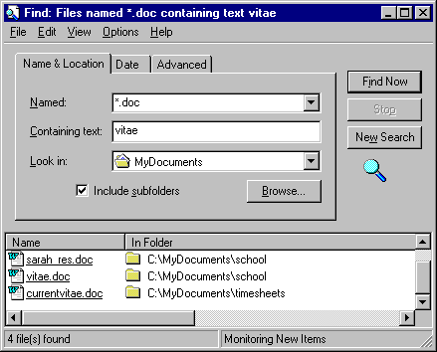

Open the files or folders in this field by clicking on the file or folder (double-click if you are using Classic style). You can also right-click the file or folder for more options, such as printing it (for files), moving or copying it, or deleting it.
The following options are also available from the Find command on the Start menu:
- Computer—search for another computer on the network by name.
- On the Internet—launches the Web browser so that you can search the Internet. For more information about finding information on the Internet, see the section “Getting Connected.”
- Using Microsoft Outlook™—opens the advanced Find dialog box for the Microsoft Outlook messaging and collaboration client. If you use Microsoft Outlook to schedule tasks, meetings, appointments, and other items, you can search for an Outlook item from this box.
- People—opens your personal address book if available.

Using Help
When you have questions about Windows 98, you can quickly and easily find the answers in the Windows 98 online help file on the Start menu. Once you have chosen the Help command, the Help dialog box opens:
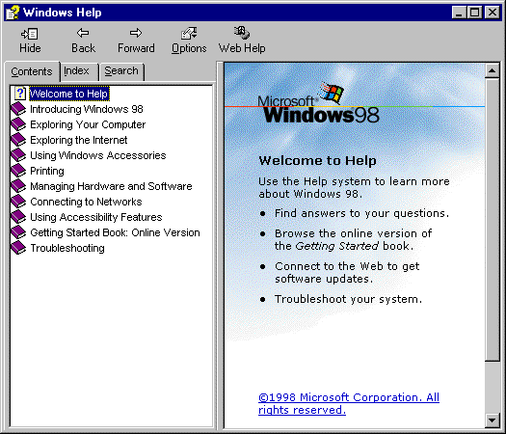
Troubleshooting
Click here to access the troubleshooting wizards.
Toolbar
Tabs
Accessibility information
Getting Started guide
The online version of the Getting Started guide

In the Help dialog box, you can search for information using one of three tabs:
- The Contents tab—Use this tab to find information as you would in a book's table of contents. This tab displays Help information that is organized to look like chapters in a book. Each "chapter" appears with a book icon next to it. If you click the book icon, the pane displays the subheadings in that chapter.
- The Index tab—Use this tab to find information as you would in a book index. As you type a keyword or part of a keyword, the one in the list that is closest to what you are typing is highlighted. You can continue typing more of the keyword to define it more specifically, click the selected keyword in the list to display it, or click one of the keyword subentries (if they exist) in the list to display it. If you click a keyword and more than one topic uses it, a list of the topics appears. When you choose one, its contents are displayed in the right pane.

Windows 98 comes with a screen magnifier accessory to help make the computer accessible for people with visual impairments. To learn more about the magnifier open Help. On the Contents tab click Using Accessibility Features. Click Using Microsoft Magnifier, and then choose a topic.

- The Search tab—Use this tab to search for information on a broad topic.
The Help window also contains a toolbar with the following buttons:
- Show/Hide—shows or hides the left pane of the Help window.
- Back and Forward—like the back and forward buttons on the Web style standard toolbar and the Internet Explorer Web browser, moves back or forward through topics you have recently visited.
- Options—a menu of commands including Refresh, and Print.
- Web Help—opens a topic from which you can link to Microsoft’s Online Technical Support Web site.
Another great feature of the Windows 98 Online Help system is the troubleshooting wizard. Troubleshooting wizards walk you through a problem you might be having one step at a time by asking you questions and offering information and possible solutions. You will find the Troubleshooting Wizards on the Contents tab. Click on Troubleshooting and then click Windows 98 Troubleshooters and select from the list of available wizards. The following illustration shows the first screen of the print troubleshooting wizard.
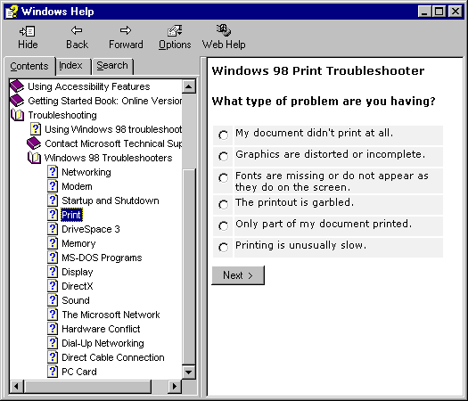
Click on the option that is most like your situation and then click Next. The wizard will continue to guide you through troubleshooting your problem and offer solutions.

Using Windows Explorer
Windows Explorer is the comprehensive organization and management tool for Windows 98 files and folders. Using this tool, you can view all the files and folders on a selected drive (such as your hard drive, your floppy disk drive, or a network computer), open the file or folder, move and copy them, rename them, delete, print, and use files on other locations on the network.
You may want to display the Windows Explorer icon on your office toolbar or your desktop for easy access to this tool, which you will probably use often. However, you can also access Windows Explorer by clicking Start, pointing to Programs, and clicking Windows Explorer. The following illustration shows the Exploring window in Web style (the Exploring window will look slightly different if you are using Classic style). Learn more about web style and Classic style in the next section “Using the Desktop.”:
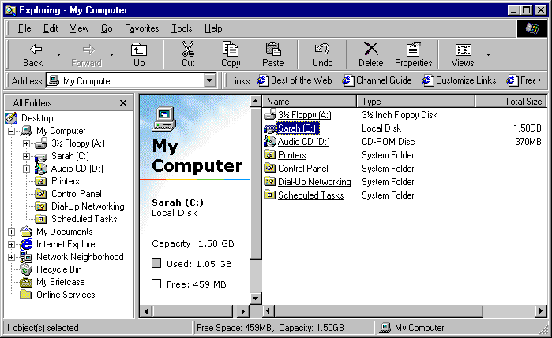
Left pane
you see all of the available drives and folders. If a drive or folder has a plus sign next to it, it means the drive or folder contains subfolders. Click the plus sign to display the subfolders.
Right pane
you see the contents of the selected drive or folder. This includes all of the subfolders you can see in the left pane, but it also includes all of the files on that level of the drive or folder. (Files are not displayed in the left pane.)

With Windows Explorer it is fast and easy to open, move, create and organize your files and folders. And with Windows 98 and Microsoft Internet Explorer, you can even browse the Web from the Exploring window (just click Internet Explorer in the left pane, your default home page will open in the right pane and the URL will appear in the Address bar). In the next section, “Using the Desktop,” you will learn how to create folders and organize your files in them.
Putting it Together
Now that you are familiar with the basic features of Windows 98 and how to use them, you can try the following ideas and activities in and out of the classroom:
- Adjust the mouse to a slower setting for younger children and those just learning how to use the mouse.
- Teach students to use the features of dialog boxes and give them a pop geography quiz at the same time. Use the World Clock as appropriate in lessons.
- Remember to use Windows 98 Help whenever you need more information. Windows-based programs also often have their own online Help.
- Use Windows Explorer for group editing or creative writing activities. Have students access papers to be edited from a group folder in Explorer.

