**[How to Hide and Lock Hard Disk Drives in "My Computer"](http://www.wikihow.com/Hide-and-Lock-Hard-Disk-Drives-in-%22My-Computer%22)**

Did you know you can secure the data on the hard disk drives by hiding or locking them. In Windows, use the steps below to do just that

## Steps

1. [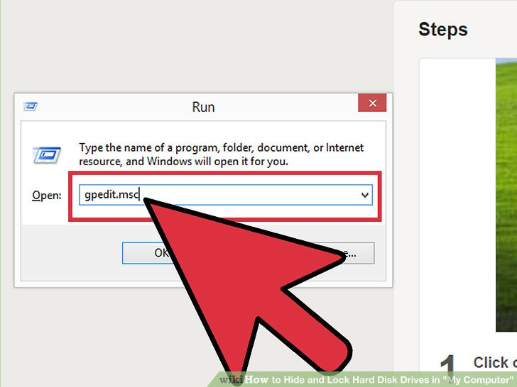](http://www.wikihow.com/Hide-and-Lock-Hard-Disk-Drives-in-%22My-Computer%22#/Image:Hide-and-Lock-Hard-Disk-Drives-in-%22My-Computer%22-Step-1-Version-2.jpg)

1

**Click on the "Start" button.** Go to "Run", type "gpedit.msc" and press enter.

1. [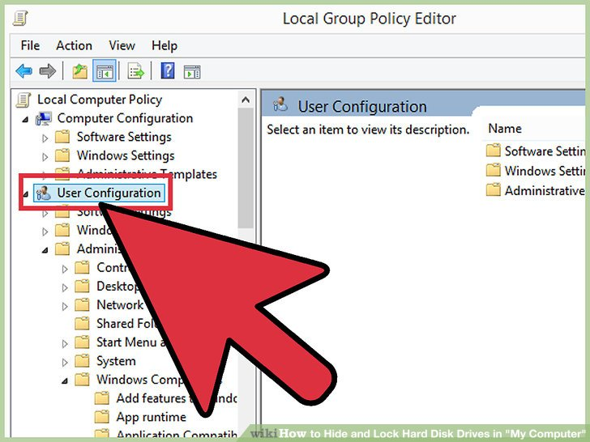](http://www.wikihow.com/Hide-and-Lock-Hard-Disk-Drives-in-%22My-Computer%22#/Image:Hide-and-Lock-Hard-Disk-Drives-in-%22My-Computer%22-Step-2-Version-2.jpg)

2

**Wait for the "Group Policy" window to appear.** Click on the "+" button beside User Configuration then click on the "+" button beside "Administrative Templates". Then click the "+" button beside "Windows Components" and then click "Windows Explorer", or "File Explorer"

1. [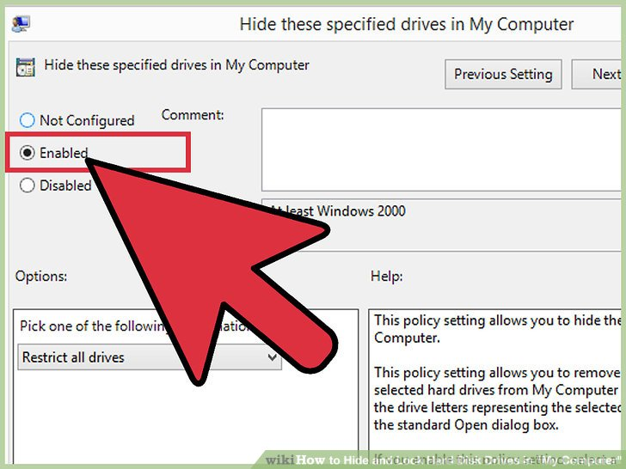](http://www.wikihow.com/Hide-and-Lock-Hard-Disk-Drives-in-%22My-Computer%22#/Image:Hide-and-Lock-Hard-Disk-Drives-in-%22My-Computer%22-Step-3-Version-2.jpg)

3

**Search for "Hide these specified drives in My Computer" in the options that appear in the right column of the window.** Double click it, enable it and choose the drive(s) you want to hide.

1. [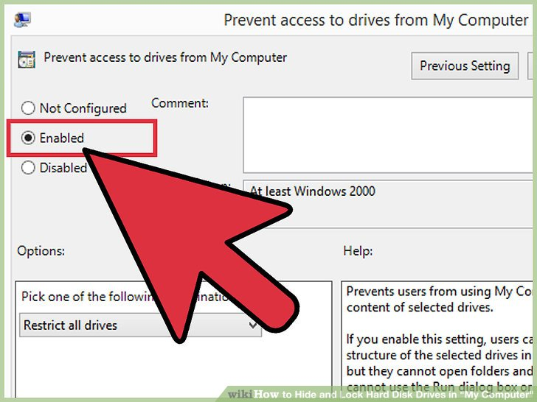](http://www.wikihow.com/Hide-and-Lock-Hard-Disk-Drives-in-%22My-Computer%22#/Image:Hide-and-Lock-Hard-Disk-Drives-in-%22My-Computer%22-Step-4-Version-2.jpg)

4

**Search for "Prevent access to drives from My Computer".** Double click it and repeat the previous step if you want to stop accessing any drive by "command" (e.g, by typing "C:" in the address bar or "Run").

1. [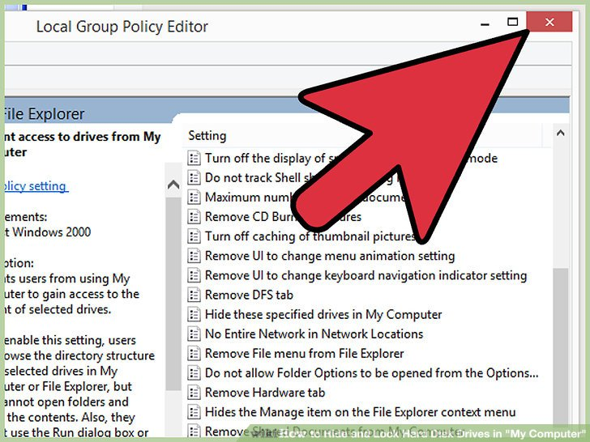](http://www.wikihow.com/Hide-and-Lock-Hard-Disk-Drives-in-%22My-Computer%22#/Image:Hide-and-Lock-Hard-Disk-Drives-in-%22My-Computer%22-Step-5-Version-2.jpg)

5

**Close the group policy window.**

1. [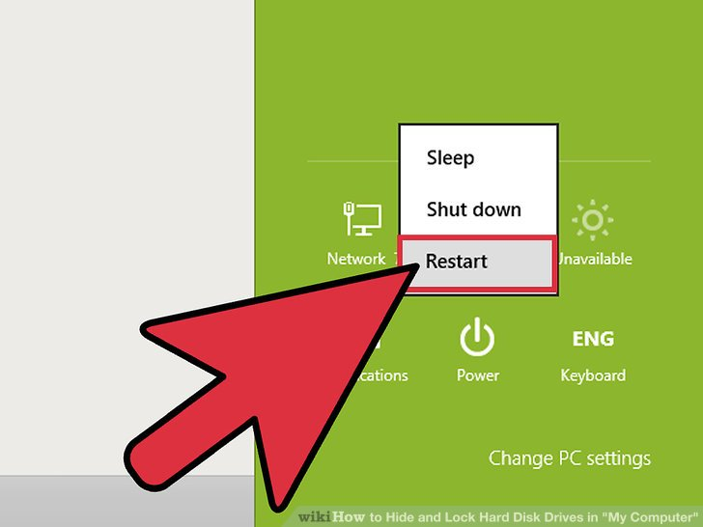](http://www.wikihow.com/Hide-and-Lock-Hard-Disk-Drives-in-%22My-Computer%22#/Image:Hide-and-Lock-Hard-Disk-Drives-in-%22My-Computer%22-Step-6-Version-2.jpg)

6

**Restart your computer for changes to take effect.**

1. [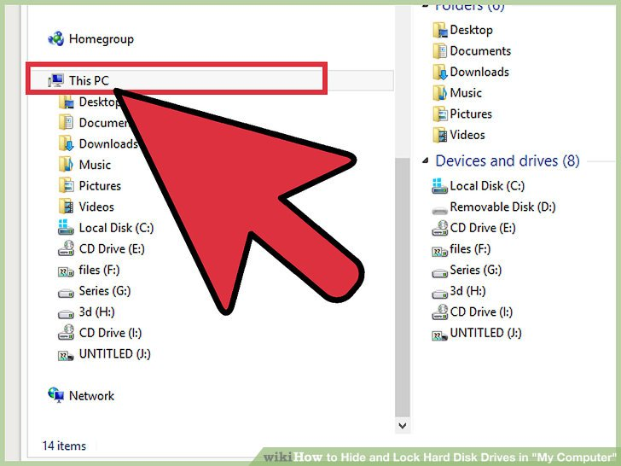](http://www.wikihow.com/Hide-and-Lock-Hard-Disk-Drives-in-%22My-Computer%22#/Image:Hide-and-Lock-Hard-Disk-Drives-in-%22My-Computer%22-Step-7-Version-2.jpg)

7

**Only the first hard disk drives can be locked here.**

**Can you password protect an external hard drive?**

**Download and install an encryption program, such as TrueCrypt, AxCrypt or StorageCrypt. ... **Plug in your external hard drive to your computer and wait for your computer to detect it. ... **Open your encryption program and select the option to create a new volume. ... **Choose the password you want for access to this drive.

**How can I lock my USB flash drive?**

**To lock and protect USB flash drives, follow these simple steps:**

1. Plug in USB flash drive, and run the Setup program to install USB Secure on your USB flash drive. ...
2. Open USB-Drive.
3. Protect This USB Drive.
4. Click 'Protect This USB Drive', and set and confirm a new password for the USB drive.

### [How to lock flash drives with USB Secure? - NewSoftwares.net](http://www.newsoftwares.net/usb-secure/howto/lock-flash-drives-with-usb-secure/)

[www.newsoftwares.net/usb-secure/howto/lock-flash-drives-with-usb-secure/](http://www.newsoftwares.net/usb-secure/howto/lock-flash-drives-with-usb-secure/)

**How can I lock a folder in external hard disk?**

**Password Protect Folder in External Hard Disk with Renee File Protector**

1. Step 1: Launch Renee File Protector and click “Lock File” in “External Disk”. ...
2. Step 2: Click “Lock Folder” on the right side and select the target folder in external hard drive. ...
3. Step 3: Check & edit the files inside the password protected folder.

[**How to Password Protect Folder in External Hard Drive**](https://www.reneelab.com/password-protect-folder-in-external-hard-drive.html)**?**

https://www.reneelab.com/password-protect-folder-in-external-hard-drive.html

Search for: [How can I lock a folder in external hard disk?](https://www.google.com/search?client=firefox-b&q=How+can+I+lock+a+folder+in+external+hard+disk%3F&sa=X&ved=0ahUKEwiIma_j2f3TAhUDP48KHUVGB4YQzmcIRw)

Can you password protect an external hard drive?

**Download and install an encryption program, such as TrueCrypt, AxCrypt or StorageCrypt. ...

**Plug in your external hard drive to your computer and wait for your computer to detect it. ...

**Open your encryption program and select the option to create a new volume. ...

**Choose the password you want for access to this drive.

**How do you password protect an external hard drive?**

**Step 1: Run the program and select a drive to encrypt. First of all, plug your external hard drive into computer and double click the icon of this program. Select a target drive disk in the drive list. ...

**Step 2: Set password to protect USB drive. Enter password and a" password hint" in the pop-up box.