**Annotated Bio-Bibliography of Mineralogy and Crystallography 1469-1919**

**by Curtis P. Schuh (1959-2007)**

***SEE FULL LISTING AT*** [**http://mineralogicalrecord.com/library.asp**](http://mineralogicalrecord.com/library.asp)

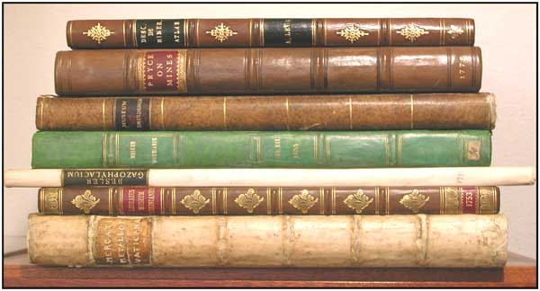

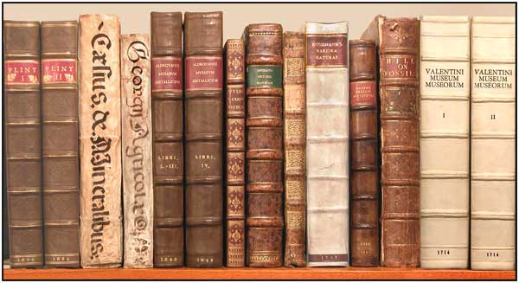

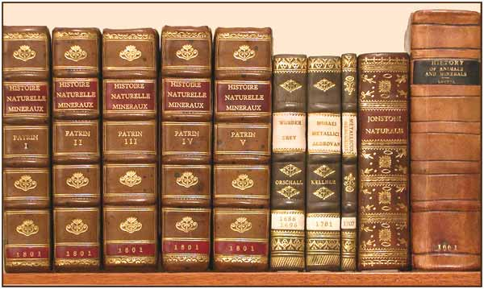

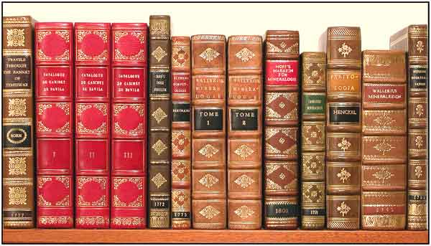

<http://mineralogicalrecord.com/library.asp>

This annotated bio-bibliography of mineralogy and crystallography is the work of the late Curtis Paul Schuh, prominent but largely unpublished mineralogical bibliographer. He was born in Boulder, Colorado on April 16, 1959, and grew up in Broomfield, north of Denver. His father, George Schuh, a retired agent for the Internal Revenue Service, died in 1984 and his mother, Jane Hantschel Schuh, died in 1985. Curtis never married, and lived a solitary life of scholarship and study.  
  
He first became interested in minerals when he was only three or four years old, through the influence of neighbors who enjoyed polishing agates. When he was eight another collector of minerals and fossils who lived a few houses down from his family heard of Curtis's interest and invited him and his mother to see his basement full of specimens; from then on Curtis was hooked. Later he was mentored in his hobby by Drue York, who had homesteaded to Colorado in the 1920's from South Dakota and had developed an interest in minerals. Her daughter, Marrianna B. (Bunny) Kennedy, took up her interest and studied palaeontology. Together they guided Curtis's interest. (Bunny later coauthored, with Richard W. Holmes, *Mines and Minerals of the Great American Rift.*)  
  
Curtis had first become interested in lapidary, especially opals, but he soon changed his direction and concentrated instead on crystallized minerals, which he found fascinating. He was a young collector when the National Show came to the old Shrine Auditorium in Denver in 1974, and his parents took him to the show. They further encouraged his interest by driving him over to Boulder Colorado every month for the mineral club meetings.  
  
When his father retired in 1976, he said he was tired of snow and wanted to move to Tucson. So the family packed up the Monday after Curtis's high school graduation in June of 1977 and headed for Arizona. Curtis had heard of the Tucson Gem and Mineral Show through articles in *Rocks and Minerals* and *Arizona Highways,* and had figured that someday he would attend, but hadn't expected to actually live in Tucson. He was delighted to find that Tucson also had a great University and an excellent library (better than any library in Colorado!).  
  
While still living near Denver, Curtis had purchased a specimen of native silver from Canada that had come with a label that read: "Bideaux Minerals, Tucson, Arizona." After his family settled in Tucson, he discovered that the shop still existed on Washington Street in downtown Tucson. So Curtis and his father went there in late June 1977, and met George Bideaux. During that visit his father also bought him a copy of the *Mineralogical Record*'s Tsumeb Issue and a softcover copy of *Minerals of Arizona* by Anthony, Bideaux and Williams.  
  
Curtis visited the Bideaux shop many times thereafter, and during several of these visits George's son Richard came in; however, George never introduced him! Nevertheless, Curtis must have made an impression on George, because he once asked Curtis to keep the shop open for a week while he and Mrs. Bideaux travelled back east. After he returned he hired Martie Scott to help him with the shop.  
  
In August, 1978 George Bideaux died, and that morning Curtis went down to the shop to see if he could help in any way. That was actually the first time he met Richard Bideaux. After Richard decided to keep the shop open he assigned Martie to mind the store during the week, and Curtis to work at the shop on Saturdays. It was through Richard that Curtis met many people in the mineral world whom he would never have known otherwise, especially when Bideaux Minerals displayed at the Tucson Show. After Bideaux Minerals closed its doors, Herb and Moni Obodda invited Curtis to help out in their Tucson Show booth, where he continued to enjoy the opportunity to meet and talk with mineral people.  
  
Curtis attended the University of Arizona where he earned three different bachelor's degrees, in Systems of Industrial Engineering (essentially a computer degree), Mathematics, and Engineering Mathematics. While still a student in 1979, he had considered becoming a mineralogist, but felt there must be some other way in which he could contribute something to the science. As it happened, he had purchased at the 1979 Tucson Show a copy of the 1832 edition of Comstock's *Introduction to Mineralogy.* He asked Richard Bideaux if he knew of any bibliographies that could tell him about other mineralogy books. Bideaux gave him the address of John Sinkankas's *Peri Lithon* book dealership in San Diego and invited Curtis to his house to see his own books (on a previous visit Curtis had only seen Bideaux's mineral collection). Bideaux, it turned out, had a substanial libary of early books. He took a rutile crystal from his mineral collection and opened to a plate in Gratacap's *Popular Guide to Minerals* (1912), then placed the specimen on the plate. It was clear the pictured specimen and the actual specimen were the same! This made a deep impression on Curtis. A few years later, when Bideaux sold off Frederick Pough's library, he enlisted Curtis to write the catalog and Curtis was thereby able to examine closely the many very rare colored mineralogical books that Pough had accumulated.  
  
Marge and John Sinkankas recommended to Curtis the bibliography in the 7th edition of Dana's *System of Mineralogy,* but the Comstock Curtis had bought was not listed there. He decided at that moment that he would compile a bibliography of mineral books with short annotations. He figured that it would be a three to five-year project, but would be a worthwhile contribution to mineralogy. If he had noticed that the Dana bibliography had books in seven languages, Curtis later said, he might have rethought this idea.  
  
Beginning his research on the project, he soon discovered Ferguson's *Bibliotheca Chemica* (1906), with its long annotations and reference lists. He decided that mineralogy deserved a bibliography of a similar nature, though as yet he had no idea of the long and interesting history of the science. He began to collect books on his own, mostly primary literature and reference books on the history of mineralogy, crystallography, geology, chemistry, botany and general science. Thus he began the laborious process of building his *magnum opus, Mineralogy and Crystallography: An Annotated Biobibliography of Books 1469 to 1919*—a massive compilation which occupied most of his spare time for the rest of his life. It remains unpublished in paper format, but Curtis prepared a final copy in html format just days before his death, so that the Mineralogical Record could post it on this website.  
  
Curtis worked for many years in Tucson as the computer support person for a number of local companies, most recently the Muscular Distrophy Association. He was their trouble-shooter, the person who would be called in when the computers broke down and no one else could figure out what was wrong with them. He liked that kind of intellectual challenge. He also served for many years as voluntary librarian for the Mineralogical Record, cataloged the antiquarian portion of the Mineralogical Record Library, and helped locate many needed volumes as they appeared on the book market. Around 1980, as an off-shoot of his bibliography project, he developed an interest in using computers to translate languages (i.e., German-to-English). Literally from scratch he programmed several systems over the years.  
  
Curtis was a kind, gentle, somewhat introverted soul and a dedicated scholar, always willing to give help when needed. Living alone in his Tucson apartment, Curtis socialized only rarely, and was often out of communication with his friends across the country for weeks and months at a time. Much of this seclusion was the result of his chronic medical difficulties (hepatitis-C), and he was hospitalized many times over the years, often coming close to death. He never complained about his sufferings but, in the end, the long-term damage to his heart and other organs meant that he had only a short time to live. At our last lunch together a few weeks before his death Curtis seemed comfortable and was not depressed as we discussed our mutual love of obscure historical research. But at last, tired of the long battle and not wanting to linger painfully, he donated his mineral collection (around 200 specimens, mostly miniatures) to the University of Arizona Mineral Museum and his reference library to the Mineralogical Record. After putting his other affairs in order, he drove out into the desert about 10 miles from the famous Tiger mine, where he left a suicide note with his abandoned vehicle and apparently took his own life. He was last seen alive on September 28, 2007; his body has not been found.

**Wendel E. Wilson**