The Photo-Atlas of Minerals Glossary
Note: This glossary does not include geological terms used in the Environment data field. For recommended on-line references on geological terms, see the Photo-Atlas of Minerals Links Page

Acicular: Needle-like crystal habit.
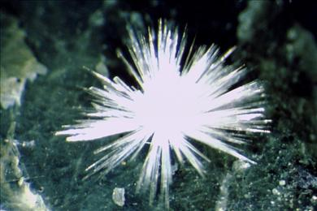
Artinite exhibiting acicular habit
Acid: An acid is a chemical compound that produces hydrogen ions when dissolved in water. Strong or weak indicate the concentrations of hydrogen ions produced. Common strong acids include hydrochloric acid (HCl), nitric acid (HNO₃), and sulfuric acid (H₂SO₄). A common weak acid is acetic acid (CH₃COOH or HC₂H₃O₂); vinegar is a 3% solution of acetic acid. Another weak acid important in geology is carbonic acid (H₂CO₃) which forms whenever atmospheric - or other - carbon dioxide (CO₂) dissolves in water (H₂).
Stronger acids will attack many minerals and can be used to help identify them. For example, acids attack carbonate minerals, such as calcite, causing carbon dioxide bubbles to be given off in an affect known as effervescence.
Strong acids are dangerous and should be handled with care, only while wearing safety glasses and with plenty of water available.
Adamantine: Hard brilliant luster; like that of a diamond.
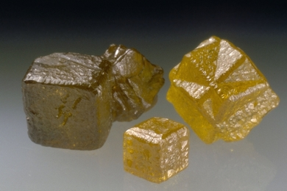
Diamond exhibiting adamantine luster
Adularescence, Adularescent: Strong pearly-to-blue floating sheen seen in the moonstone varieties of the feldspars Orthoclase, Albite, and Oligoclase.
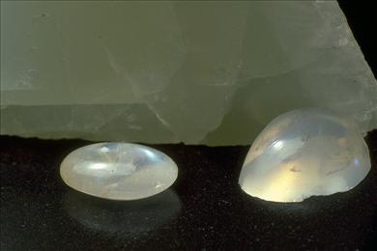
Oligoclase, variety moonstone
Aggregate: A combination of minerals joined in irregular fashion to form a material similar to concrete
Albite law twin: Type of lamellar twin on the {010} plane typical of albite and exhibited by other members of the plagioclase series.
Aliphate: Hydrocarbon in which carbon atoms are linked into chains.
Alloy: Homogeneous mixture of two or more metals in variable proportions.
Alteration: Change in the chemical composition and/or atomic structure of a mineral brought about by chemical attack or changing physical conditions.
Alumino-: Compound containing aluminum usually in combination with an anionic group (e.g. aluminosilicate).
Amalgam: Alloy of mercury with another metal.
Amide: Organic compound containing the amino group (NH₂ or NH).
Amorphous, Metamict: Amorphous materials are non-crystalline, that is they lack long-range regularity in their atomic structure. By definition they cannot be minerals. Nevertheless, some natural amorphous substances have been accepted as minerals.
Some minerals containing radioactive atoms have become amorphous as a result of radiation damage to their atomic structures; they are called metamict.
Analogue: A mineral which is identical to another, usually with respect to both chemical composition and atomic structure with the exception of a single attribute, typically one of the elements essential to its composition. For example, Calcite, Magnesite, and Strontianite are analogues, containing respectively calcium, magnesium, and strontium.
Anastomosing: Network of branching and rejoining veins.
Ångstrom Å:
One ten billionth of a meter (0.0000000001 m);
One hundred millionth of a centimeter (0.00000001 cm);
One tenth of a nanometer
While the Ångstrom is not a metric system unit, it remains in use because it is such a convenient unit for specifying interatomic distances and unit cell dimensions. A typical unit cell dimension for minerals is between 2 and 30 Å.
Anhedral: Crystal with no well-formed external faces.
Anhydrous: Mineral with no water (H ₂O) in its formula.
Anisotropic: Crystal which affects light differently when light passes through the crystal in different directions. See index of refraction.
Arborescent: Intergrowth of crystals in the shape of slender divergent branches like a plant.
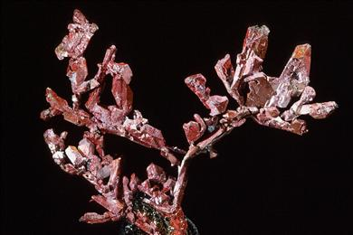
Arborescent copper
Archeotype: General type of atomic structure; used to indicate similarities in the atomic structures of minerals with differing chemical compostions. SnS-archeotype refers to the atomic structure of the mineral herzenbergite. PbS-archeotype refers to the atomic structure of the mineral galena.
Arcuate: Curved or bent.
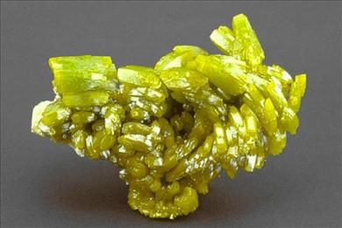
Arcuate crystals of pyromorphite
Arsenate: Compound containing the arsenate group (AsO₄⁻³).
Arsenite: Compound containing the arsenite group (AsO₃⁻³).
Asbestiform: Crystal intergrowth, similar to that commonly exhibited by asbestos, consisting of fibers generally aligned in a single direction, often at right (90º) angles to the walls of a vein. See cross-fiber.
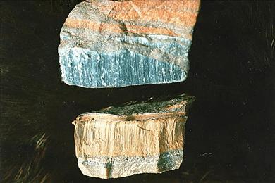
Riebeckite, variety crocidolite (cross-fiber asbestos)
Atom, Element, Electron, Proton, Neutron, Nucleus, Ion, Antion, Cation: An atom is the smallest particle of matter impervious to attack with energies short of nuclear reactions. There are only 90 chemically distinct kinds of atoms found in all of nature. Thus atoms are the building blocks on which we base our understanding of the composition of and the formation of minerals under geological conditions; atoms are rearranged - but not changed - during geological processes.
At the center of an atom is the nucleus, a combination of positively-charged protons and uncharged neutrons. The outside the nucleus are negatively-charged electrons. The number of protons in the nucleus determines the chemical behavior of the atom.
An atom has the same number of electrons as protons (thus; electrically neutral). Most atoms, when mixed with atoms of a different element, lose or gain electrons to form ions. Negatively charged ions (atoms with extra electrons) are anions; positively charged ions (atoms with a deficit of electrons) are cations.
Atomic bonding: It is useful to classify the bonds that hold atoms to one another in chemical compounds and crystals into three types - ionic, covalent and metallic.
As the name implies, ionic bonding is due to the attractions between positively and negatively charged ions. Some atoms are not able to retain all their electrons in competition with other electron greedy atoms. Under these conditions they lose a few electrons forming cations, ions with a positive charge; the electron greedy atoms gain electrons to become anions, ions with a negative charge. Oppositely charged ions attract one another forming ionic bonds. The optimum arrangement is one which surrounds each charged ion with several charged ions with the opposite charge.
When the different atoms are almost equal competitors for electrons, neither can take an extra away from the other, and so such atoms bond together by sharing electrons. This kind of bonding is called covalent bonding. It holds two partners together in a very precise geometrical arrangement. The two bonded atoms can be thought of as an ellipsoid with nuclei at the two foci. Discreet covalently bonded atom groups are found in many minerals. These usually have a net negative charge and are called anionic groups or polyatomic ions. An example is the phosphate ion in which four oxygen atoms surround a central phosphorous atom; the whole unit behaves like an anion with a charge of -3. Many of these groups form the basis for the common mineral classification schemes (Dana, Strunz).
Atoms in metals bind together by electron sharing, but in these compounds the electrons are shared between large numbers of atoms and are essentially free to move from atom to atom throughout the material. This type of bonding is weaker. Shear forces can cause the atoms to slip with respect to one another and then re-bond in the new position. This explains the malleability of many metals. The relatively free flow of electrons explains the electrical and heat conductivity of metals.
Atomic group, Anionic group, Polyatomic ions: Certain atoms form especially tightly bonded atomic groups. In minerals, these usually consist of an covalently bonded to three or four surrounding oxygens. These groups usually have a net negative charge, in which case they are called anionic groups. An example is the phosphate ion, (PO₄⁻³), in which four oxygen atoms surround a central phosphorous atom and the whole unit behaves like an anion with a charge of -3.
Atomic structure: Atomic structure refers to the orderly, repetitive, 3-dimensional arrangement of atoms in a crystalline substance such as a mineral. Nowhere is the orderliness and perfection of nature more apparent than in atomic structure. In an atomic structure, atoms come together into stable configurations by forming networks of bonds between one another. Knowledge of the atomic structure of a mineral helps us to understand all of the mineral's properties.
Barrel-shaped: Habit of a stout prismatic crystal in which the prism faces are bowed so that the crystal has a greater diameter at its center than at either end. The crystal usually also has flat terminations.
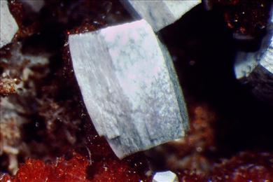
Barrel-shaped vanadinite crystal
Basal pinacoid: crystal form consisting of the two parallel faces, (001) and (00-1), which transect the c axis.
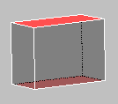
Basal pinacoid (red)
Base: Compound that when dissolved in water yields free hydroxyl (OH⁻) anions.
Baveno law twin: Type of simple contact twin on the {021} plane exhibited by orthoclase, microcline and other members of the feldspar group.
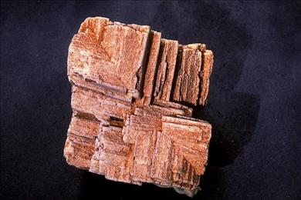
Orthoclase Baveno law twin
Beryllo-: Compound containing beryllium usually in combination with an anionic group (e.g. beryllosilicate).
Birefringent: Having different indicies of refraction along different crystal directions.
Bladed: Habit of a crystal that is flat and long; like a knife blade. Also an intergrowth of blades stacked together.
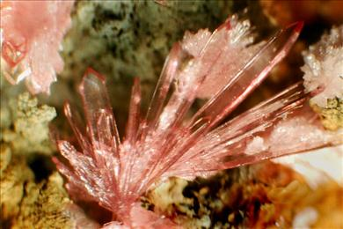
Strengite exhibiting bladed habit
Bleb: A rounded crystal grain of one mineral imbedded in another.
Blocky: Habit in which a crystal roughly block-shaped and nearly equidimensional.
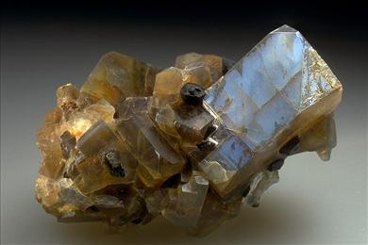
Anorthoclase exhibiting blocky habit
Borate: Compound containing the borate group (BO₃⁻³) or linked borate groups.
Boro-: Compound containing boron usually in combination with an anionic group (e.g. borosilicate).
Botryoidal, Reniform: Crystalline intergrowth with smooth, rounded surfaces.
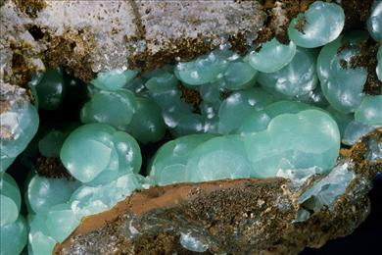
Botryoidal smithsonite
Brazil law twin: Type of penetration twin in quartz in which right- and left-handed crystal segments are twinned across the {11-20} plane. It is usually only possible to detect Brazil twinning under special polarized light.
Brittle: Breaks or powders easily. A type of tenacity.
Butterfly twin: Simple contact twin consisting of two wedge-shaped individuals, exhibiting no prominent re-entrant angle, and having an overall shape resembling a butterfly.
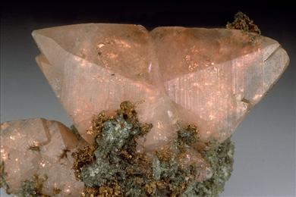
Calcite butterfly twin with copper inclusions
Capillary: Very thin, hair-like crystal habit.
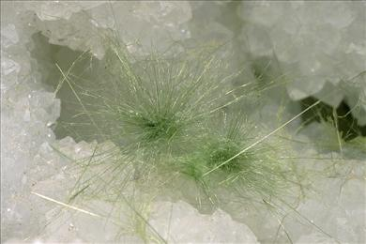
Capillary millerite on quartz
Carbide: Compound of a metal with carbon and nothing else.
Carbocycle, Cyclic hydrocarbon: Hydrocarbon in which carbon atoms are linked into rings.
Carbonate: Compound containing the carbonate group (CO₃⁻³).
Carlsbad law twin: Type of penetration twin about the {001} axis exhibited by orthoclase, sanidine and other members of the feldspar group.
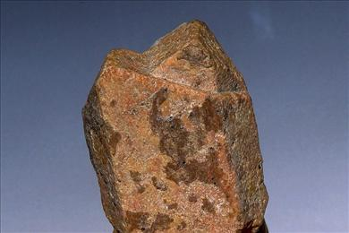
Orthoclase Carlsbad law twin
Cathodoluminescence: Emission of visible light by a mineral when it is bombarded by electrons.
Chalky: Having the color, luster, fracture, or general appearance of chalk.
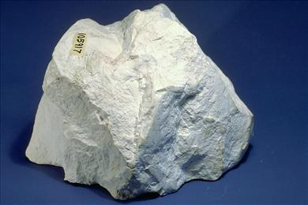
Kaolinite
Chemical formula, Chemical composition: The chemical formula the standard way of stating the chemical composition of a mineral, that is, the relative numbers of atoms of each element contained in that mineral. The formula is given as a series of element symbols, often followed by subscripts. The subscript indicates the number of atoms of that element in the formula. The presence of the element symbol indicates the presence of at least one atom, so subscripts of 1 are considered redundant and are omitted.
With the exception of the native metals and carbon, minerals are usually composed of positively and negatively charged units called ions (often uncharged water molecules are part of the composition). Many ions have only one typical charge state, e.g. oxygen is always -2 (O⁻²) in minerals, and sodium is always +1 (Na⁺¹). If an atom is capable of forming ions with more than one charge state, e.g. iron which can form both a +2 or +3 ion (Fe⁺²or Fe⁺³), a superscript may be used to indicate the charge. (Standard chemical notation is to use a Roman numeral in parentheses for this purpose.) Notice that only some of the ions in a formula will have their charges indicated. The total of all the ionic charges in the formula must equal 0; positive and negative charges must exactly balance.
Parentheses in chemical formulas are used either to indicate atomic groups, e.g. the carbonate group (CO₃⁻²), or to indicate a solid solution relationship between two or more atoms, e.g. (Fe,Mg).
Chromate: Compound containing the chromate group (CrO₄⁻²).
Cleavable: Able to be easily split into smaller fragments, especially along cleavages. The term is usually used in reference to massive intergrowths of a mineral.
Cleavage, Parting: Cleavage and parting are ways in which certain minerals to break along flat surfaces. The tendency to cleave is a characteristic feature of all crystals of a particular mineral species. Cleavage occurs parallel to planes in the atomic structure that correspond to relatively weak bonds between atoms. For example, a mineral is likely to cleave along a plane which leaves equal numbers of + and - charges on the two new surfaces, but it unlikely to cleave along a plane which leaves all + charges on one and all - charges on the other. If the bonds in the structure are of nearly equal strength in all directions, the mineral will fracture, but not cleave.
Parting differs from cleavage in that parting is only developed in certain samples of a mineral along exsolution lamellae or in response to applied pressure. The planes along which cleavage and parting occur are designated by Miller indices. The perfection with which cleavage and parting are seen in a mineral is usually described with the following terms:
perfect
imperfect
distinct
indistinct
excellent
good
fair
poor
Coarse-grained: Consisting of an aggregate of relatively large crystals or grains.
Cockscomb: Intergrowth of long, slightly offset crystals in semi-circular fans.
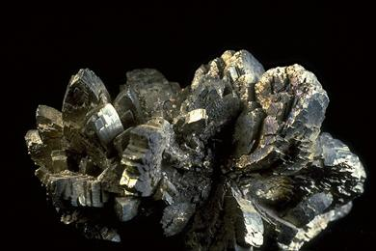
Cockscomb marcasite
Cogwheel twin: Penetration twin with a circular pattern of protruding crystal edges resembling the teeth of a gear or cogwheel.
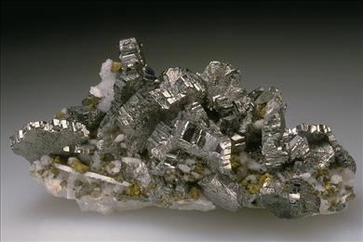
Bournonite cogwheel twins
Colloform: Crystalline intergrowth with smooth, rounded surfaces.
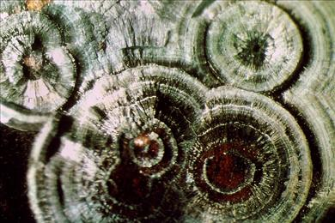
Colloform rockbridgeite
Colloidal: Aggregates of extremely small grains thought to have formed from a gel.
Color, Streak: Color is one of the most obvious of mineral properties, but as a guide to recognition it must be used with caution. Some minerals always exhibit the same color, while others can be found in many different colors. Trace color impurities can produce dark color when viewed through a large thickness of a mineral, thereby masking the true color of the mineral.
By scraping the mineral against a piece of white unglazed porcelain, the streak of the finely powdered mineral is obtained. The color of the streak can be much more reliable characteristic of the mineral.
Light absorption related to position changes of electrons within minerals causes most of the colors we see in minerals. While all minerals absorb light, only some absorb those frequencies of light which are visible to the human eye, and thus appear to be colored. The electrons involved may be associated with transition elements, charge transfers, or color centers.
Transition elements, such as iron, copper and manganese, contain electrons that can absorb visible light, selectively absorbing certain wavelengths. A mineral that contains a certain transition element as an essential constituent will always have color imparted by that element. The exact color is dependent on the neighbors of the transition element (e.g. all iron-containing minerals will be colored, but not all will be the same color).
A mineral that in pure form is colorless may exhibit any of a variety of colors if it contains small amounts of various transition elements. A good example is beryl, which in pure form is colorless. Various impurities impart color to form a variety of colored gemstones.
Some very intense colors in minerals are the result of light absorption by electrons that jump between atoms in the mineral, a charge transfer. An example is the blue color of the sapphire variety of corundum which results from an electron jumping from Fe⁺² to Ti⁺⁴.
A variety of processes including mistakes made in the rush of forming a crystal or mistakes introduced during irradiation by natural or artificial radioactive sources of the crystal after initial formation leave atoms out of position. These defects, called color centers, result in the absorption of visible light.
Columnar: Subparallel intergrowth of crystals.
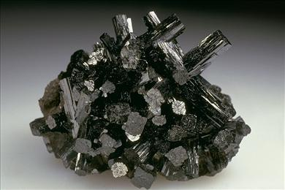
Manganite exhibiting columnar habit
Compact: Dense, close-packed crystalline texture in which individual crystals cannot be distinguished without magnification.
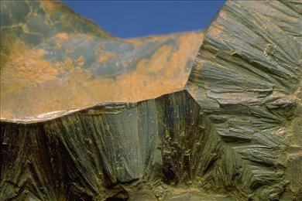
Compact intergrowth of goethite crystals
Complex: Group of tightly bonded atoms behaving as unit.
Conchoidal: Manner in which certain minerals fracture along smoothly curved surfaces.
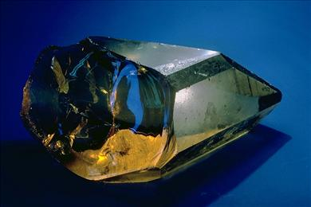
Quartz exhibiting conchoidal fracture
Concretion: A hard, rounded mineral mass that usually forms in sedimentary rocks surrounding a fragment of organic material. In a general sense, any spherical crystal aggregate.
Contact twin: Twin in which the crystals meet along a well-defined plane (composition plane).
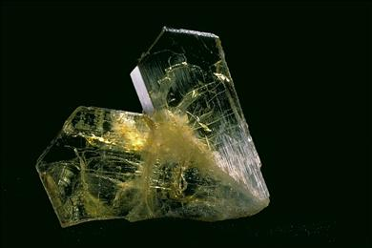
Chrysoberyl contact twin
Cross-fiber: Consisting of parallel fibers oriented at right (90º) angles to the walls of a vein. See asbestiform.
Riebeckite, variety crocidolite (cross-fiber asbestos)
Cruciform twin: Penetration twin consisting of two prismatic crystals assuming the configuration of a cross.
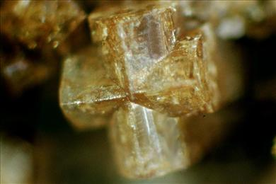
Harmotome cruciform twin
Cryptocrystalline: Consisting of crystals too small to see under an ordinary microscope.
Crystal, Crystalline: When people talk about crystals, they usually are referring to solid pieces of matter that are bounded by regularly arranged flat faces. Crystal faces result as the solid grows by adding atoms in a completely orderly, repetitive, 3-dimensional array called its atomic structure. A substance is crystalline if it has this orderly atomic structure, even if it lacks the regular faces (which are dependent on the growth environment and the history since formation). A crystal formed as the result of geological processes is a mineral.
Crystal face: The flat exterior surfaces of a crystal are called crystal faces. Obviously an infinite variety of planes pass through a given point, only a tiny number of these are observed to bound or define a crystal. Once scientists were able to determine crystals' atomic structures, they found that the few planes used were those that were oriented to include the highest density of atoms. Because of this connection with atomic structure, specimens of different minerals exhibit different faces. The result may be a characteristic crystal shape which can be used for identification purposes, even without understanding of the underlying connection with the atomic structure of the mineral.
Crystal faces (and forms) are indexed by notations known as Miller indices. By studying the geometrical relationships between crystal faces, one may be able to determine the symmetry of the crystal and its crystal class.
Crystal form: The symmetry that relates the atoms within the crystal also relates the faces on the crystal. Thus if the atoms within a crystal are related by a mirror plane, there will also be pairs of external faces on the crystal related by that same mirror plane. A crystal form is a group of crystal faces that are equivalent to one another because they are related by the crystal's symmetry.
Observation that serveral crystal faces on specimens of a mineral form a crystal form may aid one in identifying the symmetry of the crystal and its crystal class.
Crystal growth: A crystal begins to form when the proper atoms/ions arrange themselves in a pattern (the atomic structure of that mineral). Crystal growth continues as various identical atoms/ions bond themselves to the original cluster following the same pattern. Crystal growth may take place from molten rock, from a water solution, or from a gas. Depending upon natural conditions during growth, atoms/ions will deposit upon one plane more quickly than another, causing growth to occur more rapidly in the favored direction. The faces that we observe on crystals are the atomic planes to which atoms/ions have been added most slowly. (If you grow fast, you get covered)
Crystal habit: Crystal habit refers to the general shape of a crystal. The crystal habit is determined both by the atomic structure of the crystal and by the environment in which the crystal grows. Because of variability in the growth environment, natural crystals rarely grow in ideal geometric shapes. Nevertheless the angular relationships between crystal faces will always provide evidence of the symmetrical relationships between crystal faces. Some of the terms used to describe crystal habits are:
Acicular: needle-like
Fibrous, capillary, filiform: very thin; hair-like
Prismatic: longer than wide, surrounded by parallel faces; like a column
Bladed, lath-shaped: flat and long; like a knife blade
Platy, lamellar: in very thin sheets
Tabular: like a tablet of paper
Equant: nearly equal in all three dimensions
Crystallite: Minute incompletely crystalline particle.
Cubic: See isometric.
Cuboidal: Similar to a cube in shape.
Cubo-octahedron: A crystal shape which combines the shape of a cube and the shape of an octahedron.
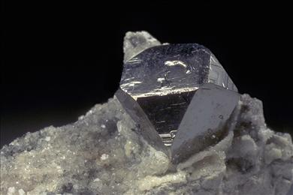
Carrollite exhibiting cubo-octahedral habit
Cuneiform: Wedge-shaped.
Cyclic twin: Repeated twin in which the crystals are related by two or more symmetry equivalent planes or axes ideally resulting in a complete circular array, such as a disk, ring, or star-like group.
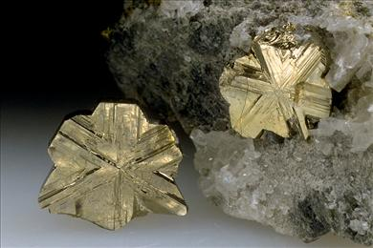
Cubanite cyclic twins
Cyclo-: Applied to minerals containing anion groups linked into rings (e.g. cyclosilicate)
Cyclosilicate: Mineral characterized by rings of silicate groups: 3-membered rings (Si₃O₉⁻⁶), 4-membered rings (Si₄O₁₂⁻⁸), 6-membered rings (Si₆O₁₈⁻¹²).
Dana System, Dana number: Scientists have developed various schemes for classifying minerals in order to better visualize and understand the relationships between them. One of the most popular schemes, known as the Dana System, is based on chemical composition and atomic structure. This classification was originally published by James Dwight Dana in A System of Mineralogy (1837). The system was most recently updated in Dana's New Mineralogy (8th edition, 1997) by Richard V. Gaines, H. Catherine Skinner, Eugene E. Foord, Brian Mason, and Abraham Rosenzweig.
The Dana number is composed of four parts. The first three parts correspond to the class and subclass, type and group. The 4th part of the number is an integer specific to an individual mineral species.
For example, in the Dana classification, almandine is assigned the number 51.4.3a.2, which can be decoded as follows:
51. Silicate class and Nesosilicate subclass
4. Cations in 6 or greater coordination
3a. Garnet group
2 Almandine
Dauphin law twin: Type of penetration twin in quartz in which two right-handed (or two left-handed) crystals are rotated by 60º to one another about the [0001] axis. The twin regions are separated by irregular internal boundaries, which can be observed on the crystal surface as interruptions in the horizontal striations on the prism faces.
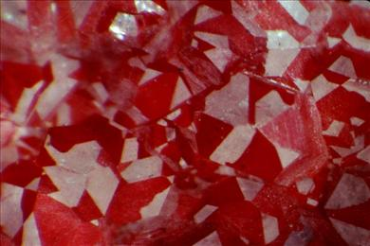
Hematite selectively coating Dauphin law twinned quartz
Deliquescent: Dissolves and become liquid by absorbing moisture from the air.
Deltoid: Used to refer to a four-sided polygon with two adjacent and equal long sides and two adjacent and equal short sides, which consequently is somewhat similar in appearance to a triangle (the Greek letter "delta").
Dendritic: Intergrowth of crystals in the shape of slender divergent branches like a plant.
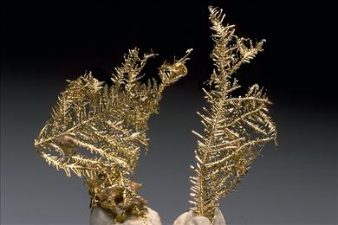
Dendritic gold crystals
Density, Specific gravity: The same volume of two different minerals will not have the same weight. This is because the minerals contain different atoms and/or because their atoms are packed together more or less closely. A sophisticated collector will spot an error on labeling a Calcite specimen, labeled "Barite", because it "feels too light for its size".
Density is a measure of the weight of a given volume of a material, usually expressed in grams per cubic centimeter (gm/cm³). Commonly we report the ratios of mineral densities to the density of water which is 1 gm/cm³ at 4ºC. Such relative measurements give the specific gravity, which is the same numerically as the density, but is a dimensionless number. One way to measure a mineral's density is to weigh it suspended by a thread in air and then to weigh it immersed in water. It will weigh less in water by an amount equal to the weight of the water that its volume displaces. The volume of the mineral is equal to the difference between the two weights because each cubic centimeter of displaced water weighs 1 gram. Finally divide the weight of the mineral by its volume to obtain the density.
Seldom does one have a crystal of a mineral unadlerated by matrix. None of the measurement procedures cope with tiny specimens. Thus density/specific gravity measurements are useful, but limited to macro specimens of pure materials.
Devitrified: Changed from glass to crystalline.
Dihexagonal: Literally double-hexagonal, this indicates a form in which the faces are related by a 6-fold rotational axis combined with parallel mirror planes and/or perpendicular 2-fold axes.
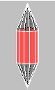
Dihexagonal Prism (red)
Dimorphism, Dimorphous: Two minerals that have the same chemical composition, but different atomic structures. See polymorphism.
Dioctahedral: Type of layered atomic structure in which only two of three possible octahedrally coordinated sites are occupied by cations. An octahedrally-coordinated site is a position in the structure in which a cation can form bonds to six anions. The anions can be thought of as positioned at the corners of an octahedron. See also trioctahedral.
Diploid: A crystal form consisting of 24 nonparallel faces related by the combined symmetry of the 2/m B3 (diploidal) crystal class.
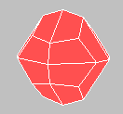
Diploid
Dipyramid, Dipyramidal: A crystal form consisting of two identical pyramids joined base to base.
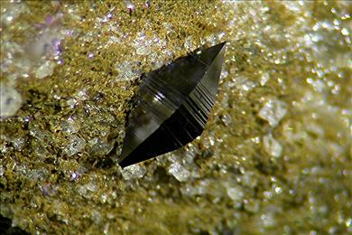
Anatase exhibiting dipyramidal habit
Discredited: Term used for a once accepted mineral species that has been determined not to meet the requirements of a mineral species. A mineral species is often discredited by proving that it actually corresponds to another known mineral species or that it is a mixture of two or more known mineral species.
The almost universal application of x-ray diffraction analysis has lead to the discrediting of a number of older mineral names, but the insistence on such analysis for new minerals has made future discrediting of newly approved species unlikely.
Dispersion: The color of light depends upon its wavelength. Normal white light contains a mix of all visible wavelengths and includes red, orange, yellow, green, blue, and violet (from longer to shorter wavelength). When a beam of light enters a transparent solid at an angle, it is refracted (the angle of the beam is changed). Longer wavelengths of light are refracted more than shorter wavelengths, so the material separates white light into its component colors. This phenomenon is called dispersion. Minerals differ in their ability to create dispersion. Diamond produces strong dispersion, which is the reason that one is able to see distinct flashes of color in an otherwise colorless diamond gem.
Disphenoid: A crystal form consisting of four nonparallel faces related either by three 2-fold rotational axes or by one 4-fold rotational-inversion axis.
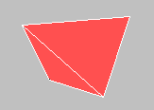
Disphenoid
Disseminated: Scattered as small particles throughout a rock.
Ditetragonal: Literally double-tetragonal, this indicates a form in which the faces are related by a 4-fold rotational axis combined with parallel mirror planes and/or perpendicular 2-fold axes.

Ditetragonal prism (red)
Ditrigonal: Literally double-trigonal, this indicates a form in which the faces are related by a 3-fold rotational axis combined with parallel mirror planes and/or perpendicular 2-fold axes.
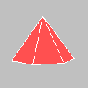
Ditrigonal pyramid
Divalent: Cation having a charge (valence) of 2.
Divergent: Intergrowth in which crystals radiate from a common center.
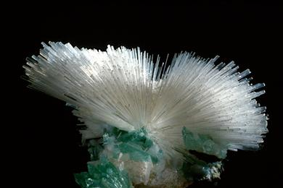
Divergent intergrowth of mesolite crystals
Dodecahedron: A three-dimensional shape bounded by 12 diamond-shaped faces. The dodecahedron is a crystal form in the isometric crystal system.

Dodecahedron
Dome: A crystal form consisting of two nonparallel faces related by mirror symmetry.
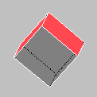
Dome form (red)
Double refraction: When light enters or leaves a transparent crystal at an angle, it is refracted (bent). If the crystal is of low enough symmetry, light traveling along different axes of the unit cell is refracted to different angles. An image viewed through such a crystal appears to come from two sources. It is doubled, as shown in the picture below.
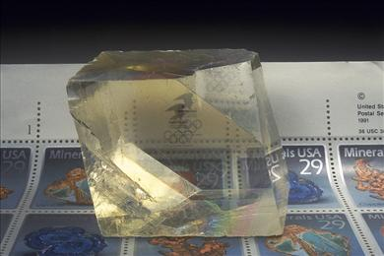
Calcite exhibiting double refraction
Doublet twin: Two crystals intergrown in a twin relationship
Druse, Drusy: Intergrowth of small projecting crystals that line the walls of a cavity in rock. Usually only the terminations of the crystals are visible.
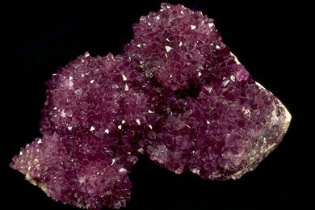
Drusy quartz, variety amethyst
Ductile: Able to be drawn into a wire without breaking (e.g. Copper). See tenacity.
Dull: Lowest mineral luster typified by no reflectance; light disperses in all directions from rough granular surface.
Kaolinite exhibiting dull luster
Earthy: Used to describe a dull luster or a slightly rough fracture like that of hard clay.
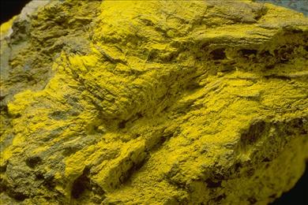
Carnotite exhibiting earthy luster
Effervescence, Effervescent: Giving off small bubbles. Carbonate minerals usually effervesce by giving off carbon dioxide bubbles when they are treated with acid.
Efflorescence, Efflorescent: Formation of a fluffy or powdery crystalline coating on the surface of a rock or mineral that occurs as the result of loss of water from the mineral.
Eightling twin: Group of eight crystals intergrown in a twin relationship.
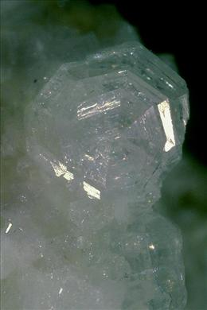
Dachiardite eightling twin
Elastic: Able to return to original shape when released after bending. See tenacity.
Element symbols: The one and two letter abbreviations for the elenemts used in chemical formulas. The first letter is always upper case; the second, if one is part of the abbreviation. For example:
Ag = silver
Al = aluminum
As = arsenic
The symbol is an abbreviation of the element name, but the element name used in defining the symbol may be in English, Latin, German, or French, so that information is not always helpful.
Environment: As it is used in The Photo-Atlas of Minerals, environment refers to the geologic conditions or the type of deposit in which a mineral occurs. This glossary does not include geological terms used in the Environment data field.
Epitactic, Epitaxy: The growth of a crystal of one mineral on the surface of a crystal of a different mineral in a definite orientation determined by the atomic structures of the two minerals. Compare twinning.
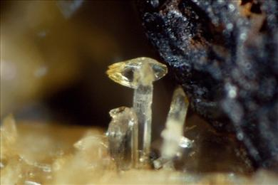
Goedkenite epitactic on palermoite
Equant, Equidimensional: Crystal habit in which a crystal is about the same size in all directions.
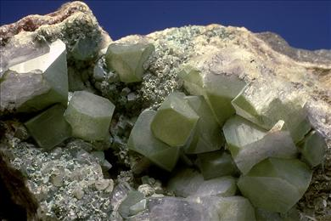
Equant crystals of fluorapophyllite
Equigranular: Consisting of grains of roughly equal size.
Euhedral: Crystal completely surrounded by well-formed faces.
Exsolution: The separation of a mineral solid solution into two separate mineral components. Exsolution generally occurs when the mineral cools because the two components are no longer stable in solid solution. Exsolution usually results in oriented lamellae of one mineral within another.
Faden: A descriptive term applied to tabular quartz crystals containing a white thread-like zone at their centers. The thread-like zone consists of fluid and gas inclusions trapped during crystal growth as a result of repeated breaking and healing. Faden quartz usually occurs in Alpine vein environments.
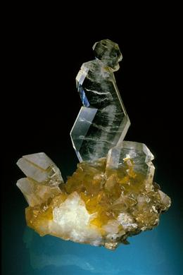
Faden quartz
Feldspathoid: Group of minerals chemically related to the feldspars, but containing relatively less silicon.
Felted,Felt-like: Intergrowth consisting of interwoven fibers.
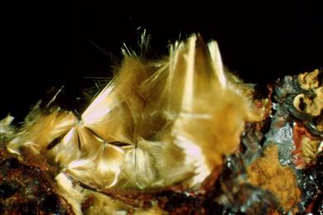
Felted fibers of cacoxenite
Fibroid: Intergrowth resembling fibrous tissue.
Fibrolamellar: Intergrowth consisting of layers of flattened fibers.
Fibrous, Filiform: Very thin, hair-like crystal habit. Also an aggregate of fibers.
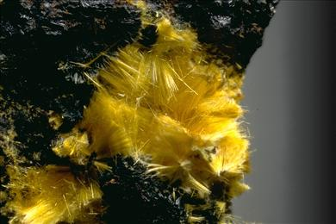
Cacoxenite exhibiting fibrous habit
Fine-grained: Consisting of an aggregate of relatively small crystals or grains.
Fishtail twin: See swallow-tail twin.
Fiveling twin: Group of five crystals intergrown in a twin relationship.
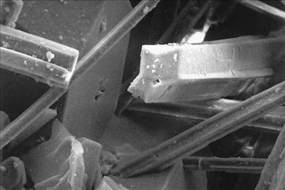
Pentagonite fiveling twin
Flexible: Bends without breaking but does not return to its original shape. See tenacity.
Fluorescence, Phosphorescence: When some minerals are subjected to invisible ultraviolet (UV) radiation, they emit visible light, seeming to "glow-in-the-dark." This effect, called fluorescence, was named after the mineral fluorite, which often spectacularly displays the effect. Relatively few mineral species exhibit fluorescence, and those that do are usually not invariably fluorescent; they often require a certain impurity ion which serves as an activator. Some minerals may fluoresce under short- wave (SW) ultraviolet radiation, but not under long-wave (LW), or vice-versa. Many different fluorescent colors have been observed in minerals, and the same mineral species may exhibit different fluorescent colors depending on its chemical impurities. If the emission continues after the ultraviolet radiation has been turned off, the mineral is said to be phosphorescent.
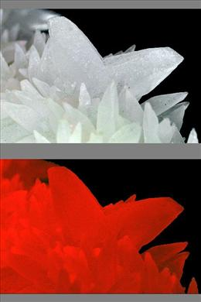
Calcite twin exhibiting fluorescence (bottom)
Foliated, Lamellae, Lamellar, Micaceous: Intergrowth consisting of thin, leaf-like layers.
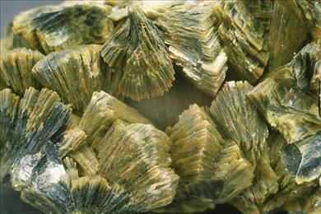
Foliated crystal intergrowths of meta-autunite
Fourling: Group of four crystals intergrown in a twin relationship.
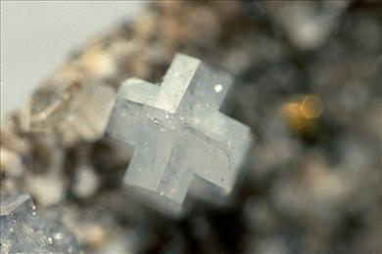
Harmotome fourling twin
Fracture: The manner in which a mineral breaks along relatively irregular or non-flat surfaces. The following terms are used to describe fracture:
Conchoidal: smoothly curved surfaces
Subconchoidal: more irregular curved surfaces
Hackly: jagged surface like that of broken metal
Uneven, irregular: more or less flat surfaces with some roughness
Even, regular: relatively flat surface, but not cleavage
Splintery, fibrous: surface composed of slender fragments or fibers
Earthy: slightly rough, irregular surface like that of hard clay
Friable: Crumbly; easily broken or pulverized.
Front pinacoid: A crystal form consisting of the two parallel faces, (100) and (-100), which transect the a axis.
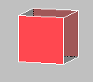
Front pinacoid (red)
Fusible: Capable of being melted by heating.
Geniculated twin: Repeated contact twin consisting of prismatic crystals in a back-and- forth configuration yielding knee-shaped forms.
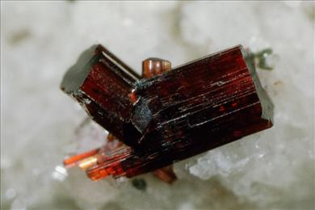
Rutile geniculated twin
Glass: An amorphous substance that is actually a highly viscous (slow- flowing) liquid.
Globular, Nodular: Crystalline intergrowth with smooth, rounded surfaces.
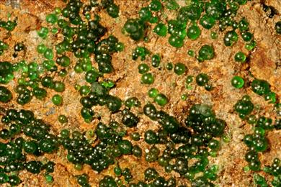
Globular conichalcite
Granular: Consisting of grains of roughly equal size.
Greasy: Poorly reflective mineral luster; similar in appearance to the surface of grease.
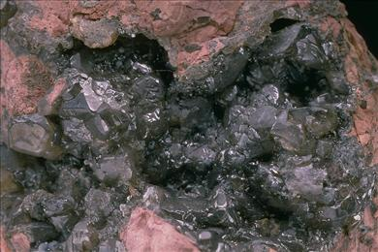
Calomel exhibiting greasy luster
Gwindel: A descriptive term applied to groups of stacked, twisted quartz crystals, which generally occur in Alpine vein environments.
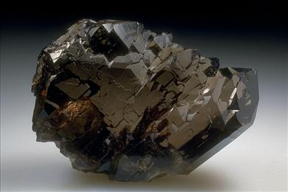
Gwindel quartz
Gyroid: A crystal form consisting of 24 nonparallel faces related by the combined symmetry of the 432 (gyroidal) crystal class.
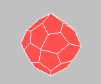
Gyroid
Hackly: Type of mineral fracture that produces a jagged surface.
Halide: Compound of a metal with a halogen (F, Cl, Br, I)
Hardness: Hardness is the resistance of a mineral to scratching. This property is indicative of the strength of bonds within crystals because it requires the breaking of bonds between atoms. Hardness varies greatly from species to species and it can, therefore, be a very useful property for identification.
The most common way of determining a mineral's hardness is to try to make a scratch on it using another material whose hardness is known. If you are able to make the scratch, then the mineral has a hardness less than that of the material used to scratch it. The test may, of course, be reversed by trying to scratch the material of known hardness with the mineral.
A German mineralogist Friedrich Mohs (1773-1839) developed a scale of hardness based upon 10 common minerals:
(1) talc
(2) gypsum
(3) calcite
(4) fluorite
(5) apatite
(6) orthoclase
(7) quartz
(8) topaz
(9) corundum
(10) diamond
By successively testing the unknown mineral with each of the minerals in the list, you can determine its Mohs hardness. For example, a mineral of hardness 6½ can be scratched by quartz, topaz, corundum and diamond, but not by orthoclase or any of the minerals of lesser hardness. Common non-mineral materials are often useful for hardness testing: fingernail (2½), copper penny (3), pocket knife (5-5½), window glass (5½), and steel file (6½). A few cautions are in order. The best results are obtained by using sharp corners (points) to scratch smooth even surfaces. The difference in hardness between successive minerals in the Mohs scale is not equal. In some minerals hardness varies with direction. Intergrowths of small crystals may appear harder or softer than the surfaces on individual crystals of the same mineral.
Heart-shaped twin: Simple contact twin consisting of two wedge-shaped individuals, exhibiting a prominent re-entrant angle, and having an overall shape resembling a heart (Valentine's Day type, not real).
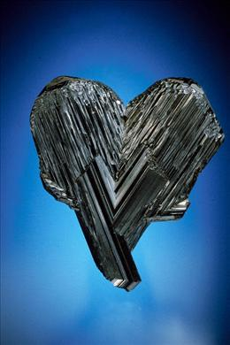
Rutile heart-shaped contact twin
Hemihedral: Exhibiting only half of the faces corresponding to the maximum symmetry possible for that crystal system.
Hemimorphic: Lacking a center of symmetry such that identical faces are not found on directly opposite sides of crystals.
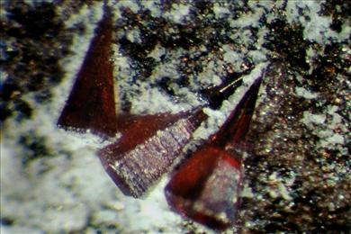
Wurtzite exhibiting hemimorphic habit
Hemispherical: In the shape of half a sphere; usually in reference to a radial intergrowth of crystals.
Hexagonal: The hexgonal unit cell can be defined by three axes. Two of them, labeled a, are equal in length and at an angle of 120º to one another. The third axis, labeled c, is perpendicular to the a axes and of a different length. The c axis corresponds to a 3-fold or 6-fold symmetry axis.
To highlight the presence of 3-fold or 6-fold symmetry, usual practice is to include a third a axis at 120° to the other two, and correspondingly to use a redundant 4th integer in the Miller index. (The extra integer is placed in the 3rd position and equals the negative of the sum of the first two.).
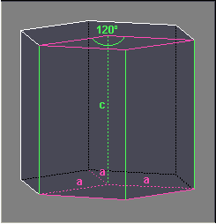
Hexagonal unit cell
Hexahedron: A three-dimensional shape bounded by 6 equivalent faces.
Hexoctahedron: A three-dimensional shape bounded by 48 triangular faces. The trapezohedron is a crystal form in the isometric crystal system.
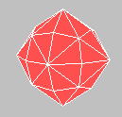
Hexoctahedron
Holohedral: Exhibiting all of the faces corresponding to the maximum symmetry possible for that crystal system.
Hopper: Crystal habit in which the growth of crystal faces has been quicker along their edges than at their centers, so that the centers of the faces are depressed.
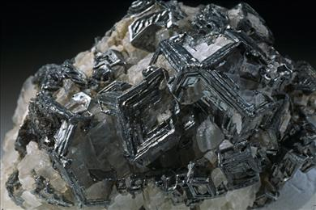
Hopper crystals of aguilarite
Hydrate: Compound containing water (H₂O).
Hydrocarbon: Organic compound composed entirely of carbon and hydrogen.
Hydrous: Mineral with water (H₂O) in its formula.
Hydroxide: Compound containing the hydroxyl group (OH⁻).
Hygroscopic: Readily absorbing moisture, as from the atmosphere.
Idiomorphic: As individual euhedral crystals.
Igneous: Pertaining to rocks formed by solidifaction from molten material.
Imide: Organic compound containing nitrogen with two attached carbonyl groups (CO).
Inclusion: A foreign body within a crystal. Inclusions usually represent material trapped during crystal growth. They commonly are earlier-formed crystals of other minerals or remnants of the fluid from which the crystal grew.
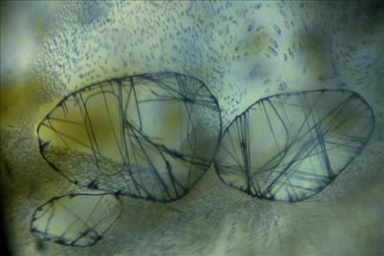
Rutile and liquid/gas inclusions in corundum, variety sapphire
Incrustation, Crust: A coating of minerals formed on a surface.
Index of refraction, Double refraction, Birefringence: When a beam of light strikes the surface of a transparent material at an angle, part will be reflected away and part will penetrate the material. The part of the beam that enters the material will be bent or refracted by an amount related both to the angle at which the beam strikes the material (the angle of incidence), to the density of the material, and to the light absorbing properties of the material. In general, the denser a material, the more the light entering it will be bent, but because additional factors affect the bending, this determination is not the same as a measurement of the density. Also the amount of bending may vary with wavelength of the light. By measuring the angles of incidence and refraction, a quantity called the index of refraction can be determined. This index can be used as an identifying characteristic for the material.
The atomic structures of many mineral crystals are quite different in different directions. A light beam entering such a crystal will be split into two beams - each bent at a different angle. This is called double refraction or birefringence. An image viewed through a birefringent crystal will appear to be two images.
Ino-: Applied to minerals containing anion groups linked into chains (e.g. inosilicate)
Inosilicate: Mineral characterized by chains of silicate groups: single chains (Si₂O₆⁻⁴), double chains (Si₄O₁₁⁻⁶).
Intergrowth, Aggregate: Most natural crystals form as intergrowths or aggregates. Where crystals come in contact with one another as they are growing, they form irregular contacts rather than regular crystal faces. The term massive refers to intergrowths in which the mineral crystals have grown in contact with other crystals on all sides leaving no empty space in between. Most rocks are massive intergrowths of one or more different minerals. Many minerals grow in distinctively shaped aggregates. Crystal faces are sometimes present at the periphery of such an aggregate. Some of the terms used to describe crystal aggregates are:
Drusy: surface covered with a layer of intergrown crystals with terminal faces
Fibrous, felted, asbestiform: aggregate of slender fibers
Botryoidal, colloform, mammillary, globular, reniform: large rounded masses
Radiate, divergent: crystals radiating from a common center
Lamellar, foliated: thin plates stacked together
Bladed: blades stacked together
Dendritic, arborescent: in slender divergent branches like a plant
Cockscomb: long, slightly offset crystals in semi-circular fans
Rosette: numerous platy crystals overlapping like flower petals
Intermetallic: Refers to a compound composed of two or more metals in definite proportions. (An alloy is a mixture of two or more metals in variable proportions.)
Interstitial: Between grains or in pores in rock.
Iodate: Compound containing the iodate group (IO₃⁻).
Iridescent: Exhibiting rainbow-like colors in the interior or on the surface of a mineral.
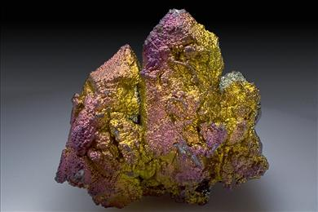
Iridescent hematite
Iron cross twin: Twin consisting of two penetrating pyritohedra related by rotation about the [110] axis; typical of pyrite.
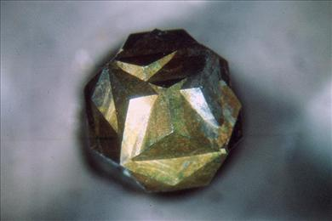
Pyrite iron cross penetration twin
Isometric, Cubic: The isometric (=cubic) unit cell is defined by three axes of equal length, all labeled a. All angles between axes are 90°. Because of the equivalence of all axes and angles.
The isometric system can contain combinations of many different types of symmetry elements: 2-, 3-, and 4-fold rotation axes, 3- and 4-fold rotation-inversion axes, mirror planes, and centers of symmetry.
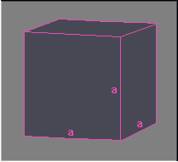
Isometric or cubic unit cell
Isomorphism: Two different minerals that possess the same atomic structure are called isomorphs. The minerals may be related chemically through the replacement of the atoms of one element for those of another. An example is the olivine series consisting of the minerals fayalite, Fe₂SiO₄, and forsterite, Mg₂SiO₄. Isomorphous minerals may have nothing in common chemically. For example halite, NaCl, and galena, PbS, have identical atomic structures.
Isostructural: Having the same atomic structure (but different chemical composition)
Japan-law twin: Type of contact twin on the {11-22} plane of quartz. The two crystals are at a nearly right angle (84º33') forming a "V". Both crystals are usually flattened parallel to their front-facing prism faces.
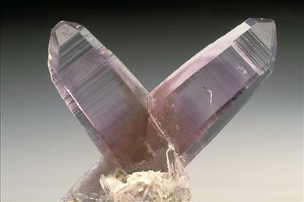
Quartz Japan law twin
Lamellar twin: Polysynthetic twin in which the individual crystals are thin plates.
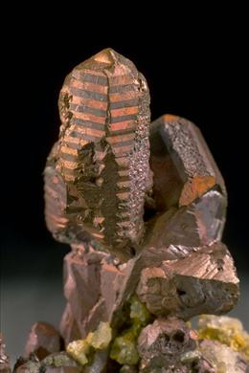
Copper exhibiting polysynthetic twinning
Lath-like: Habit of a crystal that is flat and long; like a knife blade.
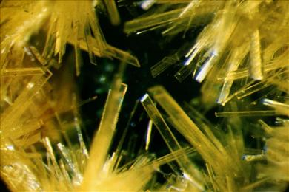
Lath-like crystals of uranophane
Lenticular: Habit of a crystal that resembles a double-convex lens in cross-section.
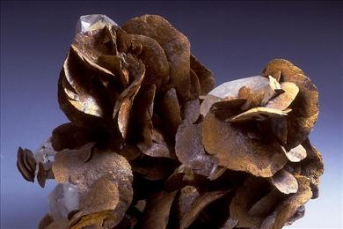
Lenticular crystals of siderite
Lozenge: Rhombus or diamond (as in one of the four suits in a deck of cards).
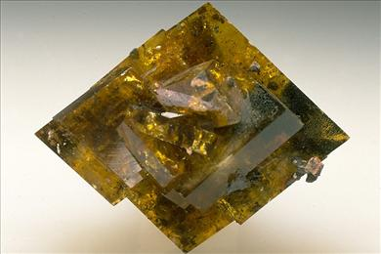
Lozenge-shaped crystal of barite
Luminescence: A general term which describes any process in which energy is emitted from a material at a different wavelength from that at which it is absorbed. It is an umbrella term covering fluorescence, phosphorescence, and triboluminescence.
Luster, Sheen: Luster refers to the appearance of a mineral surface as a result of light reflecting from it. To a trained eye luster can be one of the most important clues for the sight-identification of minerals. Minerals with higher indices of refraction reflect more of the light that strikes them and, therefore, have a higher or brighter luster. The following terms are often used to describe luster:
Dull, earthy: no reflectance; light disperses in all directions from rough granular surface
Waxy: slightly reflective; typical of minutely granular surfaces
Greasy, oily: poorly reflective; similar in appearance to the surface of grease or oil
Vitreous: brightly reflective; similar to the luster of freshly broken glass
Resinous: very reflective; like the luster of broken resin or shellac
Adamantine: hard brilliant luster; like that of a diamond
Submetallic: silvery or nearly metallic luster
Metallic: brilliant, highly reflective luster of metals; material is always opaque
Characteristics just below a mineral's surface can affect the way it reflects light and give the mineral an unusual sheen. Examples include:
Pearly: caused by tiny partly-developed cleavages parallel to the surface
Silky: caused by reflections from a fibrous growth structure or from parallel hair-like inclusions
Magnetism: Very few minerals are noticeably attracted to a magnet. Certain elements, most notably iron, have nuclei that tend to align themselves in the same direction in a magnetic field. When the atomic structure of an iron-rich mineral allows most of its iron atoms to align their electron fields in the same direction, it will be attracted by a magnet. Under certain conditions, the iron nuclei can be locked in place, thereby producing a magnet. Magnetite, an iron oxide, is attracted to magnets and can itself be naturally magnetized. Many meteorites are attracted by magnets because they contain native iron.
Malleable: Able to be hammered into thin sheets without breaking. See tenacity.
Mammillary: Crystalline intergrowth with smooth, rounded surfaces.
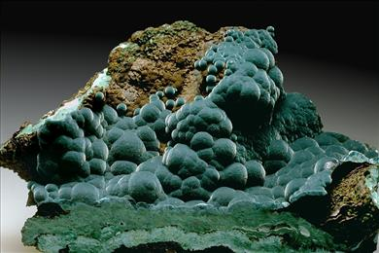
Mammillary rosasite
Manebach law twin: Type of simple contact twin on the {001} plane exhibited by orthoclase, microcline and other members of the feldspar group.
Massive: Uniform intergrowth of crystals.
Mealy: Resembling meal in texture or consistency; granular.
Metal: Element whose atoms have outer electron shells which are less than half full. Metals tend to lose electrons to form positively charged ions (cations) in the presence of electron greedy elements or polyatomic ions. When no electron greedy species are nearby, metals form metallic bonds by sharing with adjacent metal atoms.
Metallic: Brilliant, highly reflective luster of metals.
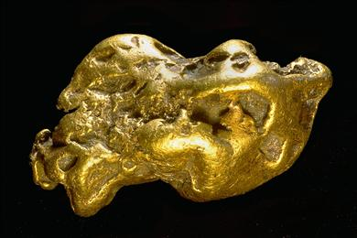
Gold exhibiting metallic luster
Metalloid: Non-metallic element that exhibits some metallic characteristics.
Metamict: Amorphous as the result of radiation damage.
Metamorphic: Pertaining to rocks that have been significantly modified by heat and pressure, for the most part without melting.
Microcrystalline: Made up of crystals so small that they can only be seen with a microscope.
Micron, Micrometer, µm:
One-millionth of a meter (0.000001 m);
one-thousandth of a millimeter (0.001 mm).
Miller indices: Three integers (sometimes four in the hexagonal crystal system) used to indicate the orientation of a plane or direction in a crystal such as those corresponding to a crystal face or cleavage. The three numbers are related to the three (or four) axes that define the unit cell. The three numbers are enclosed in parentheses, as (111), to indicate a single face or plane. They are enclosed in braces, as {111}, to indicate a crystal form (set of planes related by symmetry). They are enclosed in brackets, as [111], to indicate a direction.
Mimetic: Appearing to have a higher degree of symmetry as the result of twinning.
Mineral, Mineral species: A mineral is a chemical element or combination of chemical elements that is normally crystalline and which has formed by natural geological processes. Being crystalline means having an atomic structure. For the mineral to be a distinct mineral species, it must differ from every other mineral species either in its combination of chemical elements or in its atomic structure.
Mineral class, Mineral group: Minerals are usually classified according to aspects of their chemical composition and atomic structure. Most classification systems (Dana, Strunz) are based principally upon the major anions and anionic groups in minerals. This leads to the following major classes:
native elements
sulfides and sulfosalts
oxides and hydroxides
halides
carbonates
borates
sulfates and chromates
phosphates, vanadates and arsenates
tungstates and molybdates
silicates
The silicates are further divided into the following subclasses depending on different types of silicate linkages:
nesosilicates
sorosilicates
cyclosilicates
inosilicates
phyllosilicates
tectosilicates
These classes are then split into groups of more closely related minerals.
Mineral name: Each distinct mineral species is given a distinct name. Names are chosen in many ways. Minerals have been named after persons, places, properties, and similarities with other minerals. The discoverer usually proposes a name as part of the submission for approval. Current practice is to not approve self-naming.
Modified: Term used to describe a crystal shape or form that varies from another. For example, a cubo-octahedron is an octahedron modified by a cube.
Molybdate: Compound containing the molybdate group (MoO₄⁻²).
Monoclinic: The monoclinic unit cell is defined by three axes, a, b, and c, of unequal lengths. The angles between the a and b axes and between the c and b axes are exactly 90°.
The b axis is chosen to correspond to a 2-fold axis of rotational symmetry axis or to be perpendicular to a mirror symmetry plane. The standard convention for assigning the other axes is c < a. The unit cell is also chosen so that the angle beta, lying between the a and c axes, is obtuse (between 90º and 180º).
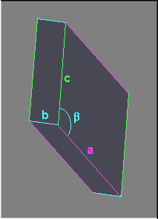
Monoclinic unit cell
Monovalent: Ion having a charge (valence) of 1.
Morphology: Crystal shape.
Myrmekitic: Intergrowth consisting of blebs, drops, or vermicular grains of one mineral in another.
Nanometer, nm:
One billionth of a meter (0.000000001 m);
One-millionth of a millimeter (0.000001 mm).
Ten Ångstroms (10 Å)
Neso-: Applied to minerals containing individual isolated anion groups (e.g. nesosilicate)
Nesosilicate: Mineral characterized by single isolated silicate groups of general formula SiO₄⁻⁴.
Nitrate: Compound containing the nitrate group (NO₃⁻).
Nitride: Compound of a metal with nitrogen and nothing else.
Nodular: In the form of or consisting of nodules (small rounded lumps).
Non-metal: Element whose atoms have their outer electron shells more than half full. Such atoms can form only covalent bonds with one another. Non-metals (except the noble gases) tend to take electrons from metals to form negatively charged ions (anions).
Ocherous: Resembling ochre, an earthy, pulverulent, red, yellow, or brown iron oxide (hematite).
Ocherous carnotite
Octahedron: A three-dimensional shape bounded by eight triangular faces and having six corners. The octahedron is a common crystal form in the isometric crystal system.
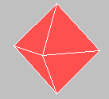
Octahedron
Oily: Poorly reflective mineral luster; similar in appearance to the surface of oil.
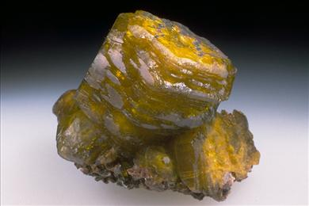
Ettringite exhibiting oily luster
Oolitic: Consisting of many spherical bodies.
Opalescent, Opaline: Having a milky or rather pearly sheen such as that shown by some kinds of opal.
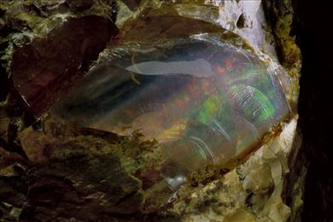
Opal exhibiting opalescent sheen
Opaque: Impervious to visible light even in thin fragments.
Organic: Compound containing carbon, hydrogen, and whatever else. In an early version of creationism it was believed that compounds made by living organisms were inherently different that those made in the laboratory and that never the twain should meet. Most naturally occurring carbon-containing compounds were formed by some living organism, so organic became to mean carbon containing, although early on it was recognized that compounds containing only carbon and oxygen (e.g., carbon dioxide, carbonates, oxalates) did not fit this pattern.
Laboratory synthesis of urea from inorganic compounds disproved the premise, but the classification into organic and inorganic has survived as a convenient way to subdivide the huge field of chemisty. The distinctions are dying.
Orthorhombic: The orthorhombic unit cell is defined by three axes, a, b, and c, of unequal lengths. The angles between all axes are exactly 90°.
The axes are chosen to correspond to 2-fold axes of rotational symmetry axis or to be perpendicular to mirror symmetry planes. The standard convention is that c < a < b.
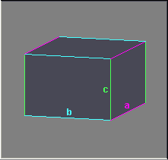
Orthorhombic unit cell
Ovoid: Egg-shaped
Oxalate: Compound containing the oxalate group (C₂O₄⁻²).
Oxide: Compound of an element with oxygen.
Oxidize: To chemically change through contact with oxygen or oxidizing conditions typical on or near the earth's surface. This type of alteration generally results in the formation of minerals having compositions with greater amounts of oxygen or with one or more cations in a higher charge state than in the original mineral.
Paramorph: A pseudomorph with the same composition as the mineral it replaces.
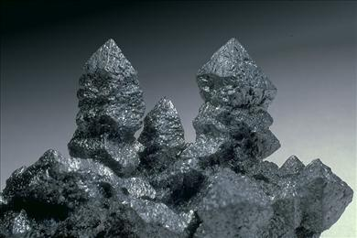
Acanthite paramorph after argentite
Parting: See cleavage.
Pearly: Pearl-like sheen caused by tiny partly-developed cleavages parallel to the surface.
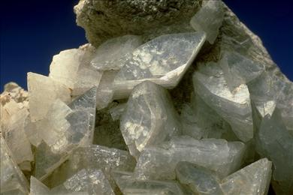
Heulandite exhibiting pearly sheen
Pedion: A crystal form that consists of only one face.
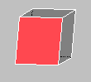
Pedion (red)
Penetration twin: Twin in which two or more crystals appear to interpenetrate each other with the surface between them being irregular or poorly defined.
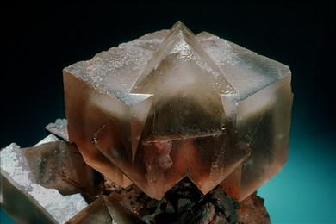
Fluorite penetration twin
Pericline law twin: Type of lamellar twin about the [010] axis exhibited by the members of the plagioclase series.
PGE, PGM: Used as acronyms for Platinum Group Elements and Platinum Group Minerals. The Platinum group elements are platinum (Pt), palladium (Pd), rhodium (Rh), iridium (Ir), osmium (Os) and ruthenium (Ru).
Phosphate: Compound containing the phosphate group (PO₄⁻³).
Phosphide: Compound of a metal with phosphorous.
Phosphorescence: See fluorescence.
Phyllo-: Applied to minerals containing anion groups linked into sheets (e.g. phyllosilicate)
Phyllosilicate: Mineral characterized by sheets of silicate groups of general formula Si₄O₁₀⁻⁴.
Piezoelectricity, Pyroelectricity: The atomic structures of certain minerals that lack a center of symmetry become electrically polarized when heat or pressure is applied. When heat is involved it is called pyroelectricity. When pressure is involved it is caused piezoelectricity. The effects are generally reversible.
For example, by applying an alternating electrical current to opposite ends of a piece of quartz, you can make it vibrate.The piezoelectricity of quartz has proven useful for accurately tuning frequencies in radios and clocks. The pyroelectricity of tourmaline has made it useful in devices that measure high pressures. Tourmaline was used to measure the pressure of the first atomic bomb test.
Pinacoid: A crystal form that consists of two parallel faces.
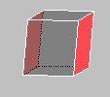
Pinacoid
Pisolitic: Composed of pea-like grains.
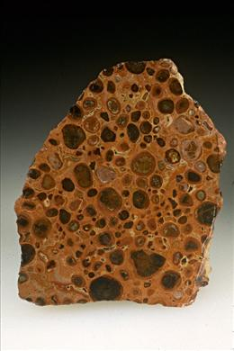
Bauxite rock exhibiting pisolitic texture
Pitchy: Rather dull luster similar to that of pitchblende, a massive variety of uraninite.
Platelet: A very small platy crystal.
Platy: Very thin sheet-like crystal habit.
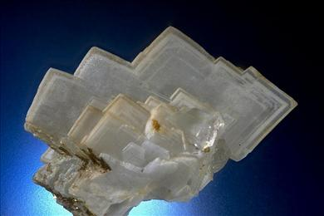
Barite exhibiting platy habit
Pleochroism, Dichroism, Trichroism: Pleochroism is an optical property observed in the crystals of certain minerals in which light is absorbed differently as it passes through the crystals in different directions. Differences in the atomic structure of a crystal in different directions account for the differential light absorption. Three distinct colors (trichroism) or two distinct colors (dichroism) may be seen as a crystal is held in front of a light and turned. Most pleochroic mineral crystals exhibit only small differences in color intensity as they are turned.
Plumose: An aggregate of many small scales spreading into a formation that looks like a feathery plume.
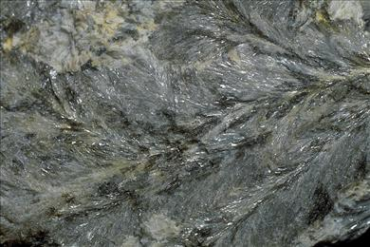
Plumose muscovite
Poikiloblast: A large crystal of metamorphic origin that contains within it many small grains of other minerals.
Polished section: A slice of rock that has been highly polished for viewing under the microscope. Polished sections are usually made for studying opaque minerals using light reflected from the polished surface of the mineral grains embedded in the rock.
Polymorphism: Two or more minerals that have the same chemical composition, but different atomic structures are called polymorphs. Such a polymorphic relationship exists between the minerals andalusite, kyanite, and sillimanite which all have the chemical formula, Al₂SiO₅. Typically, polymorphs form under differing conditions of temperature and/or pressure.
Polysynthetic twin: Repeated twin in which the crystals meet along parallel planes.
Copper exhibiting polysynthetic twinning
Polytype: Mineral that differs from another only in the stacking of similar structural units in its atomic structure.
Porcelaneous: Dull white luster resembling unglazed porcelain.
Kaolinite exhibiting porcelaneous luster
Porphyroblast: Euhedral crystal formed in a metamorphic rock.
Positive form, Negative form: Terms used to distinguish symmetrically similar, but distinct forms in certain crystal classes.
Prism, Prismatic: Crystal habit characterized by greater length than width, with prism faces parallel to and completely surrounding the long direction of the crystal. Also, a crystal form consisting of three or more symmetry-related faces parallel to a common axis.

Hexagonal prism (red)
Pseudo-: This prefix is used in combination with many roots:
pseudocubic
pseudocubo-octahedron
pseudododecahedral
pseudohexagonal
pseudo-isometric
pseudo-octahedral
pseudo-orthorhombic
pseudorhombohedral
pseudotetragonal
pseudotetrahedral
pseudotrigonal
The prefix indicates that the visible shape of the sample falsely implies that the sample has more symmetry than is indicated by the internal atomic structure of the mineral.
For example, the distinction between an orthorhombic crystal and a lower symmetry monoclinic crystal is the value of one angle in the unit cell. If the angle is 90º, then the mineral is orthorhombic; any other value makes the mineral monoclinic. However, the angle in a monoclinic mineral may be so close to 90º that the mineral appears to be orthorhombic. Such a mineral would be termed pseudo-orthorhombic.
Pseudomorph: Any given mineral will form only within a specific range of conditions of heat, pressure and chemical composition. When the mineral's environment changes, the mineral will often change or alter to a different mineral. Even though the new mineral would normally form in its own distinctive crystal shape, occasionally the new mineral not only takes the place of the original, but also retains its external crystal shape. The new mineral is then said to be a pseudomorph (false form) of the original.
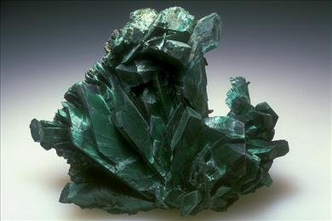
Malachite pseudomorphs after azurite
Pseudo-spinel law twin: Twin relationship closely resembling the Spinel law, but relating crystals not in the 4/m B3 2/m crystal class.
Pulverulent: Easily powdered.
Pyramid, Pyramidal: A crystal form consisting of 3, 4, 6, 8, or 12 nonparallel faces meeting at a point.
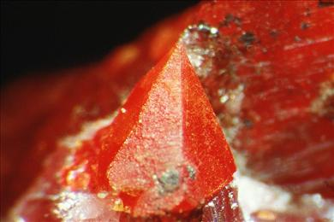
Zincite exhibiting pyramidal habit
Pyritohedron: A dodecahedron (three-dimensional shape bounded by 12 faces) with five-sided faces. The pyritohedron is so named because crystals of pyrite sometimes take this shape. It is a crystal form in the isometric crystal system.
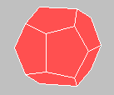
Pyritohedron
Quatravalent: Ion having a charge (valence) of 4.
Radial-fibrous: Intergrowth in which fibrous crystals radiate from a common center.
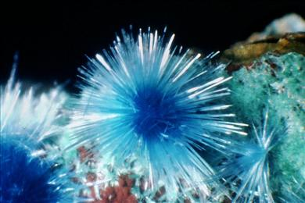
Radial-fibrous intergrowth of cyanotrichite
Radiate, Radial: Intergrowth in which crystals radiate from a common center.
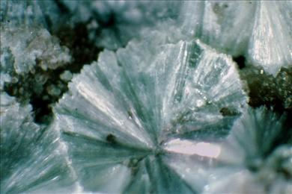
Radial intergrowth of basaluminite crystals
Radioactivity: Some kinds of atoms have nuclei that are unstable and break apart to form atoms of other elements. In the process of breaking apart these atoms release radiation in the form of alpha and beta particles and gamma rays. The most common radioactive elements in minerals are uranium and thorium. Minerals rich in these elements will be very radioactive, causing a Geiger counter to react strongly. Minerals containing small amounts of these elements are only slightly radioactive.
While the number of protons in an atomic nucleus determines what element it is, the number of neutrons in the nucleus is somewhat variable for a given element. Uranium nuclei always have 92 protons (atomic number = 92) and they most commonly have 146 neutrons, giving them an atomic weight of 92 + 146 = 238. More rarely uranium nuclei in minerals have only 143 neutrons yielding an atomic weight of 235. These are the different isotopes U238 and U235. They breakdown at different rates, known as half lives, and therefore give off radiation at different rates. Some other elements whose most common isotopes are not radioactive also exist as in the form of rarer radioactive isotopes.
REE: Acronym for Rare Earth Elements used in chemical formulas as a element symbol to represent a mixture of several different rare earth elements: La, Ce, Pr, Nd, Pm, Sm, Eu, Gd, Tb, Dy, Ho, Er, Tm, Yb.
Re-entrant angle: V-shaped depression marking the junction between two twinned crystals.
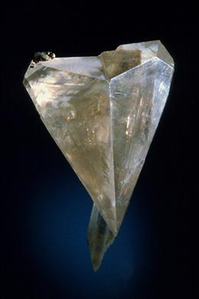
Cerussite twin exhibiting re-entrant angle
Reniform: see Botryoidal
Repeated twin, Multiple twin: Twin consisting of three or more crystals.
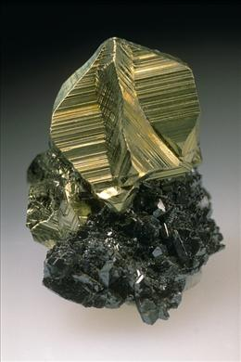
Multiple twin of chalcopyrite
Resinous: Very reflective luster; like the luster of broken resin or shellac.
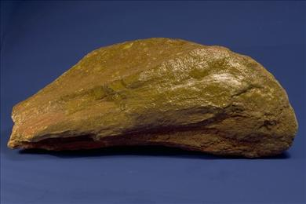
Jarosite exhibiting resinous luster
Resorbed: Dissolved.
Reticulated: Intergrowth pattern consisting of criss-crossed slender crystals; often indicative of a twin relationship.
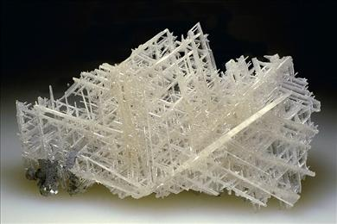
Cerussite reticulated twin
Rhombic: Having the shape of a rhombus (like the diamond in a deck of playing cards).
Rhombohedron, Rhomb: A three-dimensional shape that can be thought of as a cube stretched or compressed in the direction of two opposite corners. The rhombohedron is a common crystal form in the hexagonal crystal system.
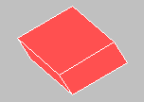
Rhombohedron
Right-handed, Left-handed: Crystals in those crystal classes with no center of symmetry or mirror planes can occur in right-handed or left-handed variations. These variations are identical except that they are mirror images of one another in the same way that your right and left hands are related. (If you place both palms down, then thumbs are on opposite sides, and if you turn hands with both thumbs up, one palm is towards the left and the other is towards the right.) In the same way, certain crystal forms in these crystal classes can be termed right(-handed) or left(-handed).
Rock: An aggregate of minerals. Most rocks fall into three general categories depending on processes by which they formed: Igneous: rocks formed by solidification from molten material. Sedimentary: rocks formed by the deposition of sediments. Metamorphic: rocks that have been significantly modified by heat and pressure, for the most part without melting.
Rosette: Intergrowth consisting of numerous platy crystals overlapping like flower petals.
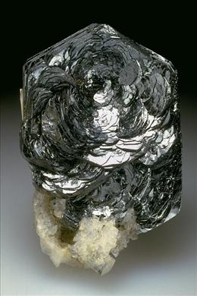
Hematite rosette
Saddle-shaped: Crystal habit with curved faces and edges so as to resemble a saddle.
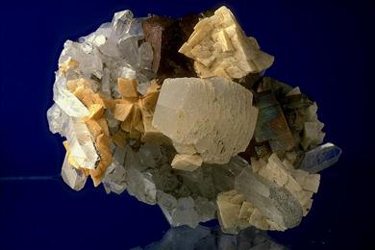
Saddle-shaped crystals of ankerite
Salt: Compound that results when an acid reacts with a base. Note that "table salt" is sodium chloride (NaCl), the mineral halite. NaCl results from the reaction between hydrochloric acid (HCl) and the base, sodium hydroxide (NaOH); HCl + NaOH -> NaCl + H₂O
Scalenohedron: A crystal form consisting of symmetry-related faces that are scalene triangles (three unequal sides). The tetragonal scalenohedron has 8 faces related by the combined symmetry of the B42m (tetragonal scalenohedral) crystal class. The trigonal scalenohedron has 12 faces related by the combined symmetry of the B32m (trigonal scalenohedral) crystal class.
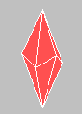
Scalenohedron
Scepter: Unusual prismatic crystal habit in which the diameter of the prism is greater near the termination of the crystal than near its base.
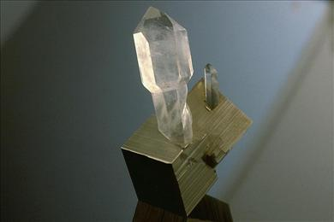
Scepter quartz on pyrite
Schiller: Optical effect in which flashes of bright colors appear as the mineral is turned. Schiller is caused by the diffraction of light from closely spaced layers.
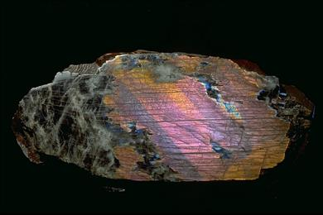
Labradorite exhibiting schiller (labradorescence)
Schistose: Layered texture of an aggregate of fibrous or platy mineral grains.
Sectile: Can be cut into thin shavings with a knife. See tenacity.
Sedimentary: Pertaining to rocks formed by the deposition of sediments.
Selenite: Compound containing the selenite group (SeO₃⁻²).
Semi-metal: Element whose atoms have outer electron shells that are one half full. They tend to form covalent bonds with one another and with non-metals. In pure form semimetals are often semiconductors.
Semimetallic, Submetallic: Luster somewhat less than metallic.
Sheaf: Bundled intergrowth of fibers.
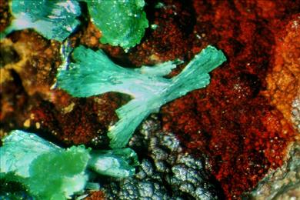
Sheaf intrgrowths of cuprian adamite
Side pinacoid: A crystal form consisting of the two parallel faces, (010) and (0-10), which transect the b axis.
Silicate: Compound containing the silicate group (SiO₄⁻⁴) or linked silicate groups.
Silicide: Compound of a metal with silicon.
Silky: Silk-like sheen caused by reflections from a fibrous growth structure or from parallel hair-like inclusions.
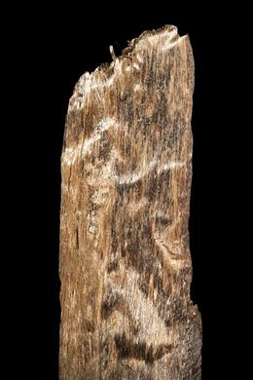
Cerussite exhibiting silky luster
Simple twin: Twin composed of only two crystals.
Sixling: Group of six crystals intergrown in a twin relationship.
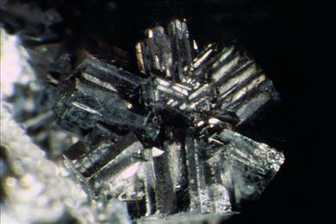
Arsenopyrite sixling twin
Slag: Residual material from the refinement of a metallic ore.
Slickensided: Having a polished and smoothly striated surface usually the result of movement along the surface.
Solid solution, Series, Substitution: The chemical formula given for each mineral provides the atomic components in the pure mineral. In fact, natural minerals almost always contain atoms of some other elements in partial substitution for those provided in the formula. Certain ions, such as Fe⁺² and Mg⁺², are similar enough that they can take each other's place in any proportion in an atomic structure. The minerals fayalite, Fe₂SiO₄, and forsterite, Mg₂SiO₄, have the same atomic structure and any composition intermediate between them is possible. This is called a solid solution series (or simply a mineral series), and such a substitutional relationship can be indicated by providing the formula as, (Fe,Mg)₂SiO₄. The name applied to the mineral compound depends upon which element is present in greatest amount. A separate name may be applied to the series. For example, fayalite and forsterite belong to the olivine series.
Soro-: Applied to minerals containing finite linkages of anion groups (e.g. sorosilicate)
Sorosilicate: Mineral characterized by finite linkages of silicate groups: double groups (Si₂O₇⁻⁶), triple groups (Si₃O₈⁻⁴), etc.
Sphenoid: A crystal form consisting of two nonparallel faces related by 2-fold rotational symmetry.
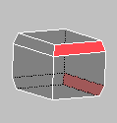
Sphenoid (red)
Spherulitic: As spherical intergrowth of crystals.
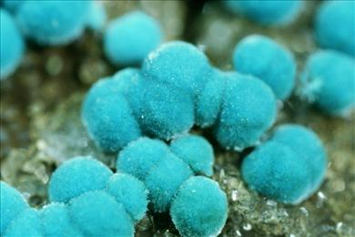
Spherulitic rosasite
Spinel law twin: Type of twinning occurring in octahedral crystals of spinel and many other minerals of the isometric system. The octahedron can be thought of as cut through its center along a plane parallel to a set of octahedral faces and then one of the halves of the octahedron rotated by 60º relative to the other.
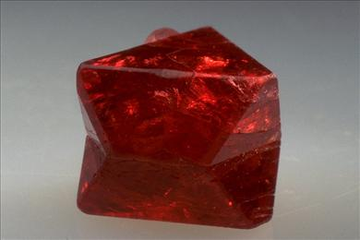
Spinel law twin of spinel
Splendent: A luster of the highest intensity.
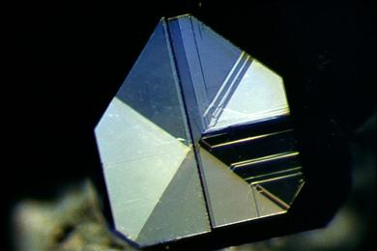
Perovskite exhibiting splendent luster
Stalactitic: As concentrically layered intergrowth with conical or cylindrical shapes; similar to stalactites.
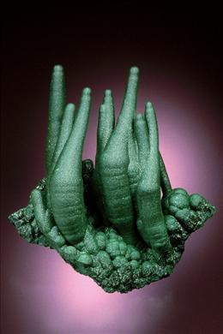
Stalactitic malachite
Stellate: Star-like intergrowth of crystals, often resulting from cyclic twinning.
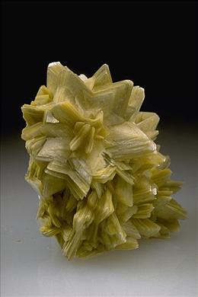
Stellate intergrowths of muscovite crystals
Striated: Marked by a series of parallel straight lines (striations). On crystals striations generally represent the oscillation between two crystal forms.
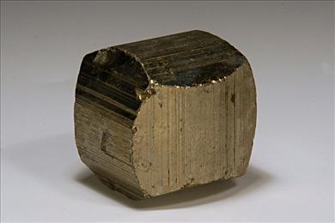
Striated pyrite crystal
Strunz System, Strunz number: Scientists have developed various schemes for classifying minerals in order to better visualize and understand the relationships between them. One of the most popular modern schemes, developed by Professor Hugo Strunz, is based upon a combination of chemical composition and atomic structure.
The Strunz number is composed of four parts. The first three parts correspond to the class, group, and subgroup. In the complete Strunz System, the 4th part of the number is a three-digit integer specific to an individual mineral species; however, in the Photo-Atlas of Minerals we have simplified this to a one-digit integer, so that very closely related minerals often have identical Strunz numbers.
For example, in the full Strunz classification, almandine is assigned the number 9.AC.110, which can be decoded as follows:
9. Silicate class
A Nesosilicate division
C. Garnet group
110 Almandine
In the Photo-Atlas, we assign almandine the number 9.AC.1, the same as for the closely related garnet minerals: pyrope, spessartine, grossular, hibschite, henritermierite, and katoite.
Subadamantine: Luster somewhat less than adamantine.
Subconchoidal: Fracture along surfaces that are not quite as smoothly curving as for conchoidal fracture.
Subhedral: Crystal partially bounded by well-formed faces.
Subparallel: Not quite parallel, usually used in reference to intergrowths of prismatic crystals.
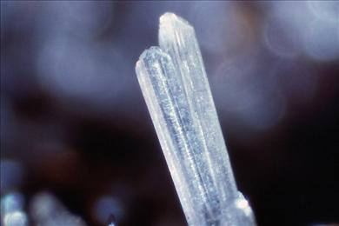
Subparallel valentinite crystals
Subresinous: Luster somewhat less than resinous.
Subvitreous: Luster somewhat less than vitreous.
Sulfarsenites: Compounds based on AsS₃⁻³ groups. Sulfantimonites (SbS₃⁻³) and sulfbismuthinites (BiS₃⁻³) are closely related compounds.
Sulfarsenates: Compounds based on AsS₄⁻⁵ groups.
Sulfate: Compound containing the sulfate group (SO₄⁻²).
Sulfide: Compound of a metal or semi-metal with sulfur.
Sulfite: Compound containing the sulfite group (SO₃⁻²).
Sulfosalt: Compound of both a metal and semi-metal with sulfur.
Swallow-tail twin, Fishtail twin: Contact twin that results in a v-shaped termination similar in appearance to the tail of a swallow or fish.
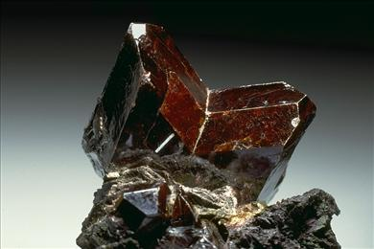
Rutile fishtail twin
Symmetry, Crystal class, Crystal system: Hold up your hands side-by-side in front of your face with your fingers spread. At least in an approximate way, your hands are identical, except that they are flipped as though one were the reflection of the other in a mirror. This is a type of symmetry called mirror symmetry. Objects can exhibit rotational symmetry so that rotation around a symmetry axis repeats the object two or more times in each full rotation. If the object assumes the same appearance four times (every 90º) as it is rotated a full 360º, it is said to have four-fold symmetry. A center of symmetry is present if every point on an object has a corresponding identical point on the opposite side of the object the same distance from its center.
Symmetry is an important property of mineral crystals. The symmetry we see in the external shape of a crystal results from the symmetry of the mineral's atomic structure. The symmetry of the crystal may not be obvious because of irregular growth; however, the angles between the crystal's faces will always be related by the true symmetry of the mineral. Careful study, sometimes along with angular measurements, may be necessary to determine the symmetry of a crystal. Recognizing the symmetry of a crystal will be a big help in identifying the mineral.
There are ten kinds of symmetry (symmetry elements) that can be seen in the external form of crystals:
1: no symmetry; identity
2: two-fold rotation
3: three-fold rotation
4: four-fold rotation
6: six-fold rotation
B1: center of symmetry
m: mirror plane
B3: three-fold rotation with inversion
B4: four-fold rotation with inversion
B6: six-fold rotation with inversion
There are only 32 possible ways in which the various symmetry elements can be combined. These are called the crystal classes, and they can in turn be organized into six crystal systems. The symbols used to represent the symmetry elements are combined to represent each of the crystal classes. The rules for interpreting these combined symbols are:
(1) if a mirror plane symbol "m" immediately follows a rotational axis symbol, the rotational axis lies in the mirror plane;
(2) if a slash "/" separates the rotational axis and the mirror symbol, the mirror plane is perpendicular to the axis;
(3) if two or three mirror plane symbols or two or three rotational axis symbols immediately follow one another, they are perpendicular to one another.
These conventions are not rigorously followed for the cubic system in which the symmetry relationships are more complex. The 32 crystal classes are listed below, organized according to the six crystal systems.
Triclinic: 1, B1
Monoclinic: 2, m, 2/m
Orthorhombic: 2/m 2/m 2/m, 222, mm2
Tetragonal: 4, B4, 4/m, 4mm, B42m, 422, 4/m 2/m 2/m
Hexagonal: 3, B3, 3m, B3 2/m, 32, 6, B6, 6/m, 6mm, B6m2, 622, 6/m 2/m 2/m
Isometric or cubic: 23, 2/m B3, 4/m B3 2/m, B43m, 432
Symplectic: Intimate intergrowth of two different minerals.
Tabular: Crystal habit appearing like a tablet of paper.
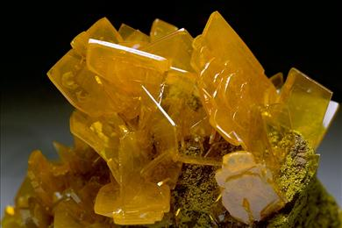
Wulfenite exhibiting tabular habit
Tarnish: Formation of a thin alteration film on the surface of certain minerals. The thin film, itself called tarnish, affects the mineral's color and luster.
Tecto-: Applied to minerals containing anion groups linked into three- dimensional frameworks (e.g. tectosilicate)
Tectosilicate: Mineral characterized by a three-dimensional framework of silicate groups of general formula SiO₂. Aluminum commonly takes the place of some of the silicon.
Tellurite: Compound containing the tellurite group (TeO₃⁻²) or linked tellurite groups (Te₂O₅⁻², Te₃O₈⁻²).
Tenacity: Tenacity refers to the strength rather than the hardness of a mineral. It actually represents its resistance to breaking, crushing, bending, or tearing. The following terms are used to describe the tenacity of minerals:
Brittle: breaks or powders easily
Malleable: can be hammered into thin sheets without breaking
Sectile: can be cut into thin shavings with a knife
Ductile: can be drawn into a wire without breaking
Elastic: can be bent and then returns to its original shape
Flexible: can be bent but does not return to its original shape
Tenebrescence: The ability of certain minerals to change color when exposed to sunlight.
Termination: The tip of a crystal; ideally made up of crystal faces.
Tetartoid: A crystal form consisting of nonparallel faces related by the combined symmetry of the 23 (tetartoidal) crystal class.
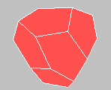
Tetartoid
Tetragonal: The tetragonal unit cell is defined by three axes. Two of them, labeled a, are equal in length; and the c axis is of a different length. All angles between axes are 90°.
The c axis corresponds to a symmetry axis of either 4-fold rotation or 4-fold rotation inversion. The c axis can be either longer or shorter than the a axes.
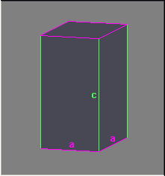
Tetragonal unit cell
Tetrahedron: A three-dimensional shape bounded by four triangular faces
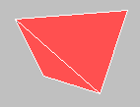
Tetrahedron
Tetrahexahedron: A three-dimensional shape bounded by 24 faces that are isosceles triangles (two sides equal). The tetrahexahedron is a crystal form in the isometric crystal system. It can be visualized as a cube with each of its six square faces split into four triangular faces.

Tetrahexahedron
Thermoluminescence: Emission of visible light by a material when it is heated.
Thiosulfate: Compound containing the thiosulfate group (S₂O₃⁻²).
Translucent: Capable of allowing visible light to pass through, but not clearly enough that an object can be seen looking through the material.
Transparent: Capable of allowing visible light to pass through clearly so that an object can be seen looking through the material.
Trapezohedron: A three-dimensional shape bounded by 24 faces. The trapezohedron is a crystal form in the isometric crystal system.
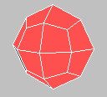
Trapezohedron
Triboluminescence: Emission of visible light by a material when it is scratched, crushed or rubbed.
Triclinic: The triclinic unit cell is defined by three axes, a, b, and c, of unequal lengths. None of the angles, alpha, beta, and gamma, between these axes are exactly 90°.
The standard convention for assigning axes is c < a < b. The angle alpha lies between the b and c axes; beta lies between a and c, and gamma lies between a and b. The cell is usually chosen so that alpha and beta are obtuse (between 90º and 180º).
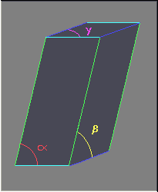
Triclinic unit cell
Trigonal: A subgroup of the hexagonal crystal system characterized by one three-fold symmetry axis. The remaining crystal systems in the hexagonal crystal system have a six-fold symmetry axis.
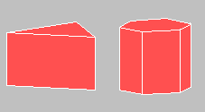
Trigonal prism & hexagonal prism
Trilling: Group of three crystals intergrown in a twin relationship.
Trimorphous: Three minerals that have the same chemical composition, but different atomic structures. See polymorphism.
Trioctahedral: Type of layered atomic structure in which all three of the possible octahedrally coordinated sites are occupied by cations. An octahedrally-coordinated site is a position in the structure in which a cation can form bonds to six anions. The anions can be thought of as positioned at the corners of an octahedron. See also dioctahedral.
Trisoctahedron: A three-dimensional shape bounded by 24 faces that are isosceles triangles (two sides equal). The trisoctahedron is a crystal form in the isometric crystal system.
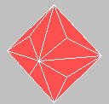
Trisoctahedron
Tristetrahedron: A three-dimensional shape bounded by 12 three-or-four-sided faces. The tristetrahedron is a crystal form in the isometric crystal system. The trigonal tristetrahedron can be constructed by splitting each of the four faces of a tetrahedron into three triangular faces.
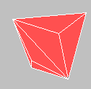
Tristetrahedron
Trivalent: Ion having a charge (valence) of 3.
Tuft: A crystal aggregate in the form of clumps of fibrous crystals.
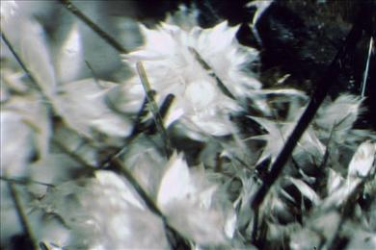
Tufts of pectolite with aegirine
Tungstate: Compound containing the tungstate group (WO₄⁻²).
Turbid: Appearing cloudy or translucent because of suspended material.
Twinning: The intergrowth of two or more crystals of the same mineral in a definite orientation determined by the atomic structure of the mineral. The twin relationship is indicated by specifying the Miller indices of a plane on which the structures meet (e.g. on {100}) and/or an axis about which one structure is rotated relative to the other (e.g. about [310] axis). If a plane is specified without indicating an axis, the twinning is understood to be by reflection across that plane.
Quartz Japan law twin
Uneven: Fracture characterized by more or less flat surfaces with some roughness.
Unit cell: The unit cell is the smallest group of atoms in the atomic structure that if repeated in each of the three dimensions would completely generate the atomic structure. The atoms in the unit cell and their arrangement are unique to a given mineral and define its atomic structure, chemical composition, external symmetry, and many of its properties.
The shape and dimensions of the unit cell are given by three lengths (axes), a, b, and c, and the angles between them: alpha (angle between b and c), beta (angle between a and c), and gamma (angle between a and b).
In the higher symmetry crystal systems certain lengths are equal and certain angles are precisely defined so that they need not be stated:
Triclinic: a ≠ b ≠ c; α ≠ β ≠ γ (All dimensions need to be given.)
Monoclinic: a ≠ b ≠ c; α = γ = 90º ≠ β (Only a, b, c, and β need to be given.)
Orthorhombic: a ≠ b ≠ c; α = β = γ = 90º (Only a, b, and c need to be given.)
Tetragonal: a = b ≠ c; α = β = γ = 90º (Only a and c need to be given.)
Hexagonal: a = b ≠ c; α = β = 90º, γ = 120º (Only a and c need to be given.)
Isometric or cubic: a = b = c; α = β = γ = 90º (Only a needs to be given.)
Uranyl-: Compound containing the uranyl group (UO₂⁻²).
Vanadate: Compound containing the vanadate group (VO₄⁻³).
Vanadin-: Compound containing clusters of vanadium atoms surrounded by oxygen atoms (exclusive of the vanadate [VO₄⁻³] group).
Variety: Variety names have traditionally been given to minerals that have some distinctive physical characteristic, such as color, that sets them apart from other minerals of the same mineral species. Variety names are most commonly used for minerals that have use as gems. Amethyst, for example, is the purple variety of the mineral species quartz, which has many other varieties as well.
Vein: A thin tabular or sheet-like body usually partially or totally filled with intergrown crystals.
Vermicular, Vermiform: Worm-like in shape.
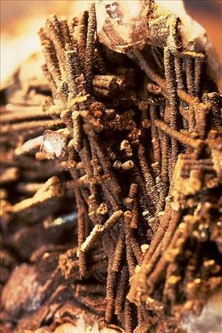
Siderite exhibiting vermicular habit
Vicinal: Crystal face that closely approximates a larger face in orientation.
Vitreous: Brightly reflective; similar to the luster of freshly broken glass.
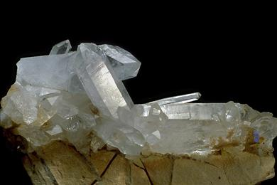
Quartz exhibiting vitreous luster
Vug: Small cavity in rock, usually lined with crystals.
Waxy: Slightly reflective mineral luster; typical of minutely granular surfaces.
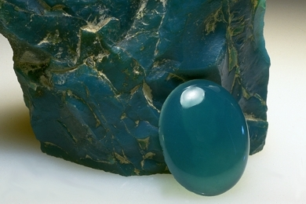
Chrysocolla exhibiting waxy luster
Xenoblast: A mineral grain without faces that has grown in a metamorphic rock.
Xenomorphic: Pertaining to crystals that are not bounded by faces; anhedral.

END

