**Sicilian Amber, Simetite – the Tears of the Sun God’s Daughters**

[**https://siciliangodmother.com/2014/02/13/sicilian-amber-the-tears-of-the-sun-gods-daughters/**](https://siciliangodmother.com/2014/02/13/sicilian-amber-the-tears-of-the-sun-gods-daughters/)

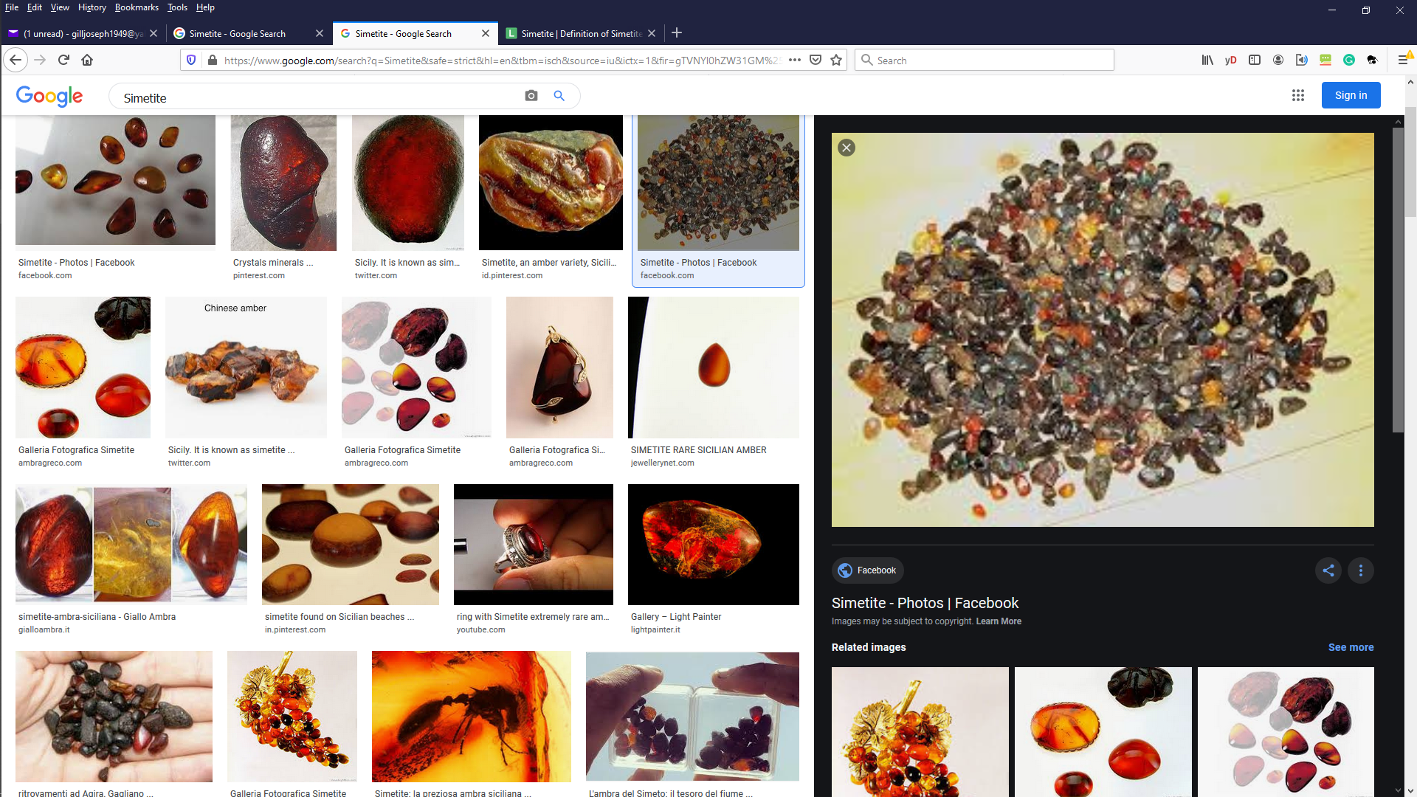

Posted by [VDG](https://siciliangodmother.com/author/siciliangodmother/) on [February 13, 2014](https://siciliangodmother.com/2014/02/13/sicilian-amber-the-tears-of-the-sun-gods-daughters/)

On some of Sicily’s beaches after a big storm, if you’re sharp-eyed and lucky as well, you can find pieces of a rare type of amber called simetite. Some pieces of simetite have recently been found to contain hitherto unknown types of prehistoric insect.

It dates from the Miocene, a later period than the more widely found Baltic amber which originated in the Eocene. It was in the Miocene that the ancestors of humans first branched off from the other species of primates.

[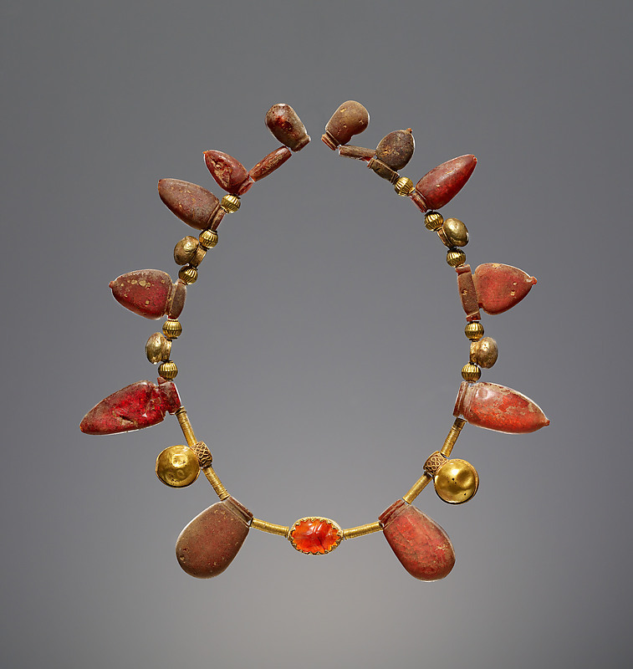](https://siciliangodmother.files.wordpress.com/2014/02/roman-amber.jpg)

Ancient Roman Necklace with a Pendant Scarab made of simetite, 550–400 B.C. The necklace is simetite, gold, and carnelian, and it is in the J. Paul Getty Museum, Los Angeles

The ancient Greeks and Romans in Sicily searched for simetite and made it into jewellery, and they had a beautiful story to explain where it came from.

In Greek mythology, a female sea spirit called Clymene had a son called Phaethon. Phaethon’s father was Helios, the god of the Sun. Clymene’s husband, King Merops of Ethiopia, adopted Phaethon even though he knew the boy was not his own.

To the ancient Greeks, Ethiopian meant all black Africans, and Ethiopia meant all of sub-Saharan Africa, as far as the Greeks knew of it. The Greeks regarded Ethiopians as a superior variety of people, half way between humans and gods. Homer’s poetry, the *Iliad* and the *Odyssey*, contains tales of the Gods popping down to have lavish feasts  with their buddies the Ethiopians, sometimes marrying them, and engaging in sporting events with them, and he regularly mentions that the Ethiopians were the best archers in the world. He describes them as pious, just, noble and faultless.

Herodotus, in his histories (written in 440 B.C.) stated that there were 18 black pharaohs of Egypt, rulers from the Kushite Dynasty in Ethiopia which conquered Egypt. He described Ethiopia saying “There gold is obtained in great plenty, huge elephants abound, with wild trees of all sorts, and ebony; and the men are taller, handsomer, and longer lived than anywhere else.”

Ethiopia’s fabulous wealth and palaces full of gold, diamonds, sapphires, ivory and exotic animals made a staggering impression on foreign visitors and tales about them spread around the ancient world. The Ethiopians conquered Egypt and had so much wealth and power that, according to the Greek religion, there could be only one explanation: obviously, the gods loved them more than any other race of men.

One day Phaethon, the young prince of this paradise on earth, asked his mother who his true father was. She answered that he was Helios, the god of the sun. Phaethon told his friends this, but the other children mocked him and refused to believe it, for he had not inherited his father’s immortality  and was just a normal human.

Phaethon asked Helios if he really was his father, and Helios swore to grant him anything he asked, in order to prove it. Phaethon asked if he could drive his father’s chariot, the sun, across the sky for just one day. Helios did all he could to put him off this idea. The chariot was a blaze of flames and the horses snorted fire. Even Helios himself got scared sometimes, he told his son.

Phaethon was adamant. Helios was distraught, but he could not go back on his word.

When the fateful day came, the horses realised they were being driven by a lighter driver than usual and they bolted. Phaethon was terrified and dropped the reins. The horses veered off their usual course and stooped so close to earth that the planet, and the people loved by the gods, were changed forever.

The Ethiopians’ blood began to boil inside them and bubble to the surface, making their skin turn black. The rivers and lakes evaporated and the vegetation was scorched, creating the Sahara desert throughout much of the Ethiopian Empire. Ethiopia, the kingdom beloved of the gods, was being burned away.

Planet Earth herself screamed out to Jupiter, the king of the gods, for help. He did the only thing he could: he struck Phaethon down with a bolt of lightning.

The Heliades, sisters of Phaethon, were so sad at this tragedy that they wept tears which dried up in the blazing heat and became amber. The Heliades were trapped inside poplar trees – and there is another whole myth to explain that. I wonder if the Greeks who invented this story really knew that amber is tree sap that has dried in the sun.

[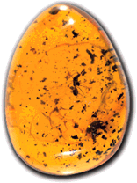](https://siciliangodmother.files.wordpress.com/2014/02/ambra3.gif) 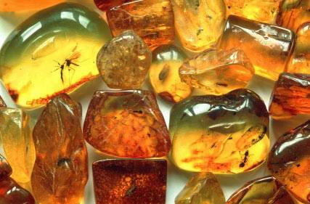 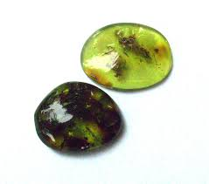 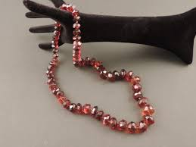 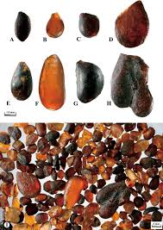

Sicilian amber



The Tears of the Heliades; or, Amber as a Gem - Amber from Sicily, Simetite - 'The Necklace of Galatea' - W. Arnold Bauffam 1896

The tears of the sun god’s daughters were so copious that they were scattered throughout the land. They remained as a permanent reminder of the tragedy that dried up the continent of Africa.

In ancient times, a lot of this Italian amber was found washed out at the mouth of the River Po, in northern Italy. In more recent times, it is still found washed down after very violent storms from the River Simeto near Catania in Sicily, from which it derives its name, *simetite*.

Although pieces of simetite can still be picked up from the beach near Catania, they are very rare nowadays.

Some pieces are also found on the beaches between

* Punta Braccetto, the riviera of Santa Croce Camerina on the southern Sicilian coast in the Ragusa region, and
* Contrada Chiappa in the Pachino region, which is also known as the Amber Coast (*Costa dell’Ambra*). This is in the Siracusa region.

[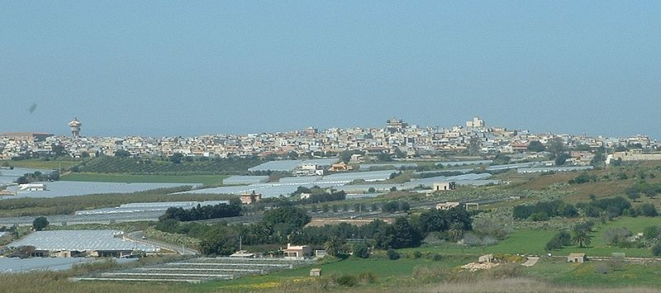](https://siciliangodmother.files.wordpress.com/2014/02/800px-pachino_panorama.jpg)

The Pachino coast, Sicily

Simetite jewellery is sold at very high prices by some of the exclusive jewellers in Taormina and other fashionable towns in Sicily. But if you should encounter a piece of jewellery made from Sicilian amber or simetite, remember how it originated: it is the tears of the sun god’s daughters, weeping for their dead brother, and for the destruction of the lush and beautiful countryside in the Empire of the noble Ethiopians.