**John Sinkankas 1915-2002 Wikipedia Oct 8 2015**

https://en.wikipedia.org/wiki/John_Sinkankas

|  |
| --- |
|  |

**1915–2002  
87 Years of Inspiration**

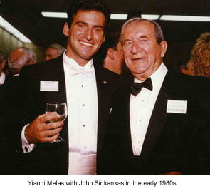 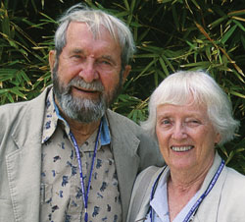 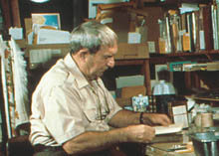 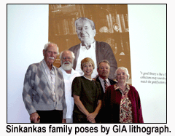

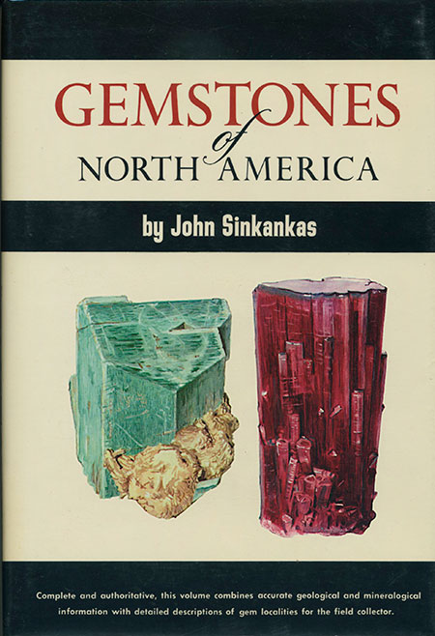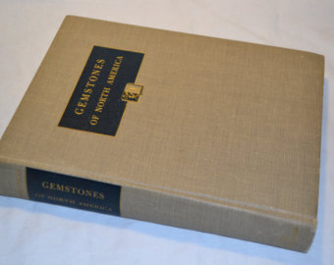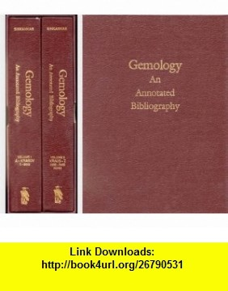

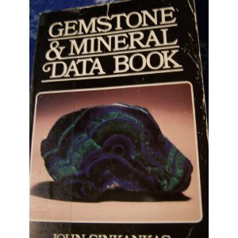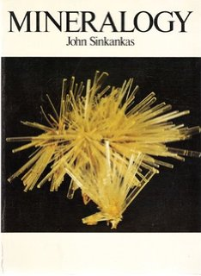 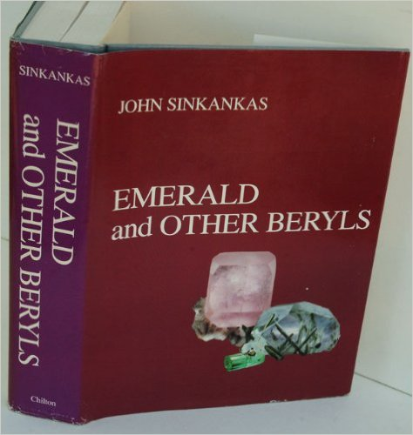

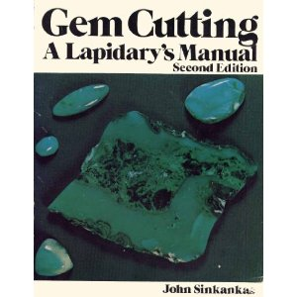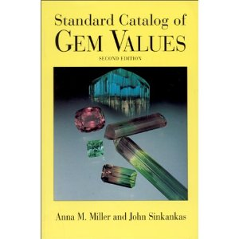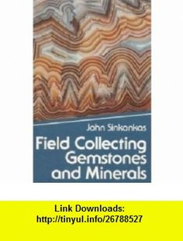

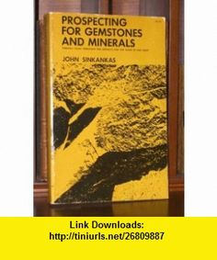 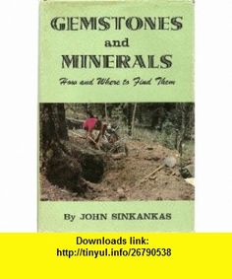

|  |  |
| --- | --- |
| **John Sinkankas** | |
| **Born** | May 15, 1915 Paterson, New Jersey |
| **Died** | May 17, 2002 (aged 87) San Diego, California |
| **Nationality** | American |
| **Occupation** | gemologist, micromounter, bookseller, bibliographer, US Navy officer. |
| **Known for** | [Sinkankasite](https://en.wikipedia.org/wiki/Sinkankasite) |

**John Sinkankas** (1915–2002) was an honored Navy officer and aviator, noted gemologist, gem carver and gem faceter, author of many books and articles on minerals and [gemstones](https://en.wikipedia.org/wiki/Gemstones), and a [bookseller](https://en.wikipedia.org/wiki/Bookseller) and [bibliographer](https://en.wikipedia.org/wiki/Bibliographer) of rare books.

**Contents**

* [1 Early life](https://en.wikipedia.org/wiki/John_Sinkankas#Early_life)
* [2 US Navy Aviator](https://en.wikipedia.org/wiki/John_Sinkankas#US_Navy_Aviator)
* [3 Gemology](https://en.wikipedia.org/wiki/John_Sinkankas#Gemology)
* [4 Sinkankasite](https://en.wikipedia.org/wiki/John_Sinkankas#Sinkankasite)
* [5 Bookseller and bibliographer](https://en.wikipedia.org/wiki/John_Sinkankas#Bookseller_and_bibliographer)
* [6 Honors](https://en.wikipedia.org/wiki/John_Sinkankas#Honors)
* [7 Publications](https://en.wikipedia.org/wiki/John_Sinkankas#Publications)
* [8 References](https://en.wikipedia.org/wiki/John_Sinkankas#References)
* [9 Bibliography](https://en.wikipedia.org/wiki/John_Sinkankas#Bibliography)

**Early life**

John Sinkankas was born in [Paterson, New Jersey](https://en.wikipedia.org/wiki/Paterson,_New_Jersey). He was the son of Joseph Sinkankas and Domicelė Klimas, who immigrated from [Lithuania](https://en.wikipedia.org/wiki/Lithuania) just before the turn of the century. At the age of seven he visited the [New Street Quarries](https://en.wikipedia.org/w/index.php?title=New_Street_Quarries&action=edit&redlink=1) in Paterson, where he saw and collected crystals of [apophyllite](https://en.wikipedia.org/wiki/Apophyllite), [prehnite](https://en.wikipedia.org/wiki/Prehnite), [quartz](https://en.wikipedia.org/wiki/Quartz), [calcite](https://en.wikipedia.org/wiki/Calcite) and other mineral specimens. When older, he would go on field trips with Dr. [James Morton](https://en.wikipedia.org/wiki/James_Morton)[[*disambiguation needed*](http://dispenser.homenet.org/%7Edispenser/cgi-bin/dab_solver.py?page=John_Sinkankas&editintro=Template:Disambiguation_needed/editintro&client=Template:Dn)], curator of the [Paterson Museum](https://en.wikipedia.org/wiki/Paterson_Museum), and visited the [magnetite](https://en.wikipedia.org/wiki/Magnetite) mine, abandoned [blast-furnances](https://en.wikipedia.org/w/index.php?title=Blast-furnance&action=edit&redlink=1), quarries and mines.

In high school he developed a love of flying, and frequently visited the [Teterboro Airport](https://en.wikipedia.org/wiki/Teterboro_Airport) and spoke with early aviators and to see the [Fokker](https://en.wikipedia.org/wiki/Fokker) aircraft, [Gates Flying Circus](https://en.wikipedia.org/w/index.php?title=Gates_Flying_Circus&action=edit&redlink=1) and others. While still in high school, he made a glider with a seat in the front, but his father did not allow him to fly it more than once. After completing high school, he obtained his BS degree from the [New Jersey State Teacher's College](https://en.wikipedia.org/w/index.php?title=New_Jersey_State_Teacher%27s_College&action=edit&redlink=1), later to become the [William Paterson College](https://en.wikipedia.org/wiki/William_Paterson_College) of New Jersey.[[1]](https://en.wikipedia.org/wiki/John_Sinkankas#cite_note-1)

In 1940 He married [Marjorie Jane McMichael](https://en.wikipedia.org/w/index.php?title=Marjorie_Jane_McMichael&action=edit&redlink=1) of Paterson, New Jersey, and had four children: John William, George Martin, Sharon Jane Tooley, and Marjorie Ellen Coates.

**US Navy Aviator**

Sinkankas graduated from the [Naval Air Station](https://en.wikipedia.org/wiki/Naval_Air_Station) in [Pensacola, Florida](https://en.wikipedia.org/wiki/Pensacola,_Florida), in 1937, as US Navy Aviator #5390. Before and during [World War II](https://en.wikipedia.org/wiki/World_War_II), Sinkankas was employed in flying patrol [seaplanes](https://en.wikipedia.org/wiki/Seaplane) engaged in convoy work and anti-submarine warfare in numerous places. Fortunately, he was never shot at. During the course of the war he had an opportunity to fly Colonel [Bernt Balchen](https://en.wikipedia.org/wiki/Bernt_Balchen) around [Greenland](https://en.wikipedia.org/wiki/Greenland) where they visited various colonies along the western coast, including [Ivigtut](https://en.wikipedia.org/wiki/Ivigtut). There Sinkankas collected several flats of specimens from the famous [cryolite](https://en.wikipedia.org/wiki/Cryolite) deposit and elsewhere found [rhodolite](https://en.wikipedia.org/wiki/Rhodolite) [garnet](https://en.wikipedia.org/wiki/Garnet).[[2]](https://en.wikipedia.org/wiki/John_Sinkankas#cite_note-2)

He retired from the Navy as a Captain in 1961.

**Gemology**

In 1951, the journal *Rocks and Minerals* revised its column *The Amateur Lapidary* and asked Sinkankas to be the author. It was this assignment that launched his career in writing about gems and minerals. He became a frequent contributor to the column and also wrote other articles for the magazine - nearly 35 articles appear under his name. To date Sinkakas has published well over 130 papers in numerous hobby and professional journals, including *Lapidary Journal*, *Gems and Minerals*, *Rock and Gem*, *Mineral Digest*, *Mineralogist*, *Gems and Gemology*, *Journal of Gemology*, *American Mineralogist*, *Mineralogical Record*, *Industrial Diamond Review*, *Lapis*, *Desert Magazine*, *Bookman's Weekly*, *Antiquarian Bookman*, and others."[[3]](https://en.wikipedia.org/wiki/John_Sinkankas#cite_note-3)

Some of his examples of [gem cutting](https://en.wikipedia.org/wiki/Gem_cutting) and [faceting](https://en.wikipedia.org/wiki/Faceting) are shown in the [Smithsonian Institution](https://en.wikipedia.org/wiki/Smithsonian_Institution). They include a 7,000 carat faceted egg of [rock crystal](https://en.wikipedia.org/wiki/Rock_crystal); a cut [golden beryl](https://en.wikipedia.org/wiki/Golden_beryl) of over 2,054 carats. He also has large faceted gems on display in the [Royal Ontario Museum](https://en.wikipedia.org/wiki/Royal_Ontario_Museum) in [Toronto](https://en.wikipedia.org/wiki/Toronto) and the [American Museum of Natural History](https://en.wikipedia.org/wiki/American_Museum_of_Natural_History) in New York.

Sinkakas thought of himself as a [micromounter](https://en.wikipedia.org/wiki/Micromount). He was listed as such in the *International Directory of Micromounters*, published by the [Baltimore Mineralogical Society](https://en.wikipedia.org/w/index.php?title=Baltimore_Mineralogical_Society&action=edit&redlink=1), as long ago as the third edition (1966).[[4]](https://en.wikipedia.org/wiki/John_Sinkankas#cite_note-4)

**Sinkankasite**

[Sinkankasite](https://en.wikipedia.org/wiki/Sinkankasite), mineral formula: H2MnAl(PO4)2(OH)•6(H2O), was named after Sinkakas.[[5]](https://en.wikipedia.org/wiki/John_Sinkankas#cite_note-5) It is triclinic; as colorless, bladed to prismatic crystals up to 4 mm in length, often as divergent, radial aggregates and as [pseudomorphs](https://en.wikipedia.org/wiki/Pseudomorph) after triphlyte crystals; occurs in the [Barker pegmatite](https://en.wikipedia.org/w/index.php?title=Barker_pegmatite&action=edit&redlink=1) (formerly [Ferguson pegmatite](https://en.wikipedia.org/w/index.php?title=Ferguson_pegmatite&action=edit&redlink=1), east of [Keystone, South Dakota](https://en.wikipedia.org/wiki/Keystone,_South_Dakota), and in the [Palermo pegmatite](https://en.wikipedia.org/w/index.php?title=Palermo_pegmatite&action=edit&redlink=1), [North Groton, New Hampshire](https://en.wikipedia.org/wiki/North_Groton,_New_Hampshire).[[6]](https://en.wikipedia.org/wiki/John_Sinkankas#cite_note-6)

**Bookseller and bibliographer**

To provide a source of materials for earth scientist, Sinkakas and his wife established Peri Lithon Books company.[[7]](https://en.wikipedia.org/wiki/John_Sinkankas#cite_note-7) The company name, Peri Lithon is Greek for "about stones." It is in honor of the book, [*Peri Lithon*](https://en.wikipedia.org/w/index.php?title=Peri_Lithon&action=edit&redlink=1), by the Greek naturalist [Theophrastus](https://en.wikipedia.org/wiki/Theophrastus), a disciple of [Aristotle](https://en.wikipedia.org/wiki/Aristotle), who wrote the first known book about minerals about 450BC.[[8]](https://en.wikipedia.org/wiki/John_Sinkankas#cite_note-8)

Sinkankas was also a [bibliographer](https://en.wikipedia.org/wiki/Bibliographer) on the history of gems and minerals. He developed the John and Marjorie Sinkankas Gemological Library which was sold to the [Gemological Institute of America](https://en.wikipedia.org/wiki/Gemological_Institute_of_America). Involved in the negotiations were 350 book archive boxes holding some 750 linear feet of shelf space. Included were some 8,000 books and 6,000 pamphlets, scientific reprints, offprints and the like. Altogether, it added over 20,000 new items to the [Richard T. Liddicoat Library](https://en.wikipedia.org/w/index.php?title=Richard_T._Liddicoat_Library&action=edit&redlink=1) and Gemological Information Center.[[9]](https://en.wikipedia.org/wiki/John_Sinkankas#cite_note-9)

**Honors**

Sinkankas was a Fellow of the [Mineralogical Society of America](https://en.wikipedia.org/wiki/Mineralogical_Society_of_America); honorary Fellow of the [Gemmological Association All-Japan](https://en.wikipedia.org/w/index.php?title=Gemmological_Association_All-Japan&action=edit&redlink=1); member of the [Mineralogical Association of Canada](https://en.wikipedia.org/w/index.php?title=Mineralogical_Association_of_Canada&action=edit&redlink=1); honorary member of the [Rochester Academy of Sciences](https://en.wikipedia.org/w/index.php?title=Rochester_Academy_of_Sciences&action=edit&redlink=1); honorary member of the [San Diego Mineral and Gem Society](https://en.wikipedia.org/w/index.php?title=San_Diego_Mineral_and_Gem_Society&action=edit&redlink=1); and the [Cosmos Club](https://en.wikipedia.org/wiki/Cosmos_Club) of Washington, DC.

In 1982, he was awarded the "Distinguished Associate Award" from the [Gemological Institute of America](https://en.wikipedia.org/wiki/Gemological_Institute_of_America).

In 1982, the Board of Trustees of [William Paterson College](https://en.wikipedia.org/wiki/William_Paterson_College) presented to John Sinkankas the degree of [Doctor of Humane Letters](https://en.wikipedia.org/wiki/Doctor_of_Humane_Letters).

In 1989, he was presented the [Carnegie Mineralogical Award](https://en.wikipedia.org/w/index.php?title=Carnegie_Mineralogical_Award&action=edit&redlink=1).

**Publications**

* Sinkankas, John. 2000. "William Maclure and the Library of the Academy of Natural Sciences of Philadelphia". Earth Sciences History. 19: 33–35.
* Sinkankas, John. 1999. "What Is Polishing? - The art of shaping and polishing gems is thousands of years old. technical nature of polish". The Lapidary Journal. 52 (11): 51.
* Sinkankas, John. 1998. Rukovodstvo po obrabotke dragot︠s︡ennykh i podelochnykh kamneĭ. Moskva: "Mir". Translation of: Gem cutting: a lapidary's manual.
* Schneer, Cecil J., and John Sinkankas. 1994. "Review of Gemology: An Annotated Bibliography". Isis. 85 (3).
* Sinkankas, John. 1994. "Collecting Mineralogical Bookplates". Rocks & Minerals. 69 (2): 108-111.
* Miller, Anna M., John Sinkankas, John Sinkankas, and John Sinkankas. 1994. Standard catalog of gem values. Tucson, Ariz: Geoscience Press.
* Sinkankas, John. 1993. Gemology: an annotated bibliography 1. Metuchen, NJ u.a: Scarecrow Press.
* Sinkankas, John, John I. Koivula, and Gerhard Becker. 1992. "Peridot as an Interplanetary Gemstone". Gems & Gemology. 28 (1): 43-51.
* Sinkankas, John. 1991. "Bao shi diao zhuo da quan. 寶石雕琢大全 ." 徐氏基金會 Taibei Shi: Xu shi ji jin hui. Gem cutting. [ISBN 9571801429](https://en.wikipedia.org/wiki/Special:BookSources/9571801429); 9789571801421.
* Sinkankas, John. 1988. Field collecting gemstones and minerals. Prescott, Ariz: Geoscience Press. "Formerly titled Gemstones and minerals: how and where to find them."
* Sinkankas, John, and Peter G. Read. 1986. Beryl. London: Butterworths.

**References**

• Nassau, Kurt. 1989. "Dr. John Sinkankas: An extraordinary collection put together by an extraordinary individual, the Sinkankas Library is now part of the [Gemological Institute of America](https://en.wikipedia.org/wiki/Gemological_Institute_of_America)." Lapidary Journal. Volume 43 (4), July 1989. Page 44.

• • Mitchelll, Richard S. 1986. "Who's Who in Mineral Names; John Sinkankas." Rocks and Minerals. Volume 61 (1), pages 28-29

• • Mitchelll, Richard S. 1986. "Who's Who in Mineral Names; John Sinkankas." Rocks and Minerals. Volume 61 (1), page 30.

• • Wright, Quintin. 2003. "Microminerals: John Sinkankas, Micromounter." The Mineralogical Record. Volume 34 (2), page 179.

• • Burns P C, Hawthorne F C. 1995. "Sinkankasite." American Mineralogist, 80 (1995) p.620-627.

• • Mitchelll, Richard S. 1986. "Who's Who in Mineral Names; John Sinkankas." Rocks and Minerals. Volume 61 (1), page 28.

• • Mitchelll, Richard S. 1986. "Who's Who in Mineral Names; John Sinkankas." Rocks and Minerals. Volume 61 (1), page 31.

• • Nassau, Kurt. 1989. "Dr. John Sinkankas: An extraordinary collection put together by an extraordinary individual, the Sinkankas Library is now part of the [Gemological Institute of America](https://en.wikipedia.org/wiki/Gemological_Institute_of_America)." Lapidary Journal. Volume 43 (4), July 1989. Page 46.

* 1. • Nassau, Kurt. 1989. "Dr. John Sinkankas: An extraordinary collection put together by an extraordinary individual, the Sinkankas Library is now part of the [Gemological Institute of America](https://en.wikipedia.org/wiki/Gemological_Institute_of_America)." Lapidary Journal. Volume 43 (4), July 1989. Page 49.

**Bibliography**

* Burns P C, Hawthorne F C. 1995. "Sinkankasite." American Mineralogist, 80 (1995) pages 620-627.
* Mitchelll, Richard S. 1986. "Who's Who in Mineral Names; John Sinkankas." Rocks and Minerals. Volume 61 (1), pages 28–31. ISSN: 0035-7529.
* Nassau, Kurt. 1989. "Dr. John Sinkankas: An extraordinary collection put together by an extraordinary individual, the Sinkankas Library is now part of the [Gemological Institute of America](https://en.wikipedia.org/wiki/Gemological_Institute_of_America)." Lapidary Journal. Volume 43 (4), July 1989. Pages 42–49. ISSN: 0023-8457.
* Peacor, D.R. 1984. "Sinkankasite, a new phosphate from the Barker pegmatite, South Dakota. American Mineralogist. Volume 69, pages 380-382.
* Wright, Quintin. 2003. "Microminerals: John Sinkankas, Micromounter." The Mineralogical Record. Volume 34 (2), pages 179-182. ISSN: 0026-4628.
* Baranauckas, Carla. 2002 "John Sinkankas Dies at 87; Expert on Precious Stones" The New York Times, 16 June 2002.

=============================================================================================================