Frederick Harvey Pough 1906-2006

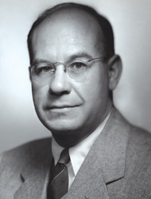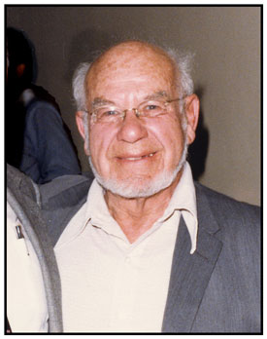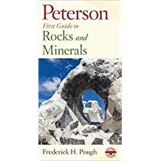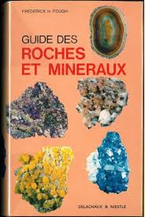
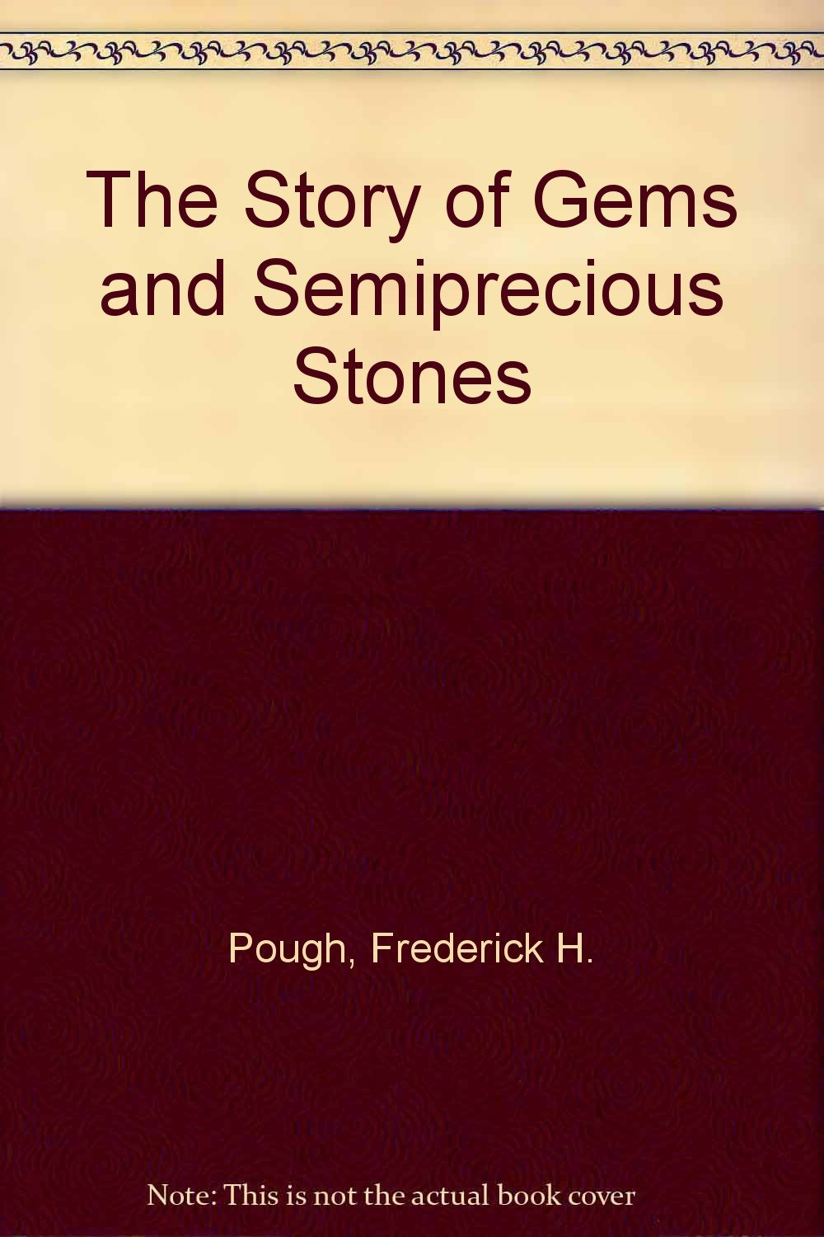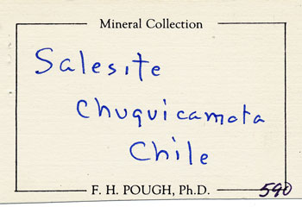

http://www.minrec.org/labels.asp?colid=583

Frederick H. Pough was born in Brooklyn, New York on June 26, 1906, the son of Francis H. Pough, a chemist and manager of the Union Sulfur Company's refinery, and Alice Hooper Backler. His parents had met at the Massachusetts Institute of Technology where Francis taught chemistry and Alice was a student in 1899.
Fred enrolled at Washington University in 1924, and transferred to Harvard the following year, graduating cum laude in 1928. His family moved to St. Louis, Missouri around 1930, and Fred worked there briefly as an insurance salesman, then returned to Washington University for graduate school; he did his Master's work at the Rueppele iron mine in Stanton, Missouri. He spent the years 1931-1932 in Heidelberg, Germany studying mineralogy under Victor Goldschmidt (he was Goldschmidt's last American student). He was awarded his M.S. (1934) and PhD (1935) degrees by Harvard, on the basis of his studies on phenakite morphology and paragenesis with Goldschmidt.
Fred taught mineralogy for a while at Harvard, then took a position as Assistant Curator at the American Museum of Natural History in New York. During the war he worked as a field mineralogist for the Manhattan Project in Brazil in 1941, and served in the Army Signal Corp in 1943. Returning to his post in the American Museum following the war, he was promoted to chairman of the Department of Geology and Mineralogy in 1952. From 1955 to 1964 he was President of Gem Irradiation Laboratories in New York, doing pioneering work on the irradiation of diamonds.
From 1964 to 1967 Fred served as Director of the Santa Barbara Museum of Natural History. He then worked as an organizer of mineral-oriented tours for a San Francisco travel agency, and as consulting mineralogist for such companies as Harry Winston and Bulova, and was thereafter self-employed as a consultant under the company name of Mineralogy, Inc.
Fred served as gem expert for Jewelers' Circular-Keystone, contributing editor for Lapidary Journal (since 1945), and a consultant for the Gemmological Association of Japan. He was a Life Fellow of the Mineralogical Society of America and the Geological Society of America, and an honored member of many other professional organizations. He was awarded the Derby Medal by the Brazilian Geological Survey (1945), a Bronze Medal by the Royal Geographical Society of Belgium (1948), the Chilton Editorial Achievement Award (1972), the Hanneman Award (1988), and the Carnegie Mineralogical Award (1989).
Fred's principal fame as an author rests on his Field Guide to Rocks and Minerals, first published in 1953 and thereafter in numerous subsequent editions, total sales of which have exceeded one million copies. Generations of mineral collectors grew up with this book at their side. Fred also wrote hundreds of popular magazine articles, and numerous articles in technical mineralogy journals; he published the first descriptions of the new minerals brazilianite, mackayite and blakeite. He also supplied the mineralogical, gemological and geological definitions of terms for various dictionaries and encyclopedias, and has even produced educational films.
Fred Pough was a virtual legend in mineralogy and mineral collecting, his name and works universally known. He remained active, energetic and feisty in his old age, traveled and lectured widely, and was attending the Rochester Mineralogical Symposium at the time of his death on April 7, 2006.
===========================
To contribute
more information
please E-mail us at:
minrecord@comcast.net
[Citation format for this entry:
WILSON, Wendell E. (2006)
Mineralogical Record Label Archive, at www.mineralogicalrecord.com.]
===========================
References:
GAIT, R.I. (1991) Who's who in mineral names: Frederick H. Pough. Rocks & Minerals, 66, 462-463.
WILSON, W.E. (2006) Notes from the editors: Died, Frederick H. Pough, 99. Mineralogical Record, 37 (3), 197.

==============================================================================================================================================================================

Frederick H. Pough, Writer of Gem Guide, Dies at 99 - NY TIMES
http://www.nytimes.com/2006/04/14/books/14pough.html?ex=1302667200&en=22b7e99ec0aaae01&ei=5088&partner=rssnyt&emc=rss

Top of Form

Bottom of Form
By JEREMY PEARCE
Published: April 14, 2006
Frederick H. Pough, a mineralogist and museum curator who wrote a guide to collecting gems and minerals that became an essential tool for budding geologists, died on April 7 in Rochester. He was 99.
The cause was a heart attack, said a grandson, Thomas F. Moore. Dr. Pough (pronounced POE) collapsed while attending a mineral symposium near his home in Pittsford, N.Y.
The book, "A Field Guide to Rocks and Minerals" (1953), was written while he was a curator of physical geology and mineralogy at the American Museum of Natural History in Manhattan.
Part of the Peterson natural history series, the guide used photographs and plain prose to steer the serious amateur among rocks, gems and crystals and the geological forces that formed them. Five decades after Dr. Pough wrote it, the book remains in print and has sold more than a million copies.
Carl A. Francis, curator of the Mineralogical Museum of Harvard University, which received part of Dr. Pough's gem collection, said the field guide was "accurate and substantial, and covered hundreds of minerals, showing their relative shapes and size in the photographs."
Dr. Francis added: "It was aimed at teenagers as well as adults and identified the specimens that found their way into the hands of many, many people."
As a mineral collector working for the American government in the 1940's, Dr. Pough went to Brazil, where he was first to describe a greenish yellow phosphate mineral.
With Edward P. Henderson, a United States Geological Survey mineralogist who analyzed the find, he named it brazilianite and published the results in a journal, American Mineralogist, in 1945. Other deposits of brazilianite were later uncovered in New Hampshire.
While at the museum, Dr. Pough experimented with X-ray radiation and its brilliant effects on aquamarines and other gemstones. He found that precious and semiprecious gems changed color under radiation, although often only temporarily. He also warned jewelers and gem dealers to be wary of irradiated stones because sunlight could cause enhanced colors to fade.
After leaving the museum in 1953, he became president of Gem Irradiation Laboratories, a company he founded to explore the possibility of selling irradiated stones in the legitimate market.
Frederick Harvey Pough was born in Brooklyn. He received his undergraduate degree from Harvard and a master's degree from Washington University. In 1935, he earned his doctorate in mineralogy from Harvard.
He joined the natural history museum staff as an assistant curator in 1935. From 1964 to 1967, he was director of the Santa Barbara Museum of Natural History.
In the 80's and 90's, Dr. Pough worked as a consultant and wrote a monthly column on gems and their formation for Lapidary Journal, a trade magazine for gem cutters and jewelers.
A Harvard researcher named a mineral, Poughite, in his honor in 1968, based on his work in studying and describing similar minerals known as the iron tellurites.
Dr. Pough's first wife, the former Eleanor Hodge, died in 1966. A second marriage ended in divorce. He lived in Reno, Nev., before moving to Pittsford two years ago.
He is survived by a son, F. Harvey Pough, of Pittsford, a biologist at the Rochester Institute of Technology; a daughter, Barbara P. Moore, of Pittsford, a museum conservator; a brother, Harold, of Wynnewood, Pa.; and three grandchildren.

==============================================================================================================================================================================
http://www.amfed.org/heavenly.htm#fredpough

Fred Pough
We just returned from the Rochester Mineral Symposium and unfortunately have some sad news to report.
Fred Pough, who would have turned 100 this coming June passed away while attending the symposium. Shortly after arriving and talking with a few friends in the lobby, he collapsed. He was given CPR within seconds by someone with 30 years of ER experience and another nurse and transported to the local hospital where he passed away about an hour later.
Fred was excited about coming to the symposium so he could be with his many friends. His family feels that this was the perfect place for him to have passed, among his many friends and doing what he'd devoted his life to.
Many (most?) of us have a copy of Fred's most popular book - "A Field Guide to Rocks & Minerals" which first appeared in 1953 and was revised many times since. It's still in print and still a best seller.
About 5 years ago Fred donated many of his mineral slides to the EFMLS for our use. These are being duplicated and organized and will represent future programs for our library. A generous donation, now even more treasured.
Contributions in Fred's memory may be made to the AFMS Scholarship Foundation (checks to "AFMS Scholarship Foundation" and sent to Bob Livingston, 59 Ely Drive; Fayetteville, NY 13066.
Carolyn
Carolyn Weinberger AFMS Editor
=======================================================================================================================================
http://findarticles.com/p/articles/mi_m0GDX/is_4_81/ai_n16533482

Doctor Frederick Pough, arguably the best known popular mineralogist in North America, died on Friday, 7 April 2006, exactly where he would have wished: amidst his friends and surrounded by minerals, at the Rochester Mineralogical Symposium (RMS). His collapse at the symposium was sudden, and he never regained consciousness.
It would be hard to envision a life more full than that of Fred Pough. Born in Brooklyn, New York, to a scientifically inclined family, he wound his way through three universities--Washington University in St. Louis, Missouri (twice); Harvard (twice); and Ruperto Carola University, Heidelberg, Germany, where he studied with Viktor Goldschmidt in 1932 and 1933. At Harvard, he finished his MS in 1934 and his PhD in 1935.
Although his first employment was also at Harvard, as a lecturer in crystallography, he soon switched to the American Museum of Natural History (AMNH) in New York City, where he remained until 1952. His break from a routine career, however, came with his travels, particularly during World War II, when he prospected in South America for uranium for the Manhattan Project, then went back to Brazil in 1943 to find tourmaline and quartz for the U.S. Army Signal Corps. His adventures there sparked an "Indiana Jones" reputation that led to his enthronement as a comic book hero (Ellsworth 1948)--probably the only mineralogist ever to have been recognized in this way. In the same period, the National Research Council sent him to observe and film the birth and development of the volcano Paricutin in Mexico. Attendees at the 1988 and 1990 RMS sessions will long remember Fred's "Reminiscences," and his scratchy movies of the growth of the newest volcano in North America.
Advertisement
It was just as he left his post as curator of physical geology at the AMNH that Fred began writing the books that would put him further in the public eye. Mthough his best known is the famous A Field Guide to Rocks and Minerals (part of the Peterson Field Guide Series), published in 1953, he published another, All About Volcanoes and Earthquakes, in the same year, and continued thereafter to write other books and hundreds of articles in both scientific and popular journals. His attention had been drawn to gemology as early as 1940, and many of his works focused on that field. He was the gem expert for Jewelers Circular Keystone magazine for forty-five years and was named an honorary member of the International Gemmological Conference (an association of research gemologists) at their Australian meeting in 1985. He was president of the Gem Irradiation Laboratories from 1955 to 1964, director of the Santa Barbara Museum of Natural History from 1964 to 1967, a consulting mineralogist from 1967 to 1977, and president and CEO of Mineralogy, Inc., from 1977 to 2004.
Dr. Richard Gaines named the mineral poughite [[[Fe.sub.2.sup.3+][(Te[O.sub.3]).sub.2](S[O.sub.4]) * 3[H.sub.2]O] in honor of Fred in 1968. At that time, the mineral, discovered in Mexico and Honduras, was known from only two not very pretty specimens. Fred, who liked the beauty of gemstones and euhedral crystals, was grateful but would have preferred a more spectacular species.
As Dr. Pough, describer of brazilianite, member of a half-dozen prestigious mineralogical societies, honorary member of many more, author of ten definitive papers in the American Mineralogist, and winner of many national and international awards, he was a towering figure in scientific circles. As plain Fred Pough, however, he was a down-to-earth friend to amateurs in both fields--a professional who disliked pretension, who wrote to a popular audience successfully (A Field Guide to Rocks and Minerals sold more than a million copies), and who did not talk down to those with lesser expertise. In fact, the only people he treated with suspicion were fellow mineralogists who spent their time shut away in laboratories. His assessment of them was quite succinct: "Today, most are unable to distinguish calcite from quartz without an X-ray" (Smith 2000). He was a true field mineralogist of the dirt-under-the-fingernails variety, and he did not hide his feelings about the state of modern mineralogy.
At the time of his death, Fred was approaching his one-hundredth birthday, but although a bit flail in body, he was still remarkably strong of mind. He remained, to use his own descriptive term, his "curmudgeonly" self to the end. Nevertheless, despite his cutting wit and unwillingness to accept laboratory-bound researchers as true mineralogists, he had hidden soft spots. I once gave a talk in which I mentioned that I lacked slides from a particular locality in France. Fred was in the audience and sent me a package of his own slides from that locality immediately afterward.
Perhaps the most telling point about Fred Pough is that news of his death went round the world instantly. That happened because people cared, and they cared because of the man he was. His hundred-year span made an impression that will last for a long time.
ACKNOWLEDGMENTS
I thank Ms. Dona Dirlam, Dr. Carl Francis, and Dr. Robert Gait for providing information.
REFERENCES
Ellsworth, W., ed. 1948. Dr. Frederick H. Pough: Keeper of the gems. Real Fact Comics, 14 (May/June). New York: National Comics Publications.
Gait, R. I. 1991. Who's who in mineral names: Frederick H. Pough (b. 1906). Rocks & Minerals 66 (6): 462-64.
Smith, A. E. 2000. Collecting tales from Brazil, part 2. Rocks & Minerals 75 (2): 106-11.
Quintin Wight
https://www.encyclopedia.com/

Pough, Frederick H. 1906-2006
Contemporary Authors
COPYRIGHT 2009 Gale

POUGH, Frederick H. 1906-2006
(Frederick Harvey Pough)

OBITUARY NOTICE—
See index for CA sketch: Born June 26, 1906, in New York, NY; died of heart failure, April 7, 2006, in Rochester, NY. Mineralogist, museum curator, and author. A former curator at the American Museum of Natural History, Pough was the author of the important mineralogy guide A Field Guide to Rocks and Minerals. A graduate of Harvard University, where he did his undergraduate work and earned a Ph.D. in 1935, he completed a master's degree at Washington University. During the rest of the 1930s and 1940s, he worked at the American Museum of Natural History, becoming curator of physical geology and mineralogy from 1942 to 1952, and serving as a consultant until 1964. His well-known field guide, first released in 1953, has been revised several times since then, most recently in 1991 under the title The Peterson Field Guide to Rocks and Minerals. As a researcher, Pough was noted for discovering the mineral brazilianite in 1945, and for his experiments showing that certain gemstones change color when subjected to radiation. He applied this knowledge of radiation to gems as president of Gem Irradiation Laboratories, which he founded in 1953. Later directing the Santa Barbara Museum of Natural History from 1964 to 1967, Pough was a columnist for Lapidary Journal during the 1980s and 1990s and generally worked as a consultant from the mid-1960s on. Also the author of two children's books, Our Earth: What It Is (1961) and The Story of Gems and Semiprecious Stones (1967), Pough was recognized for his scientific contributions in 1968 when the mineral Poughite was named after him.

OBITUARIES AND OTHER SOURCES:

PERIODICALS
New York Times, April 14, 2006, p. A19.

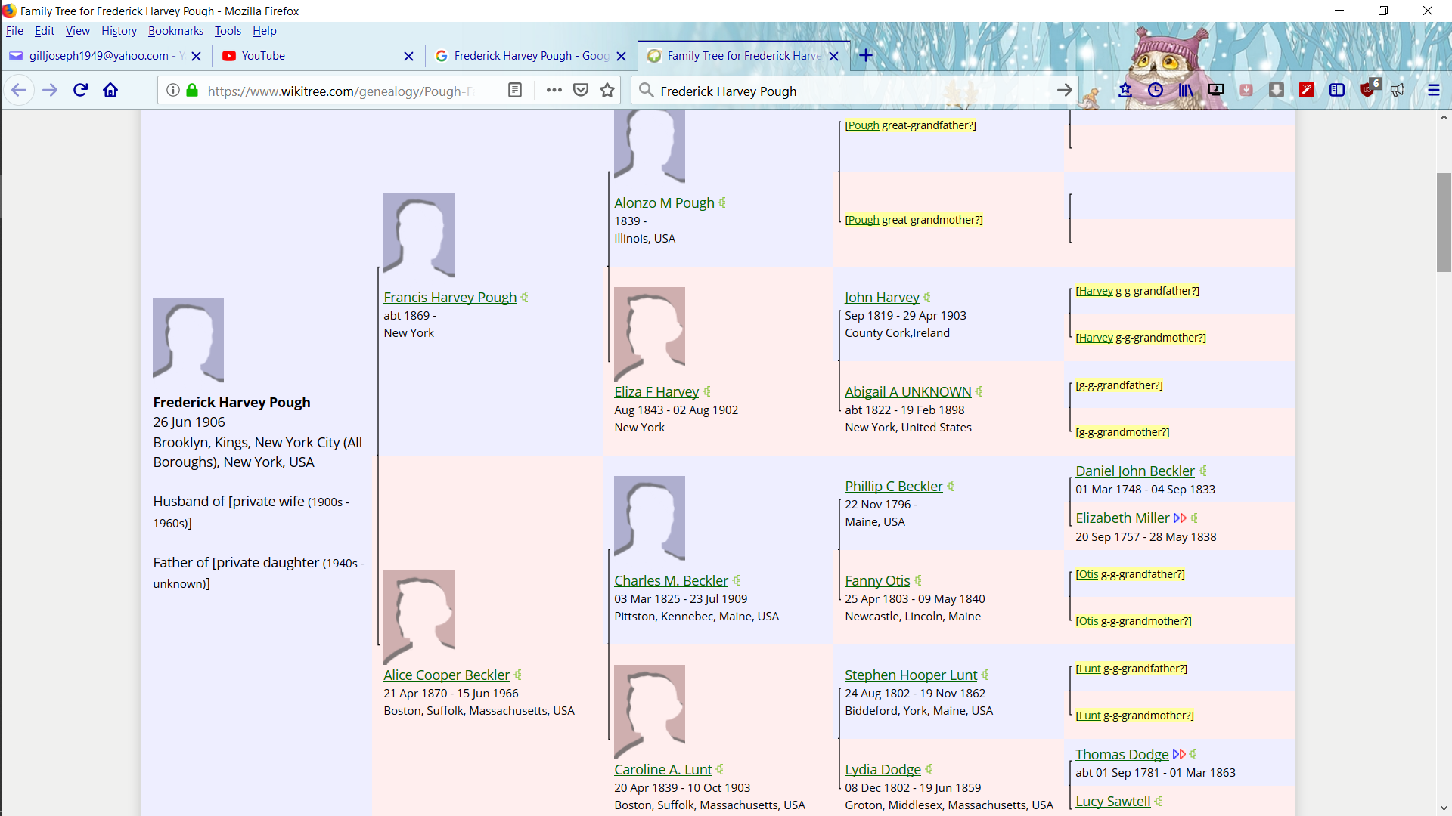
END

