**THE CURIOUS LORE OF GEORGE FREDERICK KUNZ.**

**Part One.**

**Lawrence H. Conklin**

**INTRODUCTION**

George Frederick Kunz (1856-1932) really needs no introduction. His many books and hundreds of minor publications on gems and minerals have long been consulted by experts in those fields and they are eagerly collected today by bibliophiles.

**FOREWORD**

George Frederick Kunz was born on September 29, 1856 at 141 Duane Street, New York City. He was the eldest of six children of Gottlieb Kunz an immigrant German baker and Maria Widmer Kunz who came from Switzerland.

Self-educated and self-made as he was, he accomplished so much during his lifetime, mostly during his years as "Gem Expert for Tiffany & Co.," that the world of gems and minerals was never the same after his time on this earth.

Late in his life George Kunz granted a series of interviews to a reporter which appeared "as told to Marie Beynon Ray," with some illustrations, in The Saturday Evening Post issues of November 26, 1927, called American Travels Of A Gem Collector; December 10, 1927, with the same title; January 21, 1928, called The Gem Collector in Europe; March 10, 1928, called Trailing Gems in Europe; March 31, 1928, called Discoveries of a Gem Expert and, finally on May 5, 1928, The Indestructible Value.

These interviews, which are long out-of-print and have become impossible to acquire in their original format, are re-printed here verbatim, in plain text with all mineral names editorially italicized or printed in bold-italics for emphasis.

My comments, amplifications of Kunz' recollections taken from the surviving record and observations on the general scene of mineralogy and gemology in Kunz's time are offered in italics and, occasionally, remarks are made within editor's brackets.

The interviews sometimes seem fragmented, and their chronology is not always precise. Kunz tended to jump from place to place and from age to age, but this is understandable considering that he was discussing a career in gems and minerals of more than fifty years duration. He did more and saw more than many men combined, in his day and, perhaps, his memory was overloaded. The essentials, however, are not only accurate but seem, surprisingly, in some instances, to be somewhat understated; there are, however, a few notable exceptions.

Kunz related that:

**The great collections of gems are perhaps even more interesting in the making than in the seeing or owning. At any rate, I should much rather be in possession of the experiences, adventures, travels and friendships collected while I was gathering what are often spoken of as the greatest gem collections of our time than of the gems themselves. I have made in all some dozen collections, including the J. Pierpont Morgan Collection, which is considered the finest in the world; the Chicago Exposition Collection, now in the Field Museum in Chicago, surpassed only by the Morgan Collection; and the Dr. L.T. Chamberlain Collection.**

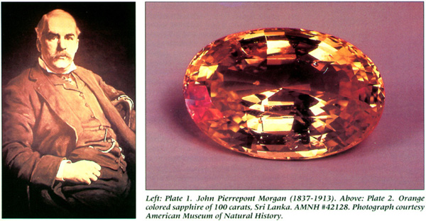

Actually, Kunz made two preliminary "J. Pierpont Morgan Collections," (See Plate 1) and added major individual items to them right up until Mr. Morgan's death in 1913, and it is this grand total of more than 4,500 pieces, collected over a period of twenty four years, to which he refers. In 1889 he exhibited, on Tiffany & Co.'s behalf, at the Paris Exposition, a collection of American gems, minerals and pearls, and after the fair, convinced Mr. Morgan that he should buy this collection and make a gift of it to the American Museum of Natural History. Mr. Morgan obliged, but some fancy and lengthy negotiations took place first. Tiffany's price for this collection was $20,000 and Mr. Morgan would pay only $15,000. Charles Tiffany finally acceded, but insisted that the disputed $5,000. be credited as his contribution to the museum. Mr. Morgan did not object and the museum surely did not mind. Everyone was happy. Their success with this collection led Kunz and Tiffany to believe that assembling another collection, one of a more general nature, would be a worthwhile project. Kunz immediately went to work putting together such a collection and, this time consulting with Mr. Morgan in advance, it was agreed that Morgan would purchase this new collection also, on the condition that it be exhibited at the Paris Exposition of 1900. Happily for Kunz and Tiffany, it won a Grand Prize and followed its predecessor to the American Museum of Natural History. The single finest specimen of this latter collection, is, in the opinion of the writer, a faceted red-orange or padparadschah sapphire of 100 carats, from Ceylon. (See Plate 2.)

A major collection of minerals called simply the "Chicago Exposition Collection," was sold by Kunz and Tiffany, after it was exhibited at the Chicago Exposition, to Stanley Field (1875-1964) after whom the mineral stanfieldite, was named. This collection survives today, essentially intact, at the Field Museum of Natural History in Chicago.

In 1894, Frances Lea Chamberlain bequeathed to the United States National Museum a collection of gemstones assembled by her father, Isaac Lea (1792-1886), an important early writer on mineralogy and, especially, paleontology. When he died, at the age of ninety-four, he left behind a mineral collection that totaled nearly 10,000 specimens, many of which were supplied by George Kunz and Tiffany & Co.

The Dr. Leander T. Chamberlain collection was one principally of gems of United States origin, and was put together by Kunz to order for Dr. Chamberlain, chiefly to augment the Isaac Lea collection (his father-in-law) given previously to the museum by his wife. Chamberlain also made gifts of cash to the museum, and this largess resulted in his being named, in 1897, honorary custodian for gems and precious stones. He held this position until his death in 1913. One important gemstone in this collection is a singular, rich-green, brilliant-cut tourmaline of fifty-eight and one-half carats from Mt. Mica in Paris, Maine, which probably ranks as the finest known from the locality.

**Not the least interesting part of my work were the additions made to other men's collections as, for instance, Mr. Clarence S. Bement's, Mr. Heber R. Bishop's collection of jade, Colonel Roebling's collection and many others.**

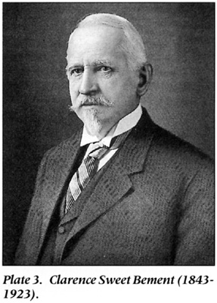

Over the years Kunz sold many mineral specimens to Clarence S. Bement, (who was honored by the naming of the mineral species bementite ), (See Plate 3.) and, in the year 1900, not only convinced J.Pierpont Morgan to buy the great Bement Collection, but to make a gift of it to the American Museum of Natural History. If one were to think of this Bement assemblage as part of Mr. Morgan's collection, which, technically, it is, but is rarely referred to as such, then the Morgan holdings of gems and minerals are truly matchless; but more on that later. Kunz apparently supplied one-third of the great jade carvings to the legendary collection formed by Heber Reginald Bishop, (1840-1902), indeed Bishop's first purchase was a jade vase from Tiffany & Co. in 1878. In 1902 this collection was presented by Mr. Bishop to the Metropolitan Museum of Art in New York City with an added gift of $55,000 to re-create the Louis XV style room that had housed the collection in his home. Shortly thereafter he added another $50,000 to the gift, but he died before other of his planned projects could be completed.

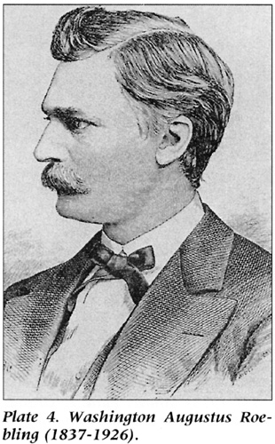

Washington Augustus Roebling, (1837-1926), (See Plate 4.) along with his father John, is better known, as the builder of the Brooklyn Bridge in New York, although he did assemble a superb mineral collection of more than 16,000 specimens. This collection went to the United States National Museum after his death. The mineral species roeblingite was named in his honor in 1897.

**A private collector is, of course, in a somewhat different position from mine. On the whole things come more naturally to me, and I would not compare my adventures in search of treasure with those of men like Mr. Bishop, for example, who, not having agents all over the world at their beck and call, set forth themselves, not once but many times, to the far corners of the earth in search of some coveted bit-always, at that moment, the most coveted bit in their entire collection-and experience veritable Arabian Nights' adventures by the way. And yet I, too, have set out in quest of gems, have known the thrill of pursuit and capture and, above all, the thoroughly satisfying experience of adding one rare gem to another in the ever-growing collections that even Time perhaps will not destroy.**

It seems here that Kunz said that he was different from his collector-clients, when the record shows he was not. He formed many private collections of gems and minerals over his lifetime but tradition says that personal financial considerations, apparently, forced the sale of most of them. He did, however, end his life with many significant gem and mineral items in his possession and these were presented to the American Museum of Natural History.

***In a Small Boy's Pockets***

**The beginning of this lifelong devotion to gems was in my childhood. You are to imagine one of America's first meek attempts at a Coney Island-the tinny tempo of The Blue Danube being suffocated by a German band; little shrieks as hooped skirts billow upward and women's feet clear the floor, bonnets askew, faces blazing; beyond the rough dance floor, tables on which mugs of foaming beer beat time to the music; and in the green and still beautiful distance, raucous yells from a ball field and the criers of those poisonously brilliant ices known as "hokey-pokey, penny a lick; the more you eat the more you kick"-such were the Elysian Fields on the Plains of Hoboken in the late [18]60's.**

George Kunz, at the age of eleven, had moved with his family from lower Manhattan Island to Hoboken, New Jersey.

**On the outskirts of the crowd pauses for a brief moment a small boy whose pockets bulge with lumpy mysteries. Even the ball game claims but a perfunctory glance and he passes along, on sterner business bent. Arrived at a secluded spot, he kneels and he empties the contents of his pockets on the ground, sorting them carefully, muttering their names and an occasional affectionate word: "Good old quartz! Oh, you beauty! Fine bit of ore." A litter of stones-not stones whose smoothness and roundness made them pleasant to the touch, not seashore pebbles picked for their glistening beauty, not small hard stones to fit neatly into the deadly sling shot. No, these delectable bits of shale and rock would have interested no other small boy, and no adult of his acquaintance would have given them house room. When away from home he trembled for their safety, tucked beneath his mattress, furtively hidden under loosened boards in the floor, concealed hither and yon like a squirrel's hoard of nuts. All his holidays were devoted to collecting them, crawling at risk of life and limb over fresh excavations and down into new railroad cuts.**

**Every boy has his passion-his collection of stamps or coins or marbles or what not, and the only difference between another boy's and mine was that I never outgrew it. Given a fresh excavation today, I am just as apt to go down on my knees and begin grubbing about as I was at the age of ten. Each one of those treasured stones contained its nugget of pure gold for me-its zeolitic minerals, green quartz, pectolite, iron ore; and I called them all by name as other boys spoke of their reals, their agates, their alleys and their pures.**

These latter names that Kunz mentioned are all designations for types of so-called "marbles" which were used in boys' games in the gutters and on the manhole covers of city streets. I recall vividly engaging in such games as a boy on the streets of New York City. The "pures" were called purees in my time and were simply of clear, flawless glass. Kunz could also have added "their steelies" which were actually large ball-bearings and were a most important component of the game. Kunz said here that at the age of ten he was already familiar with the correct names of minerals. He did not mention it but he almost certainly received help in these identifications from his father, who, as he has said, had a keen interest in natural history. The serious mineralogical texts by James Dwight Dana were available at this time and perhaps, with the aid of his father, he could have identified what he found. The potential for finds was enormous right in his own backyard. The zeolites and related minerals were being found in great quantities during the excavation for the Bergen Hill, New Jersey tunnel, and all the museums of today preserve great suites of them. Manhattan Island was (and, technically, still is) fertile mineral collecting ground too. An entire monograph was written on the subject of Manhattan Island's minerals (and surrounds), The Minerals of New York City And Its Environs, by James G. Manchester, New York, 1931, and some of the best specimens extant were found during the shallow excavations for building foundations in Kunz' time.

**The Elysian Fields, the new excavation for the Bergen Tunnel, the many developments on Staten, Long and Manhattan islands, including the Fourth Avenue cut and the extension of the New York Central Railroad-all the pioneer engineering of our great city offered virgin soil to the collector of minerals-and a collector of minerals too poor-and too proud-to buy from dealers, I already was.**

Unfortunately for the collector of such minerals today, the excavated mineral-bearing rock, especially from Manhattan, is transported to faraway dump-sites, and admission to the overwhelmingly deep excavations themselves is virtually impossible to gain. In 1885 Kunz added to his personal collection a very large (9 pound, 10 ounce) Manhattan Island garnet crystal that was found by a man digging a sewer on West 35th Street between Broadway and 7th Avenue. That crystal he donated to the American Museum of Natural History where it remains today. (See Plate 5.)

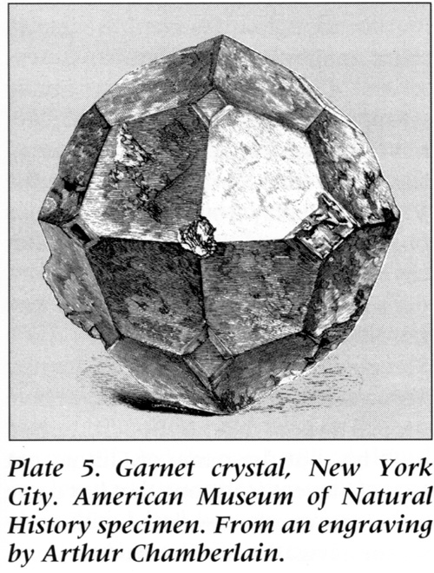

**I hadn't acquired this passion from any acquaintances; I certainly didn't inherit it; yet I can't remember the time when I wasn't solitarily and unbearably thrilled by the spot of ore in a bit of rough rock.**

Did he forget about his father's influence? Or was there really none?

**I first became conscious of this strange passion one day when, aged ten, I dropped into Barnum's Museum on Ann Street and Broadway, opposite the old Astor Hotel, just a few weeks before it burned down. The collection of minerals formed by Mr. Bailey was on exhibition and I hung, suffocated with pleasure, over the cases. Since then my eyes have looked upon more wealth in gems, I suppose, than any other living eyes, yet nothing has ever seemed to me more thrillingly beautiful than those not-even-precious stones in old Barnum's Museum. The only person who even understood this curious passion of mine was Mr. Benjamin Chamberlain, a man when I was a boy, who devoted twenty five years to making the finest collection of minerals from Manhattan Island ever gathered, a collection that is now in the [American] Museum of Natural History.**

Kunz's information about the Chamberlain collection is still valid today in that the collection remains at the American Museum, but alas, it is now completely in storage. For many years it occupied a place of honor near the entrance to the old hall, beautifully displayed in its own large case. Perhaps one day it will again emerge.

***Acclaimed***

**Shortly after the Barnum Museum fire my family moved to [Hoboken] New Jersey and I was able to start collecting minerals from the vicinity of Bergen Hill and the Elysian Fields, gradually, as I grew older, extending my excursions to include Franklin [New Jersey], Staten Island and New York City. At the age of fourteen I started sending specimens abroad for exchange, and had already begun that unending stream of correspondence on mineralogy which now inundates the vaults of several museums, the cellars and several of the rooms of my home, my private offices, and heaven knows what outlying territories. It all seems to me very interesting and important, though I suppose its custodians would gladly see it heaped in a pyre on the Mall of Central Park, its flames licking the sky.**

This statement about his correspondence is very interesting and most provocative, but puzzling. Kunz was certainly correct when he said that by the year 1927 (he lived another five years) his letter files were vast. Beginning around the year 1973, and over a period of about two years, I was offered the privilege of purchasing the largest known segment of these files, around eight thousand "letters to Kunz." They were offered for sale by the bookseller Raphael Gould who did business as the "American Library Service" in New City, New York. He supplied them in small affordable lots and every lot offered was purchased by me. He had bought them en bloc from a book-selling firm, now out of business, by the name of De Forest in New Orleans, Louisiana, some years before, and had made prior sales of only a few small lots, privately and at auction, whenever the mood suited him. How all those letters wound up in New Orleans, Ray did not know, nor has anyone to this day been able to shed any light on this mystery. There were many visits from Ray with folders filled with these precious documents, and, as the end of this adventure was nearing, and when it seemed certain that the supply was finally exhausted, he managed to find "just one more box" in his basement. Ray died a few years ago and, ironically, "just one more box" of Kunz letters that he had overlooked was found. Unfortunately they were offered and sold elsewhere, but happily they ended up as an addition to the largest holding. The only museum that previously owned any Kunz letters in any quantity, is, the New- York Historical Society. The majority of my large lot of Kunz letters (the largest single holding known) is now safely ensconced in the library of the American Museum of Natural History. Some letters were retained by me (later sold to Richard Hauck and the Hauck Archives) and some were discussed in detail in my book "Notes and Commentaries on Letters to George F. Kunz," Privately Printed, New Canaan, Connecticut, 1986, and other letters are still at hand as this is written. There was a "Special Limited" edition of the book, each copy of which contained, loosely inserted, one of the forty-three original letters described therein. It is difficult to understand what Kunz meant by the "correspondence on mineralogy which now inundates the vaults of several museums....," because these caches cannot be located today. Perhaps he was referring to the letters he received rather than those he sent.

Kunz takes a big jump in time in the coming paragraph, and these are the years of his life about which he was most reticent. Very little can be uncovered about what he did for his daytime employment, but apparently he was some sort of clerk. The collection that he refers to next was sold by him in 1876 when he was twenty years old, leaving us to fill in the considerable gap of approximately nine years in his life.

**Between working days and studying nights at Cooper Union, with a few holidays in the summer, I managed to complete my first collection, and whatever else may be said of it, it was, from the point of sheer bulk and weight, the most considerable I made. It contained 4000 specimens and weighed two tons! It now became my great and consuming ambition to sell this collection, not so much for the money it might bring but to mark myself in the eyes of the world as a real collector.**

Things have certainly changed. Today no one would think of Kunz as a "collector" for having sold such a two-ton collection to the University of Minnesota, in fact, he would be called a "dealer."

Many years after this time, in 1916, Kunz wrote one of his classic books, "Rings for the Finger," and, recalling those early days, he dedicated it to Peter Cooper and to "The Cooper Union of Arts and Sciences, in the laboratories, lecture rooms and library of which the author spent useful, profitable evening hours for several years, at a time when there were no other opportunities of a similar nature in the city of New York."

**Of course such collections are of value only to museums, their interest being purely mineralogical and geological. A mineralogist collects everything that Nature produces, and those things with the least commercial value often have the greatest value in his eyes. Already my collection was so good that I was able not only to exchange abroad but even to sell duplicates here, some to Dr. Harvey Wiley, the pure-food expert; and when I finally received an offer of $400 for the lot-it was, of course, worth much more-from the University of Minnesota, I was smothered in pride. Not, I think, when I received the honors of Officier de la Légion d'Honneur, of a Knight of the Order of St. Olaf, or Officer of the Order of the Rising Sun of Japan, did I experience the same thrill as on that day that officially placed me among recognized mineralogists.**

Harvey Washington Wiley, M.D. (1844-1930) was a very important and influential person in his day. He was a chemist, teacher, author, lecturer and pure food reformer. It was because of his efforts that the very first Food and Drug Act was passed by Congress in 1906.

The mineral collection Kunz referred to still exists today, at the Geology Department of the University of Minnesota, in considerably diminished status, but each surviving piece still retains its original Kunz label. Four hundred dollars of 1876 can, perhaps, be translated to approximately $40,000 of today, especially where mineral specimens are concerned.

**Not all my childhood was a delectable grubbing for minerals. I remember less passionate but not less happy hours spent in walks-before we moved away from New York-with my father, who was a great lover of Nature, in search of various wild flowers through the fields and lanes and little wooded stretches of New York City. Everything north of Forty-second Street was an open cut, and at Fifty-ninth Street the city broke into a turbulent wilderness. Below that, one house to a block was a good average, horse cars and carriages were the only means of getting about, and it took three-quarters of an hour to go from Canal Street to Fifty-ninth.**

Kunz' description of the rough nature of the landscape of the city at that time and the thought of all those outcrops of the Manhattan schist with their mineral-rich, pegmatite-dike intrusions should make the pulse of any modern day mineral collector quicken. Today only Central Park retains such outcroppings, and they are strictly forbidden to collectors, although some display, provocatively, large and attractive garnet crystals on their surfaces. It is reasonable to assume that Kunz' father introduced him to the study of rocks and minerals on their nature-walks in spite of his claims to the contrary, as the pair, seeking wildflowers as Kunz stated, could hardly have missed observing so many areas of bedrock that were being blasted and broken up. This was, after all, the time of the great leveling of Manhattan Island. (See Plate 7.)

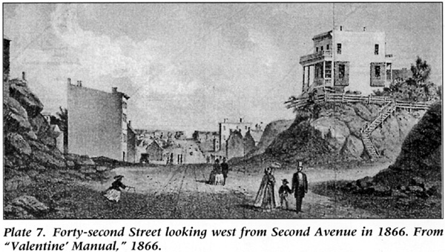

**Then, in Jersey, I had a playground it would be hard to beat-one that had cost almost $5,000,000. At the foot of Third Street in Hoboken lay the bulk of one man's magnificent but impractical dream. In 1861, when the war broke out Edwin Stevens, founder of the Stevens Institute of Technology, had a beloved daughter in the South. He couldn't face the torture and suspense of being separated from her during the uncertain duration of the war, nor any perilous attempts she might make to win her way north. So, like the lordly gentleman he was, he built her a ship of her own to sail south for her and carry her home in triumph. No ordinary passenger ship was this-no gentleman's pleasure yacht-but, killing two birds with one stone, this amazing man-who feared as much for the safety of New York as for that of his daughter, and always maintained that any properly guarded enemy ship could enter the harbor and blow us to pieces-built a submersible gunboat for our defense.**

**Alas, though at his death he left an extra million to complete it, it was never finished and was finally scrapped and sold in 1875 for $55,000, never having fired a shot in defense of the city. When I was a lad it was the $5,000,000 playground of the Stevens boys and their friends, and better caves, mines, pirate holds or thieves' dens I defy any boy to find. They had no luck with their boats, those Stevenses. There was an earlier Stevens who built a single and double propeller boat before Robert Fulton built his, but the name of Fulton, not that of Stevens is the one that has come to be commonly associated with early steam navigation on the Hudson.**

***Why are They Precious?***

**I made other mineralogical collections after that-better if not bigger-and sold them to various museums, so that it was natural that I should eventually become connected with the [American] Museum of Natural History in New York, which at that time modestly occupied two floors in the little old red brick Arsenal Building in Central Park. Later I was offered the directorship of the National Museum at Washington, but I had already begun to look in another direction.**

This is a most provocative statement indeed. It is the only such reference in any of the Kunz literature, published or otherwise. The obvious question that pops to mind is- was Kunz speaking of the directorship of the entire USNM or just the department of gems and minerals? John Sampson White, formerly Curator of Gems and Minerals at the National Museum asked me for help in supporting or denying Kunz' claim, but I could do no more more for him than to show him the original source of the remark. There is, apparently, no surviving record at the United States National Museum to support Kunz' claim. It would be most interesting to know how much "later" the offer was made. If, by the term "look in another direction" Kunz was referring to his employment by Tiffany & Co., the date in question would have been around 1875.

**I wanted to continue working at one thing only as long as I felt I could better myself, and though I still employed my leisure in studying mineralogy and chemistry I had become interested in another phase of the science.**

Today we would call that science- gemology.

**At that time the jewelry profession was strictly confined to precious stones, of which there are but four-the diamond, ruby, emerald and sapphire-and-not a stone but none the less precious-the pearl. These were, as a matter of fact, the only gems that were really seriously considered, although cameos had a certain less solemn vogue, as also the onyx and bloodstone. Up until the middle of the nineteenth century, coral, opal and turquoise had been considered precious gems, but due to the change in fashion, to the great quantities of inferior material put on the market and to increased understanding of the nature of gems, they had by this time been ranked with the semiprecious gems.**

**Now in my mineralogical investigations I had from time to time come across many beautiful minerals that had all the qualities of gems, being of great hardness, tenacity, brilliancy, transparency, purity and exquisite coloring. Cut and polished, many of these stones rivaled in beauty the precious stones. They were indeed, in every acceptance of the term, gems, even though denied the epithet "precious."**

**The question of preciousness is an interesting one. Just what is it, I am often asked, that ranks a gem as precious? What excludes it? It is no one quality but a combination of several. The opal may certainly lay claim to be as beautiful as the ruby; yet the ruby is precious and the opal is not. The zircon is as brilliant as the diamond, yet not precious. The beryl is as hard as the emerald, yet not precious. The tourmaline is as durable as the pearl, yet not precious. The hiddenite is more rare than the sapphire, yet not precious. Here are the prime qualities that determine the rank of a gem-all of them possessed by stones ranked as semiprecious. But preciousness is like the beauty of a face; it is not alone a fine pair of eyes or a lovely complexion that constitutes beauty, but a combination of several qualities.**

**Therefore it is only when a gem possesses to the nth degree, first hardness-the principal qualification-then brilliancy, then beauty, then durability, then rarity, that it is given the brevet of preciousness. As in a horse or a dog, it is a question of the highest number of points. That is why the diamond outranks all other jewels. It really possesses the qualities of all other stones-the greatest hardness, an unsurpassed brilliancy, an unrivaled beauty-due to its play of color and its fire-an unexcelled durability and extreme rarity. But, above all, it is its supremacy in hardness that places it beyond all other stones. It is the hardest known substance on earth and, as far as we can judge, on any planet.**

**Rubies and sapphires come next in hardness-they are one and the same stone, except for the coloring matter-and emeralds rank third, being, even though third, yet so hard that nothing will scratch them but a precious stone. The pearl stands alone. The diamond is king, the pearl, queen-with just that touch of feminine frailty that is part of a woman's charm. For the pearl is less hard than many even of the semiprecious stones; yet-again like a woman-it has as much endurance as the masculine gems. I have myself tried its feminine durability by the severest tests. I once took a number of pearls weighing two grains each and, placing them on pine, oak, mahogany and rosewood boards, pressed them in with my heel, and none of them was broken or scratched, though they sank clean into all the boards, with the exception of the rosewood, into which they sank only halfway. It is this quality of the pearl that raises it unquestionably above the opal, which is more or less fragile.**

**In those early days, as I have said, no so-called fancy stones were on sale in any jewelry store in the country; one could scarcely find them in a lapidary's shop, yet, reviewing those that I had gathered, it seemed to me that many ladies, even those who could afford the gesture of diamond tiara and pearl choker, would be happy to array themselves in the endless gorgeous colors of these unexploited gems. As I looked over a collection of them, with the sunlight imprisoned in the sea-green depths of the tourmaline, lapping at the facets of the watery-blue aquamarine, flooding the blood-red cup of the garnet, glancing from the ice-blue edges of the beryl, melting in the misty nebula of the moonstone, entangled in the fringes of the moss agate, brilliantly concentrated in the metallic zircon, forming a milky star in the heart of the illusive star sapphire-how, I thought, could a woman ever resist their appeal?**

***A New Gem***

**So one day, buckled in youth, I wrapped a tourmaline in a bit of gem paper, swung on a horse car, and all the way to my destination rehearsed my arguments. Arrived there, I was finally received by the managing head of what was even then the largest jewelry establishment in the world, and showed him my drop of green light. I explained-a very little; the gem itself was its own best argument. Tiffany bought it-the great dealers in precious stones bought their first tourmaline from me. The check which crinkled in my pocket as I walked home in the late afternoon, forgetting there were cars, stargazing, tripping over curbs, meant very little in comparison with the fact that I had interested a foremost jeweler of that time in my revolutionary theory and made the acquaintance of a man who was later to become my close friend.**

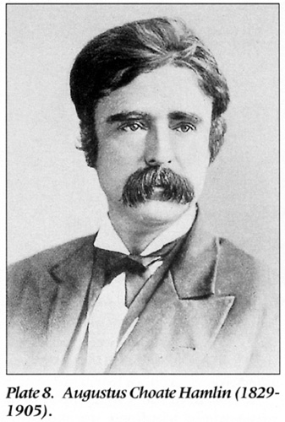

The time frame for the above event is around 1875, and this particular green tourmaline came, almost certainly, from Mount Mica in West Paris, Maine, and was mined by Augustus C. Hamlin, M.D. (1829-1905). (See Plate 8.) Dr. Hamlin, with his family had been mining tourmaline since 1869, and by this time, had written, in the year 1873, the lovely book "The Tourmaline. Its Relation As A Gem; Its Complex Nature; Its Wonderful Physical Properties, Etc., Etc.; With Special Reference To The Beautiful And Matchless Crystals Found In The State Of Maine." He later wrote, in 1895, the more comprehensive work "The History Of Mount Mica Of Maine, U.S.A. And Its Wonderful Deposits Of Matchless Tourmalines." Hamlin will be remembered by the general public for his famous book "The History of Andersonville," published in 1866. Kunz and Hamlin conducted a long and fruitful correspondence over the years, and the Kunz end of these files may be consulted today at the American Museum of Natural History library. A few other Hamlin letters were published in "Letters to Kunz." Kunz, for the Tiffany account, purchased many of the best tourmalines that Hamlin unearthed over the decades. Hamlin wrote Kunz in 1887 and described "1 tourmaline cut 27-1/2k another cut 34-1/4 brilliant grass green hue. The two finest colored gems yet found in the US Val[ue] $1000 each." The 27-1/2 carat stone was acquired by Kunz for Tiffany and the 34-1/4 carat example was retained by the Hamlin family for inclusion in the famous "Hamlin necklace" now in the collection of the Harvard Mineralogical Museum.

**Thereafter I sold Tiffany's many other semiprecious stones. Then one day came the offer to join the firm as their first gem expert, and ever since I have held that position.**

It did not take Charles Tiffany long to recognize the potential of the future of young Kunz, who even at that age knew so much about gems and minerals and delivered his information so well. No other jewelry firm of that time was able to boast a "gem expert" on its staff.

**In those first days very naturally a large part of my interest was engaged in this problem of discovering and introducing, one after another, as the public gradually became interested, these lovely unknown semiprecious stones in which no jeweler of the time was even slightly interested. Of course, with the backing of such a firm I was in a commanding position to do this. Naturally, at first the public was skeptical. I not infrequently heard such withering remarks as "A zircon? What's a zircon? It's just an imitation stone, isn't it...You mean it grows like that?...Oh, no thank you, I'd feel like a gypsy. I'd just as lief wear a lump of colored glass. It has no real value." And the poor little blob of sunlight would dwindle in my palm till even I had some difficulty in maintaining my respect for it-the zircon that today sells as high as forty dollars a carat and a single fine gem of which has brought as high as $2000, not to mention the tourmaline, fine examples of which sell for thirty dollars a carat, and a very fine cat's-eye for more than $100 a carat.**