George Frederick Kunz 1856 - 1932

http://en.wikipedia.org/wiki/George_Frederick_Kunz

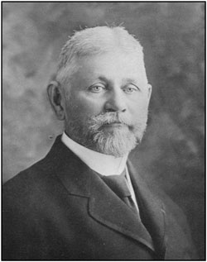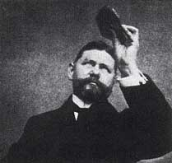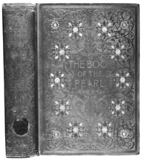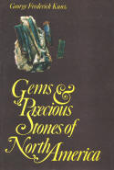

George Frederick Kunz (September 29, 1856 – June 29, 1932) was an American mineralogist.

Contents

1 Overview
- 2 Awards
- 3 Reference
- 4 External links

Overview
Kunz was born in New York City, USA, and began an interest in minerals at a very young age. By his teens, he had amassed a collection of over four thousand items, which he sold for four hundred dollars to the University of Minnesota. Kunz attended Cooper Union but did not finish and did not attend college. Nonetheless, he taught himself mineralogy from books and field research. This expertise landed him a job with Tiffany & Co., and his knowledge and enthusiasm propelled him into a vice presidency by the time he was 23.
He gained much notoriety for identifying a new variety of the mineral spodumene which was named "Kunzite" in his honor.
He headed up the US mining and mineralogical exhibits at the international expositions in Paris (1889), Chicago (1893), Atlanta (1895), Paris (1900), and St. Louis (1904). As a gentleman scientist, he was a member of the Mineralogical Society of America, the American Association for the Advancement of Science, New York Academy of Sciences (of which he was once a vice president), the New York Mineralogical Club, the American Scenic and Preservation Society (for which he served as president), the American Chemical Society, the American Institute of Mining and Metallurgical Engineers (of which he was once a vice president), and many other cultural, scientific, and naturalist organizations. He was the founder and president of the Museums of the Peaceful Arts in 1913, special agent for the US Geological Survey (1883-1909), a research curator at the Museum of Natural History in New York City, and the leading advocate in the establishment of the international carat as a unit of measure for precious gems. He also assembled the Morgan-Tiffany collection of gems in the American Museum of Natural History. Kunz had an active life dedicated to science and public service.

Awards
He was given many honorary degrees from US and European universities. He wrote over 300 articles during his life.
Kunz married Sophia Hanforth in 1879, who died in 1912. In 1923, Kunz married Opal Logan Giberson but soon annulled the marriage. Nonetheless, Opal continued to maintain Kunz's household until his death, on June 29, 1932.

Reference
Biographical article on George Frederick Kunz, American Mineralogist 18 (1933), 91-94.

External links
- Shakespeare and Precious Stones, available at Project Gutenberg.
- Kunz: the book of the pearl available online and in pdf downloads from the Gem and Diamond Foundation.
- Gems and precious stones of North America. Overview of all locations of famous gemstones such as emeralds, sapphire, rubies to rare ones such as hiddenite

