Charles William King 1818 - 1888

http://en.wikipedia.org/wiki/Charles_William_King

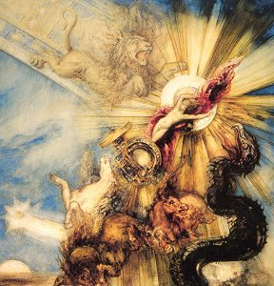

Charles William King (September 5, 1818 - March 25, 1888), was a British Victorian writer and collector of gems.

Contents
- 1 Early Life
- 2 Gem Expert
- 3 Classicist
- 4 External links

Early Life
He was born at Newport, Monmouthshire, south east Wales, and entered Trinity College, Cambridge, in 1836. He graduated in 1840, and obtained a fellowship in 1842; he was a senior fellow at the time of his death in London.

Gem Expert
He took holy orders, but never held any cure. He spent much time in Italy, where he laid the foundation of his collection of gemstones, which, increased by subsequent purchases in London, was sold by him in consequence of his failing eyesight and was presented in 1881 to the Metropolitan Museum of Art, New York.
King was recognized universally as one of the greatest authorities in this department of art. His chief works on the subject are:
- Antique Gems, their Origin, Uses and Value (1860), a complete and exhaustive treatise
- The Gnostics and their Remains (2nd ed. by J Jacobs, 1887, which led to an animated correspondence in the Athenaeum)
- The Natural History of Precious Stones and Gems and of the Precious Metals (1865)
- The Handbook of Engraved Gems (2nd ed., 1885)
- Early Christian Numismatics (1873).

Classicist
King was thoroughly familiar with the works of Greek and Latin authors, especially Pausanias and the elder Pliny, which bore upon the subject in which he was most interested; but he had little taste for the minutiae of verbal criticism.
In 1869 he brought out an edition of Horace, illustrated from antique gems; he also translated Plutarch's Moralia (1882) and the theosophical works of the |Emperor Julian (1888) for Bonn's Classical Library.

External links
- "The Gnostics and their Remains" - online text of the book
=====================================================

