Gill’s Index Available as Free Digital Download

http://www.palagems.com/gem_news_2009_v1.htm#gill_index

Updated, Searchable Index of 20,000 Docs on Gems and Jewels
Joseph O. Gill is offering a newly revised edition of his classic Gill’s Index to Journals, Articles and Books Relating to Gems and Jewelry. For free. And in an easily searchable digital format. Originally published in 1979, Gill’s “analog” database was only the second book published by the Gemological Institute of America that was not written by a GIA staff member, according to a lively scrapbook/biography offered as “Appendix 1” to the new digital version.
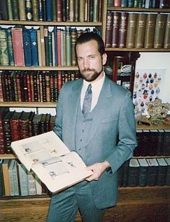
Joseph O. Gill, the author, in his library at Gill and Shortell, Ltd., San Francisco, 1987. (Photo courtesy Joseph O. Gill)
Both Gill’s Index and Appendix are available for free download via Internet Archive (host of the famous Project Gutenberg).
Since 1988, Joseph O. Gill, formerly of Sotheby’s and his own business Gill and Shortell Ltd., has spent his (early) retirement on the big island of Hawaii and, since 2003, trotting the global south and east that he’d traveled as a child—this go-’round sampling far-flung sights and vegan delights, laminated cheat-sheet in hand. (How do you say, “No flesh, please,” in Laotian?)
Gill packed a lifetime of achievement into his brief fifteen-year career: successfully challenging the Gemmological Association of Great Britain’s first-year exam and receiving both his F.G.A. from Gem-A and G.G. from GIA in 1973; a year later becoming head gemologist for Boston’s J. & S.S. DeYoung Inc. (and providing the firm with its single biggest sale—sans commission); being appointed western U.S. director of Sotheby’s jewelry sales in 1980 (increasing business by 400% in the first year); eighteen months later starting his own business and then being offered (and declining) the top job at GIA, by Richard Liddicoat…
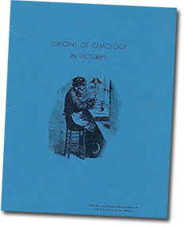
Origins of Gemology in Pictures was compiled by Gill for the AGS Conclave held in Boston, during his time as J. & S.S. DeYoung’s head gemologist. (Image courtesy Joseph O. Gill)
And, of course, the publication of his magnum opus, the product of nine years of compilation on 48 inches’ worth of 5"x8" index cards—about 4,500 by our estimation. Typing the book’s draft alone took eighteen months.
So you can look up France and find that a rough diamond was found there or what gems were found in Antarctica or California or Nigeria or Ghana or Florida or in the oceans or anywhere including from outer space. You can find all the references ever in English from the first book done by Thomas Nicols on gems in 1652 until 2008, near 350 years of all the publication in English on gems along with more than 18 journals on gems and minerals. I went through each sentence of each publication and all was put in this handwritten annotated index.
While still on the road in Katmandu, Gill obtained a high-quality optical character recognition scan of the original Index. He proofed the text and for three years, with limited resources, he revised the text to the best of his ability. The text includes links to other gemological works offered by Internet Archive, where Gill also has posted:
- The Personal Scrapbook of Henry D. Morse (Trained the First Diamond Cutters in America) and Charles M. Field (Inventor of the Modern Diamond Cutting Machine) – Scrapbook (and Many Extras)
- Origins of Gemology in Pictures by Joseph O. Gill, presented to attendees of the Bicentennial 1976 American Gem Society Conclave in Boston
As Gill told us, “You will definitely want to go to Archive.org and do a search for ‘gems, gemology, jewelry, Gill’ to see the many other unique texts that I have contributed to this wonderful web site.” [back to top]
— End February Newsletter • Published 2/25/09 —
-==========================================================================================
http://www.palagems.com/gem_news_2009_v1.htm

Gill’s Historical Index Gets Update

Check back often for free revisions
Joseph O. Gill’s Historical Index to Gems and Jewelry Online, which we profiled last month, has been updated as of March 8. The book, in Microsoft Word 2007 format, is available for free download from the Internet Archive.
Gill urges those interested in the index to check the above website from time to time in order to take advantage of the most recent version. [back to top]
— End March Newsletter • Published 3/18/09 —

