Gem and Jewelry Industry Mourns the Passing of
Richard T. Liddicoat, 'Father of Modern Gemology'

Richard T. Liddicoat March 2, 1918-July 25, 2002

http://www.fashionwindows.com/fashion/jewelry/richard_liddicoat.asp

Jul 25, 2002/ FW/ --- The global gem and jewelry industry lost one of its true giants and greatest contributors on July 23 when the man known worldwide as the "Father of Modern Gemology," Richard T. Liddicoat, passed away at age 84 in Los Angeles after a lingering illness.  Liddicoat joined the Gemological Institute of America (GIA) in 1940 after graduating from the University of Michigan with a B.S. in geology and an M.S. in mineralogy. He assisted GIA's founder, Robert M. Shipley, in guiding the young Institute as it grew into the gem and jewelry industry's premier source for education, research, gemological instrument development, and laboratory services for diamonds, colored stones, and other gem materials.  Liddicoat became executive director of GIA in 1952 (later re-titled president) and led the Institute until 1983, when he retired as president and was unanimously elected chairman of the board. In 1992, he was named chairman of the board for life. Liddicoat was also editor-in-chief of Gems & Gemology, GIA's professional journal, from 1952 to the present.  He was revered throughout the jewelry industry and the gemological community, as well as in scientific circles, for his pioneering efforts in advancing the science of gemology and for his breakthrough innovations, the most famous of which was creation of the International Diamond Grading System™ in 1953. This method of evaluating diamonds, based on the Four Cs (cut, color, clarity, and carat weight), became the de facto worldwide standard for grading diamonds. Liddicoat was also instrumental in organizing and building GIA's renowned Gem Trade Laboratory.  In addition, Liddicoat was acclaimed internationally for his work in the development of GIA's education program (with more than 25,000 recipients of the prestigious Graduate Gemologist [G.G.] diploma alone) and numerous contributions to the gemological literature -- including such staple publications as The Handbook of Gem Identification, The Diamond Dictionary, and The Jeweler's Manual.  He was also involved in developing new gem-testing techniques and instruments, and oversaw the establishment of a formal research program at GIA. In the eyes of many, however, his greatest achievement was his personal influence on the professionalism and ethical standards of the international gem and jewelry industry.  William E. Boyajian, president of GIA, who was personally mentored by Liddicoat for more than 25 years, gave voice to the sentiments that many in the gem and jewelry industry felt on learning of Liddicoat's passing: "We have lost a man of incredible dedication and achievement in this great industry, a man of monumental stature."  "Richard Liddicoat's contributions on behalf of jewelers, gemologists, and the consuming public have changed the course of history. He was a true friend and a father figure to me, as I know he was to others, and it saddens me immensely that he will no longer be here to provide the wisdom and guidance that only a man of his remarkable intellect and incomparable accomplishments could offer," Boyajian continued.  Glenn Nord, who succeeded Liddicoat as president of GIA in 1983 and served in that position until Boyajian was appointed in 1986, said, "Richard T. Liddicoat meant the world to me, and I'll miss him deeply. He inspired me to excel in gemology and as a person, and he set the highest standards of achievement and integrity for everyone at GIA, students and staff alike, as well as for the entire industry. We'll not see a man of his character and significance for a long, long time."  A celebration of the life of Richard T. Liddicoat will be held at GIA's Carlsbad headquarters on Saturday, August 24. For more on Richard T. Liddicoat's life and his incomparable contributions to GIA and the gem and jewelry industry and for updates on observances for him, visit the GIA web site at www.gia.edu. | 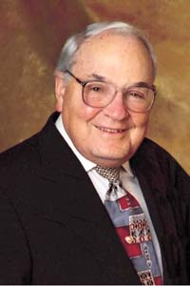Richard T. Liddicoat, the "Father of Modern Gemology"

Previous: Bottega Veneta Got London in the Bag | Next: Weddings Provoke Mixed Emotions
Start Fashion Review | End Fashion Review

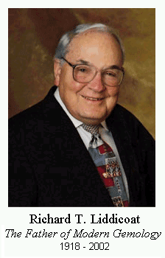
http://www.gia.edu/richardliddicoat/rtlhousing.cfm
Dear Friends,
With deep sadness I share with you that our beloved Chairman, Richard T. Liddicoat, passed away July 23. As many of you know, Mr. Liddicoat's health had declined to such an extent, with pain so severe in recent weeks, that I can honestly say this is a blessing.
As all of us grieve over this profound loss, we can perhaps take comfort in having known and loved such a great man. He was remarkable in every way: a leader, a scholar, and someone who knew what it meant to be deeply human.
I for one will cherish the moments we shared, the things I learned, and the inspiration I gained through knowing and working alongside Richard Liddicoat. I encourage each of you to take consolation in the wonderful times you had with the man we affectionately called "Mr. L."
A memorial and remembrance service was held at GIA Carlsbad on August 24, during which more than 500 of his friends and colleagues from all avenues of life and all parts of the world joined in a special celebration of life. I realize that many members of our extended GIA family around the globe were unable to attend, but I know that you were here in spirit as we remembered the man who will always be known to us as "Mr. GIA."
Warm regards,
Bill Boyajian
GIA President

Warm regards,
Bill Boyajian
GIA President

Richard T. Liddicoat Dies at 84
July 18, 2002
http://www.jewelerssearch.com/News/richard_t.htm
By Rapaport
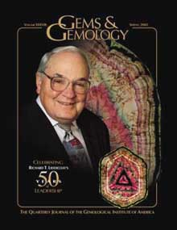
Richard T. Liddicoat, chairman of the board at the Gemological Institute of America (GIA) and editor-in-chief of Gems & Gemology, passed away July 23 in Los Angeles after a lingering illness. He was 84.
Liddicoat joined GIA in 1940 after graduating from the University of Michigan and became the executive director in 1952. He led the Institute until 1983, when he retired as president and was unanimously elected chairman of the board. In 1992, he was named chairman of the board for life. Liddicoat also served as editor-in-chief of Gems & Gemology, GIA’s professional journal, from 1952 to the present.
The man known worldwide as the “Father of Modern Gemology” was renowned for his innovations, the most famous of which was the creation of the International Diamond Grading System in 1953. This method of evaluating diamonds, based on the Four Cs, became the de facto worldwide standard for grading diamonds. He was also acclaimed for his work in the development of GIA’s educational program, his numerous contributions to gemological literature, as well as his personal influence on the professionalism and ethical standards of the international gem and jewelry industry.
A celebration of the life of Richard T. Liddicoat will be held at GIA’s Carlsbad, California headquarters on August 24.

In Memoriam

Richard T. Liddicoat 1918 – 2002

http://www.ganoksin.com/orchid/archive/200208/msg00090.htm

The gem industry has lost another giant when Richard Liddicoat
passed away last week. He was 84.

Richard Thomas Liddicoat Jr. was born in Kearsarge, Michigan in
1918. He received a bachelor's in geology and a master's in
mineralogy from the University of Michigan. He served with the Navy
in World War II. Universally known as the "Father of Modern
Gemology," Mr. Liddicoat's contributions to the gem industry are
enormous. He is credited with creating the International Diamond
Grading System^(TM) in 1953, based on the Four C's. He was also
instrumental in establishing the GIA's educational program. He
taught the first classes on 1953 in Manhattan.

Mr. Liddicoat served as GIA president from 1952 to 1983. Among his
numerous writings are The Handbook of Gem Identification, The
Diamond Dictionary, and The Jeweler's Manual. He was editor of GIA
Diamond Dictionary in 1993 and editor in chief of Gems & Gemology
from 1952 until his death.

In keeping with Mr. Liddicoat's wishes, if you would like to make a
gesture of remembrance, please do so through the Richard T.
Liddicoat memorial Fund at GIA.

July 25, 2002
Liddicoat Dead at 84

http://www.professionaljeweler.com/archives/news/2002/072502story.html
Richard T. Liddicoat, a force in American gemology, died July 23. He spent more than 60 years at the Gemological Institute of America, Carlsbad, CA, where his most recent positions were chairman of the board of governors and chief editor of Gems & Gemology, GIA's scientific journal. He was chief editor for 50 years.
Hired in 1940 by GIA founder Robert M. Shipley, Liddicoat quickly progressed to director of education before leaving GIA to serve in the U.S. Navy during World War II. After military service, he returned to GIA and was named director of education and research. In 1947, he published the Handbook of Gem Indentification, which continues to be a widely used gemology textbook and is in its 12th edition.
In 1952, Liddicoat was named executive director of GIA, prior to working with a group of scientists to develop the GIA diamond-grading system, the now-standard system used by gemologists around the world. In 1955, he oversaw the GIA Gem Trade Laboratory's first diamond grading reports. During the 1960s, he coauthored several books, including The Diamond Dictionary and The Jewelers' Manual. In the 1970s, Liddicoat expanded GIA's reach globally, with gemology courses taught first in Japan and Israel. He also created the GIA Research Department.
Liddicoat stepped down as president of GIA in 1983 and was named chairman of the board of governors. In 1989, GIA honored him with the dedication of the Richard T. Liddicoat Gemological Library and Information Center. Among the many honors and awards he received over the course of his lifetime were GIA's League of Honor Lifetime Achievement Award in 1995 and the American Gem Society's Lifetime Achievement Award in 2001.
by Peggy Jo Donahue and Robert Weldon, G.G.

Richard T. Liddicoat, GIA Chairman of the Board
1918 – 2002
www.gia.org/richardliddicoat/rtlhousing.cfm?idx=3
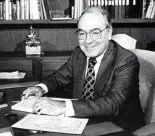
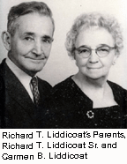
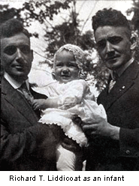
Richard T. Liddicoat, Jr. was born in Kearsarge, Michigan on March 2, 1918 to Richard Thomas and Carmen Williams Liddicoat. He attained a B.S. in Geology from the University of Michigan in 1939, and on September 21 of that year married Mary Imogene (Gene) Hibbard. His post-graduate education included an M.S. in Mineralogy in 1940 also from Michigan, and another in Meteorology from the California Institute of Technology in 1944. In between he took the GIA gemology courses, and received what is now called the Graduate Gemologist (G.G.) diploma.
Richard Liddicoat had been with GIA since 1940 (with the exception of three years in the Navy during World War II). His various positions during his tenure with GIA included director of the New York branch 1949-1950, assistant director of GIA from 1950-1952, executive director from 1952-70, president from 1970-1983, and chairman of the board from 1983 until his death.
Liddicoat was also a U.S. delegate to the International Gemmological Conference from 1960 and to CIBJO (an international jewelers' association) since 1980. Domestically, he was a delegate to the President's Conference on Small Business (1957), and was a trustee of the National Home Study Council in Washington, D.C. (1980).
He was the author of a gemology standard, The Handbook of Gem Identification, now in its 12th edition, and co-authored The Diamond Dictionary and Jewelers Manual, as well as wrote numerous articles in professional and trade journals. Additionally, he was chief editor of GIA's quarterly journal, Gems & Gemology, from 1952 until his death. He contributed to the Encyclopedia Britannica, Jr., the Encyclopedia Americana, and the McGraw-Hill Encyclopedia of Science and Technology. Liddicoat had a major part in the development of the material included in the courses offered by the Gemological Institute of America.
Liddicoat was a Fellow of the Mineralogical Society of America, American Association for Advancement of Science, and the Geological Society of America. He was a founding member of the International Colored Stone Association.
Other memberships include Sigma Xi, Sigma Gamma Epsilon, the Bel Air Country Club of Los Angeles (Board of Directors 1980-1983), the Twenty-Four Karat Clubs of New York City and Southern California, and the American Gem Society.
The American Gem Society awarded him an honorary C.G. (Certified Gemologist) title in 1947, and he was recipient of the Shipley Award (the highest award of the American Gem Society) in 1976. And at the American Gem Society's Circle of Distinction Awards Dinner in 2001, he was honored with the Society's Lifetime Achievement Award.
Liddicoat was an honorary fellow of the Gemmological Association of Great Britain, and was awarded the first honorary life membership of the Gem Testing Laboratory of Great Britain. A species of tourmaline was named liddicoatite for him in 1977. He was selected to receive Modern Jeweler magazine's Lifetime Achievement Award for 1985. Liddicoat was also honored by Golden Nuggets of Southern California (1965), named "Man of the Year" (1984) by the Consolidated Jewelers Association of Greater New York, and received awards from the International Precious Stones Congress in Tel Aviv (1983), the American Gem Trade Association (1983), the Southern California chapter of the GIA Alumni Association (1984), the International Society of Appraisers (1985), the Board of Governors and Staff of the Gemological Institute of America (1985), and the International Colored Stone Association (1987). Later in 1987, Liddicoat was the recipient of the Morris B. Zale Lifetime Achievement Award.
In 1992, Richard T. Liddicoat was named GIA's Chairman of the Board for Life by a unanimous vote of the Board of Governors. He continued his distinguished career as a leader for GIA and an eminent statesman for the international gem and jewelry industry up to his final days.
The Ultimate Gemologist: A Tribute to Richard T. Liddicoat Gems & Gemology,
Spring 2002
Richard T. Liddicoat's Curriculum Vitae

July 2000
Gemstones & Pearls/News
http://www.professionaljeweler.com/archives/articles/2000/jul00/0700gn3.html
Liddi-Coat of Many Colors
Increasing supplies of the rare Madagascar gem named for GIA's Richard T. Liddicoat are reaching the market

Liddicoatite – a dramatic gem with a special name – is seen with increasing frequency. Found almost exclusively in Madagascar, this variety of tourmaline is marked by color banding and a three-rayed star resembling the Mercedes auto logo.
The gem, long sought by collectors, is named in honor of Richard T. Liddicoat, chairman of the Gemological Institute of America. It’s usually cut in slices to show off its unusual formation and banding. But as Madagascar reveals more and more of its gem wealth, more liddicoatite is making its way into the market, and some is faceted. Faceting erases the Mercedes logo effect, but retains the striped elegance.
Tom Cushman of Allerton Cushman, Sun Valley, ID, recently exhibited several faceted liddicoatites. “When all you’ve seen is liddicoatite cut in slices, you hardly expect to see them this way,” says Cushman, who regularly travels to Madagascar.
What Is Liddicoatite?
Liddicoatite is particolored, meaning more than three colors are visible. It differs from other particolored tourmalines because it has calcium and lithium, which produce violet and red, colors not seen in other tourmaline, says Dr. Emmanuel Fritsch at the University of Nantes in Nantes, France.
Liddicoatite may be colored also by manganese, chromium and titanium. The arrangement of the elements creates the symmetrical banding and, in the crystal, the triangular pattern.
In 1990, a faceted, purplish red liddicoatite from Minas Gerais, Brazil, was presented to Liddicoat, marking the discovery of a new source. However, Madagascar remains the classic source.
– by Robert Weldon, G.G.
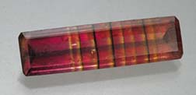
Traditionally, liddicoatite tourmaline crystals are cut in slices to show the color banding (left, courtesy of Allerton Cushman & Co., Sun Valley, ID) and the Mercedes-logo effect below, gem courtesy of Overland Gems, Los Angeles, CA).
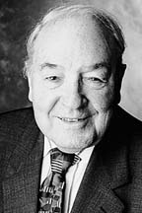
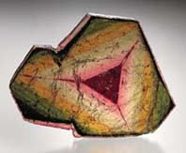
Richard Liddicoat

PHOTO GALLERY
www.gia.org/richardliddicoat/rtlhousing.cfm?idx=6
 |  | 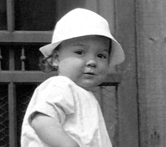 |  | 1919 Richard T. Liddicoat, born in Kearsarge, Michigan, as a young boy.
 |  | 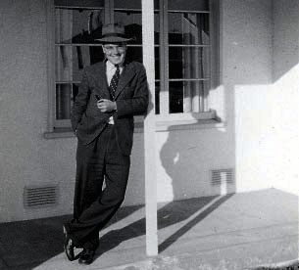 |  | 1943 Liddicoat at GIA in Los Angeles.
 |  |  |  | 1944 U.S. Navy Lieutenant Junior Grade Richard Liddicoat. From August 1942 until January 1946, Liddicoat left GIA to serve in the U.S. Navy during World War II.
 |  | 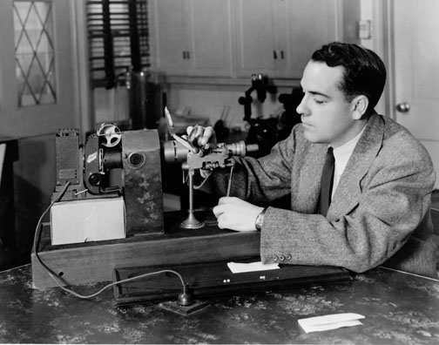 |  | circa 1945 Richard Liddicoat examines a pearl through an endoscope.
 |  | 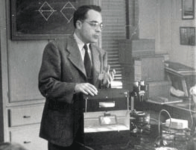 |  | 1946 Richard Liddicoat, teaching the use of the Diamolite, originally helped develop the instrument in 1941.
 |  | 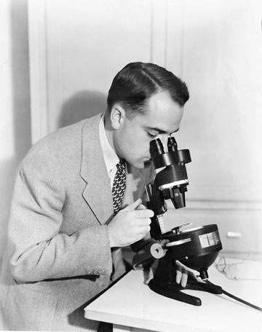 |  | 1946 Richard Liddicoat looks through a Diamondscope.
 |  | 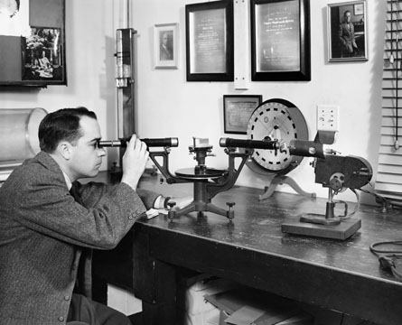 |  | 1947 Richard Liddicoat examines a so-called red spinel through the goniometer-spectroscope and finds it to be a garnet.
 |  | 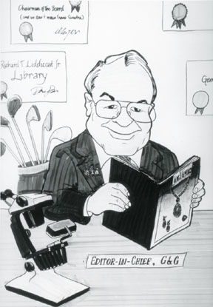 |  | April 1952 Richard Liddicoat assumes chief editorship of Gems & Gemology.
 |  | 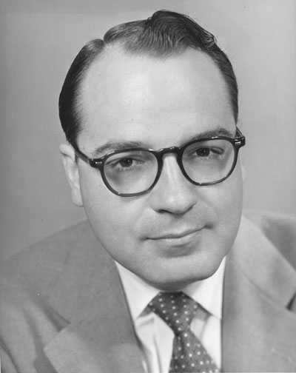 |  | 1952 Richard T. Liddicoat is appointed executive director of GIA.
 |  | 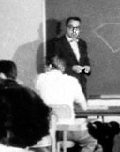 |  | 1953 Richard Liddicoat, shown teaching a diamond class, created and introduced the GIA diamond grading system.
 |  | 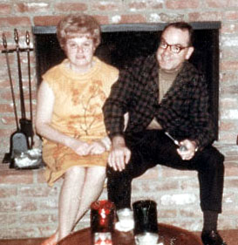 |  | circa 1960 Liddicoat with his wife Mary Imogene ("Gene") Liddicoat.
 |  | 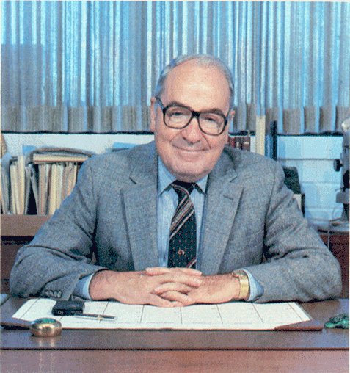 |  | circa 1975 Richard Liddicoat, at his desk, served as GIA's president from 1970 to 1983.
 |  | 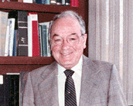 |  | circa 1980 Liddicoat at GIA's Santa Monica office.
 |  | 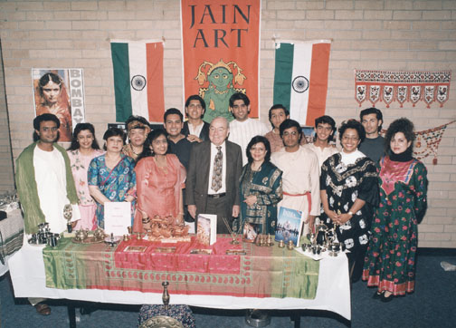 |  | circa 1993 Richard Liddicoat, shown posing with a group of Indian students, devoted more than 60 years to making GIA an internationally recognized gemological research and education institute.
 |  |  |  | 1995 Liddicoat, an avid golfer, at Bel-Air Country Club in Los Angeles.
 |  | 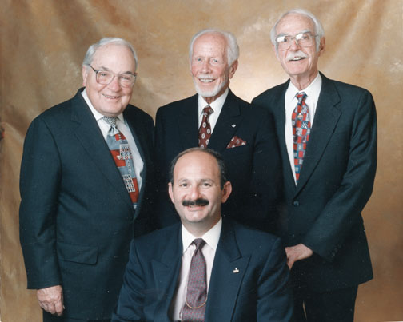 |  | November 1996 Richard Liddicoat and (clockwise from top) Swiss gemologist Dr. Edward J. Gübelin, GIA Gem Trade Laboratory legend Robert Crowningshield, and GIA president Bill Boyajian, photographed together at the formal opening of the Carlsbad campus.
 |  |  |  | circa 1999 Liddicoat poses on a stationary motorcycle.
 |  | 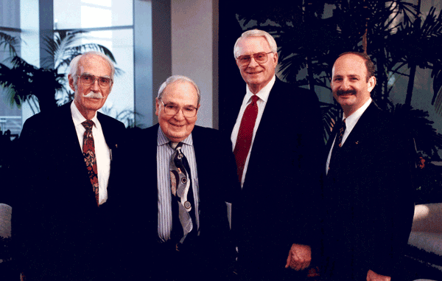 |  | 1999 Richard Liddicoat with (from left) Bob Crowningshield, Glenn Nord and GIA President Bill Boyajian at the International Gemological Symposium.
 |  | 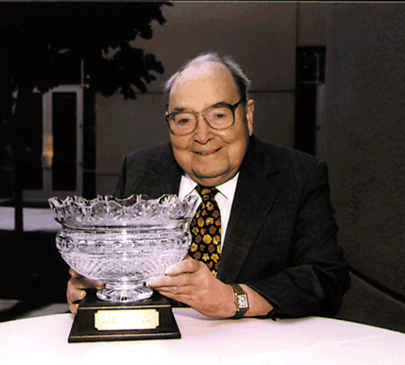 |  | 2001 Liddicoat is honored with the American Gem Society's Lifetime Achievement Award.
 |  | 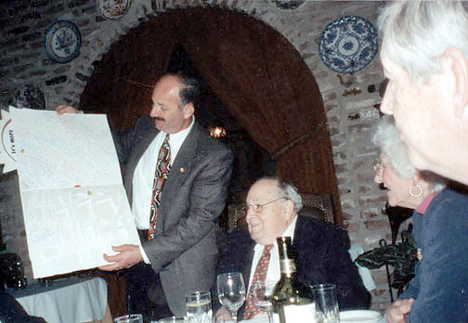 |  | March 2, 2002 Bill Boyajian presents Richard Liddicoat with a special card at his 84th birthday celebration in Los Angeles.
 |  | 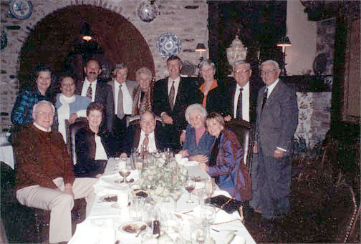 |  | March 2, 2002 Richard Liddicoat celebrates his 84th birthday with friends, family, and GIA colleagues in Los Angeles.
 |  | 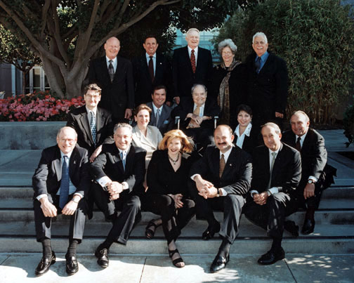 |  | May 2002 Richard T. Liddicoat, GIA Chairman of the Board, with the Institute's Board of Governors at the Carlsbad campus.

