Harry Winston 1896-1978

http://en.wikipedia.org/wiki/Harry_Winston

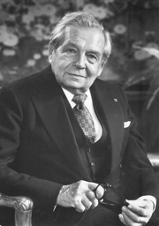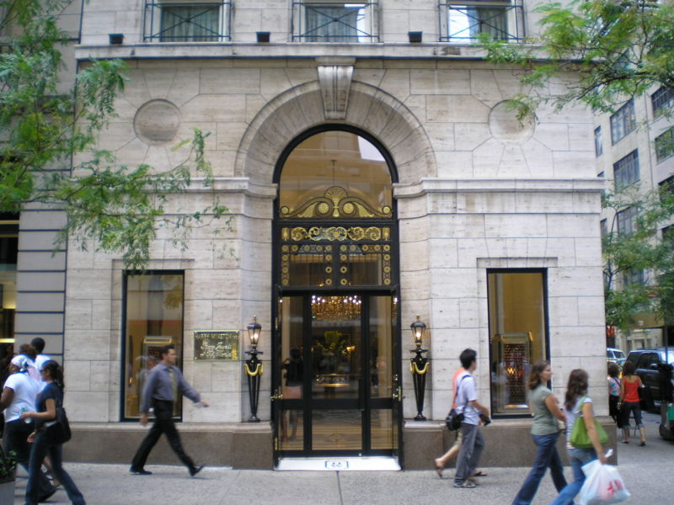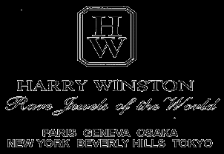
Harry Winston Jewelers, 5th Avenue, New York City

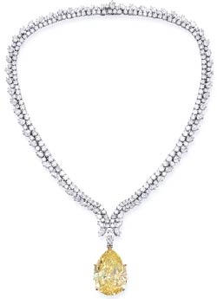

All that glitters is not gold; at Harry Winston it is probably an unimaginably expensive jewel worthy of Audrey Hepburn's lovely neck.
"THE HOUSE OF HARRY WINSTON, one of the world's largest and most prestigious jewelry empires, is unique among high fashion jewelers in that the company has extensive wholesale and manufacturing operations in addition to exclusive retail salons in New York, Geneva, Paris, Beverly Hills and in Tokyo. The specialized operation of cutting the rough diamond, polishing, designing and creating the finished jewel, is conducted in Winston's New York building on Fifth Avenue.
The House of Harry Winston, is the embodiment of three generations of Winston jewelers dating more than one hundred years back. The company which bears his name today was established in 1932 by Harry Winston, the son of a New York jeweler."
Website http://www.harry-winston.com/
Address:
718 Fifth Avenue & 56th Street
(212) 245-2000

Harry Winston (March 1, 1896 – December 8, 1978) was an American jeweller. He donated the Hope Diamond to the Smithsonian Institution in 1958 after owning it for a decade. He once sent a 726 carat (145 g) rough diamond, "The Jonker", through the US Postal Service, foregoing other more conventional means of secure transfer.
Harry Winston's jewelry empire began with his acquisition of Arabella Huntington's famous jewelry collection. The wife of railroad magnate Henry Huntington, Arabella amassed one of the world's most prestigious collections of jewelry, largely from Parisian jewelers such as Cartier.
When Harry Winston purchased the collection after her death, the designs of the collection were quite old fashioned. Harry Winston redesigned the jewelry into more contemporary styles and showcased his unique skill at jewelry crafting. According to the Huntington museum: "He frequently boasted that Arabella’s famous necklace of pearls now adorned the necks of at least two dozen women around the world."
One famous quote of his is, "People will stare. Make it worth their while."
=====================================================================================================================================

