**FAQs  
INFORMED CONSENT  
Frequently Asked Questions**

**http://www.opensourcetruth.com/informedconsentfaqs/**

**Q. Where Did the Right of Informed Consent Come From?**

A: Wars have consequences. Following WW II , a group of German Nazi doctors were put on trial by the United Stated government in the Subsequent Nuremberg Trials for violating the Right of Informed Consent by subjecting people to procedures and experiments to which they could not say no, or proceeding by force even if they did say No!

Coercing Informed Consent is a Crime Against Humanity for which the penalty for 11 of these physicians was death by hanging.

It was found that they violated both the laws of Germany and the United States: both countries had legislation guaranteeing the Right of Informed Consent and had also ratified the Geneva Conventions.

When an International Treaty like The Geneva Convention is ratified by a country, the provisions of that treaty overtake and replace any similar laws of that country. The Geneva Convention has been ratified by virtually every nation in the world making its provisions become the law of that nation.

For the Nazi Doctors’ Trial the United States articulated in a simple, direct and straight-forward summary, the Right of Informed Consent in what is known as the Nuremberg Code, which has become the basis of subsequent national and international law (American Institutional Review Board statutes and the UN Bioethics Declaration, for example).

Foundation Counsel Ralph Fucetola JD has briefed the Universal Right of Informed Consent, with citations to dozens of cases, regulations, laws and treaties here:  <http://www.inhere.org/wp-content/uploads/2020/01/Informed-Consent.paper_.1a.pdf>  
  
**Q. Do you have to be a citizen of a country to assert the Right of Informed Consent?**

A. No, if you are within the borders of the country or under its jurisdiction (in one of its embassies, for example, or in its military or diplomatic corps anywhere in the world) the Treaty Law it has ratified obligates it to honor its provisions. The Universal Right of Informed Consent is clear and non-negotiable international law under the provisions of the Geneva Convention. It is part of the UN Bioethics Declaration. Some countries have also enshrined that right as legislation and, again, that Right is protected for anyone within the borders of the nation.  
  
**Q. Can I lose other rights or benefits if I assert my Right of Informed Consent?**

A. No. At least in the United States and 16 other countries whose laws are based on the Common Law, your rights cannot be traded, one for another. In the United States that law is called the Law of Unconstitutional Conditions and Federal Courts have told State Governments over a thousand times that States may not condition the grant of a benefit on the surrender of a right.

For example, if California tells a parent that if they do not surrender their Right of Informed Consent their child will be denied the California Constitutional Right of a free public education that would be held to be an “Unconstitutional Condition” and is illegal. Some of the supporting cases are cited in our Brief on Informed Consent:  <http://www.inhere.org/wp-content/uploads/2020/01/Informed-Consent.paper_.1a.pdf>

In other countries, the particulars of the law must be understood but, in general, no, you cannot be legally forced to surrender a right to obtain another right. That’s why the Nuremberg Code says “without any element” of coercion.

“The voluntary consent of the human subject is absolutely essential. This means that the person involved should have legal capacity to give consent; should be so situated as to be able to exercise free power of choice, without the intervention of any element of force, fraud, deceit, duress, over-reaching, or other ulterior form of constraint or coercion; and should have sufficient knowledge and comprehension of the elements of the subject matter involved, as to enable him to make an understanding and enlightened decision.” http://www.hhs.gov/ohrp/archive/nurcode.html

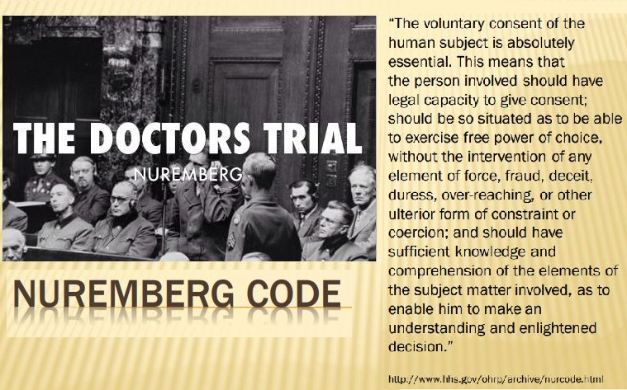  
  
**Q. Does my Right of Informed Consent kick in automatically or do I have to do something to preserve it?**

A. Under the ancient Roman legal system, silence was considered to be the same as agreement and that legal tradition continues until today.

Unfortunately, unless you assert your Right of Informed Consent AND ASSERT IT PROPERLY it will be deemed waived, as if it had never been and the authorities will continue to force unwanted medical procedures upon you and your loved ones.  
  
**Q. How do I assert my Right of Informed Consent for myself and my children?**

A. The Natural Solutions Foundation has been deeply concerned with this question for more than a decade because, frankly, we saw the forward march of medical tyranny and warned that the day of universal compulsory vaccination was coming.

For that reason, we have taken the time and effort to study the law carefully and have created a simple, effective device to preserve and assert that critically important Right. It is called the Advance Vaccine Directive card and is wallet sized to make it easy for every protected individual to have the card with them at all times.  
  
**Q. What is an Advance Directive and what does and Advance Vaccine Directive Card do?**

In virtually every country, the right of making advance decisions (called “Advance Medical Directives” or “Living Wills”) about your body is protected. If you are a diabetic, you might have a bracelet or wallet card that tells the doctors that you have this condition and direct them, in advance, to treat you for it whether you can tell them yourself or are unconscious or unable to communicate directly with them.

If you refuse blood transfusions or organ transplants or a host of other medical specifies, or you do (or do not) wish to be resuscitated or whatever, you have the legal right to make that declaration in a clear and legally binding manner.

ER personnel routinely comb through possessions of newly admitted patients in order to document on the patient’s chart and follow those Advance Medical Directive.

The Advance Vaccine Directive follows that set of laws and obligations, stating in legally correct language what your desire is and what you do NOT authorize anyone to do, which is inject you with any vaccine.

Since the card is properly dated and signed, it is a valid legal document.  
  
**Q. Will medical and other personnel ignore my signed, dated Advance Vaccine Directive?**

A. They might attempt to, but if you assert it correctly you will have serious legal grounds for action since that may constitute, according to statute and case law, assault and battery and/or other serious torts.  
It is clear that most of the time the staff attempting to vaccinate you or your child will decidedly not be happy about your refusal to allow them to do so.

You can always ask to see a member of their legal team if they persist.  
  
**Q. Do employers and schools need to know about the Advance Vaccine Directive in advance?**

A. It is very helpful to take a copy of the front and back of the Advance Vaccine Directive, sign both images and present them to the appropriate administrator, pediatrician, Human Resources officer, etc.

Ask them to sign the images and enter them in the appropriate permanent file of the individual so served.

If they refuse, and they may if they do not know that they are obligated to respect your Right, then present the copies signed by you with a note saying that you refuse all vaccines (or refuse them for your child) and ask that it be recorded in the permanent file.

Remember to take a signed copy of both the front and back of the Advance Vaccine Directive Card with you to the school, doctor’s office or medical facility.

When you get home, send an email with a scanned copy of the signed front and back to whomever you spoke with, reiterating your wish to refuse any and all vaccines based on your Right of Informed Consent asking again that these copies and this email be placed in the appropriate permanent file.

That way you have a legal record of the fact that you did not waive that right for yourself or your child, etc.  
  
**Q. Do I have to answer questions about why I do not want vaccines for myself or someone else?**

A. You do not have to have a reason or share why you do not want to be vaccinated. It is your Right to refuse any medical procedure without pressure, coercion, threats or other tactics designed to force you to comply with someone else’s wishes for your body or that of your loved ones.

***Such pressure is illegal.***

And consistently ask to see a representative from the legal department of whatever institution with which you are dealing. If a legal representative arrives, remain calm and reiterate to them that what you are doing is simply asserting your protected Right of Informed Consent.  
  
**Q. Could pressure and coercion, or even force, to try to force vaccination on me or my loved ones, result in a law suit against those involved?**

A. It is imperative for you to get the name, badge number, employee number and position of every person involved in attempting to compel you to accept a vaccine.

If you have a lawyer whom you trust, make sure that you have alerted him or her that you are asserting the Right of Informed Consent (offer to explain how to do it for himself or his family. Have him or her note in your records that you discussed asserting the Right of Informed Consent with this person on the specific day, at the specific time reserving that Right for yourself and your loved ones.

It has been an actionable tort since 1914 to provide medical interventions without Informed Consent. Even if the forced intervention helps you, it is still an assault and battery, or trespass, for which you may seek damages.

This becomes part of your legal record should you be forced and you decide to take legal action.

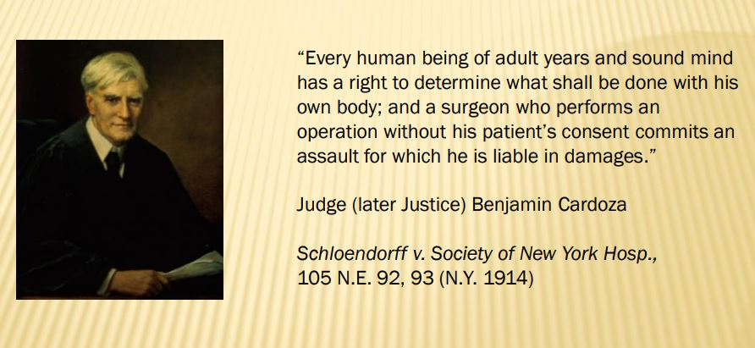  
  
**Q. Will the Advance Vaccine Directive assert my Right of Informed Consent if I am outside the United States?**

A. If you are in, or under the jurisdiction, of a country which has ratified the Geneva Convention (which includes just about every country in the world), then your Right of Informed Consent is guaranteed. Asserting it with a clear statement of that Right, as the Advance Vaccine Directive card does, is an effective way to do that.

If you are in a country in which legal documents have to be presented in a particular language which is not English, you may need an official translation of your assertion of the Right of Informed Consent.

How to obtain the AVD Card here:  <https://tinyurl.com/AVDcard>

[](https://tinyurl.com/AVDcard)

**Q. The card costs what seem like a lot of money. Why does it cost this much?**

A. The Natural Solutions Foundation is a small, private, dedicated Non-Governmental Organization (NGO) whose only resources are the income generated by donations and sales. None the less, on issue after issue, we analyze the problems and threats and find innovative, simple, natural and effective solutions and then share them as widely as we can.

Your support makes it possible for us to continue our work as the threats multiply, the censorship increases and more creativity needed to fend off those threats. If millions of people spent the few dollars for the AVD card, we could protect the Right for ourselves and future generations. What is your health freedom worth? Is it worth five cups of coffee?  
  
**Q. Can I buy one card for my family or does everyone need his or her own card?**

A. The Right of Informed Consent must be asserted on an individual basis so that every person whose rights are protected must have his or her own card. This includes children, infants, parents, spouses and any other person whom you wish to protect.  
  
**Q. Can I buy a card and then reproduce it?**

A. You can, but you would be violating Copyright Law and you would be undermining the ability of the Natural Solutions Foundation to find ways to protect your rights in the future. We anticipate that people who understand the urgently important Right of Informed Consent will also understand the legal and ethical right that the Natural Solutions Foundation has to its Intellectual Property.  
  
**Q. Can I just tell the officials that I do not want to be vaccinated?**

A. Of course you can. You will be vaccinated anyway under most circumstances since that does not constitute a legally binding assertion of your Right of Informed Consent that might lead to personal responsibility by the coercing vaccinator.  
  
**Q. I have read that the US Government and all of the States can force you to have vaccines. How will asserting my Right of Informed Consent stand up against that?**

A. You have read propaganda, not law. In fact, there is a clear legal prohibition against any such requirement although the propaganda outlets will tell you differently.

Foundation Counsel Ralph Fucetola JD addresses that issue here:  <http://www.opensourcetruth.com/prof-dershowitz-is-absolutely-wrong/>

The Courts of the United States have repeatedly held that all vaccines are “unavoidably unsafe” and there is no way that any governmental unit can force you to surrender your Right of Informed Consent to protect yourself and your loved ones from an inherently unsafe procedure.

The Supreme Court said, in the less invasive situation of a forced blood test,

Even a “…diminished expectation of privacy does not diminish the… privacy interest in preventing a government agent from piercing the… skin. And though a blood test conducted in a medical setting by trained personnel is less intrusive than other bodily invasions, this Court has never retreated from its recognition that any compelled intrusion into the human body implicates significant, constitutionally protected privacy interests…” *Missouri vs McNeely*, 569 US 141 (2013)

**That does not, however, mean that they will not try! If we, as the Supreme Court said, “never retreat…” from our commitment to the Right of Informed Consent, it will be preserved and protect us.**

Please share this information as widely as you can.

[**http://www.opensourcetruth.com/informedconsentfaqs/**](http://www.opensourcetruth.com/informedconsentfaqs/)

[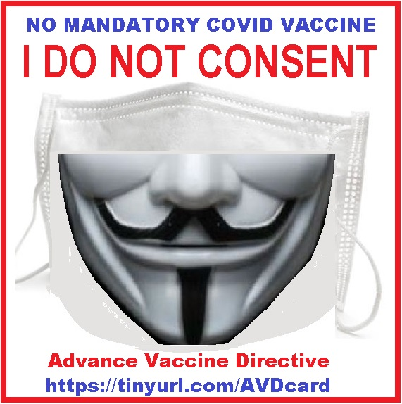](https://tinyurl.com/AVDcard)

=============================================================================================================================================================================