**Crunchy Chinese Tofu Salad**

Enjoy our nutrient-rich version of the traditional Chinese tofu Salad with crunchy almonds and homemade tangy ginger dressing giving it added taste and nutrition. This recipe contains a wealth of health-protective nutrients including 144% DV for niacin to help promote energy production, 113% DV for vitamin C to help protect against excess free radical production, 85% DV for vitamin B2 to promote antioxidant protection, 71% of your Daily Value (DV) of protein to support proper body composition, 71% DV for vitamin K for healthy blood clotting, 53% DV for copper to help provide antioxidant protection, 46% DV for vitamin A to help support immune and inflammatory systems, 40% DV for vitamin B6 to help production of red blood cells and cholesterol metabolism, 37% DV for vitamin E to help protect against free radical damage and heart disease and much more.

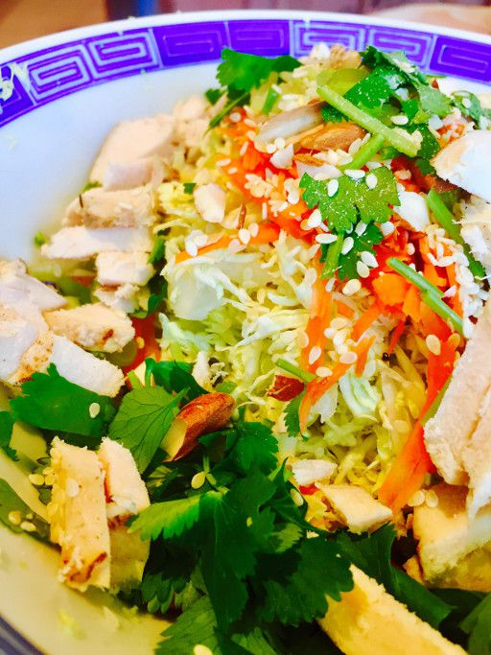

**Prep and Cook Time:** 15 minutes

**Ingredients:**

* 3 oz (about1/2 cup cooked) tofu that has been sautéed until brown then sprinkled with bronners or soy sauce
* 3 cups napa cabbage, shredded
* 1/4 cup carrots, grated
* 3 TBS thinly sliced scallion (green onions)
* 2 TBS sliced or chopped almonds
* 1/4 cup chopped fresh cilantro
* 2 tsp sesame seeds
* Optional: 1 sheet toasted nori (seaweed), cut into small strips

**Dressing:**

* 1 TBS extra virgin olive oil
* 1-1/2 TBS rice vinegar
* 1 TBS tamari soy sauce
* 2 TBS orange juice
* 1 tsp grated ginger
* pinch red pepper flakes (optional)
* Salt & white pepper to taste

**Directions:**

1. Place cooked tofu and other salad ingredients in a large bowl.
2. Whisk together dressing ingredients in a smaller bowl.
3. Pour dressing over salad and toss lightly. Top with optional toasted nori.

This salad keeps for 1 day, refrigerated

**Serves 1**