<https://www.theyliedpeopledied.com/>

[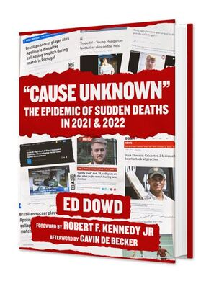](https://www.amazon.com/dp/B0BB8JTNJZ/ref=dp_kinw_strp_1)

**This is the story of Big Pharma FRAUD in 2020, 2021 and now**

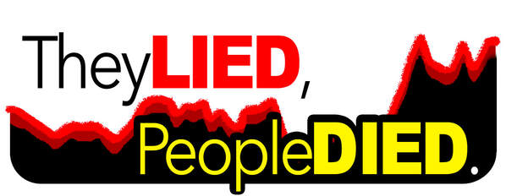

***You can use the following CDC information to hold officials accountable legally,  
launch lawsuits, educate school boards, sue for maladministration, etc.***

***From the desk of*** [***Ed Dowd***](https://www.theyliedpeopledied.com/about.html)***;***

**💉Smoking Gun #1   
Millennial Excess Deaths   
​in 2021**

**On March 7th my partner *Josh Stirling*, former #1 ranked sell side insurance analyst, created the now infamous** [**millennial excess death chart**](https://www.theyliedpeopledied.com/uploads/4/0/0/6/4006805/1761661141854-pic-hd_orig.jpg)**( full PDF below )  
​sourced from CDC data which showed an 84% spike of excess mortality into the Q3 vaccine mandates by the ​Biden administration and the​ lockstep follow on ​by​ schools, colleges and corporations.**   
  
**Between March of 2021 and february of 2022, 61,000 millennials died excessively above the prior 5 year base trend line.**  
  
**More millennials died in 2021 than American soldiers were killed in the Vietnam War.   
  
​The relative timespan and rate of change into the fall of 2021 is a signal that a harmful event occurred to this 25-44 age group.    
  
This means that millennials started dying in large numbers at the same times when vaccines and boosters were rolled out.**  
  
**​The vaccine clearly had a role, as many previously hesitant folks were forced into compliance.**  
  
*The naysayers claim the excess deaths were due to drug overdoses, suicides and missed medical treatment...*  
  
**We have fact-checked the fact-checkers.   
  
​It's statistically impossible that in a three month period, all those events up-ticked simultaneously across the country.**

***Exhibit 5 from PDF #1 ( below ) shows how excessive amounts of millennials died at the same times  
that lockdowns, vaccinations, mandates and boosters were rolled out.***

[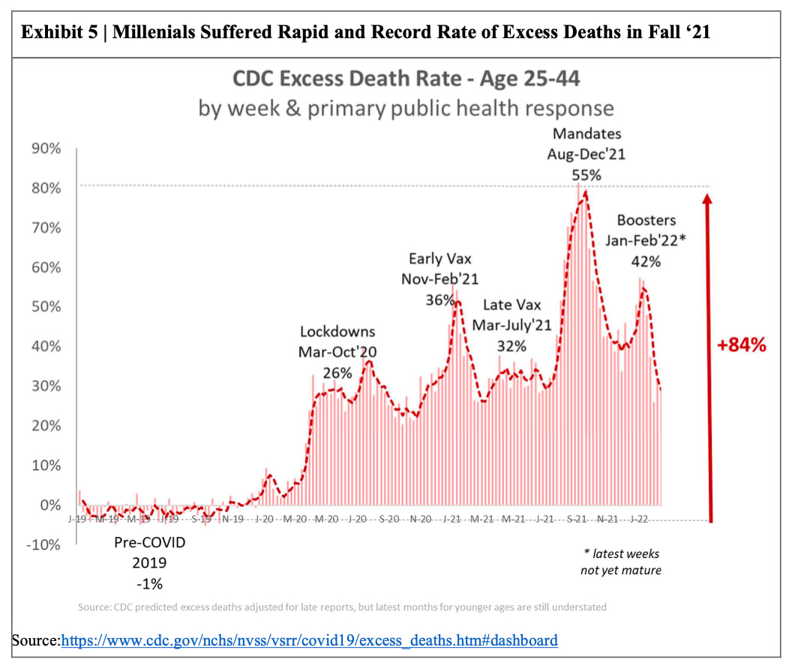](https://www.cdc.gov/nchs/nvss/vsrr/covid19/excess_deaths.htm#dashboard)

|  |  |  |  |  |
| --- | --- | --- | --- | --- |
|  | |  |  |  |
|  | **You can compare Josh's charts with the CDC data yourself;** **Step 1: Load**[**https://www.cdc.gov/nchs/nvss/vsrr/covid19/excess_deaths.htm#dashboard**](https://www.cdc.gov/nchs/nvss/vsrr/covid19/excess_deaths.htm#dashboard)**< Step 2: Scroll down on the CDC page until you see this interactive chart;** | | | |

[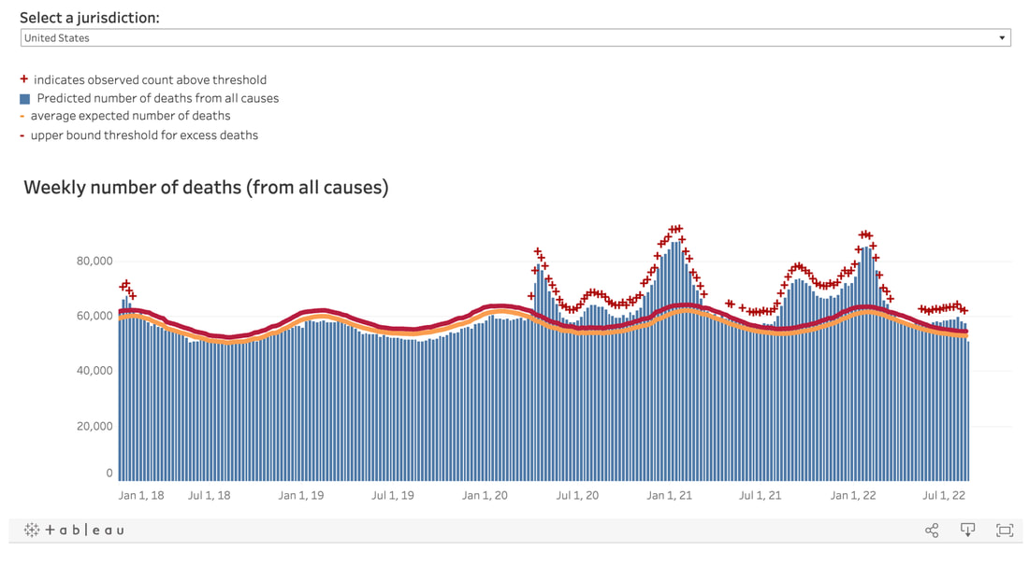](https://www.cdc.gov/nchs/nvss/vsrr/covid19/excess_deaths.htm#dashboard)

**On the CDC website, hover your mouse over the red** + **symbols on the chart to verify that the CDC dates match Josh's chart shown above.**

**💉Smoking Gun #2  
​Mix Shift**

**On March 14th, Josh Stirling made his second most important discovery in the CDC data.**  
**( See Josh's correlating chart below )    
  
It was the mix shift from old to young that occurred from 2020 to 2021.   
  
126,000 of the 592,000 excess deaths in 2020**​**were people under the age of 65 or approximately 21%.   
  
181,000 of the 512,000 excess deaths in 2021 were people under the age of 65 or approximately 35%.  
  
 More millennials died in excess than any other age group in 2021*.***  
   
***The number of excess millennial deaths in 2020 was 42,000, but jumped a whopping 45% to 61,000 in 2021.***  
  
**In 2021, Covid strains were already mutating and becoming less virulent.   
  
Also, it had already determined that the virus affected mostly older people with co-morbidities.    
  
​This indicates that the mix shift of excess deaths in 2021 was not likely due to COVID19 but rather some other external source.**  
  
***SIXTY ONE THOUSAND more millennials died in 2021 than the average baseline from 2015 to 2019.     
The virus was weaker in 2021, but yet more millennials died.     
What else happened in 2021 at the same times with millennial excess deaths spiked?*** *Jabs and mandates.*​  
  
**It’s important to note that 45,000 more people died under the age of 65 in 2021 versus year 2020.    
  
*Did the virus suddenly decide to only target younger folks disproportionately?*  *Did the virus change from respiratory to pulmonary in year 2?***  
  
**​The only thing that changed in 2021 was the introduction of the vaccine and mandates, which to simple deductive reasoning is the obvious culprit.   
  
However, the authorities and the mainstream media simply refuse to acknowledge much less comment on this data.   
  
The reason it is not allowed is because the obvious question would begin to be asked about the vaccines.**

***Exhibit 1 from PDF #2 ( below ) shows more young people died in 2021, after vaccines and boosters rolled out.***

[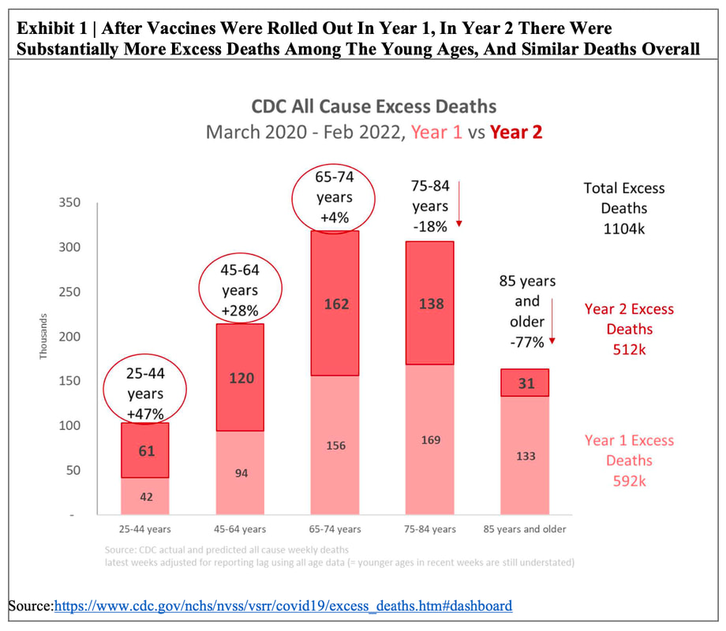](https://www.cdc.gov/nchs/nvss/vsrr/covid19/excess_deaths.htm#dashboard)

[Click here to load >  https://www.cdc.gov/nchs/nvss/vsrr/covid19/excess_deaths.htm#dashboard <](https://www.cdc.gov/nchs/nvss/vsrr/covid19/excess_deaths.htm#dashboard)

**💉 Smoking Gun #3  
    SOA Confirmation**

**On August 17th the Society of Actuaries Research Institute (SOA) published their Group Life Covid 19 Mortality Survey Report.   
  
This report represents approximately 80 percent of the group life US revenues.   
  
Table 5.7 in the report is Excess Mortality by Detailed Age Band and as you can see below there was an event that occurred in Q3 of 2021 (highlighted in red) for the two age groups 25-34 and 35-44 which represented excess mortality of 78% and 100% respectively.   
  
In March, we reported 84% excess mortality into the fall of 2021.   
Bottom line...  Our analysis has been verified by SOA and their group life claims into the third quarter as well.   
  
​It is clear that a causative event which occurred in Q3 of 2021.  We are 100% of the belief it was the vaccine mandates ordered by the Biden administration.**

**​This is what we call "democide",  
or death by government action.**

***Table 5.7 PDF #3 ( below ) shows how excessive amounts of millennials died at the same times  
that lockdowns, vaccinations, mandates and boosters were rolled out.***

[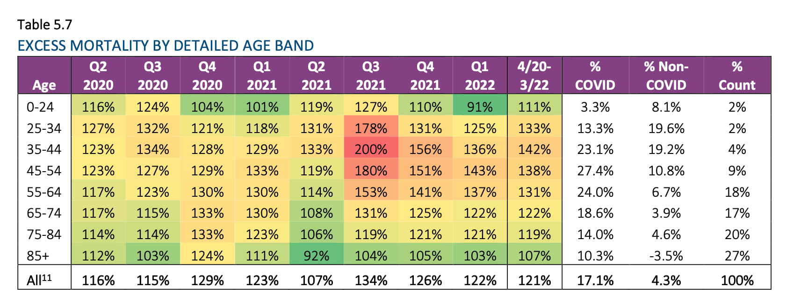](https://www.soa.org/4a368a/globalassets/assets/files/resources/research-report/2022/group-life-covid-19-mortality-03-2022-report.pdf)

<https://www.soa.org/4a368a/globalassets/assets/files/resources/research-report/2022/group-life-covid-19-mortality-03-2022-report.pdf>

|  |  |  |  |
| --- | --- | --- | --- |
|  |  |  |  |

**📣   Call to ACTION:    
       JOIN THE FIGHT**

**No one is coming to save us except "We the People".**   
  
**It's time we standup and save ourselves.**  
  
**Regulators and gov't agencies and media-tech complex received money from big-pharma and governments to suppress negative information whilst promoting the obviously fraudulent tag line "Safe and Effective."  
  
...This is a battle for the marginal mind and when we alert enough people the sentiment will shift and we reach a societal tipping point.   
  
Please use this information here in your local action with schools boards, your company's vaccine mandate and lawsuits.   
  
The time for sitting on the bench is over and time to get on the field is here and now.   
  
If we let this stand our freedoms are over and you are a slave.  
  
Activate yourself and those around you!  
  
Share this site, the information and the PDFs so that others can use them in their battles to take back our media, our court systems, our education system and our freedom!   
  
​Get involved in any way you can!**