The Five Tibetan Rites

Mi Zong Practice

www.shapeshift.net

Rite 1  - Stand erect with arms outstretched, horizontal to the floor.  - Spin around clockwise until you become slightly dizzy.  - Gradually increase practicing from 3 up to 21 repetitions per day for each rite. | 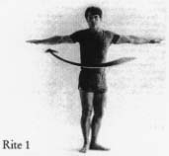
Rite 2  - First lie flat on the floor, face up.  - Fully extend your arms along your sides, and place the palms of your hands against the floor, keeping the fingers close together.  - Then, raise your head off the floor, tucking the chin against the chest. As you do this, lift your legs, knees straight, into a vertical position. If possible, let the legs extend back over the body, toward the head; but do not let the knees bend.  - Then slowly lower both the head and the legs, knees straight, to the floor.  - Allow all the muscles to relax, continue breathing in the same rhythm.  - Breathe in deeply as you lift your legs and breathe out as you lower your legs | 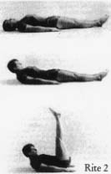
Rite 3  - Kneel on the floor with the body erect. The hands should be placed against the thigh muscles.  - Incline the head and neck forward, tucking the chin against the chest.  - Then, throw the head and neck backward, arching the spine. As you arch, you will brace your arms and hands against the thighs for support.  - After the arching, return to the original position, and start the rite all over again.  - Breathe in deeply as you arch the spine, breathe out as you return to an erect position | 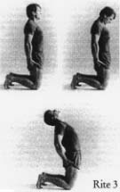
Rite 4  - Sit down on the floor with your legs straight out in front of you and your feet about 12 inches apart. With the trunk of the body erect, place the palms of your hands on the floor alongside the buttocks.  - Then, tuck the chin forward against the chest.  - Now, drop the head backward as far as it will go. At the same time, raise your body so that the knees bend while the arms remain straight. The trunk of the body will be in a straight line with the upper legs, horizontal to the floor.  - Then, tense every muscle in the body.  - Finally, relax your muscles as you return to the original sitting position, and rest before repeating the procedure.  - Breathe in as you raise up, hold your breath as you tense the muscles, breathe out completely as you come down. Continue breathing in the same rhythm as long as you rest between repetitions | 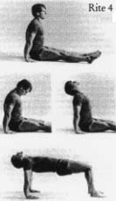
Rite 5  - When you perform the fifth rite, your body will be face-down to the floor. It will be supported by the hands, palms down against the floor, and the toes in a flexed position.  - Throughout this rite, the hands and feet should be kept straight. Start with your arms perpendicular to the floor, and the spine arched, so that the body is in a sagging position.  - Now, throw the head back as far as possible.  - Then, bending at the hips, bring the body up into an inverted 'V'. At the same time, bring the chin forward, tucking it against the chest.  - Breathe in deeply as you raise the body, breathe out fully as you lower it. | 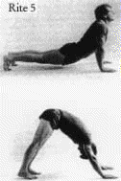
Books about the "5 Tibetan Rites"
Ancient Secret of the "Fountain of Youth" Book 1
Legend has it that hidden in the remote reaches of the Himalayan mountains lies a secret that would have saved Ponce de Leon from years of fruitless searching. There, generations of Tibetan monks have passed down a series of exercises with mystical, age-reversing properties. Known as the Tibetan Rites of Rejuvenation or the Five Rites, these once-secret exercises are now available to Westerners in Ancient Secret of the Fountain Of Youth. Peter Kelder's book begins with an account of his own introduction to the rites by way of Colonel Bradford, a mysterious retired British army officer who learned of the rites while journeying high up in the Himalayas. Fountain of Youth then offers practical instructions for each of the five rites, which resemble yoga postures. Taking just minutes a day to perform, the benefits for practitioners have included increased energy, weight loss, better memory, new hair growth, pain relief, better digestion, and just feeling younger.
Ancient Secret of the "Fountain of Youth": Book 2
When Peter Kelder's Ancient Secret of the Fountain of Youth was released by Harbor Press in 1985, it immediately touched off an incredible sales phenomenon rivaled only by The Celestine Prophecy and Conversations with God. This is the sequel to one of the biggest health and healing bestsellers of all time.
Almost as quickly as the books filtered across the globe, letters began to pour in to Harbor Press requesting more information on these mysterious rites.
Picking up where Kelder's book left off, Ancient Secret of the Fountain of Youth, Book 2 provides the complete Fountain of Youth health program, with detailed information on a variety of topics discussed only fleetingly in the original bestseller: the history and origins of the Five Rites, valuable insights about how the Rites work, diet suggestions, and easy-to-follow exercises. Illustrated with fifty black-and-white photographs, this guide will help turn back the hands of time, invigorating and energizing readers' lives as never before.
The Five Tibetans : Five Dynamic Exercises for Health, Energy, and Personal Power
Kilham brings to The Five Tibetans nicely written chapters about kundalini, the chakras and an especially insightful instruction on the role of breathing while doing each rite. Short, straight forward and excellent.

