=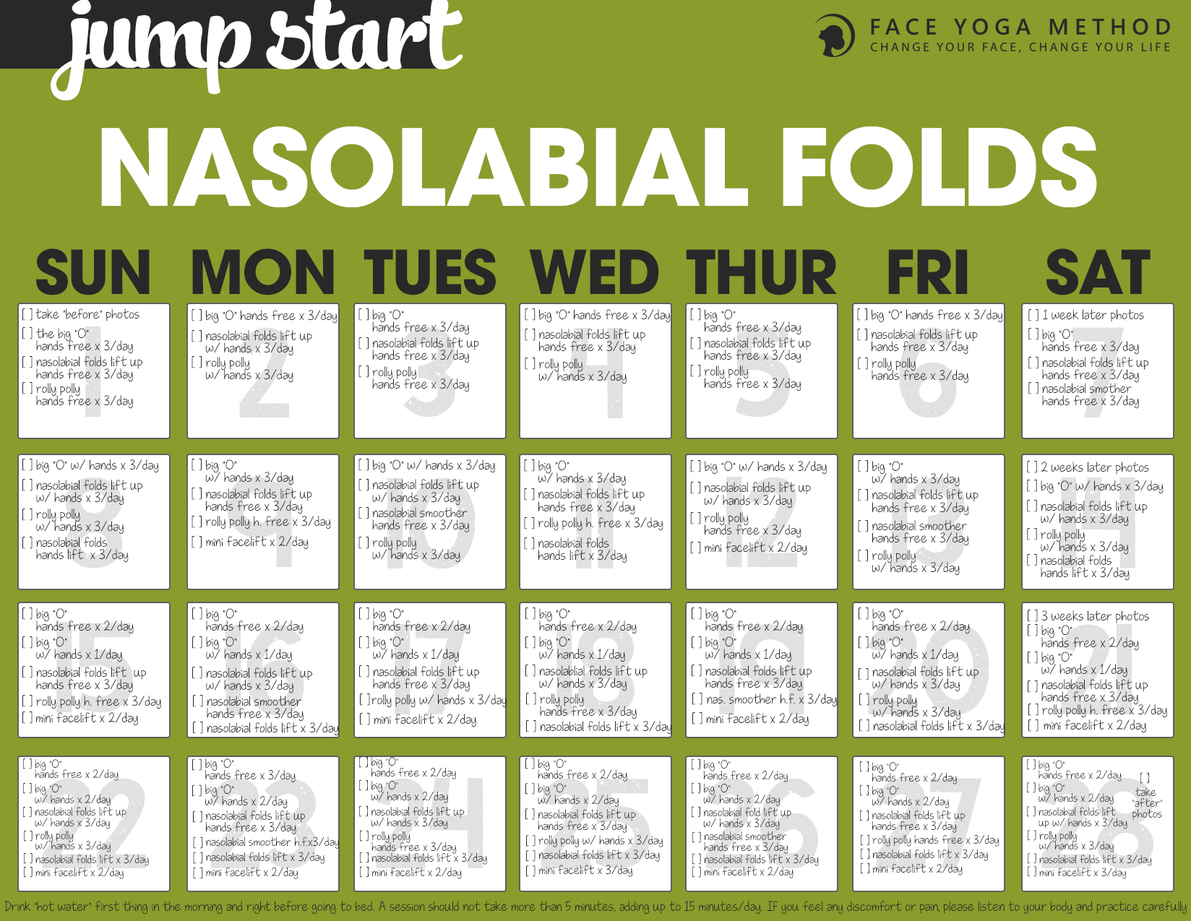

**Nasolabial Folds Jump Start**

**Introduction**

After completing the **Laugh At Those Laugh Lines – 28 Day Jump Start program**, you will learn how to combat nasolabial fold lines throughout the day.  
Nasolabial folds are sometimes called smile/laugh lines. As we age, nasolabial fold lines get longer and deeper. Longer and deeper nasolabial lines make you look older. You may think that only surgeries and injections can reduce nasolabial fold lines, but when you train certain face muscles, you can lift up and reduce these lines. If you want to reduce/prevent nasolabial fold lines naturally, this program is for you!  
First, look at yourself in the mirror. Without smiling, check your nasolabial fold lines on both sides of your mouth. Do you notice a difference between the two sides of your mouth? Are the lines deeper or longer on one of the sides? Are they symmetrical or asymmetrical?  
If you notice asymmetry in the nasolabial fold lines, I suggest you think about how you sleep. Are you a side sleeper? If so, which side do you sleep on?  
In my experience, I have noticed that many side sleepers have asymmetrical nasolabial fold lines, which means, one side of the nasolabial fold lines are much longer and/or deeper.  
If you’re a side sleeper and sleeping on the same side, your nasolabial fold lines will get deeper and longer and become permanent. For instance, if you sleep on your right side, it is very likely the nasolabial fold lines on the right side of your face are deeper and longer.  
I know it can be very hard to change sleeping positions but quite often by paying attention and changing your sleeping position you can dramatically reduce the asymmetry, length and depth of your nasolabial fold lines.  
To avoid future damage, I recommend that you check your sleeping patterns and the pillow you use at night before staring this Jump Start.  
Please refer to [this video blog post](http://faceyogamethod.com/get-rid-of-nasolabial-folds-while-sleeping/) where I talk about the relationship between nasolabial fold lines and sleeping pillows.  
One of the best ways to decrease and soften the nasolabial fold lines is to strengthen the muscles of the mouth and cheeks (there are 11 muscles). Since gravity pulls these muscles down, it is effective to lift these muscles up so that nasolabial fold lines will be lifted up. It may not be easy at first, but try to relax the rest of the facial muscles and isolate the muscle(s) you use for the exercises. If it is too hard, put your finger on your face and feel the muscles under the skin. Just paying attention to your own facial movements helps you to isolate the muscles.  
Try to keep lifting up your cheek muscles during the day. Your cheek area will get more exercise without even doing the actual poses and as a result, your nasolabial folds will become smoother and less visible.  
If you want to see results, you need to commit to the following: practice every day for 28 days and keep track of your progress on a daily basis. It has been said that it takes about 28 days to change form a new habit. This means that you need to commit to practicing the Laugh At Those Laugh Lines – 28 Day Jump Start Program every day for 28 days.

**Pro tip!**Take photos under the same conditions (lighting, same camera, clothing etc.) The before and after photos are essential because it is harder to see changes in the face compared to the body. You need motivation and you need it be fun! Here is the schedule for your photo session:  
Start – Take “before” photos (profile and close up on the nasolabial folds area)  
Week 1 – Take photos (profile and close up on the nasolabial folds area)  
Week 2 – Take photos (profile and close up on the nasolabial folds area)  
Week 3 – Take photos (profile and close up on the nasolabial folds area)  
Week 4 – Take “after” photos (profile and close up on the nasolabial folds area)

**Daily**  
Drink “hot water” first thing in the morning and right before going to bed. Drinking hot water helps you to detox from the inside out. If your body is dehydrated it shows in your eyes. Drink water throughout the day before you feel thirsty. Healthy skin starts with good hydration.

**For best results:**

* Check your sleep position
* Check your preference when chewing food/chewing gum
* Pay attention to your cheek muscles and both corners of your mouth.

When practicing these poses make sure you relax your jaw. The purpose of these exercises is not for your jaw area, it is for the nasolabial fold lines. I have seen people tense up the jaw area while doing these exercises and they end up building unwanted jaw muscles. If relaxing the jaw area while performing some exercises listed here is too hard, come out and breathe out deeply and then try the pose again.  
For best results, keep breathing and focusing on the muscles you are using to do the poses.  
Like any other exercise, if you feel any discomfort/pain or start noticing negative changes, please practice the poses carefully or ask professional help. The poses will build up as the days progress and you will do more poses toward the end of this challenge.  In that sense, this program can be little bit intense especially toward the end of 28 days. Don’t get overwhelmed! It should not take more than 15 minutes a session.  You don’t need to practice all the poses at one session but rather divide them throughout the day. You can also do some of the poses (especially hands free ones) while doing something else, like driving, cooking and watching TV. As always a good, nutritious diet with plenty of water, and a lot of fresh fruits, vegetables, and protein is important to improve your skin condition. Keep your sugar consumption very very low. Sugar is one of the worst ingredients for your skin.  
**Caution:** You can do most of these poses 3 times a day except **The Mini Face Lift**, which you can practice up to two times a day.  **The Mini Face Lift** requires you to put your fingers into an exact position so make sure you practice this pose in front of the mirror until you learn the technique. If you place your fingers in the correct position, you can expect instant changes on not only nasolabial fold lines but also your eyelids and face lines.  
**Let’s get started!**   
**You can do this!**  
**Start by visualizing your end results!**

All of us should have an opportunity to feel and look the very best for our age.

Fumiko Takatsu

# Day 1

**1. Take  “Before” photos (profile and close up on the mouth area).**

**2. The Big O – 3 times throughout the day**

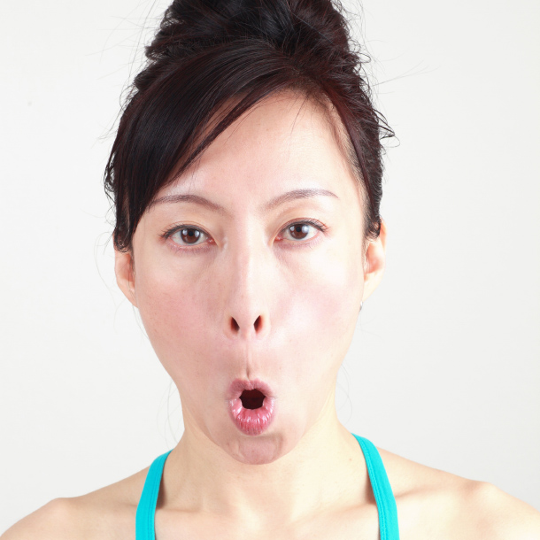

##### [Benefits](http://faceyogamethodmembership.com/lesson/day-1-6/#benefits)

##### [Instructions](http://faceyogamethodmembership.com/lesson/day-1-6/#instructions)

##### [Tips](http://faceyogamethodmembership.com/lesson/day-1-6/#tips)

Smooths the nasolabial fold lines

**3. The Nasolabial Folds Lift Up (hands free) – 3 times throughout the day**

**THE NASOLABIAL FOLDS LIFT UP – HANDS FREE**

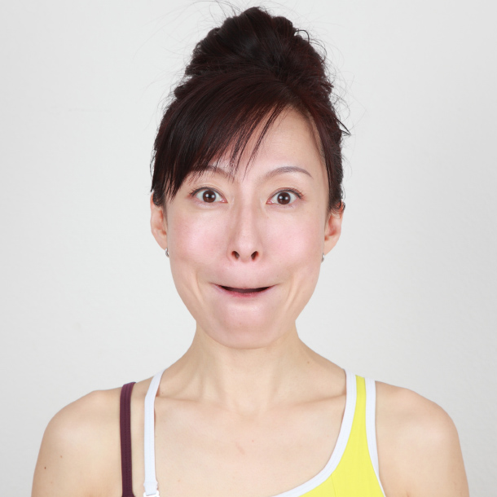

Smooths out the nasolabial fold lines.

**4. The Rolly Polly (hands free) – 3 times throughout the day**

**THE ROLLY POLLY – HANDS FREE**

Benefits: firms and strengthens the area around the mouth and reduces the nasolabial folds.

You may feel a strange tightness or stimulation under the chin area or the back of your head at first. Just try to breathe out while moving the tongue. Eventually the pain/discomfort will go away and you will be able to move the tongue much easier.

1. Push the right side of the mouth with the tongue very hard.

2. Move the tongue slowly clock-wise around the mouth, taking about 5 seconds.

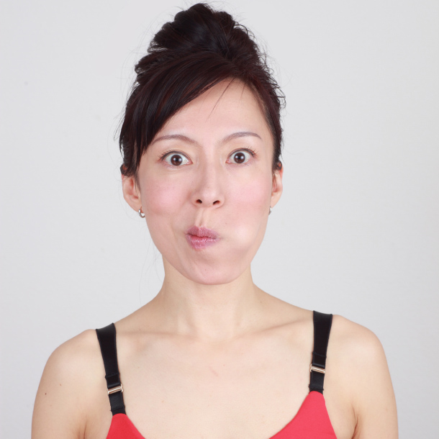

3. Repeat 2 more times.

4. Move the tongue slowly counter clock-wise taking about 5 seconds.

5. Repeat 2 more times.

