**10 Minutes All Over Toning Routine**

Exercises performed in this routine:

* The Big “O”
* The Forehead Massager with hands
* The Forehead Lift with hands
* The Eye Opening Binocular Pose
* Crow’s Feet Press with hands

**1. The Big O**

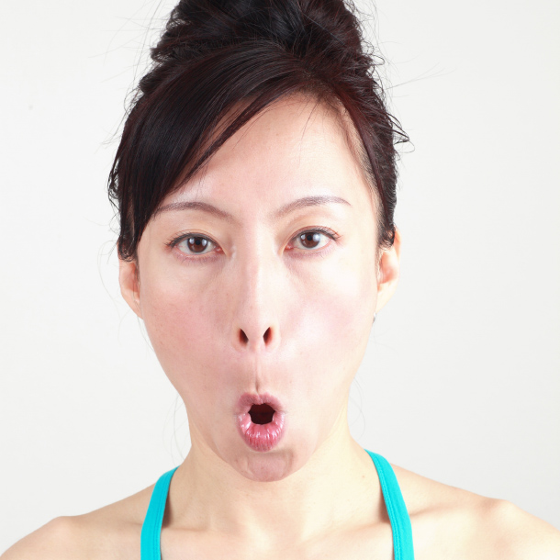

* [**Benefits**](http://faceyogamethodmembership.com/lesson/10-minutes-all-over-toning-routine/#benefits)

##### [Instructions](http://faceyogamethodmembership.com/lesson/day-1-6/#instructions) Open the mouth, make an “O” shape with the mouth, make the face long, pressing the upper mouth firmly against the teeth. Feel the stretch in the muscles surrounding the mouth and nose.

##### [Tips](http://faceyogamethodmembership.com/lesson/day-1-6/#tips) You should feel the muscle movement from the corners of the mouth to the corners of the eyes.

Smooths the nasolabial fold lines

**2. THE FOREHEAD MASSAGER (with hands)**



* [**Benefits**](http://faceyogamethodmembership.com/lesson/10-minutes-all-over-toning-routine/#benefits)
* [**Instructions**](http://faceyogamethodmembership.com/lesson/10-minutes-all-over-toning-routine/#instructions)Interlace the fingers and place them on top of the head. Applying firm pressure, move the hands back and forth 10 times, then side to side 10 times. Place the hands on the forehead. Applying firm pressure, move hands up and down 10 times
* [**Tips**](http://faceyogamethodmembership.com/lesson/10-minutes-all-over-toning-routine/#tips)Relax the shoulder and the face

Helps relax the forehead

**3. THE FOREHEAD LIFT (with hands)**



* [**Benefits**](http://faceyogamethodmembership.com/lesson/10-minutes-all-over-toning-routine/#benefits)
* [**Instructions**](http://faceyogamethodmembership.com/lesson/10-minutes-all-over-toning-routine/#instructions)Place the sides of the hands along the hairline and apply firm pressure and push the hairline back. Maintain the pressure, look down towards the floor with just the eyes. Hold this pose for 5 seconds.
* [**Tips**](http://faceyogamethodmembership.com/lesson/10-minutes-all-over-toning-routine/#tips)Keep your chest open and neck and shoulders relaxed. Make sure you are not frowning.

Helps to lift up the forehead.

**4. THE EYE OPENING BINOCULAR POSE (with hands)**

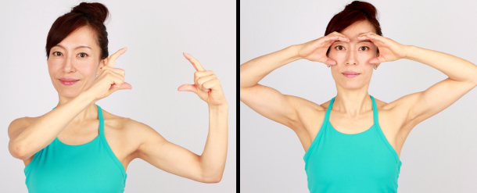

* [**Benefits**](http://faceyogamethodmembership.com/lesson/10-minutes-all-over-toning-routine/#benefits)
* [**Instructions**](http://faceyogamethodmembership.com/lesson/10-minutes-all-over-toning-routine/#instructions)Curl the hands into “C” shapes. Place the index fingers above each eyebrow, along the upper eye bones and each thumb on either side of the nose, just above the nostrils.

Reduces unnecessary forehead movement. Prevents wrinkles. Opens up the eyes.

**5. THE FEET PRESS (with hands)**



* **[Benefits](http://faceyogamethodmembership.com/lesson/10-minutes-all-over-toning-routine/" \l "benefits)**
* [**Instructions**](http://faceyogamethodmembership.com/lesson/10-minutes-all-over-toning-routine/#instructions)Look straight, forehead relaxed and breathe evenly. Place index and middle fingers of both hands on the hairline, about 45 degrees from the outer corner of your eyes. Pull the index and middle fingers up. Feel the stretch in the crow’s feet area. Without moving or wrinkling the forehead squint for 5 seconds. Close your eyes and relax for 3 seconds.
* [**Tips**](http://faceyogamethodmembership.com/lesson/10-minutes-all-over-toning-routine/#tips)Keep the forehead relaxed and feel the stretch in the crow’s feet area. Do not move or wrinkle the forehead.

Smoothes crow’s feet