Deepak Chopra, M.D. 1946-
http://en.wikipedia.org/wiki/Deepak_Chopra
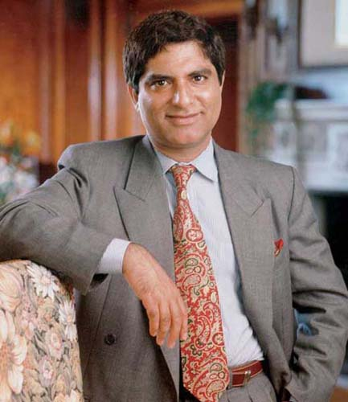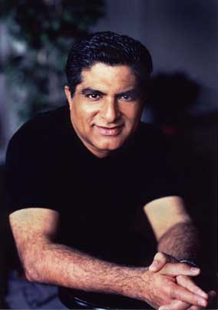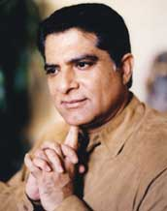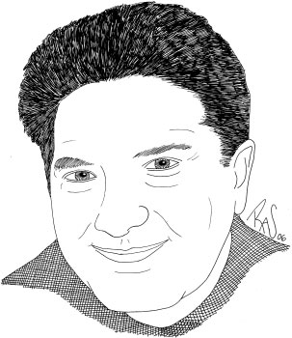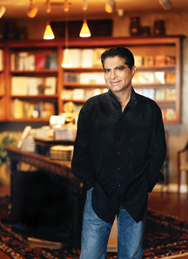
Grow Younger, Live Longer, 2001
-----------------------------------------------------------------------------------------------------------------------------------------------------------------------------------------------------------------------------------------
Deepak Chopra, M.D., (born October 22, 1946 in New Delhi, India) is a medical doctor and writer extensively on spirituality and divrese topics in mind-body medicine. His main influences are two: the teachings of Vedanta and the Bhagavad Gita from his native India and quantum physics.
Alternative Medicine
This article is part of the Complementary and Alternative Medicine series of articles.
CAM Article Index

Contents
[hide]
- 1 Background
- 2 Writings
- 3 Ideas on the current war with Iraq
- 4 Principal themes
- 5 Criticism
- 6 Books
- 7 Music CDs
- 8 Videos
- 9 Quotations
- 10 References
- 11 Notes
- 12 External links

Background
Chopra was educated in India and immigrated to the U.S. in 1970, becoming board-certified in internal medicine and endocrinology. He graduated from the All India Institute of Medical Sciences in 1968, and after interning at a New Jersey hospital, trained for several more years at the Lahey Clinic in Burlington, Massachusetts and at the University of Virginia Hospital. He taught at Tufts University and Boston University Schools of Medicine, became the chief of staff at the New England Memorial Hospital and established a large private practice. He became a leader in the Transcendental Meditation movement, but later branched off on his own to pursue broader aims in mind-body treatment.
Chopra is Chief Executive Officer and Medical Director of The Chopra Center, which he founded in 1992 in San Diego; it is currently located at La Costa Resort & Spa in Carlsbad, California with branches in New York City and elsewhere.
Chopra completed his primary education at St. Columba's School in New Delhi.
In 2004, Chopra was recruited to co-write a script with Indian film director Shekhar Kapur on a proposed film to be made about the life of Siddhartha Gautama, the Buddha.
In June, 2005, Chopra and Kapur launched a discussion blog ^{[1]} with a select group of Indian colleagues, friends, and family. The stated purpose of the blog is to present original voices from South Asia (particularly India) and discuss a variety of topics.
In 2006, Chopra launched Virgin Comics LLC alongside his son, Gotham Chopra, and Richard Branson, famed entrepreneur and thrill-seeker. The aim of the company is to promote and examine Southeast Asian themes and culture through the use of the traditional comic book medium. [1]

Writings
A voluminous writer, Chopra has more than 40 books to his credit. They range broadly across spiritual and health topics--his original interests--and now include bestsellers on aging, the "seven spiritual laws of success," the existence of God, proof of the afterlife, world peace, etc. He has also written novels and edited collections of spiritual poetry from India and Persia.

Ideas on the current war with Iraq
In March 2003, shortly before the US-led Invasion of Iraq, Chopra, upon being asked for creative ideas, gave ten suggestions. These suggestions included that Iraq could be disarmed without force; that religious leaders meet in Baghdad; increasing UN forces by ten-fold; sponsoring 25,000 Iraq exchange students to the West; etc. He also suggested that a new Disney World theme park in the Middle East would help to reduce fear and anger in children and that residents of Iraq should be provided free access to CNN, MTV and Nickelodeon [2] to expose them to the rest of the world.

Principal themes
Many of Chopra's themes and beliefs are stated in his first book, "Creating Health" in 1986. He launched himself as a staunch advocate of the interconnection between mind and body, advocating meditation and self-awareness as primary factors in both illness and healing. He deepened these themes in "Quantum Healing" (1989), where he examined the mysterious phenomenon of spontaneous healing of cancer. Here he introduced quantum physics as a means of understanding the mind-body connection, arguing--as he would in many other books--that consciousness is the basic foundation of nature and the universe.
In "Perfect Health" (1991) Chopra authored the first widely read book on Ayurveda, the traditional system of Indian medicine. Besides outlining the Ayurvedic concept of body types (Prakriti), Chopra emphasizes that the roots of Indian healing lie in changing the holistic balance of mind and body.
Subsequent books have turned toward larger spiritual questions. In "How to Know God" (2000) and "The Book of Secrets" (2004) an argument is made for an all-pervasive intelligence that unites every living thing rather than the traditional Western concept of God as a person, "a venerable white male sitting on a throne in the sky." Chopra sees God as a projection of human awareness who becomes more expansive and universal as individual consciousness expands.
In 2006, his book "Life After Death: The Burden of Proof" extends personal consciousness beyond the "artificial boundary that separates the living from the departed." Assessing the seven varieties of the afterlife espoused in world religions, Chopra offers the startling proposal that a person's awareness in the present shapes existence after death; that is, the afterlife is created uniquely for each of us by our present level of consciousness.
In 2005 Chopra became a staunch advocate for disarmament and international peace in "Peace Is the Way," where he argues that a "critical mass" of people who band together in their spiritual worldview can defeat the age-old "addiction to war" that continues to create mass suffering. In the same regard he became president of a broad-based organization, Alliance of a New Humanity, that seeks to form "peace cells" around the world and to foster such related goals as environmental healing and sustainable economies in developing nations.

Criticism
Chopra has been both appreciated and criticized for his frequent references to the relationship of quantum mechanics to healing processes, a connection that drawn skepticism from some quarters because it can be considered as possibly contributing to the general confusion in the popular press regarding quantum measurement, decoherence and the Heisenberg uncertainty principle.^{[2]}
In August 2005, Chopra posted a series of articles on the blog The Huffington Post (to which he is a frequent contributor) in which he offers his solution to the creation-evolution controversy. In doing so he expressed support for Intelligent Design and offered a series of questions about evolution he believed could not be answered by science alone (thereby requiring an "intelligent designer").^{[3]} ^{[4]} Science writer Michael Shermer, founder of The Skeptics Society and long-time critic of Chopra, posted a response. [3]
Biologist PZ Myers has also critized these claims in depth. [4] In October 2006, Myers again fisked a blog post by Chopra [5] for displaying a lack of understanding of genetics. [6] Fellow science blogger Orac has criticized Chopra's views [7]
In 1998, Chopra was awarded the Ig Nobel Prize in physics for "his unique interpretation of quantum physics as it applies to life, liberty, and the pursuit of economic happiness." [8]
In its May 22/29, 1991 issue, the Journal of the American Medical Association (JAMA) published an article by Sharma, Triguna and Chopra: Maharishi Ayur-Veda: Modern Insights Into Ancient Medicine.^{[5]} This article was represented as discussing the traditional healing system practiced in India known as Ayurveda. Upon investigation, JAMA editors discovered that the co-authors had financial interests in the complex web of interlocking organizations that promoted and marketed Maharishi Ayur-Veda products and services. In the August 14, 1991 edition of JAMA, the editors published a financial disclosure correction^{[6]} and followed up in October 2, 1991 with a six-page Medical News and Perspectives exposé.^{[7]} In response, two Transcendental Meditation groups and Chopra sued the author, Andrew Skolnick, JAMA's editor Dr. George Lundberg, and the AMA for $194 million in July 1992. The courts dismissed the suit without prejudice in March 1993, and no part of Skolnick's article was retracted. The series of events was later reviewed by Skolnick in the Newsletter of the National Association of Science Writers.^{[8]}
Chopra has cast himself as a critic but not an enemy of conventional medicine. He teaches an annual update in Internal Medicine at Beth Israel hospital Harvard Mmed School and physicians' continuing education through his center has been certified by the AMA.

Books
- 1987 Creating Health ISBN 0-395-75515-8
- 1988 Return of the Rishi ISBN 0-395-57420-X
- 1989 Quantum Healing: Exploring the Frontiers of Mind/Body Medicine ISBN 0-553-34869-8
- 1991 Perfect Health: The Complete Mind/Body Guide ISBN 0-517-58421-2
- 1993 Ageless Body, Timeless Mind : The Quantum Alternative to Growing Old ISBN 0-517-59257-6
- 1993 Creating Affluence: Wealth Consciousness in the Field of All Possibilities
- 1994 The Seven Spiritual Laws of Success: A Practical Guide to the Fulfillment of Your Dreams
- 1995 The Way of the Wizard: Twenty Spiritual Lessons in Creating the Life You Want
- 1995 The Path to Love: Spiritual Strategies for Healing
- 1999 Everyday Immortality: A Concise Course in Spiritual Transformation ISBN 0-609-60484-8
- 2001 The Deeper Wound: Recovering the Soul from Fear and Suffering, 100 Days of Healing
- 2001 Grow Younger, Live Longer: 10 Steps to Reverse Aging ISBN 0-609-60079-6
- 2000 How to Know God : The Soul's Journey into the Mystery of Mysteries
- 2003 Golf for Enlightenment: The Seven Lessons for the Game of Life
- 2003 The Spontaneous Fulfillment of Desire: Harnessing the Infinite Power of Coincidence ISBN 0-609-60042-7
- 2003 Synchrodestiny: Harnessing the Infinite Power of Coincidence to Create Miracles ISBN 1-84413-221-8
- 2004 The Book of Secrets: Unlocking the Hidden Dimensions of Your Life ISBN 0-517-70624-5
- 2005 Peace Is the Way : Bringing War and Violence to an End ISBN 0-307-23607-2
- 2006 Power Freedom and Grace: Living from the Source of Lasting Happiness ISBN-13:978-1-878424-81-5
- 2006 Life After Death: The Burden of Proof ISBN 0-307-34578-5

Music CDs
- 1998 A Gift of Love: Love poems inspired by Rumi
- 2001 Soul of Healing Meditations - A Simple Approach to Growing Younger
- 2002 A Gift of Love II: A Musical Valentine to Tagore
- 2004 Chakra Balancing: Body, Mind, and Soul

Videos
- 2004 Soul of Healing - Body, Mind, and Soul Vol. 1

Quotations
"The living body is the best pharmacy ever devised. It produces diuretics, painkillers, tranquilizers, sleeping pills and antibiotics. It applies the right dosages with minimal or no side effects, and the directions are inbuilt."

References
- Chopra, Deepak (2001). The Seven Spiritual Laws of Success: A Practical Guide to the Fulfillment of Your Dreams (paperback ed.). Crown Publishing. ISBN 0-609-80219-4.
- Chopra, D., Skolnick, A.A., et. al. (1992). Letters to the Editor. JAMA. 1992 Mar 11;267(10):1337-1340.
- Skolnick, A. A. (1991). Maharishi Ayur-Veda: Guru's marketing scheme promises the world eternal "perfect health". JAMA. 1991 Oct 2;266(13):1741-2, 1744-5.
- Skolnick, A. A. (1991). The Maharishi Caper: Or How to Hoodwink Top Medical Journals. Skeptical Inquirer, 1992 16(3)254-259
- Stenger, V. J. (1995). The Unconscious Quantum: Metaphysics in Modern Physics and Cosmology. Prometheus Books.

Notes
- ^ Chopra and Kapur's discussion blog www.intentblog.com
- ^ Quantum quackery Article discussing quantum mechanics and new age medicine by Stenger in Skeptical Inquirer magazine.
- ^ Chopra D, Intelligent Design Without the Bible Huffington Post August 23, 2005.
- ^ Chopra D, Rescuing Intelligent Design--But from Whom? Huffington Post August 24, 2005.
- ^ Sharma, Triguna and Chopra. Maharishi Ayur-Veda: Modern Insights Into Ancient Medicine. JAMA. 1991 May 22-29;265(20):2633-4, 2637
- ^ JAMA: Erratum in: JAMA 1991 Aug 14;266(6):798
- ^ JAMA. 1991 Oct 2;266(13):1769-74.
- ^ Andrew Skolnick. The Maharhish Caper: Or How to Hoodwink Top Medical Journals ScienceWriters, Fall 1991

External links
- The Chopra Center Official website.
- Deepak Chopra's Events & summary biography by Global Leaders
- Deepak Chopra's blog
- Big Picture TV Free video clips of Deepak Chopra
- Rasa Music Record label responsible for producing Deepak's musical endeavors.
- Deepak Chopra and the Chopra Center entry from ReligionFacts
- SkepDic The Skeptic's Dictionary entry for Deepak Chopra
- A critical essay by Stephen Barrett.
- Article discussing quantum mechanics and new age medicine by Stenger in Skeptical Inquirer magazine.
- Deepak Chopra Audio Books The Higher Self, Magical Mind/Magical Body, Journey to the Boundless & other audio books by Dr. Chopra.
- [9]"The Maharishi Caper: Or How to Hoodwink Top Medical Journals," published in ScienceWriters.
- The Great Debate:Deepak Chopra v. Michael Shermer Chopra and Shermer debate the philosophy of scientific skepticism, with emphasis on intelligent design.
- Deepak Chopra Profile Page - speaking topics and book lists.
- Creative criticism of Deepak Chopra's blog posts by Ravi Kopra on Deepak Chopra's writings which appeared on Intentblog.
=============================================================================================================================
END

