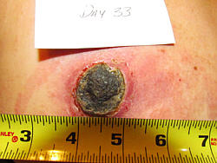
Update for 2020: We first posted the pictorial below (and the two cases that follow) sometime in 1996 -- early in the days of the internet. These cases go back to the early '90s -- our earliest days at Alpha Omega Labs. The purpose of this page and the two that follow is to show someone who knows little or nothing about escharotic medicine how the process works and what to expect when you use our Black Salve. A far more detailed pictorial can be found in Chapter 2 of our book, Black Salve (2019), or you can view here a pictorial of removal of skin cancers and keratosis from my own body in Appendix F of that same book over a 30 year period.Moreover, hundreds of pictorial examples can be found in the Cansema testimonial section. [GC]
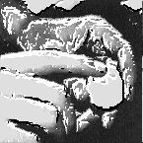

How Cansema Works:

A Pictorial Demonstration

http://www.altcancer.net/index.htm


"In 1989, the incidence of cancer topped one million for the first time and the number of deaths reached 500,000... (yet) in the name of orthodoxy, both new and traditional scientific theories are suppressed, medical records seized, clinics shut down, and innovative clinicians thrown in prison.
"But while orthodoxy appears to have all the cards -- money, power, prestigious credentials, influence in the major media -- the continuing failure of orthodox medicine to deal satisfactorily with the major forms of cancer guarantees the growth of nonconventional approaches... It is the job of the true scientist, and all those who love truth, to take a serious and open-minded look at all methods and claims..."
"A million new cases a year demand no less."
Ralph W. Moss - The Cancer Industry (1989,91)
Pulitzer Prize-Winning Author
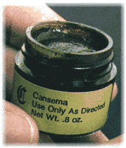
They say a picture's worth a thousand words. We don't know about that, but we do know, having worked with thousands of Cansema users, how our topical formula works. What happens. What are the stages of cancer necroses and subsequent healing. This we know quite well.
So please follow along with us. Below we present you with three pictorial cases and explain the stages involved, from initial application through complete healing over of the decavitated area.

-- CASE I --
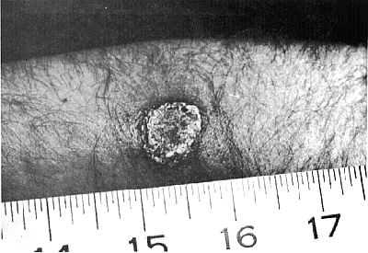

Melanoma:

30 Hours Later
1. ESCHAR FORMATION -- This is the first in a progressive series of photographs taken following the application of Cansema on a cancerous skin lesion, this one on the forearm of a middle-aged user from Ohio (USA). The example above involves one of the more serious types of skin cancer: melanoma. The photograph above shows that only 30 hours into the treatment, the entire neoplasm has formed into a scab, or "eschar." The cancer is completely dead, but the healing process has only begun.

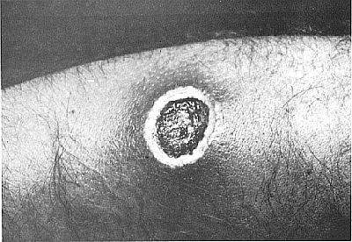

4 Days Later
2. EDEMA & ISOLATION -- There is a buildup of antibodies and serum in the surrounding tissue. As is often typical of edema, there is a reddening and a general puffiness. The degree can vary considerably from case to case, but in all ways it is an important part of the body's healing process. Cansema has successfully triggered the body's immune system and the necrosis is recognized as an invasive agent. The eschar becomes better defined from the surrounding, healthy, non-cancerous tissue.

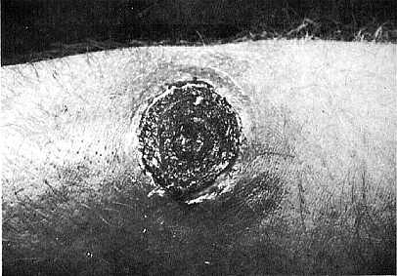

7 Days Later
3. ESCHAR CONTAINMENT -- The eschar begins to dry up and contract like any other scab. As healthy dermal layers are formed beneath the eschar, which nears perfect and separate formation, it is slowly ejected from the body. We also call the intermediate step before eschar expulsion "separation." Edema and redness disappear.

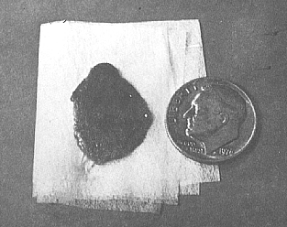

8 Days Later
4. ESCHAR EXPULSION -- The entire eschar, representing what had been a thriving cancer only days before, is pushed out of the body when the last connective skin tissue beneath it is broken or deteriorates. What remains at the site of expulsion is a decavitation, which we will examine next...

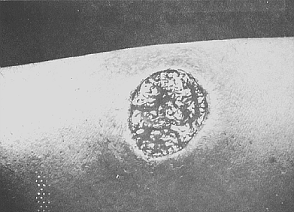

Still 8 Days Later
5. DECAVITATION -- Now back at the body... a decavitated area remains where the tumor was ejected. Epidermal layers have not completely formed, so to the lay person the area can look extremely raw and unprotected. Nonetheless, in the thousands of cases we have been involved in, never once have we had a case of secondary infection resulting from the process. Vitamin E or petroleum jelly is applied to minimize scarring and aid the healing process.

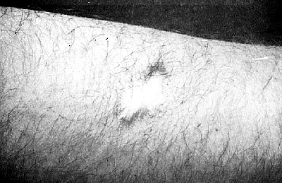

40 Days
6. FINAL HEALING (also called "Heal Over") -- The epidermal layers have come in. There is usually minimal scarring and discoloration, where instructions have been thoroughly followed. In time even the little scarring seen at right will be marginalized.

Click here to view Case II.
Home Page Top of This Page Cansema (Top) Order Form

Cansema® Instructions
For Topical (Skin Cancer) Applications
"Please read carefully before using!"

The medical definition of "cure" is the non-reoccurence of pathology within five years after treatment. By the very definition used by orthodox medicine, Cansema® is empirically a proven cure for skin cancer for the majority of those who use the product according to our instructions. An extensive history of Cansema®, in particular -- and escharotics, in general -- can be found in Chapters 1 and 2 of Meditopia®. Note that we have special protocols for use in treating internal cancers, but the instructions below are specific to skin cancer, pre-cancerous growths and a number of other diseased skin conditions.

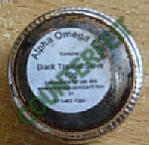
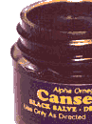
CAUTION: There are numerous counterfeiters of Cansema® who use our trademark, information, graphics -- even our testimonials, even though they are not connected to us; the formula is not the same; and the performance of their product is substandard to the genuine article! We list known counterfeiters -- one of which we know is receiving FDA assistance in making an adulterated / misbranded version -- on our Fake Program Compensation Program page. This Cansema® User Instructions page is currently being recommended by a company run by Jennifer Wilson / George Ackerson -- who are telling the public that they are us. Do not believe it. We do not and will not provide customer service for their products.
WARNING: Please read the following instructions through carefully before applying Cansema®. Do not, in any way, deviate from the following. If you have questions after a thorough reading, please call Alpha Omega for any clarification, or just write to support@herbhealers.com. Remember, Cansema® will provide results only if you have skin cancer, as opposed to a benign growth. This includes basal cell and squamous cell carcinomas and melanomas of the skin. For information on an alternative to benign moles and warts, see Bloodroot Paste.

--- (1) PREPARATION ---
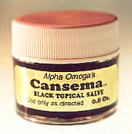
Understand at the onset that applications to the face / nose / and ears, breast, and the rest of the body should be treated differently.
- Face / Nose / Ears: Never apply to an area larger than the end of a pencil eraser (roughly 1/4 inch or a little over one-half centimeter. Inflammation can be considerable, depending on the area to which you apply, as well as the depth and size of the targeted growth.
- Breast: With certain exceptions, we don't recommend applying Cansema to breast tumors. The process is long and arduous, and although it may take longer, using an internal escharotic approach is easier, all things considered.
- Other Areas: Apply no more than one to two centimeters (up to about an inch) to the targeted growth. If the growth is larger, it must be worked on in stages.
- Areas to which you should NEVER apply:
  - Eyelids: The thinness of the skin risks perforation and foreign bodies entering the eye. Successful cases have involved serious guidance from a skilled practitioner -- often our own in-house practitioners.
  - The right or left temple: The temporal artery can readily be compromised, leading to a serious bleeding problem. Since 1990, we have had three such cases, and each of them required surgical intervention. Our advice: don't do it.
  - Cervical lymphatic chain in the neck: Large vascular pockets are present in this area, and they may be involved in the growth of the malignancy. An active arterial bleed in this area can be fatal. Again, our advice: don't do it.
  - Scrotum (in men) and vulval area (in women): In the case of the scrotum, the removal of a larger growth escharotically can risk the ejection of a testicle. In the case of applications on or near the vulva, pain management can be a significant issue, and all the successful cases we know of that involve the treatment of cancers in and around the vagina have involved the experienced guidance of a practitioner who is skilled in the use of escharotic preparations. If you have questions about this, please consult one of our in-house practitioners.
Additional advisements before preceeding include:
- Cansema® should only be applied between one to three times (24 hours apart) per escharotic cycle, which is described on our pictorial demonstration page. More is not better. Once a white/yellowish plaque of sterile pus forms, no more applications are needed at that point. Adding more salve is not helpful. Most superficial skin lesions need only one application.
- If you're treating multiple growths, in the interests of pain management, treat only one growth at a time. It is also recommended so that the treatment does not overwhelm the body's immune system. This advice is self-evident if you understand Cansema's mechanism of action.
- The application of the salve over diseased cells (cancerous or precancerous) produces an acute immune response. This response is followed by a localized inflammatory response. The inflammation will gradually reduce over the next few days after the initial application.
- Understand that the white or colored pus that forms is cellular detritus -- that is, dead cells -- or a combination of your own white blood cells and dead diseased cells. We know this as a result of pathology reports on eschars that have come back to us. (You can do this yourself if you keep a freshly ejected eschar preserved in formaldehyde.)
- Do NOT disturb this freshly formed scab, or eschar, as this increases the risk of scar tissue formation. Do not cut into it. Do not pinch it. Do not try to drain it. Leave it alone! Be patient! Another reason for leaving the eschar alone is that the dead cells hold together such that when the eschar ejects, you get a nice, clean separation, leaving only a decavitation that subsequently fills in.
- Most confirmed diagnoses of malignancy (melanoma, BCC, SCC, etc.) need multiple cycles of escharotic treatment before there is no longer a reaction. Larger malignancies grow with tentacles and deep roots. All confirmed diagnoses should start with an internal protocol as a preventative. See Botanical Support.
- Understand that infection is very rare with the use of Cansema. Out of thousands of cases with which we have worked since 1990, we have seen only a handful of cases of infection, and even in these cases, the growth was of a considerable size. We say this because most medical doctors have no training or knowledge of escharotic medicine. Consequently, when they see the edema, inflammation, and eschar formation that is integral to this process, they automatically think they're looking at an infection and prescribe antibiotics. This is unnecessary because the entire escharotic process is mediated by your own immune system.
First, as stated earlier, the user may want to have an antigen test or other non-invasive diagnostic procedure performed to ascertain whether or not there is, in fact, skin cancer. People should be aware of the very well-established risks associated with biopsies or otherwise cutting into the cancer growth.
Many people, on the observation that they have a "mole" or similar skin marking that is growing and getting darker, have elected to use Cansema® anyway. After all, Cansema® is selective in its action and will only "go after" neoplastic (cancerous), precancerous and similar diseased tissue. Healthy tissue will only redden and become mildly irritated when Cansema® is applied. This decision is entirely at the discretion of the user; there is no danger, toxic or otherwise, of applying Cansema® to healthy tissue, although doing so is simply a waste of the product.
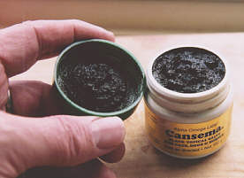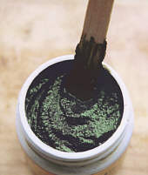
PREPPING CANSEMA® SALVE: Few escharotic salves, if any (and Cansema® is no exception), use emulsifying agents, so to get the best results from Cansema®, you should spend a few seconds stirring the contents before applying. For the smaller (22 g.) container, this can be done with a toothpick; for the "clinical sized" jar, we find the best implement to be an ice cream stick. You will find the latter's consistency yields the best results.
Note on Altering Consistency: Not everyone wants the same consistency in a salve. Some users have noted that their Cansema® is thicker than they want it. (Thickening can also occur if Cansema is left out and allowed to dry up.) The solution to thinning the product is simple. Since Cansema® is water-soluble, just add a few drops of water to the desired consistency, while -- again -- stirring vigorously. Doing this will not appreciably affect the strength or efficacy of the product.

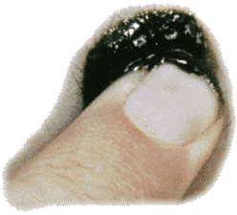
--- (2) APPLICATION ---
Cansema® comes in both small 22 gram (roughly 0.8 oz.) and "clinical-sized" 102 gram (roughly 3.6 oz.) jars. The product has the consistency of a thick, moist paste. It can easily be self-applied with the fingers and should be spread over the lesion or cancerous tissue in a thin covering, almost lightly "caked." Wash hands thoroughly before and after applying Cansema®.
The following is observed following the application of the product when diseased tissue is detected:
- The applied area will start to tingle shortly afterwards -- anywhere between 5 minutes to 6 hours after the initial application. (In fact, if you feel "nothing" after three to six hours, it is most likely that nothing more will happen: Cansema® has failed to come into direct contact with the cancer.)
- After 24 hours, you may wish to remove the Cansema® and reapply, repeating this process up to three times, until the Cansema® can reach and "grab" the underlying aberrant growth. Know that anywhere from one to three applications are normally required initially to escharize a skin cancer. However, if the growth is considerably larger, two or three complete escharotic cycles may be required to eradiate a malignancy in its entirety.)
- In some cases, there is a burning sensation with larger lesions. For this reason, we ask that users thoroughly read our pain management page.
- It is also a good idea to place a bandage over the area, particularly if the forming eschar is on a place on the body that might be subject to being bumped or bruised in the course of daily activity. For practical, aesthetic, and cleanliness issues, covering the site is a good idea. We recommend lining the bandage or gauze with a healing salve, cream, or ointment so prevent sticking to the eschar. If sticking occurs, wet the bandage or gauze completely and remove slowly. Again, the point here is to NOT disturb the eschar.
" . . . I applied Cansema® and no eschar appeared! . . . What do I do now?"
Cansema® has to come into contact with the target cancer area in order to work. It has transdermal properties (i.e. skin penetrating ability) - a characteristic that is enhanced with the Cansema® - Deep Tissue, as well as our veterinary versions. However, a couple of simple tricks can also speed up the process and/or reduce the number of applications required to "reach" a skin cancer that is well below the epidermis. Most people don't need these techniques if the skin cancer is close to the skin surface. We recommend that these "tricks of the trade" only be used if an initial application does not produce results - which turns out to be a minority of cases.
"Deep Loufah Wash" - Many people use a loufah sponge to rigorously wash and prepare the skin before applying Cansema® Salve. This serves to remove some of the dead cells in the top layer of the epidermis (the stratum corneum), so that Cansema® has less tissue through which to travel to get to the underlying cancer.
"Needle Points" - This technique is more effective, but more invasive. It involves taking a sterilized needle and carefully making holes in the skin - about a sixteenth to eighth inch deep, very much as an acupuncturist would - except that the needle is removed as soon as the holes are created, usually spaced about a quarter-inch apart. Following the creation of the "skin holes," Cansema® Salve is then (re)applied. We recommend that this technique be used by practitioners and not end users. We also advise that practitioners prep the area by rubbing three drops of Lugol's into the freshly "pricked" skin before Cansema® is (re)applied, provided that the subject is not diabetic - a clear contraindication, in which case hydrogen peroxide (3-6%) will act as a suitable substitute.

--- (3) MANAGING THE ESCHAR ---
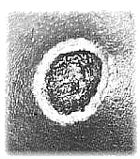
The following should be observed in managing the resulting eschar:
- After 24 hours remove the bandage.
- Wash the area thoroughly with clean water and a gentle soap to remove any excess Cansema® and other organic debris (i.e. pus, serous fluid, etc.) Some salve can become part of the white plaque. Do NOT forcefully remove. Leave it alone. It will become part of the eschar.
- If a full pus formation is not evident or is incomplete, repeat step 2 and leave the new application on for an additional 24 hours before proceeding. Normally one application is sufficient for small growths (a few milliters in diameter), but several applications or entire cycles may be required for larger tumors.
- There are instances when repeated applications of Cansema® are required because of "accessibility" problems - although this can be limited using the techiques cited in the preceding section. In order to initiate the escharization process, however, and begin killing the malignancy, it is vital that Cansema® be able to penetrate and reach the targeted growth. Again, this can take multiple (three or more) applications, though one to two applications for smaller growths is more common.
- After the eschar has formed, keep it well protected. You can apply Sangre de Drago, H3O, among other topicals in treating the area. (H3O is also known as "Calcium Sulfate Hydronium Solution" in our U.S. and Canadian markets). H3O should be diluted with purified water at the 16:1 ratio to accelerate healing - but know that this is better to use once you reach the decavitation stage. (Although recent reports have been submitted where H3O was used throughout the entire process as a cleaning agent - acting to accelerate healing and minimize scaring.)
- Wash over the area daily with clean water and gentle soap. We do not recommend "soaking" the eschar. This includes swimming, sitting in a bathtub, or otherwise subjecting the site to anything more than minimal exposure to water. The reason for this is that this part of the escharotic cycle involves the drying up, contraction, and ejection of the eschar. If you're keeping the area wet, this process is only inhibited.
- In advanced cases there is considerable "drainage," that is, a steady emission of pus. In the sense that Cansema® kills the cancer cells and takes certain leukocytes (defending white blood corpuscles) with it in the process of eliminating the neoplasm, it is a suppurative agent: that is, drainage should not be viewed as abnormal. The range of possible response is very little pus and only one bandage ever required, to a regular change of bandages required in the case of advanced melanomas. Your case will be somewhere in-between.
- Time to ejection: This will vary from case to case, depending primarily on the depth and size of the target growth. This averages between ten to sixty days. Those that are closer to the sixty day mark tend to be massive growths.

--- (4) REMOVING THE ESCHAR ---
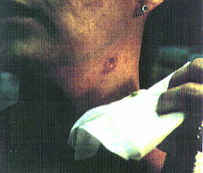
The eschar itself represents the death of the neoplasm, and this occurs shortly after application. Everything that follows from there is the body's own reparative responses. From here on out, the body knows exactly what to do and wastes no time doing it. However, to us the days and weeks that follow may seem lengthy.
The next stage is the removal of the eschar, or scab. This usually happens, as stated previously, within 10 to 60 days after initial application. As with any scab, let it fall out when it is ready. Do NOT pull it out prematurely, although you may find that it will eventually be attached with a small thread of connective tissue which can be easily and safely severed. If you remove the eschar premature, you further risk developing scar tissue. Also, know that if the eschar is slow in ejecting on its own, there are simple methods of quickening the process.

--- (5) DECAVITATION & "HEALING OVER" ---
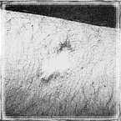
After the eschar comes out, the pit or "decavitation" can look raw and unsightly. Nonetheless, if kept covered and the everyday principles of good hygiene are followed, there will be no threat of secondary infection. If you work in area that is less than clean, however, you might want to have H3O handy. You can apply this liberally at the 16:1 dilution ratio to the site once a day to kill any invasive germs. Another option is the use of Sangre de Drago -- a natural tree resin, sold by Alpha Omega Labs which also accelerates the healing process.
Over a period of a few months, or in some cases two years, the entire area will be healed with only some "depigmentation" or scar tissue. The result is rarely more unsightly or unaesthetic than if surgery had been chosen instead.
In most cases the cancer does not "come back" to the area applied, unless there is underlying metastasis. To be sure that the area is clear of cancer, however, many users elect to initiate a second, or even third, application after they get to the "heal over" stage. We take a dim view to doing this indiscriminately because the risk of scarring is increased with each new re-application. However, with particularly aggressive forms of cancer, such as melanoma, a user may want to weigh the potential advantages of re-application, particularly if the initial cancer is located somewhere on the body that is not usually aesthetically sensitive or viewed in public (i.e. on the back, upper leg, etc.). None of this should be taken as a substitute for using some of the better cancer marker tests that are now available from qualified, licensed physicians.
In other words, once Cansema® has finished its work, there are normally no residual cells from the original malignancy. This rule finds more exceptions the larger the original cancer growth is, the deeper it is beneath the skin, the more instances of skin cancer the subject has experienced, and/or the more extensive a person's history of skin cancer is or has been. Remember, you may need to repeat this process if the skin cancer is sufficiently extensive such that residual cancer cells have been left behind after you finish your first "cycle." (Although, this same admonition would exist if you had your skin cancer surgically removed.) To be on the side of caution, have your health care practitioner check the site to see if there is any remaining cancer. There are excellent antigen marker tests that your physician can utilize to determine if you have a "clean bill of health."
Back to Cansema® Opening Page | Home Page | Order Form

Alpha Omega Labs: Virtual Store

We appreciate your sharing!

https://store.gregcaton.com/

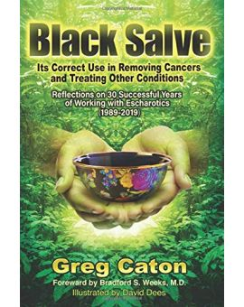
Black Salve -- paperback edition
$18.95
In Black Salve, Caton, a master herbalist who lives near the Amazon forest, provides a knowledgeable study showing how escharotics have been used for centuries -- usually quite privately -- to cure cancer and other diseases. But, thankfully, these miraculous natural remedies have survived all while having to confront the wrath of organized medicine and the official establishment.

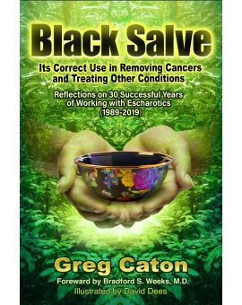
Black Salve -- digital edition
$9.95
In Black Salve, Caton, a master herbalist who lives near the Amazon forest, provides a knowledgeable study showing how escharotics have been used for centuries -- usually quite privately -- to cure cancer and other diseases. But, thankfully, these miraculous natural remedies have survived all while having to confront the wrath of organized medicine and the official establishment.

