Astro-Diagnosis A Guide To Healing

by

Max Heindel and Augusta Foss Heindel

A Treatise On Medical Astrology and Diagnosis
From the Horoscope and Hand

The Rosicrucian Fellowship
International Headquarters
Mount Ecclesia
P.O. Box 713
Oceanside, California, 92049-0713, USA

FOREWORD
Of the thirty years devoted by the undersigned to research and the study of astrology and astro-diagnosis, a large part was spent with Max Heindel, first as co-student and companion and later as his wife. A portion of the astro-diagnosis in this book have been taken from Mr. Heindel's former monthly lessons to esoteric students, and this fact together with our association in astrological research in the reason why this volume goes out under both our names, even though he passed into the larger life in 1919.
This book may differ in a few instances from other books which deal with the science of diagnosis from the planets. The authors of this volume, however, have had opportunities such as few other writers on this subject have had. The Rosicrucian Fellowship, of which they were the founders, has a very successful healing department. A description of the method used in this department may be found on page 440. Of the thousands of patients who have written to us for healing since the department started, each one has sent in data describing the disease from which he suffered, its symptoms and peculiarities, the doctor's diagnosis, etc. This information was in every case carefully compared with the patient's horoscope, and a detailed study made of both. The most striking as well as typical cases were used as monthly lessons for the esoteric students of the Fellowship. From these lessons we have chosen the best to print in this book. At no time have we diagnosed direct to the patient. His horoscope, however, has given us a wonderful key to the disease from which he was suffering and its causes, and it has been used as a guide in giving advice regarding diet, exercise, environment, and similar matters.
We do not claim that this book is the last word on the subject, neither do we claim that it is infallible. The knowledge which we have gained by years of unceasing labor we are sharing with the world. We give it freely, and if others can add to it, we shall rejoice.
--Augusta Foss Heindel

INTRODUCTION
Astro-diagnosis is the science and art of obtaining scientific knowledge regarding disease and its causes as shown by the planets, as well as the means of overcoming it. This new science of diagnosis and healing is slowly permeating the medical world. It is a science which will not set aside the old school of medicine and diagnosis, but it is an addition to the old school The latter, we feel, will in time accept this newer method. At present many physicians are willing to cooperate with the newer schools of osteopathy, nature-cure, chiropractic, etc., and these open-minded men are ready to accept a more advanced method of diagnosis when it has been demonstrated to them as reliable.
Depending entirely upon outward symptoms in locating disease and relying wholly upon the action of medicine have cost millions of lives in the ages past. But man is now becoming too enlightened, too broadminded to stick stubbornly to old methods which have been proved by many mistakes, by the sacrifice of many lives, to be inadequate. Medical science with its improved instruments, the X-ray, iri-diagnosis, blood tests, etc., has made great strides toward better methods of diagnosis. But the time is not far hence when it will be generally conceded that to know in advance where human chain is weakest, to understand by the science of the stars where the practitioner may look for trouble, is by far the best way. Doctors will then arrive very quickly at the cause of disease, and they will also know what methods will be best to effect a cure. When they can use the key to the soul, the horoscope, they will find the treatment to which the patient will respond. They will also know the character of the patient, whether his will is weak, and whether he is negative or emotional. They will then be guided in their methods of treatment according to the information thus obtained.
Disease may be classed under two heads, latent and active. "Symptoms" give indication of disease which is in process of materializing. Latent tendencies to disease are shown by the planetary afflictions in the horoscope of birth. In some instances these tendencies may remain latent during the entire life because the native has lived in such a manner that no strain was put on the body which would give the planets a chance to develop their latent weakness. If there is a weak link in a chain but no strain is put upon it, the chain will remain whole. So in the case of planetary afflictions, they too may remain latent. But let the native abuse his body and at once these weak spots will appear. This gives us the second class of disease, the active type. When the planetary aspects have been stirred into action and disease has appeared, the progressed planetary positions give the diagnostician the key to it.
When the medical men, the scientists, the occult scientists, and the astrologers have reached a friendly understanding, when the budding discoveries and the broader thoughts of man are no longer at variance with each other, then humanity will know that the terrors and the pain of the operating room are things of the past. Then buoyant health will be universally enjoyed, for mankind will be taught how to live in order to avoid suffering. The doctors will be just as anxious to keep people well as they now are to help them to recover from disease. The time is not far hence, we believe, when the government will feel the necessity of paying doctors a yearly salary to teach the people how to avoid the pitfalls which lead to disease.

TABLE OF CONTENTS

- Foreword
- Introduction

PART I

- The Anatomical and Physiological Properties of the Signs
- Chapter II: Rulership and Qualities
  - Anatomy and Physiology Correlated to the Zodiac
  - Pathological Qualities of the Signs
  - Physiological Afflictions of the Signs
  - Anatomy and Physiology Correlated to the Planets
  - Pathological Qualities of the Planets
  - Astrological Affinities of the Sense Organs
- Chapter III
  - Sympathy and Antipathy
- Chapter IV
  - The Science of Right Living
- Chapter V
  - The Mentality
- Chapter VI
  - The Sixth House Influences
- Chapter VII
  - Preliminary Steps in Diagnosing
- Chapter VIII
  - Hints and Helps for the Healer
- Chapter IX
  - Aphorisms
- Chapter X
  - Diagnosing from the Hands and Finger Nails

PART II

Diagnosis From Horoscopes

  - Chapter XI
    - A Lesson in Directing
  - Chapter XII: The Ears
    - 1A: Ears and Nerves
    - 1B: The Ears
    - 1C: The Ears -- Abscesses in Frontal Bone
  - Chapter XIII: The Ears
    - 2A: The Eyes
    - 2B: The Eyes
    - 2C: The Eyes
    - 2D: Eye Trouble
    - 2E; 2F: The Eyes
    - 2G: The Eyes
    - 2H: The Eyes
  - Chapter XIV: The Throat
    - 3A; 3B: Tonsils, Adenoids
    - 3C: Throat and Tonsils
    - 3D: Goiter; Tonsils
    - 3E: Goiter
    - 3F: The Vocal Organs
    - 3G: Loss of Speech
  - Chapter XV: The Lungs
    - 4A: Tuberculosis
    - 4B: Tuberculosis
    - 4C: Tuberculosis
  - Chapter XVI: The Heart
    - 5A: The Heart
    - 5B: Heart; Kidneys
    - 5C: The Heart
    - 5D: The Heart
    - 5E: The Heart
  - Chapter XVII: The Stomach
    - 6A: Stomach Trouble and Tuberculosis
    - 6B: Stomach Trouble and Inflammation of Kidneys
    - 6C: The Pylorus
    - 6D: Stomach and Kidney Trouble
  - Chapter XVIII: The Kidneys
    - 7A: The Kidneys
    - 7B: The Kidneys and Mastoiditis
    - 7C: General Breakdown
    - 7D: Renal Calculi
    - 7E: Renal Circulation
    - 7F: Bladder Trouble
    - 7G: Diabetes
    - 7H: Diabetes
  - Chapter XIX: Sex
    - 8A, 8B: Sex and Throat
    - 8C: Sex
    - 8D, 8E: Gonorrhea
    - 8F: Venereal Disease
    - 8G: Venereal Disease
    - 8H: Uterine Trouble
    - 8I: Childbirth
    - 8J: Abortion
  - Chapter XX: The Spine
    - 9A: Spinal Trouble
    - 9B: Spinal Trouble
    - 9C: Tuberculosis of the Spine
    - 9D, 9E: Inability to Walk
  - Chapter XXI: The Liver and Gall Bladder
    - 10A: The Liver
    - 10B: Gallstones
    - 10C, 10D: Gallstones
  - Chapter XXII: The Circulation
    - 11A: Palpitation of the Heart
    - 11B: Sluggish Circulation and Cataracts
    - 11D: Varicose Veins
    - 11E: Restricted Circulation
    - 11F: Pernicious Anemia
    - 11G: Rheumatism and Impure Blood
    - 11H, 11I: Rheumatism
  - Chapter XXIII: Leprosy
    - 12A, 12B: Leprosy
  - Chapter XXIV: Paralysis
    - 13A: Paralysis
    - 13B: Paralysis and Hardening of the Arteries
    - 13C: Facial Paralysis
    - 13D, 13E: Paralysis
    - 13F: Infantile Paralysis
    - 13G: Rickets and Tetany
  - Chapter XXV: The Nerves
    - 14A, 14B: Nervous Breakdown and Paralysis
    - 14C, 14D: Defective Walk
    - 14E: Exaggerated Hysteria
    - 14F: Obstruction of the Pneumogastric Nerve
  - Chapter XXVI: The Bones
    - 15A: Injury to Femur
    - 15B: Arthritic Muscular Atrophy
    - 15C: Osteomyelitis--Inflammation of Marrow of Bone
  - Chapter XXVII: Spirit Control
    - 16A: Spirit Control
  - Chapter XXVIII: The Ductless Glands
    - 17A, 17B: Thyroid Gland Trouble
    - 17C: The Thymus Gland
    - 17D: The Adrenals
  - Chapter XXIX: Special Conditions
    - 18A: Deficiency in Lymph
    - 18B: Polypi and Kidney Trouble
    - 18C: Pyorrhea
    - 18D: Auto Intoxication
    - 18E: Peritonitis
    - 18F: Arterio-Sclerosis
    - 18G: Typhoid and Spinal Trouble
    - 18H: Narcotics; Cigarettes
  - Chapter XXX: Insanity
    - 19A: A Mental Case
    - 19B: Insanity
    - 19C: Insanity, Obsession, and Tuberculosis
  - Chapter XXXI: Asthma
    - 20A: Asthma
    - 20B: Asthma,; Morphine Addiction
    - 20C, 20D, 20E: Asthma
  - Chapter XXXII: Cancer
    - 21A: Cancer
    - 21B: Cancer
  - Chapter XXXIII: Rosicrucian Healing
    - How the Rosicrucians Heal the Sick
  - Alphabetical Index

CHAPTER I

THE ANATOMICAL AND PHYSIOLOGICAL PROPERTIES
OF THE SIGNS
ARIES
When Aries, which has rule over the head, is on the Ascendant, we have a person whose actions are impulsive and aggressive. He acts and speaks quickly. An excess of life force is generated by these people. This is intensified when the dynamic Mars, which is the ruler of Aries, is also in Aries on the Ascendant, or when the life-giving sun is there. When these planets add their vital energies to the Ascendant, we have a person who is very apt to dissipate his forces. people who express Aries very strongly are apt to be quick of temper of an explosive kind, but will not hold spite. Those with Aries on the Ascendant, or with the sun or Mars there, are quick to anger but also ready to forgive.
Aries rules the head, the cerebral hemispheres of the brain, the upper jaw, the eyes, and the face. The nose, however, is ruled by the martial sign of Scorpio.
Aries is hot, dry, and inflammatory. Aries people with a slight cold or disturbance of health may have a very high temperature. In illness their fever will often be from three to four degrees higher than that of the persons born under the watery of airy signs. Under planetary afflictions these people are subject to brain fever, dizziness, nosebleed, neuralgia, inflammation of the cerebral hemispheres, and diseases of the brain and face. They frequently suffer from a rush of blood to the head.
The will of the patient plays a great part in the success of healing. People under positive signs are most likely to respond, for they make personal effort to help the healer, while negative-sign people are prone to follow the line of least resistance and to be neglectful in following the instructions of the healer.

TAURUS
Taurus has rule over the region of the neck, the ears, palate, larynx, tonsils, thyroid gland, lower jaw, occipital region, cerebellum, atlas, and cervical vertebrae, vocal chords, carotid arteries, jugular vein, and the pharynx.
The Taurean is very stubborn and tenacious. Taurus being a negative sign, when a Taurean contracts a disease, he holds on to it tenaciously. He has great fear of sickness, and on account of this fear he makes a poor doctor or nurse, whereas the Arian, being under Aires which is a positive sign, will go into a sick room without fear and quickly throw off the disease. If you have a patient who has Taurus rising or the sun in Taurus, never let him think he is much ill, for his fear of sickness will often bring on a spell of it. The Taurean has a tendency to take on flesh in middle life. Being short and thickest as a rule, he becomes very fleshy about the neck and base of the skull. This has a tendency to cause the swelling of glands, tonsillitis, quinsy, and various diseases of the organs of the neck; also polypi.

GEMINI
Gemini has rule over the arms, hands, shoulders, lungs, thymus gland, upper ribs, trachea, bronchi, capillaries, breath, and oxygenation of the blood.
The Gemini person is subject to nervous troubles. Gemini being one of the common signs, a person born with this sign rising is often very careless of his health and habits, and on this account we find more tubercular patients among Gemini people than among people of any one of the other eleven signs. Gemini being classed among the positive signs, the Gemini person can, if he is given the least bit of help, often throw off a disease. The diseases to which Gemini is most subject are pulmonary troubles, bronchitis, asthma, pneumonia, consumption, pleurisy, and nervous disorders.

CANCER
When we have a horoscope to diagnose for one who has the watery and negative Cancer rising, we may look for one who is low in vitality; one who is very timid yet loath to follow the advice of others. Cancer people are apt to do the opposite from that which they are advised to do. They are also full of suspicion, and on account of lack of faith in others they are difficult to reach; but when their faith has once been established, they are most loyal and ready to cooperate. A little praise or appreciation will often win them over. They are unduly sensitive, and when hurt do not forget it readily. When the sun is in this watery sign, the native has more vitality than when it is rising, for the sun is the giver of life and energy.
Cancer has rule over the stomach, diaphragm, the mammae, upper lobes of the liver, thoracic duct, chymification, peristalsis, the pancreas, gastric vein, and the serum of the blood.
The afflictions which may be classed under the sign of Cancer are indigestion, hiccough, flatulency, dropsy, and sclerosis. Cancer people are very fond of food and are usually hearty eaters. Consequently they are often afflicted with diseases which originate in wrong diet; especially do we find this so with the people have Saturn in Cancer. This planet has a restricting influence, and wherever he is found he robs the corresponding organ of its fluids. When in Cancer he gives a desire for pastry and sweets.

LEO
When we have to deal with a patient with Leo on the Ascendant, we have one with great vital energy, one who will not readily succumb to disease. The Leo usually puts up a brave fight to overcome without calling upon others for help, but when he gives up, he is usually very sick; he recovers rapidly from illness, however. His pride will not permit him as a rule to become a charge upon others. Being a positive sign the greatest handicap to the Leo is impulse. He feels he must do everything with a very great amount of energy, which is detrimental to the health of the parts of the body ruled by this vital sign: the heart, aorta, vena cava, dorsal region of the spine, and the spinal cord.
The sun, which is the life giver, rules this sign of Leo and also has rule over the vital etheric fluid coming through the spleen, which is the gateway of the solar forces. Through the spleen the sign of Leo draws its strength largely. We find those born with this sign rising very vital and full of force, especially if the sun is also in Leo; but by the destructive use of their surplus energy they are often afflicted with heart trouble of various kinds, also spinal troubles. They suffer frequently with disturbance of the spleen, which has an effect upon the activities of the blood, causing an excess of white blood corpuscles, which are destroyers and not policemen of the blood stream as medical science claims.

VIRGO
Virgo is a feminine and negative sign, the second of the earthy triplicity, and has less power of resistance that the fixed sign of Leo. Virgo may stand considerable strain, however, being of a nervous and wiry temperament; still when the Virgoan gives up, he finds it very hard to rise and shake off an illness. Being of a negative disposition he is apt to let circumstances rule him, and does not assert his will power to overcome. Virgo is the natural sixth house sign, the house which has rule over sickness; hence when Virgo people once get into the clutches of sickness, they are apt to become chronic invalids. Therefore though such people make excellent nurses, they should be advised against this vocation and avoid sick rooms and hospitals, for they are like sponges and every ready to take on the disease of their patients.
Virgo rules the abdominal region, intestines, the lower lobes of the liver, the spleen, the duodenum, and the sympathetic nervous system.
The afflictions which may be classed under the sign of Virgo are determined largely by the planets which may be afflicted in this sign. Cramps in the intestines, wind, colic, malnutrition, diarrhea, constipation, peritonitis, cholera, dysentery, worms, catarrh of the bowels, and appendicitis may result from afflictions in Virgo.

LIBRA
Libra is one of the signs wherein the sun is weak. The sun is symbolized by Sampson, who is minus his strength, for Delilah, who is the feminine Virgo, has shorn him of his power, which was in his hair, representing the sun's rays. As the sun enters Libra, it changes from north to south declination; and as Libra is the sign of Saturn's exaltation, the sun's rays at this point, the crossing of the equator, are weakest. Libra people on this account are not always able to rise above physical conditions. Their moods waver like the symbol which represents the sign, the scales. At one time Librans are up in the seventh heaven of happiness and optimism, but at the least mental disturbance they may drop to the very bottom of pessimism and despair. Idealism is well developed in the Libran. The Libran patient should, if possible, never be discouraged in whatever he has set his heart upon doing, for shatter his ideals and down goes one side of the scales into the very deepest discouragement, which often causes ill health. The Libran should cultivate equilibrium.
Physiologically this sign rules the kidneys, the lumbar region of the spine, the skin, the ureters, which are the tiny ducts running between the kidneys and the bladder, and the vaso-motor system. The afflictions from with the Libran is most likely to suffer are Bright's disease, lumbago, disturbed urine. The disease depends greatly upon the planets afflicting: if Saturn, there is a scarcity of urine; if Jupiter, an excess, etc. Nephritis, eczema, and diabetes are also diseases from which the Libran is likely to suffer.

SCORPIO
The martial, watery sign of Scorpio is one of the least understood signs of the entire twelve. Scorpio produces a number of types. Usually the Scorpio person is of a secretive, timid, retiring nature, one who does not talk of his affairs. But there is another type of Scorpio who is ready to argue at "the drop of the hat," holding our for his point, and he can become very cruel. He usually has an explosive temper, which may, if the horoscope has afflictions, undermine the health. The greatest danger to the health of the Scorpio, however, comes from the generative organs and the ducts through which the excretions of the body pass, such as the urethra (the small canal through which the urine passes from the bladder outward) and the colon, including the anus.
The bladder, the sigmoid flexure, prostate gland, pubic bone, the red coloring matter of the blood, and the nasal bones are also under the rule of Scorpio.
People born under this sign make good healers, surgeons, doctors, and nurses. But there is often a cruel and tyrannical streak in the Scorpio, and the desire nature is strong, sometimes sensual. Low desires often bring excesses, which may cause the following diseases, expressing themselves according to the planets and the afflicting aspects: syphilis, hernia, scurvy, fistula, piles, inflammation and falling of the womb, uterine troubles, stricture of the prostrate gland, and nasal catarrh.

SAGITTARIUS
The Sagittarian is usually the most gentle and easily cured of all patients, for with his frank and kindly nature he is most trusting and ever ready to follow all the instructions of the healer; but he will also respond to every negative suggestion. The healer may have given constructive advice and left the patient feeling encouraged, but should one of his many friends (for the Sagittarian is usually very popular and good mixer and therefore attracts many friends to him) suggest sickness or tell him that he is looking bad or give him some other remedy to follow he is very apt to accept the suggestion. The result is that he often retards his recovery. Therefore it is necessary for the Sagittarian patient to be placed under the care of someone who will protect him from adverse suggestions.
Sagittarius rules the region of the body directly surrounding the hips, the sacral region of the spine, the coccygeal vertebrae, the femur, the ileum, the iliac arteries, the sciatic nerves, and the ischium.
The Sagittarian diseases are locomotor ataxia, sciatica, rheumatism, and hip disease.

CAPRICORN
The sign of Capricorn is an earthy sign and ruled by the planet Saturn. Capricorn people do not yield to disease very readily. They are of a wiry, persistent, and stolid nature, and will suffer considerable pain before they will succumb to illness. But once they have given in to sickness then they are just as slow and stubborn in holding on to it. They sometimes become hypochondriacs, and the healer must use most diplomatic methods to break up the crystallized condition with which these Saturnian people clothe themselves. The most unfortunate part of it is that if a Capricorn who is in this mental and physical state is aware that anyone is endeavoring to help him, he will resist help and close up against the friend who thus approaches him. Capricorn people are super-sensitive and very retiring. They often form habits of entertaining gloom and despondency, which have a deteriorating effect upon the health.
The sign of Capricorn has rule over the knees, the skin, the joints, and the hair. The skin of a Capricorn person is often sallow and dry.
The diseases to which Capricorn is subject are eczema, syphilis, leprosy; also dislocation of the bones.

AQUARIUS
The fixed and airy sign of Aquarius is under the rule of two planets, the melancholy, fearful, and overanxious Saturn, which is ordinarily termed the planet of obstruction, and the impulsive, heedless, emotional, and hysterical Uranus. While Aquarius is a fixed sign which endows the native with a strong will, still when the Aquarian is afflicted by adverse aspects between certain planets, especially Saturn or Uranus when they are strongly placed in the horoscope, he is prone to develop extreme gloom, pessimism, and sensitiveness, or he is rash and responds to the emotional Uranus. These varying moods frequently result in ill health, which too often takes the form of nervousness. Aquarius being a mental and airy sign, its natives are wiry and ambitious, and are prone to overdo. They can never measure their strength until the body is strained to its very limit, therefore when they do give up they are usually in a critical state; but they will give the healer every opportunity to help them, for they are ever ready to cooperate.
Physiologically the sign of Aquarius rules the lower limbs and ankles.
The diseases with which the Aquarian may be afflicted are varicose veins, swelling of the legs, and nervous diseases of various kinds. One indication that the Aquarian has when the nerves begin to get weak is extreme sensitiveness of the skin. There is a crawling sensation felt all over the body, as if little insects were crawling on the skin.

PISCES
Pisces is a watery and common sign, and the people born under it are of a lymphatic and negative nature very fond of luxuries, which too often lead them to seek a life of ease; in later life they are prone to take on an excess of soft, flabby flesh, which leads to ill health. The Pisces people respond very readily to suggestions, whether they are good or evil, and they will also respond just as quickly to the influence of the healer. Do not allow anyone who is of a too sympathetic nature to visit the Piscean while he is ill. Of the over-sympathetic type there are too many in the world today, who think it a social duty to call upon every sick friends and encourage the ailing one to talk about his disease, and then extend to him, oh, so much sympathy! The Piscean person will enjoy the visit of the sympathizer, but when the latter has gone, he usually has a relapse and must quickly send for the doctor or healer. He should be placed in a very cheerful room, with a cheerful attendant, and a sign on the door, "No sympathetic visitors allowed."
The Piscean is prone to drift into the habit of drink and the use of narcotics, especially if we find an affliction of the moon and Neptune in the horoscope.
Pisces rules the feet, the toes, and the fibrin of the blood. On account of their fondness for good food and an easy life. Piscean people are subject to gout and the swelling of the feet.

CHAPTER II

RULERSHIPS AND QUALITIES
ANATOMY AND PHYSIOLOGY CORRELATED TO THE ZODIAC
ARIES-Brain, cerebral hemispheres, cranium, eyes, face, upper jaw, internal carotid arteries.
TAURUS-Neck, throat, palate, larynx, tonsils, lower jaw, ears, occipital region, cerebellum, atlas, axis, external carotid arteries, jugular veins, pharynx, thyroid gland, cervical vertebrae.
GEMINI-Shoulders, arms, hands, upper ribs, lungs, trachea, bronchi, capillaries, breath, oxygenation of blood.
CANCER-stomach, esophagus, diaphragm, the mammae, lacteals, upper lobes of liver, thoracic duct, pancreas, serum of blood, peristalsis of the stomach, chymification.
LEO-Heart, dorsal region of spine, spinal cord, aorta, superior and inferior vena cava.
VIRGO-Abdominal region, large and small intestines, lower lobe of liver, spleen, duodenum, chylification, peristalsis of the bowels.
LIBRA-Kidneys, adrenals, lumbar region, skin, ureters, vasomotor system.
SCORPIO-Bladder, urethra, genitals, descending colon, prostate gland, sigmoid flexure, nasal bone, pubic bone, red coloring matter in blood.
SAGITTARIUS-Hips, thighs, femur, ileum, coccygeal vertebrae, sacral region, sciatic nerves, ischium.
CAPRICORN-Skin, knees, joints, hair.
AQUARIUS-Lower limbs, ankles.
PISCES-Feet, toes, fibrin of blood.

PATHOLOGICAL QUALITIES OF THE SIGNS
ARIES-Energy, forcefulness, excesses; heat, dryness, inflammation.
TAURUS-Stubbornness, brooding, uncontrolled anger, luxuriousness.
GEMINI-Negativeness, restlessness, nervousness.
CANCER-Lack of vitality, tenacity, unforgiveness, distrustfulness.
LEO-Impulse, arrogance, fixity, vitality, ardor.
VIRGO-Selfishness, criticism, lack of sympathy, chastity.
LIBRA-Self-centeredness, sensitiveness, melancholy, jealousy.
SCORPIO-Tyranny, destructiveness, worrisomeness, reproduction.
SAGITTARIUS-Restlessness, venturesomeness, accidents.
CAPRICORN-Limitation, deliberation, crystallization, dryness.
AQUARIUS-Gloom, endurance, nervousness; super-sensitiveness
PISCES-Sensitiveness, lack of vitality, indolence, secretiveness.

PHYSIOLOGICAL AFFLICTIONS OF THE SIGNS
ARIES-Neuralgia, insomnia, cerebral congestion, brain fever, baldness, headache, dizziness, eye affections, toothache, gumboils.
TAURUS-Goiter, diphtheria, laryngitis, tonsillitis, croup, polypi, quinsy, glandular swelling of throat, apoplexy.
GEMINI-Bronchitis, asthma, pneumonia, consumption, pleurisy, corrupted blood, nervous trouble, anemia.
CANCER-Indigestion, dipsomania, gastric catarrh, hiccough, flatulency, dropsy, sclerosis.
LEO-Heart disease, angina pectoris, locomotor ataxia, hyperemia, spinal disease, spinal meningitis, fevers.
VIRGO-Peritonitis, malnutrition, dysentery, colic, constipation, diarrhea, cholera, typhoid, appendicitis, tapeworm
LIBRA-Bright's disease, lumbago, suppression of urine, nephritis, diabetes, renal calculi, uremia.
SCORPIO-Syphilis, rupture, gravel, scurvy, fistula, piles, diseases of the womb or uterus, urethral stricture, prostatic stricture, nasal catarrh, disease of nasal mucous membrane and nasal cartilage.
SAGITTARIUS-Locomotor ataxia, sciatica, lumbago, rheumatism, hip disease, accidents to thighs.
CAPRICORN-Eczema, erysipelas, leprosy, dislocation of bones, weak knees.
AQUARIUS-Varicose veins, swollen ankles, leg ache, nervous diseases, sensitive skin.
PISCES-Bunions, gout, deformed feet and toes, tumors, dropsy.

ANATOMY AND PHYSIOLOGY CORRELATED TO THE PLANETS
SUN-Vital fluid, spleen, distribution of heat, pons varolii, oxygen, heart.
VENUS-Throat, kidneys, thymus gland, venous circulation.
MERCURY-Nerves, bronchial tubes, pulmonary circulation, thyroid gland, right cerebral hemisphere, cerebro-spinal system, sensory nerves, vital fluid in nerves, vocal cords, ears, sight, tongue, all sense perception, breath.
MOON-Esophagus, uterus, ovaries, lymphatics, sympathetic nervous system synovial fluid, alimentary canal, lymph, chyle, nerve sheaths.
SATURN-Gall bladder, pneumogastric or vagus nerve, teeth, skin, joints, ligaments, sigmoid flexure.
JUPITER-Liver, glycogen, suprarenals, arterial circulation, fibrin of blood, disposition of fats.
MARS-Iron in blood, red coloring matter in blood, genitals, motor nerves, left cerebral hemisphere, muscular movements, desire body, rectum.
URANUS-Ethers, eyes, pituitary body, gases.
NEPTUNE-Pineal gland, spinal canal, nerve fiber.

PATHOLOGICAL QUALITIES OF THE PLANETS
SUN-Hot, dry, vital, constructive, expansive, tonic.
VENUS-Warn, lymphatic, relaxing, sedentary.
MERCURY-Cold, dry, nervous.
MOON-Moist, cold, nutritive, receptive, collective, fluidic.
SATURN-Cold, dry, chronic, contracting, crystallizing, binding, restricting, centripetal, obstructive.
JUPITER-Warn, moist, nourishing, expansive, corpulent, gourmandizing.
MARS-Hot, dry, inflammatory, energetic, eruptive, excessive, violent, positive.
URANUS-Dry, spasmodic, electric, explosive, convulsive, disorganizing.
NEPTUNE-Comatose, shrinking, stunting, restricting, constricting.

ASTROLOGICAL AFFINITIES OF THE SENSE ORGANS
EYES-Aries, Uranus, sun, moon, Ascelli, Antares, Pleiades.
EARS-Taurus, Mercury.
NOSE-Scorpio.
TONGUE-Taurus, Mercury.

CHAPTER III

SYMPATHY AND ANTIPATHY
Pythagoras taught that the solar system is one mighty musical instrument, that the twelve signs of the zodiac may be compared to the semitones of the chromatic scale, and that the planets constitute the seven white keys of the cosmic key board. Each sign responds to a certain tone; some tones blend and are harmonious, while others clash. As we find disharmony and conflict between certain notes of a piano and between certain strings of a harp, so do we find similar inharmony between various signs of the zodiac and various planets in their effect on man.

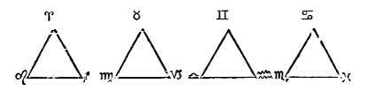
The symbol of the trine is the triangle. In astrology the trine is considered harmonious and benefic. Then we have the signs which represent the four elements, forming the fiery, earthy, airy, and watery triangles.
The fiery and airy signs are in harmony with each other, and the earthy and watery triplicities are friendly; but the fiery and watery will not harmonize, neither will the earthy and the fiery signs. Planets in these various groups of signs will express the same sympathy or antipathy as the signs themselves. The sign triplicities express themselves through harmony in the temperaments and personalities of people, while the squares express their afflictions through physical discomforts.
Disease is really a lack of harmony between the spirit and the personality, a conflict between the lower and the higher man. The trines or triplicities act as peacemakers, while the squares and oppositions place limitations upon the spirit. The latter pair bring the lessons which are to be learned. They exact payment of the debts of destiny from a person for the mistakes made and the selfishness expressed in past lives. The squares and oppositions are most vital in their action. The squares operate through three groups of signs which constitute--

THE VICIOUS CIRCLE
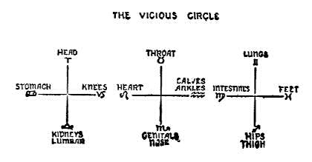
Doctors have for years been studying the strange sympathy between different parts of the body which they have found manifested in the diseases of various patients. When they find a disease in one organ, they are in the habit of looking for the cause in another organ which is in sympathy with the first. For instance, in glaucoma or certain kinds of eye trouble they have invariably found that the real cause or seat of the trouble was in the stomach or the kidneys. In certain types of throat trouble and in goiter a weakened heart has frequently been found to be the cause.
The four points of the circle of the cardinal or equinoctial signs, namely, Aries the eyes, Libra the kidneys, Cancer the stomach, and Capricorn the knees, are closely in sympathy with one another, and trouble in one will frequently manifest in one of the other signs of this circle. For instance, if we find Saturn in the sign of its fall, Cancer, and afflicted, digestive troubles ensue and invariably the kidneys will be disturbed; sometimes stiff knee joints are the result. Eye troubles are frequently developed as a result of wrong eating. People with Saturn in Cancer are extremists in their selection of food. They have strange likes and dislikes.
The second vicious circle is that of the fixed signs: Taurus the throat; Scorpio the generative organs, rectum, urethra, and nose; Leo the heart and spine; Aquarius the legs, below the knees. When the organs of voice or the tonsils are operated upon in childhood there will be disturbances at puberty and later troubles in childbirth. Great sympathy is found between the sex organs and the organs of speech. The removal of parts of the sex organs causes change of voice, the male voice becoming feminine, and the female voice masculine. Valvular heart trouble often causes the swelling of the ankles.
The third group of squares we find composed of the common or mutable signs, corresponding to the cadent houses. The 6th house, which is correlated to Virgo, and the 12th house, correlated to Pisces, are especially vital in the horoscope, for they are respectively the house of sickness and the house of confinement and hospitals. We find great sympathy between these two signs and houses. Common signs are the most productive of sickness, and more hopeless invalids are found among common-sign people than in any other group for the reason that their will power is not overly strong.
Two common signs are ruled by Mercury, which has dominion over the breath, nerves, and sense perception; and one by Jupiter, which has rule over the fibrin of the blood, the arterial circulation, and the liver. Gemini rules the lungs, and through these organs the blood is oxidized. Virgo has rule over the intestines, sympathetic nervous system, and spleen. How often we hear the remark, "I caught cold (or pneumonia) due to wet feet," involving Gemini and Pisces. Many more examples could be cited of the action of the vicious circles.

CHAPTER IV

THE SCIENCE OF RIGHT LIVING
In the previous chapters we studied the properties of the signs of the zodiac, and had the anatomical groupings so arranged as to make it easy for the student of astro-diagnosis to study them. It is very necessary that he become familiar with the basic properties of the signs as well as of the planets. It is impossible to make any headway in the art of diagnosing a chart unless the student has considerable knowledge of the zodiac and the properties of the signs and planets. He should also familiarize himself with the science of progression. All these different phases he will have to make use of before he can become proficient in diagnosis so that he may tell what certain positions, aspects, and planets indicate. It is essential that he understand the temperament and character of the patient before he can really be sure of his diagnosis of disease.
To find the key to a disease and the reason why a man or woman has become an invalid, whether the disease is organic, and whether the patient has broken the laws of nature, is just as necessary as the diagnosis itself. What is the good of knowing what kind of a disease is shown in the horoscope if you cannot show the patient where he is breaking the laws of nature? Disease in ninety-five cases out of every hundred is due to wrong methods of living, and to be able to point these out to the patient leads to the cure. First, you must remove the cause, and then the cure will follow as a natural result.
The secret of the success of the progressive doctor lies in the fact that he will never, if he can possibly avoid it, diagnose the disease to his patient directly. He will only give advice and prescribe, and sometimes he may give a hint regarding the cause of disease; he will also give directions as to food and methods of living, and tell why the patient should discontinue certain habits. From this diplomatic handling of the patient comes the doctor's greatest success. He will never express a discouraging word. He never robs the patient of his hope, and when he leaves the home of the patient, he leaves with a smile and an encouraging word.
There are exceptions, however, for there are doctors, and they are not in the minority by any means, who are posing under the name of physician but who will predict death or the necessity of operations of various kinds before they have really and truly diagnosed the disease. Under the care of such a physician the poor patient is frequently doomed, for the one from whom he has expected relief has really robbed him of hope. So we want to impress it very strongly upon our students that NEVER at any time should they predict death; also never at any time tell the patient that he has heart trouble, that he is in danger of insanity, or that he is afflicted with the dread disease of tuberculosis; from such statements he would get the thought of fear. Fear is usually worse in its effect upon the mind of the negative one than the disease itself. Ninety patients out of every hundred are ill because of wrong and dangerous methods of eating, ill because of fear, or ill because of the lack of will power to resist temptations; in fact, all disease is the result of ignorant violation of the laws of nature. This may not have occurred in this life alone. It may have been brought over from a life previous, and thus the patient has latent weaknesses.
So we may realize that to be of real help in the healing of the sick the healer or the diagnostician must have sufficient knowledge to be able to give the suffering one instruction in right living. Our advice to the reader would be to study carefully and memorize if possible the lessons in astro-diagnosis which have just preceded; also to familiarize himself with the properties of the various foods and their combinations, for you may expect if you tell a patient to change his diet that he will ask you what he should eat. One may see from all these considerations how very necessary it is to get a sane and safe knowledge of the science of right living.

CHAPTER V

THE MENTALITY
Our first thought when judging the mental qualities of a patient is to find the position of Mercury. First note the sign in which it is placed, then the house, and thirdly the aspects which this planet of reason is making.
To save time and space in these lessons we will not give the effects of Mercury in the different signs of the zodiac, but will refer the reader to The Message of the Stars, pages 201 to 207, also pages 549, 550, where he will find the basic qualities of Mercury in the twelve signs. These should be studied very carefully, and this study will give a foundation upon which to base the judgment.
The next planet to consider is the moon. If there is a good aspect between the moon and Mercury, especially if these two planets are well placed in the angles and in signs in which they can express their best qualities, we may expect the patient will be able to cooperate with the healer. If Mercury, however, is conjunct Saturn, we find a mind which is stubborn, slow, and subject to melancholia. When Mercury is trine or sextile to Saturn, a well balanced mind with good reasoning qualities will develop, and a retentive memory is shown. When Mars or Uranus is in conjunction with Mercury, the patient is of a high-strung, emotional, erratic type with little control over the mind; but should Mars or Uranus be sextile or trine to Mercury, it will have a tendency to quicken the mental faculties, giving impulse. If we find Mercury or the moon afflicted by Neptune, the mind is inclined toward unhealthy and unnatural conditions, obsession, religious mania, mediumship, drink, or drugs. Observe the house and sign in which these planets are placed to find how they tend to express themselves. Neptune being the higher octave of Mercury, this planet has a strong influence on the higher mind. Neptune when afflicted by Uranus or the moon gives tendencies towards undesirable experiences in psychism. When Neptune is afflicted by Mars, especially when it is in conjunction with this fiery planet, the native is often tempted to use hypnotism or black magic upon others, and is himself prone to become the victim of those who unscrupulously use these dreadful practices on others.
When the mental afflictions are in the eighth or the twelfth house they have a more subtle influence than elsewhere. Afflictions in the eighth house may give the mind suicidal tendencies, but if in the twelfth house being the house of self-undoing, hospitals, prisons and insane asylums, they may cause confinement in some institution.
We wish to impress it very firmly upon the mind of the reader, never, never at any time to base a diagnosis on only one or two aspects, but always upon the entire horoscope. To illustrate the dangers of superficial judgment we will take the horoscope of a man who had Mercury in Capricorn in the sixth house, making only one aspect which was a weak square to Neptune. Judging the horoscope quickly one would say that he had a dull mentality, but as a boy he stood at the head of his class. In spelling and mathematics he was very bright. As a man he has reached a high status among his associates. He is a leader in a line of work which requires executive ability and a keen mentality. To illustrate our point we will note what the other planets indicated. He had seven planets in airy signs, five planets in mental signs, the moon and Neptune both well aspected and in angles, the sun and moon in fixed signs, and fixed and cardinal signs on the four angles. When summing up the entire horoscope we can well see why this man reached such a high position in mental work with a weak Mercury. So we want to impress it firmly upon our readers to use their reasoning powers before giving a judgment on a horoscope, whether it is for mental, moral, spiritual, or physical qualities.

CHAPTER VI

THE SIXTH HOUSE INFLUENCES
After we have carefully studied the mental qualities of our patient we must try to find the strength of the will. The Ascendant as a rule gives us a key to will and to the mentality. Now we will see what bearing the 6th house has on the matter. The 6th house is the house of sickness, and very often gives the key to the patient's condition. We therefore first look to the ruler of this house to see what it indicates, in what sign and house it is placed, and what the nature of the sign is and what part of the body is ruled by it. Next we must see what planets are aspecting the ruler of this house of sickness.
Let us suppose that Aquarius is on the cusp of the 6th house. Then we would look for the two planets, Uranus and Saturn, which have rule over this sign. Naturally they will have rule over the health of the patient to a very great extent. Now, suppose that Uranus is in the sign of Virgo and on the Ascendant, as we find it in the horoscope of a man who was born April 22nd, 1881, at 2 P.M. Uranus rising gives the key to the nature, which is one of great impulse. The co-ruler of the 6th house is Saturn. We find in the greater number of horoscopes that Saturn is the afflicter. He is the taskmaster that brings to man the needed lessons. Saturn in the horoscope which we have under consideration is in Taurus, intercepted in the 9th house and in conjunction with the sun and Jupiter. Saturn is not in this case the worst afflicter.
We now consider the planets which may be in the 6th house. Here we find the vacillating moon in Aquarius and square to Venus and Neptune. The latter two planets are in the sign of Taurus in the 9th house. Here we have the whole trouble. The moon and Venus are both feminine, indicating women; the moon is the ruler of the 11th house, and thus represents women friends, who tempted and caused this man to respond to the Uranus-Mars impulse. So we may look for trouble through overindulgence of the desires, which are indicated by the planets in Taurus and by Mars, the latter ruling the sign of Scorpio, which governs sex. Hence we may expect that wine and women will bring this man to his undoing.
Note that Mercury is in the 8th house, and aspected very weakly by a semi-sextile of Saturn, the sun, Jupiter, and Neptune. Mercury in Aries works under impulse. It being practically unaspected in this sign and Uranus being in opposition to Mars indicate a lack of forethought. With these conditions and having a common sign on the Ascendant this man was a perfect slave to his passions and desires. Here we may see what the, Virgo Ascendant with Uranus in conjunction shows regarding the will. A decided lack of will power is indicated. With Virgo, the natural 6th house sign on the Ascendant, and the sun in Taurus, this man was an easy victim of disease for both Virgo and Taurus have a decided fear of sickness.
We must never base our diagnosis on one or two afflictions, but we must study all the signs and planets very carefully. Some horoscopes show very plainly what is the matter, and at a glance we can see from a few aspects what the disease may be. But other horoscopes hide the symptoms, just as the doctor often finds it to be the case with his patients. Some tell him at once where the disease is, while others are a puzzle and the disease may be difficult to locate. Therefore the astrologer must study and reason to be very sure that he has the correct diagnosis.

CHAPTER VII

PRELIMINARY STEPS IN DIAGNOSING
We are now ready to begin the real work of reading and diagnosing a chart. First we must know what the rising sign indicates, for by this we get the key to the patient's disposition. The Ascendant indicates the general nature of the planetary baptism which a man received at birth, and which will influence him all through this physical life. According to the stamp of the stellar forces at birth will a man's tendencies be. Remember, we do not say fate, but tendencies, for man has the power within him to change to a very great extent the influences that are shown in the horoscope. We must admit that the horoscope is the result of his past living and that it indicates a certain probable destiny. If he allows the stars to rule him, why then he becomes the victim of fate; but the wise man is he who rules his stars.
The Ascendant indicates the general characteristics and tendencies which are latent within a man. Therefore this should be the starting point of our diagnosis. Then we must see how the four angles are represented. If we find common signs, namely, Gemini, Virgo, Sagittarius, and Pisces on the cusps, we have a patient who will respond quickly to suggestions, and while he will listen to the healer and may seemingly try to cooperate with him, still on account of his wavering tendencies, or let us say the weakness of will of the common sign person, he is prone to forget to follow directions. One's instructions must be repeated often or the common sign patient is apt to forget them.
If the Ascendant and the four angles, however, are occupied by the four cardinal signs, namely, Aries, Cancer, Libra, and Capricorn, you may expect cooperation from your patient; but if Aries is on the Ascendant, you must let him think that he is doing the work himself. Never order an Arian to do anything, but diplomatically ask him if he does not think so and so would be good for him, for Aries dislikes to follow the dictates of another. When he does follow your instructions, however, he will do it with great force, and impulsively. We sometimes hear of people who follow the doctor's orders to the extent that they will take a whole box of pills at one dose. Well, such is the Aries patient. He must have results quickly or he will lose his interest. The cardinal sign people as a rule are willing to cooperate with the healer, and they will also make every effort to overcome disease.
The fixed sign people, namely, those under Taurus, Leo, Scorpio, and Aquarius, are creatures of habit; that is, they are so fixed that when they get into a rut, or if they form a habit, they are very difficult for the healer to handle. This habit, which may be at the very bottom of the trouble and have caused the disease, they hold on to with tenacity. The fixed sign people have great determination, and when once they are aroused they cooperate fully with the healer. Taurus and Scorpio people may at times display a stubborn nature which is hard to combat, and they are also so full of fear that the healer must be very careful of his suggestions in their presence. He must always be optimistic and give suggestions of hope.
The healer should be familiar with the temperament and disposition of each sign, and realize that if the ruler of the sign is afflicted or if malefic planets are in the sign, the response will be very different than it will when the best sign of the sign is expressed. Remember, the unafflicted magnanimous, jovial, and loving Leo is a very different person from the afflicted blustering, bragging, quarrelsome, stubborn Leo. Similarly, we may find two sides to each sign. Let us study the signs and their rulers very carefully. Note also very carefully what aspects the ruler of the Ascendant makes, for this plant is usually the life ruler and has a great influence on the life of the native.
The next step is to study the mind, for if the mentality is weak, the healer finds his work most difficult. In the mind of man lies the power which may be used to control disease. A strong and well aspected Mercury will guide a man into a safe and sane path of living, and such a person is not prone to succumb to disease. But the afflicted Mercury often leads man into temptations, and if the desire nature is strong and the mind weak, we may expect that the patient will not have the will to cooperate with the healer. Hence we may say that the healer must study the chart very carefully in order to trace the latent tendencies of his patient. When he has traced them, he is able to get to the first cause. Remember, everything in life has a first cause, and to get an understanding of a case we must go back to the beginning.

CHAPTER VIII

HINTS AND HELPS FOR THE HEALER
1.--NEVER, NEVER predict the time of death to your patient. Let the reader repeat this injunction so as to impress it firmly upon his mind. If you predict DEATH to a patient, YOU may become his executioner, and before your God you will be held accountable for a great wrong. There is an old adage which says, "While there's life, there's HOPE." No matter how strong the affliction may be in the horoscope, sometimes Divine Providence may lend a hand, and very serious periods may be passed with the proper help.
2.--The LAW does not permit a layman to diagnose disease for others; only the licensed physician may do this.
3.--The wise healer will NEVER discuss disease with his patient, nor will he ever diagnose to the patient. He will keep his knowledge for his own use in healing.
4.--At all times keep the patient's mind, if possible, from thoughts of disease, and before leaving give him some pleasant thought to help him along. Laugh and joke with him; always leave him with a smile, for cheerfulness is half the cure.
5.--Refrain from asking him the question, "How do you feel?" This has a tendency to throw his thoughts back to his physical body, which in illness is a good thing for him to forget. Let your first words of greeting be, "What a beautiful day! I am glad to see you." Any greeting is good that will bring cheer, and help the sufferer to forget his pain.
5A.--Never discuss the patient's horoscope with him; if he insists however, then give him encouraging hints only, but NEVER tell him of an impending crisis.
6.--Sick people often have a morbid desire to probe into the future, to know of any impending crisis or of possible death, especially if they have some knowledge of astrology. The healer should request the patient to discontinue the study of his own horoscope while he is under his care; otherwise he will find that many adverse suggestions obtained from such study will appear in the mind of the patient, which will hinder the healing.
6A.--There are lines of force running between the two poles of a magnet, and there is in all nature a positive and negative side. The human body is a most powerful magnet expressing both the positive and the negative aspects. When a man is ill, he expressed the negative side of his nature, and therefore the healer should (and will if he is the right healer) express the opposite aspect, namely the positive. When this is done, the patient will respond quickly, and the healing will be successful. Therefore it is very necessary that the healer express positiveness and cheerfulness in the sickroom.
7.--When a man is ill, his power of resistance is at its lowest ebb, and he is very sensitive to influences from without. At that time the currents of the vital body are turned inward, and he is apt to attract thoughts and magnetism from others which if negative will have an adverse effect upon him. When a man is in good health, the vital body ethers radiate outward and thereby keep out negative elements, also throw out impurities.
8.--When one is ill, his power of resistance is low, and at that time the vibrations of the healer have a grater effect than at other times; his influence is therefore powerful either for good or evil. If the healer's thoughts are not pure, if his life is not clean, then his influence on the patient is not good. Therefore it is most necessary that the healer LIVE THE LIFE of purity, otherwise he can do more harm than good.
9.--If the healer's Saturn is on the Ascendant or in the sixth house of the patient, he will have little success in helping the latter.
10.--A healer with the sun in Scorpio or with Scorpio on the Ascendant is usually successful.
11.--The sun in fiery signs gives good healing power, also greater power over the diseases of those signs than is possessed by others.
12.--People born with common signs on the angles or with the sun in a common sign make the best nurses; they have power to soothe the sick, and they bring a quieting influence into the sick room.
13.--When Saturn is the afflicter, the skin is often very dry, and the vitality low. Rub the skin briskly with rough bath gloves to stimulate circulation.
14.--People with Virgo on the Ascendant or with the sun in Virgo make good nurses.
15.--To calm a patient who has an afflicted Mars, it is well to choose a Saturn hour.
16.--People with Saturn in the sixth house rarely make a success in the art of healing.
17.--When the patient is suffering with nervous trouble, but Mars is not afflicted, it is well to use a sun or a Mars hour for manipulations or ministrations.
18.--When the moon is increasing in light, namely, between the new and the full, stimulants have the greatest effect and sedatives the least.
19.--When the moon is conjunction Saturn, stimulants have very little effect; but should the moon be conjoined to Mars, especially if Mars is strong in the horoscope or is in the sign of Aries, then the healer should be most careful in administering stimulants.

CHAPTER IX

APHORISMS
1.--The moon may be regarded as the giver and the taker of life; that is, the moon acts as a medium in carrying the life forces from the sun to the earth and man, and the moon forces also eventually produce death.
2.--When the moon is full, the tides are higher, the bones are fuller of marrow, and oysters are fuller than at any other time. The temperature is then also highest in fevers.
3.--During the first half of life, particularly in childhood the moon has greatest rule, and during the latter half of life the sun has the strongest influence.
4.--The moon has great influence over insane people, that is, lunatics, and over hysterical, epileptic, and nervous patients. These patients feel the changes of the moon very greatly; especially are they very restless during the full of the moon. They should never sleep with the moon shining on them.
5.--At the new of the moon the material forces are weakest. The period of the waning moon, namely between the full and the new, is strongest for spiritual work, for at that time the influence of the sun is greatest.
6.--Do not perform an operation when the moon is in the sign which rules the part of the body to be operated upon. Ptolemy says, "Pierce not with iron that part of the body which may be governed by the sign actually occupied by the moon."
7.--Operations performed at the exact change of the moon are rarely successful. Choose the time for an operation when the moon is waxing or, as it is commonly termed, the light of the moon. Do not operate when the sun is in the sign which rules the part of the body to be cut.
8.--The moon revolves around the zodiac in about twenty-eight days. Disease reaches a turning point every seven days. Starting from the place of the moon at the beginning of the illness, a change may be expected in seven days (the square), on the fourteenth day (the opposition), and on the twenty-first day (another square).
9.--The moon rules acute disease, the sun chronic.
10.--It is well to watch the squares and the opposition of the moon to the transiting sun, Mars, and Saturn when operating.
11.--The moon has greatest rule over the health of the woman while the sun influences the health of the man.
12.--From the new to the full moon stimulants produce the most effect and sedatives are the weakest; decrease the dose of the one and increase the other.
13.--When the increasing moon is in good aspect to the radical Jupiter or Venus, cardiac stimulation produces most lasting results. Palpitation is most efficiently treated when the moon is decreasing and aspecting the above planets favorably. Apply heart stimulants with extreme care when the moon is evilly aspected to these planets and especially when it is dark or waning.
14.--Good aspects to the radical moon from the transiting Jupiter and Venus are very helpful.
15. Saturn when placed in the sixth house of the horoscope at birth has a tendency to lower the vitality.
16.--The sign in which the sun is at birth is a very vital locality in the horoscope, its influence varying according as it is cardinal, fixed, or common. Also the house containing the sun, be it cadent, succedent, or an angle is important. From the strength of the sun you may often judge the response which you will get from your patient.
17.--Benefic aspects between the radical sun and Mars give great vitality and resistance to disease. An evil aspect between the Sun and Mars is better from a health standpoint than no aspect at all.
18.--Aspects to the Ascendant and the Midheaven are often unreliable unless you are absolutely sure of the minute of birth, and as clocks are frequently off time and there is much confusion in regard to different kinds of time, these two points should be used with great discretion.
19.--Planets that are in critical degrees (See Simplified Scientific Astrology, page 81) have a greater influence either for good or evil than in other degrees.
20.--Certain fixed stars have a powerful influence on disease. Especially should the three following nebular spots be watched: the Pleiades, 29 degrees of Taurus; Ascelli, 6 degrees of Leo; and Antares, 8 degrees of Sagittarius.
21.--A child with no aspect between the sun and Mars is subject to many child's diseases.
22.--A patient with many planets in airy signs requires more air in the sleeping apartment than others do; planets in fiery signs incline one to require much sunlight; and people with planets in watery or earthy signs suffer from too much sunlight.
23.--With fixed signs on the angles and afflictions in common signs, the native overcomes disease; when common signs are on the angles and the afflictions in fixed signs, he is more apt to succumb to disease.
24.--A well aspected sun when in the sign of Aries or Leo gives great vitality and an ability to throw off disease.
25.--When people with Aries rising or the sun or Mars in the sign of Aries at birth are ill, their temperature rises much higher than that of other patients, and they suffer much more quickly from fever, for there is a tendency of the blood to rush to the head and to the skin.
26.--An affliction between the Sun and Saturn or a square between the moon and the sun gives low vitality. When this condition is found in the horoscope it is well during illness to watch the progressed moon in aspect to these afflicted plants, and also especially the transits of the new and full moons.
27.--Retrograde planets give very little help in disease. Regardless of whether they are in good or evil aspect, their influence is latent until they turn direct; then we may look for their awakened influence.
28.--Planets when they turn from retrograde to direct are slow in motion. Their influence while in this slow motion is not as vital nor as powerful as when they are swiftly moving.
29.--Planets are strong when in signs of their own nature, also when in aspect to planets which are in compatible signs.
30.--When the hour of birth is not known a fairly accurate diagnosis may be obtained by using a flat chart, i.e., by placing Aries on the first house, Taurus on the second, Gemini on the third, etc.
31.--Saturn's influence is contracting, while Mars' is loosening.
32.--The sun rules the vital fluid which is specialized through the spleen. When the sun is afflicted at birth disease frequently occurs when progressions of the planets afflict the sun.
33.--When the radical sun or moon is within orb of the Pleiades in 29 degrees of Taurus, the Ascelli in Leo 6, or Antares in Sagittarius 8, trouble with the eyes is indicated, especially if Saturn, Mars, or Uranus is also at one of these spots.
34.--Mercury in the twelfth house, afflicted by the sun, Saturn, Uranus or Mars, also Mercury in Capricorn, the house of Saturn, when afflicted by a malefic will affect the hearing.
35.--Watch the malefic planets when they are placed in either the sixth or the twelfth house, the sixth being the house which has rule over sickness, and the twelfth having rule over hospitals and places of confinement.
36.--It is necessary to observe the antipathy between certain signs and planets. For instance, the fiery Mars may be posited in the water Pisces, or the cold, earthy Saturn in the fiery sign of Aries. When a planet is in the sign of its detriment, it may especially become a menace to health.
37.--The place where Saturn is found in the horoscope is most likely to be a weak place in the physical body, the place most easily affected by disease.
38.--The Lucifer spirits from Mars aid in maintaining the heat of the blood by dissolving the iron, a Mars metal, and enabling the blood to attract oxygen, a sun element.
39.--A patient with the planet Mercury in square aspect to Saturn is apt to suffer from gloom. A cheerful, sunny room should be chosen, with rose colored walls.
40.--The sign of Leo on the Ascendant with the sun in its exaltation sign, Aries, gives abundant vitality and the power to throw off disease.
41.--If a disease is caused by an affliction of Mars, we may look for help when the progressed moon reaches a good aspect of Venus. When the disease is of a Saturnian nature, we may expect the greatest help when the moon aspects Jupiter. Note the symbol of Venus, the higher octave of Mars, and that of Jupiter, the higher octave of Saturn; in each case the latter symbol is the inversion of the former.
42.--If the moon is in conjunction with Saturn at the beginning of disease, we may expect that the disease will be of long duration.
43.--Disease related to the moon is of an acute nature and may change within twenty-eight days, but when the disease is related to the sun, it is of a more chronic nature and likely to be of longer duration and more stubborn in resisting treatment.

CHAPTER X

DIAGNOSING FROM THE HANDS AND FINGER NAILS
The astrologer often finds himself at a great disadvantage in his reading and diagnosing in that the patient is frequently mistaken in the hour of birth or is not able to give any time. Also in seven out of every ten cases in which the native thinks he has the right time, the horoscope when corrected by events or rectified is found to be wrong in this particular. People are constantly coming to the Rosicrucian Headquarters with horoscopes which they have erected or have had some professional astrologer set up, and in numerous cases in which they have been positive they had the correct time of birth the rising sign does not tally with their personal appearance and temperament.
In one instance a woman claimed to have Pisces rising, but when we met her personally we at once concluded that she had the first degrees of Aries on the Ascendant for she had red hair a decided ram's profile, a prominent Roman nose, and full lips, which if you read The Message of the Stars you will find tally with Aries. Another woman came to Headquarters claiming to have Leo on the Ascendant, but she had a slender little body, a long face with decidedly receding chin, long slender conical fingers, and long nails--a perfect picture of Virgo. One case came to our notice of an extremely tall woman. The hour of birth she gave brought Taurus on the Ascendant, but her personal appearance was very similar to that of Gemini. The horoscope had many planets in the signs indicating height: the sun, Jupiter, Mercury, and Neptune were in Gemini, and the moon and Venus in Aries. This would
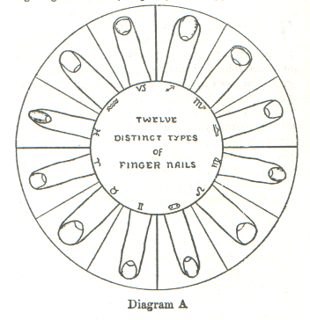
give her length of arm and upper body. At first appearance we doubted her rising sign of Taurus, but when we examined her finger nails they were found to be the perfect Taurean type. Taurus was also indicated by the heavy jaw and full neck. A Gemini person's nails are small and the neck slender.
Diagram A will give the reader a key to the pure types of finger nails, correlated to the signs of the zodiac. Horoscopes with many planets in one sign will change the nails. In the time the student will be able by using
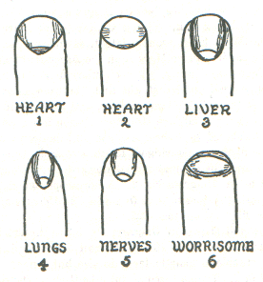
this chart to detect the characteristics of any type. Note how the types harmonize. Fixed sign nails are broad, showing great persistence and determination. The signs ruled by Venus, Taurus and Libra, give a more rounded nail; the fingers are well shaped and long, and the mount of Venus, which is at the base of the thumb is quite rounded and full. We could write much more on the hands and their characteristics as compared with the horoscope, but as this chapter is especially written to help in the diagnosis of disease, we will confine ourselves largely to this matter.
It is not very difficult to detect diseases which are latent. For instance, look at Diagram No. 1. We see a large, broad nail. This is similar to the pure Leo type. With heart trouble latent, as in case No. 5A, where the impulsive Mars is on the Ascendant, square to Venus indicating poor circulation and a weak heart, we will find that the little half-moons at the base of the nail are blue in color, and the lines in the palms of the hands are also blue. When heart trouble has developed to a chronic stage and is deep-seated, we find the nails ridged lengthwise as in Diagram No. 1, and the corners turned upward away from the flesh as in Diagram No. 2. A horoscope which will illustrate this case may be found in The Message of the Stars, figure 3 on page 625.
The nail shown in Diagram No. 3 is characteristic of cases such as No. 10A. The nail which indicates liver trouble is usually large in size but longer than No. 1 or 2. The nail wedges into the flesh on the sides, and is usually of a yellowish tint. The lines of the palm are also yellow. Remember when looking into the palm of the hand that the color of the lines is a valuable clue to the health of the patient. If in good health the lines should be of a soft pin; if the blood is impoverished, the lines are pale and white; if the patient is feverish, the lines are red; if the liver is out of order, they are yellow; and if the heart action is wrong, the color is blue.
In Diagram No. 4, we have a nail which is generally found on the hands of people who have common or watery signs on the angles. Many planets in common or watery signs produce what is called the psychic type. People with long, slender, claw-like fingers and nails are supersensitive and lacking in strength and vitality. This type of nail is often found on the hands of the idle rich, women who nurse a lap dog instead of a child and always have a box of chocolates at their side. Long, slender, well shaped hands and nails belong to the psychic type, and when the nails are ridged lengthwise and the color of the nail is pale, it is an indication of a tendency to weakness of the lungs. People with long, slender nails are usually susceptible to colds and coughs.
Nail No. 5 belongs to the nervous person who is intellectually inclined and prone to overdo.
Diagram No. 6 is that of a nail which indicates the person who frequently bites his nails. It shows one who has little control over his temper and whose feelings are very easily hurt. Such people are always carrying a chip on their shoulder and always looking for slights.

THE THUMB
A well balanced thumb indicates ability to control the emotions, including anger. but where the thumb is short and the end of it is club- shaped with a short nail, there is no control whatever over anger and things easily turn red before the eyes.

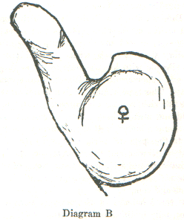DIAGRAM B
The thumb is a wonderful indicator of character, and must be taken into consideration when diagnosing from the hand. In Diagram B we see that the mount of Venus and the thumb are both a little too heavy. This is a typical Taurean thumb with the mount of Venus very large, indicating a very strong desire nature. The thumb is short and thick, showing a lack of will power to rule the desires. When the thumb is long and well shaped, it is an indication of high ideals and the will to carry them out.
In a well proportioned thumb the first phalanx should occupy two- fifths and the second phalanx three-fifths of the length of the thumb. The tip of the thumb should reach the middle joint of the first finger. A very long thumb indicates that a person is obstinate, headstrong; a very short one indicates lack of logic and a constant changing from one thing to another. If the thumb is very thick throughout its entire length, the desires and tastes are more or less coarse and primitive, and the person is lacking in tack and refinement. If the thumb is very wide, especially at the tip, it indicates one who "sees red" easily, often one who has an ungovernable temper; it also indicates stubbornness. The patient who has a normally developed thumb will carry out the physician's orders.
If the first phalanx of the thumb is very long and the second one is short, it indicates one who is reckless and whose actions are not controlled by reason. If the first phalanx is short and the second very long it indicates a talker, but not a doer. Such a person is mistrustful of everybody and lacks self-control.
The mount of Luna is located on the little finger side of the palm and extends from about the middle of the palm to the wrist. When large and full it indicates excessive emotion and imaginations, but when properly proportioned it gives a well balanced mind. It is this mount of the moon and lines found upon it which give the diagnostician a clue to mental afflictions and designate the lunar person.

INDICATIONS FROM THE FINGER NAILS
Long, slender nails curving inward toward the flesh: scrofulous and impure blood, weakness of the lungs, and throat trouble.
White spots on the nails: anemia, impoverished blood, nervousness.
Long nails, thin and brittle: weak vitality, negativeness, timidity.
Black or blue spots on the half moons: poison in blood, obstructed circulation, or restricted heart action. The shape of the nails should be taken into consideration before making a decision; see diagrams on page 63.
Well rounded and clear cut half moons on nails indicate good circulation; if pale pink, they indicate health; if dark blue, see page 64 for meaning.
Nails whose top surface is concave indicate spinal weakness.
Patients who have long smooth hands, the flesh soft and smooth, the fingers flexible, the nails white in color, and especially when the nails wedge tightly into the side of the finger and the wedge portion is colored, may be said to have been born tired. They will make little attempt to help the healer; they would prefer to have the Invisible Helpers do the work for them.

PART II
DIAGNOSIS FROM HOROSCOPES
CHAPTER XI

NO. 1--A LESSON IN DIRECTING
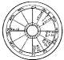
Birth Chart No. 1

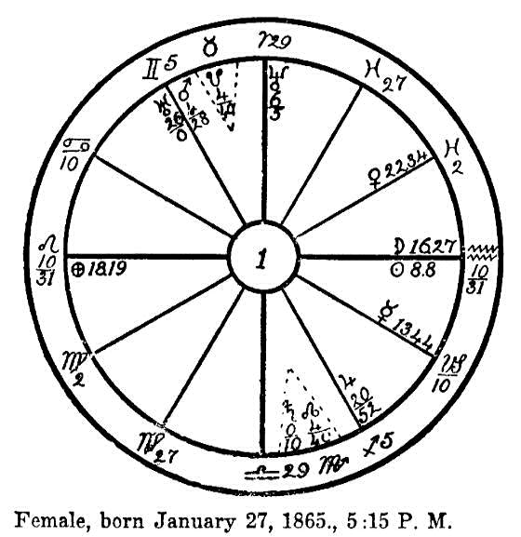
Female, born January 27, 1865, 5:15 P.M.
Instead of using this horoscope for the diagnosis of disease, we will use it to illustrate the art of directing, and judging the crisis and the duration of the disease.
We find the fixed sign of Leo on the Ascendant, with the cardinal signs of Aries and Libra on the 10th and 4th cusps respectively; the fixed signs of Taurus and Scorpio intercepted. In this horoscope we have two rulers; the ruler of the Ascendant, the sun, which is in the sign of its fall in Aquarius and near the cusp of the 7th house; and the dynamic Mars, which is the ruler of the 10th house, placed on the cusp of the 11th house in a critical degree of the sign of Gemini. Mars is sextile to Neptune in the 9th house and trine to the sun in the 6th house. Therefore we may look to the sun and Mars as having the greatest influence on the life of this woman.
Now let us find the afflictions which were responsible for the sickness which overtook her. We find Jupiter, which has rule over the arterial blood, in its own sign of Sagittarius in the 5th house, square to Venus which rules the venous circulation, and which is exalted in the watery sign of Pisces in the 8th house. Jupiter is in opposition to Uranus in the sign of Gemini and the 11th house. Venus is also square to Uranus. Now what do these afflictions from the common signs indicate? We have had similar indications in the horoscopes of those who were afflicted with tuberculosis of the lungs. Venus and Jupiter both so strong by sign and afflicted by Uranus, this last named planet being in Gemini, which has rule over the lungs, would naturally interfere with oxygenation, also giving a tendency to coughs and colds.
On January 21, 1909, this woman contracted a heavy cold which culminated in double pneumonia. The adjusted calculation date (calculated as taught on page 470, The Message of the Stars) is August 16, 1864.
We will now progress the planets from August 16, 1908, which corresponds to their places in the ephemeris on March 12, 1865. By adding the distance which the principal planets move in 5 months, we find that in January 1909 the progressed sun was in 22-22 of Pisces; the moon was in 27- 28 of Virgo; Mars was in 21 degrees of Gemini; Jupiter in 27-19 of Sagittarius; Venus in 7-50 of Taurus; Mercury in 17-16 of Pisces.
Now to judge the kind of sickness we must see what aspects were made between the progressed and radical planets bearing on the organic weakness of the lungs and poor circulation of the blood as shown in the radix. We first look for the afflictions of the planets in common signs, and find that the sun had progressed to the conjunction of the radical Venus in Pisces, which made a square to the radical Jupiter. Mars had progressed to the opposition of the radical Jupiter, and was square to the progressed sun. We also find that the progressed moon was square to the radical Uranus in the sign of Gemini, indicating the lungs.
The above aspects of the progressed planets to the radical were a very severe affliction and especially since they were from the common signs.
There are three points to be taken into consideration in reading a horoscope; the radical chart is as the fact of the clock; the progressed planets are the hour hand; and the daily transits and the daily transits and the new and full moons may be compared to the minute hand which tells the exact time. The progressed aspects alone will not act; there must be an exciting factor. The transits act as the match that lights the fuse, and the transiting moon with its aspects and its lunations is the time marker.
On January 21, 1909, we find that the moon was in conjunction with the sun, and this was a new moon in the sign of Aquarius in square aspect to the radical Saturn, which is in the fourth house in Scorpio. This lunation marked the day when the woman first contracted the cold which culminated in pneumonia. Saturn at birth is square to the radical sun, and the lunation naturally strengthened this affliction. This of itself would not have affected the lungs, but we find the progressed sun in conjunction with the radical Venus in the 8th house and in the watery sign of Pisces. Venus is the most adversely situated planet in the horoscope; it is in its exaltation in Pisces, but is afflicted by a square of Jupiter and Uranus at birth. The radical Jupiter is receiving assistance from the sextile of the moon, and Uranus has a trine from Saturn, which will ameliorate the evil of these two planets, but Venus is afflicted from both sides and without a single good aspect to offset the evil. We also find that Venus had progressed to 7-50 of Taurus in the tenth house and had reached a square of the radical sun. The double affliction of the sun, the effect of which is of a hot and inflammatory nature, was in this case responsible for the inflammation which took place in the capillaries of the lungs.
But the question may be asked, Why should this inflammation take place in the lungs? Why not in the throat or the feet where the afflicting planets are found? Mars, which is another hot and inflammatory planet had progressed to 21-00 degrees of Gemini and was then squaring the radical Venus and progressed sun. Mars, therefore, was the focusing point of the disease.
We have previously stated that the moon is the time marker of a disease and also marks the crisis. We therefore go to the beginning when the cold was contracted and watch when the moon came to a square to the place of the lunation, which was at midnight of Jan. 27, 1909, seven days later. Medical science counts its critical days by 7, 14, and 21. The moon has particular influence over man, and marks the time when recovery is apt to take place.
Let us follow the transiting moon on her journey and see her influence. On the 25th she reached the conjunction of the radical Venus and progressed sun, also the opposition to the progressed moon, which was in 27-28 of Virgo. This did not bring any great change, but on the night of the 27th and the early morning of the 28th when the transiting moon reached the square of the preceding lunation, a conjunction with the Midheaven, the Dragon's Tail, and the progressed Venus, also an opposition to the radical Saturn, death was very close. At 1 A.M. of the 28th the woman passed out of the body. She was able to see herself lying on the bed, and was fully conscious that death was near when the cries of the nurse who shook her brought her back to life.
The length of an illness may be known by the signs in which the planets which caused the illness are found. If in fixed signs, the recovery is slow; in cardinal signs, the illness is very severe but quickly over. In all cases it is well to look to the radical aspects of Mars and the sun. If these planets are well situated and aspected as in the case of this woman, (Mars trine to the sun) and if fixed signs are on the angles it is an indication that the patient will win out, where many under similar afflictions would go to the grave.

CHAPTER XII

THE EARS
NO. 1A.--EARS AND NERVES
Female, born June 1, 1884, 11: 45 A.M.
"It matters not how strait the gate,
How charged with punishments the scroll,
I am the master of my fate;
I am the captain of my soul."
Well may Henley say that man is the captain of his soul. When we look at this horoscope, we read the message in the planets that this soul had prepared a wide gate for itself and that the Path should be smooth and full of sunshine, for we find twenty-four good and but eight evil aspects. This from an astrologer's point of view should bring good health and happiness.
We find the common and earthy sign of Virgo on the Ascendant, with the moon and Uranus in conjunction in the first house, forming a sextile with Venus and a trine with Mercury, which latter is the ruler of the Ascendant and Midheaven; also a trine to the higher octave of Mercury, the mystical Neptune. This will give a degree of intellectuality. This woman should be attracted to the study of dietetics and interested in humanitarian work, for the humanitarian and advanced Uranus, which is so prominent in the first

Birth Chart No. 1A

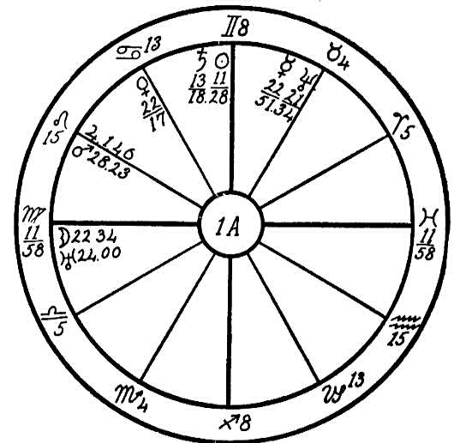
house and in conjunction with the moon, is ruler of the sixth house which governs the common people, the laboring classes.
The common and earthy sign of Virgo gives a tendency to drift along the path of least resistance. The people under this sign are not keen to battle with the tide but prefer to drift and are prone to become victims of their physical ailments. In the case of this woman we find Mars, the planet of dynamic energy, posited in Leo in the 12th house, that of self- undoing. When Mars is in the fixed and fiery sign of Leo, its influence for good or evil is much greater than elsewhere. We find in this case that Mars is the chief afflicter, being square and parallel to the life ruler, Mercury, and square to its higher octave, Neptune. But why should this affliction be considered important when there are so many good aspects to offset it? People with Mars in Leo may be likened to a keg of powder: they are apt to go off at any moment, especially when Mercury and its higher octave, Neptune, are square to Mars and in the fixed sign of Taurus. These aspects give an ungovernable temper and indicate one who would hold resentment.
We find Venus, the planet ruling the appetite, the palate, and the pleasures of the table, in the 11th house, friends, in the sign of Cancer, governing the stomach. Venus is sextile to Mercury and Neptune, both of which are placed in the home of Venus, the sign ruling the throat, Taurus. Venus is also sextile to the moon, the ruler of Cancer, and to Uranus, the natural ruler of the 11th house. These aspects and positions indicate that this woman was blessed (or shall we in this case term it afflicted?) with many friends who invited her to many dinners, and she was ever ready to respond, for with the moon and Uranus in conjunction in the first house she was naturally of a restless nature and ready to go whenever an invitation arrived. A sextile between Venus in Cancer and the moon gives desire for rich pastries and sweets, consequently her stomach was much abused by excesses. Also her nervous system was shattered by fits of anger. Thus the vagus or pneumogastric nerve was weakened.
This cranial nerve, which has its origin in the fourth ventricle, plays a prominent part in the functions of the physical body. Its branches extend to the ear, throat, heart, lungs, and liver, and it surrounds the esophagus, the tube through which the food passes after it leaves the mouth, with a network of little nerves. Its branches also surround a large part of the stomach. An excess of food which dilated and distended the stomach, brought about by the impacts of the moon and Uranus on the Ascendant, and the temper of Mars square Mercury undermined this poor woman's health so that she became a chronic invalid.
The sun is in a common sign near the Midheaven and afflicted by a conjunction with Saturn in the Mercurial sign of Gemini. Mercury, the life ruler, has rule over the hearing. We naturally look to the place occupied by the strongest planet for the affliction. This woman was afflicted with deafness in both ears, for one branch of the vagus nerve rules the auricle of the ear. She also suffered from a constant pain under her right shoulder blade, indicating liver trouble, and she was abnormally nervous.
Here we may see how man may be his own executioner as indicated in this horoscope. The ruler of the house of death, the eighth house, is afflicted in the house of self-undoing, the twelfth. The only remedy for a patient of this type is to eliminate all sweets and pastries, cut down the supply of food to one-half, and learn to be still, to relax.

NO. 1B--THE EARS
This woman was born on June 22, 1881, at noon. We find the Venusian sign of Libra on the Ascendant and the sun on the cusp of the Midheaven. This is the most powerfully situated planet and therefore the life ruler. The sun is sextile to Mars. In The Message of the Stars, page 164, we are told that a good aspect between these two fiery planets strengthens the constitution and makes the person able to perform hard tasks and produces a superabundance of vital energy. As the sun is accidentally dignified by being placed in the 10th house and on the cusp of the Midheaven, the native should have an abundance of will and energy to overcome almost any disease. This we will touch upon later.
We find here a very strange combination of planets, a blending of benefics and malefics, all clustered in the 8th house and in the fixed sign of Taurus, ruling the region of the throat and neck.
We find Mars in Taurus, the sign of Venus where he is in his detriment, in conjunction with Saturn; this strengthens the malefic tendencies of

Birth Chart No. 1B

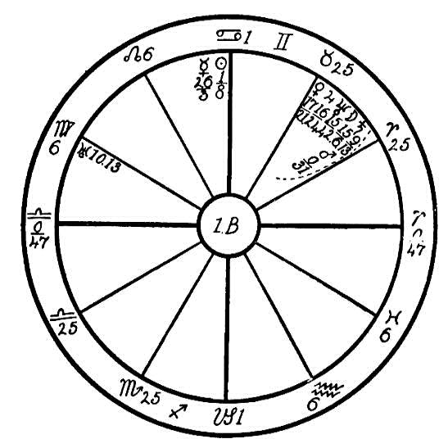
Mars. Some may question the conjunction of Mars 0-31 and Saturn 9-13 as we have heretofore given six degrees as the orb of the minor planets, but there are exceptions to this rule. Where we find a cluster of planets placed in a sign in which their evil tendencies are strong, especially when in a fixed and also a bestial sign, then the orbs of those planets are greater, their influence is stronger. Now, with Saturn's evil enhanced by the martial rays, Saturn will have a strong influence for evil when he is placed within orb of a conjunction with the moon and Neptune.
We look for the physical trouble from the above four planets. These placed in Taurus, the sign ruling the neck, also the glands, nerves, and arteries within this region of the body which Saturn is afflicting, indicate atrophy or obstruction. Saturn's influence on Neptune and the moon would cause a contraction of the nerves. We find Jupiter and Venus also in conjunction with the moon and Neptune and therefore indirectly influenced by the orb of the afflicting Saturn. So we may conclude that this entire group of six planets situated in the fixed sign of Taurus and in the 8th house is under affliction.
Jupiter rules the arterial blood, and Venus the venous blood. Neptune and the moon on account of the conjunction with Saturn may be termed malefic and will restrict the circulation in the carotid artery and interfere with the various tubes that carry air and fluid to the ear, for the moon also rules the white fluids or body oil. As a result of the restriction of the various fluids, the semi-circular canals of the inner ear are lacking in the liquid known as endolymph. This liquid acts upon the nerves that run to the three canals as the acid acts upon the copper plates in an electric battery. Where this endolymph is lacking, the equilibrium of the body is disturbed, and, as in the case of this young woman, people so afflicted can not walk without pitching forward.
With the obstructed circulation of both arterial and venous blood, she has also suffered with spasmodic torticollis, the twisting of the cervical muscles. The square of Mercury to Mars would give this nervous contraction.
The trouble developed in the fall of 1914 when the progressed moon had reached a conjunction with the radical Mercury, the transiting Uranus was in 8 degrees of Aquarius making a square to Saturn, and the transiting Saturn was in conjunction with the radical sun in the Midheaven. These transits excited the affliction of the progressed moon, and naturally the nervous system was disturbed.
It has been said in our astrological diagnosis in the past that the conjunction of Saturn and Neptune in Scorpio or Taurus may cause malformation of the generative organs, and in The Message of the Stars a case was given proving this. The affliction of planets often works in squares and oppositions. In this case all the planets are in Taurus, which rules the larynx and throat and is the sign opposite to Scorpio, ruling the generative organs. Here we find the cause of a disturbance which to some extent helped to bring about the physical trouble. There was an abnormal and unnatural sex desire which, not finding expression, excited the flow of blood to the throat, and this being obstructed caused a disturbance.
Now regarding the sextile of the sun and Mars and the trine of Uranus to the various afflicted planets in Taurus, were it not for these good aspects this young lady would not have grown to womanhood, for great trouble would have arisen during puberty. But the life-giving sun, so powerfully situated in the Midheaven, sextile to Mars, and also within orb of a sextile to Saturn, saved her much trouble during this period.
If she could come under the care of an experienced osteopathic physician who understands proper manipulations, this together with a careful diet would enable her to overcome her physical afflictions.

NO. 1C.--EARS, ABSCESSES IN FRONTAL BONE
Female, born December 30th, 1864, at 9:30 P.M.
In this horoscope we will continue with afflictions found in cardinal signs. While they may be in different signs of the cardinal group, yet the effect is similar in all.
In this lesson we have the horoscope of a woman with Virgo on the Ascendant and common signs on the angles. Two prominent planets, Uranus and Mars, are in or near the 10th house. While they are retrograde and not in conjunction, still they are parallel to each other and parallel to the sun. Mars being in conjunction with the Midheaven, sextile to Neptune, and trine to the moon, gives great enthusiasm. Whatever this woman attempts to do is done under impulse and with great force. With Mars and Uranus so prominent and the sun in Capricorn she feels that she must rule at any cost. Should she be denied this privilege, she would become very resentful and revengeful.
With Saturn in its sign of exaltation, Libra, square to Mercury in the Saturnian sign of Capricorn, we meet the vicious circle of the cardinal signs. The sun in Capricorn afflicted by a square of Neptune, both in cardinal signs, together with the parallel of the nervous and excitable Uranus to the hot and inflammable Mars has caused a succession of abscesses in the frontal bone, resulting in partial deafness in both ears. Here we find the previously mentioned circle culminating in the ears. The writer has found numerous cases of partial deafness resulting from an afflicted Mercury in

Birth Chart No. 1C

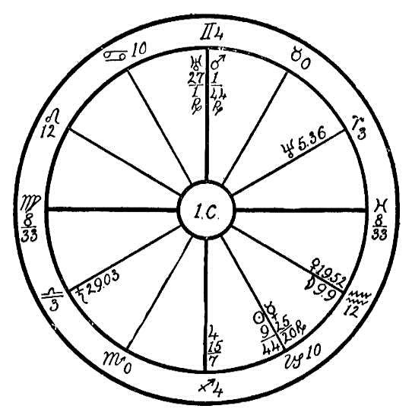
Capricorn, conjunction, square, or opposition Saturn especially when Saturn was in a cardinal sign.
It is not necessary, however, that these afflicted planets should cause deafness. The planets impel, they excite. But wisdom is ever a friend which saves; man has but to learn to know himself. If he would be as zealous in understanding the functions of his own physical body as he is those of his radio or automobile, then when planetary afflictions became known to him and the symptoms appeared in the physical body, he would at once set to work to conquer them just as he would go about repairing the mechanism of his machine, oiling it, and cleaning it. For instance, if congestion were felt in the neck or ears, there would most likely be some discomfort experienced before any damage was done. Then a slight manipulation should be made about the ears and the frontal bone, up and down the jugular vein, the back of the neck, and wherever the fingers can find sore spots on and about the cranium. Frequently a towel wrung out of hot water will relax the restricted nerve centers in head and neck and regulate the blood flow to and from the brain. This will keep the congestion down, and all serious trouble may be avoided.

CHAPTER XIII

THE EYES
NO. 2A.--EYE TROUBLE
Male, born March 21, 1847, between 1:00 and 2:00 A.M.
We usually judge the appearance of the native by the ruler of the Ascendant and the planets on or near the Ascendant, also by the positions of the sun and moon and their aspects. In this case we find there are two rulers, Capricorn being intercepted in the 1st house. One of the rulers, the planet Jupiter, is in its detriment in the sign of Gemini, making a square aspect to the co-ruler Saturn, showing that these two planets are very active in affecting the personal appearance and also the personality. Saturn has a tendency to darken the eyes and hair and to make the body and the features small. This man has the physical appearance of a Capricornian, is thin-featured and small of body, and very nervous and restless. It is always necessary to study the temperament of the patient in order to know how to deal with him, as it often gives a clue to the cause of disease and also helps to guide us in giving advice.
We find that the man, Uranus, Mercury, and Venus are all in the martial and energetic sign of Aries, with the sun making a sextile to Jupiter and Mars. The last named planet is intercepted in the 1st house in the

Birth Chart No. 2A

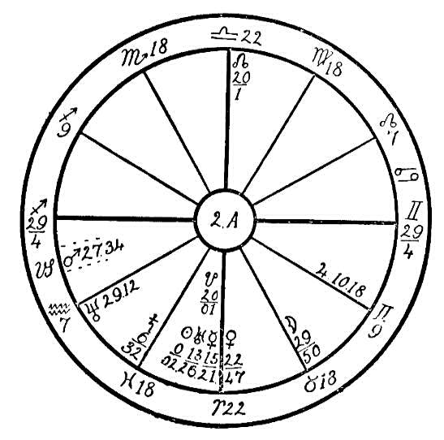
saturnine sign of Capricorn and is making a square to Venus and a trine to the moon. Mars thus placed in the first house gives a very materialistic state of mind. This man would sacrifice his health in the pursuance of success in worldly matters. He craves riches, and worries and becomes very restless when material matters do not prospect. This would in time, if continued, undermine his health and cause him to suffer from nervous disease.
Neptune in the sign of Aquarius in square aspect to the moon in the worrisome and pessimistic sign of Taurus in the 5th house, the house of investments, indicates that he expends much energy in speculation. It is plainly indicated that he has a tendency to become entangled with large corporations. He wrote to Headquarters several times endeavoring to get us to advise him regarding his speculations, but was told repeatedly that this was against our teachings. During the war he invested his all in a large corporation which was building a submarine boat in which it hoped to interest the government; but the corporation did not succeed in this, and in consequence he lost heavily. We find that Saturn in the 2nd house in the watery sign of Pisces, square to Jupiter in Gemini; also the watery planet Neptune is in the last degree of Aquarius in the 2nd house, square to the watery moon in the 5th house and the second sign, Taurus, all indicating speculation and loss.
Worry over financial loss aggravated the eye trouble from which he had suffered for a number of years. He has been an incessant reader and has put a heavy strain on his eyes. The mental disturbance over his financial loss weakened the nervous system, causing him to lose the sight of one eye. We find the moon in 29 degrees of Taurus conjunction the Pleiades and square to Neptune; Jupiter is in 10 degrees of Gemini in the 6th house, that of sickness, in opposition to the fixed star Antares, which is situated in 8 degrees of Sagittarius; also Jupiter is making a square to the obstructing Saturn, all indicating eye trouble.
We find Mars square to Venus and trine to the moon in Taurus. This man has in the past been fond of the "flesh pots of Egypt," and has gone to excess in drink and good things to eat. The result is constipation and internal hemorrhoids. We note that with Jupiter square to Saturn he has also suffered from obstructed arterial circulation. Due to the amount of food consumed in the past the poor body has been unable to bear the strain. At present he is fearing the loss of the second eye, which if he is not more careful in his diet and mode of living may be the case.
This man would be a very hard patient to heal, as Mars in Capricorn near the Ascendant is a most stubborn influence; he will not take advice from anyone. It would take great persuasion and diplomacy to get him to follow the advice of the healer.

NO. 2B--BX: THE EYES
The Rosicrucian method of healing is not only one of faith, but it is faith joined with common sense. We recognize disease, we acknowledge that it is caused by breaking the laws of nature. Sometimes there is lack of will. The horoscopes that we will herewith diagnose will show how one can overcome where another will succumb to almost the same astrological conditions.

NO 2B
Female, born December 1, 1862.
Application for healing was made by this woman during the winter of 1918, to assist her during an operation for the removal of cataracts on both eyes. She had been under the care of the doctor for a number of months. He concluded that the cataracts had reached a stage where they could be removed with safety, but the woman felt that she desired the assistance of our Invisible Helpers during this trying period. She had previously heard of the wonderful success of our healers from friends who had been benefited.
There were a number of good aspects in the horoscope, which always make for safety, especially Mars trine the sun, which gives great recuperative power. In looking for the afflictions we find Mercury opposition to the Pleiades in Taurus, and the sun and Venus conjoined to Antares. The Pleiades and Antares are fixed stars which have direct influence over the eyesight; especially is this true when they are afflicting the sun and Mercury.

Birth Chart No. 2B

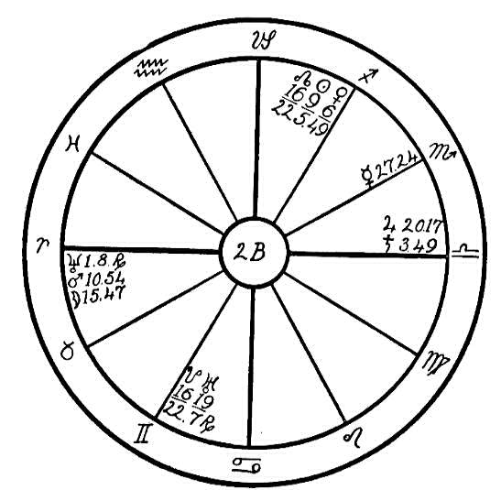
Much of this woman's trouble is due to the afflictions which we find in the cardinal signs, Aries and Libra, the latter of which has rule over the kidneys. Jupiter is conjoined to the restricting Saturn which is strong in Libra, its sign of exaltation, and these two planets, namely, Jupiter and Saturn, are in opposition to Neptune in Aries, while Mars is also strong in Aries, being conjoined the moon. These are danger signals, showing that through wrong living (moon conjoined Mars stimulates the appetite) she has undermined her health by wrong choice of foods and by eating to excess. These practices have filled the kidneys with poisons, and when the kidneys suffer the eyes go wrong, for the eyesight is frequently impaired through the kidneys. However, cataracts are usually due to an excess of sweets, creams, and very rich foods, and the afflictions in Libra are prone to send these impurities to the eyes. But since Mars is in good aspect to the sun and Venus, and the sun and Venus are in conjunction, this woman has overcome the obstacles and been cured, passing successfully through the operation for removal of cataracts.

NO. 2BX.
Female, born April 9, 1851.
The chart for this case is the same as 11B, page 279. We here give the outcome of this case in 1919, and earlier stage of which in 1915 is described in No. 11B.
This is the case of a woman afflicted similarly to the one in No. 2B, but the reverse condition is found as regards the aspects of the planets. Nothing but adverse aspects exist with the exception of one, Mars trine to the moon. We find the sun, the life giver, in the sign Aries, restricted by a conjunction of Saturn and in opposition to Jupiter, ruling the arterial blood, placed in the sign Libra, ruling the kidneys. These three planets are also square to the moon in Cancer, the stomach. Here we find the kidneys (the janitor), the stomach, (the cook), and the head of the home, Aries, all afflicted, careless, and not doing their work. How can a home be kept clean and fit to live in if all the workers are on a strike? The dust will accumulate, an naturally the tenant will be very uncomfortable. We find the stove full of ashes; it will not burn, and the smoke is escaping through the doors and windows instead of through the chimney.
In this horoscope we find the same indications as in No. 2B. The kidneys have not been eliminating properly, and an abundance of food has been consumed which has not been properly digested. Naturally the body has become overcharged with poisons, which must find an outlet. We again find that the weakest place is the head and eyes. When this woman called upon us she had been operated on by a doctor who claimed that it was necessary to remove both eyeballs as they had become diseased. The operation had already been performed upon one of them, which affected the sight of the other. The result was that our healing was not successful. We were able, however, to help the patient greatly in the matter of her stomach trouble, it having seemed almost impossible for her to digest her food. But in her horoscope we find little encouragement. Mars evidently did not give the assistance necessary. Mercury, the sun and moon are all afflicted. The native had not the strength of will or mentality to assist nature in a cure of her blindness as we find Mercury square the moon and conjunction Saturn.
In order to help such patients it is necessary first to remove the cause of the disease. We must advise them to live so that the kidneys will be purified. An entire change of diet is necessary; tea, coffee, meat, and all starchy foods must be eliminated. Nine patients out of ten will respond to healing very quickly as soon as you give them a sane and rational diet. Teach them how to live, and the work of the Invisible Helpers will be greatly reinforced.

NO. 2C.--THE EYES
Female, born June 13, 1873, 11:55 P.M.
First we judge the mind, by the aspects and position of Mercury and the moon. We find that Mercury is in conjunction with the sun, but not so close as to be combust; therefore he is in a very good position. We also see that he is sextile to Jupiter and Neptune and trine to Mars. This gives the mind considerable energy and brightness and creates an optimistic nature. On the other hand we find the moon in conjunction with the planet of obstruction, Saturn, and square to Venus, which is a testimony in the opposite direction. Saturn is square to Neptune and Uranus is square to Mars. Thus all four malefics are afflicting one another, and there can never be any great cheerfulness where this is the case unless the person can learn through philosophy or religion to seek a peace that is above earthly understanding. At the same time it must be understood that all the good aspects in the present case will help to give the native occasional periods of optimism and joy, which will break the periods of gloom and despondency.
We find that there are common signs on the angles, which is a testimony of a flexible character, difficult to rouse from sickness or trouble into which the native may fall. The moon in conjunction with Saturn in Aquarius, the sign which governs the ankles and lower parts of the limbs, is evidence of a poor circulation; and Uranus in Leo, the sign of the heart, in opposition to the moon and Saturn shows that there is a fluttering of that

Birth Chart No. 2C

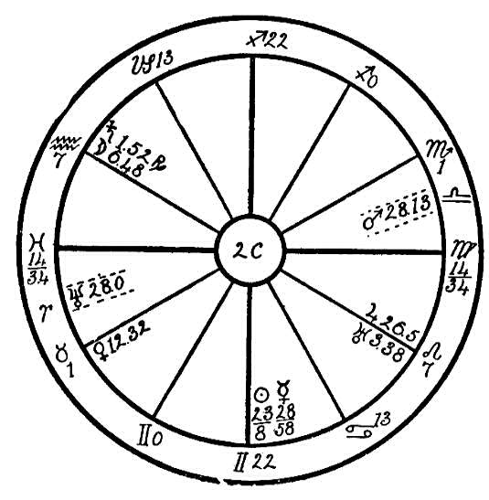
organ. This condition is much aggravated by the aforementioned square of the four malefics.
Saturn rules the pneumogastric nerve; if you count four degrees forward from the position of Neptune to make the exact square with Saturn, you will find that the point thus reached falls in Taurus, which governs the lower part of the head and the neck. This shows that there is pressure upon the pneumogastric nerve where it leaves the head. If this could be relieved by an osteopathic treatment, much good could be done for this person. On the other hand, the square of Saturn to Mars in the last degrees of Libra (which works also upon the first degrees of Scorpio), shows that there is trouble with the elimination of the urine, a restriction of account of scalding urine and bleeding piles, for Mars afflicted always causes heat and eruption.
But the worst affliction in this person's life arises from the fact that Uranus is in the nebulous spot of the zodiac called the Ascelli, which is centered in Leo 6. Uranus being there an in opposition to Saturn and the moon causes blindness, which sad to say cannot be cured by any physical means, for the afflictions which come from the fixed signs usually indicate a destiny which we have made for ourselves in past lives and which is now "ripe." All that we can do for this person is to endeavor to make her as cheerful as possible under that affliction.
With respect to the poor circulation and the faulty elimination of waste products a great deal can be done by osteopathic treatments and the proper kind of food. She should avoid all condiments and stimulating foods which heat the urine, and she should be taught to walk for exercise so as to strengthen the circulation in the body.
There are many people who have been afflicted with blindness yet who have made their mark in the world. "What man has done, man can do." By constantly stimulating her to effort she may be roused from the lethargy indicated by the common signs on the angles so that she will cease to feel her condition as she does at the present time.

NO. 2D.--EYE TROUBLE
Male, born February 11, 1918, 3:45 A.M.
If the poor child whose horoscope we are about to diagnose had lived, he might well have said, "I could have been the master of my fate, but instead I have become a slave." Freedom of will depends upon the limitations which the soul has placed for itself in its former lives. It may have placed obstacles in its way by wrong use of knowledge or by breaking the laws of nature in some way. Man was made in the likeness of God and God gave him dominion over the lower kingdoms. Therefore he has no one to interfere with his freedom of will; he is absolute master of his destiny.
Now, if this is so, why do we find so many who are born with misshapen and deformed bodies or whose lives have been so unfortunate? Sometimes through accidents as wee babes they are made to suffer during the rest of their earth life. A cause set going in one life has its effect in another embodiment. If it were not so, if the law of cause and effect were not

Birth Chart No. 2D

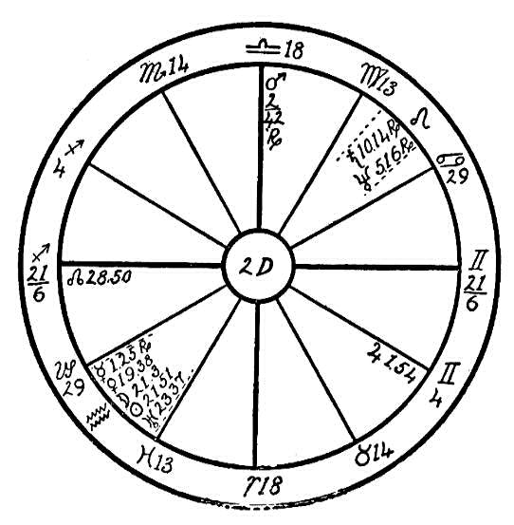
established beyond a doubt, would not God, whom we know is an all-loving Father, be very cruel and unjust? Could we love and worship such a tyrant? But He has made man a little lower than the angels and has offered him a crown of glory. This crown is not given for the asking, however; man must earn it by a life of purity and unselfishness.
Now let us see what fate we may find in this babe's horoscope:
We find Sagittarius rising, with Venus, moon, sun, and Uranus all in conjunction in the advanced sign of Aquarius, intercepted in the 2nd house, sextile to the Ascendant. Also the Dragon's Head, which is of a Jupiterian nature, is in conjunction with the Ascendant. This would have given the little fellow a most beautiful and charming personality. With Mars near the Midheaven, trine to Mercury, which is in the mental sign of Aquarius, he was very bright mentally.
At eleven months of age he could stand alone. On July 12, 1919, at the age of 17 months, he fell from a balcony, but no serious symptoms developed. At that time we find the transiting moon and Mars square to the radical Mars in the Midheaven; this is a very strong indication of accident. On July 14th and 15th the boy began to get drowsy, and could not keep food in his stomach, for on that day the transiting moon was in Aquarius, making an opposition to Saturn and Neptune in the eighth house in Leo. On the morning of the 16th he was taken with convulsions, the transiting moon having just passed a conjunction with Venus, moon, sun, and Uranus. Uranus when afflicted causes convulsions. At the third convulsion the child lost his eyesight, for the transiting Mercury had reached an opposition to the planets in Aquarius, (especially the lights, the sun and the moon), which brought on total blindness, as indicated in the radical chart by Neptune in conjunction with fixed stars, the Ascelli, and also in conjunction with Saturn. On the fifth day of his illness he became unconscious, lost his hearing and the control of his tongue, and the head was drawn back over the spine. A number of the most noted doctors were consulted, but none could diagnose the case. They operated on the head and spine, however, and the operations failed.
Now, from the astrological diagnosis what do we find? Neptune rules the spinal canal, that channel of spiritual fire from which all life emanates. Saturn, the planet of obstruction, the chastener, is found in conjunction with this occult planet, which also has rule over the pineal gland through which the spiritual faculties first become awakened. Abuse of the spiritual powers in former lives brings about physical infirmities. From birth this boy's spine was affected, the spinal fluid obstructed, and total blindness unavoidable. It is a known fact to astrologers that a child born at the new or the full of the moon, if not supported strongly by benefics, rarely lives. This child was born when the sun and moon were in exact conjunction with the benefic Venus, and Mars, the planet of energy, was elevated near the cusp of the 10th house, trine to Jupiter and Mercury. These benefic aspects made it possible for this babe to live for a short time. We have not the exact date of the child's death. The last letter we received from the parents stated that he was very low on November 6th, and was not expected to live. We find on November 14th, 1919, the transiting sun making a square to the cluster of planets in Aquarius, and the transiting moon in conjunction with the afflicting planets in Leo and making an opposition to the planets in Aquarius. It would be almost impossible for the babe to pass these afflictions, and death, no doubt, occurred at that time.

THE EYES
We will here give a lesson on the effect of Saturn, the obstructer, when in the last decanate of Aquarius. The writer has observed that many cases of eye trouble may be traced to Saturn when he is posited between the 24th and the 30th degrees of Aquarius, and especially does this affect the sight of the left eye.

NO. 2E.
Female, born August 19, 1905.
We will use a flat figure as the hour of birth is missing. We find the sun in its own sign of Leo. Saturn is retrograde in its own sign, Aquarius, and Mars is in Scorpio, the sign in which it is able to exercise its full strength. These three powerful planets are all in fixed signs and in opposition or square to one another. Here we find a debt of ripe destiny facing this soul which it was impossible to avoid. At the age of twelve this girl was almost entirely blind.

Birth Chart No. 2E

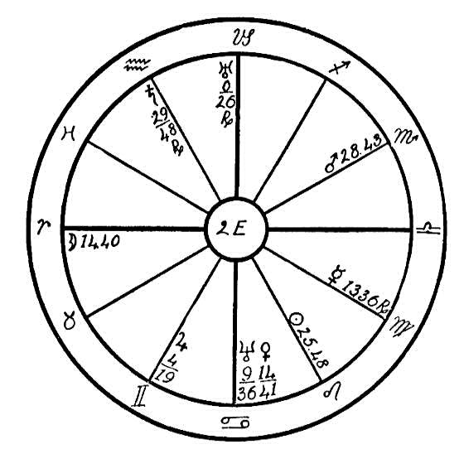
Now let us see if we cannot read the message of the stars and see why this dreadful affliction should come upon one so young. What is the debt that she is called upon to pay? Neptune, the planet which rules spiritual sight, is exalted in the watery sign of Cancer. This occult planet is in opposition to Uranus, which is retrograde and in the saturnine sign of Capricorn. Uranus stands for clairvoyance and the unseen. Capricorn is the natural 10th house sign of authority, that of one who rules. The sun, Saturn, and Mars, all at home and in fixed and dominant signs and Mars parallel to both Neptune and Uranus indicate that this poor soul in a previous life, and in a cruel and dominant manner while occupying a male body, used his occult powers to enslave the opposite sex, thereby causing many tears to be shed. It is said, "The mills of God grind slowly, but they grind exceeding small." The Lords of Destiny have brought this Ego, who caused so many tears to flow in a past life, into the weak body of this little girl, whose mother, fearing childbirth, shed many tears while carrying her. The result was a tender, sensitive body with impaired eye sight.

NO. 2F.
Female, born January 31, 1876, 8:00 P.M.
Here we have Saturn in the 26th degree of Aquarius in conjunction with Mercury and in the 6th house, the house ruling sickness. The moon is

Birth Chart No. 2F

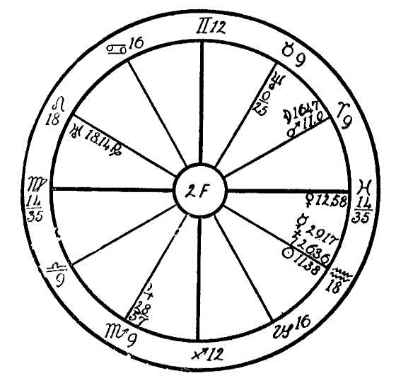
parallel to and in conjunction with Mars in the sign of Aries. This indicates emotion and impulse. It shows one who does not reason but jumps into things thoughtlessly and with fear. Especially is fear indicated when in addition the sign of Virgo is rising. Sometimes in such cases the resulting acts of impulse rebound upon the native, causing great suffering as in the case of this woman. When she began to suffer with eye strain she permitted the doctors to operate on her eyes on two different occasions. The first time they removed the right eyeball, and the second time the operation destroyed the sight of the left eye. From planetary indications, with the proper care and diet her eyesight might have been saved, but unfortunately she did not hear of the Invisible Helpers until too late.
We see that in the case of horoscope no. 2E, the native was in the hands of fate, and she had to pass through the greater part of this life in darkness, while in the second figure fear and excessive emotion precipitated total blindness.

NO. 2G.--THE EYES
Female, born July 27, 1856, at 9:00 A.M.
This woman has the feminine, earthy, and common sign of Virgo on the Ascendant. We are taught in the Cosmo-Conception that the Law of Consequence works in harmony with the planets, and that the spirit is born into the physical world at that opportune time when these may operate in harmony with each other. The birth of the Ego is so timed by the Lords of Destiny that the horoscope, which is the clock of destiny, registers the kind of debts which the Ego has incurred in its previous lives and the time when these debts come to fruition, when the harvest from the seeds which have been sown must be garnered.
However, the law of destiny is not a blind law, for it may be modified to a certain degree in proportion to the strength of the will of the Ego. When fixed or cardinal signs are on the angles and the afflictions are from common signs, then the Ego is often able to modify the effect of planetary afflictions; but when, as for instance in the horoscope under consideration, we find a common sign on the Ascendant and the afflictions come from fixed signs, then it is very probable that the forces involved in the debt of destiny are too powerful for the Ego and the Law must take its course.
In this horoscope we find the sun strongly placed in its own sign, Leo, which is a fixed sign, in conjunction with Venus, square to the inflammatory Mars, and parallel to Uranus. The fiery planet, the sun, is also in conjunction with the Ascelli, a fixed star which is in 5-41 of Leo and has influence over the eyes. We find Uranus in 24-36 Taurus, a fixed sign, in

Birth Chart No. 2G

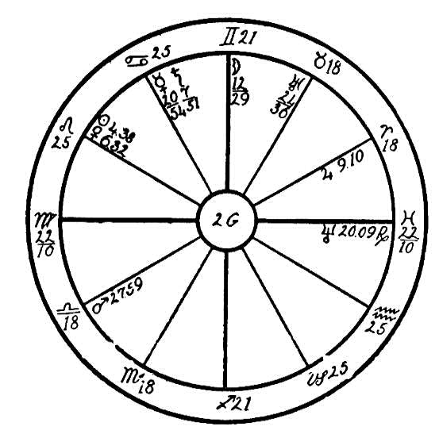
conjunction with the Pleiades, a group of fixed stars which are in 28-41 of Taurus, also having an afflicting influence upon the eyes. We find the moon prominently situated near the Midheaven in 12-29 of Gemini and in opposition to another fixed star, Antares, which is in 8 degrees and 27 minutes of Sagittarius.
Here we may read from the clock of destiny that blindness was likely to be the fate of this woman. With the feminine, earthy, and common sign of Virgo on the Ascendant and the afflictions from fixed signs, what could be expected but that the will of this soul would not be strong enough to overcome. Total blindness was the result.
But what did she do to precipitate this? We find Saturn, the planet of obstruction, in the 10th house in the sign of its fall, Cancer, and square to Jupiter. Saturn is most evil in this watery sign, the sign of the stomach, where he can undermine health by denying the stomach the fluids which are so necessary for digestion. In Cancer Saturn also perverts the appetite. People with Saturn afflicted in Cancer have strange likes and dislikes regarding food and are most stubborn about it. Even if they know that too many chocolate creams and sodas and too much pie, cake, etc., will undermine their health, they will have them. People with this affliction frequently suffer from auto-intoxication. The poison which is then generated by the stomach is mixed with the blood stream, and this very frequently precipitates blindness.
We find in this horoscope a well aspected Mercury, which is sextile to Uranus and the Ascendant and trine to Neptune, indicating that the native had a keen desire for knowledge, especially along occult lines, and did not save her eyes, but very likely read with poor light late at night, perhaps reading in bed, which is a most dangerous habit and which has caused many to lose their eyesight. But every cloud has its silver lining, and although this poor woman has been totally blind for some years, yet she has developed the sixth sense. With Neptune sextile Uranus and trine Mercury, she has a wonderful development of the spiritual faculties, making it possible for her to leave her body at will and she claims to be able to travel to far-off planets.
Had these afflicting planets and the Ascendant been reversed, with a fixed sign rising and the afflictions from common signs, even though Saturn had been in Cancer, the will would have been strong enough to have saved at least a degree of this woman's eyesight.

"One ship sails east and another sails west
With the self-same winds that blow.
'Tis the set of the sail and not the gale
Which determines the way they go."

NO. 2H.--THE EYES.
Female, born June 28th, 1868.
This horoscope is minus the hour of birth, therefore we are using a plain figure with the planets copied from the Ephemeris for noon, Greenwich Mean Time; but from all indications we believe that this woman has the last part of Cancer on the Ascendant.
The sun is in conjunction with Uranus, square to Jupiter, Uranus being square to Neptune, while Jupiter is in conjunction with Neptune in Aries. If we take the rising sign to be Cancer, this would bring the moon back so that it would be within orb of an opposition to Jupiter and Neptune and square to Uranus. We have here a configuration of planets which indicates that excesses and emotions have ruled this woman to a very great extent, especially as we find the planet of desires, the hot tempered Mars, in its fall in Taurus. Mars when in Taurus has a tendency to express his evil side and is prone to cause excesses in food and also in temper. Now, with Cancer, the sign ruling the stomach, on the Ascendant and with Uranus, the planet of impulse, in conjunction with the sun and square to Jupiter and Neptune, we have a woman who has very little self-control. Excesses of all kinds have filled her body with toxic matter. The blood vessels have become clogged and hardened. When a woman at the age of fifty- five who has had to work hard to support herself and family gives away to anger, and when as a result the blood bounds through the hardened arteries bringing an unusual rush of it to the head, we may expect trouble. Let us see where this may be found:

Birth Chart No. 2H

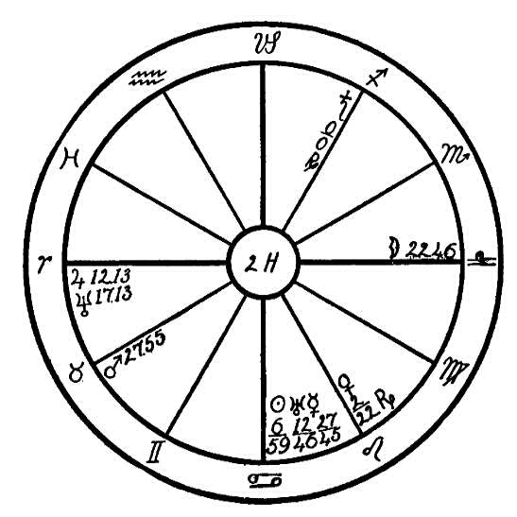
Mars is in conjunction with the group of fixed stars, called the Pleiades, which have an evil effect upon the eyes. With Mars in 27-55 of Taurus in conjunction with fixed stars of a Mars-moon nature, with the progressed sun within orb of a square to Mars, and with the progressed Saturn retrograded back to the opposition of Mars, there is a tendency for the temper to be aggravated, bringing trouble upon parts of the body which Mars affects,--in this case the eyes. Saturn has a hardening, ossifying, restricting influence upon the part of the body corresponding to his position in the horoscope. We find this planet in 0 degrees and 0 minutes of Sagittarius in opposition to Mars radical. With these afflictions we may expect some trouble with the eyes.
In the early part of July, 1923, this woman developed what doctors called retinitis of the right eye, which is an inflammation of the retina. This caused a rupture of one of the blood vessels accompanied by severe pains in the neck and shoulders.
We would not, however, attribute all the damage to temper and hardened arteries, for the foundation of the trouble had been laid by eye strain. This woman was employed during the day as a chiropodist, and at night she spent long hours in reading occultism and studying astrology. She had the pernicious habit of reading with a bright light close to the eyes while lying upon a couch or bed, thereby causing a strain of the muscles of the eye. With Neptune in opposition to the moon and Uranus square to both Neptune and the moon, there has been a desire to force development. Intensive gazing at bright objects, such as crystals, etc., which is ignorantly taught by some occult orders, has a most destructive effect upon the eyes and has caused much eye trouble among occult students.

CHAPTER XIV

THE THROAT
NO. 3A.--B: TONSILS--ADENOIDS
Male, born March 20, 1911, 3:10 P.M.
Figure No. 3A has Leo rising, with the ruler, the sun, in conjunction with and parallel to Mercury in the 8th house, and in the 12th house sign of Pisces. This position and aspect of the ruler would deplete the vitality and create nervousness. The boy would be easily disturbed and of a fretful nature. This would interfere with the assimilation of food in the small intestines, for the conjunction of Mercury an the sun would have an effect in the opposite sign of Virgo, the intestines. But we find another affliction which will have a much more evil effect upon the health. Mars, the planet of dynamic energy, also hot and fiery by nature, is posited in the airy and nervous sign of Aquarius and in the 6th house, ruling sickness. Mars afflicted in this saturnine sign shows an evil side. We find him square to the obstructive Saturn in the 9th house and in the sign of Taurus, ruling the throat and the tonsils. Wherever we find Saturn, especially when afflicted, we may expect restriction, crystallization, and lack of fluids, and with a square aspect to Mars, the planet causing fevers and inflammation, what can we expect but a disturbed condition of the throat,

Birth Chart No. 3A

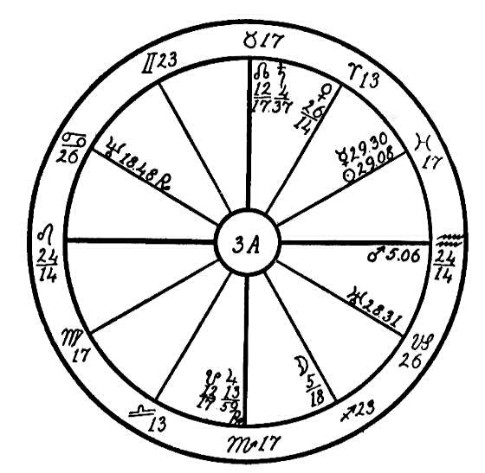
a swelling of the tonsils? The affliction coming from fixed signs, and Mars being in the 6th house, sickness, the trouble will be somewhat difficult to overcome, for this physical weakness was brought over from a former life in which the soul had broken the laws of nature. A case of this kind is often the result of abuses of the most sacred function of the body, that of the generative organs. The results of abortions, or abuses of like nature, are often brought back into the next embodiment producing weakened organs.
This boy could be helped greatly by manipulation and massage to keep the circulation normal. The Piscean sun, conjunction Mercury, requires a quiet and harmonious environment which we fear he will not have. Jupiter in Scorpio supplies good food and plenty of it which, however, he should not indulge in to excess. A simple vegetarian diet will be most necessary for him. Saturn in Taurus would indicate that one of the parents will be apt to interfere with his freedom too much. A Leo can be ruined by the "don'ts" of a saturnine parent, and the boy would suffer in health as a result of this restriction by one parent and overindulgence of the other.

NO. 3B
Female, born May 22, 1915, 3:22 A.M.
Horoscope No. 3B is that of a little girl who suffered from the same illness as in the case of 3A, vis., the swelling of tonsils, adenoids, etc., but with very different astrological afflictions. This shows how invaluable the study of astrology would be to the physician in his diagnosis and that it is absolutely dangerous to treat each case alike. What will heal one might be dangerous to another.
Here we have another fixed sign on the Ascendant, Taurus, ruling the throat, with its ruler, Venus, near the cusp of the 1st house and sextile to Saturn, but square to Neptune and in conjunction with Mars. The symptoms would be very similar to those of 3A, but the trouble is from a different source.
We find Saturn, the planet of obstruction, in the sign of Cancer, the stomach. Although this planet is not afflicted, yet wherever he is placed, or whatever organ he rules over, there we may find a lack of fluids. Saturn "dries up" and when he is in Cancer the appetite is abnormal and digestive fluid is lacking. He craves the things that are detrimental and refuses those which the body needs, and is very apt to gourmandize when the palate is tickled with pie, cake, candy, etc. The result is that the body becomes clogged like a stream dammed up: the material must find an outlet somewhere. In this case Mars, the planet of energy, is in conjunction with Venus, the planet ruling the venous blood. This indicates the section of the body that will be affected. The blood becomes impure, causing swelling and inflammation in the throat. To manipulate this afflicted region would

Birth Chart No. 3B

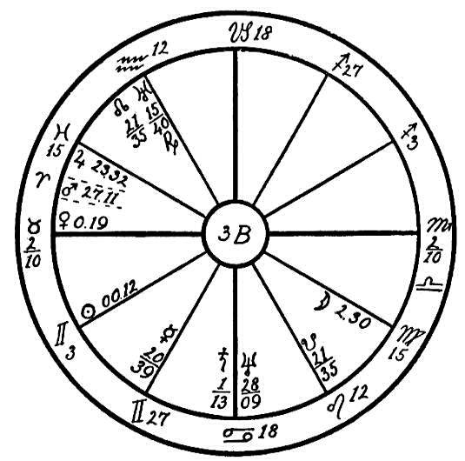
cause more inflammation. The remedy here would be to discontinue all food for a day or two and give the girl only pineapple juice, putting the feet in hot water with cold cloths on head and throat, in order to draw the surplus blood to the lower extremities. This would give instant relief.
Can we wonder, after comparing two horoscopes of this kind, why the medical man often fails in his treatment and feels that the only cure is the removal of the inflamed parts? If he could read the stellar script, he would make few failures and would then not be so apt to ruin the life of the child by an operation. He little realizes that a removal of the tonsils or an operation upon the throat interferes with the function of the generative organs. A child who has been operated upon will suffer as a result when it reaches puberty. Painful menstruation and trouble in childbirth are likely to affect the life of the woman who has been thus operated upon in childhood. Inflammation of the prostate gland in the man, and various other physical weaknesses are often the result of an operation upon the throat.

NO. 3C.--THROAT AND TONSILS
Male, born July 11th, 1882, 11:15 A.M.
Here is given the horoscope of a man with the cardinal sign of Libra on the Ascendant, and the ruler, Venus, in the fixed sign of Leo in the 11th house, square and parallel to both the malefics, Saturn and Neptune. The last two planets we find in the fixed sign of Taurus and in the 8th house. This at the start is a very serious affliction, indicating that this man came into life facing a heavy debt of destiny.
Now let us see if we can find the cause of the condition and why this soul has been restricted even from birth. Leo and Taurus are both fixed signs, stubborn and immovable, therefore they are also the signs which bring chronic and incurable illnesses; and where the afflictions come from two of the most subtle planets, both slow in their motion, one may expect that the disease is of a nature which the soul has attracted to itself as a debt of destiny by the breaking of nature's laws in past lives, and not so much on account of misdeeds in this embodiment.
Planets often work in opposite signs. Afflictions as in this horoscope, in the fixed sign of Taurus governing the throat, may have been brought about by the abuse of the generative function (Scorpio) in one life, causing a weakness of the throat or larynx in the next life, or vice versa. The unnecessary removal of the female organs in one life may cause the Ego, who changes sex in each life, to be born in a male body with the afflicted planets in the opposite sign, Taurus, as in the case of this man who was born with underdeveloped organs of voice and throat.

Birth Chart No. 3C

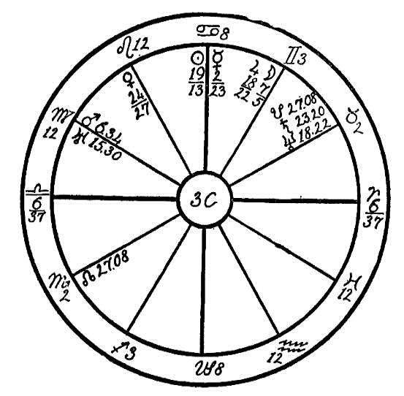
The above statement does not mean that all women who have been operated on will have these afflictions. Often through childbirth, or neglect of nurse or doctors, the poor woman is forced to undergo an operation. These are conditions for which she is not held accountable; but should she on account of excesses or abortions have weakened the organs of sex, which would make it necessary for their removal, such sins will bring their reaction in restrictions of some kind, usually of the throat which is under the rule of Taurus, the opposite sign to Scorpio, which rules the generative organs. In fact the larynx and brain were developed in primitive man by the sacrifice of one half of the creative faculty. Afflictions may not be active in the body in childhood, and with a knowledge of the planets and a strict adherence to the rules of right living, man may pass through life with but little inconvenience; but whenever the laws are broken, when abuses are allowed, then it is that the afflicted parts give way, for as it is said, the chain is only as strong as its weakest link.
We find the sun in Cancer, which is the sign of the stomach, sextile to Neptune in Taurus, the throat and palate, also sextile to Uranus which is the ruler of the 5th house, the house of pleasures. Venus is sextile to Jupiter. All these facts show that this man has been very popular with his women friends, who have entertained him lavishly, and the pleasures of the table have helped in his undoing.
The planet which helps to bring about physical ailments, the inflammatory Mars, is in the sign of the intestines, Virgo, square to the moon in Gemini, showing that the intestines suffered first from an excess of food and drink. When the small intestines are inflamed, as they would be in this case, they are unable to assimilate food properly. This inflammation throws considerable poison into the blood, which seeks an outlet in the weakest spot. Saturn conjunct Neptune in Taurus indicates that the throat received the poison. This man has had his throat lanced twice for what the doctors termed quinsy, an inflammation of the tonsils. He has had pieces taken from the tonsils, showing that the blood was contaminated, causing suppuration in the tonsils.

NO. 3D.--GOITER--TONSILS
Female, born August 12, 1911, 7:27 A.M.
We will consider here the horoscope of a girl with Virgo on the Ascendant. Virgo people have somewhat less resistance to disease than the average, especially when common signs occupy the four angles and Mercury and the moon, which rule the mentality, are also in common signs and in opposition to each other. The three strongest planets, namely, the sun, Saturn, and Mars, are in fixed signs. We may expect that these planets will indicate in what part of the body the disease will show itself.
The sign of Taurus, we are told, in "The Message of the Stars," page 541, has rule over the neck, throat, tonsils, the carotid arteries, etc. >From this we may infer that Taurus also has rule over the veins and arteries which serve the organs located in the throat; likewise it has rule over the lower part of the occipital region of the jaw. The arteries of the human body have their beginning in a common center. The aorta is to the circulatory system what the trunk is to the tree. All main arteries and veins have a connection with the great human engine, the heart. The aorta is the main trunk line, from which many branches carry the blood to all parts of the body, after which the veins carry it back to the heart. These branches feed the various parts of the body. The branch in which we are most interested in this lesson is the carotid artery, from which branch off the thyroid arteries, two in number, the superior and the inferior.
In this horoscope we have the inflammatory Mars in Taurus. Mars focuses heat, and wherever this planet is placed we find an abundance of blood. Mars here is in the sign ruling the neck and afflicted by the conjunction of

Birth Chart No. 3D

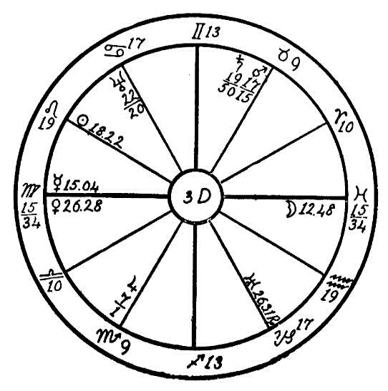
Saturn, the planet of obstruction. Saturn has a drying-up effect upon the parts which he influences. The effect of these two malefic planets may be pictured by filling a rubber tube with water and closing both ends, then pinching one end of the tube and forcing the water into the other end. We may expect this to be the condition of the blood in the arteries and veins of this girl's neck. Mars fills them full of blood, and Saturn with his restricting influence holds the blood in one part, obstructing its flow and resulting in enlarged veins of the neck, goiter, swollen tonsils, etc. Saturn and Mars are afflicted by a square from the life-giving sun. The sun is strong in its own home, Leo, which rules the vena cava, the aorta, and the heart.
At the age of eleven years this young girl suffered with goiter and swollen tonsils, having constant trouble with the throat and a tendency to coughs and colds. One important fact will be found in the case of most children with a tendency to throat trouble, namely, that they formed the habit when tiny babies of breathing through the mouth. In nine cases out of ten of children who are suffering with diseased tonsils and throat afflictions they have not been taught to breathe through the nose. Parents should at all times watch small children, and if they show a tendency to mouth breathing while asleep, they should be given a solid rubber nipple, minus the opening. This will force the breath through the nostrils and thereby save the child much suffering in later years.
With the sun in Leo, square to Saturn and Mars, this girl has a latent tendency to valvular heart trouble. This may not develop until later in life when the Mars-conjunction-Saturn-in-Taurus temper has been permitted to do its damage, and Mercury in Virgo in opposition to the moon, in the 12th and 6th houses, the latter ruling the health, have made themselves felt.
There is great hope in this horoscope, however, due to Saturn being in trine aspect to Mercury and sextile to the moon. This will give balance and also persistence to the mind, which will help to stave off any illness and save the girl much suffering in later life.

No. 3D.--GOITRE
Female, born June 14, 1853
As we have no birth hour, the signs are entered on the houses in numerical order so that Aries occupies the first house, Taurus the second, Gemini the third, etc. and the noon positions of the planets are used just as they are given in the ephemeris.
We will first note that the progressed position of the sun in 1916 is Leo 23-27, and that of Mercury is Leo 26-27, retrograde.
The aspects which particularly concern us are: Moon parallel Neptune, square Jupiter, the sun and Mercury; Jupiter opposition the sun and Mercury; Saturn parallel and conjunction Mars, squared by the progressed sun and Mercury.
We will first acquaint ourselves with the condition of the mind of this woman. Gemini and Sagittarius are the signs ruling mind. Mercury is essentially dignified in Gemini, and Jupiter in Sagittarius. The sun also is favorably situated in the Mercurial sign Gemini. So far so good, but Mercury, our significator of the mind, follows the sun and is too close to this luminary; furthermore, Jupiter is in opposition to the sun and Mercury. Add to this that the moon, the other significator of the mind, is square to Jupiter, the sun, and Mercury, and it will be apparent that the mental state of the native is not a very happy or auspicious one.
Saturn is in Taurus, the sign of the throat. He is the planet of obstruction and has always an inimical influence on whatever part of the body he occupies by sign. We may therefore judge that the throat will be

Birth Chart No. 3E

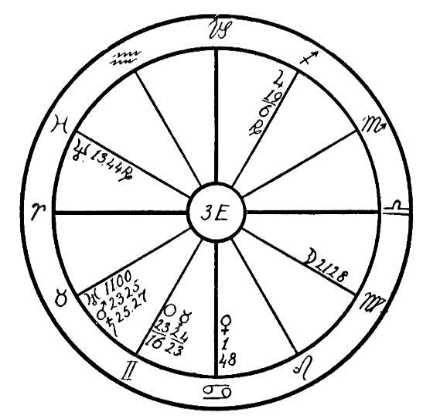
obstructed, causing hoarseness of speech; and we may also be sure that Saturn has an effect in the opposite sign Scorpio, which governs the generative and eliminative organs. Saturn is cold, clammy, and moist. Mars is hot and dry. He is posited in the sign Taurus, closely conjoined and parallel with Saturn, giving a tendency to inflammation and swelling. In the region governed by the opposite sign he would produce scaling urine and copious menses.
Thus to inimical forces of opposite natures have been at war in the region of the throat from birth on, but the case did not become really acute until 1914. Then the moon by progression reached the opposition of the radical sun and Mercury, and at the same time the sun by progression came within orb of a square to Saturn and Mars from the sign Leo, which governs the heart. The keynote of Saturn is obstruction, and in Taurus he is particularly powerful with respect to the heart action for he governs the pneumogastric nerve which produces cardiac inhibition. On the other hand, when the dynamic energy of Mars is directed by a square to the progressed sun in Leo violent palpitation is bound to be the effect. Thus the enormous range of heart action attendant upon exophthalmic goiter is produced in this case. We also find that Saturn is near a conjunction with the Pleiades located in Taurus 29, and his square to the progressed sun has an effect upon the eyes, which protrude in people affected with exophthalmic goiter.
The configurations of the significators of mind previously mentioned couples with the absence of radical squares and oppositions to Saturn and Mars indicate that the basic cause of the patient's condition is mental. The diagnosis is further confirmed by the fact that the acute condition was brought about by the above noted progressed positions of the sun and Mercury. As this affliction is from a fixed sign there is danger that the condition may become chronic. If the person, however, is placed in a quiet, cheerful environment and if she can be taught to wean herself from her morbid imagination, there is a good chance of a permanent cure being accomplished when the sun gets out of orb of its square to Saturn and Mars, particularly if the proper diet is adopted.

NO. 3F.--THE VOCAL ORGANS
Male, born May 30, 1919, 11:55 P.M.
"The tissue of the life to be
We weave with colors all our own,
And in the field of destiny
We reap as we have sown."
--WHITTIER
This is truly so in the life of the soul whose horoscope we are to study here.
With the fixed, Saturnine sign of Aquarius on the Ascendant and the second ruler of Aquarius, the inspirational and advanced Uranus, in Pisces, intercepted in the first house, we may say that there are really two rulers of this horoscope: Saturn, which is in its fall in the seventh house in Leo, and Uranus, which is strong in the occult sign of Pisces in the first house.
Planets in angles have a greater influence on the life of the native than when they are in cadent or succedent houses. Planets which are in fixed signs and afflicted also bring with them a debt of destiny, which is usually most difficult to overcome.
In this horoscope we find Mercury in the fixed sign of Taurus, square to the obstinate and obstructive planet, Saturn, which is in Leo, a fixed sign, and in the seventh house angle.
Saturn being one of the life rulers, though in the sign of its fall, will have the post powerful rule over the life, and when Mercury and Saturn are afflicting each other from bestial signs, namely, Taurus and Leo, we may look for an impediment in the speech.

Birth Chart No. 3F

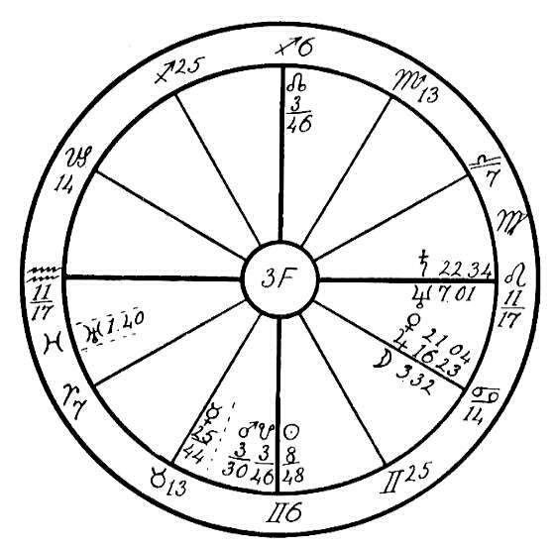
This boy at the age of five years refused to talk. He is able to speak, but will do so only when the greatest persuasion is used.
Doctors have operated on him twice for water on the brain but have failed to find anything wrong, and what the effect of these operations may have upon the organism in the future remains to be seen. Up to the present time, however, the health of the boy has been normal.
He will repeat only the sentences which are suggested to him, but if the parents are persistent they may in time help him to overcome his weakness.
On page 154, in the Cosmo-Conception we are told: "What we are, what we have, all our good qualities are the result of our own actions in the past. What we lack in physical, moral, or mental excellence may yet be ours in the future."
This boy has truly taken up his life where he laid it down in a previous one. The planets are the clock of destiny, which shows when each soul must needs learn certain lessons, when it must reap from the seeds which it has sown in its past lives.
We learn in the Rosicrucian teachings that we are in this life here on earth preparing to build the archetype of the body which we are to use in our next life. In the case of this poor soul as we look back into his past, we see where in his keen desire for spiritual development he neglected to build his physical body by mortifying the flesh and neglected to use the organs of speech, being a member of a silent Brotherhood. In which the life was spent in silence and prayer. In this extremely one-sided life he developed the spiritual faculties at the expense of the physical senses.
We see here the mystical Uranus is in the sign of Pisces, in the first house, trine to the moon, which is in its own sign of Cancer. Neptune, another spiritual planet, is parallel to Mercury and sextile to Mars and the sun, indicating a soul who is highly developed along spiritual lines, but one who is lacking in the ability to use his development in this life on account of the lack of desire to use the organs of speech.
This child may, however, be assisted by the parents in developing this desire, but it will require great patience, as the mentality, on account of Mercury square Saturn, will be slow to respond, and the boy will be very stubborn, because of this aspect being from fixed signs. Mars, however, which is in the Mercurial sign of Gemini, will lend its assistance in overcoming the influence of Saturn to some extent.

NO. 3G.--THE LOSS OF SPEECH
Male, born December 19th, 1896, at 12:30 A.M.
The young man whose horoscope we will analyze here has the cardinal and airy sign of Libra on the Ascendant. Physically he expresses the sign of Libra, being six feet in height, splendidly developed and with beautiful blue eyes. People with cardinal or fixed signs on the angles have more power of resistance than others. The will is stronger than that of common signs. In the case of this young man, however, we find an affliction active before he reached the age where he could be of assistance to the healers.
In the Cosmo-Conception we are told that in the latter part of the Lemurian Epoch man's body became upright, this being necessary before he would become an indwelling, self-conscious being, and certain changes then had to take place in the bodily structure in order that the Ego might express itself through its vehicles. When the Ego entered within its vehicles, it was necessary that part of the sex force be used to build the brain and larynx, for it was destined that man should henceforth learn to do his own thinking, and the voice was necessary that he might make himself understood and thereby communicate with others. To accomplish this a part of his sex force had to be used. So a part of the creative organ remained with the upper portion of the body, and was gradually converted into what now constitutes the brain and larynx. Thus we may see that there must of necessity be a close connection between these organs, namely, the generative organs, larynx, and brain.
It is interesting to note through astrology how this works out. We find Scorpio,

Birth Chart No. 3G

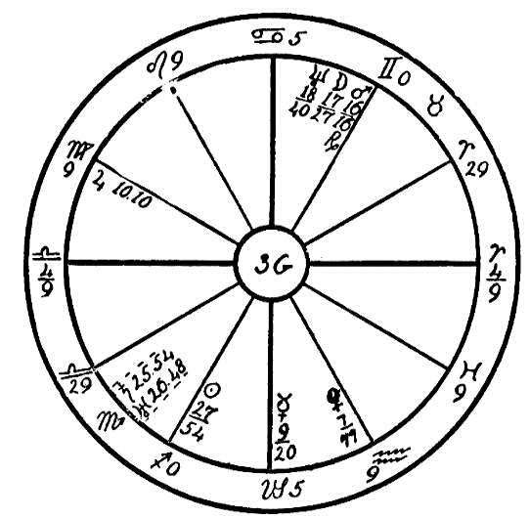
the sign ruling sex, in opposition to Taurus, which has rule over the throat and larynx. Proof of the above close connection may also be found in the boy whose voice changes at puberty; also in the woman who has had her ovaries removed and whose voice becomes deep and harsh.
In the horoscope under consideration we find Saturn, the planet of atrophy, in the sign of Scorpio. Saturn is in conjunction with Uranus. These two planets are unaspected save by the conjunction with each other and a semi-sextile to the sun. And this we must consider as a condition which had its beginning in a past life. When we find Uranus and Saturn in conjunction in Scorpio and afflicted by other planets, we look for perversion or abnormal sex expression. But in reading these two planets we go into the past life for the abuses which have weakened the organs, causing the poor soul to come into this life with the larynx and brain each unable to function normally.
With Saturn conjunction Uranus in Scorpio we may look for its effect in the opposite sign of Taurus, the throat. Saturn then has a tendency to retard or restrict the secretion of the fluids of the glands or organs within the region of the neck, for instance, the thyroid, which is placed astride the windpipe at the front of the neck, and which may truly be called the balance necessary for the proper functioning of the mind. The thyroid also regulates all the other ductless glands, and every drop of blood in the circulation in the upper part of the body passes back and forth through it. Excesses or perversions of sex deplete the fluids of the thyroid gland. What a telltale the human voice is! How the misuse of sex will make the male voice effeminate and the female voice masculine!
In this horoscope we have the story of a man who at birth had a voice, but after the age of four years he would not make a sound, nor has he spoken a word since. The organs ruling the voice in this case have been weakened by the dissipation of the sex fluids in a former life. We find Neptune, the higher octave of Mercury, the planet ruling the pineal gland, in the mercurial sign of Gemini, in conjunction with the moon and Mars, and in opposition to the sun. Neptune has rule over the pineal gland and the spinal spirit fire. The brain in this case has remained childlike. The young man dresses himself but he will not speak, and he spends his entire time turning the leaves of books.
Truly, the spirit encased in this limited vehicle is learning some remarkable lessons--lessons which are likely to bring it back in its next embodiment as a childlike, virtuous woman.

CHAPTER XV

THE LUNGS NO. 4A.--TUBERCULOSIS
The horoscope here shown is that of a well-to-do man who spoiled his life by excesses of all kinds. He was born on August 28, 1881, at 11 P.M.
In the first place we find Jupiter, the planet of opulence, in the 12th house, that of sorrow, trouble, and self-undoing, sextile to Venus, the planet of attraction, in Cancer, the sign ruling the stomach, and in the 2nd house, that of finance. This accounts for the native's business instinct in money matters as well as his desire for rich and unhealthful foods; in part, too, for his fatal weakness for the opposite sex. The moon square to Venus from the fifth house, the house of pleasures, also Mars, the planet of dynamic energy, conjunct the saturnine Dragon's Tail, and both square to Uranus, the planet of unconventionality and clandestine attachments, are other strong testimonies in the latter direction. Furthermore, Saturn, the planet of obstruction, in the 12th house, that of sorrow, in conjunction with Neptune, the planet of underhandedness, in Taurus, which is the opposite of Scorpio, the sign governing the sex organs, shows trouble in that region and also in the throat.
As a whole this horoscope shows all manner of excesses, and a

Birth Chart No. 4A

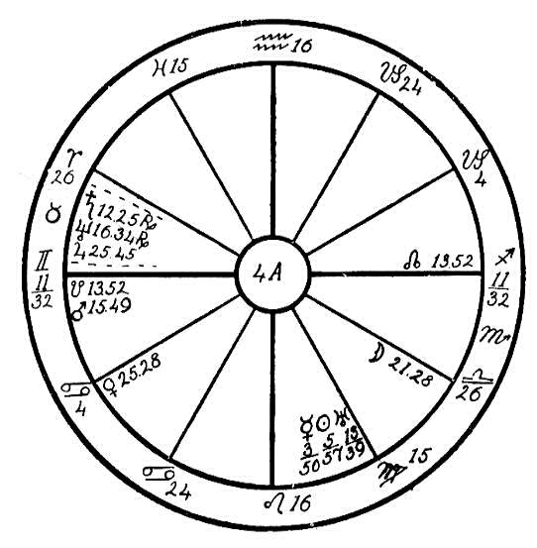
consequent clogging up of the system. Venus in Cancer, the latter ruling the stomach, gives a love of good things to eat, and especially to drink. Its square to the moon in the sign Libra, ruling the kidneys, shows that there was a very bad condition there preventing proper elimination. The conjunction of Saturn, the planet of obstruction, with Neptune in the sign Taurus, this sign having a reflex action in Scorpio, resulted in painful hemorrhoids. Mars, the planet of dynamic energy, conjoined with the saturnine Dragon's Tail in Gemini, the sign ruling the lungs, square to Uranus, the planet of spasmodic action, shows a tendency to coughs and weakness of the lungs, which finally destroyed the life.
This horoscope is a lesson on the ravages of excess and indulgence of the lower nature, and astrologers may use it for the purpose of convincing people who are on the downward path that the way of the transgressor is hard, and that our sins will surely find us out.
By the exercise of will power, at least a great deal of the trouble indicated might have been avoided. Toward the last the man realized that he was going down and wanted help, but he was too weak to cease from his indulgences. Consequently he yielded to the tendencies shown in his horoscope, and became the victim of tuberculosis and a number of complications.

NO. 4B.--TUBERCULOSIS
Female, born June 16, 1884, 8:30 A.M.
Suffering from tuberculosis is shown very plainly by this horoscope, for Saturn, the planet of obstruction and crystallization, is in Gemini, the sign which rules the lungs. Although he is unaspected he always has a malefic bodily influence in whatever part of the chart he is placed. His obstructive and hardening tendencies clog and crystallize the lungs and would be inimical even if he were not supported by evil aspects. We find that the sun, which is the giver of life, is also in Gemini, square to the moon, which is the particular significator of health in a woman's horoscope. The moon is placed in the 8th house, the house of death, in Pisces, the twelfth sign, ruling confinement in hospitals and kindred institutions. The sun is also square to the spasmodic Uranus, and Uranus is in opposition to the moon. This will produce the cough and the hemorrhage which are part of the symptoms of tuberculosis.
Leo, the strong solar sign, is rising, and Jupiter, the planet of optimism and joviality, is therein sextile to Mercury, the planet of reason and mind. We may also note that all the angles are occupied by fixed signs. These conditions show that in the first place the constitution was a good one, that the native had to begin with a strong, vigorous nature and a jovial sunny and friendly disposition. Had this horoscope been set up in childhood's days so that one could have worked with the native ad counteracted the tendencies to tuberculosis, the chances are that she would have entirely outgrown this tendency. As it is, however, the squares and

Birth Chart No. 4B

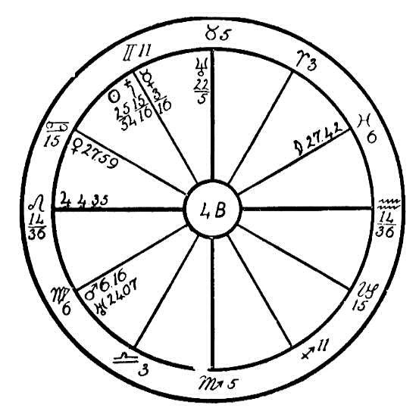
oppositions of the sun, moon, and Uranus taken together with the moon's placement in the 8th house and the 12th house sign show that this case is likely to terminate fatally. The best that can be done for the patient now is to make her suffering as little as possible. The magnetic force of an Aries person whose Saturn is not in any of the degrees encompassed by the 6th house of the patient's horoscope would be of great help to her, and milk just fresh from the cow would do a great deal to keep up her vitality as it is filled with the healthy animal ether.

NO. 4C--TUBERCULOSIS
Male, born December 1, 1883, 3:51 A.M.
By mistake this chart was first set up so that Leo occupied the Ascendant end the sun was in the fifth house. The planets show the affliction no matter what sign rises, but a glance showed the figure to be erroneous because the sun cannot be in the fifth house at four o'clock in the morning. So we had it calculated again, with the result that we find Saturn in the eighth house instead of in the eleventh and the sun in the second house instead of the fifth. This makes a great deal of difference in the strength of the symptoms. We would advise students that whenever they are given a figure for judgment it is wise precaution always to look at the place of the sun and notice if its location in the horoscope corresponds with its actual place in the sky at the time of day when the birth took place. If it does not, that is evidence that the horoscope has been incorrectly set up and is therefore unfit to be used as a basis of judgment. We are all liable to make mistakes in our calculations but this hint will undoubtedly help students to avoid this particular mistake.
The subject of this horoscope is suffering from tuberculosis, a disease neither necessarily serious nor fatal. The student of Astro- Diagnosis has special facilities for judging how deeply the disease is rooted by the positions and aspects of the afflicting planets. Saturn, the planet of obstruction, in Gemini, the sign which rules the lungs, shows the tendency to cold in the lungs and also hardening such as occurs in tuberculosis. But this testimony would not have been so dangerous if it had come from

Birth Chart No. 4C

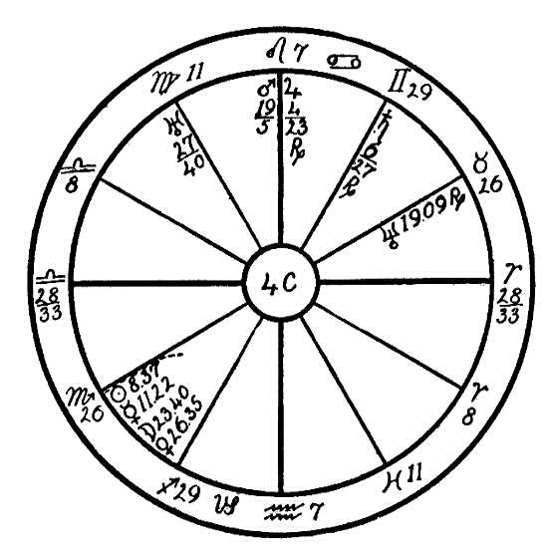
the position shown in the erroneously cast figure where Saturn was placed in the eleventh house, instead of its position in the true horoscope where he is in the eighth house, denoting the manner of death.
Mercury, the ruler of Gemini, is in opposition to Saturn, and so is the life-giving sun. We may also note that the moon, which governs the tidal air in the lungs, is in conjunction with Venus, which rules the venous blood, and is square to Uranus. All these are signs which show that there is comparatively little hope of escape for this patient from the dread disease until death looses the silver cord and frees him from the body.
You will notice that the last degrees of Libra are rising so that the native has really more of the impulsive Scorpio characteristics than those of Libra. Mars, ruler of Scorpio, in Leo adds to his energy and makes him fond of swaggering and showing off, prodigal of his vitality. Mars trine Mercury in Sagittarius shows an inclination for sport and probably overexertion, which may have been responsible for the first breakdown about the twenty-eighth year when the progressed moon was over the place of the radical moon and Venus, or the year preceding when it was in opposition to Saturn.
It would be extreme cruelty to tell the patient that there is little hope, of course, and no aspirant to invisible helpership would be so thoughtless, but would strive to make his lot as easy as possible during the remaining time, though realizing that whatever measures were taken would only palliate but not cure. Meanwhile, it should be made clear to the person that there is a spiritual reason for disease and that occult investigations have established the fact that a materialistic conception of life in a previous embodiment is a fruitful source of just such a condition as this one, for by the thought that death ends all, the materialist gradually puts himself out of tune with all activities in the spiritual world. When he enters the Second Heaven where the archetypes of new bodies are built, he puts all his crystallizing thoughts into the new vehicle, which is then born under the hardening rays of Saturn, who in some way obstructs the life- giving sun. If such a patient can be taught to believe this and become a devoted Christian, he will be saved a similar fate in a future life.

CHAPTER XVI

THE HEART
NO. 5A.--THE HEART
Female, born October 16, 1907, 2:00 P.M.
Aquarius, a fixed and airy sign, is on the Ascendant. The fiery planet Mars is just above the cusp in the 12th house, and the plastic and watery moon is in the same sign in the first house. This gave this young woman a very strange nature, for there is a great difference between the temperaments given by the moon and Mars. Mars on the Ascendant afflicted by a parallel to the ruler, the impulsive Uranus, gave the native a very impulsive nature. It indicates one who would fly into a fit of rage at the least provocation. The two natures given by Mars and the moon were continually at war with each other, the one impulsive, energetic, dynamic, and the other restless, plastic, and changeable. The moon, however, is trine to the sun, which gave a soft, peaceable, kindly nature, directly opposed to the martial temperament. The restless, critical Mercury is placed near the Midheaven in the martial sign of Scorpio; this added to the temper.
Planets when situated in angles and in fixed signs, as are several in this horoscope, have a larger orb than otherwise, and we give eight degrees or a little more to the major planets in such cases. We would consider

Birth Chart No. 5A

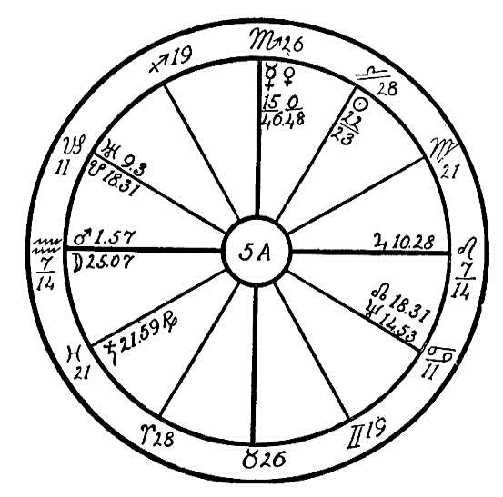
Jupiter here to be in opposition to Mars. Venus is in square aspect to Mars, and Mercury is parallel to Venus and square to Jupiter. With Venus ruling the venous blood and Jupiter the arterial blood, both being afflicted by Mars and Jupiter by Mercury also, this young woman suffered from restricted circulation, especially due to the fact that the afflictions are all from fixed signs and angles, which affected the action of the heart. With her high-strung, nervous temperament and uncontrolled fits of temper she precipitated an attack of heart trouble each time she permitted herself to be ruled by this emotion.
There are also indications of in harmony in the home, for we find the rulers of the 10th and 4th houses, Venus and Mars, in square aspect. Mars is also the ruler of the 3rd house, which stands for sisters and brothers. The above aspect would indicate that this young girl was greatly domineered by those in the home, and being of a very impulsive and dominant nature herself, this provoked much display of temper, which was very injurious to the health of one with the above planetary configurations.
In 1917 the progressed sun reached the square to the radical Mars, while the progressed Mars was in conjunction with the Ascendant. The result was that a chronic condition of heart trouble set in which slowly led to dropsy, for restricted heart action frequently bring about other complications. The doctors, unfortunately, were unable to diagnose the disease correctly, and she was treated for Bright's disease. In 1921 the progressed moon reached the opposition to its radical place at birth. This opposition usually marks the beginning of puberty, and is sometimes a critical period for young girls, especially when Venus and Jupiter are both afflicted. When the moon passed through Leo, the sign of the heart, while making the opposition to its radical place, it aggravated the dropsy, for the moon in Leo or Aquarius has a tendency to cause dropsy in a patient suffering with heart trouble.
Uranus, the planet of impulse and the higher octave of Venus, which also has an influence over the circulatory system, is in opposition to Neptune in Cancer, the sign ruling the stomach. Neptune is in the 6th house, health; this would indicate that there was trouble with the digestive organs and an abnormal desire for indigestible food.
The young woman's parents called upon Headquarters for healing after the doctors had given her up. They were told that the case was hopeless; she passed out three weeks after she was put on our healing list. The case was an incurable one when it reached our hands. She died in February, 1921. We may here see how powerful afflictions are and how difficult to over some when they are from fixed signs and in the angles. This was truly a debt of destiny which this soul was called upon to pay, and it was beyond the power of the Invisible Helpers.

NO. 5B.--HEART; KIDNEYS
Male, born October 25, 1862, at 5:20 A.M.
We will use here the horoscope of a man with Libra on the Ascendant and cardinal signs on all the angles. The planet of obstruction, Saturn, is exalted in Libra, and is placed in the twelfth house. Saturn is in opposition to Mars and Neptune. Mars and Neptune are in conjunction and parallel with each other. We have here three malefic planets, one in the 12th house, ruling hospitals, and two in the 6th house, the house of sickness. The twelfth and the sixth houses are very dangerous positions for planets afflicting each other by opposition.
Saturn in Libra, when afflicted, causes obstruction of the renal secretions, and lack of these secretions disturbs the chemical laboratory of the kidneys. Poisons are thrown off by the blood after it passes through the renal arteries to the kidneys, where it is purified and undergoes a thorough filtering process, leaving its poisons such as urea, phosphoric acid, sulphuric acid, potash, lime, and other refuse matter which it has taken from the food.
If the kidneys are healthy, these organs receive enough water from the flood to dissolve these poisonous secretions, which are then washed out from the kidneys as urine. But in a case such as we have for our diagnosis, where Saturn is afflicted in Libra, this washing out is not fully accomplished. The kidneys retain some of these poisonous secretions, which become hardened mineral matter. In course of time a hardening process develops and the kidneys refuse to function properly. The result is that the

Birth Chart No. 5B

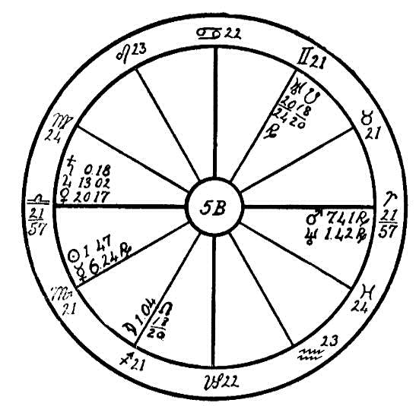
blood is not purified, and this mineral matter is lodged in the blood vessels, which become clogged, and the circulation becomes impaired.
The eyes are closely allied with the kidneys, and when the latter organs are sluggish and filled with mineral matter, the eyesight becomes impaired.
People with Mars in Aries have a desire to drink much liquid, as in the case of this man, who was afflicted with an unquenchable thirst. As the kidneys were not able to extract the excess water from the blood, this liquid, which was not eliminated through the skin, remained in the blood, and in time the man suffered from palpitation of the heart and dropsy. his case was diagnosed by the doctors as heart disease. People suffering with this affliction have very scanty and very highly colored urine.
If a case of this kind is taken in time, the kidneys can be flushed and the poisons eliminated by a proper diet. String beans, carrots, asparagus, and tomatoes are most helpful in stimulating the kidneys and assisting in the elimination of water. Onions are astringents, and where there is an excess of urine, the onion will regulate it. Therefore it is very necessary that the vegetables be properly chosen to work against and not with the disease.

NO. 5C.--THE HEART.
Male, born October 6th, 1855, 1:00 A.M.

"We shape, ourselves, the joy or fear
Of which the coming life is made,
And fill our Futures' atmosphere
With sunshine or with shade.
We weave with colors all our own
The tissues of the Life to be,
And in the field of Destiny
We reap as we have sown.
"Still shall the soul around it call
The shadows which it gathered here,
And, painted on the eternal wall,
The past shall reappear.
Think ye the notes of holy song
On Milton's tuneful ear have died?
Think ye that Raphael's angel throng
Has vanished from his side?
On, no! we live our life again;
Or warmly touched, or coldly dim,
The pictures of the past remain--
Man's work shall follow him!" --Whittier.
Well may we say of the soul whose destiny we read through this mystic scroll that his work in the past followed him. He hewed a path for himself, and chose one that was rough and rocky. His was the path of a leader of men, for he had the sign of Leo on the Ascendant, with the moon in conjunction with Mars and the Ascendant and sextile to the ruler, the sun. He also

Birth Chart No. 5C

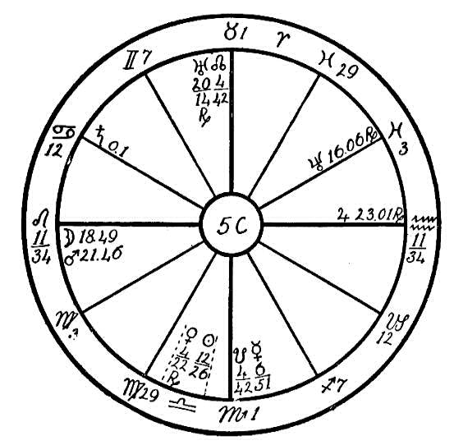
had fixed signs on the four angles and five planets therein. This is the sign of a strong soul, a man who will never lean on anyone, but who will be a doer, a lifter; as such he spent his life. This was a man who carried his cross willingly and who bore the stripes of the cruelties of the world uncomplainingly. One with such signs on the angles and with the planets as strongly placed as in this horoscope and afflicting one another surely finds his life full of lessons, and many responsibilities are placed upon him.
In his home he was most unhappy, as we see from Mercury in conjunction with the Dragon's Tail in Scorpio in the 4th house. This indicates that the wife was a nagger and a scold. Mercury in Scorpio shows that the wife would never permit the husband to have a moment's peace. Then we find Saturn in Cancer. Cancer is the natural fourth house sign. Saturn is square to Venus, again indicating a masterful and discordant marriage partner. With Jupiter in the seventh house, in opposition to the moon and mars and square to Uranus, marriage and partnership are shown to be accompanied by many trials and much opposition.
In spite of all this we find that this man achieved quite a fortune, did a big work, and made many friends. He was a leader in Masonry, where he did many kind acts, helping the widow and orphan generously with his money. He was deeply interested in prison work and also in occult studies. Neptune in Pisces, sextile to Uranus, shows his interest in occultism, but both these planets are retrograde, which brought him all kinds of restrictions. He was never free to follow his higher ideals.
With his many crosses, hard work, and disappointments he developed heart trouble of a very serious nature, and for years he used heart stimulants so as to keep at his work. He never allowed his physical sufferings to interfere with his business, however, which was of a very responsible nature, with many branches scattered over a large pat of America; also he had many men under him. With leakage of the valves of the heart and in spite of the resulting suffering he lived to the ripe old age of seventy years. We may see from this that the will can be used to overcome and that man is truly the master of his fate. Had this man had Virgo on the Ascendant or some other sign less strong than Leo, together with the afflictions from fixed signs, he would have become a confirmed invalid or have passed out as a young man. Hence we may see that "the wise man rules his stars; the fool is ruled by them."

NO. 5D.--HEART DISEASE
Male, born September 12, 1858, 8:15 A.M.
Our first concern when diagnosing this horoscope is to ascertain the mental caliber of the patient. Jupiter placed in the house of the higher mind and Mars near the cusp of the house of the lower mind are in opposition, also square to the sun and Mercury, a fact which stamps the native as a pessimist of an irritable nature. This is accentuated by the opposition of mercury to Neptune, the lower mind being out of tune with all spiritual concepts. Saturn square Venus prevents the native from seeing the beauty of life. As these adverse testimonies are only counterbalanced by the moon sextile Mercury and the sun, and trine Neptune, we may conclude that this person is in a sad state and needs all the help and cheer it is possible to bring him. We are afraid that even the best efforts will avail little against such a barrier of pessimism as he has built around himself.
Regarding the disease to which he is subject, the cold hand of Saturn in Leo shows us the obstructed heart action, and the consequent sluggish circulation is designated by the square of Saturn to Venus and the square of the sun and Mercury to Jupiter, for Jupiter and Venus govern the arterial and venous circulations respectively. Uranus sextile Saturn produces a spasmodic action felt as a fluttering of the heart; and being posited in Gemini he also imparts a spasmodic motion to the lungs, making it at times difficult for the patient to breathe, though the condition is not so well defined as in asthma. The affliction of the sun and Mercury in Virgo op-

Birth Chart No. 5D

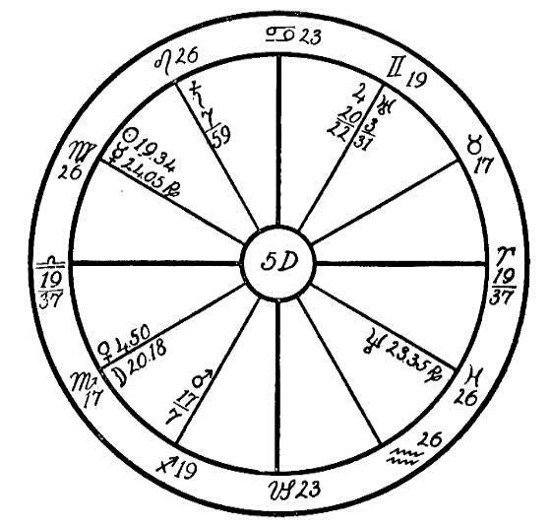
position Neptune indicates intestinal trouble. The affliction of the sun and Mercury by Jupiter and Mars from the houses of travel, also the opposition of the last named planets, show a predisposition to accidents, especially when on a journey. With this phase of the indications we are not, however, concerned at the present time.
We may bend our efforts to accelerate the action of the heart and promote impaired digestion in order to give the person relief and a brighter outlook upon life. As Saturn controls the pneumogastric nerve, his presence in Leo shows us that this is the principal set of the trouble, for his nerve inhibits the heart action and acts also upon other vital organs. It is difficult to reach this nerve in an efficient manner when we are clothed in our dense bodies. But the conscientious Rosicrucian health adjuster has other means at his disposal, for his Obligation to himself taken before the Elder Brothers enables him to work upon his patients during the hours when his body is sleeping. And he is taught how he may materialize fingers inside the body of the ailing and thus give the needed help to remove obstructions, growths, etc.; yes, even to adjust displaced bones. We receive many letters at Headquarters from patients who sense the presence of the Invisible Helpers and the withdrawal of hands from their bodies at the moment when they awake.
The best method to treat such a case as this would be for the healer to thoroughly impress upon his or her mind where the seat of the malady is to be found, physiologically and astrologically. Then after retrospection in the evening say, "Now, I will go to help my patient under the direction of the Elder Brothers," letting that be the last waking thought.
The healer best fitted to take charge of this case would be one whose rising sign is in harmony with Libra. Aquarius would be the first choice and Gemini the second. It is further required that he or she should not have Saturn in Libra or Pisces.

NO. 5E.--THE HEART.
Female, born September 18, 1854, 10:00 A.M.
Here we have a horoscope with the energetic, active, and aggressive sign of Scorpio on the Ascendant, with the life ruler, Mars, in the 1st house within orb of the Ascendant and in its own sign, where a planet has the greatest power either for good or evil. In the case of this woman this martial energy is dissipated and not kept under control, for the planet Mars is in opposition to the erratic and impulsive Uranus which is posited in the 7th house in the fixed sign of Taurus where it is in its fall and therefore apt to show its evil side. The combined influence of Mars and Uranus, both being planets of impulse, acts like a fire fanned by the wind which has got beyond control.
We find the water moon near the Midheaven in the hot, fiery, and fixed sign of Leo, and this planet is in square aspect to both the above planets of impulse. Fire in contact with water generates steam. This affliction of the planets of fire to the watery and emotional moon has a similar effect upon the mind of this woman. Mars in Scorpio afflicted and on the Ascendant

Birth Chart No. 5E

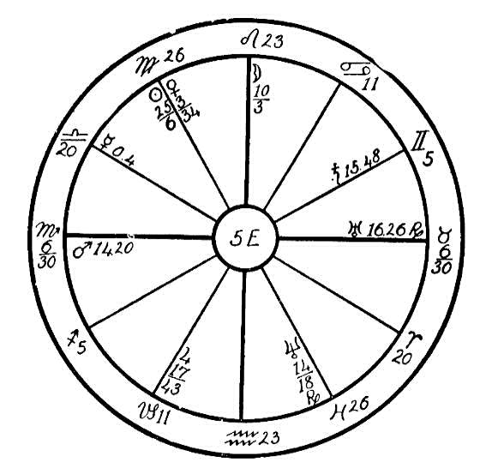
gives an uncontrolled temper, showing a woman who would fly into a rage at the least provocation and this anger is apt to be directed toward the marriage partner. If we place a kettle of water on a fire which is kept fanned into a red heat, in time the water boils down, the bottom of the kettle becomes dry and burns out. In this state we find this woman. For years she has created such a nervous and emotional environment about her in her home that the poor heart has been burned and scorched, for the moon afflicted in Leo indicates that the heart has been under a great strain. The result is that in the year 1916 when the progressed moon reached the conjunction of the radical Mars in the 1st house and later the opposition of Uranus in the 7th house (indicating the husband), domestic relations reached a critical point. With the progressed Venus, Mercury, sun, and moon all transiting the 1st house and in the martial sign of Scorpio, the resulting fiery emotions were too much for the body, and the poor woman lost all control of herself. She wanted to cry all the time, she could not digest her food, and would often swoon away with heart trouble.
There is, however, another cause for this physical break. We find a wonderfully strong and well fortified Neptune in its own sign of Pisces in the occult 4th house, in sextile to Jupiter and Uranus and trine to Mars. These aspects, especially the sextile between the two occult planets, Neptune and Uranus, ordinarily give a strong desire for development along mystical lines and would cause one to develop rapidly. But Neptune is making a square to Saturn, and Uranus is square to the moon. Evil aspects between planets as well as good will bring development but the development is of a different nature.
As we have often stated in our lessons, anger and evil emotions are much more injurious to a person who is endeavoring to live the higher life than if he were content to drift and be of the earth earthy. Each time that this woman gave way to her anger she set in motion a counter-clockwise vibration, a fire that burned up the spiritual life that had been awakened, and the poor body could not stand the strain. She cannot long continue placing this strain upon the heart, for with the squares and opposition of Mars, moon, and Uranus from angles and fixed signs, the heart will not be able to stand the strain and death may be very sudden.

CHAPTER XVII

THE STOMACH
NO. 6A.--STOMACH TROUBLE AND TUBERCULOSIS
In the diagnosis of disease by the science of the stars it is sometimes most difficult to know in what direction the afflictions may work. For instance, we have so often written of the sinister effects of Saturn in Cancer, the sign which has rule over the stomach. When he afflicts in this sign he robs the stomach of its gastric juice, which is necessary for the digestion of the food. Saturn in this place has also a tendency to create a desire for unhealthful foods and leads to the excessive use of cream, sugar, desserts, etc. But in this lesson and the next we will endeavor to show how Saturn when placed in the opposite sign, Capricorn--in which Saturn is at home and where his influence is much more subtle and malevolent than when he is in the sign of Cancer--has similar effects.
We will use two horoscopes by which we will show the effects of Saturn in Capricorn whereby diseases are produced of vastly different natures. We will first use horoscope 6A, which is that of a man born February 19, 1902, 3:00 P.M.
We find Saturn in 23-21 of Capricorn in the 6th house which has rule over the health. Saturn is in opposition to the moon. This last named planet is in its own sign of Cancer, the sign ruling the stomach. The moon is also in opposition to Jupiter. When Jupiter has any connection with signs or

Birth Chart No. 6A

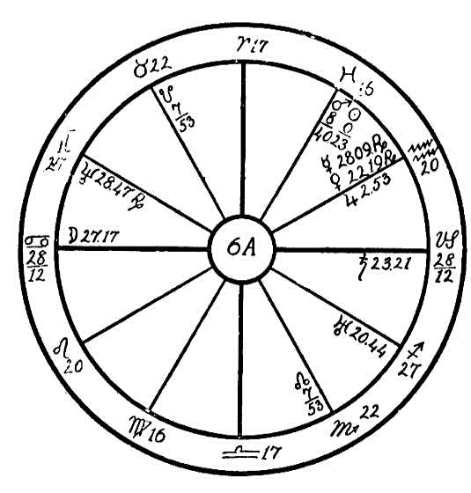
planets which rule the appetite, he creates a desire for food in large quantities. Whatever Jupiter does must be on a big scale; with the moon and Jupiter in opposition we may look for the gourmand.
With Saturn afflicted in Capricorn the gastric juice of the stomach is sluggish, and we may expect trouble in the digestion of the food.
If the stomach is filled with an excess of rich food, the man will receive nourishment from only that part which the stomach can digest. The blood is carried to the lungs to be oxygenated. Oxygenation is to the body what the draft is to the stove. If we shut off the draft, we smother and kill the fire, and so it is in the body. If man stops breathing, he dies. In shallow breathing the lungs are not able to supply sufficient oxygen for warmth and energy, and they do not exhale all the carbon dioxide.
In this horoscope we find Neptune in Gemini. Gemini has rule over the lungs. Neptune is on the cusp of the 12th house in opposition to Uranus in the 5th house in Sagittarius. Uranus and Neptune when afflicted indicate a nervous, cramping, spasmodic action. Neptune here indicates that the capillaries of the lungs were incapable of taking the amount of oxygen necessary to oxygenate the blood. Consequently the carbon dioxide formed faster than the lungs were able to exhale it. The result was that poison was stored up in the system. The nerve cells became weak and sluggish, and little by little the body became lowered in resistive power; the weakest organ was then unable to keep up with its work. The bellows of the body, the lungs, in the case of this man were unable to inhale enough air to burn up the poisons. The result was the lungs became diseased and tuberculosis set in.
People with planets afflicted in common signs are frequently susceptible to tuberculosis. With the sun and Mars in conjunction in Pisces, and with Uranus in Sagittarius in opposition to Neptune in Gemini--Pisces, Sagittarius, and Gemini being common signs--the lungs as a consequence attracted the impurities. hence we can see that Saturn in either Cancer or Capricorn may be the direct cause of disease which expresses itself in another sign.
Three years ago this man began to suffer with stomach trouble, which has now been followed by tuberculosis of the lungs, a disease which had its beginning in wrong eating. It can at this stage be cured by a very carefully chosen diet of raw vegetables and fruits and very little protein.
We will in our next lesson take up Horoscope 6B, which has Saturn in Capricorn, but which has its outcome in a quite different disease.

NO. 6B.
STOMACH TROUBLE AND INFLAMMATION OF KIDNEYS
Horoscope 6B is that of a man born February 26, 1871, 4 P.M.
This will be a continuation of the lesson on the effect of Saturn in Capricorn, showing how this planet may express its evil side through the planet which it aspects adversely.
We find Saturn, the planet of obstruction, in the sign of Capricorn, a cardinal sign. Signs of the like nature, especially the cardinal signs, have an affinity for one another and respond to afflictions more readily on that account. In this horoscope Saturn is in Capricorn, square to Mars in Libra, both cardinal signs. Libra rules the kidneys and the little ducts leading from the kidneys to the bladder, the ureters. Where we find Mars afflicted we may look for heat and excessive action. Saturn in Capricorn gives tendencies similar to those which he gives in Cancer--perverted tastes, desire for strange and unnatural foods, and a liking for sugar, pastries, etc.
Saturn in Capricorn also obstructs the flow of the gastric juices in the stomach, hence we can see why people with an afflicted Saturn in tropic or cardinal signs, namely, Capricorn or Cancer, are often afflicted with indigestion, rheumatism, uric acid deposits, etc. When we find the inflammatory Mars in the cardinal sign of Libra, square to Saturn in Capricorn, we may expect that the poisonous elements which are left undigested to ferment in the stomach will lodge in the kidneys, creating highly acid urine, which causes inflammation in the kidneys and ureters.

Birth Chart No. 6B

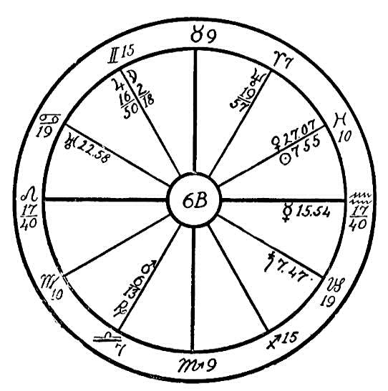
In this horoscope we find the moon in Gemini, square to the sun in Pisces. Gemini and Pisces, being common signs, here obstruct the oxygenation of the blood and interfere with its purification, hence more impurities are sent to the kidneys from this source. Thus we may see the similarity of causes in this horoscope and horoscope 6A, although the results are not the same.
This man should be placed on a milk diet for several weeks, and after the kidneys have been purified by this system of flushing, he should eliminate all highly seasoned and most starchy foods from his diet.

NO 6C.--THE PYLORUS
Female, born March 29, 1909, 1:30 P.M.
We find that this girl has a very bright mind, with Mercury, the mental planet in sextile aspect to the quick-witted and active planets, Mars and Uranus, in the sign of Capricorn which gives stability and balance, bringing the saturnine influence to bear upon the impulse and quick wit of the last two planets. Mercury is also making a trine to the moon which is in its own sign of Cancer. But we find much that is dangerous in this active mentality should the parents allow this child to take up the dangerous fads of mystic writing such as the planchette, Ouija board, etc. Saturn in the sign of the head, Aries, in square aspect to the mystical planet Neptune, Neptune being in conjunction with the moon, and the moon in opposition to Uranus and mars from the 12th to the 6th house, show that some time in life, if the parents are not careful this girl may suffer through insanity or spirit obsession.

Birth Chart No. 6C

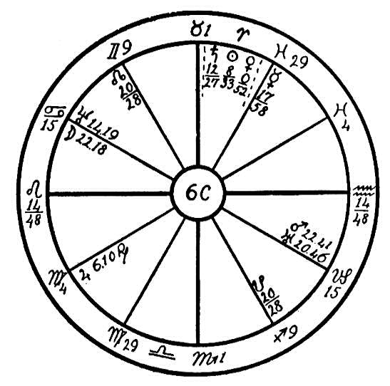
This horoscope has another affliction which makes it a very interesting figure for diagnosis. The moon is in the sign of Cancer, the stomach, in opposition to the inflammatory Mars and the nervous and contracting Uranus which has a tendency to disturb digestion and create gas in the stomach, also inflammation of the mucous membrane. Uranus is airy, the moon watery, Mars fiery. In order to illustrate the effect of these three planets upon one another, we kindle a fire, allow a strong breeze to blow upon it, and after it is in full blaze pour water upon it; this will describe to a certain extent the effect of these three planets when acting upon the stomach. Every bit of food that was taken into the stomach created a disturbance. This child rarely tasted food without having great distress, nausea, and vomiting; nothing could be retained in the stomach. She was afflicted in this manner even from birth. At the age of eight years she was operated upon by the doctors, who diagnosed her trouble as being in the cardiac orifice, saying that this was too small. But the patient received no relief from this operation.
If the physician could only have reasoned that the vomiting and disturbance when food was in the stomach could not have been caused by a defect in the entrance of the stomach but by another cause deeper down in the organ! Astrology tells us that Saturn in square to Neptune indicates malformation, undersize. if these two planets had been in the first pat of the sign of Cancer or the last degrees of Gemini, it would have indicated the cardiac orifice, but we find that the moon is in 22 degrees of Cancer, showing that it was nearer the lower part of the organ. Mars and Uranus indicate involuntary muscular action. Mars, when afflicting the moon, shows nausea, and Uranus, when afflicting the moon, causes contraction. Thus we see indications that there were involuntary muscular action and contraction which caused nausea. But why should the food be thrown back out of the stomach? as the child could retain nothing. We find an undersized pylorus, an undersized outlet. After the food was in the stomach it could not be passed into the intestines in the proper manner, and there being also insufficient mucous membrane, there was faulty digestion. Naturally vomiting would be the result.
In such a case it would have been difficult to cure this young woman without an operation, but instead of operating upon the cardiac orifice, the doctors should have observed the pylorus and watched the action in this part of the stomach.

NO. 6D.--STOMACH AND KIDNEY TROUBLE
Female, born January 23, 1886, 4:00 A.M.
A number of operations have been performed in the abdominal region of this patient, and she has gone from one doctor to another until now she is a physical and mental wreck.
When we trace these effects back to their primal cause, we come to Saturn in Cancer, the sign which rules the stomach. It is our experience that most people who have Saturn in this position are mincers and peculiar in their choice of food. Saturn in this horoscope is square to Jupiter, the planet of self-indulgence, and to Uranus, the planet of spasmodic and irregular action. Thus Saturn causes this person to indulge unduly her desire for good things to eat.
Uranus and Jupiter in the sign Libra, which rules the kidneys, square to Saturn, the planet of obstruction, show that after the system has been filled with food which it cannot assimilate, the kidneys are unable to eliminate the waste products. Thus there is a general clogging of the system with toxins and poisons of all kinds. Then the hot and fiery Mars placed in Virgo, the sign ruling the intestines, lights the fire of inflammation in order to cleanse the system. As the native's will power is not particularly strong on account of the weak sign Sagittarius rising, she is easily persuaded to undergo operations rather than undertake a reform in her ways of living which would bring about an amelioration of her condition even at this late hour.
If is very sad to say that this is the case with a great many people. They are sometimes ready to admit being gluttons when the fact is shown

Birth Chart No. 6D

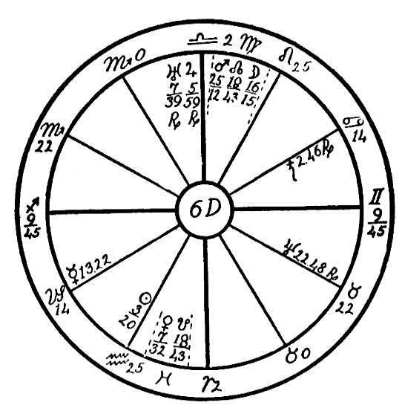
them, but in most cases they think they are models of self-control as far as the appetite is concerned even when they admit that they are eating the wrong food. We have had a number of cases, however, where they admitted this but claimed absolute inability to overcome the fault and curb their appetite. The person whose horoscope we are considering was not exception to the general rule, and therefore all our efforts to aid her were in vain. She would not even expend the energy necessary to keep up the weekly letters required of patients. In such cases there is of course nothing to do but to leave the patient to his own resources until he learns his lesson--if not in this life, then in some other one.

CHAPTER XVIII

THE KIDNEYS
NO. 7A.--THE KIDNEYS
Male, born March 14, 1892.
The horoscope which we will use here is a flat figure. The hour of birth is not known, but in astro-diagnosis it is not necessary that we have the hour of birth unless we are looking for a crisis. We must then take into consideration the exact degree of the progressed moon and its aspects, also the transiting planets; but the natural tendencies as to temperament and morals, also the organic weaknesses are shown by the radical planets, which give the astrologer they key to the health of the native, although if one has the rising sign to show the will and the strength it is a help. Certain signs such as Aries, Gemini, Leo, Libra, and Aquarius will overcome and fight off a disease where most of the feminine signs, especially Taurus and Virgo have not the will power to rise above physical conditions. Of the common signs the sign of Gemini is the best able to control physical ailments.
In this horoscope we find the sun, the life-giver, in the common and negative sign of Pisces. The sun is afflicted by an opposition and parallel of the destructive Saturn. Here we have at the beginning an indication of low vitality. Jupiter, the ruler of Pisces and having rule over the

Birth Chart No. 7A

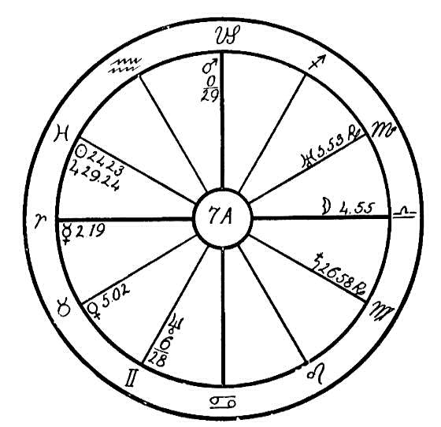
arterial blood is in its own sign in conjunction with the sun and in opposition to Saturn. This opposition tends to lower the vitality, for if the blood stream is stagnant, the entire body must suffer. We find Venus, the planet having rule over the venous blood, in its own home in Taurus where this planet is strong. Venus is afflicted by the opposition and parallel of Uranus. This will increase the ill effects of Jupiter and the sun afflicted by Saturn. With the afflicting influence of Saturn from Virgo, the sign which has rule over the small intestines, we may expect impaired assimilation of food.
We find the moon in opposition and parallel to Jupiter and square to Mars. These aspects coupled with Venus in Taurus in opposition to Uranus in Scorpio would indicate that sensual pleasures have ruled this young man and that his health was quickly shattered. Uranus in Scorpio in opposition to Venus indicates indiscretion regarding the sacred generative function, and at the age of sixteen when the progressed moon had reached the conjunction of Venus and the opposition of Uranus, he contracted the dread disease of syphilis. Although later seemingly cured, yet the powerful compounds such as those of mercury and the various remedies used by medical science to combat this disease left their destructive influence in the blood, and tuberculosis of the kidneys set in. This is shown by the moon in the sign of Libra, ruling the kidneys, square to Mars, in opposition and parallel to Jupiter, and in opposition to Mercury.
This young man entered the medical profession. Later he was operated on and had one of his kidneys removed, which was found to be hollow. The doctors diagnosed his condition as tuberculosis of the kidneys.
He passed out at the age of twenty-eight. When he reached that year, we note that the progressed moon had finished its cycle and had again reached its place at birth in Libra, and the progressed Jupiter had reached the opposition to the radical and progressed moon. The time when the moon has made the circle of the whole horoscope and reached its place at birth is a critical time, and frequently when the moon is afflicted in the radical figure, this is a time of illness and one in which the native is faced with many trials.

NO. 7B.--KIDNEYS AND MASTOIDITIS
Male, born May 8th, 1865, at 1:45 A.M.
This horoscope has the fixed sign of Aquarius on the Ascendant, with the sun in the fixed sing of Taurus and in conjunction with Venus and Mercury. The sun is also sextile to Mars. Jupiter, the planet of opulence and benevolence, is in the 10th house in its own sign of Sagittarius. These positions and aspects of the sun and Jupiter indicate one who is a great lover of humanity, a man who is very generous financially and very ready to go out of his way for others, even sacrificing his own comfort if he finds anyone whom he can relieve of suffering or shield from harm. But we find Jupiter, Mercury, Venus, and Saturn all retrograde. This indicates that the man will find difficulty in realizing his ideals and in doing as much good as his heart dictates, for retrograde planets indicate latent talents, possibilities, and opportunities.
Ability for earning money is very marked. This man is also a liberal spender, having Venus in its own sign, and house--Taurus and the second house--in conjunction with the sun and sextile to Mars. Whatever he does must be done on a large and generous scale. He is a good entertainer also and a good liver, for the sun, Venus, and Mercury in Taurus, sextile to Mars in Cancer, and Taurus ruling the palate, give a desire for good things to eat and plenty of them. Likewise does Mars in Cancer, sextile to Venus and the sun, desire rich, highly seasoned foods and in large quantities.
With Mars in the 5th house this man loves to share with his friends. But while this generosity may have been good for others and he has made people

Birth Chart No. 7B

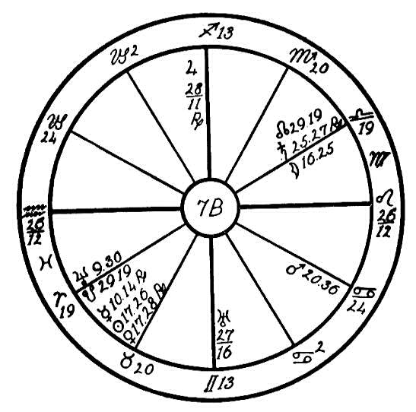
happy by tickling their palates, the result has been disastrous to himself. His health could not withstand the onslaughts made upon the body by high living.
To find in what part of the body the damage done by excess of food will show, we look for the strongest afflictions. We find Mars in Cancer, ruling the stomach, square to the moon and Saturn, which are in the sign of Libra, Libra having rule over the kidneys. We also find Saturn in conjunction with and parallel to the moon. The moon rules the white fluids of the body and the lymph. Saturn being the afflicter would as a result resist the free flow of these fluids. As Jupiter, the planet ruling the arterial blood, is in its own sign of Sagittarius, near the Midheaven, in opposition to the nervous, excitable, and spasmodic Uranus in the Mercurial sign of Gemini, and as Mars is parallel to both Jupiter and Uranus, we find an obstructed arterial circulation with the lymphatic circulation also impaired.
When the man is continually breaking the laws of health by excessive eating, we may expect that the break must come some time. In 1906 while the progressed sun was in conjunction with the radical Uranus in Gemini and the progressed moon was making a square to Mars and an opposition to both the moon and Saturn radical, this man was taken down with a severe attack of pneumonia. In 1907 the progressed sun reached the opposition to the radical Jupiter. This was followed in 1912 by the progressed moon in conjunction with the radical Mars in Cancer. During that same year the progressed moon afflicted by square its own place at birth and the radical Saturn, both in Libra. This brought on a severe attack of kidney trouble and constriction in the ureters, which interfered with the waste water passing from the kidneys to the bladder.
At the age of thirteen, when the progressed moon had reached the sign of Aries, and during its transit through this sign, it came to a conjunction with the radical Neptune, an opposition to the radical moon and Saturn, a square to Mars, and a conjunction with the Dragon's Tail. This brought on trouble with the ears and continual headaches and earaches. When the moon reached the conjunction with the radical Mercury and the retrograde progressed Venus in Taurus, inflammation of the mastoid cells developed. The doctors operated on the mastoid bone twice, draining the pus which had formed in the mastoid cavity. These operations left the patient with a chronic headache and impaired nerves.
If this man had been taught that he should eat to live instead of living to eat he might have been saved much suffering.

NO. 7C.--GENERAL BREAKDOWN
Female, born April 19, 1888, 4:30 P.M.
Judging the mind first as usual, we find that Mercury is in conjunction with Venus and trine to the moon and Jupiter in fiery signs. Thus all the three significators of mind may be said to be in trine. Jupiter is in a measure concerned in the mental makeup because he is ruler of the ninth sign, Sagittarius, and from him come the benevolent impulses which are gradually lifting humanity from savagery through civilization to sainthood.
It is at once apparent that we have here a person of unusually fine mentality. Even the conjunction of Saturn with the moon is very beneficial, for as we have often said before, the nature of Saturn is obstruction, and when he lays his restraining hand upon Mercury or the moon, it helps to steady the flighty mind and gives power of concentration. At the same time, of course, there is a tendency to melancholy connected with any of the aspects of Saturn to the significators of mind. Therefore it may be said that those who have the greatest and deepest minds are usually of a sad disposition.
This woman is not of a deliberative nature, however. She does not moan her days away over the sorrows and sufferings of the world for there are cardinal signs upon the angles and Mars is conjunction Uranus in the first house. This gives here a very impulsive and restless nature. She has the mind to see where reforms are needed, but the nature of her effort to carry out these reforms depends upon her station in life, with which we are not acquainted. If she had been born into a broad environment where wealth,

Birth Chart No. 7C

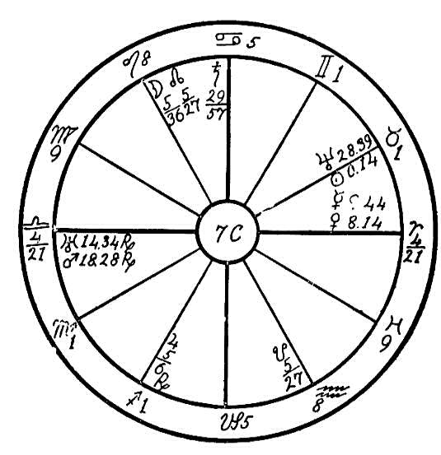
position, and influence were at her command, she would have been a powerful factor, felt in a wide sphere; but if she was born in a financially cramped environment, she would be correspondingly hampered by its circumstances. However, no matter where she is her influence is bound to be felt, and she will endeavor to revolutionize things with the inevitable result that she will wear herself out in her efforts for improvement.
As a chain always breaks at the point where the weakest link is found, so it is also with the human life. Uranus, the planet of spasmodic, uncontrolled action is in opposition to Mercury, the planet which governs the cerebro-spinal system, showing that there will be a nervous breakdown whenever great strain is put upon the body. Saturn, the planet of obstruction, is in conjunction with the moon in the sign that governs the heart, Leo, and it is square to the sun, ruler of Leo. Thus it is evident that the heart action is very poor and there is an inability to specialize the vital force from the sun, also a poor circulation. In fact, the chart shows the possibility of a condition which can only be described as a general breakdown from overwork and nervous tension, affecting every organ in the body, for Uranus and Mars in Libra will interfere with the action of the kidneys, the sun afflicted in Taurus will act upon the throat, and the rectal elimination, governed by Scorpio, will be interfered with. This condition has finally materialized.
It is almost needless to say that in such a case as this, absolute rest, mental and physical, is necessary, preferably on a diet of fruits, for it is very detrimental to force food into a system that is in such a shape as this one. An Aquarian nurse whose Saturn is not in Libra or Pisces would have a quieting and beneficial influence. But even though relief is given and a cure effected, persons with this nature and temperament are bound to work themselves to death some time sooner or later. Nothing that one can say or do to educate them to the fact that they should take things quietly in order that they may last will have any effect, for the spasmodic urge of Uranus and the dynamic energy of Mars on the Ascendant will outweigh any consideration because there are cardinal signs on the angles. This woman is bound to work even if she knew that she would drop dead the next minute. There is no doubt, however, that she is bound to benefit very much in soul growth even if the body is destroyed in the process.

NO. 7D.--RENAL CALCULI
Male, born September 21, 1863, noon.
In this horoscope Saturn is in conjunction with Mars and Venus. Neptune is in opposition to all three, and the moon is square Saturn and Venus. Mars, the planet of impulse, causes the native to see red on the slightest provocation, and were he left alone there would be absolutely no chance of restraining him save by putting him in a straight-jacket, particularly as the sun is square Uranus, which would intensify the impulsiveness and obliterate reason. But the saturnine ray is sufficiently effectual to wet-blanket most of the erratic tendencies for he is in the sign of his exaltation, Libra, and highly elevated.
Mercury in conjunction with Jupiter, both elevated and in trine to Uranus, shows us that there is a wholesome, kindly, and religious side to the mind. From Mars comes the readiness to take offense even where no reasonable ground for it exists; Saturn will cause the native to brood over injuries whether they be real or fancied; but Jupiter will endeavor to instill charity and judgment. It is apparent, however, that the forces which tend to accentuate the evil side of the nature are the strongest and that it is a hard and uphill fight for the higher nature.
Saturn in the first part of Libra, the sign ruling the kidneys, acts in such a manner that the secretion of urine is obstructed. Mars there causes inflammation. The conjunction of Saturn with Venus, the latter governing the venous circulation, reveals the fact that the branch of the portal system which conducts the blood from the kidneys is obstructed, and the square

Birth Chart No. 7D

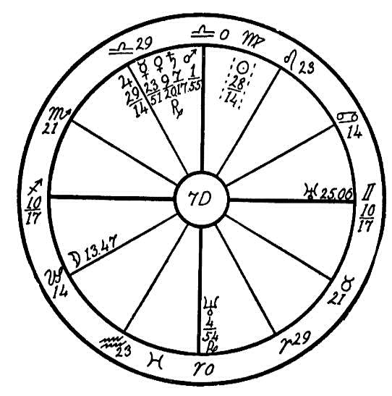
of Saturn to the moon diminishes the amount of urine secreted. Neptune in opposition to Saturn shows clearly a mental cause, irritability and worry, interfering with nerve action. Thus renal calculi are formed, and the person is subject to one of the most painful maladies imaginable.
To help a person of this nature we must invoke the aid of Jupiter and Mercury trine Uranus. Mars is the great energizer that impels to action, but Saturn in conjunction puts a damper on him, and the native becomes indolent, averse to the exercise generally enjoyed by the Sagittarians. We must therefore wake the native up to the urgent necessity for exercise and plenty of it. The moon in Capricorn acts in the opposite sign, Cancer, ruling the stomach, and because it squares Saturn in Libra, the sign of the kidneys, it interferes with the secretion of urine. Hence the necessity for the regulation of the diet. Nothing of an irritating or unduly stimulating nature should be eaten.
The best healer for this person would be one who has Leo rising, as that is in harmony with Sagittarius. Aries is second choice for the reason that an Arian may be too rough and arouse antagonism without so intending. Neither should have Saturn in Sagittarius or Taurus, these being on the cusps of the patient's first and sixth houses respectively.

NO. 7E.--RENAL CIRCULATION
Female, born March 24, 1845, 5:06 A.M.
In judging the case presented in this horoscope our first care, as usual, is to find out what sort of mental quality this person has, for always we must remember that the mind is the maker of the body. Therefore the wisest doctors now use harmless pills and helpful suggestions.
Mercury and the moon, the two particular significators in respect to mind, are in opposition. The moon is also in opposition to the sun, Jupiter, and Uranus. Mars is square to the sun, moon, Jupiter, Mercury, and Uranus. Thus the person is extremely erratic, vacillating, and torn between different purposes. There is only one redeeming feature, namely, Saturn trine the moon and sextile Jupiter. Were it not for these aspects, which steady the mind, the native would likely have gone insane. Take now in conjunction with the foregoing remarks the fact that four common signs are on the angles and you will understand that she is extremely difficult to handle mentally. She is one of those unfortunate weaklings afflicted with a wishbone instead of a backbone. The sun square Mars makes her impulsive, also the adverse aspects from cardinal signs give a certain surplus energy which manifests as impulse. But she lacks the persistence to carry out her impetuous designs.
The affliction of Jupiter indicates faulty circulation, and naturally we judge the presence of Saturn in Aquarius as an indication of obstruction in that place, for the diseases to which the human body is heir are found in the weakest spot, and Saturn usually marks this. Aquarius governs the lower

Birth Chart No. 7E

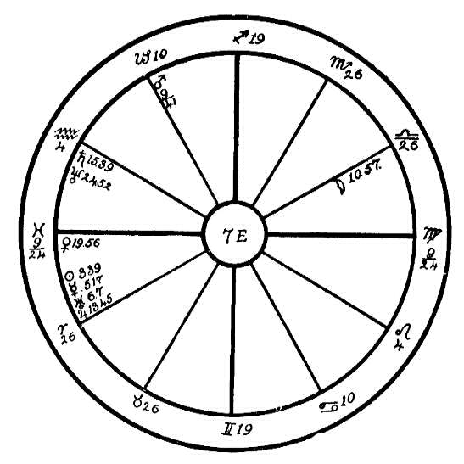
limbs, and the presence of Saturn there shows us that the obstruction of the circulation is at work in that region. Moreover, Mars has progressed to the conjunction of Saturn in Aquarius, and both are in the twelfth house, the house which indicates confinement. Therefore we may judge that the person is afflicted with a severe case of impeded circulation, and it is no surprise to learn that her legs are numb and cold, that she cannot use them properly, and that she is confined to her bed on that account.
The moon in Libra, which rules the kidneys, and her opposition to Jupiter shows that the renal circulation is out of order, and the presence of so many planets in Aries, which governs the head, is a sure indication that there is a riot of conflicting forces there. Thus because of the afflictions of these planets we have a case of sleeplessness, extreme nervousness, and the irritability given by Uranus. The blood runs riot in the upper part of the body, and there is too little in the lower.
As the native is well along in years there is not much to build upon, but an effort should nevertheless be made to stimulate the kidneys. The secretion of urine is often totally stopped by the opposition of Uranus, Mercury, and Jupiter to the moon in Libra. This leaves deposits of poison in the system, and as long as these are not eliminated the person will be weighted down by a heavy and sluggish feeling which makes the body seem as if it were made of lead. Great care should be taken to soothe and calm this woman as every bit of anger or irritability makes elimination more difficult and causes more poison to collect in the system. A healer who has Scorpio rising and who does not have Saturn in Aquarius, Pisces, or Leo would have a beneficial effect.

NO. 7F.--BLADDER TROUBLE
Female, born October 21, 1886, 11:00 A.M.
When we note that the moon and Mercury, which are significators of the mind, are squaring each other from fixed signs, it is at once evident that this patient will be rather set in her opinions and on that account difficult to handle. A person with Leo or Aries rising whose Saturn is not in Gemini would probably have the best success in making her obey orders. Saturn, the planet of obstruction, in Cancer, the sign which rules the stomach, shows that the digestion is poor, and his square to the sun, Jupiter, and Venus placed in the sign Libra, which rules the kidneys, indicates that there is difficulty in the removal of the waste material through these organs. The sun being close to the cusp of Scorpio, the sign which rules the rectum, further accentuates the trouble of elimination, showing that the person is subject to constipation.
It should be noted that when the significator of bladder trouble is in the fore part of the sign Libra, the difficulty will usually be found in the kidneys themselves, but if in the latter part of Libra, the bladder will be affected. Thus, following out this line of judgment we may know that as of the sun is in 28 degrees of Libra, the trouble will be found more in the bladder than in the kidneys. The square of the moon to Mercury in Scorpio shows that there is nervous trouble in the rectal region. Altogether the various signs and aspects which we have enumerated show that this person is suffering from constipation and bladder trouble.

Birth Chart No. 7F

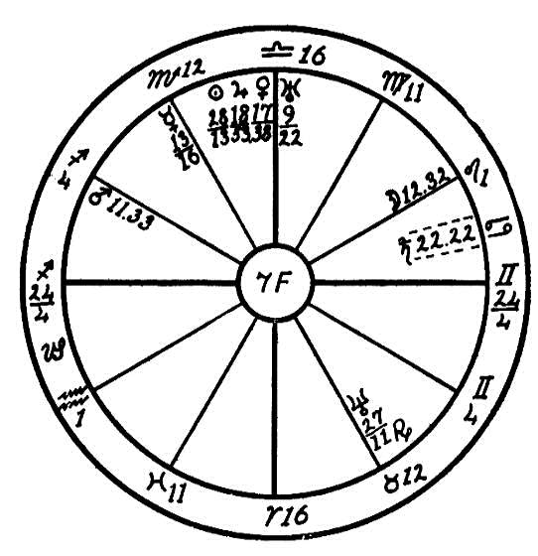
This is not all. We find Mars, the planet of surgery, conjunction Antares. When one of the malefics is placed near the nebulous spot Antares, Sagittarius 8, and either of the lights are afflicted, trouble with the eyes is quite certain to result. In this horoscope both the sun and moon are afflicted, one by a square of Saturn, the other by a square of Mercury. We may therefore judge that this woman will have trouble with her eyes, and as Mars is placed in the twelfth house, which rules confinement in hospitals or kindred places, it is evident that she is facing a grave danger from that source.
It is also plain from the horoscope that Saturn in Cancer is at the root of all the trouble by obstructing the digestion, and if we can once convince the patient that right living is the key to health, it may not be too late to restore the tone of the system. It will probably be very difficult to so convince her on account of her fixed mental attitude indicated by the square of the moon and Mercury in fixed signs.
A diet of coarse food consisting of whole wheat bread and vegetables which have a great deal of fiber in them will be necessary to stimulate the peristaltic action of the bowels. Asparagus and other foods which act on the kidneys, with plenty of lettuce and spinach, which are full of iron, will help to tone the system up so that in time elimination will become normal and then the eyes will grow better.

NO. 7G.--DIABETES
Female, born December 28, 1885, 11:55 P.M.
The patient in this case is suffering from diabetes, a disease in which the food is turned to sugar in excess of the requirements of the body, and this product is eliminated in the urine. Here we find Jupiter on the Ascendant in the sign Libra, which governs the kidneys, conjunction and parallel Uranus, and square the sun and Saturn, the latter in the sign Cancer, which rules the stomach. We also find that the sun is square the moon in Libra, and parallel and opposition Saturn. Thus it is very evident that the stomach and kidneys are the weakest links in the chain of the body, and therefore we may look for disease in these organs.
Jupiter afflicted and on the Ascendant denotes one who is too fond of good things to eat, a glutton. The conjunction with Uranus tells us that this person is not satisfied with quantity alone but desires her food to be superfine in quality and to be excessively seasoned. Saturn, the planet of obstruction, being in Cancer, the sign governing the stomach, interferes with digestion. Consequently the food cannot be entirely assimilated, and some of it must be expurgated from the system or it will cause a clogged and poisoned condition. Jupiter has rule over the liver, where the sugar usually required in the economy of the body is manufactured but he is sorely afflicted by a square of Saturn and the sun. Consequently this activity is abnormal, and as Jupiter is placed in the sign of the kidneys, Libra, he allows the sugar to slip out in the urine, thus giving rise to the symptoms which we diagnose as diabetes. There is also a throat affliction because

Birth Chart No. 7G

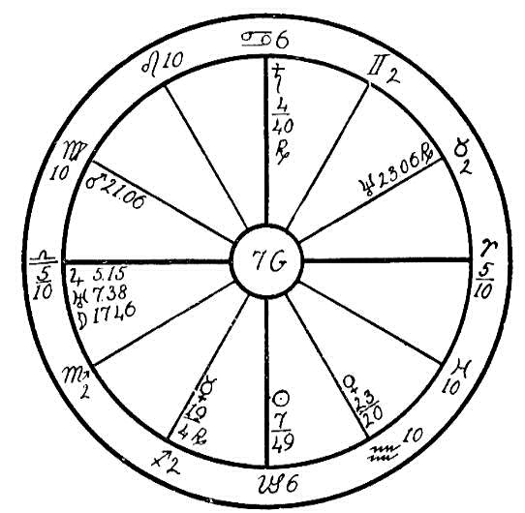
Neptune is in Taurus, the sign that governs the throat, afflicting Venus, the ruler of Taurus.
When we look to the inner causes of this disease in our endeavor to find a remedy we note that Saturn is elevated and afflicting the sun and Jupiter. This makes the person morose and irritable, given to looking upon the dark side of life and to finding fault with everything and everybody. The ductless glands are centers of important spiritual activity. An afflicted Neptune in Taurus and an afflicted Uranus in Libra interfere with the activities of the thyroid gland and the adrenals.
Before such a person can be really cured she must experience some kind of a shock or be taken into an entirely new environment and more cheerful surroundings. A healer with Gemini or Aquarius rising whose Saturn is not in Pisces would probably have the most beneficial effect.

NO. 7H.--DIABETES
Female, born February 24, 1863, at 9:50 P.M.
The horoscope of this woman has the sign of Libra on the Ascendant, with cardinal signs on the four angles, and Leo intercepted in the 10th house. These are all signs of strong feeling. The cardinal signs are the favorites of the universe, for the sun's entrance into these four signs marks the four seasons. People with the cardinal signs on the angles feel more keenly, live more intensely, and as a result suffer more than others.
The ascending sign of our patient is that of Libra, with Jupiter retrograde on the Ascendant. Jupiter is parallel to the sun, but its being retrograde naturally weakens the effects of this planet. We find Jupiter in the latter degrees of Libra, a Venusian sign, and Venus and the sun in the Jupiterian sign of Pisces; usually under such conditions the body taken on an abundance of flesh after middle life. This woman was of immense size, weighing over two hundred pounds, which is indicated by the above positions, also by Jupiter on the Ascendant and Mars in Taurus sextile to Venus in Pisces. Venus being in the fifth house, this woman found great pleasure in good things to eat and wanted her food in large quantities. This naturally caused her to put on much flesh.
Neptune, the planet of mysteries, representing hidden or occult things is in Aries in the 6th house, sextile to the moon. The 6th house rules labor and the 10th house the vocation. The moon is the ruler of the 10th house, and together with Neptune indicates the vocation which this woman would choose. It is thus clearly indicated that she was a professional medium.

Birth Chart No. 7H

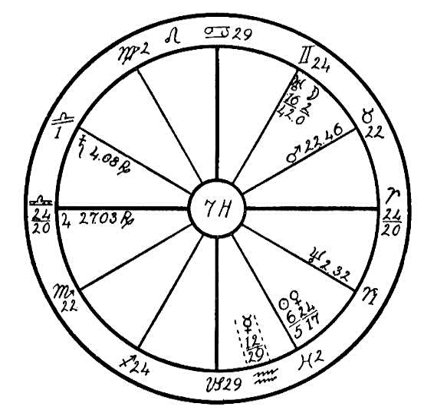
She was reported to be a very good one, which is shown by the moon sextile to Neptune and trine to Saturn, the 6th, 8th, and 12th houses being involved. Uranus being trine to Mercury, she would seek reasons for spiritualistic phenomena, also because Mercury is in the intellectual sign of Aquarius. Uranus is in the mercurial sign of Gemini, a sign of intellectuality, and Uranus and Mercury are therefore in mutual reception, which is conducive to much sympathy between these two planets. What is meant by "mutual reception" is that these planets have exchanged signs; Uranus is in Mercury's sign, and Mercury is in the Uranian sign. These two planets as a result have a strong influence on the life of the native. This woman conducted classes in spiritualism and gave spiritualistic readings.
We find Venus and the sun in Pisces in the 5th house, the house of pleasure. Venus is sextile to Mars and has a weak square to Uranus. This was clearly expressed in the woman's life, for she lived with a man whom she introduced as her husband but to whom she had never been married. This man was represented by the sun and Venus in Pisces and by Venus sextile to Mars and in weak square to Uranus. The man was large, red-haired, and fond of drink. He depended upon this woman entirely for his support, and they both lived to eat, and to make merry upon the money which she earned as a medium. This kind of a life may do for a while, but there comes a time when nature rebels, when the vital organs refuse to stand the strain any longer, as in this case.
When the progressed Venus reached a conjunction with Mars in Taurus and the progressed moon was in Aquarius, making a square to Mars radical and to Venus progressed, the strain which the woman had placed on her body by her riotous living found a weak spot in the kidneys, for the chain is only as strong as its weakest link. Saturn usually shows the spot where the weakness is apt to show itself. We find in this case Saturn in Libra in opposition and parallel to Neptune. This woman called upon headquarters when she was suffering very greatly from diabetes. It was, however, very difficult for her to follow the diet laid down for her as she was accustomed to the richest foods, which were taken in large quantities.

CHAPTER XIX

SEX
SEX AND THROAT
NO. 8A--B.
We are told in the Rosicrucian Cosmo-Conception, page 269, that when the Ego entered into possession of its vehicles, it became necessary to use part of the creative force for the building of the brain and the larynx. The latter was originally a part of the sex organ. The larynx was built while the dense body was yet bent together in the bag-like shape which is still the form of the human embryo. As the dense body straightened and became upright, part of the creative organ remained with the upper part of the dense body and later became the larynx.
It is always possible to make the lesson stronger by using two horoscopes. In this case we will begin with the horoscope numbered 8A, which is that of man born April 22nd, 1881, at 2 P.M.
The common sign of Virgo is on the Ascendant and common signs on all the angles. In this horoscope we will show the law of the vicious circle, which the doctors are so interested in and which is so baffling, and how this law proves the truth of the statement quoted from the Cosmo-Conception.
We have Saturn, the sun, and Jupiter in conjunction, and Saturn and Jupiter are parallel to the moon. Neptune is in conjunction with Venus and both

Birth Chart No. 8A

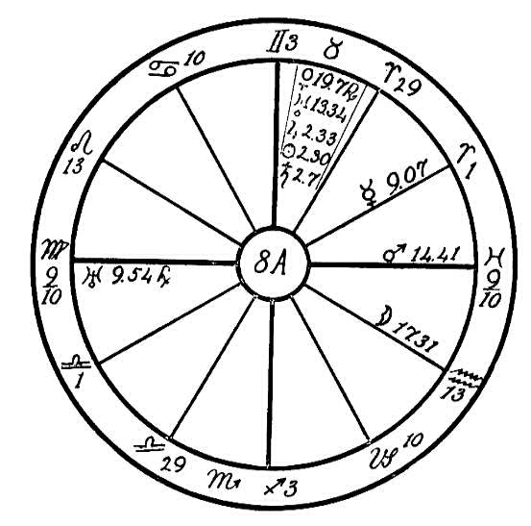
are square the moon. All these planets except the moon are in Taurus, the sign which has rule over the throat.
We find the planet of impulse, Uranus, retrograde on the Ascendant in Virgo and in opposition to Mars. These planets are in common signs and in angles. Thus they are strong by house position but placed in weak- willed signs. Uranus and Mars give the desire for pleasure and the gratification of the senses. Mars is sextile to Venus and Neptune in Taurus, a sign which

Birth Chart No. 8B

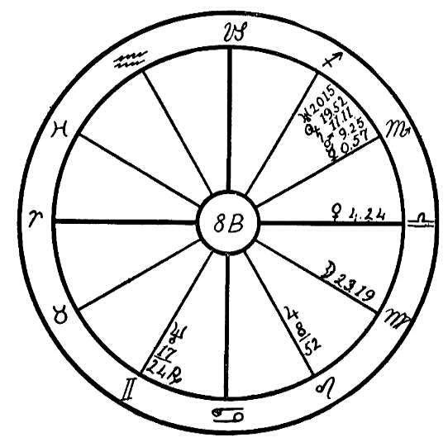
makes one apt to drift along the same path, Taurus ruling the sense of taste. Neptune and Venus in Taurus, square to the moon in Aquarius, would lead to the habit of drink and also to irregular association with women friends, for the moon is the ruler of the house of friends, the 11th.
We find no planets in Scorpio, the sign which rules the generative organs, but Uranus afflicted by Mars gives a tendency to venereal diseases. Syphilis was the net result. Therefore we may see that Taurus which rules the throat and larynx, here expresses itself through the opposite point of the vicious circle of the fixed signs, namely Scorpio, ruler of the generative organs. The moon in Aquarius, the third point of the circle, is also a contributing factor in the situation.
In the second case we will use a plain figure, as the hour of birth is lacking. This is the horoscope, numbered 8B, of a woman born November 12th, 1895.
In this figure we find Mercury, Mars, Saturn, the sun, and Uranus all in the sign of Scorpio, which has rule over the generative organs, with Saturn and Mars in conjunction and square to Jupiter. The sun and Uranus are also in conjunction with each other and the sun is parallel to Jupiter.
This woman had her tonsils removed at puberty. The tonsils are ruled by Taurus. Due to Mars in conjunction with Saturn, and the sun in conjunction with Uranus in the sign of Scorpio, she unfortunately yielded to the vicious practice of abortion, which so weakened the functions of the generative organs that removal of the ovarian tubes was necessary. Here again we see the vicious circle of the fixed signs in operation, Taurus and Scorpio being the points affected.
We may see by comparison of these two horoscopes how the generative organs and the throat are closely in sympathy with each other and that abuses of the function of one of them often express themselves through impaired functioning of the opposite organ.

NO. 8C.--SEX
Female, born November 24, 1909, hour of birth not known.
We will here illustrate how it is possible to diagnose a disease correctly from a flat figure. It is, however, impossible to predict the exact time of crises or to judge the strength of the will of the patient, for those with a common sign on the Ascendant some times become hopeless invalids if planetary aspects are also weak, while one with fixed signs on the angles (especially with the vital sun sign Leo ascending), even if the planets are weak, will often through the determination and will power of the fixed signs overcome adverse conditions. The Taureans, however, although under a fixed sign, sometimes allow fear to throw them into a chronic condition of ill health which with the fixed and stolid nature of this sign it is very difficult to overcome.
In this lesson we shall deal largely with the ductless glands, upon which science has spent so much time, though it has been unable as yet to arrive at a full understanding of these little organs. We will deal particularly with the thyroid gland, which is under the rule of Mercury and in which

Birth Chart No. 8C

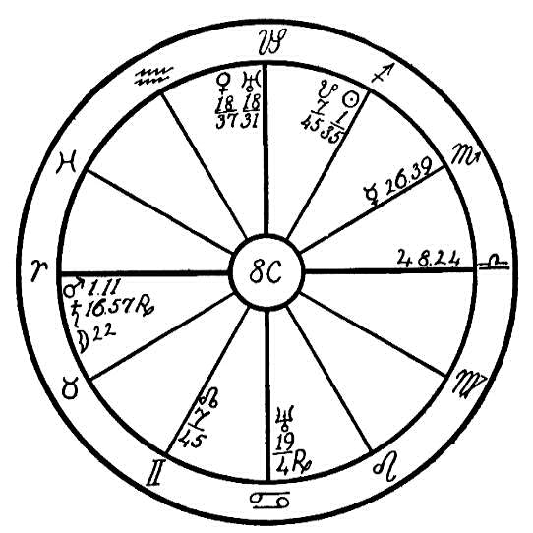
science is greatly interested, the thyroid glands of goats and monkeys having been grafted into men to rejuvenate them.
In the above horoscope we find Saturn, the planet of obstruction and crystallization and ruler of the pneumogastric nerve, in conjunction with the moon, which rules the uterus, ovaries, and sympathetic nervous system. Venus, the planet ruling the sign of Taurus, the throat, also rules the thymus gland, the organ through which the child receives the parental blood necessary to build the body. This gland has especially to do with the development of the reproductive organs. At puberty the thymus gland atrophies, and its work is then continued by the pituitary body, ruled by Uranus, which is the higher octave of Venus. In this girl's horoscope we find the planets Venus and Uranus in conjunction, square to Saturn and the moon, and in opposition to the planet Neptune, which has rule over the pineal gland and which is the higher octave of Mercury. Scientists have observed that the pineal gland has some connection with the mind. Dr. J. S. Lankford stated in The New York Medical Journal some time ago that "the pineal gland, which is at the base of the brain, is a partly glandular and partly nervous structure, and is known to be the center of all sensation and emotion; at the same time it rules and directs all the activities of the whole system of ductless glands and the vegetative nervous system, thereby governing all the functions of organic life. It also serves as a communicating center between the brain and the other organs."
Now, where we find the planets which have rule over the nervous system and the brain in square and opposition, what can we expect but that abuse of one kind or another will cause bodily disturbance! In the case of this young girl, whose guardians called upon our Healing Department for help, she had for some years been afflicted with the secret sex habit, of which the guardians were unaware until apprised through our diagnosis. The venous circulation is obstructed by the conjunction of Venus and Uranus. The latter planet, according to The Message of the Stars (page 573), "is responsible for strange and abnormal growths which produce...freaks of nature." The thymus gland in this case has an abnormal growth caused by the conjunction of Venus with Uranus, which created too much blood for the development of the generative organs in childhood. This in turn created a disturbance in the parts of the body ruled by this gland.
We are told by the doctors that the pineal gland (under Neptune) rules and directs all the ductless glands. Max Heindel has been alone in his claim that Neptune is the higher octave of Mercury, the latter planet having rule over the thyroid gland. Other astrologers have claimed that Neptune is the higher octave of Venus. But science corroborates our contention that the pineal gland has rule over the mentality. The COSMO- CONCEPTION states that this was at first an organ of sensation and orientation, and that when it began to withdraw into the head, the division of the sexes began to take place and the brain and larynx were developed.
Dr. Lankford further states that the large amount of sugar consumed by humanity overdevelops and overstimulates the pineal gland. The truth of this has been shown in our experience with cases in which Neptune was afflicted and especially where the afflictions were such that the patient had to overcome unnatural sex desires. These patients invariably were heavy sugar eaters. Sugar in excess as well as liquor is a false stimulant and excites the ductless glands, which when overstimulated are responsible for sex degeneracy. This young girl by years of abuse had dissipated the vital fluids that were necessary to help build the brain, and consequently at the age of eleven she was afflicted with epilepsy, which is a disease caused by abnormality of one of the ductless glands. The doctors could not find the cause and wished to remove the tonsils. When there is an abnormal exercise of the sex function or unexpressed unnatural desires, the throat, and especially the tonsils and the larynx, are often enlarged and swollen. Oh, what a pity that all surgeons and the doctors of all schools do not have a knowledge of diagnosis by the wonderful science of astrology to combine with their own science!
In order to help a case such as the one under consideration it is first necessary to remove the cause, which is to help this poor girl overcome her unnatural desires. The diet must be changed; all highly seasoned food, condiments, eggs, and especially sugar, must be eliminated, and the vegetables which contain elements that work directly upon the nervous system should be used, such as celery, onions, parsley, lettuce, et cetera. This body should be kept clean by bathing and dry rubbing, and plenty of exercise in the fresh air and sunshine should be taken. It will be difficult at the girl's present age to build up the brain, which is very undeveloped. Young people who have dissipated their vital fluids between the ages of seven and fourteen when the creative force should be used for the development of the brain will seldom be very bright mentally. The physical body, however, can be built up, and if the habit is overcome before the age of twenty-one, there is hope that by careful living the brain can be developed, giving an average mentality.

NO.8D--E: GONORRHEA
Female, born July 30, 1896, hour not known.
Two horoscopes will be used in this lesson in an endeavor to illustrate how the planets show when disease may be the result of breaking the laws of nature in former lives, and how the seeds that have been sown by past sins will bring their fruits in this life.
The first horoscope is that of a woman whose hour of birth is not known. Nor is it necessary for diagnosis in a horoscope with planets so strangely grouped and in the fixed signs. We will set the figure with Aries on the Ascendant. We find Mercury, sun, Venus, Jupiter, and the Dragon's Tail all in the fifth sign, Leo, which represents the pleasures of the native. We find Mars in Taurus in its detriment, the sign in which this planet of dynamic energy shows its most evil tendencies. This planet is afflicted by the opposition of the licentious Uranus and the obstructive Saturn. These last named planets are in conjunction and in the fixed sign of Scorpio. These three malefic planets, Mars, Uranus, and Saturn are also square to the planets in Leo.
Here we find a very heavy debt of destiny. In the Rosicrucian teachings we are told that we lay the foundation in this life upon which we shall build the structure of future lives. This woman in her previous life had developed a very powerful desire nature, which in this embodiment was very hard to keep under control. Venus in conjunction with the sun and Jupiter

Birth Chart No. 8D

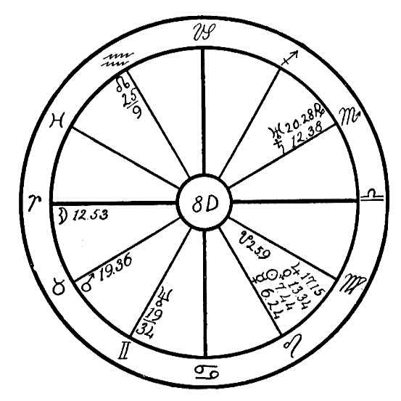
and square to Uranus and Saturn in the sign of Scorpio, also Mars, the planet which has rule over the desires, square to Venus and Jupiter, all lead to free love and clandestine attachments, with the result that this poor woman has contracted that dread disease, gonorrhea, which has resulted in tuberculosis of the pelvic and hip bones.
Now planets impel but they do not compel. This woman by her former living had attracted to herself these planetary afflictions, but she was not impelled to respond to their weakness, for we find the moon well aspected, making a sextile to Neptune and a trine to Jupiter, Venus, sun, and Mercury. Neptune is also sextile to Venus and Jupiter. If the woman had used her will and followed the desire to live right which naturally must have come to her from time to time, she could have transmuted this seeming evil into good. But the path of sensual pleasure was so much broader and so alluring, while the upward path meant self-surrender!

NO. 8E.
Male, born August 13, 1920, 1:18 A.M.
The second horoscope is that of a young boy born with the dread disease with which the woman in case No. 8D was afflicted. The boy's poor little body at birth was covered with sores, and in the early part of November of the birth year this poor soul passed out under great suffering.
Now as regards the man who does not understand and believe in rebirth and the law of consequence this last case would be apt to disturb his faith in God, who to him might appear cruel and unjust to have visited this suffering upon an innocent babe. But when the occultist who has a knowledge of

Birth Chart No. 8E

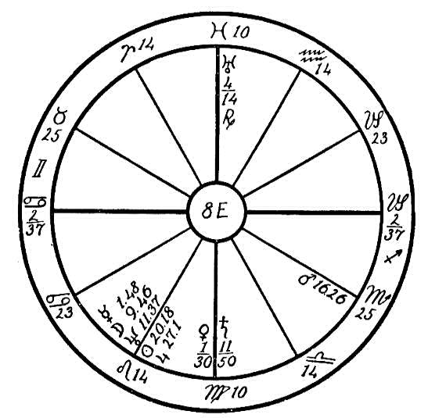
astrology seeks an answer to this seeming injustice, he finds Uranus in Pisces, the 12th house sign of self-undoing, near the Midheaven and in opposition to Saturn, which is in the 4th house. These two planets represent the parents and show that this soul had sinned in its previous lives in such a manner as to be attracted to parents who were afflicted with the above disease.
We also find Mars in the sign of Scorpio, square to Neptune, sun, and moon, which are in the fixed sign of Leo, the natural 5th house sign of pleasure. This soul had passed out of its former embodiment in a manner very similar to that of the woman with the first horoscope. The parents were only the instruments through which it received its lesson.
How strangely the threads of life cross one another, weaving in and out with the threads of other persons' lives we have wronged, and who then must be the means through which we learn our lessons.

"The mills of God grind slowly,
But they grind exceeding small."

NO. 8F.--VENEREAL DISEASE
Male, born April 5, 1896, 4:00 A.M.
Pisces, a watery and negative sign, is on the Ascendant, and the ruler, Jupiter, is in another watery sign, Cancer, 29-18. Planets that are in the last three degrees of a sign are not as helpful and active as when they are less advanced in the sign. They act in the same manner as a ball thrown with force; by the time it reaches its destination it has to some extent lost its speed, and the greater the distance it travels the less its force. So we find that planets situated in the last three degrees of a sign partake partly of the sign in which they are placed and also of the one following, giving a mixed vibration; therefore they express the nature of two signs. In this horoscope Jupiter is in the 5th house, pleasures, and trine to Mercury, the planet of reason, which is in the impulsive and martial sign of Aries. The moon, the ruler of the 5th house is in the 11th house, ruling friends in the sign of its fall, Capricorn, and in sextile to the planet of love and pleasure, Venus. When this last named planet is on the Ascendant the native is very apt to drift into the pleasure-loving path, the path of the senses. He is easily influenced by attention and flattery from the opposite sex. In this case, the moon, a feminine planet, in the house of friends, indicates that this young man's women friends will have the strongest influence in his life. Venus, another feminine planet, on the Ascendant, afflicted by a square of Neptune, the co-ruler of the Ascendant and the higher octave of Mercury, situated in the mercurial sign of Gemini in the 4th house, indicates that his women friends will lead him into paths of

Birth Chart No. 8F

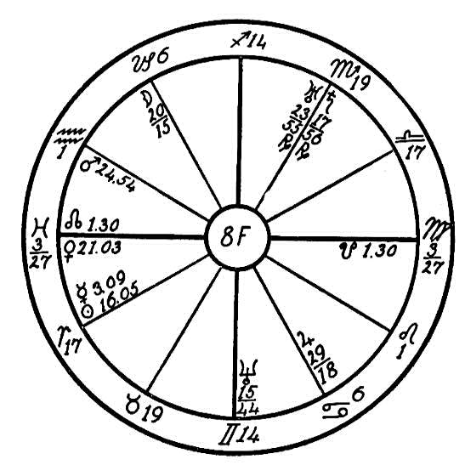
the senses and may destroy his love for the home, for Venus is also trine to the restless and romantic Uranus and the materialistic Saturn. These last named planets are retrograde and in the martial sign of Scorpio, governing sex. Mars, the planet of passion, is in the fixed sign of Aquarius, in the 12th house, that of self-undoing, and in square aspect to Uranus and Saturn. Saturn and Mars are in mutual reception strengthening the good or evil of these planets.
What do we find? It happens that this poor young man's weakness and love for women have attracted licentious and free-love companions, and the result is venereal disease which has poisoned the blood. An with Venus, the planet ruling the venous circulation, on the Ascendant and afflicted by the watery planet Neptune in the sign of the lungs, Gemini, quick consumption is the result.
In February, 1919, the progressed moon reached the conjunction of the radical Saturn, which brought on the lung disease. In July, five months later, when the man called upon Headquarters for healing, he was already in an advanced stage of galloping consumption. The following month, August, the moon made a square to the inflammatory Mars, which brought on hemorrhages.
Here we an see the influences of the planets, their causes and effects. The relatives of this young man did not understand why he should have contracted this disease of the lungs which worked so rapidly and was so destructive. With the affliction from watery signs, the soil was well prepared for the seeds which were sown through dissipation and thoughtlessness.
A case of this kind is very difficult to heal, for with the negative Pisces on the Ascendant, and Saturn and Uranus, the planets indicating impulse, yes, even stubbornness, in conjunction in Scorpio and square to Mars, all in fixed signs, it is very hard to guide such a person into safe channels. And we find both the lights afflicted, the moon in the saturnine sign of Capricorn, showing determination and stubbornness, square to the sun in the impulsive sign of Mars. Hence this young man would not listen to reason. He would do as he pleased regardless of caution and advice. A life in the open air with careful diet and pure surroundings would be the only cure; if he would listen to reason and adopt it he might get well.

NO. 8G--VENEREAL DISEASE
Male, born October 6, 1895.
Leo is on the Ascendant, and Jupiter is just above the cusp of the first house, making a square aspect to Saturn and Mercury in the sign of Scorpio. The moon in Taurus, its exaltation sign, is in the 10th house and in opposition to Uranus, which is also posited in its exaltation sign, Scorpio, ruling the generative organs. The moon so strongly situated will have the greatest influence over the young man's life and health. Being in opposition to the licentious Uranus, it will make him very free and unconventional in his love affairs, and he will be attracted to women of a low type. With the afflicted Jupiter ruling the arterial blood, and with Neptune in Gemini in the 11th house, the house of friends, in square aspect to Venus, which has rule over the venous blood, this young man is apt to be led into association with undesirable women friends. As a matter of fact they are responsible for his contracting a severe case of syphilis which poisoned the blood.
In 1914 we find the progressed sun in the first degree of Scorpio, and the progressed moon in the sign Aquarius forming an opposition to the Ascendant and the radical Jupiter in Leo. It is also coming up to a square of the radical Saturn, Mercury, and Uranus in Scorpio. In this same year two new moons afflicted the three latter planets. The one on January 26th fell in five degrees of Aquarius in opposition to Jupiter and square to Saturn and Mercury. On April 25th the new moon fell in four degrees of Taurus, square to Jupiter and opposition Saturn and Mercury. This was the time when

Birth Chart No. 8G

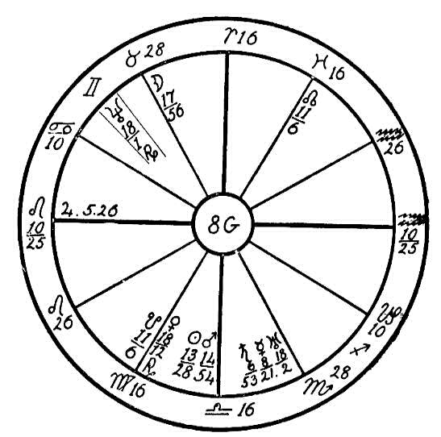
the venereal disease was contracted.
In 1918 the sun by progression formed a square to the radical Jupiter in Leo, and in 1919 a conjunction with Saturn in Scorpio. In the latter year, however, the progressed moon trined the Ascendant, and on May 29, 1919, an eclipse of the sun in seven degrees of Gemini sextiled the Ascendant. These vibrations no doubt saved the young man's life during the adverse aspects of the progressed sun.
In 1921 the progressed sun came into conjunction with the radical Mercury. On April 22nd the full moon eclipse fell in two degrees of Scorpio opposing the transiting sun and Venus. At the same time the transiting Mars was within orb of a conjunction with the radical moon and in opposition to Uranus. In the spring of that year the young man submitted to an operation for an abscess under the diaphragm, which after being opened was a very long time in discharging, necessitating a drain tube. The doctors claimed that the pus was from the lungs, but the patient denied ever having had trouble with these organs. The horoscope shows, however, that the doctors' diagnosis was correct, for Neptune in Gemini, ruling the lungs, afflicted by a square of Venus from the common and earthy sign of Virgo, would obstruct the delivery of the venous blood to the lungs, causing poor oxygenation. With the blood stream polluted by the dread disease of syphilis and with both the arterial blood (ruled by Jupiter) and the venous blood (ruled by Venus) obstructed, the weakest organ, the lungs, would naturally receive the poison generated in the blood.
After the patient had somewhat recovered from the operation he returned home. On April 25th, he was taken back to the hospital (that was three days after the total eclipse of the moon in Scorpio) with what at first was termed a case of mumps. The throat, jaw, and larynx were very much swollen and inflamed. This condition was later diagnosed by some of the doctors as actinomycosis, an infectious, chronic disease of cattle, sometimes transferred to man. But there was a difference of opinion among the doctors. Some held that the disease was cancer.
As the moon is the most heavily afflicted planet in the natal chart, naturally when by progression in 1922 it reached the opposition of the radical Saturn and Mercury and the square to Jupiter from the 10th house and the sign of Taurus, the disease reached a stage where the body could no longer rid itself of the poisons which had been stored up during eight years. There were two new moons in 1922 which helped to bring about the crisis. On January 27th the new moon fell in Aquarius, seven degrees and eighteen minutes, opposing the radical Jupiter and square to the radical Saturn and Mercury. On April 27th the new moon fell in six degrees and nine minutes of Taurus, square to Jupiter and in opposition to Saturn and Mercury. All these afflictions were from or reacted upon the signs of Taurus and Scorpio. The tonsils, the larynx, and the throat therefore received much of the pus generated in the body. The result was death.
Had this young man, after he contracted the disease, lived a life of abstinence from rich foods, tobacco, meat, liquor, etc., he might have overcome it and perhaps have lived for a number of years. But the poisons which were lodged principally in the lungs were increased by more impurities generated through ignorance of diet.

NO. 8H.--UTERINE TROUBLE
Female, born July 29, 1881, 6:00 P.M.
Capricorn, the Saturnian sign of the cardinal quadruplicity, is on the Ascendant, and the ruler, Saturn, is in the 4th house, that of the home, in the determined, stubborn, persistent sign of Taurus, making a square to the life-giving sun, in the fixed sign of Leo ruling the heart. This has a tendency to obstruct the life forces. The vitality is low, the heart action sluggish, especially as we find Jupiter, the planet ruling the arterial circulation, afflicted by the conjunction of the fiery Mars. This is a latent condition which will give the native much greater trouble after she has reached the period of menopause. Her restricted heart action will then be more troublesome than before.
When she called upon Headquarters for healing in the early part of 1914, the progressed moon had reached the opposition to the afflicted planets in the 4th house in Taurus. The doctor who had been treating her for catarrh of the stomach and nervousness failed to benefit her. She was very skeptical and did not believe in spiritual healing, but friends who had been by

Birth Chart No. 8H

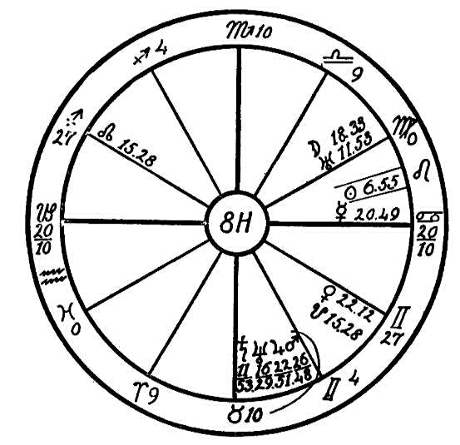
the Invisible helpers persuaded her to write to Headquarters for diagnosis. She did not ask for healing, but only wanted to know what was the matter with her physically, stating that the doctor could not understand the cause of her general poor health.
In our diagnosis we told her that she had not developed normally. With the obstructing Saturn conjunction Neptune in the sign of the throat, trouble was indicated at puberty, also restricted menses, adenoids, and inflamed tonsils. This had a reflex action in the opposite sign of Scorpio, which rules the generative organs, showing that these organs had never become fully developed. Neptune has this tendency when afflicted, especially in the sign of Taurus or Scorpio and in conjunction with or opposition to Saturn. Then the generative organs are underdeveloped, and childbirth becomes very severe and painful. This woman had four children, and at each birth her life was despaired of. The result was uterine trouble.
A tendency to catarrh of the small intestine is also indicated, for we have the moon, the ruler of the sign Cancer, the stomach, placed in the sign Virgo, the small intestines, conjunct the spasmodic Uranus, showing that there was spasmodic action of the intestines and that the food was not properly assimilated. This aspect also interfered with the digestion of food in the stomach, as the moon is the ruler of that organ; this was aggravated by a square of the moon to Venus.
Uranus in conjunction with the ruler of the 7th house, the moon, shows inharmony in marriage. The husband as indicated by this aspect is of a very nervous, irritable nature, fond of drink (Venus square moon). A separation is shown. This woman acknowledged that she had had trouble with her husband, that he had left her suddenly, and stated that she was compelled to support her four children. One with Saturn, Neptune, Jupiter, and Mars in Taurus afflicting one another has a tendency to be critical and severe in the home, but at the same time of a very frugal, hardworking nature, not saving oneself but always working beyond one's physical strength.
Due to the conditions noted this woman had become a broken-down, nervous wreck, with severe uterine trouble and catarrh of the stomach and intestines. She was not able to do a full day's work. Inside of two months, however, through the aid of the Invisible Helpers she was able to take a position, and she became a healthy, happy woman. We advised a rational, careful diet, eliminating all liquids with meals, for one with the planetary conditions noted likes to drink a great deal during meals. This is often dangerous to one with poor assimilation, and where there is a lack of digestive fluids in the stomach and intestines.

NO. 8I.--CHILDBIRTH
Female, born June 3rd, 1884, 9:00 P.M.
It is evident from the figure that the native is of a very nervous, restless temperament, for Mercury, the planet which rules the mind and the nerves, is in conjunction with its higher octave, Neptune; this makes her very high-strung. Then we find Saturn, the planet of obstruction, conjoined with the life-giving sun in the mercurial sign Gemini. This diminishes the vital solar life currents which feed the nerves, so that instead of assimilating a great among such as is necessary to feed the nerves of a high-strung person, she gets less than the normal amount and therefore is "on edge" and run down. Add to this that Mars, the planet of passion, is square Mercury, the planet of mind, which makes her temper very short, and that the moon, ruler of the imaginative mind, is square Venus, the planet of love, and you will understand that this person is very unhappy and always out of patience with her condition and environment.
Her trouble is due to the after effects of childbirth. The astrological figure gives a very good description of the case. Mercury is conjunct Neptune in the fifth house, which governs children, indicating an abnormal condition. The planet of parturition, the moon, is in mutual reception with and square to Venus. Mars in the eighth house, which indicates the manner of death, is square to Mercury in the fifth house, ruling children, which shows the use of instruments, loss of blood, and a great shock to the nervous system in childbirth. She must have been near the door of death at that time. But while Saturn conjunct the sun saps the life forces, he also

Birth Chart No. 8I

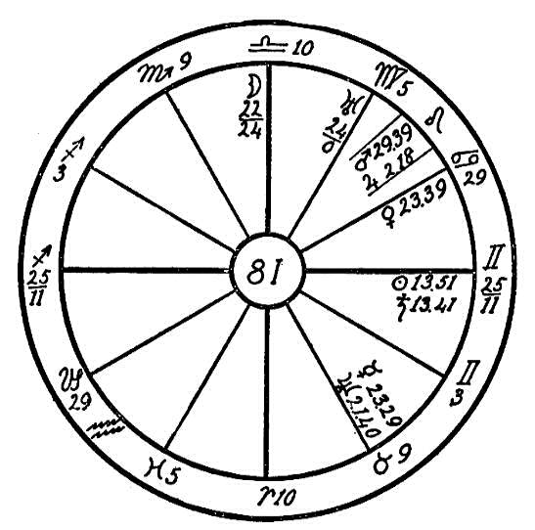
imparts a tenacity of life. Such people, unfortunately for them, do not die quickly; they linger in their agony, an almost unbearable burden to themselves and other who must perforce live with them. No one is more to be pitied. But the long years of invalidism shown by Saturn conjoined with the sun in the sixth house, must be necessary to impart to the soul some quality it lacks and has refused to cultivate in other and easier ways, otherwise our Father in Heaven would never have taken such strenuous means to teach her the lesson.
From the healer's standpoint a case with Saturn and the sun conjoined in the sixth house is almost, if not quite, hopeless, especially if there is a fixed sign on the cusp, for the patient will be antagonistic, skeptical, and recalcitrant to such an extent that he may more than neutralize all efforts to aid nature in restoring harmony. The principal work should be directed to cultivate in this patient a right understanding of the spiritual cause of her condition. If she can be brought to pray for light to see the lesson and for a chance to correct her mistake, whether in a past life or the present one, the changed attitude of mind will cause a change in her condition so that either a cure will be effected or a speedier release found in death.
In the meantime such a person should be given food that will supply ether to feed the nerves. Milk, warm and fresh from the cow, has this in abundance, and so have uncooked vegetables. Under the Law of Compatibility a healer with Aries or Leo rising whose Saturn is not in Gemini, would be best for this person.

NO. 8J.--ABORTION
Female, born February 7, 1866, 3:30 A.M.
Sagittarius is on the Ascendant in this chart. On page 133 of The Message of the Stars it states that this sign produces two distinct classes, the high and lofty type which aims its arrow at the stars, and the type which responds to the animal instincts and indulges the animal desires. The latter type will not think of the future. Like a child it will enjoy itself to the fullest, living only from day to day, never laying aside anything for a rainy day. Give such a person a million dollars and he will become a pauper in spite of it. His greatest enemies are his own appetites.
In the horoscope which we have under consideration we find the ruler, Jupiter, in the sign of his fall, Capricorn, in the first house. Jupiter is also conjunct the fiery Mars in its exaltation sign of Capricorn. This gives Mars greater power for evil than otherwise. Planets have a reflex action and often affect the signs opposite them, as in this case where the sign Cancer receives the effects of Mars conjunct Jupiter. These planets denote bulk, and when affecting the sign of Cancer the person is apt to make a god of his stomach. His food must be of the very best, rich and highly seasoned.
The ruler of Cancer, the moon, is afflicted in the fixed sign Scorpio (which has rule over the generative organs) by a conjunction of Saturn and a square of Venus and the sun. The moon is the planet of fertilization, of impregnation, and when found in the sign of Scorpio in a woman's horoscope it is an indication that she will be apt to have several children. But when

Birth Chart No. 8J

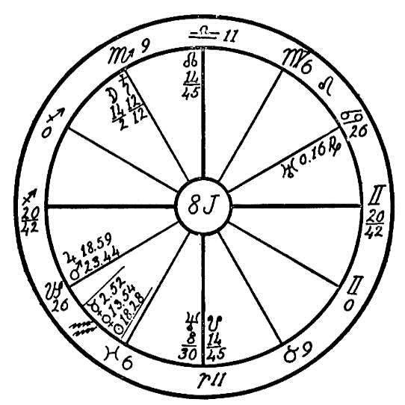
the planet of obstruction, Saturn, is also in this sign and afflicted, the organs of generation are sometimes undersized, as in the case of this woman. During the birth of her first and only child she was three days in labor, suffering greatly. This left her with a great fear of childbirth, led her to resort to abortion, the most dangerous and vicious of practices. Due to the moon in Scorpio conception was frequent, and the native's great fear caused her to employ means which destroyed the fetus. In the eyes of God she became a murderess. The continued abuse later enveloped into a most dangerous case of blood poisoning, which left her broken in health, a confirmed invalid.
Because of the rich food in which she had for years indulged, her system was overcharged with poisons, and since Venus, which has rule over the venous blood, and Jupiter, the arterial, were both afflicted, all the impurities were attracted to that part of the body where these planets were located, Capricorn and Aquarius. Sluggishness of the body is always found in the parts corresponding to the signs in which Venus and Jupiter are afflicted. There the ash is usually deposited. This woman was unable to walk for five years before her death, which occurred in February, 1920. We have not been able to ascertain the exact day of her death. We find the progressed moon in February making a square to the radical Venus. The progressed aspects alone, however, would not cause death. We must look for the exciting planets, the transits. The full moon on February 4th fell in 14 degrees and 16 minutes of Leo in opposition to the radical Venus and sun and square to the radical Saturn and moon. These aspects, we think, were responsible for the native's demise.
How wonderfully accurate is diagnosis by the planets! Each time this woman passed through a severe illness, which was quite frequently, her relatives would report that it was a case of peritonitis. We find, however, no affliction to the small intestines, but very severe afflictions to the generative organs.

CHAPTER XX

THE SPINE
NO. 9A.--SPINAL TROUBLE
Female, born June 21, 1899, 5:30 A.M.
This horoscope is the figure of a young woman who is the daughter of wealthy parents, as shown by the sun, which is ruler of the second house, trine to Jupiter. We will first consider the mental caliber, as that is the prime consideration in dealing with anyone. The sun is in the twelfth house showing that the spirit in a certain sense is imprisoned. The sun is in conjunction with the Dragon's Tail, which has a saturnine influence and tends to further obstruct. These conditions rob life of its joy and fill the soul with melancholy and fear, gloomy forebodings, and thoughts of impending evil. Mars square to the moon, which is the life ruler, shows rebellion against this condition. The square of Mars to Venus, however, adds to the tendencies which rob life of its satisfaction. The trine of the sun to Jupiter and the sextile of Mars to the sun, Mercury, and Jupiter are mitigating influences which give some light and life to this poor soul's existence. The comforts procured through the wealth of parents as indicated by these aspects help to make life more tolerable than it would otherwise be.
With regard to the health denoted in this figure, we find in the first

Birth Chart No. 9A

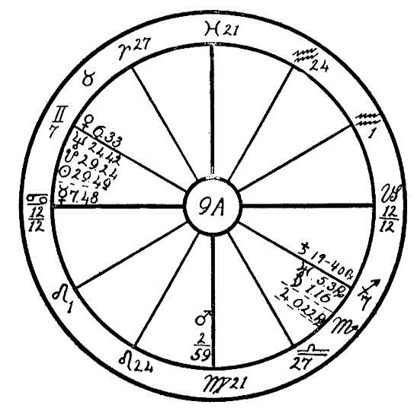
place Cancer, a weak sign, on the Ascendant. Four planets are posited in the twelfth house, which in this case denotes confinement upon a sick bed. Saturn, in the sixth house, which has to do with health, is a sufficient indication that this will be a life of suffering. Saturn, the principal significator in this respect, shows that the ailments will be deep-seated and chronic. The moon, which is the peculiar significator of health in a woman's horoscope, is within six degrees of the sixth house cusp, adding its testimony in the same direction. Mars square to the moon near the sixth house renders the native liable to operations. The sun conjunction the saturnine Dragon's Tail in the twelfth house makes such operations exceedingly dangerous for she has not the vitality wherewith to withstand and recuperate. Moreover, the sun in 1914 had progressed within orb of a parallel to Saturn at birth. Thus the native had at that time less vitality than she had had in earlier years. As the moon came into opposition to Saturn in the sixth house in October, 1913, we may well conceive that the condition at that time became critical.
Mars governs the muscles and the motor segment of the spinal cord. He is square to the moon, which governs the sympathetic nerves, and also square to Uranus, which causes spasmodic movements. Thus it is evident that the nerves are affected and that the young lady has no dependable control over her limbs. Neptune governs the spinal canal, and it is opposite Saturn, the planet of obstruction. This configuration occurs in the signs of Gemini and Sagittarius, and in the sixth and the twelfth houses. It is therefore evident that there is trouble in the spine--obstruction, as denoted by Saturn.
The obstruction will be found in the region indicated by the conjunction of Neptune, Sun, and Dragon's Tail in 24 to 29 of Gemini, namely, the dorsal region. The doctors have been unable to diagnose this case, and sad to say, it is incurable by any physical means. There is only one method, namely, the dilation of the spinal canal by repeated manipulations FROM WITHIN of the materialized fingers of the Invisible Helpers. As the young woman has not applied to us for healing, we are sorry to say that we cannot touch her case; but were it submitted to us, we should advise a healer having Scorpio rising and with Saturn neither in Cancer nor in Sagittarius, letting the healer put himself under the direction of the Elder Brothers, who would then do the work.

NO. 9B.--SPINAL TROUBLE
Male, born February 1, 1918, at 12:30 A.M.
We have here the horoscope of a boy who has fixed signs on all four angles and the martial sign of Scorpio on the Ascendant. Our first thought when looking at a horoscope for the diagnosis of disease is to find if there is strength of will so that the patient will be able to give the needed assistance to the healer, for if he has persistence to fight for his life, if he will follow the instructions given by the healer, then the healer has some cooperation and the task is not so heavy. The task is doubly hard, however, in the case of a patient who has Saturn elevated in the 10th house, conjunction with Midheaven, square the Ascendant, and with the stubborn sign of Scorpio on the Ascendant. To effect a cure against the stubborn will of such a patient might truly be classed under the head of miracles.
As a rule we look to the strongest malefic planet when diagnosing from the horoscope. Here we find the obstructing and restricting Saturn in conjunction with the Midheaven, also conjunction and parallel Neptune and in opposition to the life-giving sun. Saturn is in the sign of the sun, Leo, and the sun is in Saturn's sign, Aquarius. When planets are in mutual reception, i.e., have exchanged signs, as we find Saturn and the sun in this horoscope, and especially when they are also in angles and fixed signs, then we may expect a most stubborn and deep-seated cause of disease.
We are told on page 619of The Message of the Stars that Leo rules the spinal cord, and on page 566 of the same book that Neptune rules the spinal

Birth Chart No. 9B

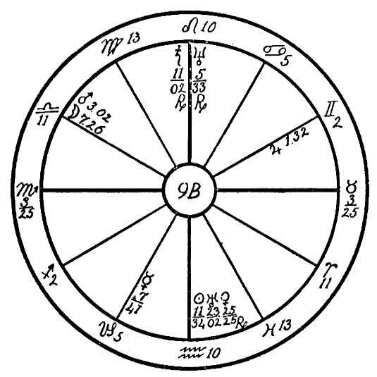
canal. In this horoscope we find 10 degrees of Leo occupying the cusp of the 10th house and the life-giving sun in opposition to Neptune, Saturn, and the Midheaven. Can we find a more pronounced affliction than this, especially with Leo ruling the spinal column and Neptune the spinal canal, the latter of which is filled with the spinal spirit fire, the life of the Father?
When we find this spirit fire obstructed by Saturn and the sun, we may conclude that this affliction is the result of serious wrongs committed in previous lives. The wasting of the vital fluids, the abuse of the generative faculty, is a sin against the Holy Ghost and brings to the Ego the most severe punishment, as in the case of this boy who was drawn to parents who were fit instruments to give him a body which would cause the spirit to suffer for past sins. And what a pitiful future faces him! He has never walked nor talked. He must be fed, and he has positively no use of his body whatever.
The question may be asked, Is there any hope for this boy? Yes, to a certain degree. The planet of reason, however, is weakly aspected by only a semi-sextile to the sun and Uranus: therefore we may expect little help from this quarter of the horoscope. But Mars, which is the ruler of the Ascendant and the sixth house, both ruling the health, is the strongest and best aspected planet in the horoscope. Mars is in the 11th house in Libra, in conjunction with the moon, trine to Jupiter; and we may also say that Mars is sextile to Saturn although seemingly out of orb, for Saturn is retrograding and therefore throwing his influence towards Mars. Also we may expect that Mars will receive some help from the life giving sun, the sun's orb being larger than that of other planets.
When a patient has fixed signs on the four angles and a well aspected Mars, he will make a greater effort to overcome than one who has not these influences. This boy should be placed in the home of a nurse who has Scorpio or Aries on the Ascendant, and away from the parents, for the home, under the rule of the Father, is no place for him. With this change and proper care he might be able to gain at least partial control of his body and be able to walk and feed himself; but he will never be very bright mentally, and will always to some extent be a charge to his parents.

NO. 9C.--TUBERCULOSIS OF THE SPINE
Female, born March 17, 1889, 7:04 A.M.
The fiery and martial sign of Aries is on the Ascendant, with Mars, the ruler of the horoscope, in its own sign in the 1st house, giving great energy and impulse. Mars also in opposition to the erratic Uranus will make this young woman unable to use moderation in anything. But she will be like a skyrocket which is sent with great force into the air; as soon as it has spent its energy it falls back to earth dull and lifeless. With the life-giving sun, the ruler of the 6th house, sickness, in the negative and watery sign of Pisces, and posited in the 12th house in opposition to the watery moon which is in the house of sickness and in the earthy and common sign of Virgo, this woman has not sufficient vitality to keep up with the impulse of the double fiery influence on the Ascendant and is soon depleted in strength.
Mercury is sextile to Mars from the mental and fixed sign of Aquarius. This makes the native very quick and active mentally, but whatever she becomes interested in she takes up with such force that the nervous system suffers. This is increased by Mercury square to its higher octave, Neptune, in Taurus.
The sun afflicted and intercepted in the 12th house in Pisces, would indicate a very unhappy and restricted life in early childhood. And as the moon, ruler of the 4th house, the home and the mother, is afflicted, it would indicate that much of the restriction will come from this direction.
We are told in the Rosicrucian teachings that we are building the archetype in this life of the body we shall inhabit in a future life, and

Birth Chart No. 9C

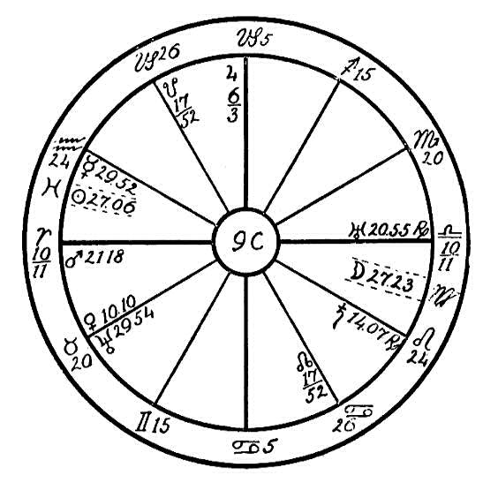
that we are attracted to the parents who are physically, mentally, and morally able to supply us with such a body. In this case this young girl was attracted to a mother who was selfish and neurasthenic, for the afflicted Moon in Virgo in the 6th house would represent the mother. The moon also afflicts the small intestines, giving poor assimilation of food, which lowers the vitality. We find Saturn, the ruler of the 10th house, representing the Father, square to Venus in her own sign of Taurus, ruling the throat and palate, which indicates that the Father was fond of the wine cup; he was, in fact, a drunkard. This would corroborate the indications, shown by the afflicted sun above the Ascendant, of a hard life with many privations in childhood.
Now let us see how the afflictions between Saturn and Venus would affect the health. As Leo is the sign ruling the heart and the spinal cord, Saturn, the restrictor, when placed in this sign, square to Venus which rules the venous blood, causes a restricted circulation. It is stated in The Message of the Stars, page 555, that Saturn in Leo gives a tendency to curvature and disease of the spine. The physical body is the crystallized counterpart of the finer vehicles. The vital body holds the physical atoms together. This vital body, which is ruled by the sun, surrounds and interpenetrates the physical. If the sun in a person's horoscope is afflicted, the vital fluid is obstructed and the vital body becomes diseased, as this invisible force gains its entrance through the spleen which is also ruled by the sun. Therefore, we can readily see that the vital fluids were obstructed from childhood.
This young woman's case was diagnosed by the doctors as tubercular disease of the spine, Potts' disease. In December of 1918 and January 1919 she had severe attacks of inflammation of the spine and has had several spinal operations.
It will be very difficult to heal this patient on account of her great impulsiveness and the wasting of vitality. With sun and moon afflicted in the 6th and 12th houses, she will dissipate her strength and will rebel at restraint.
She has Venus in the 1st house in Taurus, trine to Jupiter on the cusp of the Midheaven. This with Neptune in Taurus sextile to the sun should give wonderful musical ability and the faculty of writing and improvising music. The impaired physical body and consequent suffering will soften the nature and bring out the spiritual side. Neptune is making a trine to the moon as a result of which this girl could develop talent for the inspirational and spiritual side of music which would bring wonderful soul growth. This soul will make greater spiritual progress in this one life of suffering that she could in three ordinary lives with perfect health.

NO. 9D--E: INABILITY TO WALK
Male, born January 18, 1919, 12 Noon.
In this lesson we will try to show how a doctor, who can only observe from outward and physical signs and who depends for his diagnosis upon symptoms only, can err in his diagnosis, and how the science of astro- diagnosis proves that functional weakness is shown even at birth. "A chain is as strong as its weakest link," is a proverbial expression, and so it is with the physical body. We may go along smoothly for many years, seemingly in good health, when suddenly something goes wrong, a link begins to weaken; the strain which we have been putting on our physical body causes this weak place to give way.
This horoscope is that of a boy with the fixed sign of Taurus on the Ascendant, and with the sun in Capricorn on the cusp of the Midheaven. The life-giving sun, however, makes only a semi-sextile to Mars and Uranus, besides its conjunction with the Midheaven, therefore the boy cannot expect a great amount of help from this planet. We find Uranus in its own sign of Aquarius, elevated in the 11th house, in conjunction with and parallel to the dynamic Mars, and in opposition and parallel to the obstructive Saturn, which is in the fixed sign of Leo and in the 5th house. We also find the moon in the same sign, in conjunction with Saturn and in opposition to Mars and Uranus.
We are told in The Message of the Stars, page 555, that Saturn afflicted in Leo gives a tendency to spinal diseases and sclerosis of the spinal cord. The moon has rule over the synovial fluid, and with its affliction by Saturn, which has rule over the bony structures and the

Birth Chart No. 9D

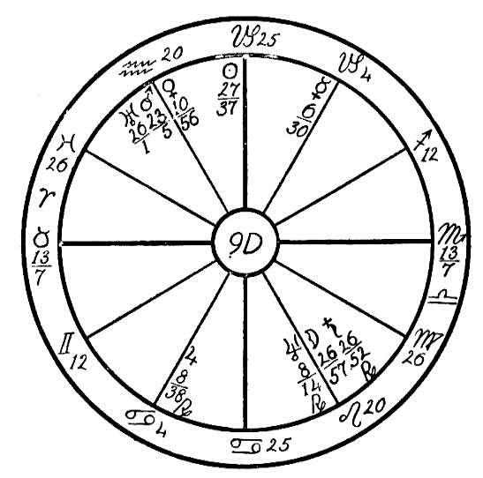
ligaments, and with the moon and Saturn both in the sign of Leo, which has rule over the spinal column we may expect that the seat of the trouble will be found in this latter region. Saturn dries up and causes atrophy. Therefore we may diagnose this case as a lack of synovial fluid to lubricate the vertebrae of the spine, also a loss of strength in the ligaments which connect the spinal bones.
The result is that this child while healthy and well formed, seemingly in moderate health, still was unable to bear his weight on his legs. He would draw them up Each time that the nurse attempted to teach him to stand. This affliction, which comes from fixed signs, will be a most difficult one to overcome unless a miracle is performed through spiritual healing, although by patient manipulation with olive oil over the spinal region and a careful vegetarian diet the child may be helped to a very great extent.

NO. 9E.
Male, born December 13, 1868.
This horoscope leads to a very different diagnosis. Having no hour of birth we use a flat figure. We find in this case also the moon in

Birth Chart No. 9E

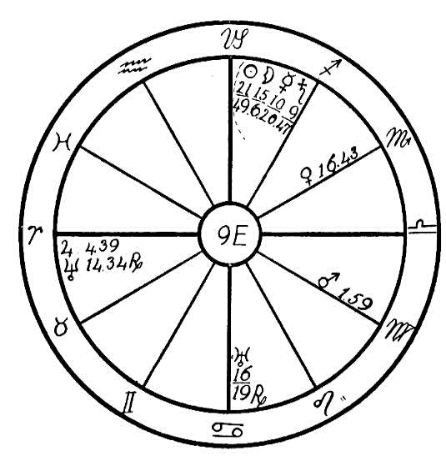
conjunction with the obstructive Saturn, but in the sign of Sagittarius ruling the hops. Saturn is in conjunction with and parallel to Mercury, and square to Mars. In 1914, after a spell of typhoid fever, this man was unable to walk without crutches. He could not stand without swaying. The doctors believed this weakness to have its seat in the spinal cord, while astrology diagnoses it as a drying up of the synovial fluid of the hip joints. When the weight is put on the pelvic region by standing, stooping, or by any strained position, the pelvic bones slip out of position and in turn press on the sciatic nerve, which controls the sacral plexus and the limbs. A pressure on this nerve may cause what is termed paralysis of the lower limbs.
A case of this kind, however, is curable. A slight adjustment by an osteopathic physician or a chiropractor will eliminate the pressure upon the sciatic nerve. Here we may see what a vast difference there is between astro-diagnosis and medical diagnosis. The healer who has a knowledge of the planets and their effect upon the physical body may find a great difference in cases which may have the same outward or physical symptoms. Also a knowledge of body adjustment is often very helpful.

CHAPTER XXI

THE LIVER AND GALL BLADDER
NO. 10A.--THE LIVER
Male, born March 6th, 1831, 4 P.M.
This is the horoscope of a man with the fixed and fiery sign of Leo on the Ascendant, and the obstructing Saturn in Leo in the 1st house.
Whenever Saturn is placed in an angle, a fixed sign, or near the Ascendant, his influence is much more destructive than elsewhere, especially when in the sign of Leo, which rules the heart. Then we may expect that the person will be lacking in vitality. Especially so in the case of this man as we find Saturn in square aspect to the dynamic Mars, and Mars in its fall and near the cusp of the 10th house, where its destructive influence may result in the greatest amount of damage, particularly as we find these two afflicting and powerful planets in Leo and Taurus, two of the most powerful signs in the horoscope. These planets are of opposite natures; Saturn is cold and moist, while Mars is fiery, and dry. Consequently we may expect that the body will suffer as a result.
The sun, the ruler of the Ascendant, is posited in the 8th house, in the negative sign of Pisces, square to the moon. Here again we find an indication of depleted energy and lack of vitality.
Now let us see how these afflictions work. The 10th house indicates the

Birth Chart No. 10A

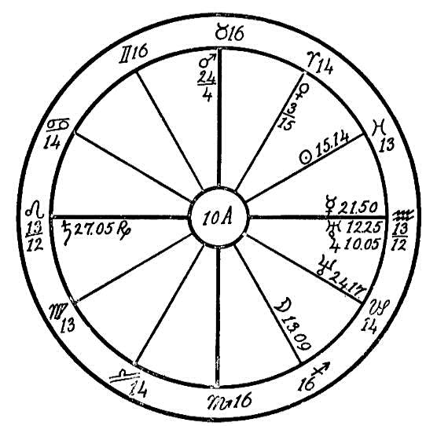
the Father, and Mars afflicted by a square to Mercury and Saturn, and in Taurus near the cusp of the Midheaven would indicate the death of the Father by accident. At the age of twelve years when the moon passed the Midheaven and the conjunction of Mars, the Father was killed by the falling of a tree, leaving the mother and three small children penniless. This forced the eldest boy, whose horoscope we are delineating, to help earn the wherewithal to live. He was placed as an assistant to a blacksmith in the neighborhood, and was compelled at the growing age of twelve years to do a man's work, wielding the heavy sledge hammer. As a result the valves of the heart were not fully developed. For years he suffered, and Each time he reached a state of financial success, his health would break, forcing him to give up and change to another climate for relief. Some doctors diagnosed his trouble as tuberculosis, others as asthma. He had all the indications of asthma, but these spells would come and go. Each winter while in the cold, eastern climate he spent some time in bed with pneumonia or congestion of the lungs.
Here we see the effect of the affliction of sun square moon from the two common signs of Pisces and Sagittarius. We find Mercury in the fixed sign of Aquarius, in opposition to Saturn and square to Mars in Taurus, the throat, which would give some tendency toward a nervous contraction of the trachea.
Now we have found the afflicting planets indicating valvular heart trouble and weak lungs, but the man died from an abscess of the liver. Where do we find the indication of liver trouble? Mars in Taurus is in his detriment. This planet is the strongest in the horoscope; in fact Mars may be called the life ruler. When in the sign ruling the throat, it gives a desire to tickle the palate and a thirst which often leads to strong drink. In this case we find Mars sextile to the sun and trine to Neptune. Neptune governs and sometimes predisposes to the use of drugs. This had its result in an abnormal desire for strong, black coffee. Instead of quenching his thirst with water, this man would drink cold coffee and in large quantities.
Mars in Taurus also gives an abnormal appetite, indicating one who is apt to gourmandize. With the lowered vitality on account of the affliction to the heart and poor oxygenation in the lungs, the native was unable to do manual labor, thereby being unable to work off the excess of food. Consequently the poor liver was worked over time and became a receptacle for the poisons created by the excess of food which could not be absorbed by the blood. Jupiter rules the liver; we find Jupiter in conjunction with and parallel to Uranus in the 6th house, sickness, also parallel to the moon. Naturally the liver would be sluggish and easily overtaxed.
If this man had lived normally, he could have reached a ripe old age in spite of the planetary afflictions, for with Mars elevated and sextile to the sun, with the moon sextile to Jupiter, and with fixed signs on the angles there is no reason why he should have passed out at the comparatively early period of middle life.

NO. 10B.--GALLSTONES
Male, born November 13, 1885, 8:52 P.M.
We will judge first the mental caliber so that we may be better able to deal with our patient, for the basic quality and trend of the mind have a great determining influence as to the way a person views sickness, and we must be prepared to meet his ideas in such a manner that we inspire confidence. Mercury rules the 3rd house, which governs the lower mind. Its parallel to Saturn, the planet of obstruction, curbs this flighty constituent of the personality and gives it depth, but this aspect also gives a tendency to look at the dark side of things; pessimism and melancholy are among its results. Mars in the mercurial sign of Virgo, square to Mercury, makes the native cynical and quick to anger.
Saturn in Cancer, the sign of the stomach, shows us that digestion is obstructed. His opposition to Venus and the square of both to Uranus in Libra show that the venous circulation is also obstructed, particularly that of the renal veins which carry the blood from the kidneys (Uranus in Libra), and that part of the portal system which carries the blood from the stomach (Saturn in Cancer), through the liver. Saturn rules the gall bladder, and his position in Cancer, square Uranus in the sign of the kidneys (Libra), shows the concretion of sediment in both of these organs. As brick is baked clay, hardened by heat pent up in the kiln, so this sediment is burned into gallstones and renal stones by the restraining action of Saturn when anger is kindled by Mars. Inward impotent rage and vindictiveness which wait for an opportunity to get even, the nursing of a grievance instead of letting

Birth Chart No. 10B

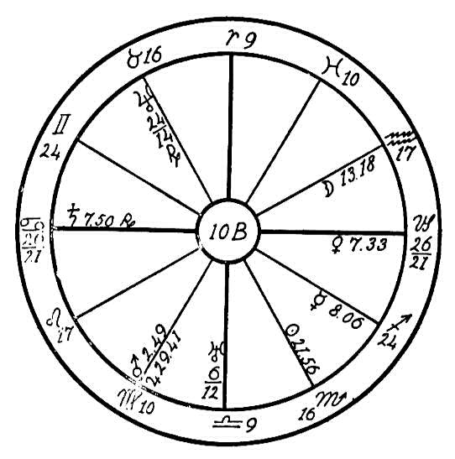
anger have vent and then forgetting it, harmful though that may be, are the true cause of one of the most painful maladies to which flesh is heir.
The trine of Jupiter and Neptune show the way of liberation through appeal to the higher nature, for there is a basic benevolence that may be invoked. Physical treatments can and must of course be given, but however effective they may prove for the time being, they are merely palliative, for until the patient changes his mental attitude there can be no real cure. Continued inward rage will form new stones to take the place of those eliminated or dissolved by the treatment. To thoroughly impress this fact upon the patient is the first duty of the astro-therapeutic health adjuster. The harm has been done in the present case, and cultivation of serenity can only act to correct. But if a configuration like this is noted in the horoscope of a child, we ought to warn the parents so that this trait of nursing wrath may be eradicated ere it gets a hold on the growing girl or boy. Prevention is always better than cure. It is not enough just to help people to regain health; our aim should be to teach them how to live in harmony with the laws of love and life that they may never be sick. Until we thoroughly realize this and practice it we are missing the greatest part of our privilege.
A person with Scorpio rising would be our first choice when selecting a healer for this case; one with Taurus would come next. But neither may have Saturn in the degrees of the signs included in the patient's 1st or 6th houses. The treatments, both mental and physical, should be given in the hour of the sun. Large doses of olive oil or copious draughts of hot water would be of great assistance.

NO. 10C--D: GALLSTONES
Male, born April 23rd, 1850.
No. 10C is the horoscope of a judge of the Supreme Court, whose hour of birth we could not ascertain, but from events in his life we judge that Capricorn would be on the cusp of the Ascendant. Although the writer never met this man in person, yet from indications in the home he was born some time near 9:30 or 10 P.M. This would place Jupiter and the moon in or near the Midheaven or the 9th house which would correspond with his character, for from reports of friends he was a very efficient and just judge. He had much inharmony in his home, which would be indicated by Saturn and Uranus in Aries in the 4th house, describing the wife as nagging and erratic. Saturn is square to Mars in Cancer in the 7th house, again showing inharmony and quarreling with the marriage partner.
The Judge was also greatly troubled through the weakness of an only son, who squandered his time in drink and immorality, spending his money on the opposite sex. This is shown by the position of Venus in the 5th house, governing children, also pleasures. Venus is very strong in the sign of Taurus, which rules the palate and it is also sextile to Mars in Cancer, ruling the stomach.
People with Capricorn rising and with the ruler, Saturn, afflicted have a tendency always to see the dark side of life and to brood over it, and when Saturn is square to Mars there is much temper but not of the explosive kind. Capricorn people cannot as a rule forgive and forget. Suppressed

Birth Chart No. 10C

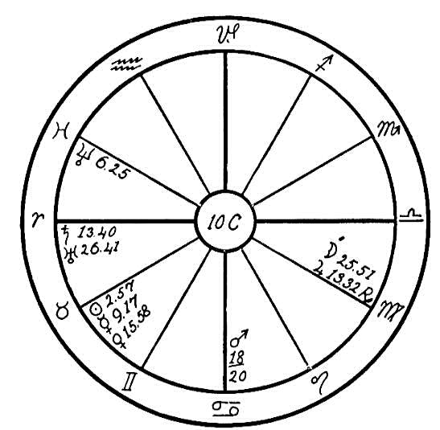
anger when continued for years will crystallize the bile in the gall bladder, which will have a tendency to form into small stones, causing intense pain while they are being eliminated. The Judge suffered from these stones for nearly twenty years. About 1894 the progressed Saturn neared an exact square to the radical Mars, which may have set the time for the beginning of the forming of these stones. This patient passed into the higher life on January 1, 1916, when the transiting Saturn had reached the square to its own place at birth.

NO. 10D.
Female, born December 14, 1855, at 10 A.M.
This is the horoscope of a woman who has Capricorn on the Ascendant, and the ruler, Saturn, is in the 5th house, square to the inflammatory Mars. We have noted from a number of horoscopes in our files of patients who have suffered from gallstones that they have had Saturn and Mars conjunction or square. Saturn in this horoscope is in the house ruling children, the 5th, and square to Mars in the 8th. This woman's troubles were caused by aggravations by the children of her husband's first marriage, the stepchildren. Note how clearly this is shown by Mercury and the sun in the 11th house, which rules stepchildren, square to Neptune, ruler of the 2nd house. Anger and inharmony arose in her home on account of her husband's finances, and as usual the Capricorn nature would not forget and forgive, holding resentment within until she paid the penalty in 1903 when she had the first attack of gallstones, followed by another attack fourteen years later, about 1917. The progressed moon was in Sagittarius in 1903 and in Gemini in 1917. The exact time of the illness is not given, but the opposition and the conjunction of the progressed moon with Saturn will no doubt register the exact time.

Birth Chart No. 10D

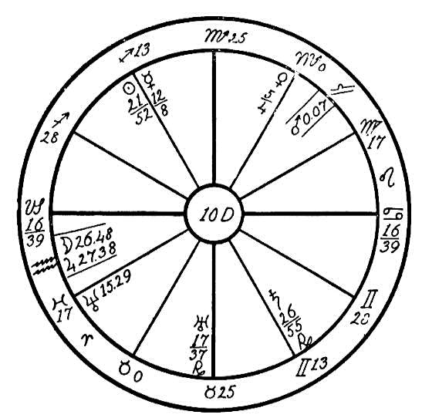
This disease is one of the most painful of afflictions. When the stones pass from the gall bladder, pressing through the tiny gall duct which leads into the duodenum, they often get partly through this duct but remain wedged in, causing intense suffering. A very safe and often most beneficial remedy is to have ready one-half cup of olive oil and the juice of one lemon. Set the alarm clock to go off at 3 A.M.; at that time drink all of the oil followed by the juice of the lemon. Refrain from eating breakfast, and eat very little during the day. Repeat this for three nights in succession, and the third morning take a cathartic. A tablespoon of Epsom salts has been used by some with excellent results. If this does not eliminate the gallstones, try the remedy again about two or three weeks later.

CHAPTER XXII

THE CIRCULATION
NO. 11A.--PALPITATION OF THE HEART
Female, born April 24, 1862, midnight.
The Ascendant in this chart is occupied by the Saturnine sign of Capricorn, with Saturn, the ruler, intercepted in the 8th house. When we find the life ruler so weakly situated and afflicted, we may look for a person who is very likely to become a victim of circumstances, instead of being victor; one who will allow the planets to rule her instead of her ruling the planets. Where Saturn is afflicted in the house of limitations, the native is very gloomy and always looks at the dark side of life, and if he suffers physically, he is very apt, like the Virgoans, to give in to the disease. Wherever Saturn, the plant of obstruction, is posited in the horoscopes, we may look for trouble. In this case we find him in the sign of Virgo, ruling the small intestines, and in conjunction with the planet Jupiter, which rules the arterial circulation. Jupiter also has rule over the adrenals. The secretion of these glands is necessary to give tone to the blood, and when restricted by Saturn we may expect that the arterial blood will be disturbed.

Birth Chart No. 11A

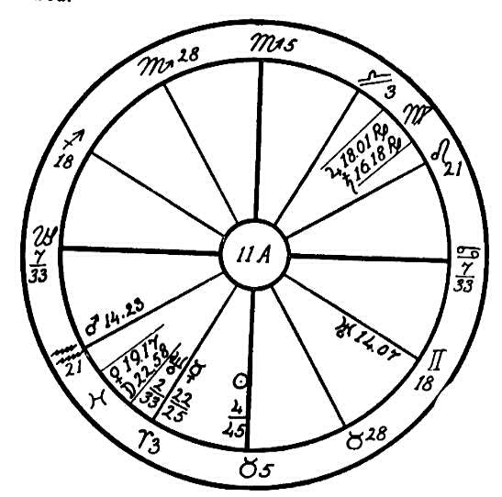
But we do not judge by Saturn and his influence alone. We find the planet Venus, ruling the venous blood, in conjunction with the moon, which has rule over the synovial fluids, the lubricants of the body. Venus and the moon are in opposition to Jupiter and Saturn. What would be the effect upon the body of the afflictions of the above four plants? Due to the restricting influence of Saturn we may expect trouble with the arterial circulation. With the venous blood also restricted there is no freedom to the blood flow, and the effect is the same as that of a stagnant stream of water which becomes muddy and full of poisonous weeds. We may expect the blood to become polluted and stagnant.
We extract a certain amount of minerals from our food, which while we are children can all be utilized to build bone; but after we have reached our full stature and the body can use little of this mineral matter for its growth, if taken in excess it then deposits in the joints and blood stream, clinging to the surface of the little blood vessels in the same manner that it does on the inside of a teakettle. If the circulation is good and the blood has freedom to flow through the arteries and veins in a natural manner, this deposit is very slight; but in old age or when circulation is impaired, this mineral is deposited in the blood and causes what is commonly known as sclerosis or hardening of the arteries. In this case the walls of the blood vessels are covered with a deposit of hard mineral substance, consequently the blood flow is impeded; the muscles and joints become stiff and sore, and gradually as this condition becomes chronic the person loses the use of arms and limbs and chronic invalidism is the result.
In this horoscope we find both Jupiter and Saturn posited in Virgo, ruling the small intestine. This small tube, although it is between 20 and 25 feet in length, is coiled in a small space in the abdominal region. It is lined with mucous membrane and small tongue-like vessels that assist in digesting and absorbing the food elements, afterwards distributing various minerals extracted from the food into the white and red fluids of the body. If the mucous membrane and these villi of the intestines are obstructed by Saturn, as in the case of this woman whose moon is also opposed by this afflicter, then the secretion of lymph and chyle, the white fluids of the body, is obstructed, and in addition, the blood receives little nourishment.
The woman suffers greatly from palpitation of the heart, headaches, high blood pressure, and a constant pain in back and limbs. When the blood has become sluggish and filled with ash it stands to reason that the heart must suffer, for when through undue excitement or anger an excess of blood is drawn to the heart and the clogged condition of the blood vessels prevents it from freely leaving this central station, palpitation, high blood pressure, rush of blood to the head, and various other afflictions naturally result.
Now, what can we give as a remedy for such a condition? First of all we would advise a simple and very light diet with very little starch, less sugar, but more of raw onion, lettuce, spinach, etc. Always keep the bowels free, and give the body a dry rub with a pair of bath mitts each morning on arising and at night before going to bed. Unfortunately, a woman with the sun aspected, as in this case, except by a semi-sextile to Neptune, and with afflicting planets in Virgo and Pisces will not make the effort to get well. It is so much less trouble to drift into invalidism.

NO. 11B.--SLUGGISH CIRCULATION AND CATARACTS
Female, born April 9, 1851, 1:58 A.M.
We first judge as usual the mentality of our patient. Aries, the sign of the head, has more planets than any other, and two of these are malefics. Even if this were all it would be unfortunate and an indication of unfavorable characteristics, but the affliction of Saturn in Aries to the sun, moon, Mercury, Uranus, and Jupiter tell us this is a subtle and untrustworthy person, who is sadly indifferent to moral obligations of truth and justice. Nor is it to be wondered at that such pronounced mental characteristics should produce a marked effect upon the bodily functions, especially as the afflictions are all from cardinal signs.
Saturn, the planet of obstruction, makes the native subtle and cautious mentally by his conjunction with Mercury and square to the moon, and also protects her from being "found out." This same configuration obstructs the flow of nerve force, and thus causes a clogging of both the voluntary and sympathetic nervous systems, which are ruled by Mercury and the moon

Birth Chart No. 11B

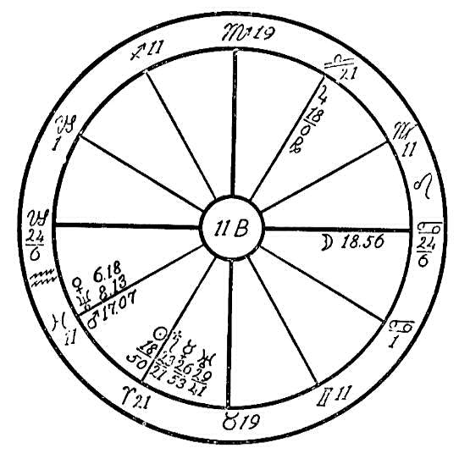
respectively. Saturn's principal field of activity will be found in the pneumogastric nerve, which is normally saturnine and suppressive in its action upon the heart, stomach, and other vital organs. The conjunction of Saturn with the sun is aggravated by the fact that they are in parallel, situated in the first cardinal sign, Aries, ruling the head, square to the moon in the second cardinal sign, Cancer, which rules the stomach, and in opposition to Jupiter in the third cardinal sign, Libra, which rules the kidneys. Were it not for the trine of Mars to the moon and the placement of the sun in its exaltation sign, Aries, it would be difficult for life to be sustained in this severely afflicted nativity.
This person is afflicted with sluggish circulation, indigestion, and nervous constipation on account of the planetary afflictions mentioned, still this is far from the worst trouble. The conjunction of the planets in Aries, the head, and their opposition to Jupiter, which rules the arterial circulation, show plainly how the nerves and blood vessels are clogged in that most important part of the body, the head. As a consequence there is a dearth of material with which to build up the various organs, and an accumulation of waste. We all know that a bad stomach reacts on the eyes, and when we consider the effect of the sun and Saturn in Aries square to the moon in Cancer, we see that it is small wonder that both eyes are afflicted with the saturnine obstruction known as cataract.
A Taurus healer would be best fitted to handle this case, and it should be made very, very plain to the patient that frankness and strict adherence to truth are an absolute necessity for recovery. Even if resented at first, a kindly statement of the fact of the opposite fault and its effects will probably bring a change. A religious attitude of mind will loosen the tension of nerves, allowing the bodily functions greater freedom. Uncooked food should be given in as large a measure as the patient will allow, for its ether is necessary to build up the nerves. Onions are prime builders, and pineapple is unrivaled as a digestive stimulant. But in this case physical factors, though of vital importance, pale into insignificance in comparison with the benefit that will be derived from a proper appreciation of the moral factors that have caused the disease, and a realization of the imperative necessity of altering the trend of mind before any permanent relief can be experienced. Nor should the healer despair and feel that this is a case analogous to that of the leopard changing its spots, for the afflictions are from cardinal signs and therefore movable. It requires thought and energy to plan how to deceive successfully, and this energy if turned to good, will be a factor of equal power in bringing the light of truth into the patient's life and letting it shine for others.
(The above was the diagnosis of this case in 1915. The outcome in 1919 is given in 2BX, page 94--EDITOR.)

NO. 11D.--VARICOSE VEINS
Female, born January 17, 1875, 7:00 A.M.
This woman has the Saturnian sign of Capricorn on the Ascendant, with the life ruler, Saturn, in Aquarius where this planet is at home and most powerful. Being in the first house, in an angle, and in a fixed sign we may look to Saturn as having the most powerful influence on the life as well as the health of the native.
We find that the obstructing Saturn is in square aspect to the inflammatory Mars. This last named plant is on the cusp of the Midheaven and also in an angle; it is in its own sign of Scorpio where it is powerful. Mars is square to the spasmodic Uranus, which is in the sign of its fall, the fixed sign of Leo, and also angular in the seventh house. Consequently, these three malefics so powerfully situated in fixed signs and in the angles will be very difficult to overcome.
Mars in the Midheaven will dominate the actions of this woman, and it being square to the restless Uranus will incline toward excessive social activity. With the Capricorn egotism enhanced by the sun and Mercury in the first house in Capricorn, square to Jupiter and Neptune, the native would aspire to shine in society. Especially would this be true with Venus in the active sign of Sagittarius and in the eleventh house, ruling friends. With Venus sextile to Saturn she would aim to lead in games and social affairs, into which she would enter with all the impulse of the Mars-Uranus nature.
Capricorn people are not very robust, and with the sun and Mercury on the Ascendant in Capricorn afflicted by the square of Jupiter and Neptune, both

Birth Chart No. 11D

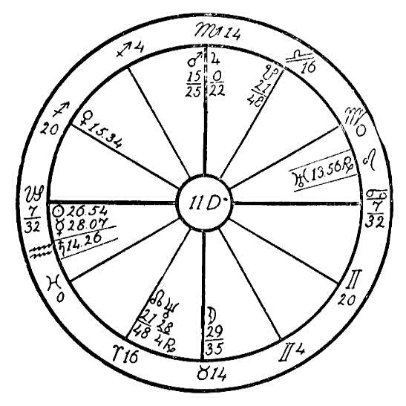
of these last named planets being in martial signs, giving impulse, the native would be very apt to dissipate her strength, the result being a physical break in the weakest part. The greatest afflictions in this horoscope are found in the region of the knees, Capricorn, and the lower limbs, Aquarius, causing enlargement of the veins. Varices are caused by interferences in the Venus circulation resulting from overtaxing the muscles or nerves of certain parts of the body.
Venus being the best aspected planet and free from afflictions in the sign of sports, Sagittarius, in the eleventh house, friends, trine to Uranus and sextile to Saturn, and Mars, being prominent in the Midheaven, indicate that the patient was an enthusiast in games; also in the entertainment of friends, for the moon is well aspected by the sun and Mercury and is in the Venus sign of Taurus in the 4th house, indicating the home, where the native would be lavish in her entertainments. The consequent exertion would put a heavy strain upon the heart. Uranus in Leo, square to Mars, and opposition Saturn indicates organic heart trouble, and causes a spasmodic gushing of blood through the aorta. Interference with the natural flow of blood through the heart will cause a disturbance in the veins in other afflicted parts of the body, as in this case where we find enlarged veins in the lower limbs.
This woman called upon our Healing Department for help in September, 1920, while under the care of the doctors in a hospital, after having had a second operation for varicose veins. At that time the progressed Venus had reached a conjunction with the radical sun, and the progressed moon was also in that part of the horoscope. The transiting sun, Mercury, and Saturn were in conjunction in Virgo, the sign of health. The transiting Saturn was square to the radical Venus, which brought on the last attack and was responsible for her submitting to the operation.
Ordinary cases of varicose veins may be relieved and even cured by bandages, and by a removal of strain so that the circulation of the blood may become more normal. When the knife is used, however, as in this case, healing is interfered with.

NO. 11E.--RESTRICTED CIRCULATION
Female, born April 13th, 1862.
This horoscope is minus the hour of birth, but as the given time of birth is frequently unreliable on account of the difference in time and clocks, unless we have some data by which we can correct the horoscope, we are nearly as safe in using a flat figure--diagnosing from the planets and signs only. A very safe diagnosis may be arrived at by this method. Only when it is necessary to watch for the crisis in order to help the patient pass through a critical period is it necessary that we have the hour of birth. This is then required in order to observe the progressed moon and the aspects of the transiting planets.
We here find Saturn, the malefic, conjunction Jupiter in the sign of Virgo. Virgo is the natural sixth house sign and therefore rules health and sickness to a very great extent. We find that people who are ruled largely by Virgo are prone to think much of their health and often become hypochondriacs. When several planets are found in this sign, we may trace the cause of disease to this part of the horoscope. The small intestine is the organ of distribution of the nutriment, where much of the food must go to be distributed to the various parts of the body through the blood. The intestines are to the body what the commissary department is to the army. Therefore Virgo necessarily is a most vital part of the horoscope.
Jupiter is the planet ruling the arterial circulation and the glycogen of the liver, and Saturn has rule over the gall bladder and the pneumogastric

Birth Chart No. 11E

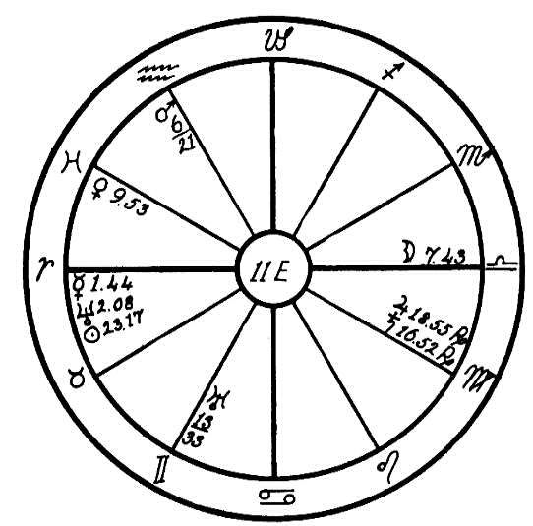
nerve, the most important of all nerves, which sends its branches to the three most important parts of the body, namely the heart, stomach, and lungs. Here they affect the distribution and digestion of the food in the small intestine due to the sluggishness of the gall bladder in furnishing the needed amount of bile and through impaired peristalsis. As a consequence the tiny blood vessels which are distributed over the inner intestinal surface are robbed of their nutriment, and the blood stream becomes deficient and sluggish causing anemia.
Especially is this true since we also find Venus, which rules the venous blood, afflicted by a square of Uranus, these planets being in the common signs of Pisces and Gemini. Uranus is also squaring Saturn and Jupiter. This will interfere with the oxygenation of the blood as it passes through the capillaries of the lungs.
Before middle life these afflictions may express themselves through colds, pneumonia, and painful menstruation. But after middle life when the body begins to feel the strain of years, these afflictions will cause anemia, arterio-sclerosis, and high blood pressure. The patient suffered from the latter three diseases, and at the age of sixty was threatened with paralysis of the right side. She also had a dizzy, reeling feeling in the head.
A healer should advise such a patient against stimulants such as coffee, tea, etc. Stimulation by friction of the skin would be of great benefit, using a pair of bath gloves night and morning and rubbing the body until it glows. Keep the mind free from excitement and worry, adopt a light and carefully selected vegetarian diet, and drink plenty of pure water between meals.

NO. 11F.--PERNICIOUS ANEMIA
Female, born Aug. 12, 1886, 5:00 A.M.
We are using this chart to impress upon the mind of the student the great necessity of advising patients as to the proper diet. Ninety per cent of those who are suffering and broken down in health are ill, not on account of the lack of food but because of wrong combinations or too much food.
This young woman has the fixed sign of Leo on the Ascendant, and the sun, the ruler, on the cusp of the first house. We find the obstructive Saturn in his detriment in the sign of Cancer, which rules the stomach. Venus, the planet ruling the venous circulation, is in conjunction with Saturn and in opposition to the negative moon, which is in its detriment in the Saturnian sign of Capricorn. Since Saturn and the moon are both in their detriment and in mutual reception, the power for evil of these two planets is greatly increased. The opposition occurs from the sixth house, that of sickness, to the twelfth house, that of hospitals, confinement, and self-undoing. We can well see how this poor soul has been responsible for her complete breakdown. She has for years been an invalid in bed, not able to use her limbs. The doctors have stated her disease to be arteriosclerosis.
We find that Jupiter, ruling the arterial circulation, is afflicted by the conjunction of Uranus in Libra, and that Venus, ruling the venous circulation is square to Mars, these two latter planets being respectively in the sign of the kidneys and the stomach. Mars is also square to the moon in the house of sickness, the sixth. With this planetary afflictions to the

Birth Chart No. 11F

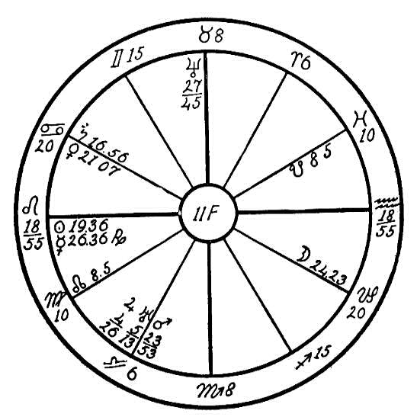
stomach there is a tendency to overeat. The opposition of Venus and the moon gives a great desire for liquids and sweets, and Saturn gives an abnormal desire for unnatural foods and an excess of pastries, starches, etc. This patient's body was like a stove that is filled with paper: when the paper is burned it makes a terrific heat, but the heat is not lasting, and the stove is quickly filled with ashes.
With Saturn in Cancer, there is a lack of gastric juice in the stomach. Leo is rising and the sun and Mercury are on the Ascendant in sextile to Mars. These positions give an unusual amount of energy but also the tendency to dissipate it. When the body has become worn out and tired, the stomach cannot digest the food; then if too much food is partaken of, decomposition takes place, especially if the meal is made up of inharmonious food elements. In the present case the poor weak stomach has been stuffed to overflowing with food, and then cold water or hot tea with sugar has been poured in after it. What was the result? Fermentation took place and the food turned to poison instead of nourishing the body. This poor young woman at the age of twenty-four was an invalid. Her body was filled with ash, and with both the venous and arterial circulation impaired the blood could not remain pure. She dissipated her energy, could not use moderation. She went to excess in food, play, and mental work, and the result was that the body could not throw out the ash accumulated from the excessive and ill-balanced food.
If she had come in contact with a doctor who would have placed her on a rational and carefully chosen diet and who would not have given her poisonous narcotics, she could have been saved much suffering. Man often starves in the midst of plenty, overloading his stomach while the body is really starving from non-assimilation, as was the case with this young woman. She lived to satisfy her appetite, but did not give her body blood-making food. Her joints became stiff, her body ached, and in a few years she became a confirmed invalid and is now confined in a hospital. If she were taken to a hospital where scientific dietary treatment is given, she could yet become a useful woman.
When we meet such poor unfortunate ones, it behooves us who aspire to become helpers and healers of humanity to use our efforts to guide them in the right direction.

NO. 11G.--RHEUMATISM AND IMPURE BLOOD
Male, born August 14, 1912, 1:30 P.M.
We are using here the horoscope of a young man with the martial sign of Scorpio on the Ascendant, and with the life ruler, Mars, in the 10th house, sextile to the Ascendant and in conjunction with the watery moon. Where we find the close conjunction of a hot and inflammatory planet with a cold and watery one as in this case, and especially in the sign of Virgo, which is the natural sixth house sign governing sickness, we may expect that it is a starting point of illness, for fire and water create steam.
Virgo is the sign which has rule over the small intestine, the intestines being among the principal organs for the digestion, assimilation, and distribution of the food. The inflammatory Mars in this sign causes inflammation of the intestines. As Mars is in conjunction with the moon, the latter having rule over the lymphatics, we may expect that the lymphatic vessels and glands will be disturbed in their functions. They are carriers between the cells of the body and the blood. Not only do they carry some of the nutriment of the food to the blood, but they also act as cleansers, taking up a part of the waste matter and carrying it where it may be eliminated from the body through the excretory organs. When the moon is afflicted by the inflammatory Mars in Virgo, we may expect the lymphatics to be inflamed and not able to function so as to help the blood in its work. The moon has rule over the chyle, or white fluid which has been extracted from the food through the villi of the small intestine. This intermingles with the lymph and passes on into the circulation. These white fluids,

Birth Chart No. 11G

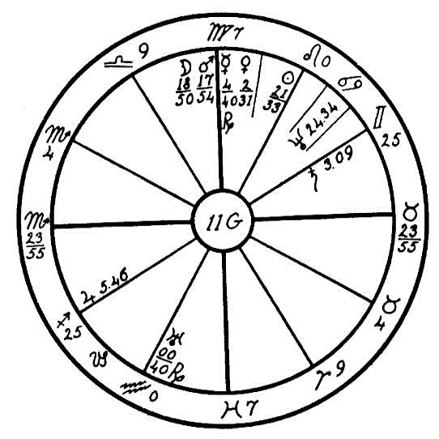
which are so necessary in the work of feeding the blood, are obstructed in the case of this boy.
We have still another affliction which interferes with the purification of the blood stream. Saturn the obstructer is in the sign of Gemini. Gemini has rule over the lungs. Saturn is in opposition to the planet Jupiter, ruling the arterial circulation, and square to Venus, which has rule over the venous blood. The lungs are the bellows of the body. Into the tiny capillaries of these organs the pure air passes and the blood is thus oxygenated and aerated. The pure oxygen is drawn into the air cells of the lungs, the poisonous carbon-dioxide is exhaled, and thus the body is freed from a large portion of its poisons. Whenever we find Saturn in the sign of Gemini, especially if this planet is afflicted by both Jupiter and Venus, we may expect the blood to be unhealthy and impure for Saturn, the obstructer, is stationed at the door of the respiratory system, partially shutting out the air from without and also partially keeping the carbon- dioxide within the body.
With these planetary afflictions we may look from a health point of view for impure and anemic blood; also a tendency to intestinal inflammation which will interfere with the proper assimilation and distribution of the food. This boy at the age of eight years suffered from blotches and eruptions of the skin. As the moon has rule over the synovial fluid, we may see how the conjunction of Mars with the moon caused rheumatism and fallen arches, an indication that Mars burned up the oils which were necessary to keep the joints of his legs and feet in order.
What a pity that the parents were not familiar with the science of astrology! If they had been, they would have known of these planetary afflictions and by a careful diet, plenty of fresh air, and training in deep breathing this boy could have been saved from much suffering. From all indications tuberculosis of the lungs may set in should he neglect his health by exposure to cold, for with Saturn afflicted by both Venus and Jupiter from common signs, he has naturally developed a habit of shallow breathing, which will tend to induce lung trouble.

NO. 11H--I: RHEUMATISM
We will use two horoscopes in order to show how planets placed in different signs will bring about the same symptoms, the real causes of the disease being different.

NO. 11H.
The native, a woman, was born on March 16, 1865, no hour given. We find the fiery, discordant Mars conjunction the restless Uranus in the nervous sign of Gemini (the arms and shoulders), and square to the life- giving sun and Mercury, which are in conjunction in the watery sign of Pisces. Mars and Uranus are also in opposition to Jupiter, which rules the arterial blood, and Jupiter is square to the sun and Mercury.
This patient has always had some trouble with obstructed circulation, especially in the arms and legs. Afflictions often work in squares and oppositions. Illustrating this we find the assimilation in the small intestine much impaired. Venus, the planet ruling the venous circulation, is in opposition to the moon, which we find in the martial sign of Scorpio, ruling elimination, the anus, urethra, and the generative organs. Saturn, the planet of obstruction, is found in Libra, the kidneys, and being placed in the last degree of this sign he obstructs elimination through the ureters, the small ducts carrying the urine from the kidneys to the bladder.
With all the many obstructions in the elimination of waste matter and the impaired assimilation of food do we wonder that when this woman reached the

Birth Chart No. 11H

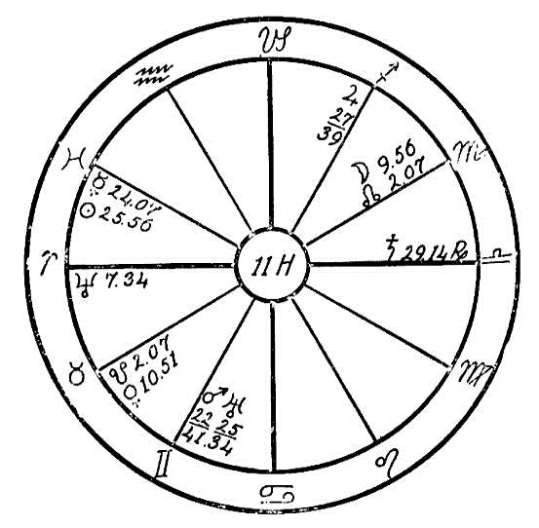
age of menopause the body suffered and the blood became so sluggish and impure that rheumatism was the result? Her body was stiff, she found it almost impossible to move about, and she suffered especially with the arms and shoulders.

NO. 11 I.
The native, a man, was born December 6, 1870, about 7:30 P.M. There are four planets in the sign Sagittarius in the 5th house, ruling pleasures and

Birth Chart No. 11I

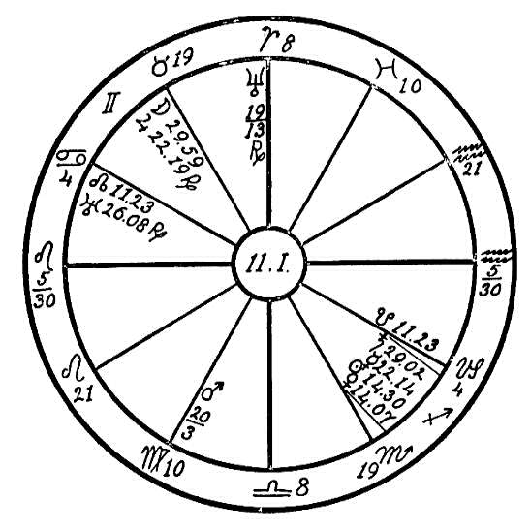
appetites. The sun, ruler of the Ascendant, and Venus the ruler of the house of friends, are in conjunction and square to the impulsive and discordant Mars, showing that this man is fond of a good time. His love for wine and women has been his undoing. He has indulged the appetites, and he is surely paying the price of such living.
Jupiter in the nervous sign of Gemini afflicted by the opposition of the obstructing Saturn and nervous Mercury, also square to the inflammatory Mars in the sign of Virgo, the small intestine, are indications similar to those in horoscope 11H. This man suffered from numbness in the arms and hands. The great strain put upon his system and the abuse of the poor stomach caused neuritis, as both the venous and arterial circulations are afflicted from the signs ruling the nervous system.
The instruction given to both these patients would be very similar, namely a simple vegetarian diet, elimination of meat, alcoholic drinks, and highly seasoned foods, using plentifully green, raw vegetables, especially lettuce and onions. The onion is a wonderful nerve tonic and body scavenger. If taken at night in the form of a sandwich when the stomach is empty it will purify the kidneys and liver and build up the nervous system. A good brisk massage with a pair of bath gloves night and morning to keep the pores of the skin open and stimulate the circulation is recommended. In case 11H the bowels and kidneys should be kept free from clogging, and food should be taken that works directly upon the liver and kidneys.

CHAPTER XXIII

LEPROSY
NO. 12A--B: LEPROSY
Male, born September 11, 1885, at 1:00 A.M.
The writer feels that horoscopes 12A and 12B, those of two brothers, will give students a most helpful lesson in the diagnosing of disease, and show that though the underlying causes and the outward appearances of both cases are of a similar nature, still these cases are entirely different when scientifically diagnosed.
In both cases the relatives called upon Headquarters for healing of the dread disease with which these brothers were afflicted.
In horoscope 12A we find the watery sign of Cancer on the Ascendant, with the obstructive Saturn near the cusp and square to Uranus in Libra. Here we have two planets which both by position and aspect indicate eruptive blood disease, and show the two stations where the poison is generated, namely, Cancer, the stomach, and Libra, the kidneys.
Saturn in Cancer interferes with the peristaltic action which is so necessary in the churning and the breaking up of food in the stomach. Saturn has a tendency also to dry up the body fluids, and when in Cancer, which is

Birth Chart No. 12A

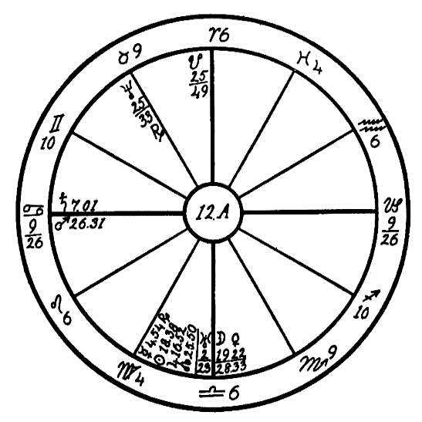
the sign of its fall, this planet is weak and therefore most evil. Uranus is the higher octave of Venus, and as Venus rules the moral nature on the lower planes, so does Uranus rule or balance the morals on the higher planes. Uranus in the Venus sign of Libra afflicted by a square of Saturn would indicate that a lack of moral balance was largely responsible for the physical ailment of the patient.
Uranus has rule over the pituitary body or hypophysis. This little organ, which is so wonderfully protected in a cradle-like bone within the brain, consists of two small lobes, the anterior and posterior. The anterior lobe has rule over the sex or creative force and over nerve fiber, while the posterior lobe contributes to and controls the circulation of the fluids of the body, especially the renal circulation.
With Uranus is Libra, which has rule over the kidneys, square to the obstructive Saturn and both in cardinal signs, also with the impulsive-cardinal signs on all the angles, we may expect excesses. With Mars, the planet of dynamic energy and impulse, in the first house in Cancer, square to the planets of pleasure and self-indulgence, Venus and the Moon, (Venus being strongly situated in its own sign of Libra and the moon being the ruler of the Ascendant, square to its own house,) we may conclude that this man through his excessive desires indulged in sensual pleasure to such an extent that the functions of the pituitary body became impaired. As the pituitary body regulates the assimilation of food, and as Saturn and Mars are afflicted in the sign of the stomach, (Saturn in Cancer gives abnormal tastes and appetites, and Mars in Cancer indicates a gourmand) we may expect that this man would be apt to make a cesspool of his body.
With Venus and the moon in conjunction and square to Mars in Cancer on the Ascendant, and with Saturn on the cusp of the Ascendant, we may expect this person to be very untidy and careless. He is one who would neglect cleanliness of the body and of his surroundings, also the elimination of toxic poisons through the colon, kidneys, and skin. This would in time fill the body with poisons which would ultimately cause eruption.
The skin would become dry and dead, for the pituitary body with the assistance of the thyroid gland feeds the skin. When these glands are tired and depleted by sensual excesses, the conditions of the skin as well as the general circulation of the body are impaired, dulling the mentality and causing the slowing up of energies of mind and body. In this case the result was leprosy.
This dread disease first made its appearance after the Flood, when vegetation was scarce and Noah and his family were forced to revert to the use of meat for food. This together with excesses and degeneracy relating to the generative function was responsible for this disease being of such common occurrence among the ancient Israelites and Egyptians. This ailment was classed as unclean, and those afflicted with it were ostracized and excluded from the church.
Truly it is a disease caused by unsanitary and unclean habits of living, and only those who, as in the case of this man, are gluttonous and careless in their personal habits are afflicted with it. We will use horoscope 12B to illustrate another phase of this disease.

NO. 12B.
Male, born March 19, 1896, at 7:50 P.M.
During the ancient Israelitic times the Jews looked upon leprosy as a peculiar disease sent to man by God. It was recognized as a mark of the displeasure of God for some great sin committed, and it was considered a dreadful moral disease. The afflicted ones were separated from others by the priests, who used ceremonies of purification for the healing of those who had this unclean disorder.
We see in this horoscope indications of moral depravity and uncleanliness: We find Saturn retrograde in Scorpio, the sign which rules the secret parts, the generative organs. Saturn is square to Mars, which is in Aquarius, the home of Saturn. Uranus is also retrograde and in the sign of Scorpio. These three planets, Saturn, Uranus, and Mars, are in mutual reception, that is, Mars is in a Saturn sign and Saturn and Uranus are in a Martian sign. Uranus is parallel to Mars and opposition the moon, both Uranus and the moon being in their exaltation signs and in angles and fixed signs. These planets are thus strong both by position and sign; therefore they are also most powerful in their afflictions. When Saturn afflicts Mars from Scorpio and Uranus afflicts Mars and the moon from this sign of sex, we may at once diagnose the case as venereal disease, but it was of such a malignant nature that it was believed to be leprosy, for all outward symptoms indicated leprosy.
Certain forms of venereal disease go hand in hand with the dread disease

Birth Chart No. 12B

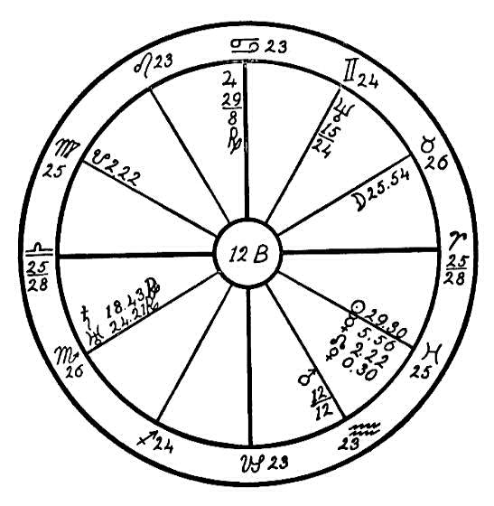
of leprosy; when the blood stream is poisoned, the glandular system is also affected, which in turn interferes with the metabolism of the entire body.
The Jews in olden times used no medicine to cure this unclean disease. They claimed that it withered all desire for grace and spiritual life; therefore the only cure was prayer and spiritual purification.
In Matthew, 8th chapter, we find: "When he (Christ) was come down from the mountain, great multitudes followed him. And, behold, there came a leper and worshiped him, saying, Lord, if thou wilt, thou canst make me clean. And Jesus put forth his hand and touched him, saying, I will; be thou clean. An immediately his leprosy was cleansed."

CHAPTER XXIV

PARALYSIS
NO. 13A.--PARALYSIS
Female, born August 22, 1899, 1:30 P.M.
Paralysis of the limbs and arms is the affliction of this young woman. We note first that this condition is indicated by the moon, which is the particular significator of health for a woman. She is in Pisces which rules the feet, and square to Saturn, the planet of obstruction, placed in Sagittarius, the sign ruling the hips. Thus the whole region of the lower limbs is afflicted. The moon is also square to Neptune and the saturnine Dragon's Tail, which are placed in Gemini, the sign ruling the arms. The life-giving sun is square to Uranus in Sagittarius and to the Ascendant, and these afflictions are all the more powerful because the sun and moon are both angular, one near the Midheaven, the other close to the Nadir. Thus there are strong tendencies to trouble with the arms and limbs, dropsy, paralysis, and wasting disease shown in the natal horoscope.
These conditions did not become manifest until the patient was eighteen years of age. At that time the progressed sun had reached Virgo 16- 33; it was then square to the radical Saturn. This brought out the latent weakness and resulted in a gradual loss of control of the limbs, which left her

Birth Chart No. 13A

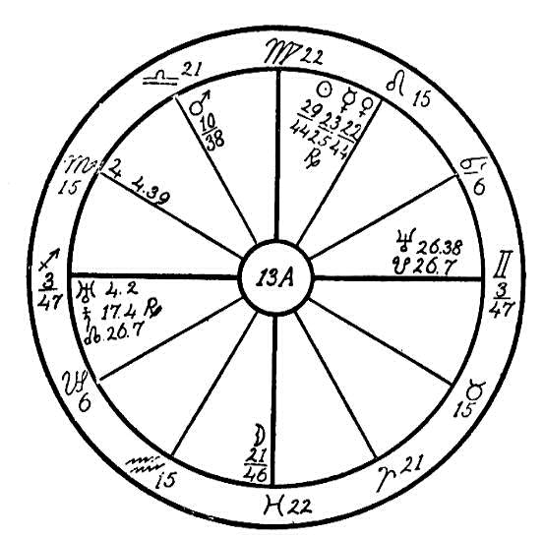
prostrate. Neptune conjunction the saturnine Dragon's Tail in Gemini, the sign ruling the lungs, gives an asthmatic condition and the afflicted moon in Pisces gives a tendency to dropsical swellings, which have also manifested. Thus for the time being she is in the grip of what seems an incurable condition. But it is noteworthy that the afflictions are all from common signs, and this gives the astrologer a ray of hope that when the sun has passed the critical points the affliction may be cured and she may regain the use of both arms and limbs even if not in full measure.
In the meantime every effort should be made to promote circulation by the manipulation and massage of the limbs and arms. A diet of fresh milk, which contains much ether, and uncooked vegetables that will give her mineral salts is sure to be of great benefit in helping to keep the limbs in shape and preventing atrophy so that when the present planetary afflictions have passed, the sextile of the radical sun and Jupiter may restore circulation. This patient can best be treated by a healer having Aries or Leo rising and whose Saturn is not in any place included in the degrees of the patient's 1st or 6th houses.

NO. 13B.--PARALYSIS AND HARDENING OF THE ARTERIES
Male, born February 9, 1855, 9:00 P.M.
We note first the mental qualities of the patient. The moon is conjoined with the Dragon's Tail, a saturnine influence, and Mercury is square to Saturn. Thus the two significators of mind are afflicted by an obstructive and melancholy influence, which also operates upon Mars and Venus through the square of Saturn. Saturn moreover is placed in the 9th house in the sign of the lower mind, Gemini. Thus there is very little joy for this person; all the world looks blue and gloomy to him; he meets everybody and everything with gloom and distrust, and is always afraid to make a move in any direction for fear something is going to happen to him.
This mental attitude is at the bottom of all his trouble, for no one who carries such thoughts of fear and worry can ever be healthy. The more cheerful and optimistic we are, the more we act as magnets for good things; we become what people call "lucky." Conversely, such an attitude as this person has is bound to bring misfortune and trouble. He thinks he has cause to be worried, and upon the surface it may appear so, but the trouble is that he mistakes effect for cause. The first work of a healer should be to show him this fatal error and teach him to smile or at least to try to smile.
Just as cheer promotes circulation and elimination, keeping the body in health, so worry produces concretion by hindering the elimination of waste matter, and therefore a diseased condition of the body follows. Three places in this patient's body are affected by the saturnine influence. In

Birth Chart No. 13B

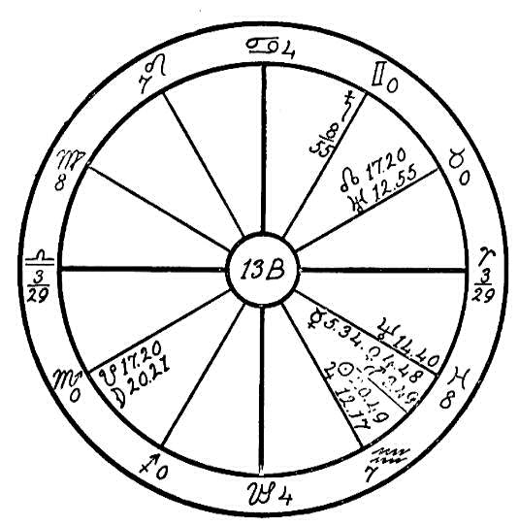
the first place Saturn is in the sign Gemini, which governs the lungs; he is square Mercury, Mars, and Venus, and thus he obstructs the expulsion of carbonic acid and prevents the proper oxygenation of the blood. The moon has particular rule over the fluids of the body. She is in the latter part of Scorpio in conjunction with the Dragon's Tail. Thus we may look for obstruction of the urine and for concretions in the bladder. The sun and Jupiter are in Aquarius. Uranus squares Jupiter and the moon squares the sun. The effects of this is felt in the opposite sign Leo, which rules the heart. The sun is also parallel to Uranus, and therefore the heart action is very uncertain, the circulation poor, the blood poisoned and heavy with waste matter that cannot be eliminated through the regular channels. So this clings to the walls of the arteries, and in the course of years the condition known as hardening of the arteries takes place, and the body becomes dry and emaciated.
The horoscope is the clock of destiny which marks the time when tendencies shown at birth are due to materialize. In August, 1910, the moon had progressed to the conjunction of its radical place. his configuration excited the moon's radical conjunction with the Dragon's Tail to action, as well as her square to the radical sun and her opposition to Uranus radical. Thus the disease which had been prepared for during so many years took a serious turn and commenced to seriously hamper the native. In January, 1912, the moon progressed to the opposition of Saturn radical and squared Mars and Mercury, thus enlivening and bringing into action the condition foreshown in the natal chart. Mars and Mercury govern the nervous system. Mars has rule over the motor nerves and Mercury over the sensory nerves. The above progressed affliction obstructed the vital flow along the nerves and paralyzed the body.
Jupiter was parallel to the sun's radical place during 1912-14, and the conjunction of the progressed sun and Mars in January, 1914, served to give more energy. These influences should have been taken on he wing. The patient should have outdoor life, on a farm if possible, with a diet in which buttermilk has a large part, and above all the cultivation of a cheerful attitude should be forced. This with manipulation of the spinal nerves would probably bring life into the paralyzed limbs and might restore a fair measure of health under good progressed aspects.

NO. 13C.--FACIAL PARALYSIS
Female, born April 13, 1912, 9:00 A.M.
This horoscope is that of a young girl with the watery and cardinal sign of Cancer on the eastern angle and with the fiery Mars in conjunction with the Ascendant. Mars is square to Venus and trine to the moon, the moon being the ruler of the Ascendant. Mars is the ruler of the 6th house, which has rule over the health; consequently we must look to Mars as the indicator of health.
Mars in Cancer afflicted by a square from Venus, and Venus in the martial sign of Aries, would indicate a gourmand, one who would as a result of too much rich and highly seasoned food suffer from indigestion or inflammation of the stomach.
Neptune in Cancer afflicted by a square from the sun and Mercury would be apt to give nervous trouble or malnutrition. But this young girl has been in the very best of health, with the digestive organs in good condition. The conjunction of Mars with the Ascendant in Cancer and square to Venus has had little effect upon her health.
The birth of this child was prepared for under the purest conditions and in the most careful manner. The parents had prepared for it even before conception, for they desired to attract to birth an Ego advanced and pure. During all the prenatal period the mother received the greatest care, and the child was loved into this physical world by advanced and pure parents. She was a most wonderful child--healthy, happy, far above the average child of her years, and superior to other children of her age in mentality.

Birth Chart No. 13C

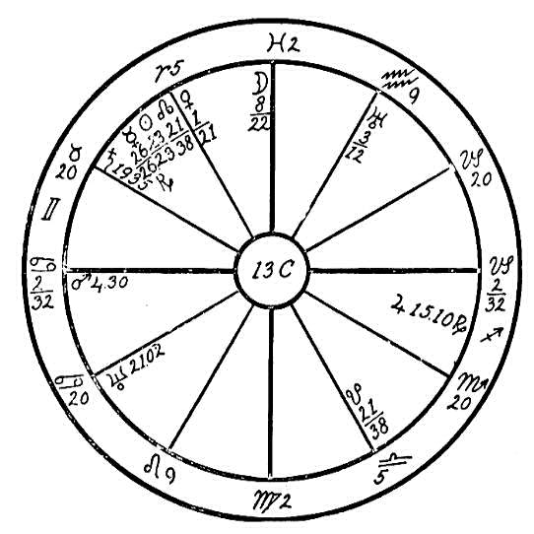
In the summer of 1922 she was taken with frequent hemorrhages of the nose and with severe headaches. The best physicians were consulted, who did everything possible to locate the cause, but to no avail. The facial muscles of the right side began to relax, and facial paralysis finally set in, greatly disfiguring a beautiful face. After trying every available method to relieve the child, the father and mother took her on a touring trip to southern California, hoping that the sea coast and lower altitude might relive her, which they did to some extent.
Having read the Rosicrucian books on astrology, and knowing of our method of healing and diagnosing, they visited Headquarters with the hope that the writer would be able to diagnose and help them in their trouble. This hope was realized. As soon as the aura of the child was contacted, the writer was impelled to lay the child on her face and to run her hand over the spinal column. Although not an osteopath nor a chiropractor, she found irregularity in the region of the upper cervical vertebrae, also in the center of the dorsal region.
During this, may we call it intuitional or spiritual, diagnosis the parents were silently watching every move of the writer, exchanging glances from time to time. When it was mentioned that the spinal column was irregular, the father spoke up, saying, "Oh, her spine is all right." When asked if she had had an adjustment, he admitted that both he and his wife were chiropractors and had practiced for almost two years. When asked if they had not both practiced on the child, they shamefacedly admitted that they had, with the result that the motor nerves had been over-stimulated.
Through the wonderful keyboard, the spinal column with its thirty- one spinal nerves, a skillful operator can by manipulation enervate or stimulate almost any part of the body, while an unskilled one may cause untold suffering. Such was the case with this beautiful young girl. The parents who had loved her into existence, who would have sacrificed their very lives for her, had in ignorance played once too often on her spinal nerves, exciting them to work overtime, and after the damage had been done, they were not skilled enough to know what method to use to undo the damage.
We take the rulers of the 10th and 4th houses to indicate the parents. Neptune is the ruler of Pisces, which is on the Midheaven, and Mercury the ruler of Virgo, which is on the cusp of the 4th house. The above two planets are squaring each other. Mars on the Ascendant indicates accidents, injuries, etc. Mars is square to Venus in Aries, the head. The cardinal signs act upon each other. the parts affected by squares such as from Aries, the head, to Cancer, the stomach, are in mutual bondage to each other. While the nerves of the stomach may have been over-stimulated, thereby sending an excess of blood to the head causing the bleeding of the nose, by a knowledge of proper adjustments a skilled osteopath or chiropractor could in a few treatments overcome this trouble. The Invisible Helpers of the Rose Cross, by materializing a hand, can also accomplish the same thing.

NO. 13D--E: PARALYSIS
Male, born March 25, 1876, 2:00 A.M.
We will use for this lesson the horoscopes of a man and woman who have afflictions in common signs, in order to illustrate why one patient will succumb to disease and become an invalid when another who has many more afflicting planets rises above them and thus becomes able to lead an active and useful life.
We will first diagnose horoscope 13D, where we find the common sign of Sagittarius on the Ascendant with the ruler, Jupiter, retrograde, and in its own sign in the 11th house, trine to the life-giving sun, but square to the obstructing Saturn, which is in the sign of Pisces, another common sign. We find the sun making only good aspects. The moon is square the Ascendant and in conjunction with the desire body Dragon's Head, which has a Jupiterian influence, sextile to Mars and Venus, and trine to Jupiter. These configurations should give much vitality and be a strong factor for health in this horoscope. Now why should a man with so few afflictions have become an invalid?
We find only two afflictions which would be detrimental to health; these are Saturn square Jupiter, and Venus conjunction Mars in Taurus square to Uranus in Leo. But with the common sign on the Ascendant this man's will was not strong enough to withstand the temptations shown by Venus conjunction Mars in Taurus, the larynx (Taurus also represents the generative organs by opposition from Scorpio), and square to Uranus. Dissipation in food and drink filled the blood with impurities, which impaired the arterial

Birth Chart No. 13D

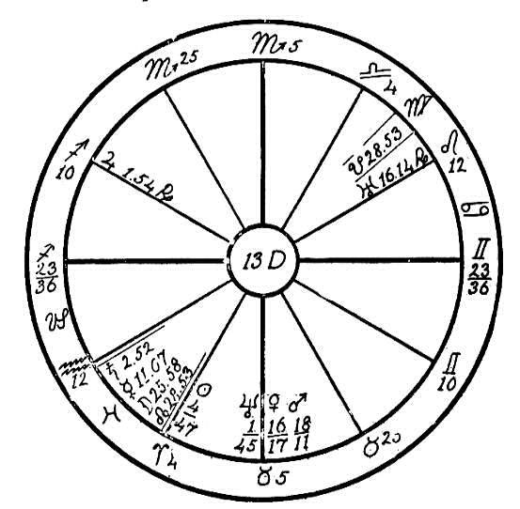
circulation. Saturn in a common sign, square to Jupiter also in a common sign, Sagittarius, which has rule over the sacral region, shows that the fifth lumbar nerve and the sacral nerves were obstructed in their function. Naturally this interfered with the circulation in that part of the body, causing paralysis of the lower limbs. The common sign man naturally follows the line of least resistance and drifts into invalidism.
Now horoscope No. 13E, that of a woman, has the fixed sign of Leo rising, and Mars is on the cusp of the Ascendant, but in this case we find the

Birth Chart No. 13E

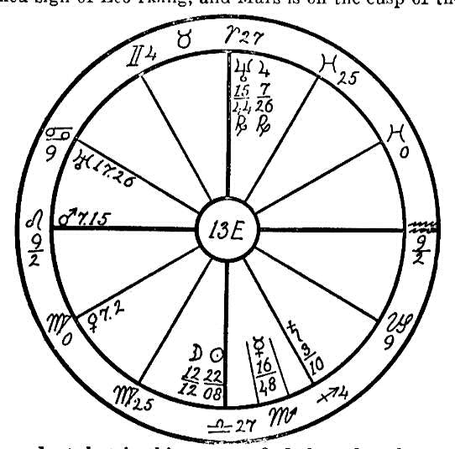
ruler, the sun, also the moon, both afflicted by the opposition of Neptune and the square of Uranus. Venus, which has rule over the venous circulation, is in the common sign of Virgo, square to the obstructing Saturn in Sagittarius, the home of Jupiter, Sagittarius also ruling the sacral region. A native with the dynamic Mars on the Ascendant in the fixed and impulsive sign of Leo is full of energy and ambition, and would naturally use up much strength and through temper and impulse dissipate much of her vitality. With the circulation restricted in the sacral region by Saturn, why should this woman not suffer with conditions similar to those of the man in horoscope No. 13D?
In the man's horoscope we find conditions indicating a phlegmatic, mentally lazy person. With moon and Mercury in conjunction in Pisces and sextile to Venus and Mars, and with Jupiter trine sun, everything came to him without any great effort. Especially was he drawn to 5th, 7th, and 10th house people--musical, theatrical people and movie actors, who led him into a life of pleasure. We find the woman in horoscope No. 3E with plenty of will and ambition, whose desire to heal and help humanity led her to take up the medical profession. But she had a constant fight to keep her joints from becoming stiff and sore. With Saturn obstructing the circulation in the sacral region she suffered greatly with granulated joints of the shoulders, hips and feet. Venus or Jupiter afflicted from common signs gives a tendency to paralysis of the limbs, but with a fixed sign on the Ascendant the native will not succumb. Therefore it is most necessary at all times when diagnosing a disease to observe the rising sign and the aspects of the sun, moon, and the ruler of the Ascendant.
One who suffers from such afflictions as the above should make an effort to keep the circulation normal by eating very lightly of plain food, exercising plentifully, and with a pair of bath mitts rubbing the limbs briskly morning and night. This will often avert a case of paralysis.

NO. 13F.--INFANTILE PARALYSIS
Male, born July 7, 1908, 2:00 A.M.
We will here examine the sympathetic aspects of planets in the cardinal signs. We find in this horoscope a most interesting lesson illustrating the sympathy and antipathy of the planets when placed in signs which are square or in opposition to each other.
The horoscope of this young man has the common sign of Gemini on the Ascendant, with Mercury, Venus, Neptune, the sun, Mars, and the Dragon's Head all in Cancer, the sign which has rule over the stomach. Four of these planets, namely, Mercury, Venus, Neptune, and the sun are in opposition to Uranus and square to Saturn. The sun is parallel to Uranus and Neptune; Neptune, Uranus, and the sun are square to the moon in Libra in the 6th house.
From our first observation we might diagnose this case as one of stomach trouble, for with Venus in conjunction with Mercury, Neptune, and the sun afflicted in Cancer we may expect poor digestion. When Neptune is one of the afflicters, especially when it in turn is afflicted by Saturn, there is

Birth Chart No. 13F

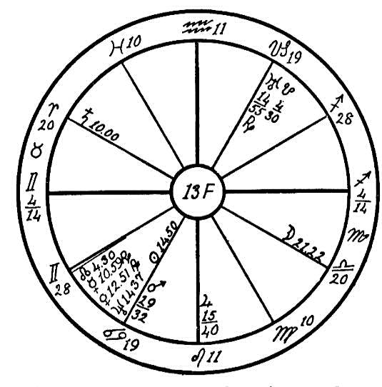
a tendency to underdevelopment; the organs affected are often undersized and Misshapen. With Saturn square Neptune and Uranus, Uranus being in the sign of Capricorn which is in opposition to the sign ruling the stomach, this child could not digest its food, which was often found in the stool in pieces. The parents, being ignorant of the cause of the condition, were indulgent and permitted him at the age of two years to eat whatever he craved; as a small child he was given solid food to eat.
With Neptune in the sign of the stomach, square Saturn, and in opposition to Uranus, the tiny glands which secrete the gastric juice of the stomach and which are so necessary to furnish the lubricating mucus as well as the digestive fluid, were lacking in vitality and prone to function spasmodically; for Uranus causes spasmodic action, Saturn sluggish action, and Neptune undersize or abnormal functioning. Therefore we would expect that the blood in this case would not receive due nourishment from the food. The body, as a result, would be deprived of the elements necessary for nourishment.
The damage in such cases generally materializes where the planet is placed which has the most evil aspects. Here we find Uranus in Capricorn making several adverse aspects as noted above. Uranus is receiving no help whatever from other planets; therefore naturally we may expect the place of such an afflicted planet to be the focusing point of the vicious circle. Capricorn has rule over the legs and joints, especially the knee joints. At the age of two years this boy was afflicted with what the doctors call infantile paralysis, which caused him to lose the use of his feet. Infantile paralysis is a disease which is diagnosed by the doctors as inflammation of the gray matter of the spinal cord but this has not been proven. Some of them are in doubt about this, and are seeking for another cause.
No two children have the same effects from this infantile disease. >From an astrological standpoint no two who are afflicted with it have exactly the same planetary afflictions nor necessarily the same rising sign. The writer has found in seven horoscopes of children afflicted with it that Neptune has been the chief afflicter in each case. As stated in The Message of the Stars, Neptune has rule over the spinal fluids and the pineal gland, and it depends upon the planet which is afflicting Neptune as to how the disease expresses itself. This naturally baffles the doctors, and they are unable to explain why one child is left with one paralyzed leg, another with both legs and arms paralyzed, and still another with one side entirely useless. But the planets tell he reason for this diversity of outward expression.

NO. 13G.--RICKETS AND TETANY
Female, born January 6th, 1911, 8:20 P.M.
We have here the horoscope of a young girl who has the common sign of Virgo on the Ascendant, with the sun in the fifth house in Capricorn. We are told in The Message of the Stars, page 544, that the sun rules the vital fluid which is drawn into the body through the spleen and how this life-giving fluid feeds the entire organism. The sun is afflicted in this case by an opposition of Neptune, which is placed in the sign of Cancer. Cancer has rule over the stomach. The sun is also afflicted by a parallel of Mars and Uranus. We here may see that the gateway of the body through which the solar force must needs enter in order to make it possible for the vital body to restore what the desire body destroys, has not worked normally even from birth. When the sun is afflicted by the spasmodic Uranus, the cramping effect of Neptune, and the inflammatory conditions of the fiery Mars, we may expect that at some time during the life of the native, when nature's laws have been broken and when the progressed planets start the afflictions into action, there will be trouble.
In the beginning of the year 1923 the progressed moon was passing through the sign of Virgo and made a square to the radical Mars in Sagittarius. This disturbed the metabolism of the digestive tract, which on account of the resulting inflammation was unable to furnish the blood with the proper amount of mineral salts. This combined with the disturbed solar force caused by an afflicted sun deprived the bones and the muscles of their

Birth Chart No. 13G

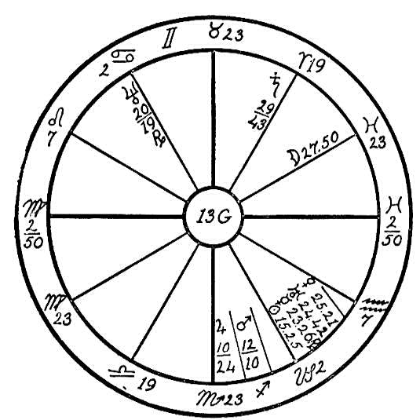
nourishment. In January 1923 the new moon fell in conjunction with the radical Venus, Uranus, and Mercury, square to Saturn, and opposition to Neptune. This excited the latent condition caused by Neptune in Cancer, the sun, Uranus, Venus, and Mercury in Capricorn, and the malefic Saturn in Aries making a square to the last three planets. Added to all these afflictions Mars radical is parallel to Uranus, Neptune, Venus and the sun. Do we wonder that this young girl was afflicted with the dread disease of rickets, which is a malady in which the bones are lacking in mineral matter, and with tetany, which is a disease causing a nervous contraction of the muscles of the extremities?
Had the parents known the tendencies in this horoscope when the child was quite young and carefully chosen her food so that she would have received the greatest possible amount of nourishment from the smallest possible amount of it, avoiding the excessive use of sugar, starches, and proteins, and had they used more of nature's pure, green vegetables, they might have helped her to build better bones and muscles. Unfortunately many of our northern countries do not have the pure green food all the year round such as we have here in sunny California, where it may be found in abundance twelve months in the year.
In prescribing a diet for the patient suffering from the above malady we would eliminate all heavy proteins, giving her plenty of pure fresh goat's milk, carrots, lettuce, onions, and spinach, adding a very small amount of entire wheat bread each day to give bulk. Let her lie in the sunshine as much as possible; especially should the sun shine upon the spine. Give her friction rubs, which will stimulate the circulation.

CHAPTER XXV

THE NERVES
NO. 14A--B: NERVOUS BREAKDOWN AND PARALYSIS
In order to illustrate to the student why the same disease will leave different after-effects we will use two horoscopes. These two charts prove the claim which we have always made that there is no more perfect way of diagnosing the disease of a patient, nothing more reliable, than astro-diagnosis.
Both patients have called upon the Invisible Helpers for healing, and both have been sufferers from that dread disease which has taken so many lives all over the world and has claimed more victims than did the world war, the disease which the doctors call influenza, or for short, the "flu."

NO. 14A
Male, born June 3rd, 1855, 2:00 A.M.
Here we have the ambitious, fiery sign of Aries on the Ascendant, with the sun in the restless, nervous sign of Gemini in the house of finances, in conjunction with the persevering, tactful, thrifty, grasping Saturn. The ruler of the horoscope, Mars, is in the last degrees of Taurus, square to Jupiter. Jupiter has great love for finance. He likes it and therefore can

Birth Chart No. 14A

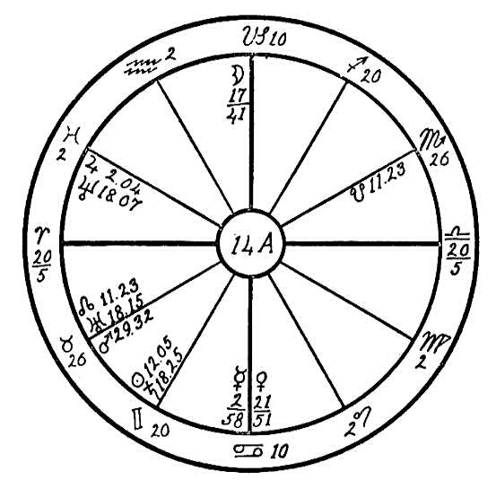
do great things with it. He is large and benevolent in all his ways. We find that this man had a great desire for wealth, and after having had influenza he put such a strain upon his physical body in order to gain wealth that he brought about a nervous condition from which he is now suffering. He has the restless moon in the Midheaven trine to the irresponsible and inventive Uranus, giving a great desire for speculation and to engage in get-rich-quick schemes. But Neptune, the planet dealing with large corporations and speculation, is square to the sun and Saturn in the 2nd house, showing that he has always been speculating with large corporations and always losing.
Venus in Cancer in the 4th house in opposition to the moon in the Midheaven gives an extravagant, frivolous, slothful, and dissolute condition in the home, indicating that money is wasted and used very foolishly, giving the native even greater desire to make money. He sacrificed his vitality for the almighty dollar. Being a telegraph operator, he used the brain and the fingers tips to excess, which caused inadequate nutrition of the nervous system. The result was a complete nervous breakdown.

NO. 14B
Male, born April 15, 1865, 8:22 A.M.
With the nervous sign Gemini rising and the restless, unconventional Uranus on the Ascendant in opposition to Jupiter, ruler of the arterial blood, this man was an easy prey to pneumonia, as the capillaries of the lungs were contracted, which made oxygenation spasmodic.
The sun, the life giver, we find in the 11th house in Aries, in opposition to the retrograde Saturn in Libra. Saturn is in his exaltation in Libra and very powerful. We would ordinarily look for the greatest trouble in the corresponding part of the body. This man would some time have suffered with renal disorder as the body was very sluggish and charged with impurities and the kidneys had not been eliminating properly for a number of years. He has always been a hearty enter. With Mars in Cancer square to Neptune, he has been very immoderate and abnormal in the indulgence of his appetite, also too fond of liquids.
The planets frequently work in opposites. In this case we find that the sign Aries is the seat of the principal trouble. This man was paralyzed after the effects of pneumonia were overcome.
We can see the difference between these two men. 14A is more able to overcome disease, having the fiery, ambitious sign of Aries on the Ascendant. He has better circulation for he has Mercury and Jupiter trine. 14B has the restless, emotional Uranus in Gemini on the Ascendant badly afflicted, and it is very difficult for him to remain quiet and calm; his emotions constantly carry him to excesses and extremes. Both should be put

Birth Chart No. 14B

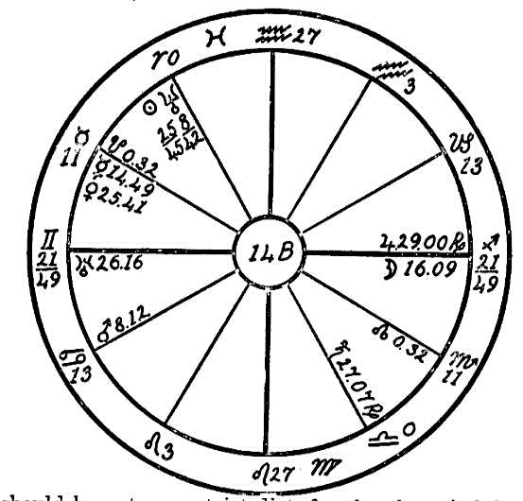
on a strict diet, for they have indulged too freely in the good things of the table. It should consist principally of vegetables, including raw onions, parsley, and celery.
14A is suffering from a complete nervous breakdown, while 14B is paralyzed.

NO. 14C--D: DEFECTIVE WALK
A pair of most interestingly similar charts, both in aspects and symptoms, will now be considered. We will first take figure No. 14C, that of a boy born November 25, 1899, 0:30 A.M.
We find the vacillating and negative moon in the 12th house near the Ascendant, as the ruler of the horoscope. This planet is square to the sun and Uranus. These last two planets are in conjunction in Sagittarius, the sign which has rule over the hips, the sacral region of the spine, and the coccygeal region. Sagittarius also has rule over the iliac arteries and veins, sciatic nerves, and locomotor muscles in hips and thighs. We also find Mars in this sign of the hips, in conjunction with Venus, Mercury, and Saturn. Venus rules the venous blood, and wherever this planet is placed and afflicted, the circulation in that part of the body is impeded. Mars burns up while Saturn restricts, contracts, and dries up. So we find that the circulation is interfered with by these two afflicting planets, and as Mercury rules the nerves we might expect that this boy would suffer from restrictions in the region of the hips. Neptune, the higher octave of Mercury, works upon the nervous system and rules the spinal canal. In this horoscope Neptune is placed in the 10th house in an angle where his power is greater than when placed in a cadent or succedent house. We also find him in the sign of Mercury (Gemini) which rules the upper spinal nerves. As Neptune is in opposition to Venus, Mercury, and Saturn, and parallel with Saturn, Mars, and Uranus, through this planet which has so many aspects and the greater number of them afflictions, we can locate the seat of the

Birth Chart No. 14C

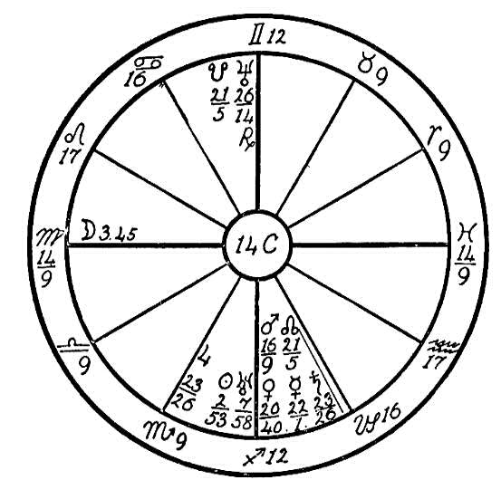
trouble--obstruction in the nervous system and spinal fluids.
This boy has never been able to walk without staggering like a drunken man. Gemini being the sign of speech, and Mercury the planet ruling speech, Neptune in Gemini has prevented his from learning to use the faculty of speech. With the moon, the life ruler, afflicted in Virgo (the moon having rule over the white fluids of the body, and Mercury, the small intestine), it will be doubtful whether this young man can overcome these afflictions, for a negative sign is rising and the afflictions from angles are stronger than the will of the patient.

NO. 14D
The second figure, that of a young man born March 17, 1900, 1:00 A.M., has the energetic sign of Sagittarius on the Ascendant with Jupiter, the life ruler, in its own sign in the 12th house, in conjunction with the nervous and erratic Uranus, which is co-ruler of the horoscope. These two planets are also in conjunction with the Dragon's Head with is of a Jupiterian nature. They are afflicted by a square of Mars, from the sign Pisces, also a parallel of Neptune and Saturn. With these afflictions of Jupiter ruling the arterial blood, in the two Jupiterian signs, Sagittarius (hips) and Pisces (the feet), what may we expect but that the arterial blood would be obstructed in the limbs? As the action of Uranus is spasmodic, it shows that at certain times only does this young man suffer with cramping of the motor nerves. But we find Saturn, the planet of obstruction, strong in its own sign of Capricorn, ruling the knees, afflicted by the square of the moon from near the Midheaven, also by the square of Mercury in Aries. As the joints of the body are largely ruled by the sign Capricorn, especially when Saturn is placed in this sign and afflicted, we may expect a lack of power in and control of the lower part of the body.

Birth Chart No. 14D

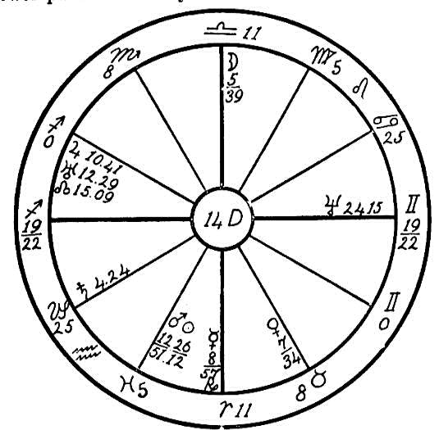
We find Neptune, the planet ruling the spinal canal and the spinal spirit fire, square to the life-giving sun. This aspect acts upon the body as a disconnected wire would upon a telephone; there would be no response. The vital fluids cannot flow freely through the spinal column; and the upper and lower part of the body may be likened to two disconnected wires. This boy, like the first one, could not walk without the support of crutches; but this affliction was very slight until he reached the age of seven years when the progressed moon reached the conjunction of the radical Saturn; then he lost entire control of his limbs.
We are told in Galatians, 6th chapter, 7th verse, that whatsoever a man soweth, that shall he also reap. The question might be asked, "How could these poor young men he held responsible for something that came upon them as babes?" We are told that this life is not all, that we have lived many lives, and that we are born to parent with whom we have made ties in previous lives. They are the instruments through which we are to receive our lessons. As we look into the lives of these poor souls we see this exemplified. They have been attracted to parents who could give them certain bodies, the archetype of which they themselves were the builders. We note in Horoscope No. 14C that Neptune is in the 10th house, opposition Saturn, Venus, and Mercury in the 4th house, indicating lewdness and drunkenness of both parents; while in No. 14D the moon is afflicted in the 9th house by an opposition of Mercury, and Saturn in square to both Mercury and moon, indicating a drunken father and a nervous and neurasthenic mother.
May the poor boys born into these miserably afflicted bodies learn their lessons, as afflictions are to the soul what fire is to gold--a refiner. Surely the experiences in this life will bring them much purification and soul growth.

NO. 14E--EXAGGERATED HYSTERIA
Female, born December 5th, 1873, 8:45 P.M.
This horoscope has the positive, vital, and fixed sign of Leo on the Ascendant, with the ruler, the sun, in the fifth house in Sagittarius. The moon and Saturn are very strong in their own home signs. Saturn, the planet of obstruction, is in Capricorn in the sixth house, the house of sickness. We usually look to such a planet and its position for the key to the trouble. Saturn is square to the retrograde planet Neptune, which is in conjunction with the Midheaven and in the impulsive sign of Aries. Neptune is the higher octave of Mercury; it is in the ninth house, ruling the higher mind. In such a case we may expect to find brain storms or some abnormal mental trouble.
The moon is in its own sign, Cancer, square to Jupiter. Therefore the native can expect little help from the moon, and so we must look to the planet Mercury to see if the mind is to receive assistance to overcome the square of Neptune to Saturn. Mercury is retrograde, which makes its influence latent, and in the sign of its fall, the common and negative sign of Sagittarius. Mercury, however, while weak by sign and retrograde, is helped by a sextile of Jupiter and by one of Saturn. This will save the native from insanity.
Uranus, the planet of impulse, is retrograde and in the impulsive sign of Leo, in conjunction with the Ascendant and in opposition to the fiery Mars. Mars and Uranus are in angles, the first and seventh houses, and have a tendency to cause spells of temper and spasmodic emotions. This causes irregularity of the action of the heart.

Birth Chart No. 14E

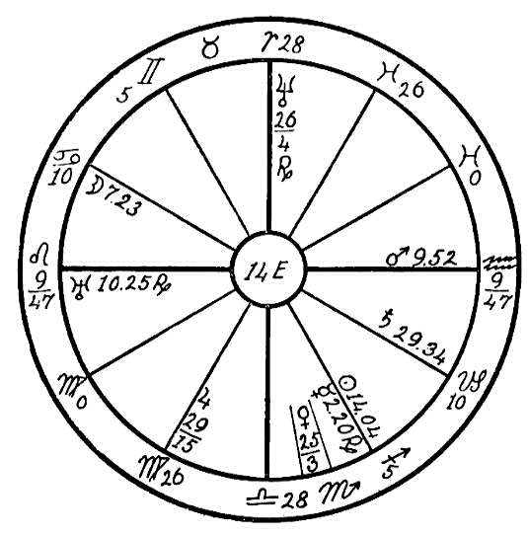
Neptune in Aries square to Saturn causes the mind to become very selfish, and from childhood this native has demanded that others grant her every wish. She would throw herself into a spasm in order to get what she wanted from her parents. This habit grew upon her, and when she reached the age of menopause, she had no control whatever over her emotions. The doctors diagnosed her case as exaggerated hysteria.
As the progressed sun neared the conjunction with the radical Mars and the opposition to the radical Uranus, heart trouble developed as a result of the strain which she had put upon her body all through life by these selfish spells. With Neptune in Aries, square to Saturn, she is lacking in mental control and allows the emotional Uranus and Mars to entirely rule her life.
Here is a case where the parents were much to blame by permitting her as a child to have her own way. If they had controlled her in these spells in the beginning, even though it had necessitated severe methods and caused the clashing of wills, it would have helped her to get mastery over the emotions. But as it is they permitted her to have her way, which has caused her untold suffering and may bring a fatal ending.
This is a case in which the patient precipitated her trouble through violent actions. There is no reason whatever for poor health with only three afflictions, namely, Saturn square Neptune and the Midheaven, Uranus in conjunction with the Ascendant and in opposition to Mars, and Jupiter square the moon; while there are 15 good aspects in the horoscope, including the parallels and the sextile of the sun to Mars, and fixed and cardinal signs are on the angles. It may well be said that this woman is digging her own grave. Think of the archetype which she is laying the foundation for to be used in her next embodiment! Can it be wondered at that some souls are born with chronic and incurable diseases?

NO. 14F--OBSTRUCTION OF THE PNEUMOGASTRIC NERVE
Female, born April 4, 1915, 5 P.M.
In this horoscope we have the common sign of Virgo on the Ascendant, common signs on the four angles, and the afflicting planets are posited in the common signs. As a rule planetary afflictions from these weaker signs are more easily overcome than from cardinal or fixed signs, but when the patient also has common signs on the four angles he will not make the effort necessary to overcome planetary conditions.
We find the sun in the martial and impulsive sign of Aries, sextile to Uranus. This latter planet is strong in its own sign of Aquarius. The moon is in the restless sign of Sagittarius, and the ruler of the Ascendant, Mercury, is in conjunction with the fiery and impulsive Mars. The positions of these various planets will give this child a most impulsive, restless, and ambitious nature, one which will keep her on the go constantly, and whatever she does will be done in a quick and impulsive manner. A lack of self-control is shown. She will eat hurriedly, failing to give proper

Birth Chart No. 14F

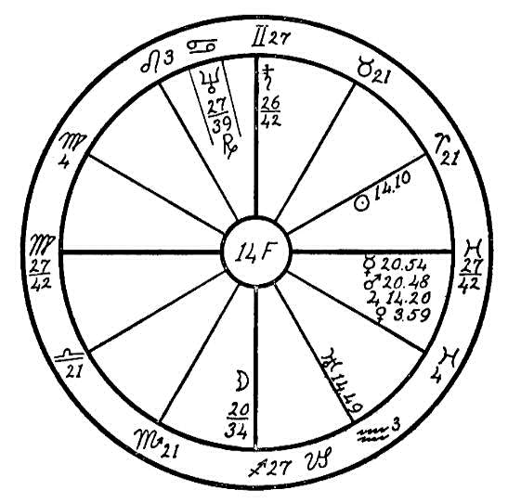
attention to the mastication of her food. This hurry and impulse will have a bad effect, for Mercury ruling the nervous system, conjunction Mars and square to the moon and the destructive Saturn, will cause the nervous organization to become deranged each time that the native gives way to great excitement, anger, excesses in eating, or anything which might produce a strain on the nerves.
The moon has rule over the esophagus and stomach, and Saturn, which is posited strongly in the Midheaven, has rule over the pneumogastric nerve. Saturn is in opposition to the moon, hence we may expect trouble from the branches of pneumogastric or vagus nerve. The two divisions of this great nerve, the esophageal and the gastric branches, are obstructed in their functions by Saturn, and this interferes with peristaltic action. The sluggish action of the esophagus and the cardiac orifice cause the good to move too slowly through this tube before it reaches the stomach, and then it remains too long a time in the stomach before it is digested, for Saturn causes a sluggish condition of these organs. This may result in great distress.
This girl suffered intensely with stomach trouble once every six or eight days, the time varying. These spells may be traced to the effect of the transiting moon as it passed through the common signs, forming the conjunction, opposition, or square of the planets in these signs. The moon transiting over its radical place in Sagittarius, over Mercury, Jupiter, and Mars in Pisces, and over Saturn in Gemini will bring these afflicted periods once a week.
The parents consulted a number of doctors, each one giving a different diagnosis. One physician was positive of cancer and wanted to operate. Between these spells of stomach trouble the girl seemed to be in fairly good health.
In a case of this kind undue excitement and all excesses should be avoided, at the time of the moon's transits over the afflicted planets. Caution in the choice of food should be exercised. All coarse foods which are hard to digest should be avoided, and everything that is eaten should be well masticated before it enters the esophageal tube.

CHAPTER XXVI

THE BONES
NO. 15A--INJURY TO FEMUR
Male, born November 11, 1886, 6:36 A.M.
Sagittarius 24-24 is on the Ascendant in the present instance and the inflammatory and destructive Mars, the planet of impulse, is on the cusp of the Ascendant in the pleasure-loving and heedless sign of Sagittarius. This man was specially fond of horses. Mercury is in the 12th house in Sagittarius, sextile to the impulsive Uranus in the 11th house, friends, which shows a desire for swift action, racing, fast driving, et cetera. Mars, the ruler of the fifth house, which has rule over pleasures, is sextile Jupiter. This young man met with accident caused by horses.
We find that at the age of 21 years the boy's progressed sun and Venus were in conjunction with the radical Mercury and sextile to Uranus, the progressed Mars having just passed the square to Uranus, and reached the sextile to Venus, indicating a most pleasurable time with friends. But the progressed moon was in square aspect to the radical Neptune, sextile to Mars, and opposition the Midheaven. This brought about an accident, the young man being thrown from a horse. From this he never recovered, the lower limbs becoming paralyzed as a result. He was rarely free from pain, and in 1916 the doctors removed part of the femur of the right leg, for the

Birth Chart No. 15A

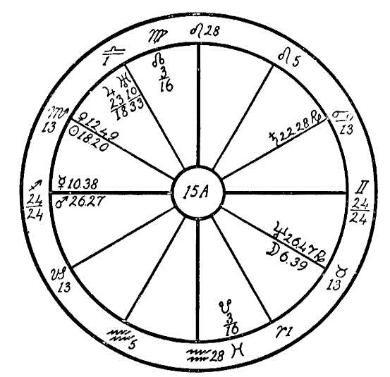
fall had bruised the bone and it had rotted.
We find Saturn in the 8th house in Cancer square to Jupiter, which is the ruler of the Ascendant. The moon is in its exaltation sign of Taurus, ruling the palate, and in the fifth house, hence there was a desire for drink. >From the indications in the 11th house, friends, he was wined and dined until he had his body over charged with ash. Now when this is the case and the boy is unable to take care of the excess of rich food, the toxic products settle in the weakest place. With Jupiter afflicted in Libra, which has rule over the kidneys, these organs were overworked and not able to eliminate the toxins and poisonous matter. The bruised femur naturally was the point which attracted this toxic poison, and decomposition necessarily took place.
After a number of operations the native passed out in June, 1918, when the progressed sun was nearing a conjunction with the Ascendant and the progressed moon was in Cancer in conjunction with Saturn in the 8th house, death; also the progressed Mars was then within one degree of an opposition to Saturn.
Now had this young man been in touch with a physician who could have properly adjusted the misplaced femur and who would have placed him on a strict vegetarian diet, eliminating all meats and highly seasoned food in order to keep the blood pure, there would have been great possibilities that the life might have been prolonged and that he would not have become paralyzed. But unfortunately he was in a small town in far-off New Zealand where proper aid could not be obtained. The dislocated and bruised bone was neglected, and the diet was largely composed of flesh foods as vegetables were very scarce there at that time.

NO. 15B--ARTHRITIC MUSCULAR ATROPHY
Female, Born December 4th, 1899, at 8 P.M.
This young woman has the watery sign of Cancer on the Ascendant, with the sun in the common sign of Sagittarius.
It is the rule when looking for physical ailments to take the ruler of the 6th house, which rules sickness, and find the position of this planet and its aspects. In this horoscope we find 28 degrees of Sagittarius on the cusp of the 6th house, but the influences of this sign is almost spent before reaching this house. We therefore consider Capricorn, the sign on the 7th house, with 28 degrees on the cusp. The greater part of this sign is thus thrown into the 6th house; therefore we may consider Saturn as having rule over the house of sickness.
We find this disturbing and crystallizing planet in 24-37 Sagittarius in conjunction with the inflammatory Mars and in opposition to Neptune and the Dragon's Tail. We are told on page 566 of The Message of the Stars that Neptune rules the spinal gas, or spinal fluid as the doctors call it. We find Neptune in conjunction with the Dragon's Tail in the sign of Gemini, which has rule over the arms and the region of the 6th and 7th cervical and the 1st, 2nd, and 3rd dorsal vertebrae. We find Mars and Saturn in the region of the lower end of the spine, the sacral or Sagittarian region. Saturn when afflicted by Neptune gives very deep-seated disease, that which is difficult to understand. Saturn when afflicted also dries up the synovial fluid of the joints wherever he may be posited. When in conjunction with Mars in the sacral region we may expect trouble, for Mars is hot

Birth Chart No. 15B

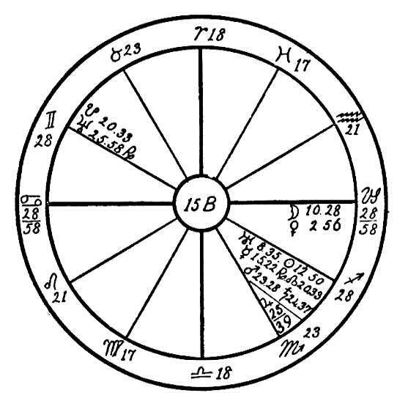
and inflammatory and Saturn is cold and moist, with a restricting influence.
We also find Uranus, the sun, and Mercury in conjunction and parallel in this same part of the body, namely the sacral or Sagittarian region. Wherever we find two hot, fiery planets such as the sun and Mars, we may expect that much of the heat and vitality of the body will be brought to this region, and when the restricting influence of Saturn is opposed to the abnormal and ossifying influence of an afflicted Neptune in the opposite region, namely the upper end of the spinal column, both exerting a harmful influence, we may liken the spinal fluid of the patient to a stream of water which has been dammed at both ends. No fresh water is allowed to flow in, and the old and stagnant water must remain and become polluted. As the greater number of afflictions are to be found in the sacral region, naturally the greater amount of impurity is also lodged there.
This young girl developed arthritis of the hip joints at a very early age, partly on account of the neglect of the parents, who were very inharmonious. The father was a drunkard and libertine and the mother careless and neglectful of her home duties, spending most of her time away from home and leaving three little girls to shift for themselves. It was never definitely known whether the beginning of this disease was due to an accident; but the stars indicate a fall, which no doubt bruised the hip bone or the sacral bones and was probably the first cause of the disease. Gradually the right leg atrophied, and the spine became bent.
In 1917 this girl called on Headquarters for the healing of her hand injured in an accident. Here we may again note the influence of Mars and Saturn in conjunction, which had their effect in the opposite sign, Gemini, and caused the breaking of one of the fingers. The bone became affected, and the doctors were unable to do anything to heal it. With the help of the Invisible Helpers, however, and a strict vegetarian diet she recovered. But the native has inherited tainted blood from the father, in conjunction with Saturn and in opposition to Neptune, which would indicate the affliction of the father, namely, the dread disease gonorrhea. Parents with this disease frequently attract souls for rebirth who must needs suffer from spinal diseases, blindness, etc. "The mills of God grind slowly, but they grind exceeding small."

NO. 15C
OSTEOMYELITIS--INFLAMMATION OF MARROW OF BONE
Male, born January 9, 1898, 8:00 A.M.
This lesson is based on the horoscope of a man who has the fixed sign of Aquarius on the Ascendant, and fixed signs on all the angles indicating a nature that has the will strongly developed, and with the sun in the Saturnian sign of Capricorn there is indication that he has great persistence in resisting disease.
How well he has succeeded in his fight is shown by the aspect between the sun and Mars, which often shows the extent of the damage which may have been done to the physical body. Any aspect between Mars and the sun, even though it be a square or an opposition, is better than no aspect. Strong signs on the angles and the sun in a determined sign is an indication of power to overcome physical restrictions. But in this case the sun is void of aspects to Mars showing that the disease has mastery over the man.
Mars, which is exalted in Capricorn, is in conjunction with Venus, square to Jupiter, and elevated in the 11th house, indicating liability to accidents. Mars in the 11th house also shows that friends would be responsible for leading him into danger.
We find a very prominent Uranus in this horoscope, which is near the cusp of the Midheaven, in conjunction with Saturn, sextile to Jupiter, and trine the moon, indicating one who wishes to shine, to be a good fellow among his friends; also one who would go to extremes in entertaining them. Uranus in Sagittarius shows impulse which finds expression through sports,

Birth Chart No. 15C

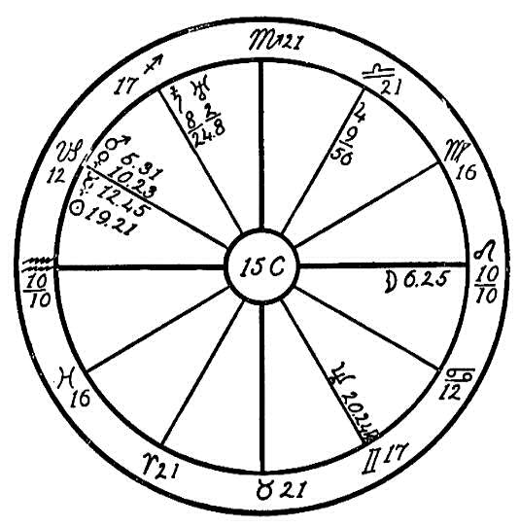

particularly in connection with four-footed animals. Saturn rules the bones.
In 1917 the progressed Mars had reached a conjunction and a parallel of the radical sun, which is in 19-21 of Capricorn in the 12th house, the house of self-undoing. At the same time the progressed Venus was in parallel to the radical Saturn and Uranus. This indicates that during the year 1917, while with friends and horses this man sustained an injury to one of the bones of the leg, which although at the time seemed but a bad bruise, nevertheless was a deep-seated injury. We will see now how clearly and precisely the clock of destiny registers events. On December 3, 1918, there was an eclipse of the sun in 10-31 of Sagittarius, conjunction with this man's radical Saturn. The effect of an eclipse lasts during all the year which follows. In 1919 we find the progressed sun conjunction the Ascendant, progressed Venus opposition to the radical moon, and the progressed Mars conjunction the radical sun. We have here three afflictions during the year following the eclipse, and when the transiting moon on June 5, 1919, fell in square to the place of the eclipse at the same time making a square to the radical Uranus and Saturn, the young man was taken with severe pains in the right ankle, followed by chills and fever. From that time the leg began to swell and a large abscess formed, which was lanced by the doctor. As soon as one abscess healed another would form and in eight months he had been operated on for abscesses at least ten times. By 1920 pus began to run from small holes in the ankle and the doctors diagnosed the disease as "osteomyelitis."
On April 26th, 1924, this man again entered the hospital for an operation, and at this time small pieces of bone were chipped away for seven inches up the leg.
In August 1924, when he called upon Headquarters for healing he was returning to the hospital for another operation.
It is unfortunate that many doctors do not realize that operations or removals of parts of the body will never permanently cure so long as the patient is not put on a proper diet.
The writer visited a friend in a hospital a short time ago who was severely injured in an automobile accident. While she was strictly a vegetarian and disliked meat, the doctors compelled her to eat plentifully of meats and broths while her wounds were healing.
In the horoscope of this young man under consideration we find Venus conjunction Mars in a Saturnian sign, and square to Jupiter. Venus and Mars are the rulers of the 4th and 10th houses indicating the parents, from whom he had inherited scrofulous blood. So we may realize that no matter how many bones the doctors may remove from his limb the real disease which is in the blood, can only be cured by the strictest vegetarian or fruit diet.

CHAPTER XXVII

SPIRIT CONTROL
NO. 16A.--SPIRIT CONTROL
Male, born April 27, 1868, 6:37 P.M.
In the horoscope before us we consider first the mental qualities as shown in particular by Mercury and the moon. Mercury has three aspects, the conjunction with its higher octave Neptune, which occurs in Aries the sign of the head, a sextile to Venus in the Mercurial sign Gemini, and a square to the moon in Cancer. We also note that Mercury goes before the sun. This shows a kindly disposition and fairly good reasoning ability, though the native will not employ the ordinary processes of reasoning, but will use the Neptunian method in all his mental operations.
The moon in the ninth house in the psychic sign Cancer, its home sign, and in conjunction with Uranus gives marked intuition. Saturn in Sagittarius, the 9th house sign, trine to Jupiter, the ruler of Sagittarius, will help to bring order into the native's thoughts, with the result that he will be much more balanced than inspirational people usually are. Nevertheless he will always stand out from the crowd for he is marked as a dreamer. Uranus and the moon conjoined in the 9th house, the house of the higher mind, will overrule everything else. But the other configurations bearing

Birth Chart No. 16A

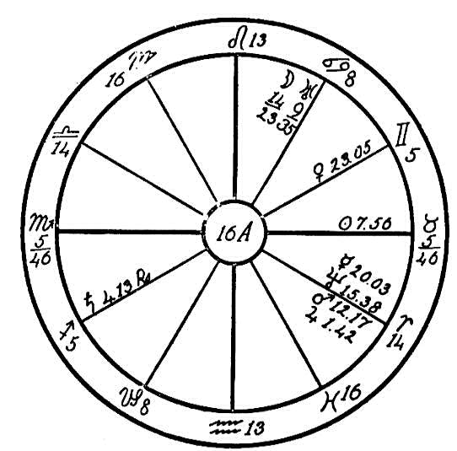
upon this matter save him from becoming foolish and a butt for jokes.
With respect to his health, we note first that the ruler of Aries is near the cusp of the 6th house in conjunction with Neptune. Neptune makes a conjunction with Mercury, which will make this man very sensitive and irritable, offsetting in that respect at times what we said concerning the kindly disposition denoted by Mercury sextile to Venus. The Moon and Uranus in Cancer, the sign which governs the stomach, shows that it will be very difficult to please him with respect to food, and the square of Mars to this configuration shows that he is likely to have gastric trouble when the resistance of the system in broken down. Strong drink will be craved, and if this desire is indulged, the psychic experiences of delirium are inevitable.
Spirit controls are very apt to take possession of the body of such a person even apart from drink because the square of the moon and Uranus to Neptune and Mars favors such a condition, and temporary insanity at least is liable to occur.
Part of these statements have already been realized, for this patient has applied to Headquarters for relief from unwelcome attention of spirits which he had attracted at spiritualistic seances. He rebelled very much against the diet which was prescribed for him and could not be made to keep up the weekly letters. There is considerable hope, however, from the sun sextile to the moon and Uranus that the Ego will ultimately free itself from outside influences, though this will naturally cause the native a great deal more trouble than if he had remained on the healing list until cured instead of doing as he has done and as so many do.
The moment such people feel the slightest relief they think there is no need for further help from others. That is not a bad attitude to take because upon the Path of Attainment it is continually held up as an ideal that "if thou art Christ, help thyself." There are too many leaners who do not wish to bear their responsibility, who shirk it whenever they can, who are always applying for help whenever they have even a toothache; some have even telegraphed because of a headache and other ridiculously small ailments. Therefore it is always best to encourage patients to help themselves as soon as it is possible, for in that way they gain spiritually even if physically their progress is more slow.
In a case of this nature the simplest diet should be prescribed in order to soothe the nerves: lettuce if it is at all obtainable, and onions in the evening in any case. Such a diet, and exercises to limber up the spine, particularly in the lumbar region where Saturn in Sagittarius has a grip on the sciatic nerves, will in time restore such a patient to health provided he avoids liquor and stays away from spiritualistic seances.

NO. 16B.--OBSESSION--TONSILS
Female, born August 17, 1881, at 9 A.M.
This horoscope is that of a woman who has the sign of Libra on the Ascendant, with cardinal signs on all four angles. The sun in the positive and fixed sign of Leo indicates that she will have determination well developed. This determination, however, may be expressed in he form of stubbornness, for Mercury is in Leo in the 10th house, square Saturn and Neptune, these last two planets being in the fixed and stubborn sign of Taurus. the squares of the above three planets, Saturn, Neptune, and Mercury, are from the natural Capricorn or Saturnian 10th house, which is a dominant position, to the 8th house, which is the natural Scorpio or Mars house; so we may expect that this woman will be very fixed in nature and determined to follow her own inclinations.
Her ideals or desires should have been expressed through Venus in Cancer, conjunction the Midheaven. Venus is sextile to Saturn, Neptune, and Uranus and parallel to the moon and Mars. This gives talent for art or music, also a love for dress and display, and Venus being ruler of the Ascendant, it should also give a sweet personality coupled with beauty of face and figure. According to the diagnosis of psycho-analysis this woman during the years of adolescence, when the life forces were welling up and the latent talents were seeking a means of expression, which would naturally be through art and music, was not finding her field. Her ideals were crushed as a result, and the spirit felt cramped and restrained.

Birth Chart No. 16B

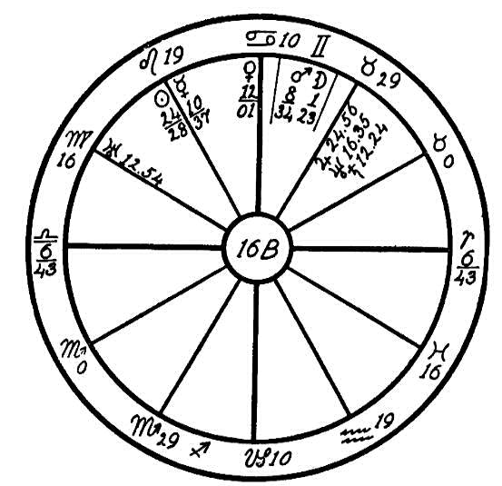
We may here see that Saturn, the ruler of the 4th house, indicating the mother, is restraining Neptune, the ruler of the 6th house, which indicates the service to be rendered. Mercury in the 10th, the house of the profession, is squaring Saturn and Neptune. We have here the proof that the mother was not in sympathy with this woman's choice of a profession, and forced her to express herself through channels where the spirit felt cramped and the artistic instincts were held in check. In the case of a weak and negative personality this sometimes works to advantage and the person does not feel the restraint. But with a fixed and positive nature such as we have in this horoscope, with five planets in fixed signs and cardinal signs on the four angles, the case is different; when a woman of this type has her ideals shattered, she finds it most difficult to adjust herself to the will of others. The impulses thus restrained most frequently find an expression in some other direction.
In this case we find Neptune and Saturn trine Uranus; the psychic side must then be the means of giving this soul relief from its pent-up feelings. Uranus is square Mars, and the moon is conjunction and parallel Mars. These afflictions together with those of Saturn, Neptune, and Mercury gave this woman a negative development. Mediumship was most attractive to her. For a short time she had the greatest joy for she developed very rapidly, which we may see from Neptune trine Uranus, indicating psychism. But had this poor soul had a knowledge of astrology and could she have seen the danger signals in the planets she would not have meddled with the negative phase of spiritual development. She would not have forced her development as we have found that she did. Being a positive character the Invisible Helpers were able with her assistance to relieve her in a short time of a very bad case of obsession, which she had developed through the practice of mediumship.
The advice given to this woman through Headquarters was to eat lightly of food consisting mainly of vegetables and fruits, eliminating heavy proteins and starches, and to keep her mind and body active, not forgetting to pray, for prayer is a wonderful help and a protection against adverse psychism.
We also find in this horoscope a very helpful lesson relative to trouble with the throat. We find Neptune and Saturn in conjunction in Taurus, which rules the throat and larynx, square to Mercury in Leo; also Jupiter in Taurus is square to the sun in Leo, indicating that the circulation of the throat would be impaired at some time. Whenever we find Saturn and Neptune in conjunction there is some difficulty in the development of the corresponding organ. This woman developed a very bad case of tonsillitis, and submitted herself to an operation in which the tonsils were removed.

CHAPTER XXVIII

THE DUCTLESS GLANDS
NO. 17A--B: THYROID GLAND TROUBLE
We will use a flat figure in both the following cases as the hour of birth is not known. This will not interfere with the diagnosis of disease, but knowledge of the rising sign is necessary, however, in determining the will of the patient. When the patient is facing a crisis it is well to know the exact time of birth in order to calculate the place of the moon and its relation to the transiting planets. These planets act as the minute hand of the planetary clock. They determine by their aspects to the radical and progressed planets whether the disease has reached a critical point. Especially do the new and full moons mark the time when changes may be expected.

NO. 17A
Female, born April 25, 1877.
We are told in The Message of the Stars that Neptune is the higher octave of Mercury, and has rule over the pineal gland, while Mercury rules the thyroid. In this horoscope we find Venus, which rules the venous circulation, in its own sign of Taurus, ruler of the throat, in conjunction with Neptune and the sun, also square to Mars in the sign of Aquarius. Neptune when afflicted by Saturn as in the second horoscope, 17B, causes

Birth Chart No. 17A

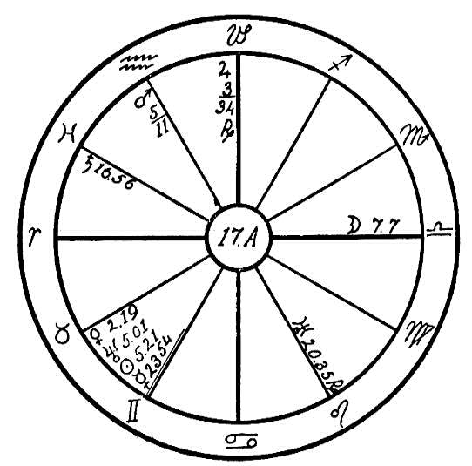
atrophy or an undersized organ in whatever part of the body he may be found by sign. If in Leo, he may cause one valve of the heart to be smaller than the others, producing irregularity of circulation. In this horoscope, however, we find Neptune between Venus and the sun, which gives bulk, The sun brings heat and a large supply of blood to that part of the body in which it is placed by sign. In this case the throat is the part receiving the greatest flow of blood. When Mars is square to the sun or Venus we may find the corresponding organ enlarged abnormally. Mercury, the plant which rules the thyroid gland, is in Taurus, square to Uranus in the fixed sign of Leo. Uranus in this sign also has a tendency to enlarge the organ affected by it. Jupiter, which rules the arterial circulation, is square to the moon.
This woman suffered from an enlarged thyroid gland, which reached such a size that it interfered with the circulation and caused poor heart action.

NO. 17B
Male, born September 26 1863.
Venus is in conjunction with the sun, Mars, and Saturn, these four planets being in the sign of Libra and all in opposition to Neptune. This

Birth Chart No. 17B

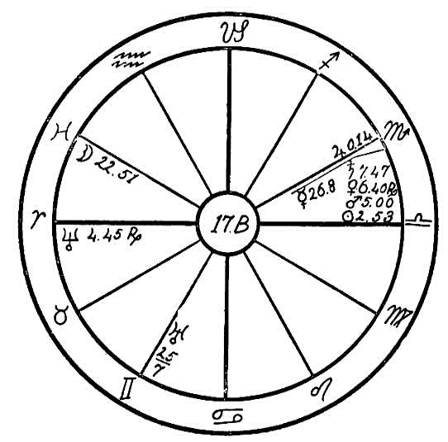
configuration, particularly the obstructing influence of Saturn, caused a disturbance in the thyroid gland, which, however, was not enlarged as in the previous case, but its functions and circulation were interfered with. This caused the man to suffer from weakened memory, deranged kidneys, and enlargement of the prostate gland.
What could be advised in order to help these patients? might be asked. In the case of the woman of the first horoscope, where an excess of blood is found in the throat and both Jupiter and Venus are afflicted, causing poor arterial and venous circulation, we would advise a brisk rubbing of the lower limbs with a pair of bath gloves, also hot foot baths to cause the blood to circulate more freely to the lower part of the body thereby taking the pressure away from the throat. We would also decrease the amount of food which makes for flesh, such as white bread, pastries, sugar, and the like. In the second horoscope we find the moon in Pisces, a watery sign, which gives a craving for liquids. It is square to Uranus. This together with the conjunction of Venus with Mars, sun, and Saturn indicates that the lower nature, especially sex, has been the native's undoing. We would advise elimination of highly seasoned foods, liquor, tobacco, and meat, and that he live a simple life with plenty of outdoor exercise.

NO. 17C.--THE THYMUS GLAND
Male, born August 16, 1918, 1:45 A.M.
This is the horoscope of a young boy who has the watery and cardinal sign of Cancer on the Ascendant. People with cardinal signs on the Ascendant are more tense, or we may call it more high-strung and sensitive than others. They feel more keenly. Not alone are their feelings more quickly hurt, but their bodies are more sensitive to pain, and heir suffering is more intense.
This boy has the magnanimous and jovial Jupiter in conjunction with the Ascendant. Jupiter is parallel to the moon, which is the ruler of the Ascendant, and Jupiter and the moon are in mutual exception. The suave and loving Venus is in the first house, which will give the native a beautiful form and face and a most lovable and attractive personality.
At the age of about twenty months he was taken ill with meningitis, which is an inflammation of the membranes enveloping the brain and spinal cord. He recovered from this illness, but his head began to enlarge, and he lost his sense of hearing. The enlargement of the head became so pronounced that it necessitated operations. At two periods a little past the age of three years (we judge the first to have been about when the progressed moon reached 27 degrees of Capricorn, which brought it to the opposition of Venus, or two months later when it reached the square of Mars) two operations were performed. A small piece of bone was removed from each temple, making an opening into the brain. This caused water to gush out of the brain, and seemed to relieve the child for a time; but later it was necessary to

Birth Chart No. 17C

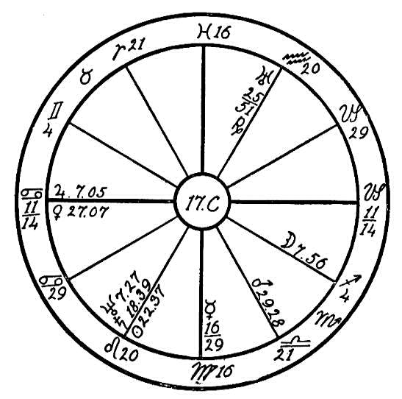
relieve the back of the head by two operations just behind the ears, one on each side of the head. We are unable to give the exact dates of these operations. We believe, however, that the moon's aspects registered them. We find that about twenty-five months after the first operation the moon was in opposition to Saturn, which registered another disturbance that we feel probably marked the time of the operation on the back of the head.
The parents brought this boy from the middle West to Los Angeles and placed him in charge of a noted osteopathic physician, who superintended the operations and treated him with the scientific manipulations of the modern and excellent method of healing, osteopathy. The parents also placed the child on our healing list with the hope that he might regain his sense of hearing, which he lost at about the age of one and one-half years. The writer was not made familiar with the past of the boy until after she had diagnosed the case to a friend, so we will see how closely the planets tally with the case.
Venus, which has rule over the thymus gland, is strong in the first house and is afflicted by the square of Mars. Mars is close to the cusp of its own sign Scorpio. Mars indicates injuries. Scorpio is the sign which has rule over the physician. The birth of this boy was a very labored one. The life of the mother as well as that of the boy was despaired of. The present-day physician does not allow the birth to be a natural one if it takes too much of his time, for he is too busy and must hurry back to his office to see his other patients. Consequently a large proportion of births are hurried through the use of instruments. In this case the forced birth caused an injury to certain nerves and to the innominate blood vessels which carry the blood through the thymus gland to the brain. With Saturn in conjunction with the sun in Leo, which has rule over the spinal cord, and both in opposition to Uranus the spinal fluid was restricted and sluggish. Uranus, which is the higher octave of Venus, has rule over the pituitary body. This body is connected directly with the outer sheath of the spinal cord, the dura mater Uranus being afflicted by the sun and Saturn has interfered much with the functions of the spinal fluids.
The thymus gland in a small child regulates the blood flow to and from the brain through the innominate artery and vein. At birth the neck of this child was in some manner injured, causing restriction of the flow of the blood. The circulation being restricted, the head consequently filled with water. The most interesting proof of this is that at the removal of the pieces of bone from the temples, also from the back of the head, there was no red blood in the wounds, at which the doctors marveled. The osteopathic physician had been very active in his manipulations and treatments of the thymus gland and the spinal column, showing that his diagnosis tallied with ours.
The boy is seemingly in good health but has lost his hearing. There is some hope that this may be regained. When he reaches puberty and the thyroid gland takes up the work of the thymus gland, the nerves and the blood vessels which serve the ear may be stimulated, and through the aid of the Invisible Helpers the hearing may be regained. There is, however, some danger that the operations which were performed on the back of the head may have permanently injured the nerves, which would affect the hearing.

(17D) THE ADRENALS
Female, born November 27th, 1905, 1:15 P.M.
This young woman has the watery and negative sign of Pisces on the Ascendant, and Jupiter, the ruler, retrograde in Gemini in the third house in opposition to the life-giving sun. This to begin with is a much hampered and restricted ruler, and is an indication that this soul has in its former lives contracted debts of destiny which have matured and await their payment in this life; for if the life ruler is afflicted by the most powerful planet, namely the sun, also the square of Saturn and the parallel of Mars, and is receiving little help, having only one helpful aspect, the trine of Mars from the twelfth house, then we may take it that this person will have her debts to pay in this life, and there will be no freedom until they are liquidated.
We find a very well-aspected Mercury in the 10th house, in conjunction with the moon, the Midheaven, and Uranus, and sextile to Saturn. The moon, which has partial rule over the mind, is in conjunction with the Midheaven, giving the native a quick, keen mind. From a mental standpoint this girl should be able to accomplish anything upon which she sets her mind, and one wonders why such a mind is seemingly not accomplishing anything. What is the cause?
We find common signs on all the four angles; the life ruler, Jupiter, is retrograde in the common sign of Gemini, which is the sign of its fall, and the sun also is in a common sign. These are indications that this soul is satisfied to drift with the tide. Whatever headway she makes in this life will be through the prodding influence of the father, signified by the tenth house.

Birth Chart No. 17D

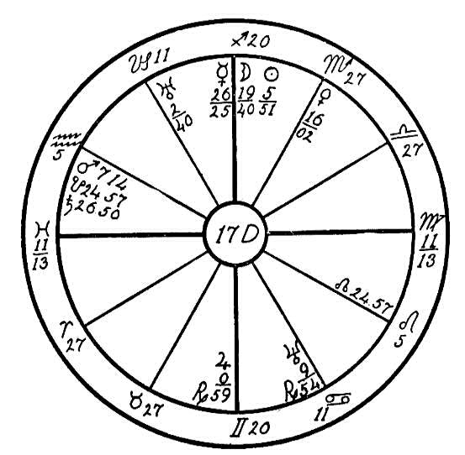
Jupiter has rule over the arterial circulation. His afflictions tend to restrict the free flow of the blood stream. Jupiter also has rule over the adrenals, the two tiny ductless glands which are over the kidneys. These two organs, like the thyroid gland, help to take care of the blood. As it passes through them, it receives its supply of adrenal secretion. This secretion gives energy to the body and causes the fluids to flow more freely. The adrenals are the organs which stimulate the body. When we find Jupiter, which has rule over these organs, as the life ruler and so severely afflicted, we may expect the patient to be lacking in energy, a negative and ambitionless person.
Neptune, which is the higher octave of Mercury, works upon the nervous system, and rules the pineal gland and the spinal canal. It is retrograde and in opposition to the spasmodic and erratic Uranus, the planet which rules the pituitary body. Therefore we may look for a general derangement of the ductless glands. We find a disturbance of the adrenals, which are excited by the emotions, causing an uneven flow of their secretions, sometimes resulting in convulsions or the opposite, coma, according to the character of the uncontrolled emotions of the patient.
This girl is the daughter of a wealthy father and a most self-willed and selfish mother, who is addicted to the use of cigarettes and liquor. While the mother was pregnant with this child, at times when she saw her husband coming from his place of business she would throw herself into a fit in order to work on his sympathy. In this manner she would get all her selfish wants supplied. We are told in he Rosicrucian teachings that the Ego is attracted to a parent through whom it may receive its lessons, and it may well be said that this girl found in her mother one who could bring to her many sad lessons.
If the girl is crossed she quickly flies into a rage which ends in a fit very similar to epilepsy. However, she does not froth at the mouth, neither do her jaws set, as is sometimes the case in the above disease. Temper causes the adrenal fluid to flow too rapidly into the blood. Excess of this fluid causes jealousy and envy.
We find two different conditions expressed in the spells under which this girl labors. Jupiter is in opposition to the sun, and parallel to Mars, which causes at times an excess of secretions, giving rise to the condition already mentioned. At other time she will swoon away, being perfectly lifeless and rigid. This last condition is brought on when the adrenals stop sending their fluid into the blood, indicated by Saturn square to Jupiter. When under the first mentioned condition she has all the appearance of one who is obsessed and becomes very cruel to those about her. This is also shown in the horoscope by the opposition of Neptune to Uranus.
The father has spent a fortune trying first one doctor and then another, but to no avail. The girl is quite normal when not laboring under the influence of these spells. She, like her mother, also throws herself into them in order to work upon the sympathy of her mother, sisters, and father.
The latest diagnosis of the doctors is that a tumor is growing in the brain near the cerebellum, and both the girl and her mother wish her to have an operation, while the father is bitterly opposed to it. What the outcome will be remains to be seen. Should she submit to the knife, as she is determined to do, she may spend the remainder of her life in an institution as a mental patient.

CHAPTER XXIX

SPECIAL CONDITIONS
NO. 18A.--DEFICIENCY IN LYMPH
Male, born May 11, 1913, 6:59 A.M.
A child is the subject of this reading, who was about fifteen months old at the time the reading was originally made. Ordinarily it might seem superfluous to judge the character and mentality of one so young. Nevertheless, when we consider the body from a spiritual standpoint as the temple of an indwelling divine spirit, it will be seen that the builder and architect of that temple must be taken into consideration from the very first breath until the time when the silver cord snaps.
The mercurial sign Gemini is rising, but there is not the ordinary Gemini nature, for Saturn in Gemini puts his obstructive hand upon this child and will give a tendency to melancholy and a retiring disposition, a desire to get away from society.
Mercury and Venus in Aries, square to the moon and Neptune, give a tendency to secretiveness, but the sextile of Saturn to Mars and Saturn's trine to Uranus make the mind idealistic and energetic. Thus on the whole there is good material for the parents to work upon. They should by all means discourage the tendency to secretiveness, encourage idealism, and make the youngster play with his companions. It looks very much as though

Birth Chart No. 18A

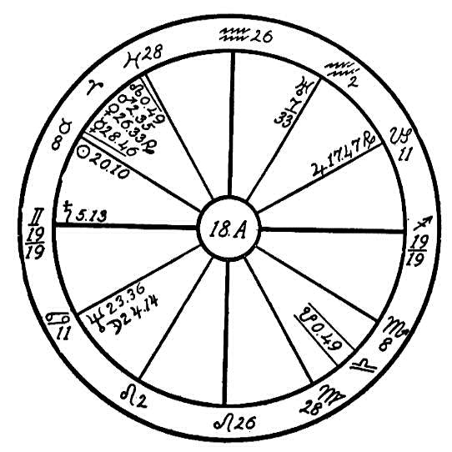
he might be too much taken with himself, and from the very earliest childhood he should be taught to go among people. He should never be allowed to go out by himself more than can possibly be helped.
Usually children of this age sleep largely from morning till night and from night till morning; as soon as they have received food they go out into dreamland that assimilation may be carried on better. But this is not the case with our little subject; sleeplessness, restlessness, and nervousness are the results of the opposition of the moon and Neptune to Jupiter and the square of these three planets to Mercury and Venus posited in Aries, the sign governing the head. Thus the whole nature is aquiver, the child cannot get the needed rest, hence it is sick.
The main trouble comes from the fact that the moon is conjunct Neptune. This interferes with the distribution of the fluid indispensable to assimilation, the lymph. Jupiter is afflicted by these two planets, and he governs assimilation. On account of these two facts the child will not grow as fast as he might other wise. He has peculiar notions about his food, and these ideas will grow as he grows. This tendency is one of the things that must be dealt with firmly, for the square of the moon to Venus gives abnormal cravings, the moon and Neptune in Cancer will cause the child to long for something that he never finds, and this might lead to the formation of habits that would be extremely dangerous. No matter how he may protest and though it may seem that ordinary foods do not agree with him, he should be taught to eat everything of a good and healthful nature that comes on the table, for the formation of a healthy appetite will counteract the strange tendency that is dormant in his nature. Sweets in moderation will help.
The circulation is interfered with by the affliction of Neptune and the moon to Venus and Jupiter. Saturn and Uranus are strongly configurated by trine and parallel from airy signs; this further reacts upon the circulation and makes it spasmodic. The heart has a tendency to flutter on account of the presence of Uranus in Aquarius. Thus the poor little child is considerably afflicted to start with. Nevertheless there is no need of worry, for the sun is trine to Jupiter and sextile to the moon and Neptune. The fact also that it is in the marvelously vital sign of Taurus will operate to preserve life, and even Saturn on the Ascendant gives persistence, resistance to disease, and tenacity of life.
There will be crises in the life, however, which knowledge of the foregoing will make it more easy for the parents to prepare for. The most severe one will come at the time of puberty. Then the progressed moon will be working in the 8th house, the house of death, and in opposition to its own place, configurated with Neptune and square to Mercury and Venus. This is a serious position but not all to be feared on account of the fact that the sun is so strong in the horoscope. Moreover the trine of Saturn and Uranus and the sextile of Saturn and Mars give a wonderful elasticity and energy to the nature so that no matter though the boy be brought near the grave, he will have the resilience to recuperate with astonishing rapidity.
At the present time it should be investigated as to whether the mother is nursing the child, and whether she has felt nervous and run down. If so, the child should at once be put upon a diet of goat's milk, which will give the needed ether to compensate for the lack of lymph, and though the child may not like the diet, he will grow accustomed to it.

NO. 18B--POLYPI AND KIDNEY TROUBLE
Male, born June 3, 1865, at 3:00 A.M.
We have here the horoscope of a man with the fixed sign of Taurus on the Ascendant, and the ruler, Venus, posited just above the Ascendant in Taurus and in the 12th house. Venus is making but two major aspects, a conjunction with the Ascendant, and a square to the inflammatory Mars, which is in the fixed sign of Leo and in the 4th house.
The sign of Taurus rules the neck, throat, lower jaw, larynx, and tonsils, and its opposite signs, Scorpio, rules the rectum, descending colon, urethra, and also the nose. These signs of Scorpio and Taurus are the most vital signs of the twelve. Mark the strange coincidence which lies in the fact that Taurus rules the greater part of the lower head and neck, and the organs adjacent to the upper end of the spinal column, while Scorpio slips in with its influence by ruling the nose in addition to the organs

Birth Chart No. 18B

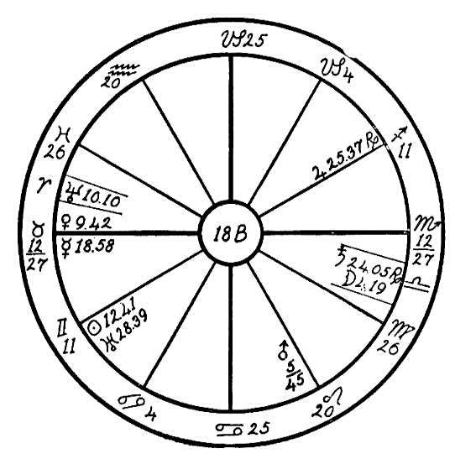
near the lower end of the spinal column. Leo, the sign which squares Taurus and Scorpio, rules the river of life, the spinal fluid, which connects the organs ruled by Taurus and Scorpio.
Now in the horoscope under consideration we find the inflammatory Mars in Leo, square to Venus in Taurus. Venus, being at home in this sign, naturally attracts to herself the inflammatory influence of Mars whenever Mars is found either in Taurus or afflicting her in that sign. Then we may look for inflammatory troubles in the nose, generative organs, or rectum. We may also look for the polypus which is a small growth peduncular in shape that grows from the mucous membrane of the nose, and which often closes the nasal passages, causing difficulty in breathing. It sometimes also grows within the vagina or rectum. The habit of mouth breathing in children often lays the foundation for these growths in the nose when planetary afflictions are present in the horoscope. The mucous membrane of the nose is then abnormally sensitive and subject to irritation, which may result in these polypi, frequently causing hay fever or asthma.
The patient whose horoscope we are considering suffered with these growths in both nasal passages, making it necessary that he breathe entirely through the mouth. The moon is in 4 degrees and 19 minutes of Libra in the 6th house, which is the house of health. The moon is the natural ruler of Cancer, the sign ruling the stomach. At the age of twenty-eight, when the moon by progression had reached its place at birth, this man became seriously ill with painter's colic, which later resulted in permanent injury to the kidneys. The latter is due to the moon and Saturn in Libra, which sign has rule over the kidneys. This general break in the health increased the small growths in the nose, which resulted in an operation when the moon progressed into Scorpio and was in opposition to Venus.
By eliminating meat, tobacco, liquor, and all condiments and living as near as possible to nature's laws, this man is again enjoying good health.

NO. 18C.--PYORRHEA
Female, born July 13, 1871, 5:30 A.M.
Leo, a fiery sign, here in on the Ascendant with the life ruler, the sun, in the 12th house in Cancer in conjunction with Mercury and Uranus and square to Neptune. We know from our reading of The Message of the Stars that Cancer rules the stomach, in which the greater amount of food must be digested. This organ is the central supply station through which the body receives its sustenance. Cancer also rules the esophagus, the tube between the pharynx and the stomach, and the thoracic duct, the principal duct which carries the lymph of the body.
We note in this horoscope Uranus afflicted by a square of Neptune from the Midheaven and the sign Aries. With Mercury and the sun also in conjunction with Uranus and square to Neptune, we may expect an abnormal or a radical mind. When an idea is formed it is carried to an extreme. This woman could find no limit in anything, and we find this tendency indicated regarding food. With the sign of Cancer on the cusp of the 12th house, the

Birth Chart No. 18C

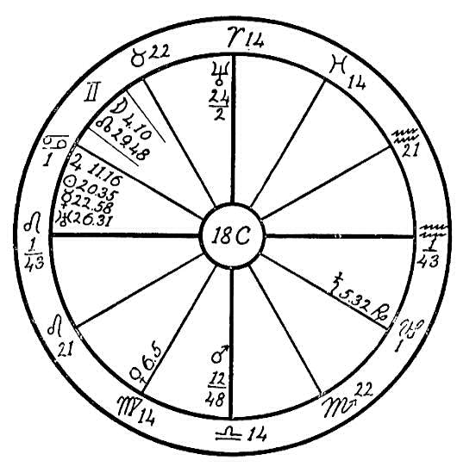
house of self-undoing and limitations, and with the above afflictions of Uranus, Mercury, and the sun we may expect great impulse and a decided tendency to overeat.
The planets in the 12th and 6th houses when afflicted are the most detrimental to health, and in this horoscope we may look to the stomach as being the seat of the trouble. Let us find the reason for this assertion:
The moon which is the ruler of the 12th house is in the house of friends, the 11th, and square to Venus in the 2nd in the 6th house sign, Virgo, ruling labor and sickness. This plainly shows us that this woman was most hospitable, loved to entertain her friends, was happy when she could regale them, and as indicated went to extremes in this direction. Venus square moon indicates an abnormal desire for pastry and sugar; it indicates one who having eaten a heavy meal, richly prepared, would indulge in chocolate creams and various other ash producing dainties. This is one of the types of women whom we often meet, whose greatest pride is in cooking and who are never so happy as when they are entertaining at a sumptuously prepared table. Cancer people are good cooks and usually take great pride in catering to the needs of the stomach.
In this horoscope we find Saturn, the planet of obstruction, in its own sign Capricorn and in the 6th house, health. Saturn is in opposition to Jupiter in the sign of the stomach and in the 12th house. Planets and their afflictions often show their effect in opposite signs, and when Saturn is in Capricorn we usually expect some derangement of the stomach, for his effects there are very similar to those of Saturn in Cancer. With Jupiter ruling the arterial circulation, afflicted by Saturn, we may expect trouble with the circulatory system of the stomach. And with the spasmodic Uranus in conjunction with mercury, the nerves are also sensitive and nervous indigestion is indicated.
Now, when Saturn afflicts the stomach, there is a lack of pepsin and stomach fluids wherewith to digest the food. Saturn in Cancer or Capricorn gives abnormal appetite and makes one very fond of pastry, especially of sugar, as does Venus square moon mentioned before. As vegetarians, such people find it very hard to keep their bodies in good order for they will usually refuse raw vegetables, preferring the starches and sugars. As a result the body does not receive the proper amount of mineral elements, and the blood soon fills with ash. When an overabundance of refuse is stored up in the blood, the body must seek a means of eliminating the waste matter. If it is unable to find an outlet through which to throw off the impurities, and if the bowels also refuse to do their part as is often the case when an overabundance of food is consumed, then an illness is the result. We frequently find cases of catarrh, skin disease, ulcers, etc., which are merely an avenue the body uses to dispose of an excess of ash.
In the case of this woman we find the gums eliminating pus and receding toward the roots of the teeth. This disease is commonly called pyorrhea or Riggs' disease and is increasing to an alarming degree in America. It was rarely heart of fifty years ago, but since there has developed such a craze for sugar and candy humanity is paying the price.
To overcome this disease a well balanced, simple, vegetarian diet, free from sugars and starches is advisable, and the careful cleansing of the gums with lemon water each day.

NO. 18D.--AUTO-INTOXICATION
Male, born November 4th 1882, 11:49 P.M.
This horoscope is that of a man with the watery sign of Cancer on the Ascendant. In diagnosing it is customary to look to the sixth house, which has rule over disease, and its ruler for the key to the trouble. In this horoscope we have the sign of Capricorn on the cusp of the sixth house, with its ruler, Saturn, in the 10th house in conjunction with the Dragon's Tail, which is Saturnian in its influence. Saturn is also conjunction Neptune in Taurus. These are all in opposition to the inflammatory Mars, which is strong in its home sign Scorpio, having rule over the rectum and generative organs. This is a most dangerous and subtle affliction, increased by Neptune parallel the sun in Scorpio, and indicates an unrestrained passional nature which in childhood found its outlet through the secret habit of masturbation. This in time depletes the vitality, stunting the mentality, and also the physical growth, and later in life causes much physical trouble.

Birth Chart No. 18D

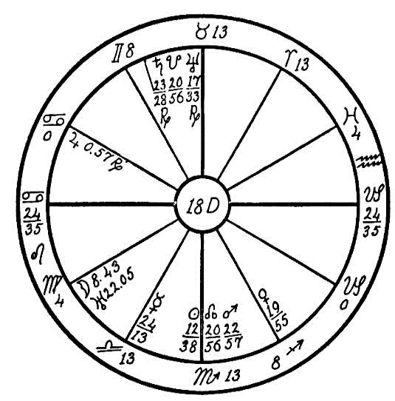
Scorpio rules both the rectum and the vital organs, and when excesses occur they often cause inflammation in the rectum resulting in intestinal hemorrhoids, interfering with elimination and causing a general sluggishness of the excretory duet.
We find the spasmodic Uranus in Virgo, the sign ruling the intestines; it is also the natural sixth house sign and the sign which rules sickness. Uranus is square to Venus, which rules the venous blood. Here we have indication of restricted circulation in the small intestine. Jupiter, the planet of opulence, the planet which wants things in large quantities, is in Cancer, the sign ruling the stomach, and in the twelfth house, the house of self-undoing, sextile to the ruler of the Ascendant, the moon, indicating that this young man has been a very hearty eater, carrying eating to excess.
He dissipated the life forces during the period of life when he was in greatest need of them, and has also consumed more food than the organs could digest and distribute. Naturally, when the organs of elimination refused to work, as might be expected, the blood stream became charged with ash, causing granulation of the joints through the excessive clogging generated in the body from too much protein. This also burned up the natural body oils, causing a granulation of the eyelids, rheumatism, and a generally weakened condition of the entire system.
Our advice to this patient would be to eliminate meats and starches, taking very little of the proteins, and to eat mostly fruits and vegetables; also to live a chaste, clean life. Care should be taken to have his surroundings clean and to sleep in a room with plenty of fresh air, for when we find Saturn afflicted by the Dragon's Tail and Neptune in Taurus, it indicates a tendency to neglect the sanitation of the body and surroundings.

NO. 18E.--PERITONITIS
Male, born August 4, 1862, 11:30 P.M.
Taurus, a fixed and stubborn sign, is on the Ascendant, with the ruler, Venus, in the watery sign of Cancer, square to the fiery and impulsive Mars, and parallel to the ruler of Cancer, and watery moon. Venus is also ruler of the house of sickness, the 6th house. Mars is in the 12th house in its own sign of Aries.
We may look for the key to the trouble in the configuration and the positions of the above three planets, Venus, Mars, and the moon.
The planets that are in a location corresponding to that part of the body in which the disease is found are not alone the cause of the disease. If a burglar has entered our home and carried away our jewels, the first step to be taken to find the culprit is to ascertain the place of his entrance. So also must we find the gateway or the cause of the disease.
Venus, we know, is the planet ruling sweets, sugars, etc. Taurus is the sign ruling the throat, the palate; therefore Taurus has great influence over the appetites. Venus is in Cancer, the sign ruling the stomach and the thoracic duct, and is afflicted by a square to Mars. Mars when afflicted by Venus and when in its own sign of Aries causes dissipation and desire for excesses in eating, especially when Venus is in the sign of the stomach. Taureans are usually very fond of food things to eat and drink; they are hearty eaters and are apt to gourmandize. Therefore with the above

Birth Chart No. 18E

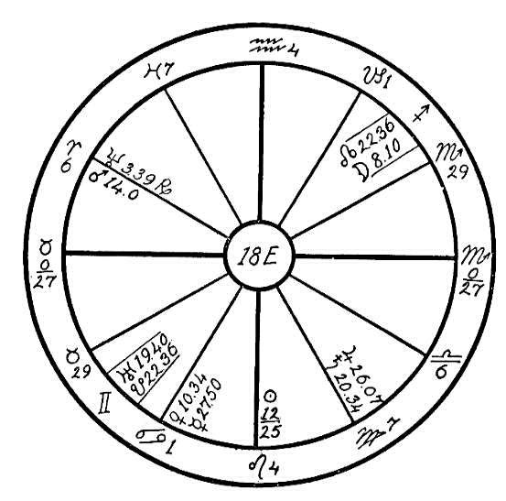
afflictions this native would eat and drink to excess.
Uranus in Gemini is in a very nervous position. This excitable, restless, and nervous planet, especially as it is squared by Saturn and Jupiter from another mercurial sign, Virgo, will have a strong effect upon the nervous system.
Now, with Venus, which has rule over the venous blood, afflicted by Mars, and with Jupiter, ruling the arterial blood, afflicted by the conjunction of Saturn and the square of Uranus, this man has a very sluggish circulation, especially of the stomach and small intestines. With both Jupiter and Saturn posited in Virgo, what could be expected but that when an affliction touches any of these planets sickness would result?
At the age of thirty-nine the native's progressed sun reached the square to Uranus which brought on nervous trouble. At the same time the sun was within one degree of a conjunction of Saturn radical. The sun takes three years to pass a conjunction; one year applying, one year in conjunction, and another year separating. Therefore, this man passed through a double affliction at that time, and a severe spell of peritonitis was the result. He was unable to recover readily from this sickness, since through his ignorance of the causes he did not stop his heavy indulgence in food and drink. In 1918, when the progressed moon came to the square of Saturn and Jupiter and the opposition of Uranus, another illness occurred, which left him with a severe case of catarrh of the intestines.
If a patient of this type should call upon a probationer for advice and help, what should he advise? He should first find the cause, and it is so evident there that excess of food and drink were responsible that he should advise abstinence from food for a short time, especially that ruled by Mars, such as highly seasoned articles and condiments. Liquor and tobacco should be entirely avoided. A strict vegetarian diet should be advised with plenty of fresh air and sunshine to assist in relaxing the nerves. Where the Venus and Jupiter circulations are sluggish, a friction bath would be advisable.

NO. 18F.--ARTERIO-SCLEROSIS
Male, born July 27th, 1856, 5:00 A.M.
As has been often stated in our astrological books and lessons, man is master of this fate. He has his whole life before him, either to make or to mar. Here we have a horoscope for diagnosis that speaks for itself, that of a man who has had everything in his favor, with but two evil aspects in the entire horoscope; everything else is good. We find the sun and Venus conjunction in the sign of the heart, Leo, one of the strongest signs of the entire twelve. Both these planets are sextile to the moon and trine to Jupiter, Jupiter being near the Midheaven. The mentality is decidedly strong and keen, especially along metaphysical lines. Neptune is in its own home (Pisces), sextile to Uranus and trine to Mercury. The moon is also well aspected and in a mental sign, Gemini. This man ha a wonderful start in life, and brought over with him from a previous life many fine qualities.
As is often stated in astrological books by old and reliable writers, Jupiter in the Midheaven brings much good to the native. And surely this man had many opportunities to succeed. Now why did he fail?
First, we find Saturn in Cancer. As stated in The Message of the Stars, page 257, this "indicates that the stomach is weak and the gums subject to pyorrhea. There is inability to properly digest the food." The stomach is lacking in the fluids necessary to aid digestion. The native is also very peculiar in his likes and dislikes as to food. This is the key to his bodily afflictions. We find Saturn making a square to Jupiter, which rules the arterial blood, and as stated on page 299 of The Message of the Stars,

Birth Chart No. 18F

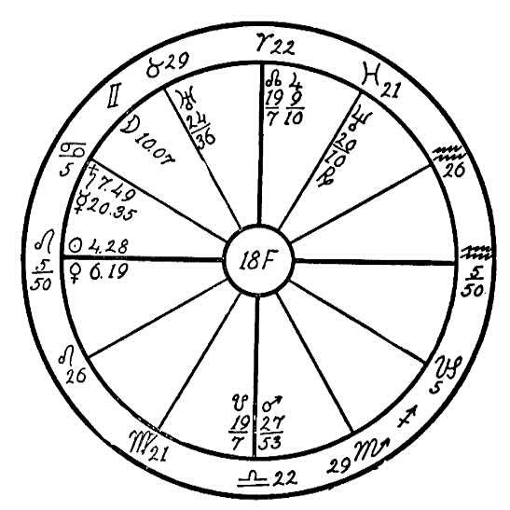
under this aspect the native is "indolent and inclined to drift with the tide; often a ward of society either in the poorhouse or prison. This aspect also gives a tendency to arterio-sclerosis."
We find the coarse, combative, discordant, passionate, and hot-tempered Mars in Libra, a Venus sign. When afflicted it brings out its own lower nature and that of Venus, creating undue attraction to the opposite sex. As Mars is co-ruler of the 5th house and is making a square to the impulsive and egotistical Mercury, the native's in harmony and hot temper have led him to excesses. Instead of expressing the beautiful, artistic, and musical nature of the sun and Venus conjunction on the Ascendant in Leo trine to Jupiter, this man has directed an excess of love and vitality in the wrong direction. He has indulged too freely in rich food, and has expended much of his energy through the 5th house, pleasures. He has had much in harmony in the home, caused by himself and his temper. As a result the blood has become vitiated, and he now is in a very advanced stage of arterio-sclerosis.
In order to find out the time of the affliction we will go to his forty-fourth year when the progressed moon had reached the 6th house in the first degrees of Capricorn. It there made an opposition to Saturn in the 12th house in Cancer, the stomach, and a square to Jupiter in the Midheaven. At the same time we find Mars progressed has reached 24-51 of Scorpio, making an opposition to Uranus in Taurus. Impulse and excesses in fast living at that time broke down his system, and since then the man has been an invalid, perfectly helpless, wheeled in a chair and confined in hospitals, due to Saturn and Mercury in the 12th house, self-undoing. But he has always found some kind hearted woman friend to look after his wants. He has been a very difficult patient; his temper has been dreadful. Through his suffering he has allowed himself to drift into this state of irascibility. Instead of responding to the beautiful Venus influence he has given way to Mars square Mercury.
In order to improve he should have a nurse with Saturn well aspected, one of an Aquarian nature, cool, calm, and collected, who could soothe him, quiet his temper, and with great diplomacy lead him into right living. At present he demands certain food and unless the nurse gives it to him he has a dreadful spell of temper. This man would have to be loved into doing things. To make a demand upon him or to tell him he dare not do a certain thing would only awaken the spirit of opposition in him. Brisk massage with a pair of rough bath gloves to open the pores of the skin and start the circulation would be beneficial. Proper food and assistance to control his temper would in time help him to overcome his condition.

NO. 18G.--TYPHOID AND SPINAL TROUBLE
Male, born December 29, 1900, 12:45 A.M.
Four cardinal signs are on the angles, with Mars trine to the sun and Saturn. These testimonies show the person to be endowed with good vitality and with an active and ambitious nature. But the counteracting aspects are also strong. The moon is square to the sun and Saturn, Mars is square to the ruler, Venus, and the majority of the planets are under the earth. This takes away from the general resistance of the person. The opposition of Neptune to Jupiter and Mercury in mental signs, Gemini and Sagittarius shows that the native is of a very nervous temperament.
Neptune in the 9th house usually gives a tendency to be a dreamer of dreams, a visionary who grasps at the illusory things in life rather than those that are near by the tangible. Neptune's opposition to Mercury, the planet of reason, shows that this would be particularly accentuated in the present case. The moon in Aries square to the sun and Saturn would further make the mind flighty and unstable.
Mars in Virgo configurated with Uranus, whether by good or evil aspects, makes a person liable to intestinal disorders. Mars is the planet of inflammation and fevers. He causes operations and other violence. Configurations of Mars with Uranus have been observed to result not only in typhoid and gastric fevers, but also very often Mars ruptures the peritoneum and causes the person to have a prominent abdomen. The young man whose horoscope we are considering had typhoid fever as an initial disease when the moon passed the conjunction of Mars by progression through the eleventh

Birth Chart No. 18G

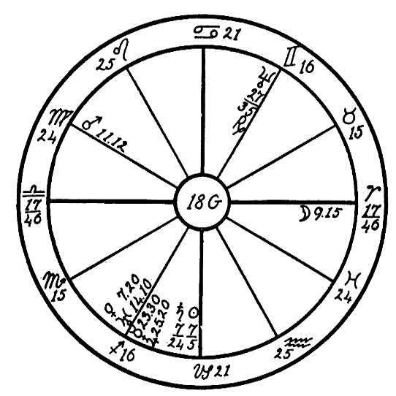
house. Later she came to the square of Neptune, Jupiter, and Mercury. Then the native's spine began to weaken. You will notice that the opposition of Neptune to Jupiter and Mercury is from Gemini to Sagittarius, covering the region of the spine. The moon later progressed to the opposition of her own place at birth, and as the radical moon in Aries has particular dominion over the cerebellum, which is the organ of coordination of movement, you will readily understand that this makes it difficult for the patient to walk.
This is a curious case of interlocking afflictions and good aspects, for you will observe that whenever the two principal afflicters Mars and the moon, are struck by an adverse aspect there is always a good set of aspects to minimize the evil effects. Were this not so the severe afflictions would certainly have done away with this young man long ago. The square between the moon and Saturn is particularly inimical.
The moon progresses around the horoscope in twenty-eight years as we measure a day for a year. Saturn in the heavens by transit actually moves around the circle of the zodiac in about thirty years. Thus the progressed moon and the transiting Saturn are always bound to follow each other pretty closely. When they are square at the birth of a person, they keep that same relationship for a considerable number of years. Thus good aspects in the horoscope are offset by the fact that the progressed moon is square to the transiting Saturn, and evil aspects are similarly accentuated by this unfortunate square. Therefore anybody who has this unfortunate configuration is certainly under the whiplash of Saturn all his life. Even the good aspects which we note in this horoscope and which are certainly very strong are to some degree nullified by the square of Saturn and the moon at birth.
Saturn always indicates that part of our destiny which has been brought over from previous lives, and is almost unalterable. Therefore in this case there is unfortunately not much to do. Baths and massage applied by a healer who has Aquarius rising and whose Saturn is not in Libra or Pisces would be most helpful.

NO. 18H: NARCOTICS--CIGARETTES
Female, born April 7, 1880, at 7:00 A.M.
We have here a most interesting case, that of a woman with the fixed sign of Taurus on the Ascendant, and with the ruler in the watery sign of Pisces, intercepted in the 11th house, in conjunction with the watery moon, and square to the fiery and destructive Mars. Mars is the ruler of the 12th house, the house of confinement, and Venus is the ruler of the 6th house governing sickness.
About 1904 the patient was operated on and had one kidney removed. She could not give the exact year, but from planetary aspects we feel certain it was in 1904, when the progressed sun ha just passed a conjunction with the radical Neptune near the Ascendant, and the progressed moon was making a square both to the radical Neptune and the progressed sun. At the present writing this poor woman, who is forty-four years of age, expects to become a mother in three months, and is struggling to overcome the dread narcotic habit, which she has had about six years, also the cigarette habit.
A most interesting principle is brought out in this horoscope. Neptune in Taurus near the Ascendant is trine to Uranus in Virgo in the 5th house. These planets are in signs of mutual reception; that is, Neptune being the higher octave of Mercury is in a Venus sign, Taurus, and Uranus the higher octave of Venus is in the mercurial sign of Virgo. The trine of these two mystical planets would indicate the development of the two ductless glands represented by them, namely the pineal gland by Neptune and the pituitary body by Uranus. When these two glands are for any reason awakened and the

Birth Chart No. 18H

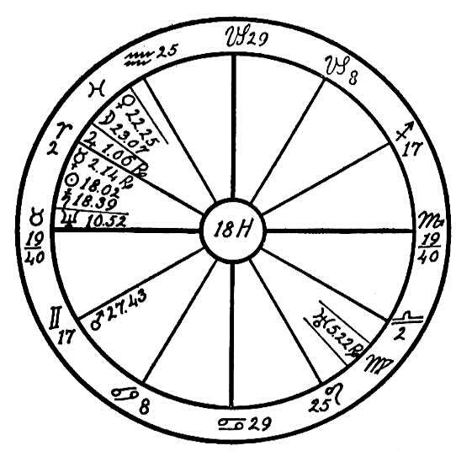
soul does not respond to the higher life but is inclined to drift into sensual and worldly channels, their awakening then frequently leads to the grossest indulgence of the lower nature--sometimes to drink or narcotics as in the case of this poor woman.
Venus and the moon in conjunction in Pisces, Venus being the ruler of the 6th house, governing sickness, and Mars the ruler of the 12th house, governing hospitals, indicate that some one in a hospital was responsible for her forming the habit of taking narcotics from which she is suffering and this person we believe to be a doctor friend who attended her. At the time when she claimed she acquired the habit of using narcotics we find the progressed Mercury trine to Uranus and the progressed Venus in conjunction with Neptune. This would have a tendency to awaken the above mentioned glands and cause a soul hunger, which in this case the woman mistook for a desire to indulge in soul flights through the use of narcotics instead of through living the Christ life.
But the struggle now comes to get relief when she is in a most weakened, despondent, and generally rundown condition from a spell of influenza complicated by pregnancy, nerves, and insomnia; also the elimination through the one remaining kidney is now being interfered with by Saturn conjunction sun in Aries, which is producing an effect in the opposite sign of Libra.
The one gleam of hope held out through the planets is the progressed sun within orb of a sextile to the radical Jupiter and the progressed Mars trine to the radical moon. These aspects are most favorable for the aid of the Invisible Helpers, who can accomplish much more under favorable planetary aspects than at other times. Especially is she likely to receive help because her spirit is most desirous of overcoming, although she is lacking in faith regarding our method of healing. She was persuaded to call upon us for help by her own doctor, who had been healed through our Invisible helpers.

CHAPTER XXX

INSANITY
NO. 19A.--A MENTAL CASE
Female, born June 12, 1897, 9:00 P.M.
We have at all times tried to impress upon the minds of students of the Rosicrucian Philosophy the great necessity of always looking at the bright side of life, and ever to hold out hope to unhappy and afflicted ones. If we aspire to be helpers of humanity, workers in God's great vineyard, we must always throw the life line to the drowning man, that is, give him that hope, that help, which means life to him. The astrologer who voices the doom of his patient and takes the last ray of hope away when one who is suffering comes to him perhaps as the last resort is little less than a murderer. This may be putting it very strongly, but the writer feels that this point cannot be emphasized too much.
To illustrate the danger that lies in the prediction of death: a woman wrote to Headquarters stating that she had but two more years to live, for the astrologers had predicted this. Would we advise her, she asked, to take up the Rosicrucian Philosophy and astrology, and should she go ahead with the school which she had started, or would it be best to give everything up and prepare herself or the coming event, her passing out of the physical

Birth Chart No. 19A

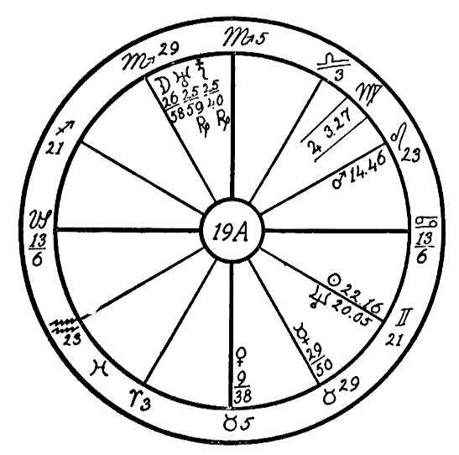
body? We can assure you that this woman received a letter from Headquarters that as surrounded by strong vibrations which scattered effectually the thoughts of death. As a result of the letter she became a student of the Philosophy and is today an active and healthy woman, destined to reach a ripe old age. The astrologer who predicted this woman's death might have been guilty of murder, but fortunately through her coming in contact with one of our pupils who advised her to write to Headquarters, this was averted.
In 19A we have a patient who has so many weak and afflicted planets that the astrologer must use the greatest diplomacy in order to encourage her. On the first house is the gloomy, pessimistic Capricorn, with the ruler, Saturn, in the Midheaven afflicted by the conjunction of the negative, visionary, worrisome moon and the irresponsible and fanatical Uranus; and to make it even more unfortunate these three planets are in conjunction in the fixed and martial sign of Scorpio, the natural eighth house sign, the house of death. Mercury, the ruler of the mind, is in the gloomy and stubborn sign of Taurus in opposition to the afflicted planets in Scorpio. Could we find anything more unfortunate for mental trouble? When Taurus is afflicted he assists Capricorn in magnifying the gloom side of life and increases his brooding over imaginary ills, so you can imagine the temperament of this poor woman. She was sadly in need of help.
Her request for help came to us in November, 1916. She was at that time in such a mental state that she had threatened suicide, could do nothing but weep, and was surrounded by imaginary troubles. But she was very faithful in writing her weekly letters and did all possible to cooperate with the healers. When she requested healing her progressed Mars was square to the radical moon, Uranus, and Saturn in Scorpio, which caused this mental disturbance. But fortunately the progressed moon at that time was in 25 degrees of Cancer trine and sextile to the afflicted planets in the 10th and 5th houses respectively. This was the life line that was ready to be thrown to help her.
Note that the artistic harmonious, and musical radical Venus is in her own sign of Taurus, trine to the reverent and optimistic Jupiter. The one window of light open to her was this good aspect--music and art. It was necessary to bring harmony into this poor inharmonious mind, and we prevailed upon her and her friends to provide her with music in the home and to interest her in art. At the time of her request for help her progressed sun was in 9 degrees and 50 minutes of Cancer, making a good aspect to the radical Venus. This as the means of saving her reason. In May 1917 she wrote us she was feeling so much better that she did not need the help of the healers any longer.
Here we can see what a wonderful work can be done through a true knowledge of astrology. Had an unscrupulous astrologer met this woman and predicted suicide, the danger of which as shown so plainly in the figure, he might have been her murderer. Therefore, dear friends, we hope you will take this as a lesson to use astrology to help and to heal and not to wound.

NO. 19B.--INSANITY
Female, Born January 7, 1868.
Although we are unable to predict the dates of crises in her illness on account of the lack of the birth hour, still the aspects between the planets in this woman's chart, show sufficiently well the nature of the illness and the yearly crises. We find the erratic and eccentric Uranus in the psychic sign of Cancer, in opposition to Mars, the planet of impulse and recklessness. Uranus is also in opposition to the life-given sun and to Mercury, the planet of reason, both placed in the belligerent and violent sign Capricorn. All four of these planets are square by Neptune in Aries, the sign which rules the head and the brain.
We find that the benevolent ray of Jupiter is quenched by its placement in the twelfth house sign of Pisces, indicating sorrow, trouble, and self-undoing. There he is conjoined with the saturnine Dragon's Tail and squared by the moon, the giver of visions and imagination, making the mind morbid. He is also squared by Saturn, the planet of gloom and melancholy. As a result of all these adverse, perverse, and perverting influences the poor woman has always been weak-minded, impulsive, reckless, gloomy, erratic, and visionary. In the year 1915 matters cam to a crisis when the sun was in the twelfth house sign of Pisces, ruling hospitals and asylums. The progressed moon also was there in conjunction with the sun and the saturnine Dragon's Tail, and all of them square Saturn, with the result that the woman as taken violently insane and had to be confined in an asylum, where she has

Birth Chart No. 19B

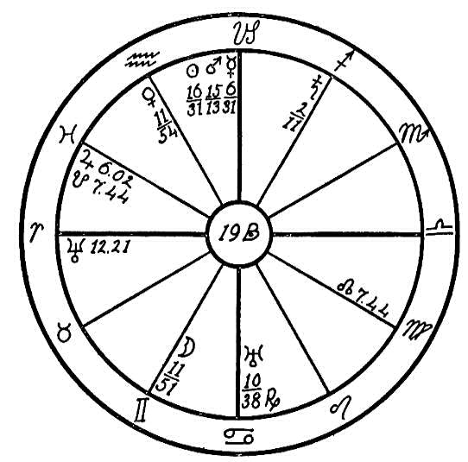
been ever since. There has been little or no improvement so far as the mental condition is concerned, and the condition of physical health is also delicate.
It is not a hopeless case, however, for the principal inimical influences are from cardinal signs, whose force is comparatively soon spent, and the remainder are from common or flexible signs which are subject to modification. Not that Neptune, the planet of the spiritual mind, is sextile to Venus, the planet of music, and to the moon, the planet of impressionability. Venus and the moon are trine; this shows that the native loves music and that she may be helped by it. With respect to health we find the moon in Gemini, the sign that rules the lungs, which gives a tendency to colds in the lungs. Uranus is in Cancer, squared by Neptune and in opposition to the sun, Mars, and Mercury, which shows nervous indigestion, for Cancer rules the stomach. This can be minimized by proper food, and if this can be provided it will help considerably to clear the mind.
In dealing with the question of insanity students should remember that it is a rupture, complete or partial, in the chain of bodies linking the spirit to the physical vehicle. When the rupture occurs between the dense body and the vital body, or between the latter and the desire body, we have the harmless idiot. When the break is between the desire body and the mind, the reckless, impulsive, and violent desire nature takes charge of the lower vehicle, and we have the violently raving maniac who must be restrained by a straight-jacket and padded cell. But when the rupture takes place between the mind and the spirit, the cunning and craftiness of the mind exert themselves to take charge of the lower personality; an insane person of this order may go about among us for years plotting and scheming with such consummate cunning that we never suspect him of being abnormal until he carries out some diabolical plot and then laughs and gloats over the ruin, sorrow, and suffering which he has brought upon his victims.

NO. 19C.--INSANITY, OBSESSION, AND TUBERCULOSIS
Male, born January 30th, 1889, at 12 noon.
This horoscope was sent us by the relatives of the native, with permission to use it as a lesson. We find some very interesting points in it, which may be of interest in the study of the science of diagnosis.
Two special points must be taken into consideration in the horoscope of a patient: the sign on the Ascendant and Mercury. The Ascendant shows the strength of the personality. If fixed signs are on the four angles, namely, the first, fourth, seventh, and tenth cusps, then the patient will be apt to help the healer with his will to overcome disease. If, however, common signs are on the angles, then the patient is apt to drift with the tide, and is prone to lean upon the Invisible Helpers, expecting them to do all the work, failing usually to do anything for himself. To get the best cooperation from the patient it is most necessary that the mind be willing to help. Where there is a weak or a stubborn mind, the patient can do much to thwart the efforts made in his behalf, as we find in this horoscope.

Birth Chart No. 19C

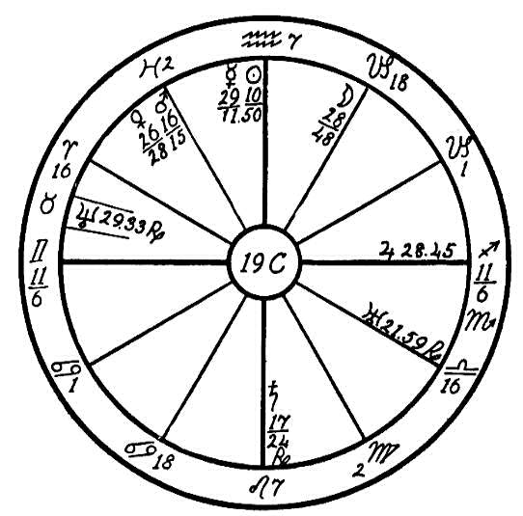
Mercury being in a fixed sign in the tenth house and square to Neptune here gives a most dominating and stubborn mentality. This is a person who will bear no interference or domination from others.
He has naturally a very devout and religious nature, but instead of following the soul's ideals, which are expressed by Jupiter in Sagittarius sextile to Mercury in Aquarius, his stubborn and ambitious mind led him to respond to the vibrations of Venus square Jupiter, Mercury square Neptune, and moon square Uranus.
Venus is exalted in Pisces, the sign of self-undoing, and in the eleventh house, square to Jupiter, which is strong in its own sign of Sagittarius, the sign of religion. This indicates that a woman friend with her flattery and attention, signified by Venus, was responsible for leading him from his religious ideals into negative metaphysical speculation. In addition, the versatile and restless moon makes a trine to Neptune in the occult twelfth house, which gave him the desire for occult knowledge, but the moon, being square to Uranus, led him to his undoing. A person with the planetary positions and aspects which we find in this horoscope is not satisfied to follow instruction or heed the warnings of those who know about occult matters, but he must needs rush in and investigate for himself. the sun in the Saturnian sign of Aquarius in opposition to Saturn in the sign of Leo gives a vein of skepticism, a nature which demands evidence and which must prove all things. This spirit was his undoing. The sun and Saturn being in mutual reception in the tenth and fourth houses respectively, strengthened this tendency.
With the moon trine Neptune and square Uranus this man developed mediumship very quickly and was able to contact the invisible realms. But he heedlessly sought his knowledge along dangerous paths. While the yogi teachings may be safe for the Fourth Race people, the Orientals, and for those of the Western races who are still on the lower rounds of evolution, yet to one of the sensitive Western type these oriental teachings are most dangerous. This poor man became attached to a group of Hindus, from whom he received instructions in breathing exercises and psychic development. He as also active in spiritualism wherein mediumship was encouraged.
After a few years the progressed moon reached the opposition to the radical Saturn and later a conjunction with the radical Mercury. Neptune, being the higher octave of Mercury, works largely upon the nervous system, and any undue stimulation will sometimes cause mental unbalance if Neptune squares the mental planet Mercury, often expressing itself through religious mania. This poor man repeatedly claims that he is the reincarnated Jesus. Especially will Neptune give this tendency when in the twelfth house, where it often causes incarceration in an institution for the insane. The moon in the ninth house in Capricorn, square to Uranus, here increased the evil by attracting undesirable entities to this already weakened mind, which was easily driven out of the body, giving the obsessing entities freedom to take possession of it.
To top off this most unfortunate condition the poor man, who has been in an insane asylum for some years, is slowly dying of that dread disease tuberculosis. This is shown by Jupiter in Sagittarius (Jupiter ruling the arterial blood) square to Venus (which has rule over the venous blood) in Pisces, two common signs.

CHAPTER XXXI

ASTHMA NO. 20A.--ASTHMA
Male, born August 15, 1915, 2:00 P.M.
We find the fiery sign of Sagittarius on the Ascendant, and its ruler, Jupiter, at home in Pisces. This planet is at home in two signs, Sagittarius and Pisces. When planets are posited in the 1st, 4th, 7th, and 10th houses, their influence is much more potent, much stronger for either good or evil than elsewhere, and especially if they are in fixed signs or in their own homes. Jupiter is in its own home and in the 4th house, an angle, and rules the arterial blood. It is in square aspect to the fiery Mars, which is in the sign of the lungs, Gemini. Mercury, the ruler of Gemini, ruling the air passing through the lungs, is in conjunction with the sun, and these two planets are in the fiery sign of Leo ruling the heart. Now that would be the physical effect of the two afflictions noted above?
It is necessary that a certain amount of air be taken into the lungs in order to supply the oxygen which is needed to give life to the blood which feeds the heart. With the ruler of Gemini, Mercury, burned up by the heat of the sun and the capillaries of the lungs filled with the fire of the feverish and afflicted Mars, we have a congested and feverish chest, and the

Birth Chart No. 20A

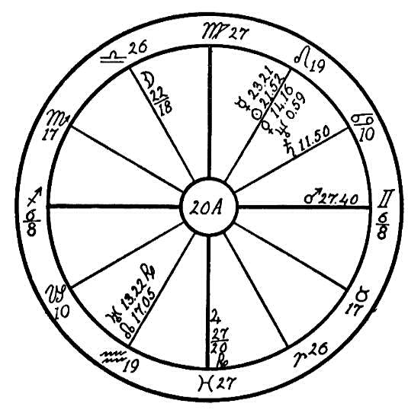
blood is clogged and becomes sluggish, causing spasmodic action as it passes through the aorta. The lungs become feverish and breathing laborious, causing spasms. We find Mars parallel to Saturn, which is in the sign of the stomach, Cancer, and in the 8th house, indicating poor assimilation of the food. We find the planet Venus, which rules the venous circulation, in the hot and fiery sign of Leo in opposition to the spasmodic retrograde Uranus, which is strong in its own sign Aquarius, giving uneven action to the heart.
This boy will suffer more or less all through life with what is commonly termed by the doctors, asthma. The first few years he suffered very much from spasms. He will also be subject to coughs and colds, which will, however, never develop into consumption as is often the case. With Mars ruling the lungs there is frequently a congested, feverish condition in the capillaries which burns up the oxygen. But here Mars is in sextile to the life-giving sum in Leo, hence this boy will recuperate very rapidly. He will be above the average in health in spite of the many afflictions, and he will reach a ripe old age.

NO. 20B: ASTHMA--MORPHINE ADDICTION
Male, born August 15, 1869, 9:00 A.M.
We will judge first the character of this person and for this purchase we note that there are four cardinal signs on the angles. This is a great help toward making people mentally alert and well balanced, but unfortunately here we find that mercury, the significator of the mind is combust, and the moon is in conjunction with Saturn. This renders the mind slow and melancholy, subject to fears, which of course never materialize. Uranus is elevated and square to Neptune, which gives a tendency toward spirit control, but we have the trine of the sun to Neptune to minimize the danger. The native has a strong love nature as shown by the trine of Venus and Jupiter, but the conjunction of moon and Saturn shows that the marriage partner is likely always to wet-blanket and resent advances. Mars opposition Neptune from the first to the seventh house makes it plain that there will be quarrels and trouble, all of which have an important bearing upon the sickness and its cause.
The Sun in Leo afflicted by Jupiter in Taurus shows that the arterial circulation is poor, a condition which is somewhat minimized by the trine of Jupiter and Venus, the two planets which govern the circulation. But the rhythmic motion of respiration is seriously interfered with because Uranus is in Cancer and elevated. This planet is spasmodic in its action and affects the diaphragm when placed in Cancer. Here it is, as said, highly elevated and square to Mars and Neptune, both in angles, a configuration that is very strong. The rhythmic rise and fall of the diaphragm is

Birth Chart No. 20B

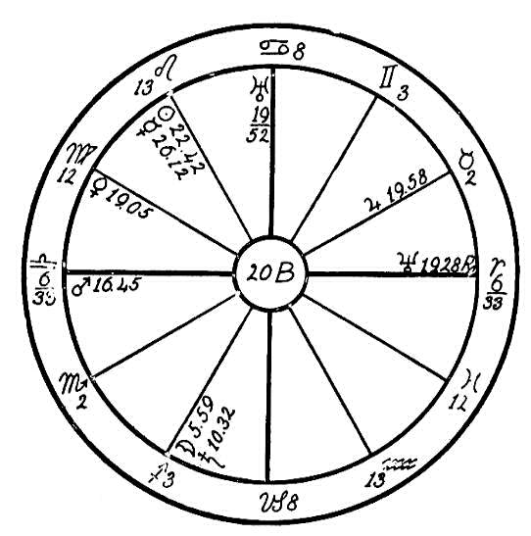
absolutely essential to proper and regular respiration, an as this action is interfered with to a degree by the afflictions here shown, we have the condition known as asthma.
It is well known that sufferers from this disease sometimes go a very long time without sleep because of their inability to lie down. Morphine is often given to relieve their condition and give them the rest they crave with all their being. The danger of this drug cannot be overestimated in any case, but it is greater for a patient who has Jupiter in Taurus afflicted by the sun like this one, for this always gives an inherent abnormal appetite, a tendency to go to extremes in whatever is taken by way of the mouth. Hence it is no wonder that this person has become addicted to the use of morphine.
There is hope, however, as shown by the horoscope. The moon rules the alimentary canal and is responsible for the passage of the food through the digestive tract. She is conjunct Saturn, and naturally this results in a sluggish condition of the bowels. Uranus in Cancer operates upon the stomach in such a way as to distend it periodically. With a full colon, a distended stomach, and the diaphragm moving erratically what wonder that the heart refuses to force the vital fluid into the lungs and take it from them? Heroic methods should be taken to clear the system and keep it clear. While this will not relieve the spasmodic action of the diaphragm, it will at any rate take the pressure away from the apex of the heart and thus materially help to reduce the condition. Mars is sextile to the sun, therefore, the heart can be strengthened. He is also sextile to Saturn showing the possibility of securing at least better action and circulation in the digestive tract.
The worst condition in this horoscope, the one most difficult to overcome, is Jupiter in Taurus square to the sun. It has been our experience that even though it is pointed out to people that they have abnormal appetites and they acknowledge it, they usually refuse to mend their ways. As the above affliction is in fixed signs, it is exceedingly difficult to overcome. The best assistance, however, would be from the trine of Venus to Jupiter, which excites the love nature and makes the native amenable to kindliness. The tender care of a woman would perhaps do more than anything else to help him overcome the habit he has formed. A healer with Aquarius rising and whose Saturn is not in Pisces would very likely have a beneficial effect in this case.

NO. 20C--D--E: ASTHMA
The disease designated by the name of asthma is one of the most difficult to diagnose, for many are suffering from symptoms which are diagnosed by the doctors as those of asthma because of the shortness of breath, wheezing, and coughing when frequently the person does not in reality have asthma. There are various kinds of this disease. For instance there is hay asthma, which comes in the fall of the year when the hay and grain are ripe. Sometimes it comes from the noxious pollen of poisonous flowers, which causes a contraction of the passages to the lungs; these when inactive fill with mucus, causing labored breathing. Then we have the heart or stomach asthma, which is often the result of irregularity of the blood flow through the valves of the heart, resulting in labored breathing and contraction of the chest and lungs. Therefore the astrologer may find the diagnosis difficult.
We will in this lesson endeavor to give a few helps showing according to the afflictions the differences in diseases which may have similar outward symptoms but the causes of which may be different.
Case 20C is that of a man born March 6, 1831, 4 P.M. The horoscope for this case is 10A, page 263. We find the disturbing Saturn in Leo, the sign ruling the heart, square to Mars in Taurus, which has rule over the throat, and opposition to Mercury, which is in the nervous sign of Aquarius. Mars is also square to Mercury and parallel to Neptune. This configuration of planets in fixed signs, would indicate spasmodic heart action, for Mercury opposition Saturn would cause contraction of the valves of the heart, thereby interfering with the excessive blood flow caused by Mars square Saturn. We also find the sun in Pisces, a common sign, square to the moon in Sagittarius. Common signs when afflicted interfere with the organs of respiration, given a tendency to trouble with the lungs. This man suffered greatly with what some doctors diagnosed as asthma and others as heart trouble, and he also frequently suffered from severe colds. Astrology shows that he had valvular heart trouble and that is was not a true case of asthma. He died from an abscess of the liver. For details regarding this condition see No. 10A.
In the case of horoscope 20D, that of a man born August 25, 1867, we find Saturn in Scorpio, a fixed sign, square to Venus and Mercury in Leo, the sign ruling the heart. We again find some trouble with poor heart action; but the most disturbing affliction is found in the stomach, for the moon and Uranus are in conjunction in the sign of Cancer, which has rule over this organ, and both are square to the inflammatory Mars, Uranus also being square to Neptune, all in cardinal signs. In this horoscope we find the seat of the trouble in the stomach, showing impulsive and unnatural habits regarding food, with a tendency to bolt the food and also excessive drinking with meals, which would cause the stomach to become distended, thereby pressing upon the heart and interfering with respiration.
In horoscope 20E, that of a woman born June 23, 1898, we find a very

Birth Chart No. 20D

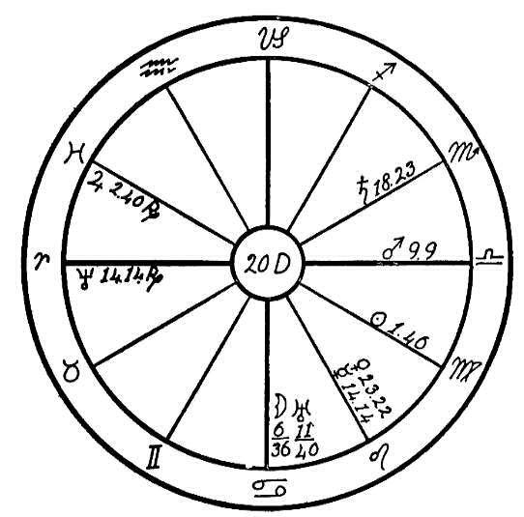
different cause, and we may diagnose this as a real case of hay asthma. Neptune is conjunction Mercury in the sign of Gemini, which has rule over the lungs. From the indications of personal appearance we should think that this young woman had Virgo rising with Gemini in Midheaven, giving Mercury as the life ruler. Neptune, being the higher octave of Mercury, has rule over the nervous system. Neptune's influence is similar to that of Saturn--constricting, astringent. When in Gemini, we may expect a

Birth Chart No. 20E

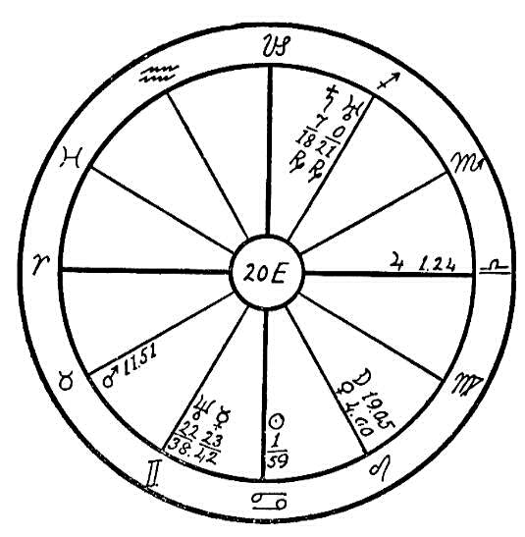
disturbance in the bronchioles, especially during the summer months, as was the case with this young woman, whose trouble was caused by the inhalation of the pollen of certain grasses and flowers.
You will, however, find that in most cases of asthma there is impaired circulation. The blood stream is sluggish, showing an affliction to Venus or Jupiter. When the blood is impure, elimination will also be sluggish.
Great care should be used in the selection of food. The patient should eat very lightly and only such foods as are easily digested but which give the proper nourishment. Especially is this true of the evening meals, for attacks of asthma invariably follow a heavy meal at night. Raw onion sandwiches eaten the last thing at night and cut the phlegm and insure a sound sleep.

CHAPTER XXXII

CANCER
NO. 21A.-CANCER
Female, born July 14, 1897, 4:00 P.M.
Sagittarius, a common sign, is on the Ascendant, and the life ruler, Jupiter is in the 9th house in the sign of Virgo; Jupiter is also square to the Ascendant. People with common signs on the four angles rarely make sufficient effort to surmount the obstacles of life, and when we also find the afflicting planets in these common signs, and the sun in the watery sign of Cancer an in the 8th house, we have as in the case of this woman one who would rather be an invalid than make the effort to keep the body in health, and we can see how weak the effort will be to overcome.
First, people with the sun and moon in Cancer are very fond of good things to eat, and when the moon is also trine to Venus this enhances their love for food and there is a tendency to overeat. Let us see what will be the result.
We find the planet Venus, which has rule over the venous blood, in the sign of Gemini, and in the 7th house, square to the inflammatory Mars and to Jupiter. Jupiter, which has rule over the arterial blood, is afflicted by a

Birth Chart No. 21A

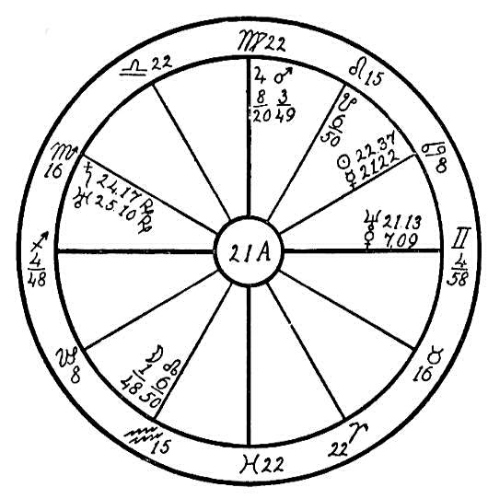
conjunction of Mars, hence the circulation is very much obstructed, especially as Jupiter is in the sign of Virgo, which has rule over the small intestine. When the patient eats very heartily (especially as Cancer people are very fond of starches), with the obstructed circulation and the disturbed assimilation of food in the small intestine what may we expect but that the bowels are filled with putrid matter. Fermentation set in, causing derangement of the entire circulatory system. Saturn, the obstructer, in conjunction with Uranus in the sign of Scorpio, which has rule over the rectum, and in the 12th house, the house of self-undoing, also the house of hidden things, is an indication that the young woman had formed secret habits which caused much irritation to the organs of elimination and which had their result in causing cancer of the rectum.
She was ailing for a long time with dreadful pains across the lower bowels and at the lower end of the spinal column. The question may be asked, Is there not a cure for this dread disease of cancer? Yes, when in its first stages, it may be cured by eliminating all food for a few days, drinking only pure, distilled water flavored with lemon juice, and giving the bowels a thorough cleansing with high enemas. Then start with the mono-diet, continuing this for three weeks if the patient is able to stand it, but not to exceed three weeks. The patient should eat nothing but carrots. This vegetable may be prepared in various ways to make it palatable, grinding it and drinking the juice, baking or steaming it or making it into salads flavored with a little olive oil and lemon. The carrot has a pronounced healing effect, especially when used as a poultice, and it has a wonderful healing power for ulcer and cancerous growths.

NO. 21B.--CANCER
Male, born December 14, 1857. Place and hour of birth unknown, but from personal appearance and traits of character we have placed Sagittarius on the Ascendant. Planets' positions for noon, G.M.T.
The doctors had told this man that he had cancer, and nothing could shake his belief that he would some day pass out with the dread disease. He kept up his letters to the Healing Department regularly for several months, but they were always filled with doubt of our methods and discouragement regarding the future. He also rebelled at the restrictions in diet, claiming that he was too weak and sick to live without his daily beefsteak and fried potatoes.
Later through the instrumentality of his son, who was working in our office as stenographer, this man with his wife rented a cottage on a tract which adjoined the Headquarters grounds. In order to make it possible for his father to partake of the health diet served in our dining hall, the son applied for a job as gardener for his father.
The first few weeks this poor man as a great trial to the cook. When he failed to get what he demanded, he left the table hungry. This lasted for a few days until hunger forced him to eat what was served. His demands were for two eggs fried in butter, a large bowl of soft, boiled mush with several teaspoons of sugar and plenty of cream, fried potatoes, white bread, and two or three cups of strong, black coffee with several teaspoons of sugar in each. The sugar bowl was emptied at each meal. He greatly tried the patience of both Mr. Heindel and myself. But the young son, who had

Birth Chart No. 21B

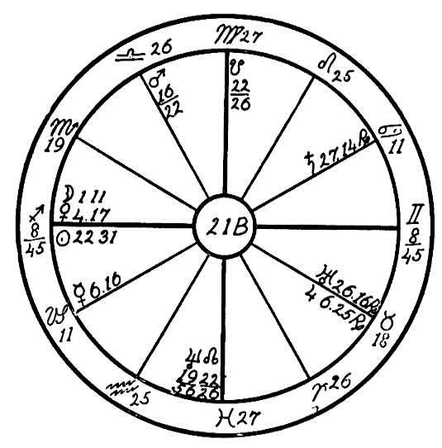
supported his father for a number of years was desperately anxious to help us to help the latter. After a few weeks the patient adjusted himself, and immediately his health began to improve. The eruptions on his face and his breast began slowly to disappear, and his general health and strength began to return.
During the day it was observed that he was constantly eating candy; his pockets were filled with this sweet. Before coming to Headquarters he would eat one to two pounds of candy every day, and thought it necessary to do so to keep up his strength.
We note the conjunction of the moon and Venus just above the Ascendant in the negative sign of Sagittarius. The moon and Venus conjoined, no matter where they may be in the horoscope, give a desire for sweets, pastry, etc.
In this case we find Saturn posited in the sign of the stomach, Cancer, and retrograde to a square aspect with Mars, which is placed in a Venus sign. this man had for years filled his body with an excess of starch, protein, and sugar. With his afflicted progressed Saturn in Cancer he was not able to extract the vitamins from his food, and he was in the habit of overeating and of bolting it. Naturally the body stores up excess amount of food taken. His stomach refused to digest such quantities of food, or rather was too weak and lacking in the juices necessary in digestion. There was also a large amount of waste matter which the organs of elimination were unable to throw off. Mars has rule over the rectum, being the ruler of Scorpio which governs this organ. With Mars afflicted by the obstructive progressed Saturn we might expect that the man would suffer from constipation.
With all this ash stored up in the body can we wonder that the system has to find some means of throwing out this poison? The result was that the skin of the nose, throat, face and breast (Mars ruling Aries the face, Scorpio the bridge of the nose, and Saturn in Cancer the breast) was used as a dumping ground for the body waste. After eight months of Mt. Ecclesia diet this man moved back to the city with not a trace of cancer on his body; all sores had entirely healed. Mars sextile to the life-giving sun brought vitality. Wherever a good aspect between these two planets is found, there is great hope of overcoming disease.
Saturn in Cancer in the eighth house, the house of death, will eventually be the case of the native's demise, together with the moon and Venus in a common sign and in the house of self-undoing. In time his desire for sweets and rich food will probably lead to excesses which will be the cause of his death.

CHAPTER XXXIII

ROSICRUCIAN HEALING
HOW THE ROSICRUCIANS HEAL THE SICK
The Rosicrucian work of healing is carried on by the Elder Brothers of the Rosicrucian Order through a band of Invisible Helpers whom they are instructing.
The work is conducted according to the commands of Christ Jesus, namely, "Preach the gospel and heal the sick."

THE ELDER BROTHERS
These are high spiritual beings through whom the Christ Spirit is working for the benefit of humanity.

THE INVISIBLE HELPERS
The Invisible Helpers are those who live a worthy life of helpfulness during the daytime while in their physical bodies, and whose evolutionary development is such as to earn the privilege of being helpful through the instrumentality of the Elder Brothers at night while functioning in their etheric bodies, as indicated in the words of the Rosicrucian Evening Service: "Tonight while our physical bodies are peacefully resting in sleep, may we as Invisible Helpers be found faithfully working in the vineyard of Christ." These Invisible Helpers are gathered together in bands according to their temperaments and their abilities. They are under the instruction of other Helpers who are physicians, and all of them work under the guidance of the Elder Brothers, who naturally are the moving spirits of the whole work.
Not infrequently patients are aware of the presence of the Invisible Helpers.

RIGHT LIVING NECESSARY FOR A CURE
The Invisible Helpers never refuse to answer an appeal for help, but in order to respond to the Divine Healing Force patients must adopt the gospel of right living; they should observe a pure meatless diet; they must fill their living and sleeping rooms with pure air, their minds with pure thoughts and their daily lives with pure actions. The Divine Healing Force is pure; if you ask for it in order to be relieved of your ailments, you must be willing to conform to the natural laws of purity. Pure air, pure food, pure thinking and pure living! If you ignore these great health giving factors you may have called in vain upon the Divine Healing Force.

HEALING FORCE
All healing force comes from God, our Heavenly Father, the Great Physician of the universe; it is latent everywhere; by prayer and concentration it is liberated and directed to the sufferer; it manifested through the Master, Christ Jesus; it goes forth from the weekly healing meetings held at the Rosicrucian Fellowship Headquarters. Through the workings of this supreme force the Invisible Helpers raise the vibrations of the patient to a higher rate, thus enabling him, first, to eliminate the disease poison from the system, and second, to rebuild every blood corpuscle, fiber, tissue, and organ until the whole body is made new. This is done, not in a miraculous manner but in accordance with nature's laws. If the patient continues to break these laws and by a wrong mode of living to accumulate poisonous substances in the system, he frustrates the healing work.

CAUSE OF DISEASE
The wonderful organism called the human body is governed by immutable natural laws. All disease results from willful or ignorant violation of nature's laws. People are ill because in this earth life or in a previous one they have disregarded the fundamental principles on which the health of the body depends. If they wish to regain and to retain their health, they must learn to understand these principles and to regulate their daily habits in conformity with them.
This is what the Master Healer, Christ Jesus, meant when he said to the man who was a cripple: "Thou art made whole: sin no more, lest a worse thing come unto thee." (John 5-14.) Even the Christ could not give lasting health unless the recipient of the healing force refrained from indulging wrong habits which cause disease, and lived in obedience to the God-given laws that rule man's body as well as his relations to his fellow creatures.

THE RIGHT TO HEALTH
Some people "demand" perfect health and claim they have a right to it. They forget that either in this or a former life some have forfeited their God-given right through disobedience to nature's laws, which are God's laws. Through suffering they have to learn obedience. When they have mastered their lesson and are willing to "sin no more," their right to health will be restored to them.

VIOLATIONS OF THE LAWS OF HEALTH
The Divine Healing Force is constructive; wrong methods of living which disregard the laws of nature are destructive.
The omissions and transgressions responsible for wrong living and consequently for disease are many; the following are the principal ones: Unnatural food; too much food; ill-proportioned food; lack of fresh air and sunshine; lack of cleanliness; lack of exercise; lack of rest and sleep; lack of self-control; sleeping in unventilated rooms; harboring thoughts of anger, hatred, and resentment; yielding to a hasty temper; gratifying low desires; harming fellow creatures whether human or animal; abusing the sacred generative function.
Since all the organs and functions of the body are interdependent, the abuse and consequent affliction of one part hurts all the others, furthers the accumulation of disease poison throughout the system, and lowers the vitality of the whole. The local symptoms are only evidence of the whole body being at fault. Therefore, all true healing, in order to achieve lasting results, is directed not to the suppression of symptoms but to the removal of the cause that made the symptoms appear.

SPIRITUAL HEALING
Spiritual healing operates on the higher planes of being but is effected in strict adherence to natural laws which prevail below as above; consequently all natural therapeutics applied on the physical plan are in harmony with the work of the Invisible Helpers on the higher planes.

RIGHT FOOD IS NATURAL MEDICINE
As the body is built up of the physical substances introduced into the blood by the daily food, right food is the natural medicine which the patient must take in order to cooperate with the Invisible Helpers in their task of reconstructing his system.

EFFLUVIA TRANSMITTED IN WEEKLY REPORT
Before the Invisible Helpers can work with the patient they must have effluvia from his vital body, which is the etheric counterpart of the physical body and the operating sphere of the vital forces. The effluvia are obtained by having the patient write every week a letter consisting of a few words or a few lines with pen and ink. This is important as a pen charged with fluid is a greater conductor of magnetism than a dry pencil. The ether which thus impregnates the paper upon which the patient writes week by week gives an indication of his condition at that particular time and furnishes an entrance key to his system. It is something which he has given voluntarily and for the express purpose of furnishing access for the Invisible Helpers. Unless the patient does his part to do anything for him; so it may be seen that it is of the utmost importance to keep up the weekly letters to Headquarters.

TIME REQUIRED FOR CURE
Instantaneous cures are frequent where the Invisible Helpers are called upon to assist in cases of acute disease. In the case of a chronic ailment which is of long standing and has taken years to develop, a certain amount of relief may be experienced immediately; complete recovery, however, which is equivalent to a renewal of the whole system, can usually be achieved only in gradual stages. As said before, the healing work of the Invisible Helpers is not suppression of symptoms but reconstruction of the whole system, and in order to be accomplished it requires time as well as the patient's faithful and constant cooperation along the lines indicated above.

HEALING MEETINGS AT HEADQUARTERS
Healing meetings are held at Rosicrucian Headquarters on the nights when the moon enters cardinal signs in the zodiac. The hour of service is about 6:30 P.M. The virtue of the cardinal signs is dynamic energy which they infuse into every enterprise started under their influence, and therefore the healing thoughts of the helpers all over the world are endowed with added power when launched upon their errands of mercy under this cardinal influence.
If you would like to join in this work, sit down quiet when the clock in your place of residence points to the given hour, 6:30 P.M., meditate on health, and pray to the Great Physician, our Father in Heaven, for the restoration to health of all who suffer, particularly those who have applied to Headquarters.
At the same time visualize the Ecclesia, the healing Temple at Headquarters, where the thoughts of all aspirants are finally gathered by the Elder Brothers and used for the stated purpose.

End of

Astro-Diagnosis--A Guide to Healing

