[Featured Download](https://www.naturalnews.com/ReaderRegistration-Downloads.asp?Subscriber=True#Featured) [eBooks](https://www.naturalnews.com/ReaderRegistration-Downloads.asp?Subscriber=True#Ebooks) [Special Reports](https://www.naturalnews.com/ReaderRegistration-Downloads.asp?Subscriber=True#Reports)

Featured Download

[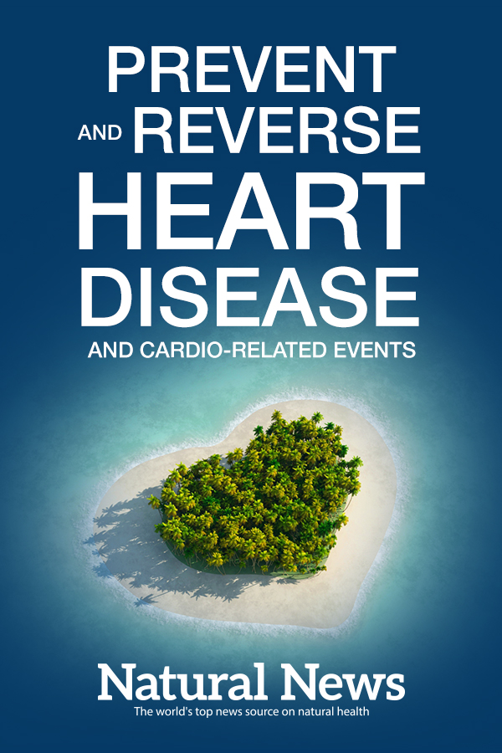](https://www.naturalnews.com/SpecialReports/Prevent-and-Reverse-Heart-Disease.pdf)

Prevent & Reverse Heart Disease and Cardio-Related Events

Heart disease can go by many names and comes in many different forms. Heart disease isn't just one disease, but rather numerous problems and conditions related to the heart muscle. Arrhythmia, angina, coronary artery disease and genetic defects can all be considered heart diseases.

Learn how you can prevent and reverse heart disease and cardio-related events in this free eBook from NaturalNews.com

[Download for Free](https://www.naturalnews.com/SpecialReports/Prevent-and-Reverse-Heart-Disease.pdf)

More eBooks

[[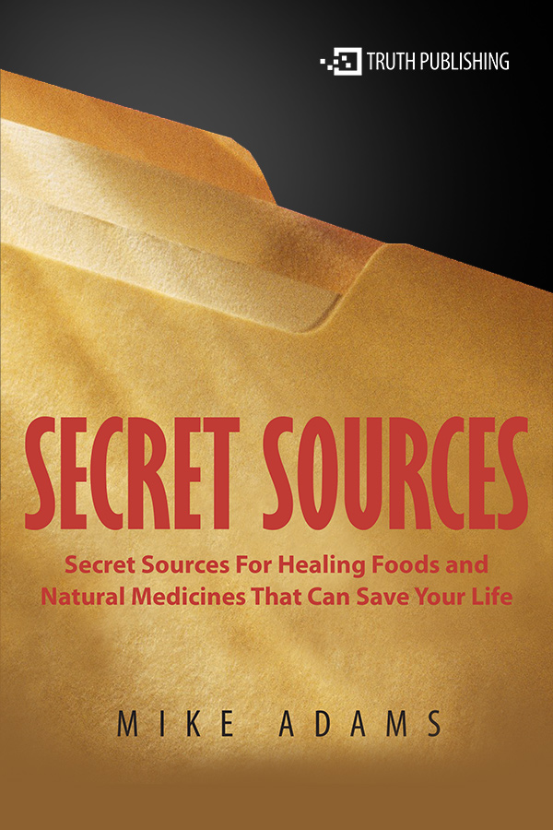](https://www.naturalnews.com/SpecialReports/SecretSources.pdf)](https://www.naturalnews.com/SpecialReports/SecretSources.pdf" \t "_blank)

[Secret Sources for Healing Foods and Natural Medicines That Can Save Your Life](https://www.naturalnews.com/SpecialReports/SecretSources.pdf" \t "_blank)

[Discover where you can purchase foods and products that are critical for overcoming chronic diseases.](https://www.naturalnews.com/SpecialReports/SecretSources.pdf" \t "_blank)

[Download](https://www.naturalnews.com/SpecialReports/SecretSources.pdf" \t "_blank)

[[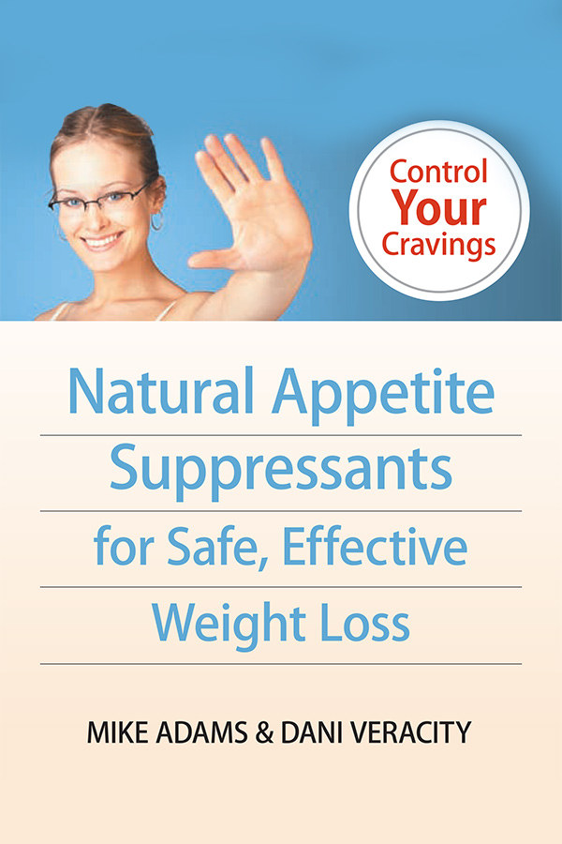](https://www.naturalnews.com/downloads/NaturalAppetiteSuppressants.pdf)](https://www.naturalnews.com/downloads/NaturalAppetiteSuppressants.pdf" \t "_blank)

[Natural Appetite Suppressants for Safe, Effective Weight Loss](https://www.naturalnews.com/downloads/NaturalAppetiteSuppressants.pdf" \t "_blank)

[Discover weight loss eating plans and strategies, how to fight food cravings, and more.](https://www.naturalnews.com/downloads/NaturalAppetiteSuppressants.pdf" \t "_blank)

[Download](https://www.naturalnews.com/downloads/NaturalAppetiteSuppressants.pdf" \t "_blank)

[[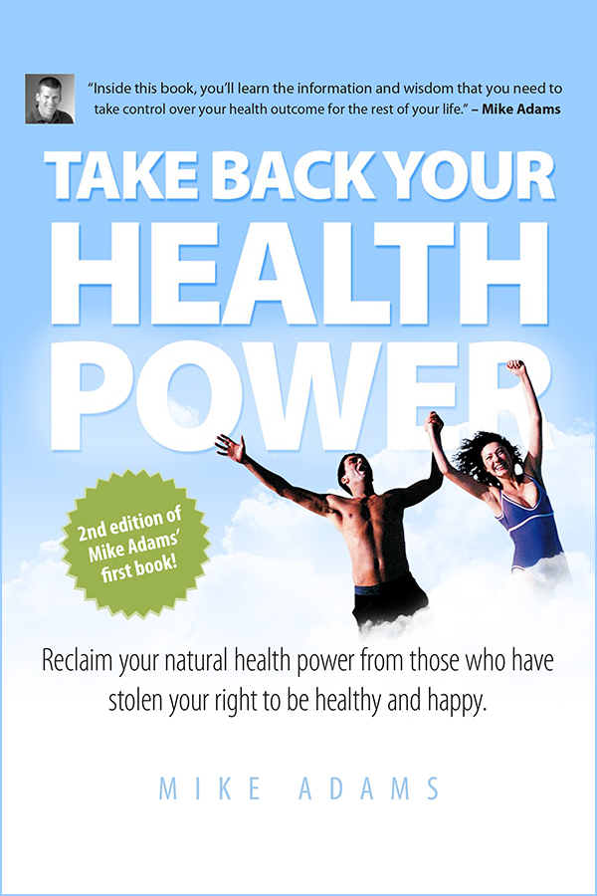](https://www.naturalnews.com/SpecialReports/Take-Back-Your-Health-Power.pdf)](https://www.naturalnews.com/SpecialReports/Take-Back-Your-Health-Power.pdf" \t "_blank)

[Take Back Your Health Power](https://www.naturalnews.com/SpecialReports/Take-Back-Your-Health-Power.pdf" \t "_blank)

[Reclaim your natural health power from those who have stolen your right to be healthy and happy.](https://www.naturalnews.com/SpecialReports/Take-Back-Your-Health-Power.pdf" \t "_blank)

[Download](https://www.naturalnews.com/SpecialReports/Take-Back-Your-Health-Power.pdf" \t "_blank)

[[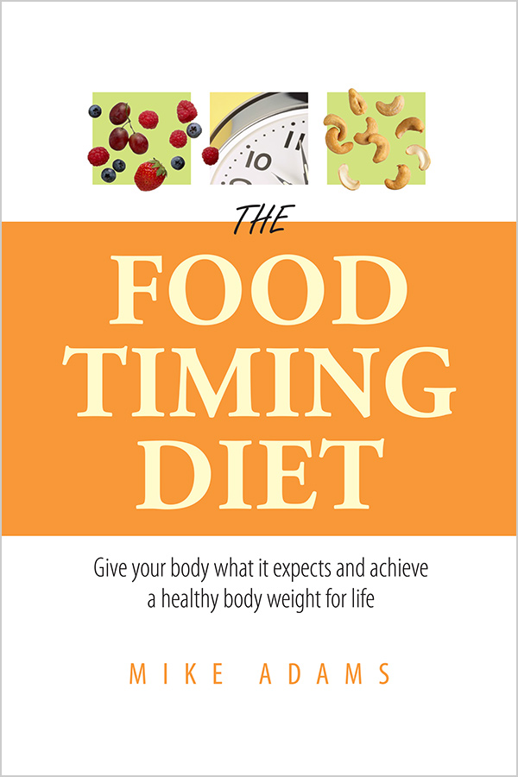](https://www.naturalnews.com/SpecialReports/The-Food-Timing-Diet.pdf)](https://www.naturalnews.com/SpecialReports/The-Food-Timing-Diet.pdf" \t "_blank)

[The Food Timing Diet](https://www.naturalnews.com/SpecialReports/The-Food-Timing-Diet.pdf" \t "_blank)

[Give your body what it expects and achieve a healthy body weight for life.](https://www.naturalnews.com/SpecialReports/The-Food-Timing-Diet.pdf" \t "_blank)

[Download](https://www.naturalnews.com/SpecialReports/The-Food-Timing-Diet.pdf" \t "_blank)

[[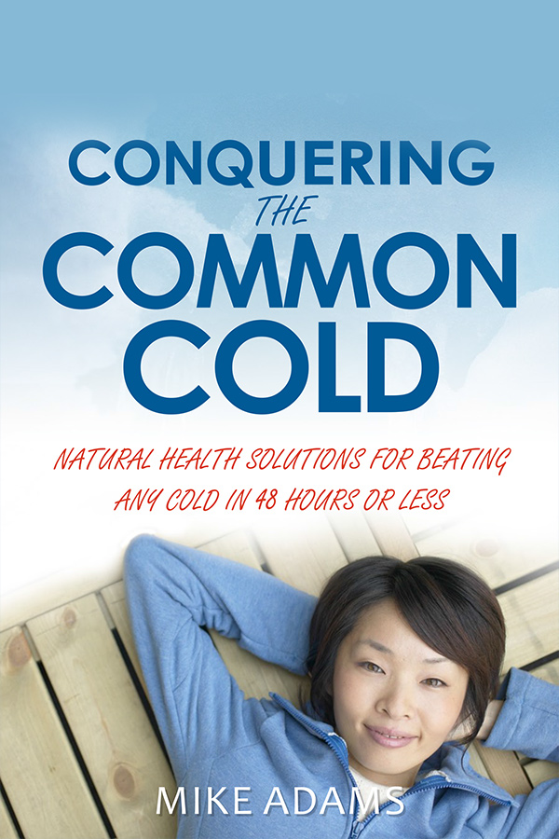](https://www.naturalnews.com/SpecialReports/Conquering-the-Common-Cold.pdf)](https://www.naturalnews.com/SpecialReports/Conquering-the-Common-Cold.pdf" \t "_blank)

[Conquering the Common Cold](https://www.naturalnews.com/SpecialReports/Conquering-the-Common-Cold.pdf" \t "_blank)

[Natural health solutions for beating any cold in 48 hours or less.](https://www.naturalnews.com/SpecialReports/Conquering-the-Common-Cold.pdf" \t "_blank)

[Download](https://www.naturalnews.com/SpecialReports/Conquering-the-Common-Cold.pdf" \t "_blank)

Free Special Reports

[[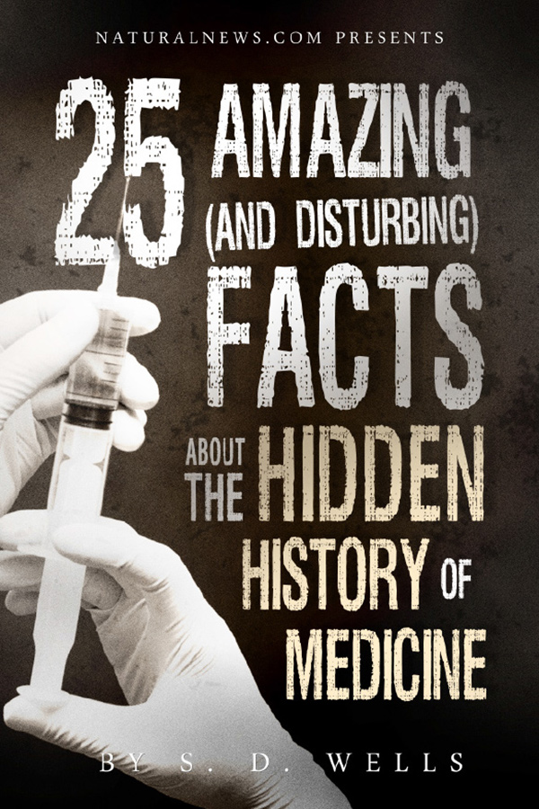](https://www.naturalnews.com/SpecialReports/25-Amazing-and-Disturbing-Facts-about-the-Hidden-History-of-Medicine.pdf)](https://www.naturalnews.com/SpecialReports/25-Amazing-and-Disturbing-Facts-about-the-Hidden-History-of-Medicine.pdf" \t "_blank)

[25 Amazing (and Disturbing) Facts About the Hidden History of Medicine](https://www.naturalnews.com/SpecialReports/25-Amazing-and-Disturbing-Facts-about-the-Hidden-History-of-Medicine.pdf" \t "_blank)

[Discover the startling details that are 100% true, yet never mentioned in the mainstream media or by health authorities.](https://www.naturalnews.com/SpecialReports/25-Amazing-and-Disturbing-Facts-about-the-Hidden-History-of-Medicine.pdf" \t "_blank)

[Download](https://www.naturalnews.com/SpecialReports/25-Amazing-and-Disturbing-Facts-about-the-Hidden-History-of-Medicine.pdf" \t "_blank)

[[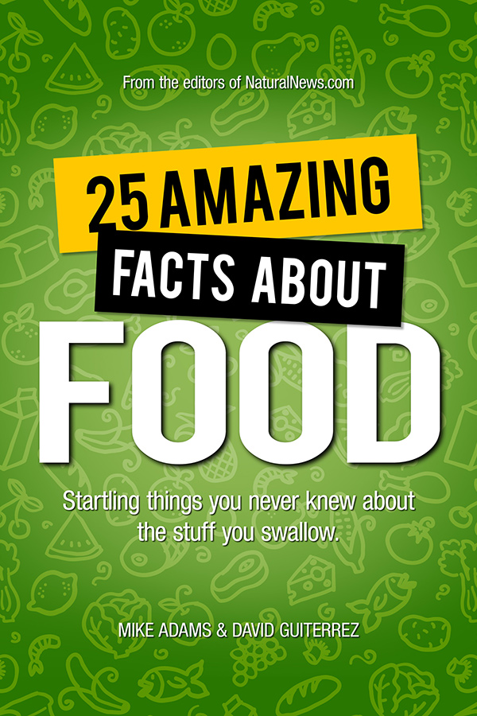](https://www.naturalnews.com/SpecialReports/25-Amazing-Facts-About-Food.pdf)](https://www.naturalnews.com/SpecialReports/25-Amazing-Facts-About-Food.pdf" \t "_blank)

[25 Amazing Facts About Food](https://www.naturalnews.com/SpecialReports/25-Amazing-Facts-About-Food.pdf" \t "_blank)

[In this exclusive NaturalNews report, you'll learn the surprising truth of how you've been eating cloned fruit without even knowing it!](https://www.naturalnews.com/SpecialReports/25-Amazing-Facts-About-Food.pdf" \t "_blank)

[Download](https://www.naturalnews.com/SpecialReports/25-Amazing-Facts-About-Food.pdf" \t "_blank)

[[](https://www.naturalnews.com/SpecialReports/25-Amazing-and-Weird-Facts-About-Food.pdf)](https://www.naturalnews.com/SpecialReports/25-Amazing-and-Weird-Facts-About-Food.pdf" \t "_blank)

[25 Amazing (and Weird) Facts About How Food is Made and Where it Comes From](https://www.naturalnews.com/SpecialReports/25-Amazing-and-Weird-Facts-About-Food.pdf" \t "_blank)

[Discover absolutely shocking details about food origins and manufacturing processes...](https://www.naturalnews.com/SpecialReports/25-Amazing-and-Weird-Facts-About-Food.pdf" \t "_blank)

[Download](https://www.naturalnews.com/SpecialReports/25-Amazing-and-Weird-Facts-About-Food.pdf" \t "_blank)

[[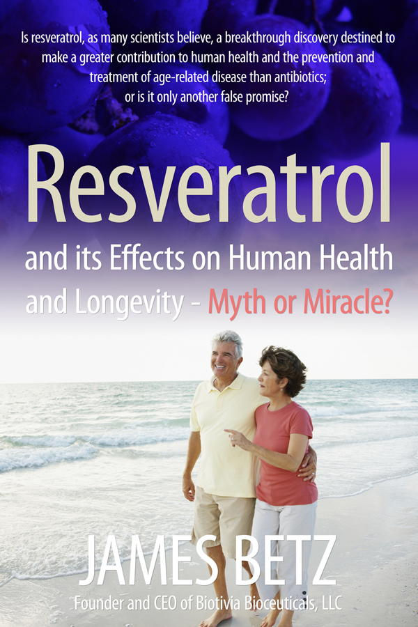](https://www.naturalnews.com/files/Resveratrol_and_its_Effects_on_Human_Health_and_Longevity.pdf)](https://www.naturalnews.com/files/Resveratrol_and_its_Effects_on_Human_Health_and_Longevity.pdf" \t "_blank)

[Resveratrol and its Effects on Human Health and Longevity - Myth or Miracle?](https://www.naturalnews.com/files/Resveratrol_and_its_Effects_on_Human_Health_and_Longevity.pdf" \t "_blank)

[Unlock the secrets of cellular health with this "miracle" nutrient.](https://www.naturalnews.com/files/Resveratrol_and_its_Effects_on_Human_Health_and_Longevity.pdf" \t "_blank)

[Download](https://www.naturalnews.com/files/Resveratrol_and_its_Effects_on_Human_Health_and_Longevity.pdf" \t "_blank)

[[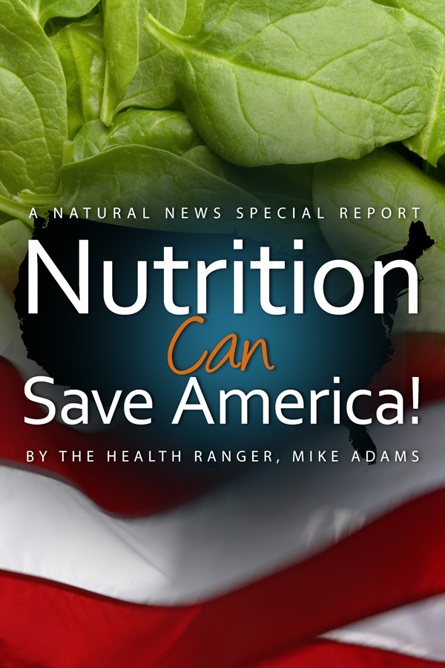](https://www.naturalnews.com/report_Nutrition_Health_America_0.html)](https://www.naturalnews.com/report_Nutrition_Health_America_0.html" \t "_blank)

[Nutrition Can Save America!](https://www.naturalnews.com/report_Nutrition_Health_America_0.html" \t "_blank)

[In this special report, you'll learn why nutrition plays such a powerful role in the rise or fall of any nation.](https://www.naturalnews.com/report_Nutrition_Health_America_0.html" \t "_blank)

[Read Online](https://www.naturalnews.com/report_Nutrition_Health_America_0.html" \t "_blank)

[[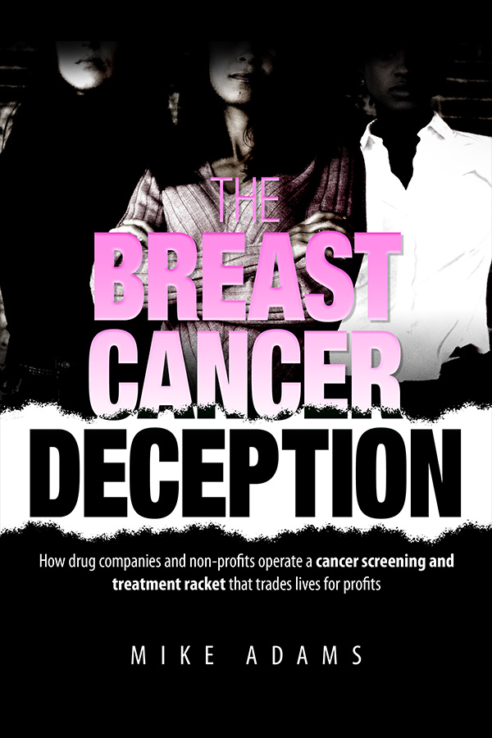](https://www.naturalnews.com/Report_Breast_Cancer_Deception_0.html)](https://www.naturalnews.com/Report_Breast_Cancer_Deception_0.html" \t "_blank)

[Breast Cancer Deception](https://www.naturalnews.com/Report_Breast_Cancer_Deception_0.html" \t "_blank)

[This is a shocking, tell-all report that exposes the scam of today's breast cancer industry.](https://www.naturalnews.com/Report_Breast_Cancer_Deception_0.html" \t "_blank)

[Read Online](https://www.naturalnews.com/Report_Breast_Cancer_Deception_0.html" \t "_blank)

[[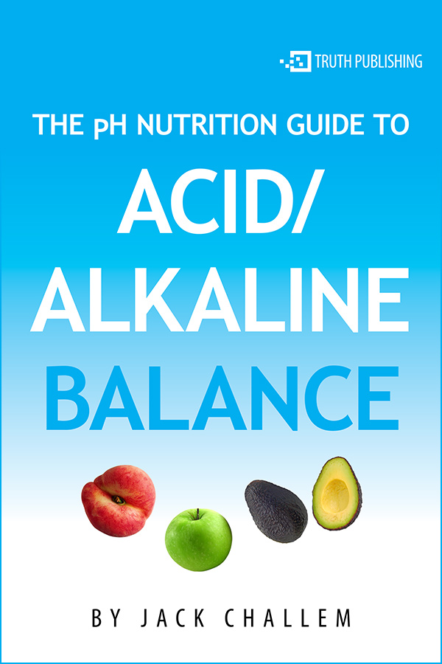](https://www.naturalnews.com/Report_acid_alkaline_pH_0.html)](https://www.naturalnews.com/Report_acid_alkaline_pH_0.html" \t "_blank)

[The pH Nutrition Guide to Acid / Alkaline Balance](https://www.naturalnews.com/Report_acid_alkaline_pH_0.html" \t "_blank)

[In this exclusive report, you'll learn one of the most important health secrets found in nutritional science: the pH secret to good health!](https://www.naturalnews.com/Report_acid_alkaline_pH_0.html" \t "_blank)

[Read Online](https://www.naturalnews.com/Report_acid_alkaline_pH_0.html" \t "_blank)

[[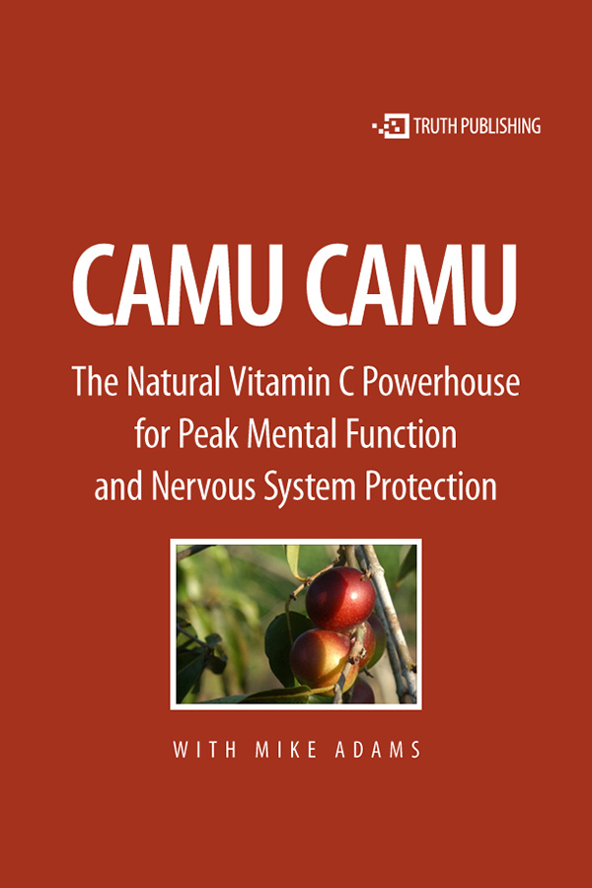](https://www.naturalnews.com/report_camu_camu_0.html)](https://www.naturalnews.com/report_camu_camu_0.html" \t "_blank)

[Camu Camu: The Natural Vitamin C Powerhouse For Peak Mental Function and Nervous System Protection](https://www.naturalnews.com/report_camu_camu_0.html" \t "_blank)

[Learn about this unique superfruit and its phenomenal health benefits.](https://www.naturalnews.com/report_camu_camu_0.html" \t "_blank)

[Read Online](https://www.naturalnews.com/report_camu_camu_0.html" \t "_blank)

[[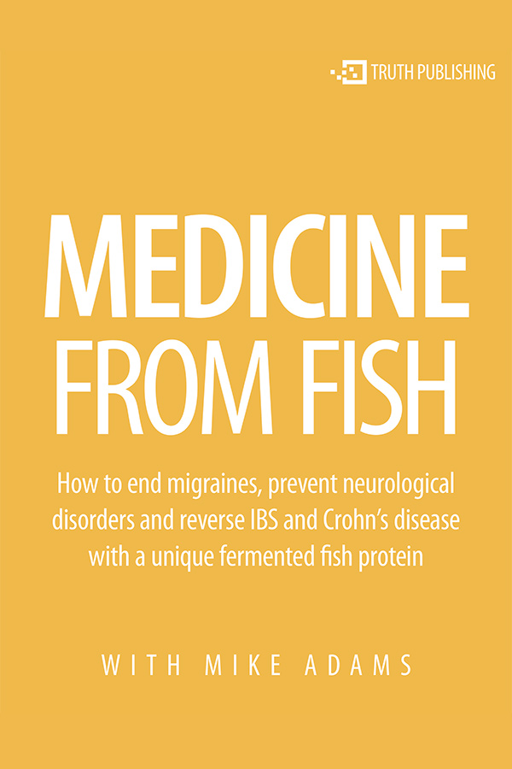](https://www.naturalnews.com/SpecialReports/MedicinefromFish.pdf)](https://www.naturalnews.com/SpecialReports/MedicinefromFish.pdf" \t "_blank)

[Medicine From Fish: How to reverse disease with therapeutic protein](https://www.naturalnews.com/SpecialReports/MedicinefromFish.pdf" \t "_blank)

[Interview Tom Staverosky about a unique fermented protein product that shows benefits for migraine sufferers and people with digestive disorders.](https://www.naturalnews.com/SpecialReports/MedicinefromFish.pdf" \t "_blank)

[Download](https://www.naturalnews.com/SpecialReports/MedicinefromFish.pdf" \t "_blank)

[[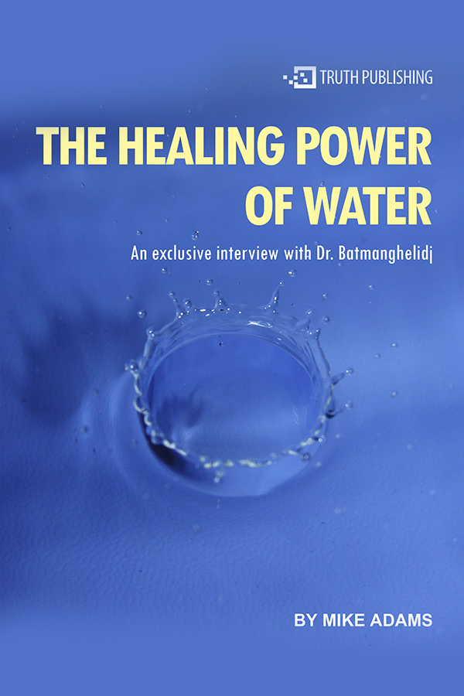](https://www.naturalnews.com/SpecialReports/TheHealingPowerofWater.pdf)](https://www.naturalnews.com/SpecialReports/TheHealingPowerofWater.pdf" \t "_blank)

[The Water Cure: An interview with Dr. Batmanghelidj](https://www.naturalnews.com/SpecialReports/TheHealingPowerofWater.pdf" \t "_blank)

[Dr. Batmanghelidj, M.D. has studied water's effect on the human body and has found it to be one of the best pain relievers and preventative therapies in existence.](https://www.naturalnews.com/SpecialReports/TheHealingPowerofWater.pdf" \t "_blank)

[Download](https://www.naturalnews.com/SpecialReports/TheHealingPowerofWater.pdf" \t "_blank)

[[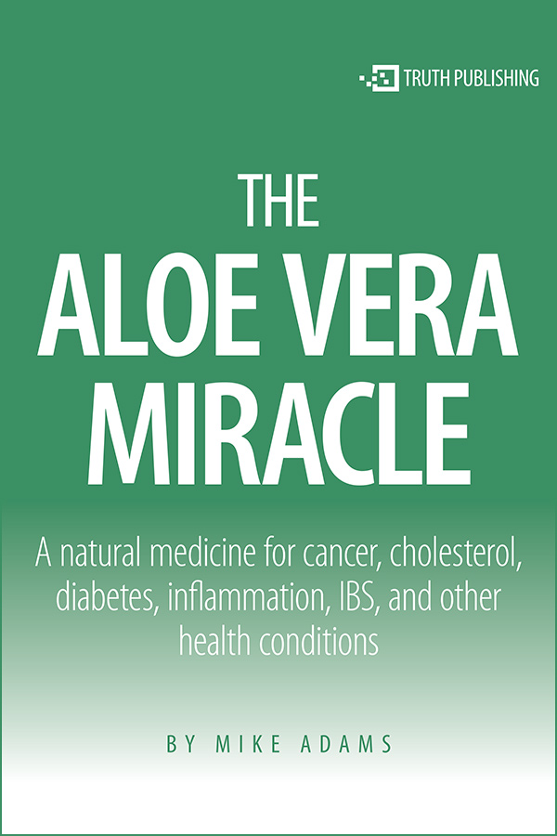](https://www.naturalnews.com/SpecialReports/AloeVeraMiracle.pdf)](https://www.naturalnews.com/SpecialReports/AloeVeraMiracle.pdf" \t "_blank)

[The Miracle of Aloe Vera](https://www.naturalnews.com/SpecialReports/AloeVeraMiracle.pdf" \t "_blank)

[A natural medicine for cancer, cholesterol, diabetes, inflammation, IBS, and other health conditions.](https://www.naturalnews.com/SpecialReports/AloeVeraMiracle.pdf" \t "_blank)

[Download](https://www.naturalnews.com/SpecialReports/AloeVeraMiracle.pdf" \t "_blank)

[[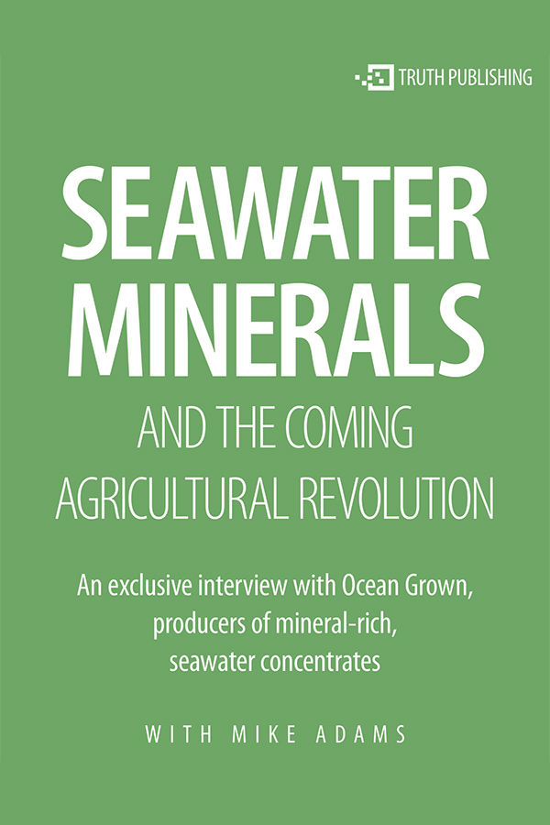](https://www.naturalnews.com/SpecialReports/Ocean_Grown.pdf)](https://www.naturalnews.com/SpecialReports/Ocean_Grown.pdf" \t "_blank)

[Seawater Minerals and the Coming Agricultural Revolution](https://www.naturalnews.com/SpecialReports/Ocean_Grown.pdf" \t "_blank)

[An exclusive interview with Ocean Grown, producers of mineral-rich, seawater concentrates.](https://www.naturalnews.com/SpecialReports/Ocean_Grown.pdf" \t "_blank)

[Download](https://www.naturalnews.com/SpecialReports/Ocean_Grown.pdf" \t "_blank)

[[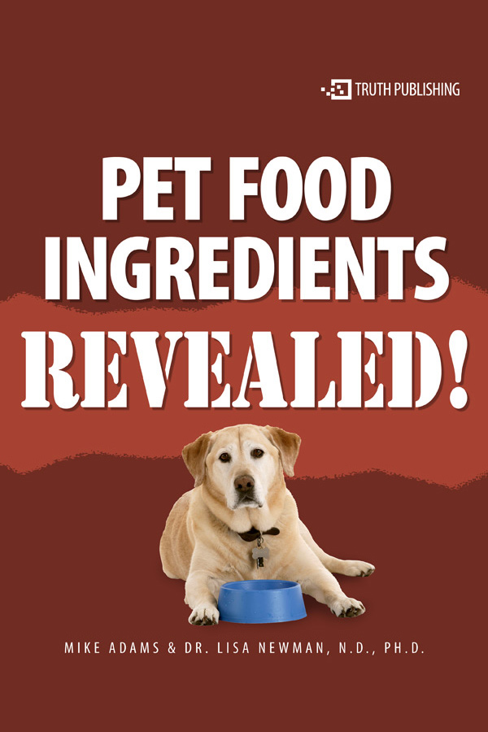](https://www.naturalnews.com/Report_pet_food_ingredients_0.html)](https://www.naturalnews.com/Report_pet_food_ingredients_0.html" \t "_blank)

[Pet Food Ingredients Revealed!](https://www.naturalnews.com/Report_pet_food_ingredients_0.html" \t "_blank)

[A NaturalNews Special Report by Dr. Lisa Newman and Mike Adams](https://www.naturalnews.com/Report_pet_food_ingredients_0.html" \t "_blank)

[Read Online](https://www.naturalnews.com/Report_pet_food_ingredients_0.html" \t "_blank)

[[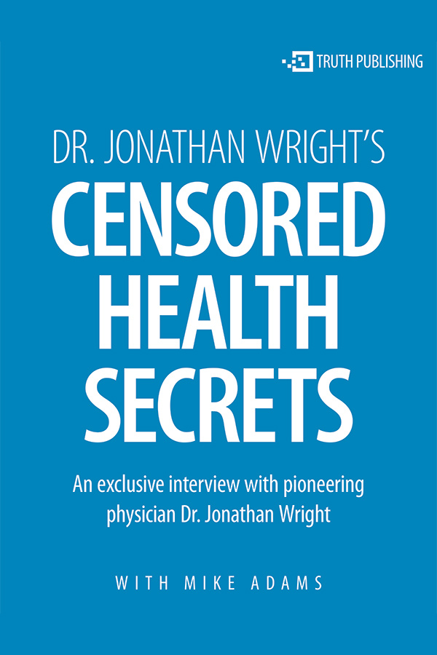](https://www.naturalnews.com/SpecialReports/DrWright.pdf)](https://www.naturalnews.com/SpecialReports/DrWright.pdf" \t "_blank)

[Censored Health Secrets](https://www.naturalnews.com/SpecialReports/DrWright.pdf" \t "_blank)

[In this exclusive NaturalNews interview, Mike Adams talks with Dr. Jonathan Wright, M.D., a true pioneer in nutrition, disease prevention and health freedom.](https://www.naturalnews.com/SpecialReports/DrWright.pdf" \t "_blank)

[Download](https://www.naturalnews.com/SpecialReports/DrWright.pdf" \t "_blank)

[[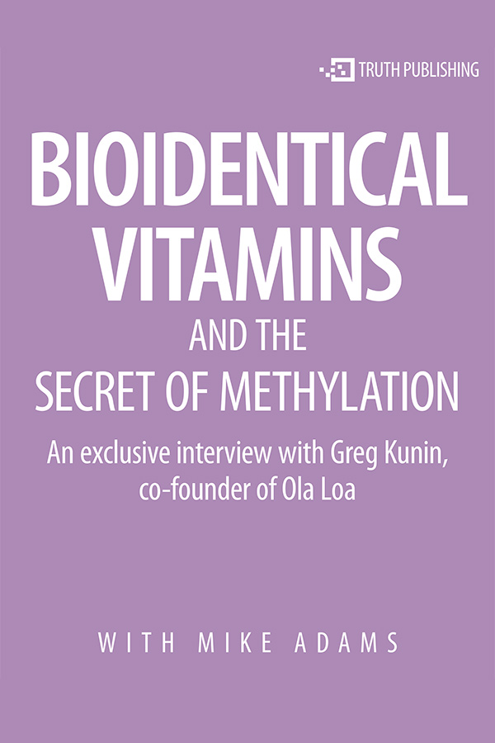](https://www.naturalnews.com/SpecialReports/BioidenticalVitamins.pdf)](https://www.naturalnews.com/SpecialReports/BioidenticalVitamins.pdf" \t "_blank)

[Bioidentical Vitamins and the Secret of Methylation](https://www.naturalnews.com/SpecialReports/BioidenticalVitamins.pdf" \t "_blank)

[Discover a treasure chest of little-known truths about vitamins and health from one of the top experts in the supplements industry.](https://www.naturalnews.com/SpecialReports/BioidenticalVitamins.pdf" \t "_blank)

[Download](https://www.naturalnews.com/SpecialReports/BioidenticalVitamins.pdf" \t "_blank)

[[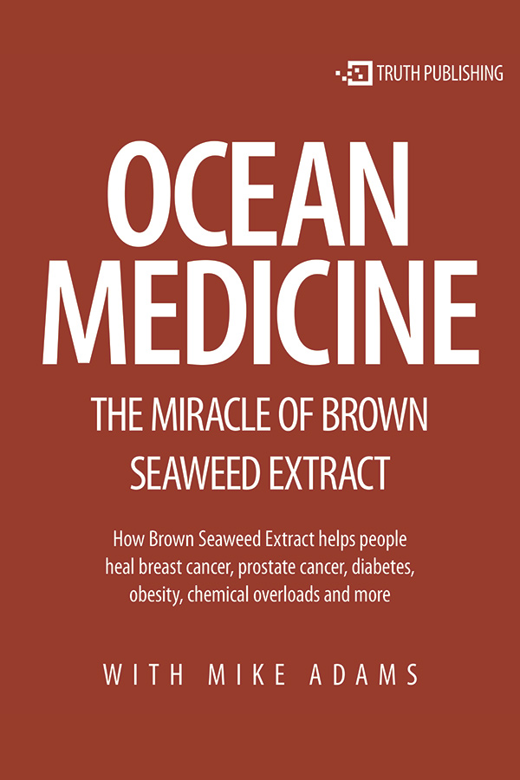](https://www.naturalnews.com/SpecialReports/OceanMedicine.pdf)](https://www.naturalnews.com/SpecialReports/OceanMedicine.pdf" \t "_blank)

[Ocean Medicine: The Miracle of Brown Seaweed Extract](https://www.naturalnews.com/SpecialReports/OceanMedicine.pdf" \t "_blank)

[Sergei Zimin, the founder of Modifilan, reveals never-before-published details about the harvesting, processing and packaging of this truly amazing medicine.](https://www.naturalnews.com/SpecialReports/OceanMedicine.pdf" \t "_blank)

[Download](https://www.naturalnews.com/SpecialReports/OceanMedicine.pdf" \t "_blank)

[[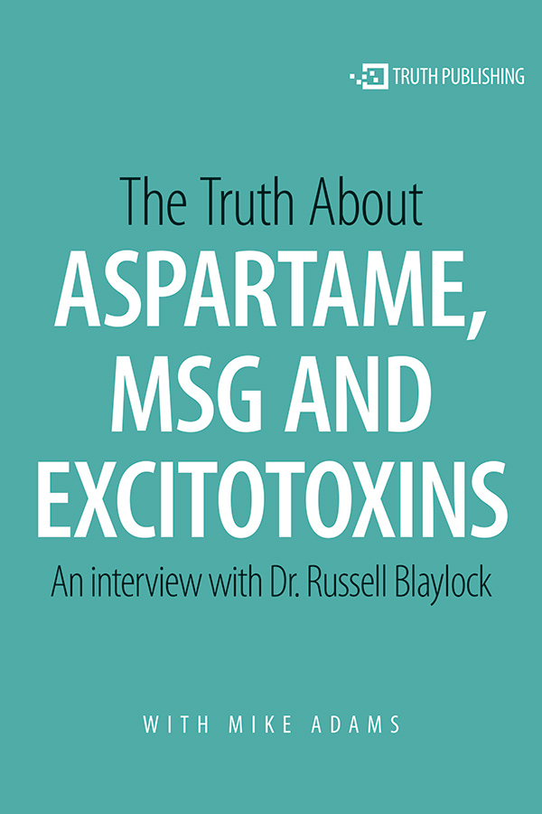](https://www.naturalnews.com/SpecialReports/Aspartame_Truth.pdf)](https://www.naturalnews.com/SpecialReports/Aspartame_Truth.pdf" \t "_blank)

[The Truth About Aspartame, MSG and Excitotoxins](https://www.naturalnews.com/SpecialReports/Aspartame_Truth.pdf" \t "_blank)

[Dr. Blaylock is the author of](https://www.naturalnews.com/SpecialReports/Aspartame_Truth.pdf" \t "_blank) *[Excitotoxins: The Taste That Kills](https://www.naturalnews.com/SpecialReports/Aspartame_Truth.pdf" \t "_blank)*[, and](https://www.naturalnews.com/SpecialReports/Aspartame_Truth.pdf" \t "_blank) *[Health and Nutrition Secrets That Can Save Your Life](https://www.naturalnews.com/SpecialReports/Aspartame_Truth.pdf" \t "_blank)*[.](https://www.naturalnews.com/SpecialReports/Aspartame_Truth.pdf" \t "_blank)

[Download](https://www.naturalnews.com/SpecialReports/Aspartame_Truth.pdf" \t "_blank)

[[](https://www.naturalnews.com/SpecialReports/LivewithFredBaughman.pdf)](https://www.naturalnews.com/SpecialReports/LivewithFredBaughman.pdf" \t "_blank)

[Live with Dr. Fred Baughman](https://www.naturalnews.com/SpecialReports/LivewithFredBaughman.pdf" \t "_blank)

[In this interview, Dr. Baughman discusses ADHD fraud and the chemical holocaust against a generation of children.](https://www.naturalnews.com/SpecialReports/LivewithFredBaughman.pdf" \t "_blank)

[Download](https://www.naturalnews.com/SpecialReports/LivewithFredBaughman.pdf" \t "_blank)

[[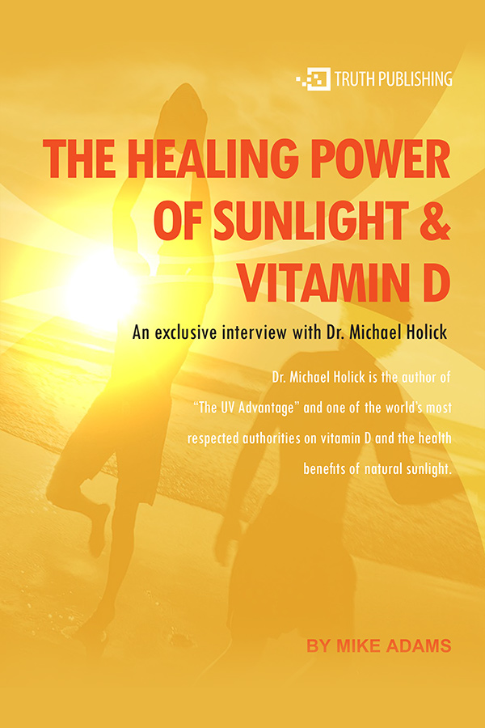](https://www.naturalnews.com/SpecialReports/Sunlight.pdf)](https://www.naturalnews.com/SpecialReports/Sunlight.pdf" \t "_blank)

[The Healing Power of Sunlight and Vitamin D](https://www.naturalnews.com/SpecialReports/Sunlight.pdf" \t "_blank)

[Dr. Holick reveals fascinating facts on how vitamin D is created and used in the human body to ward off chronic diseases like cancer, osteoporosis, mental disorders and more.](https://www.naturalnews.com/SpecialReports/Sunlight.pdf" \t "_blank)

[Download](https://www.naturalnews.com/SpecialReports/Sunlight.pdf" \t "_blank)

[[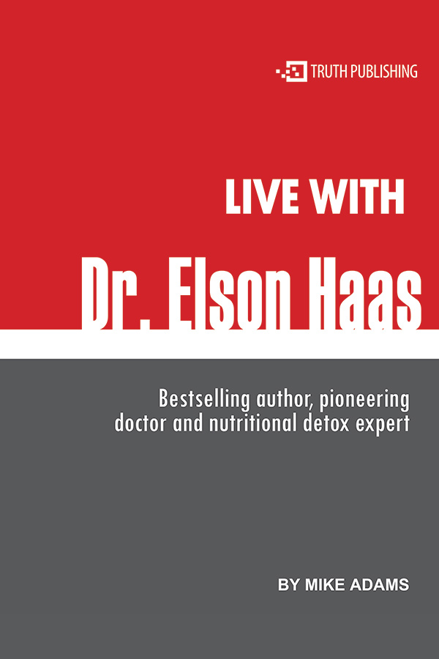](https://www.naturalnews.com/SpecialReports/LiveWithDrElsonHaas.pdf)](https://www.naturalnews.com/SpecialReports/LiveWithDrElsonHaas.pdf" \t "_blank)

[Live with Dr. Elson Haas](https://www.naturalnews.com/SpecialReports/LiveWithDrElsonHaas.pdf" \t "_blank)

[Dr. Haas is a bestselling author, pioneering doctor and nutritional detox expert.](https://www.naturalnews.com/SpecialReports/LiveWithDrElsonHaas.pdf" \t "_blank)

[Download](https://www.naturalnews.com/SpecialReports/LiveWithDrElsonHaas.pdf" \t "_blank)

[[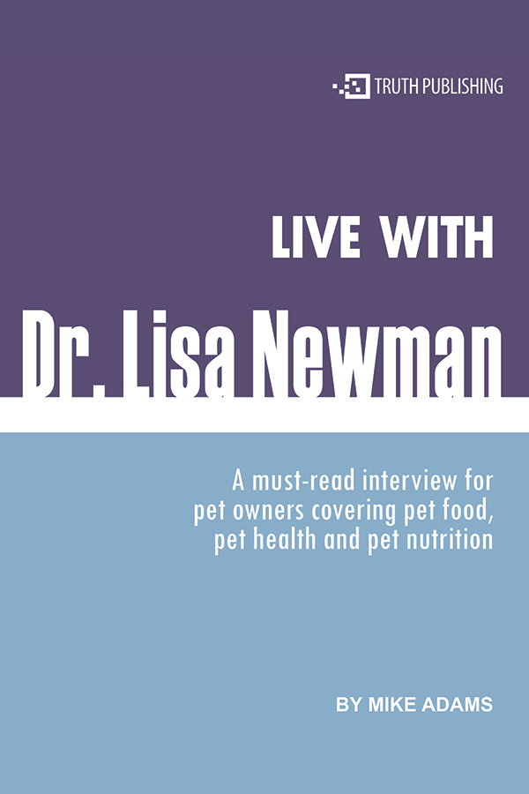](https://www.naturalnews.com/SpecialReports/LiveWithDrLisaNewman.pdf)](https://www.naturalnews.com/SpecialReports/LiveWithDrLisaNewman.pdf" \t "_blank)

[Live with Dr. Lisa Newman](https://www.naturalnews.com/SpecialReports/LiveWithDrLisaNewman.pdf" \t "_blank)

[A must-read interview for pet owners covering pet food, pet health and pet nutrition.](https://www.naturalnews.com/SpecialReports/LiveWithDrLisaNewman.pdf" \t "_blank)

[Download](https://www.naturalnews.com/SpecialReports/LiveWithDrLisaNewman.pdf" \t "_blank)

[[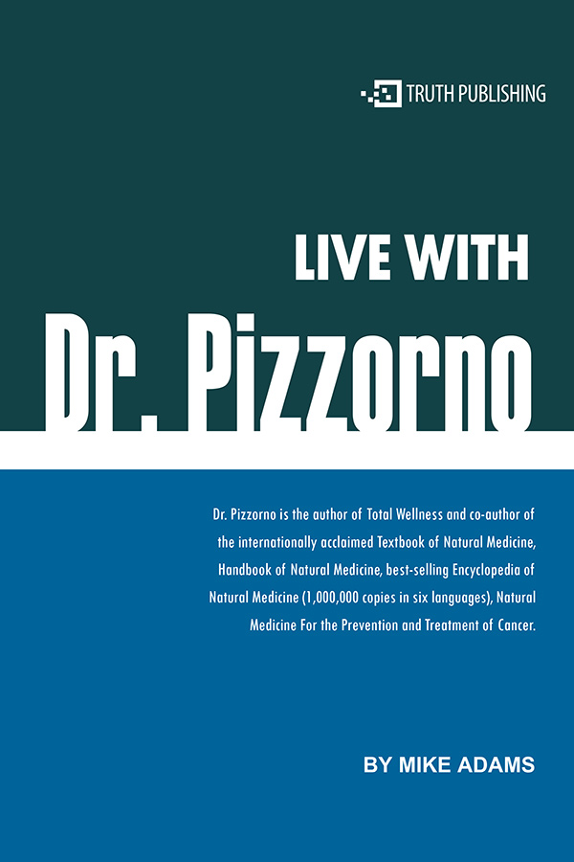](https://www.naturalnews.com/SpecialReports/LivewithDrPizzorno.pdf)](https://www.naturalnews.com/SpecialReports/LivewithDrPizzorno.pdf" \t "_blank)

[Live with Dr. Pizzorno](https://www.naturalnews.com/SpecialReports/LivewithDrPizzorno.pdf" \t "_blank)

[Dr. Pizzorno is the author of](https://www.naturalnews.com/SpecialReports/LivewithDrPizzorno.pdf" \t "_blank) *[Total Wellness](https://www.naturalnews.com/SpecialReports/LivewithDrPizzorno.pdf" \t "_blank)* [and co-author of the internationally acclaimed](https://www.naturalnews.com/SpecialReports/LivewithDrPizzorno.pdf" \t "_blank) *[Textbook of Natural Medicine](https://www.naturalnews.com/SpecialReports/LivewithDrPizzorno.pdf" \t "_blank)*[.](https://www.naturalnews.com/SpecialReports/LivewithDrPizzorno.pdf" \t "_blank)

[Download](https://www.naturalnews.com/SpecialReports/LivewithDrPizzorno.pdf" \t "_blank)

[[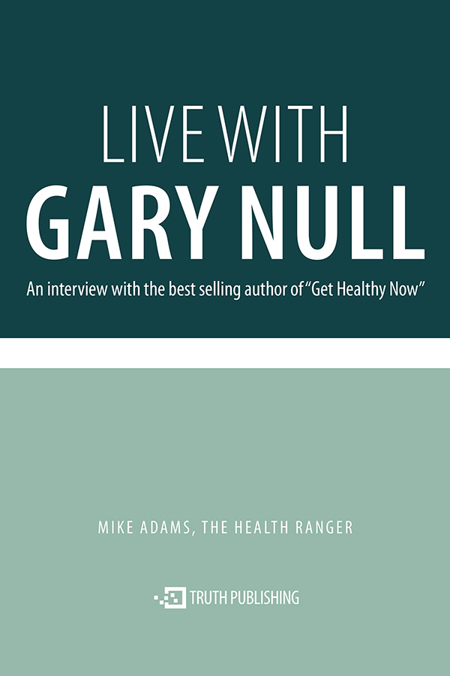](https://www.naturalnews.com/SpecialReports/LivewithGaryNull.pdf)](https://www.naturalnews.com/SpecialReports/LivewithGaryNull.pdf" \t "_blank)

[Live with Gary Null](https://www.naturalnews.com/SpecialReports/LivewithGaryNull.pdf" \t "_blank)

[Gary Null is the best selling author of](https://www.naturalnews.com/SpecialReports/LivewithGaryNull.pdf" \t "_blank) *[Get Healthy Now.](https://www.naturalnews.com/SpecialReports/LivewithGaryNull.pdf" \t "_blank)*

[Download](https://www.naturalnews.com/SpecialReports/LivewithGaryNull.pdf" \t "_blank)

[[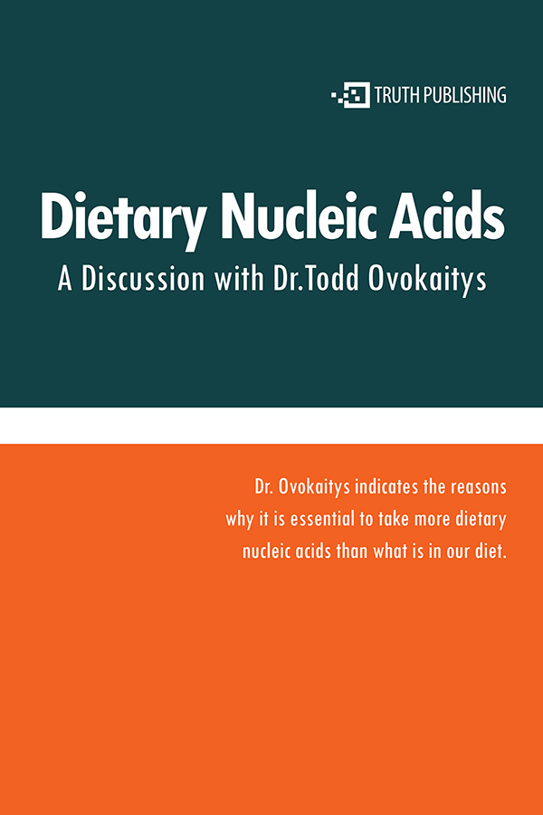](https://www.naturalnews.com/SpecialReports/ToddOvokaitys.pdf)](https://www.naturalnews.com/SpecialReports/ToddOvokaitys.pdf" \t "_blank)

[Dietary Nucleic Acids](https://www.naturalnews.com/SpecialReports/ToddOvokaitys.pdf" \t "_blank)

[A discussion with Dr. Todd Ovokaitys](https://www.naturalnews.com/SpecialReports/ToddOvokaitys.pdf" \t "_blank)

[Download](https://www.naturalnews.com/SpecialReports/ToddOvokaitys.pdf" \t "_blank)

[[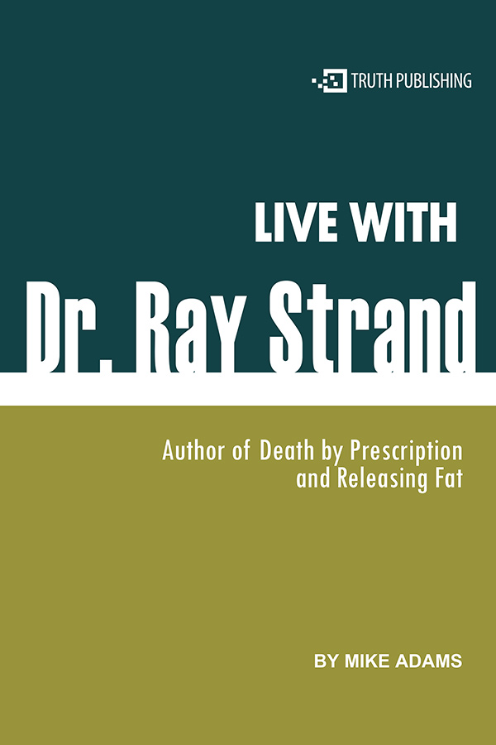](https://www.naturalnews.com/SpecialReports/LivewithDrRayStrand.pdf)](https://www.naturalnews.com/SpecialReports/LivewithDrRayStrand.pdf" \t "_blank)

[Live with Dr. Ray Strand](https://www.naturalnews.com/SpecialReports/LivewithDrRayStrand.pdf" \t "_blank)

[Dr. Strand is one of the most courageous doctors to speak out about the health effects of prescription drugs.](https://www.naturalnews.com/SpecialReports/LivewithDrRayStrand.pdf" \t "_blank)

[Download](https://www.naturalnews.com/SpecialReports/LivewithDrRayStrand.pdf" \t "_blank)

[[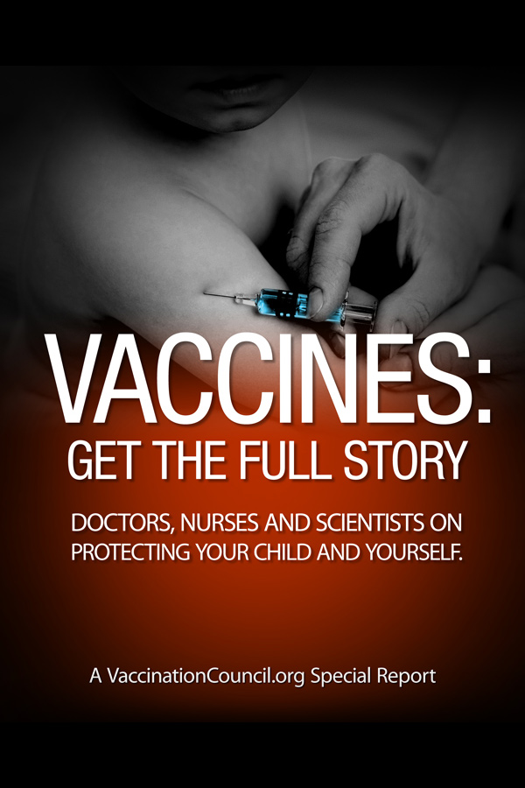](https://www.naturalnews.com/SpecialReports/VaccinesFullStory/v1/VaccineReport-EN.pdf)](https://www.naturalnews.com/SpecialReports/VaccinesFullStory/v1/VaccineReport-EN.pdf" \t "_blank)

[Vaccines: Get the Full Story](https://www.naturalnews.com/SpecialReports/VaccinesFullStory/v1/VaccineReport-EN.pdf" \t "_blank)

[Doctors, Nurses and Scientists on Protecting Your Child and Yourself.](https://www.naturalnews.com/SpecialReports/VaccinesFullStory/v1/VaccineReport-EN.pdf" \t "_blank)

[Download](https://www.naturalnews.com/SpecialReports/VaccinesFullStory/v1/VaccineReport-EN.pdf" \t "_blank)

[[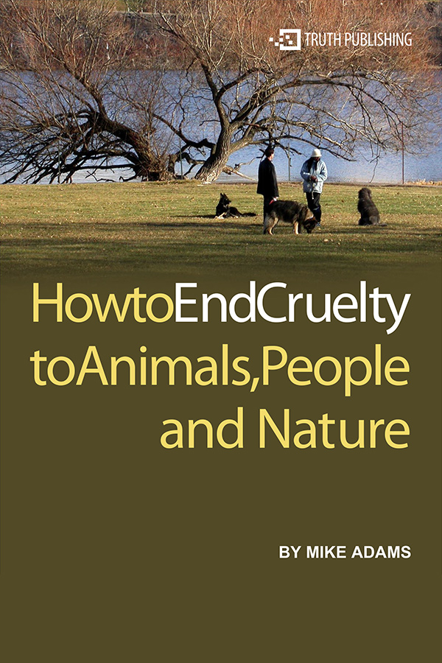](https://www.naturalnews.com/SpecialReports/HowtoEndCruelty.pdf)](https://www.naturalnews.com/SpecialReports/HowtoEndCruelty.pdf" \t "_blank)

[How to End Cruelty to Animals, People and Nature](https://www.naturalnews.com/SpecialReports/HowtoEndCruelty.pdf" \t "_blank)

[Discover what we can do to help end cruelty and enhance compassion in the world.](https://www.naturalnews.com/SpecialReports/HowtoEndCruelty.pdf" \t "_blank)

[Download](https://www.naturalnews.com/SpecialReports/HowtoEndCruelty.pdf" \t "_blank)

[[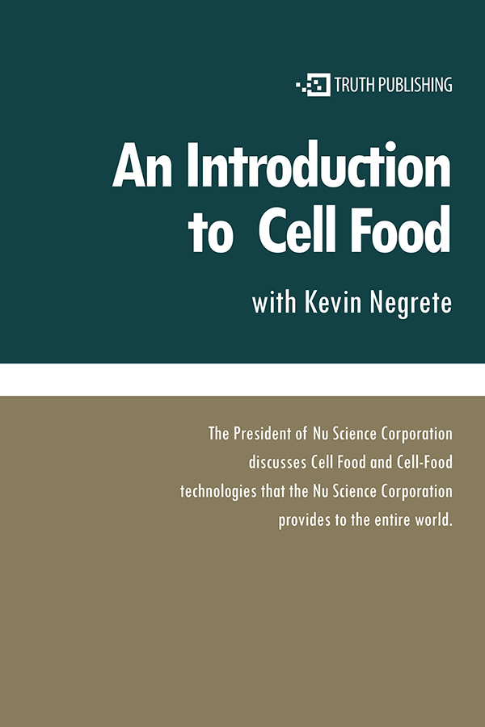](https://www.naturalnews.com/SpecialReports/CellFoods.pdf)](https://www.naturalnews.com/SpecialReports/CellFoods.pdf" \t "_blank)

[An Introduction to Cell Food with Kevin Negrete](https://www.naturalnews.com/SpecialReports/CellFoods.pdf" \t "_blank)

[The President of Nu Science Corporation discusses Cell Food and Cell-Food technologies that the Nu Science Corporation provides to the entire world.](https://www.naturalnews.com/SpecialReports/CellFoods.pdf" \t "_blank)

[Download](https://www.naturalnews.com/SpecialReports/CellFoods.pdf" \t "_blank)

[[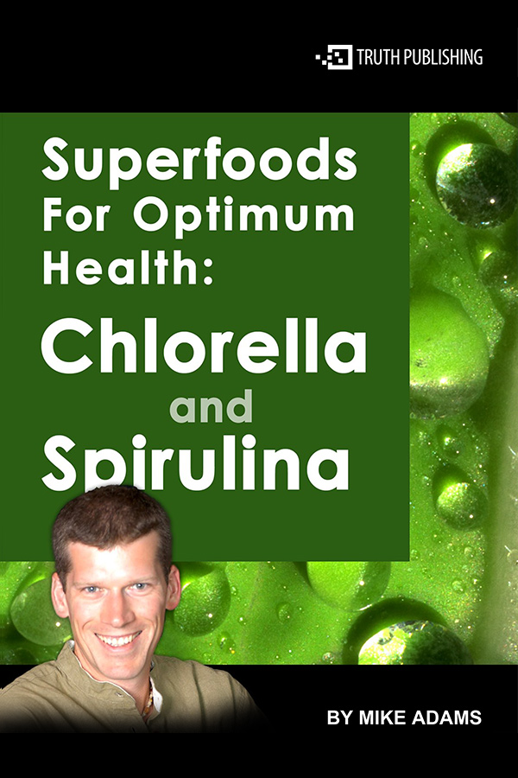](https://www.naturalnews.com/SpecialReports/Superfoods.pdf)](https://www.naturalnews.com/SpecialReports/Superfoods.pdf" \t "_blank)

[Superfoods for Optimum Health: Chlorella and Spirulina](https://www.naturalnews.com/SpecialReports/Superfoods.pdf" \t "_blank)

[Discover the astonishing health benefits and nutritional achievements of these two foods.](https://www.naturalnews.com/SpecialReports/Superfoods.pdf" \t "_blank)

[Download](https://www.naturalnews.com/SpecialReports/Superfoods.pdf" \t "_blank)

[[](https://www.naturalnews.com/SpecialReports/AmazonHerbCompany.pdf)](https://www.naturalnews.com/SpecialReports/AmazonHerbCompany.pdf" \t "_blank)

[3 Steps to Success with the Amazon Herb Company](https://www.naturalnews.com/SpecialReports/AmazonHerbCompany.pdf" \t "_blank)

[This program is for people who want to start off on the right track and really make it a success.](https://www.naturalnews.com/SpecialReports/AmazonHerbCompany.pdf" \t "_blank)

[Download](https://www.naturalnews.com/SpecialReports/AmazonHerbCompany.pdf" \t "_blank)

[[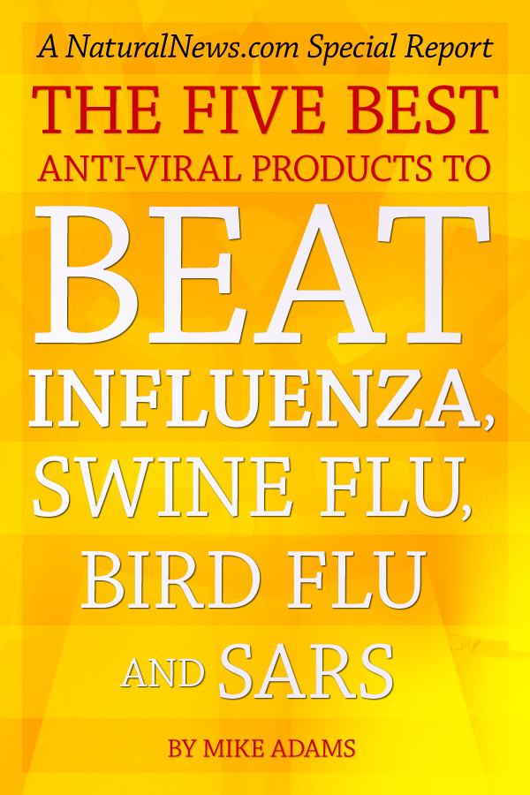](https://www.naturalnews.com/Report_Anti-Viral_Remedies_Influenza_0.html)](https://www.naturalnews.com/Report_Anti-Viral_Remedies_Influenza_0.html" \t "_blank)

[The Five Best Anti-Viral Products to Beat Influenza, Swine Flu, Bird Flu and SARS](https://www.naturalnews.com/Report_Anti-Viral_Remedies_Influenza_0.html" \t "_blank)

[This is a special report the FDA doesn't want you to read.](https://www.naturalnews.com/Report_Anti-Viral_Remedies_Influenza_0.html" \t "_blank)

[Read Online](https://www.naturalnews.com/Report_Anti-Viral_Remedies_Influenza_0.html" \t "_blank)

[[](https://www.naturalnews.com/Report_Mindful_Wealth_0.html)](https://www.naturalnews.com/Report_Mindful_Wealth_0.html" \t "_blank)

[The 7 Principles of Mindful Wealth](https://www.naturalnews.com/Report_Mindful_Wealth_0.html" \t "_blank)

[Learn how to let go of unconscious limitations to personal wealth and embrace a conscious wealth attraction philosophy that's aligned with natural living principles.](https://www.naturalnews.com/Report_Mindful_Wealth_0.html" \t "_blank)

[Read Online](https://www.naturalnews.com/Report_Mindful_Wealth_0.html" \t "_blank)

[[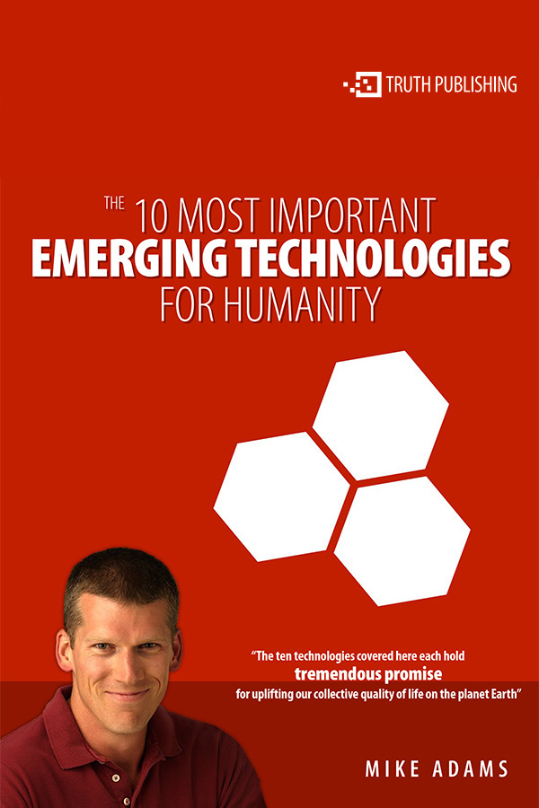](https://www.naturalnews.com/SpecialReports/EmergingTechnologies.pdf)](https://www.naturalnews.com/SpecialReports/EmergingTechnologies.pdf" \t "_blank)

[The 10 Most Important Emerging Technologies for Humanity](https://www.naturalnews.com/SpecialReports/EmergingTechnologies.pdf" \t "_blank)

[Most of these technologies will, at some point, be hotly debated for their social, economic, and political implications.](https://www.naturalnews.com/SpecialReports/EmergingTechnologies.pdf" \t "_blank)

[Download](https://www.naturalnews.com/SpecialReports/EmergingTechnologies.pdf" \t "_blank)

This site is part of the Natural News Network © 2019 All Rights Reserved. [Privacy](https://www.naturalnews.com/PrivacyPolicy.html) | [Terms](https://www.naturalnews.com/Terms.html) All content posted on this site is commentary or opinion and is protected under Free Speech. Truth Publishing International, LTD. is not responsible for content written by contributing authors. The information on this site is provided for educational and entertainment purposes only. It is not intended as a substitute for professional advice of any kind. Truth Publishing assumes no responsibility for the use or misuse of this material. Your use of this website indicates your agreement to these terms and [those published here](https://www.naturalnews.com/Terms.html). All trademarks, registered trademarks and servicemarks mentioned on this site are the property of their respective owners.

Your privacy is assured and your information is kept confidential. You may unsubscribe at anytime.