**The Theory Of Evolution – Fact Or Fiction?**

Graham Pick

Wednesday, 1 July 2015

http://www.maltanow.com.mt/?p=3690

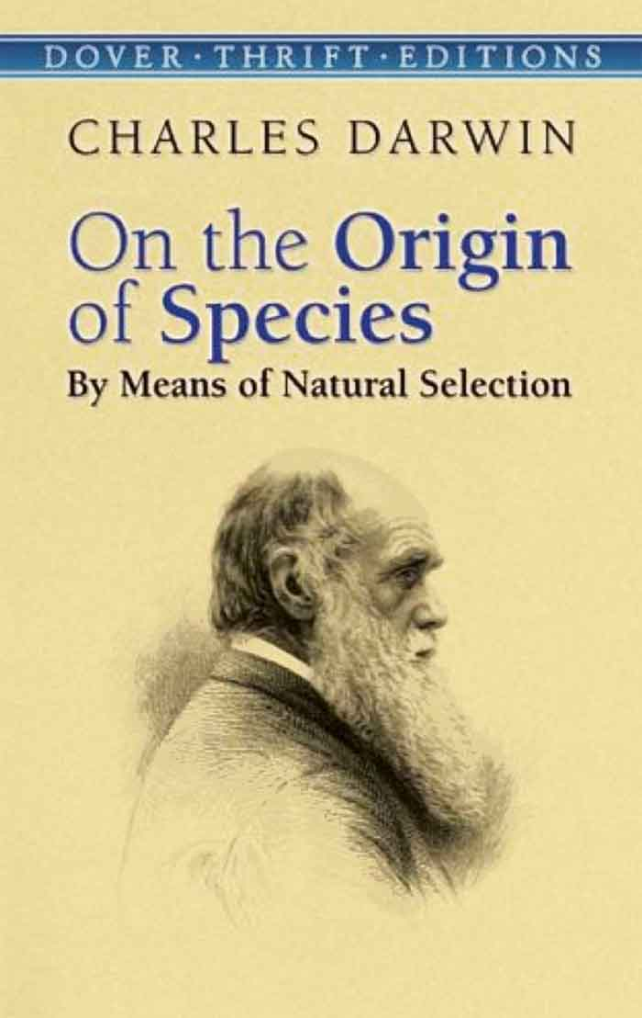

Since time immemorial the human race has pondered its origin. Many have found solace in religious teachings and beliefs that we were created by some omnipotent being in the not too distant past. Others have sought an alternative account, unable to accept religious doctrines as an explanation of our existence.

Many of these found the answer to their uncertainty on 24th November 1859, the date a new religion was founded. It was on that date a work of scientific literature was published by an eminent scientist of the time, introducing the  supposedly precise and logical theory that populations  evolve  over the course of generations through a process called natural selection.

Written by Charles Robert Darwin, ***On the Origin of Species by Means of Natural Selection, or the Preservation of Favoured Races in the Struggle for Life*** birthed the concept of the theory of evolution for the masses, and since its publication has garnered millions of followers and believers worldwide.

The basic premise of the theory of evolution is that every living thing on the planet today – bacteria, fungi, plants, reptiles, mammals, marsupials, birds, fish, and even humans, have all descended from a single common ancestor.

Even though the theory of evolution is just that – an unproven theory, many of its advocates accept the idea as factual, and despite the reality that there are many uncertainties and ambiguities within its ideology, are unwilling to accept that it is nothing more than hypothesis and conjecture.

Whilst I do not claim to be an expert, and have not studied the concept in detail, I do have a common sense rational approach to the subject, and this has stimulated many reservations regarding evolutions overall thesis, and ultimately its most basic founding principle.

The whole basis of the theory of evolution is the assumption that life on earth first bloomed around 3.8 billion years ago when a lifeless jumble of molecules and chemical compounds in a “primordial soup”, somehow sparked into life. But what turned sterile molecules into living, changing organisms?

It is theorised that possibly an electrical storm – a lightning strike – somehow brought to life this hypothesised “blob of primordial gunge”. Yet despite many of the worlds most brilliant scientific minds attempting to recreate this evolutionary concept, no one, anywhere, ever, has managed to replicate this event in a laboritory.

So the first flaw in the evolutionary theory is evident in its primary founding principle. Similar to the theory of creation, blind faith, or belief that an unproven incident actually occurred, is required for the remainder of the theory to have any validity. If this miracle of dead matter becoming living organisms did not actually occur then there is nothing further to debate.

Darwin’s general theory presumes the development of life from non-life and relies upon a purely naturalistic (undirected) “descent with modification”. That is, complex creatures evolve from more simplistic ancestors naturally over time. In a nutshell, as random genetic mutations occur within an organism’s genetic code, the beneficial mutations are preserved because they aid survival – a process known as “natural selection.” These beneficial mutations are passed on to the next generation. Over time, beneficial mutations accumulate and the result is an entirely different organism (not just a variation of the original, but an entirely different creature).

Whilst the majority of commentators, both for and against evolution, will concentrate their arguments and debates on the more complex aspects of the theory, I tend to question the simpler elements.

Let us assume that a miraculous occurrence did take place billions of years ago, and that a few molecules of inert matter were suddenly transformed into life forms. For these micro organisms to survive the first thing they would need to do is reproduce. Without reproduction or replication, these organisms would live a limited lifespan and then die out – life would be no more and once again the theory of evolution falls flat on its face.

[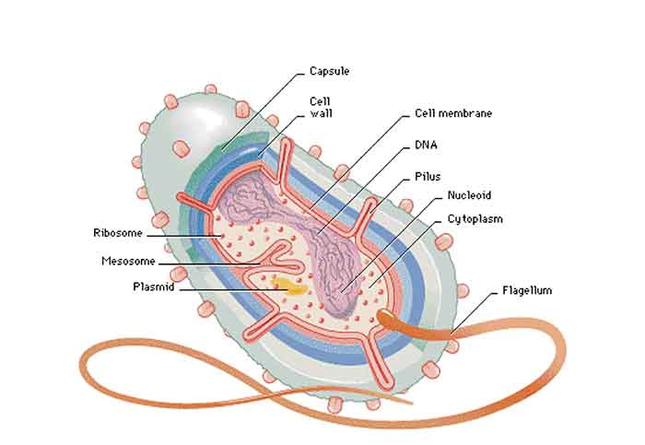](http://www.maltanow.com.mt/wp-content/uploads/2015/09/bacteria.jpg)

The complexity of simple bacteria

One has to presume that this primordial blob of inert gunge suddenly burst into life with the immediate ability to self replicate or reproduce. Whilst advocates of the theory have no problem with this concept, I tend to find it challenging to accept.

Nevertheless, in order to deliberate this theory objectively we need once again to assume that, however improbable it might seem, this did actually occur and the building blocks of all known life – both living and extinct – were born.

Unfortunately accepting this explanation as fact propagates further problems with Darwins hypothesis.

In light of the tremendous advances science has made in molecular biology, biochemistry, and genetics, over the past fifty years, we now know that there are in fact tens of thousands of irreducibly complex systems at the cellular level. Complexity pervades the microscopic biological world.

Molecular biologist Michael Denton wrote;

*“Although the tiniest bacterial cells are incredibly small, each is in effect a veritable micro-miniaturized factory containing thousands of exquisitely designed pieces of intricate molecular machinery, made up altogether of one hundred thousand million atoms, far more complicated than any machinery built by man and absolutely without parallel in the non-living world.”*

So not only is one expected to accept that inorganic matter was miraculously transformed into living cells, one also has to accept that those cells were incredibly complex in their composition.

Regrettably, this recently discovered fact invalidates Darwins theory all by itself.

Darwin wrote; *“…Natural selection acts only by taking advantage of slight successive variations; she can never take a great and sudden leap, but must advance short and sure, though slow steps.”*

Thus, Darwin conceded that;

*“If it could be demonstrated that any complex organ existed, which could not possibly have been formed by numerous, successive, slight modifications, my theory would absolutely break down.* *Such a complex organ would be known as an irreducibly complex system”.*

An irreducibly complex system is one composed of multiple parts, all of which are necessary for the system to function. If even one part is missing, the entire system will fail to function. Every individual part is integral. Thus, such a system could not have evolved slowly, piece by piece.

Furthermore, one doesn’t need a microscope to observe irreducible complexity. The eye, the ear, and the heart, are all common examples of irreducible complexity, although they were not recognized as such in Darwin’s day.

Even Darwin himself confessed that his evolutionary theory, albeit radical for its time, was highly unlikely when faced with the complexity of even the simplest life form. He wrote;

*“To suppose that the eye with all its inimitable contrivances for adjusting the focus to different distances, for admitting different amounts of light, and for the correction of spherical and chromatic aberration, could have been formed by natural selection, seems, I freely confess, absurd in the highest degree.”*

When one further analyses the timeline presented by evolutionary science in support of its premise, further misgivings present themselves.

According to Wikipedia [Here](https://en.wikipedia.org/wiki/Timeline_of_the_evolutionary_history_of_life) the first living organisms sprang into life about 3.9 billion years ago. Then things stagnated a bit. In fact things stagnated a lot and nothing really happened for another 2.9 billion years when, approximately 1 billion years ago, the first multi–cellular organisms appeared. The first simple animals appeared just 600 million years ago and the first basic land vegetation 475 million years ago.

On the same Wikipedia page is the following;

*“The similarities between all present day organisms indicate the presence of a common ancestor from which all known species, living and extinct, have diverged through the process of evolution. More than 99 percent of all species,* ***amounting to over five billion species,****that ever lived on Earth are estimated to be  extinct.*

*Estimates on the number of Earth’s current  species  range from 10 million to 14 million, of which about 1.2 million have been documented and over 86 percent have not yet been described.”*

Whilst the above at first glance may not seem extraordinary, if one performs basic maths and applies critical analysis to the numbers presented, a glaring anomaly becomes evident.

Multi cellular life (which implies “species”) supposedly didn’t evolve until 1 billion years ago, yet according to the science of evolution, over 5 billion species have individually evolved and become extinct during this period!

Just using simple mathematics this equates to 5 new species of plant or animal evolving every single year for one billion years.

Let that sink in for a while…

The very basis of the evolutionary concept is little by little over vast periods of time. A small beneficial mutation occurs within a particular plant or animal and is then incorporated into the genome of the next generation. These minute mutations accumulate over many generations, eventually culminating in a new species. Utilising this model, theoretically it should take hundreds of generations, spread over thousands of years, for a new species to appear. Yet one is expected to accept, using Darwinists own numbers, that five new species appeared every year, for one billion years.

Additionally, species denotes a group of living organisms consisting of similar individuals capable of exchanging genes or interbreeding. The species is the principal natural taxonomic unit, ranking below a genus. For example there are many different breeds of dog who all belong to the canine species, or many different types of rodent, or butterfly, or spider. Therefore, in reality, five billion species could, in reality, represent more than twenty or thirty billion different varieties of animal or vegetation.

Furthermore, if 99% of all species have also become extinct during the same period, by applying the same mathematical principle of basic division, then likewise, almost 5 species would have become extinct every year for one billion years.

If one accepts these numbers as correct then one would logically expect a similar amount of new species to be currently appearing each year. Yet although formerly unknown species are constantly being revealed, no new species, known to have been a direct result of the evolutionary process, have been discovered since records began.

Whilst evolutionary theory employs many facets of scientific and biological research in support of its premise, it also relies heavily on the fossil record. Again, when examined in detail, the fossil record doesn’t truly support the theory at all.

Darwins critics wrote;

*“If the theory of natural selection of Darwin is correct, why can’t we see evidence of the intermediate forms of species, the connecting links?”*

Darwin did not have the answer nor the archaeological evidence to support it. Although there is ample evidence for many species, fossil records provide almost no evidence for the intermediate connecting links.

The fossil record contains fossils of only complete and fully-formed species. There are no fossils of partially-evolved species to indicate that a gradual process of evolution ever occurred. Even amongst evolutionists there are diametrically different interpretations and reconstructions of the fossils used to support human evolution from a supposed ape-like ancestry.

Even if evolution takes millions and millions of years, we should still be able to see some evidence of the different stages of this process. But, we simply don’t observe any partially-evolved fish, frogs, lizards, birds, dogs, cats among us. Every known species of plant and animal is complete and fully-formed.

Another problem is how could partially evolved plant and animal species survive over millions of years when their basic organs and tissues were still in the process of evolving? How, for example, were animals breathing, eating, and reproducing if there respiratory, digestive, and reproductive organs were still evolving?

Although Darwin was partially correct by demonstrating that natural selection occurs in nature, the problem is that natural selection itself is not a creative force. Natural selection can only work with those biological variations that are possible. The evidence from genetics supports only the possibility for horizontal evolution (i.e. varieties of dogs, cats, horses, cows, etc.) but not vertical evolution (i.e. from fish to human).

Modern science has shown that there are genetic limits to evolution or biological change in nature. Again, all biological variations, whether they are beneficial to survival or not, are possible only within the genetic potential and limits of a particular biological kind, such as the varieties among dogs, cats, horses, cows, etc.

Variations across biological kinds such as humans evolving from ape like creatures and apes, in turn, evolving from dog like creatures and so on, as Darwinian evolutionary theory teaches, are not possible unless Nature has the capability of performing genetic engineering.

Biological variations are determined by the DNA or genetic code of species. The DNA molecule is actually a molecular string of various nucleic acids which are arranged in a sequence just like the letters in a sentence. It is this sequence in DNA that tells cells in the body how to construct various tissues and organs.

The common belief among evolutionists is that random mutations in the genetic code over time will produce entirely new sequences for new traits and characteristics which natural selection can then act upon resulting in entirely new species. Evolutionists consider mutations to be a form of natural genetic engineering.

However, the very nature of mutations precludes such a possibility. Mutations are accidental changes in the sequential structure of the genetic code caused by various random external environmental forces such as radiation or toxic chemicals.

Almost all true mutations are harmful, which is what one would normally expect from accidents. Even if a good mutation occurred for every good one there will be thousands of harmful ones with the net result over time being disastrous for a species.

Furthermore, mutations simply produce new varieties of already existing traits. For example, mutations in the gene for human hair may change the gene so that another type or colour of human hair develops, but the mutations won’t change the gene so that feathers grow instead.

Despite Darwin himself admitting that his theory could be considered *“absurd in the highest degree”,* millions of his followers and supporters deny that the evidence presented in support of his hypothesis is speculative at best, whilst devoid of any convincing evidence. Similar to creationism, the **theory** of evolution is no more than unproven assumptions. Even though various facets of science attempt to verify the evolutionary model, the result is nothing more than supposition supported by postulation.

It appears that the majority of advocates of the theory of evolution are willing to just accept the concept whilst conducting minimal research into its validity and applying negligible critical thinking skills. They blindly accept what they have been told, and castigate anyone who has the temerity to question their beliefs.

So to answer the question posed in the article title, in my humble opinion, based upon available evidence and utilising logic and common sense, I would have to say:

FICTION……

===================================================================================================================