Charles Robert Darwin 1809-1882
http://en.wikipedia.org/wiki/Charles_Darwin
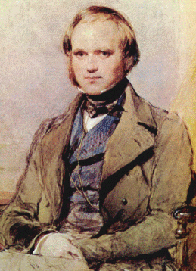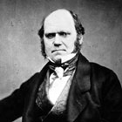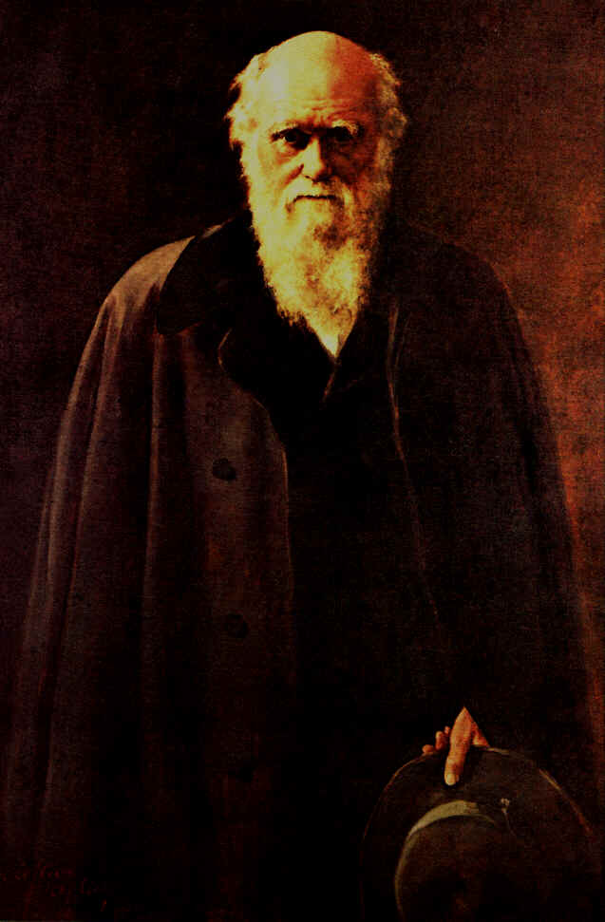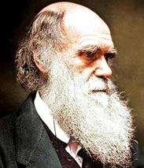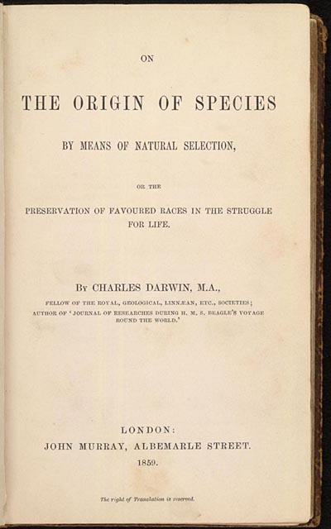
Charles Robert Darwin FRS (12 February 1809 – 19 April 1882) was an English naturalist who achieved lasting fame by producing considerable evidence that species originated through evolutionary change, at the same time proposing the scientific theory that natural selection is the mechanism by which such change occurs. This theory is now considered a cornerstone of biology, and has significantly affected other disciplines such as philosophy, psychology and anthropology.
Darwin developed an interest in natural history while studying first medicine, then theology, at university. Darwin's observations on his five-year voyage on the Beagle brought him eminence as a geologist and fame as a popular author. His biological finds led him to study the transmutation of species and in 1838 he conceived his theory of natural selection. Fully aware that others had been severely punished for such "heretical" ideas, he confided only in his closest friends and continued his research to meet anticipated objections. However, in 1858 the information that Alfred Russel Wallace had developed a similar theory forced an early joint publication of the theory.
His 1859 book On the Origin of Species by Means of Natural Selection, or The Preservation of Favoured Races in the Struggle for Life (usually abbreviated to The Origin of Species) established evolution by common descent as the dominant scientific explanation of diversification in nature. He continued his research and wrote a series of books on plants and animals, including humankind, notably The Descent of Man, and Selection in Relation to Sex and The Expression of the Emotions in Man and Animals.
In recognition of Darwin's pre-eminence, he was buried in Westminster Abbey, close to John Herschel and Isaac Newton.

Contents
- 1 Life
  - 1.1 Early life
  - 1.2 Journey on the Beagle
  - 1.3 Career in science, inception of theory
  - 1.4 Marriage and children
  - 1.5 Development of theory
  - 1.6 Announcement and publication of theory
  - 1.7 Reaction
  - 1.8 Further experiments, research and writing
- 2 Religious views
- 3 Legacy
  - 3.1 Commemoration
  - 3.2 Eugenics
  - 3.3 Social Darwinism
- 4 Works
- 5 Notes
- 6 References
- 7 External links
- 8 See also

Life

Early life
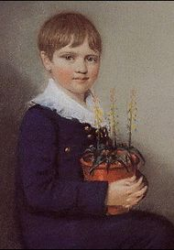
The seven-year-old Charles Darwin in 1816, one year before the sudden loss of his mother.
Main article: Charles Darwin's education
Charles Darwin was born in Shrewsbury, Shropshire, England on 12 February 1809 at The Mount, the house his father had built along the Severn River.^{[1]} He was the fifth of six children of wealthy society doctor Robert Darwin and Susannah Darwin (née Wedgwood). He was the grandson of Erasmus Darwin on his father's side, and of Josiah Wedgwood on his mother's side, both from the Darwin — Wedgwood family, a prominent English family which supported the Unitarian church. His mother died when he was only eight. He went to the nearby Shrewsbury School the next year as a boarder.
In 1825, after spending the summer as an apprentice doctor, helping his father with treating the poor of Shropshire, Darwin went to the University of Edinburgh to study medicine. However, his revulsion at the brutality of surgery led him to neglect his medical studies. He learned taxidermy from John Edmonstone, a freed black slave who told him exciting tales of the South American rainforest.^{[2]} In Darwin's second year he became active in student societies for naturalists. He became an avid pupil of Robert Edmund Grant, who pioneered development of the theories of Jean-Baptiste Lamarck and of Charles' grandfather Erasmus concerning evolution by acquired characteristics. Darwin took part in Grant's investigations of the life cycle of marine animals on the shores of the Firth of Forth which found evidence for homology, the radical theory that all animals have similar organs and differ only in complexity. In March 1827, Darwin made a presentation to the Plinian society of his own discovery that the black spores often found in oyster shells were the eggs of a skate leech. He also sat in on Robert Jameson's natural history course, learning about stratigraphic geology, receiving training in how to classify plants, and assisting with work on the extensive collections of the Museum of Edinburgh University, one of the largest museums in Europe at the time.
In 1827, his father, unhappy that his younger son had no interest in becoming a physician, shrewdly enrolled him in a Bachelor of Arts course at Christ's College, University of Cambridge to qualify as a clergyman. This was a sensible career move at a time when many Anglican parsons were provided with a comfortable income, and when most naturalists in England were clergymen who saw it as part of their duties to explore the wonders of God's creation. At Cambridge, Darwin preferred riding and shooting to studying. Along with his cousin William Darwin Fox, he became engrossed in the craze at the time for the competitive collecting of beetles, and Fox introduced him to the Reverend John Stevens Henslow, professor of botany, for expert advice on beetles. Darwin subsequently joined Henslow's natural history course, became his favourite pupil and came to be known as "the man who walks with Henslow". When exams began to loom, Darwin focused more on his studies and received private instruction from Henslow. Darwin became particularly enthused by the writings of William Paley, including the argument of divine design in nature. In his finals in January 1831, he performed well in theology and, having scraped through in classics, mathematics and physics, came tenth out of a pass list of 178.
Residential requirements kept Darwin at Cambridge until June. In keeping with Henslow's example and advice, he was in no rush to take holy orders. Inspired by Alexander von Humboldt's Personal Narrative, he planned to visit the Madeira Islands to study natural history in the tropics with some classmates after graduation. To prepare himself for this project, Darwin joined the geology course of the Reverend Adam Sedgwick, a strong proponent of divine design, then in the summer went with him to assist in mapping strata in Wales. Darwin was surveying strata on his own when his plans to visit Madeira were dashed by a message that his intended companion had died, but on his return home he received another letter. Henslow had recommended Darwin for the unpaid position of gentleman's companion to Robert FitzRoy, the captain of HMS Beagle, on a two-year expedition to chart the coastline of South America which would give Darwin valuable opportunities to develop his career as a naturalist. His father objected to the voyage, regarding it as a waste of time, but was persuaded by his brother-in-law, Josiah Wedgwood, to agree to his son's participation. This voyage became a five-year expedition that would lead to dramatic changes in many fields of science.

Journey on the Beagle
Main article: The Voyage of the Beagle
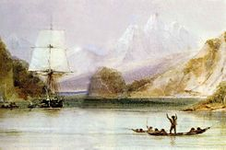
As HMS Beagle surveyed the coasts of South America, Darwin began to theorise about the wonders of nature around him.
The Beagle survey took five years, two-thirds of which Darwin spent exploring on land. He studied a rich variety of geological features, fossils and living organisms, and met a wide range of people, both native and colonial. He methodically collected an enormous number of specimens, many of them new to science. This established his reputation as a naturalist and made him one of the precursors of the field of ecology, particularly the notion of biocoenosis. His extensive detailed notes showed his gift for theorising and formed the basis for his later work, as well as providing social, political and anthropological insights into the areas he visited.
On the voyage, Charles Darwin read Charles Lyell's Principles of Geology, which explained geological features as the outcome of gradual processes over huge periods of time, and wrote home that he was seeing landforms "as though he had the eyes of Lyell": he saw stepped plains of shingle and seashells in Patagonia as raised beaches; in Chile, he experienced an earthquake and noted mussel-beds stranded above high tide showing that the land had been raised; and even high in the Andes, he was able to collect seashells. He theorised that coral atolls form on sinking volcanic mountains, an idea he confirmed when the Beagle surveyed the Cocos (Keeling) Islands.
In South America he discovered fossils of gigantic extinct mammals including megatheria and glyptodons in strata which showed no signs of catastrophe or change in climate. At the time, he thought them similar to African species, but after the voyage Richard Owen showed that the remains were of animals related to living creatures in the same area. In Argentina two species of rhea had separate but overlapping territories. On the Galápagos Islands Darwin found that mockingbirds differed from one island to another, and on returning to Britain he was shown that Galápagos tortoises and finches were also in distinct species based on the individual islands they inhabited. The Australian marsupial rat-kangaroo and platypus were such strikingly unusual animals that on 19 January 1836, in New South Wales, he recorded this in his journal:
I had been lying on a sunny bank & was reflecting on the strange character of the Animals of this country as compared with the rest of the World. An unbeliever in every thing beyond his own reason, might exclaim ‘Surely two distinct Creators must have been [at] work; their object however has been the same & certainly the end in each case is complete’.
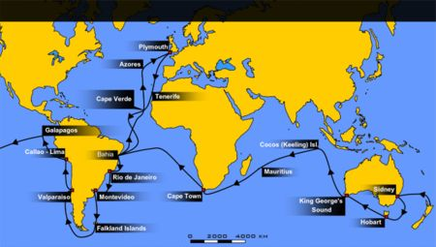
The voyage of the Beagle
He puzzled over all he saw, and, in the first edition of The Voyage of the Beagle, he explained species distribution in light of Charles Lyell's ideas of "centres of creation". In later editions of this Journal he foreshadowed his use of Galápagos Islands fauna as evidence for evolution: "one might really fancy that from an original paucity of birds in this archipelago, one species had been taken and modified for different ends."
Three native missionaries were returned by the Beagle to Tierra del Fuego. They had become "civilised" in England over the previous two years, yet their relatives appeared to Darwin to be "miserable, degraded savages". Within a year, the missionaries had reverted to their harsh previous way of life, yet they preferred this and did not want to return to England. This experience, his detestation of the slavery he saw elsewhere in South America, and other problems he found about such as the effect of European settlement on aborigines in New Zealand and Australia, persuaded him that there was no moral justification for the mistreating of others based on the concept of race. He now thought that humanity was not as far removed from animals as his clerical friends believed.
While on board the ship, Darwin suffered from seasickness. In October 1833 he caught a fever in Argentina, and in July 1834, while returning from the Andes down to Valparaíso, he fell ill and spent a month in bed. From 1837 onwards Darwin was repeatedly incapacitated with episodes of stomach pains, vomiting, severe boils, palpitations, trembling and other symptoms. These symptoms particularly affected him at times of stress, such as when attending meetings or dealing with controversy over his theory. The cause of Darwin's illness was unknown during his lifetime, and attempts at treatment had little success. Recent speculation has suggested he caught Chagas disease from insect bites in South America, leading to the later problems. Other possible causes include psychobiological problems and Ménière's disease.

Career in science, inception of theory
Main article: Inception of Darwin's theory
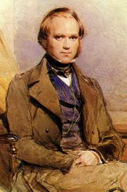
While still a young man, Charles Darwin joined the scientific élite.
While Darwin was still on the voyage, Henslow carefully fostered his former pupil's reputation by giving selected naturalists access to the fossil specimens and printed copies of Darwin's geological writings. When the Beagle returned on 2 October 1836, Darwin was a celebrity in scientific circles. He visited his home in Shrewsbury and his father organised investments so that Darwin could become a self-funded gentleman scientist. Darwin then went to Cambridge and persuaded Henslow to work on botanical descriptions of modern plants he had collected. Afterwards Darwin went round the London institutions to find the best naturalists available to describe his other collections for timely publication. An eager Charles Lyell met Darwin on 29 October and introduced him to the up-and-coming anatomist Richard Owen. After working on Darwin's collection of fossil bones at his Royal College of Surgeons, Owen caused great surprise by revealing that some were from gigantic extinct rodents and sloths. This enhanced Darwin's reputation. With Lyell's enthusiastic backing, Darwin read his first paper to the Geological Society of London on 4 January 1837, arguing that the South American landmass was slowly rising. On the same day Darwin presented his mammal and bird specimens to the Zoological Society. The Mammalia were taken on by George R. Waterhouse. Though the birds seemed almost an afterthought, the ornithologist John Gould revealed that what Darwin had taken to be wrens, blackbirds and slightly differing finches from the Galápagos were all finches, but each was a separate species. Others on the Beagle, including FitzRoy, had also collected these birds and had been more careful with their notes, enabling Darwin to determine from which island each species had come.
In London, Darwin stayed with his freethinking brother Erasmus and at dinner parties met inspiring savants who thought that God preordained life by natural laws rather than ad hoc miraculous creations. His brother's lady friend Miss Harriet Martineau was a writer whose stories promoted Malthusian Whig Poor Law reforms. Scientific circles were buzzing with ideas of transmutation of species controversially associated with Radical unrest. Darwin preferred the respectability of his friends the Cambridge Dons, even though his ideas were pushing beyond their belief that natural history must justify religion and social order.
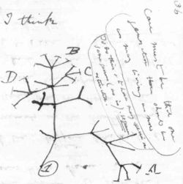
Darwin's first sketch of an evolutionary tree from his First Notebook on Transmutation of Species (1837)
On 17 February 1837, Lyell used his presidential address at the Geographical Society to present Owen's findings to date on Darwin's fossils, noting particularly the unexpected implication that extinct species were related to current species in the same locality. At the same meeting Darwin was elected to the Council of the Society. He had already been invited by FitzRoy to contribute a Journal based on his field notes as the natural history section of the captain's account of the Beagle's voyage. He now plunged into writing a book on South American Geology. At the same time he speculated on transmutation in his Red Notebook which he had begun on the Beagle. Another project he started was getting the expert reports on his collection published as a multivolume Zoology of the Voyage of H.M.S. Beagle, and Henslow used his contacts to arrange a Treasury grant of £1,000 to sponsor this. Darwin finished writing his Journal around 20 June when King William IV died and the Victorian era began. In mid-July he began his secret "B" notebook on transmutation, and developed the hypothesis that where every island in the Galápagos Archipelago had its own kind of tortoise, these had originated from a single tortoise species and had adapted to life on the different islands in different ways.
Under pressure with organising Zoology and correcting proofs of his Journal, Darwin's health suffered. On 20 September 1837 he suffered "palpitations of the heart" and left for a month of recuperation in the country. He visited Maer Hall where his invalid aunt was being cared for by her spinster daughter Emma Wedgwood, and entertained his relatives with tales of his travels. His uncle Jos pointed out an area of ground where cinders had disappeared under loam and suggested that this might have been the work of earthworms. This led Darwin to the idea for a talk which he gave to the Geological Society on 1 November, on the unusually mundane subject of worm casts. This work is considered to be the first scholarly treatment of soil forming processes. He had avoided taking on official posts which would have taken up valuable time, but by March William Whewell had recruited him as Secretary of the Geological Society. Illness prompted Darwin to take a break from the pressure of work and he went "geologising" in Scotland. In glorious weather he visited Glen Roy to see the phenomenon known as "roads" which he (incorrectly) identified as raised beaches.
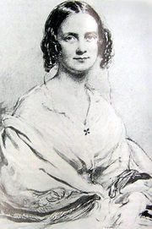
Charles chose to marry his cousin, Emma Wedgwood.
Fully recuperated, he returned home to Shrewsbury. Scientifically pondering his career and prospects he drew up a list with columns headed "Marry" and "Not Marry". Entries in the pro-marriage column included "constant companion and a friend in old age ... better than a dog anyhow," while listed among the cons were "less money for books" and "terrible loss of time." The pros won out. He discussed the prospect of marriage with his father then went to visit his cousin Emma on 29 July 1838. He did not get around to proposing, but against his father's advice he told her of his ideas on transmutation. While his thoughts and work continued in London over the autumn he suffered repeated bouts of illness. On 11 November he returned and proposed to Emma, once more telling her his ideas. She accepted, but later wrote beseeching him to read from the Gospel of St. John a section on love and following the Way which also states that "If a man abide not in me...they are burned". He sent a warm reply which eased her concern, but she would continue to worry that his lapses of faith could endanger her hope that they would meet in afterlife.
Darwin considered Malthus's argument that human population increases more quickly than food production, leaving people competing for food and making charity useless. He later formulated this in the terms of his biological theory as: "Man tends to increase at a greater rate than his means of subsistence; consequently he is occasionally subjected to a severe struggle for existence, and natural selection will have effected whatever lies within its scope." (Descent of Man, Ch.21) He related this to the findings about species relating to localities, his enquiries into animal breeding, and ideas of Natural "laws of harmony". Towards the end of November 1838 he compared breeders selecting traits to a Malthusian Nature selecting from variants thrown up by "chance" so that "every part of newly acquired structure is fully practised and perfected", and thought this "the most beautiful part of my theory" of how species originated. He went house-hunting and eventually found "Macaw Cottage" in Gower Street, London, then moved his "museum" in over Christmas. He was showing the stress, and Emma wrote urging him to get some rest, almost prophetically remarking "So don't be ill any more my dear Charley till I can be with you to nurse you." On 24 January 1839 he was honoured by being elected as Fellow of the Royal Society and presented his paper on the Roads of Glen Roy.

Marriage and children
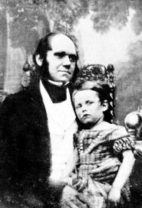
Darwin in 1842 with his eldest son, William Erasmus Darwin.
On 29 January 1839, Darwin married his cousin Emma Wedgwood at Maer in an Anglican ceremony arranged to also suit the Unitarians. After first living in Gower Street, London, the couple moved on 17 September 1842 to Down House in Downe. The Darwins had ten children, three of whom died early. Many of his surviving children and their grandchildren would later achieve notability themselves (see Darwin — Wedgwood family)
- William Erasmus Darwin (27 December 1839–1914)
- Anne Elizabeth Darwin (2 March 1841–22 April 1851)
- Mary Eleanor Darwin (23 September 1842–16 October 1842)
- Henrietta Emma Etty Darwin (25 September 1843–1929)
- George Howard Darwin (9 July 1845–7 December 1912)
- Elizabeth "Bessy" Darwin (8 July 1847–1926)
- Francis Darwin (6 August 1848–19 September 1925)
- Leonard Darwin (15 January 1850–26 March 1943)
- Horace Darwin (13 May 1851–29 September 1928)
- Charles Waring Darwin (6 December 1856–28 June 1858)
Several of their children suffered illness or weaknesses, and Charles Darwin's fear that this might be due to the closeness of his and Emma's lineage was expressed in his writings on the ill effects of inbreeding and advantages of crossing.

Development of theory
Main article: Development of Darwin's theory
Darwin was now an eminent geologist in the scientific élite of clerical naturalists, settled with a private income, while privately working on his theory. He had a vast amount of work to do, writing up all his findings and supervising the preparation of the multivolume Zoology, which would describe his collections. He embarked on extensive experiments with plants and consultations with animal husbanders, including pigeon and pig breeders, trying to find soundly based answers to all the arguments he anticipated when he presented his theory in public.
When FitzRoy's account was published in May 1839, Darwin's Journal and Remarks was a great success. Later that year it was published on its own, becoming the bestseller today known as The Voyage of the Beagle. In December 1839, as Emma's first pregnancy progressed, Darwin suffered more illness and accomplished little during the following year.
Darwin tried to explain his theory to close friends, but they were slow to show interest and thought that selection must need a divine selector. In 1842 the family moved to rural Down House to escape the pressures of London. Darwin formulated a short "Pencil Sketch" of his theory, and by 1844 had written a 240-page "Essay" that expanded his early ideas on natural selection. Darwin completed his third Geological book in 1846. Assisted by his friend, the young botanist Joseph Dalton Hooker, he embarked on a huge study of barnacles. In 1847, Hooker read the "Essay" and sent notes that provided Darwin with the calm critical feedback that he needed.
Darwin feared putting the theory out in an incomplete form, as his ideas about evolution would be highly controversial if any attention was paid to them at all. Other ideas about evolution — especially the work of Jean-Baptiste Lamarck — had been soundly dismissed by the British scientific community, and were associated with political radicalism. The anonymous publication of Vestiges of the Natural History of Creation in 1844 created another controversy over radicalism and evolution, and was severely attacked by Darwin's friends who stressed that no reputable scientist would want to be associated with such ideas.
To try to deal with his illness, Darwin went to a spa in Malvern in 1849, and to his surprise found that the two months of water treatment helped. In his work on barnacles he found "homologies" that supported his theory by showing that slightly changed body parts could serve different functions to meet new conditions. Then his treasured daughter Annie fell ill, reawakening his fears that his illness might be hereditary. After a long series of crises, she died and Darwin lost all faith in a beneficent God.
He met the young freethinking naturalist Thomas Huxley who was to become a close friend and ally. Darwin's work on barnacles (Cirripedia) earned him the Royal Society's Royal Medal in 1853, establishing his reputation as a biologist. He completed this study in 1854 and turned his attention to his theory of species.

Announcement and publication of theory
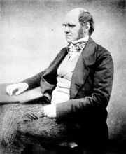
Darwin was forced into early publication of his theory of natural selection.
Main article: Publication of Darwin's theory
Darwin found an answer to the problem of how genera forked in an analogy with industrial ideas of division of labour, with specialised varieties each finding their niche so that species could diverge. He experimented with seeds, testing their ability to survive sea-water to transfer species to isolated islands, and bred pigeons to test his ideas of natural selection being comparable to the "artificial selection" used by pigeon breeders.
In the spring of 1856, Lyell read a paper on the Introduction of species by Alfred Russel Wallace, a naturalist working in Borneo. Lyell urged Darwin to publish his theory to establish precedence. Despite illness, Darwin began a 3-volume book titled Natural Selection, getting specimens and information from naturalists including Wallace and Asa Gray. In December 1857 as Darwin worked on the book he received a letter from Wallace asking if it would delve into human origins. Sensitive to Lyell's fears, Darwin responded that "I think I shall avoid the whole subject, as so surrounded with prejudices, though I fully admit that it is the highest & most interesting problem for the naturalist." He encouraged Wallace's theorising, saying "without speculation there is no good & original observation." Darwin added that "I go much further than you." His manuscript reached 250,000 words, then on 18 June 1858 he received a paper in which Wallace described the evolutionary mechanism and requested him to send it on to Lyell. Darwin did so, shocked that he had been "forestalled". Though Wallace had not asked for publication, Darwin offered to send it to any journal that Wallace chose. He put matters in the hands of Lyell and Hooker. They agreed on a joint presentation at the Linnean Society on 1 July of On the Tendency of Species to form Varieties; and on the Perpetuation of Varieties and Species by Natural Means of Selection. Darwin's infant son died and he was unable to attend.
The initial announcement of the theory gained little immediate attention. It was mentioned briefly in a few small reviews, but to most people it seemed much the same as other varieties of evolutionary thought. For the next thirteen months Darwin suffered from ill health and struggled to produce an abstract of his "big book on species". Receiving constant encouragement from his scientific friends, Darwin finally finished his abstract and Lyell arranged to have it published by John Murray. The title was agreed as On the Origin of Species by Means of Natural Selection, and when the book went on sale to the trade on 22 November 1859, the stock of 1,250 copies was oversubscribed. At the time "Evolutionism" implied creation without divine intervention, and Darwin avoided using the words "evolution" or "evolve", though the book ends by stating that "endless forms most beautiful and most wonderful have been, and are being, evolved." The book only briefly alluded to the idea that human beings, too, would evolve in the same way as other organisms. Darwin wrote in deliberate understatement that "light will be thrown on the origin of man and his history."

Reaction
Main article: Reaction to Darwin's theory
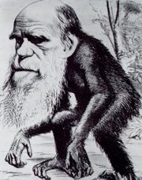
A typical satire was the later caricature in Hornet magazine portraying Darwin with an ape body and the bushy beard he grew in 1866.
Darwin's book set off a public controversy which he monitored closely, keeping press cuttings of thousands of reviews, articles, satires, parodies and caricatures. Reviewers were quick to pick out the unstated implications of "men from monkeys", though a Unitarian review was favourable and The Times published a glowing review by Huxley which included swipes at Richard Owen, leader of the scientific establishment Huxley was trying to overthrow. Owen initially appeared neutral, but then wrote a review condemning the book.
The Church of England scientific establishment including Darwin's old Cambridge tutors Sedgwick and Henslow reacted against the book, though it was well received by a younger generation of professional naturalists. Then Essays and Reviews by seven liberal Anglican theologians declared that miracles were irrational (and supported the Origin), distracting attention away from Darwin.
The most famous confrontation took place at a meeting of the British Association for the Advancement of Science in Oxford. Professor John William Draper delivered a long lecture about Darwin and social progress, then Samuel Wilberforce, the Bishop of Oxford, argued against Darwin. In the ensuing debate Joseph Hooker argued strongly for Darwin and Thomas Huxley established himself as "Darwin's bulldog" – the fiercest defender of evolutionary theory on the Victorian stage. The story is that on being asked by Wilberforce whether he was descended from monkeys on his grandfather's side or his grandmother's side, Huxley muttered: "The Lord has delivered him into my hands" and replied that he "would rather be descended from an ape than from a cultivated man who used his gifts of culture and eloquence in the service of prejudice and falsehood" (this is contested^{[3]}). The story spread around the country: Huxley had said he would rather be an ape than a Bishop.
Many people felt that Darwin's view of nature destroyed the important distinction between man and beast. Darwin himself did not personally defend his theories in public, though he read eagerly about the continuing debates. He was frequently very ill, and mustered support through letters and correspondence. A core circle of scientific friends – Huxley, Hooker, Charles Lyell and Asa Gray – actively pushed his work to the fore of the scientific and public stage, defending him against his many critics in this key scientific controversy of the era, and helping to gain him the honour of the Royal Society's Copley Medal in 1864. Darwin's theory also resonated with various movements at the time and became a key fixture of popular culture. The book was translated into many languages and went through numerous reprints. It became a staple scientific text accessible both to a newly curious middle class and to "working men", and was hailed as the most controversial and discussed scientific book ever written.

Further experiments, research and writing
Main articles: Darwin from Orchids to Variation, Darwin from Descent of Man to Emotions, and Darwin from Insectivorous plants to Worms
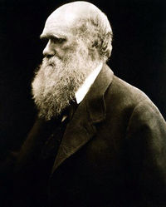
Julia Margaret Cameron's portrait of Darwin.
Despite repeated bouts of illness during the last twenty-two years of his life Darwin pressed on with his work. He had published an abstract of his theory, but more controversial aspects of his "big book" were still incomplete. These included explicit evidence of humankind's descent from earlier animals, and exploration of possible causes underlying the development of society and of human mental abilities. He had yet to explain features with no obvious utility other than decorative beauty. His experiments, research and writing continued.
When Darwin's daughter fell ill he set aside his experiments with seedlings and domestic animals to go with her to a seaside resort where he became interested in wild orchids. This developed into an innovative study of how their beautiful flowers served to control insect pollination and ensure cross fertilisation. As with the barnacles, homologous parts served different functions in different species. Back at home he lay on his sickbed in a room filled with experiments on climbing plants. He was visited by a reverent Ernst Haeckel who had spread the gospel of Darwinismus in Germany. Even at Cambridge, students now supported his ideas. Huxley gave "working-men's lectures" to widen the audience, and Wallace remained a supporter but increasingly turned to spiritualism. Variation grew to two huge volumes, forcing him to leave out humankind and sexual selection, but when printed was in huge demand.
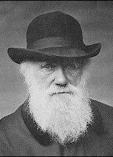
A classic image of Darwin in 1880, still researching and producing numerous books.
The question of human evolution had been taken up by his supporters (and detractors) shortly after the publication of The Origin of Species, but Darwin's own contribution to the subject came more than ten years later with the two-volume The Descent of Man, and Selection in Relation to Sex published in 1871. In the second volume, Darwin introduced in full his concept of sexual selection to explain the evolution of human culture, the differences between the human sexes, and the differentiation of human races, as well as the beautiful (and seemingly non-adaptive) plumage of birds. A year later Darwin published his last major work, The Expression of the Emotions in Man and Animals, which focused on the evolution of human psychology and its continuity with to the behaviour of animals. He developed his ideas that the human mind and cultures were developed by natural and sexual selection, an approach which has been revived in the last two decades with the emergence of evolutionary psychology. As he concluded in Descent of Man, Darwin felt that despite all of humankind's "noble qualities" and "exalted powers":
"Man still bears in his bodily frame the indelible stamp of his lowly origin."
His evolution-related experiments and investigations culminated in five books on plants, and then his last book returned to the effect worms have on soil levels.
Darwin died in Downe, Kent, England, on 19 April 1882. He had expected to be buried in St Mary's churchyard at Downe, but at the request of Darwin's colleagues, William Spottiswoode (President of the Royal Society) arranged for Darwin to be given a state funeral and buried in Westminster Abbey.

Religious views
Main article: Charles Darwin's views on religion
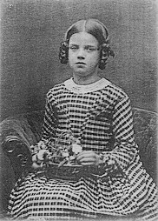
The 1851 death of Darwin's daughter, Annie, was the final step in pushing an already doubting Darwin away from the idea of a beneficent God.
Charles Darwin came from a Nonconformist background. Though several members of his family were Freethinkers, openly lacking conventional religious beliefs, he did not initially doubt the literal truth of the Bible. He attended a Church of England school, then at Cambridge studied Anglican theology to become a clergyman and was fully convinced by William Paley's teleological argument that design in nature proved the existence of God. However, his beliefs began to shift during his time on board HMS Beagle. He questioned what he saw—wondering, for example, at beautiful deep-ocean creatures created where no one could see them, and shuddering at the sight of a wasp paralysing caterpillars as live food for its eggs; he saw the latter as contradicting Paley's vision of beneficent design. While on the Beagle Darwin was quite orthodox and would quote the Bible as an authority on morality, but had come to see the history in the Old Testament as being false and untrustworthy.
Upon his return, he investigated transmutation of species. He knew that his clerical naturalist friends thought this a bestial heresy undermining miraculous justifications for the social order and knew that such revolutionary ideas were especially unwelcome at a time when the Church of England's established position was under attack from radical Dissenters and atheists. While secretly developing his theory of natural selection, Darwin even wrote of religion as a tribal survival strategy, though he still believed that God was the ultimate lawgiver.^{[4]} His belief continued to dwindle over the time, and with the death of his daughter Annie in 1851, Darwin finally lost all faith in Christianity. He continued to give support to the local church and help with parish work, but on Sundays would go for a walk while his family attended church. In later life, when asked about his religious views, he wrote that he had never been an atheist in the sense of denying the existence of a God, and that generally "an Agnostic would be the more correct description of my state of mind."^{[5]}
Charles Darwin recounted in his biography of his grandfather Erasmus Darwin how false stories were circulated claiming that Erasmus had called for Jesus on his deathbed. Charles concluded by writing "Such was the state of Christian feeling in this country [in 1802].... We may at least hope that nothing of the kind now prevails." Despite this hope, very similar stories were circulated following Darwin's own death, most prominently the "Lady Hope Story", published in 1915 which claimed he had converted on his sickbed.^{[6]} Such stories have been propagated by some Christian groups, to the extent of becoming urban legends, though the claims were refuted by Darwin's children and have been dismissed as false by historians. His daughter, Henrietta, who was at his deathbed, said that he did not convert to Christianity.^{[7]}

Legacy
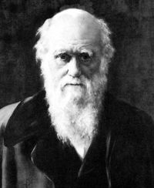
Charles Darwin's contributions to evolutionary thought had an enormous effect on many fields of science.
Charles Darwin's theory that evolution occurred through natural selection changed the thinking of countless fields of study from biology to anthropology. His work established that "evolution" had occurred: not necessarily that it was by natural or sexual selection (this particular recognition would not become fully standard until the rediscovery of Gregor Mendel's work in the early 20th century and the creation of the modern synthesis). Others before him had outlined the idea of natural selection: in his lifetime Darwin acknowledged the earlier writings of William Charles Wells and Patrick Matthew which he (and practically all other naturalists) had been unaware of when publishing his theory. However, it is clear that Darwin was the first to develop and publish a scientific theory of natural selection, and that the alleged predecessors did not contribute to the development or success of natural selection as a theory in science.
Darwin's work was very controversial at the time he published it and many during his time did not take it seriously. Evolution by natural selection proved to be a significant blow to notions of divine creation and intelligent design prevalent in 19th-century science, specifically overturning the Creation biology doctrine of "created kinds". The idea that there was no line to be drawn between human beings, races, and animals would forever make Darwin a symbol of iconoclasm who removed humanity's privileged place in the universe. To some of his detractors, Darwin would be "the monkey man", often depicted as part ape. His ideas also stood in opposition to the more common beliefs at the time that the human races had developed separately or that one race was superior by virtue of biology than another.

Commemoration
During Darwin's lifetime many species and geographical features were given his name, including the Darwin Sound named by Robert FitzRoy after Darwin's prompt action saved them from being marooned, and the nearby Mount Darwin in the Andes celebrating Darwin's 25th birthday. When the Beagle was surveying Australia in 1839, Darwin's friend John Lort Stokes sighted a natural harbour which the ship's captain Wickham named Port Darwin. The settlement of Palmerston founded there in 1869 was officially renamed Darwin in 1911 and became the capital city of Australia's Northern Territory, which also boasts Charles Darwin University and Charles Darwin National Park.
The 14 species of Finches he researched in the Galápagos Islands are affectionately named "Darwin's Finches" in honour of his legacy. In 1964, Darwin College, Cambridge was founded, named in honour of the Darwin family, partially because they owned some of the land it was on. In 1992, Darwin was ranked #16 on Michael H. Hart's list of the most influential figures in history. Darwin was given particular recognition in 2000 when his image appeared on the Bank of England ten pound note, replacing Charles Dickens. His impressive, luxuriant beard (which was reportedly difficult to forge) was said to be a contributory factor to the bank's choice.^{[8]} Darwin came fourth in the 100 Greatest Britons poll sponsored by the BBC and voted for by the public.
As a humorous celebration of evolution, the annual Darwin Award is bestowed on individuals who "aid the process of evolution by demonstrating their unfitness through fatally stupid actions."
In 2006, he was featured in his own "Darwin" exhibition at the American Museum of Natural History in New York City.

Eugenics
Main article: Eugenics
Following Darwin's publication of the Origin his cousin Francis Galton applied the concepts to human society, producing ideas to promote "hereditary improvement" starting in 1865 and elaborated at length in 1869. In The Descent of Man Darwin agreed that Galton had demonstrated that "talent" and "genius" in humans were probably inherited, but thought that the social changes Galton proposed were too "utopian". Neither Galton nor Darwin supported government intervention and instead believed that, at most, heredity should be taken into consideration by people seeking potential mates. In 1883, after Darwin's death, Galton began calling his social philosophy Eugenics. In the twentieth century, eugenics movements gained popularity in a number of countries and became associated with reproduction control programmes such as compulsory sterilisation laws, then were stigmatised after their usage in the rhetoric of Nazi Germany in its goals of genetic "purity".

Social Darwinism
Main article: Social Darwinism
In 1944 the American historian Richard Hofstadter applied the term "Social Darwinism" to describe 19th- and 20th-century thinking developed from the ideas of Thomas Malthus and Herbert Spencer, which applied ideas of evolution and "survival of the fittest" to societies or nations competing for survival in a hostile world. These ideas became discredited by association with racism and imperialism. Though the term is anachronistic, in Darwin's day the difference between what was later called "Social Darwinism" and simple "Darwinism" was less clear. However, Darwin did not believe that his scientific theory mandated any particular theory of governance or social order. Indeed, he believed that sympathy should be extended to all races and nations.
The use of the phrase "Social Darwinism" to describe Malthus's ideas is particularly disingenuous, since Malthus died in 1834 before the inception of Darwin's theory was spurred by his reading the 6th edition of Malthus' famous Essay on a Principle of Population in 1838. Spencer's evolutionary "progressivism" and his social and political ideas were largely Malthusian, and his books on economics of 1851 and on evolution of 1855 predated Darwin's publication of the Origin in 1859.

Works
Sources of free e-books online:
- Bibliography: Darwin Online Table of Contents (including alternative editions, contributions to books & periodicals, correspondence & life) Free to read, but not Public Domain.
Published works
- 1836: A LETTER, Containing Remarks on the Moral State of TAHITI, NEW ZEALAND, &c. – BY CAPT. R. FITZROY AND C. DARWIN, ESQ. OF H.M.S. 'Beagle.' [2]
- 1839: Journal and Remarks (The Voyage of the Beagle)
- Zoology of the Voyage of H.M.S. Beagle: published between 1839 and 1843 in five volumes by various authors, Edited and superintended by Charles Darwin: information on two of the volumes –
1840: Part I. Fossil Mammalia, by Richard Owen (Darwin's introduction)
1839: Part II. Mammalia, by George R. Waterhouse (Darwin on habits and ranges)
- 1842: The Structure and Distribution of Coral Reefs [3]
- 1844: Geological Observations of Volcanic Islands [4], (French version)
- 1846: Geological Observations on South America [5]
- 1849: Geology from A Manual of scientific enquiry; prepared for the use of Her Majesty's Navy: and adapted for travellers in general., John F.W. Herschel ed. [6]
- 1851: A Monograph of the Sub-class Cirripedia, with Figures of all the Species. The Lepadidae; or, Pedunculated Cirripedes. [7]
- 1851: A Monograph on the Fossil Lepadidae; or, Pedunculated Cirripedes of Great Britain [8]
- 1854: A Monograph of the Sub-class Cirripedia, with Figures of all the Species. The Balanidae (or Sessile Cirripedes); the Verrucidae, etc. [9]
- 1854: A Monograph on the Fossil Balanidæ and Verrucidæ of Great Britain [10]
- 1858: On the Perpetuation of Varieties and Species by Natural Means of Selection
- 1859: On the Origin of Species by Means of Natural Selection, or the Preservation of Favoured Races in the Struggle for Life
- 1862: On the various contrivances by which British and foreign orchids are fertilised by insects [11]
- 1868: Variation of Plants and Animals Under Domestication (PDF format), Vol. 1, Vol. 2
- 1871: The Descent of Man, and Selection in Relation to Sex
- 1872: The Expression of Emotions in Man and Animals [12]
- 1875: Movement and Habits of Climbing Plants [13]
- 1875: Insectivorous Plants [14]
- 1876: The Effects of Cross and Self-Fertilisation in the Vegetable Kingdom [15]
- 1877: The Different Forms of Flowers on Plants of the Same Species [16]
- 1879: "Preface and 'a preliminary notice'" in Ernst Krause's Erasmus Darwin [17]
- 1880: The Power of Movement in Plants [18]
- 1881: The Formation of Vegetable Mould Through the Action of Worms [19] [20]
- 1887: Autobiography of Charles Darwin (Edited by his son Francis Darwin) [21]
- 1958: Autobiography of Charles Darwin (Barlow, unexpurgated)
Letters
- Correspondence of Charles Darwin
- 1887: Life and Letters of Charles Darwin, (ed. Francis Darwin). Volume I, Volume II - Classic Literature Library
- Volume 1 Volume 2 - Google Books
- 1903: More Letters of Charles Darwin, (ed. Francis Darwin and A.C. Seward). Volume I, Volume II

Notes
- ^ Browne, Voyaging, p.6; Desmond&Moore, p.11
- ^ He would later, in Descent of Man, use his experience with Edmonstone as evidence that "Negroes and Europeans" were still very closely related despite looking superficially very different from one another. See Descent of Man, chapter 7.
- ^ Wilberforce and Huxley: A Legendary Encounter
- ^ SOF: Evolution and Wonder - Understanding Charles Darwin | Transcript of Radio Program - Speaking of Faith® from American Public Media
- ^ The Life and Letters of Charles Darwin, Ch. VIII, p. 274. New York, D. Appleton & Co., 1905 [1]: quotation in which he describes himself as "agnostic"
- ^ The Darwin Deathbed Conversion Question
- ^ Did Darwin Die as a Christian?. Retrieved on 2006-06-13.
- ^ How to join the noteworthy. Retrieved on 4 September 2006.

References
- Charles Darwin, Voyage of the Beagle, (including Robert FitzRoy's Remarks with reference to the Deluge), (London: Penguin Books 1989) ISBN 0-14-043268-X
- E. Janet Browne, Charles Darwin: vol. 1 Voyaging and vol. 2 The Power of Place (London: Jonathan Cape, 1995-2002). ISBN 1-8441-3314-1 and ISBN 0-7126-6837-3
- Adrian Desmond and James Moore, Darwin (London: Michael Joseph, the Penguin Group, 1991). ISBN 0-7181-3430-3
- Lyanda Lynn Haupt, Pilgrim on the Great Bird Continent: The Importance of Everything and Other Lessons from Darwin's Lost Notebooks. New York, 2006.
- Richard Keynes, Fossils, Finches and Fuegians: Charles Darwin's Adventures and Discoveries on the Beagle, 1832-1836. (London: HarperCollins, 2002) ISBN 0-00-710189-9.
- James Moore and Adrian Desmond, "Introduction", in The Descent of Man, and Selection in Relation to Sex (London: Penguin Classics, 2004). (Detailed history of Darwin's views on race, sex, and class)
- Diane B. Paul, "Darwin, social Darwinism and eugenics," in Jonathan Hodge and Gregory Radick, eds., The Cambridge Companion to Darwin (Cambridge, England: Cambridge University Press, 2003), 214-239.
- The Mount Residents' Group, Darwin section. Viewed 4 Nov 2006. http://www.themountshrewsbury.com

External links
Find more information on Charles Darwin by searching Wikipedia's sister projects:
Dictionary definitions from Wiktionary
Textbooks from Wikibooks
Quotations from Wikiquote
Source texts from Wikisource
Images and media from Commons
News stories from Wikinews
- The Complete Work of Charles Darwin Online
- The Friends of Charles Darwin
- Darwin's work on orchids
- Darwin Correspondence Project
- The Darwin Digital Library of Evolution
- Institut Charles Darwin International
- AboutDarwin.com
- Darwin - at the American Museum of Natural History
- Darwin's portrait on the £10 note
- Twelve different portraits of Charles Darwin at the National Portrait Gallery, U.K.
- BBC News: "Darwin family repeat flower count"
- The Mis-portrayal of Darwin as a Racist
- View digitized titles by Charles Darwin in Botanicus.org
- 1871 Caricature of Charles Darwin by Thomas Nast published in Harper's Weekly
- Charles Darwin at the Open Directory Project

See also
- Darwin Awards
- Shrewsbury – Birthplace of Darwin
- Evolution
- Darwin's Frog – a species of Frog named after Charles Darwin.
- Harriet – a Galápagos tortoise, possibly collected by Darwin; died 23 June 2006 at an estimated age of 175.
- Patrick Matthew – an amateur evolutionary theorist and contemporary of Darwin.
- Randal Keynes – the great-great grandson of Charles Darwin who wrote a book about him, his daughter, and human evolution
- The Tree of Life – an excerpt from the Origin of Species
Jean-Baptiste Lamarck – an intellectual competitor of Darwin's.

Charles Darwin
Darwin's life
Education | Voyage of the Beagle | Inception of theory | Development of theory | Publication of theory | Reaction to theory
Orchids to Variation | Descent of Man to Emotions | Insectivorous plants to Worms
Darwin's family, beliefs and health
Darwin — Wedgwood family | Views on religion | Illness
Darwin's writings
The Voyage of the Beagle | On the Tendency of Species to form Varieties | The Origin of Species
The Descent of Man, and Selection in Relation to Sex | The Expression of the Emotions in Man and Animals

v · d · e
Basic topics in evolutionary biology
Evidence of evolution
Processes of evolution: adaptation - macroevolution - microevolution - speciation
Population genetic mechanisms: selection - genetic drift - gene flow - mutation
Evo-devo concepts: phenotypic plasticity - canalisation - modularity
Modes of evolution: anagenesis - catagenesis - cladogenesis
History: History of evolutionary thought - Charles Darwin - The Origin of Species - modern evolutionary synthesis
Other subfields: ecological genetics - human evolution - molecular evolution - phylogenetics - systematics
List of evolutionary biology topics | Timeline of evolution

