THE VELIKOVSKY PHOTO ALBUM

http://www.varchive.org/dy/album.htm

  This archive is being maintained by a team of historians to ensure the integrity and preservation of Immanuel Velikovsky’s unpublished writings; it is strictly non-profit and its sole purpose is the advancement of education and scholarship.
  
  
  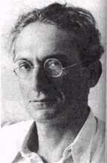
  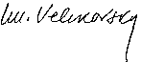

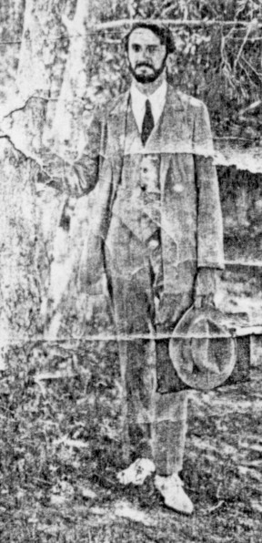
The earliest available photograph
of Immanuel Velikovsky,
probably ca. 1920

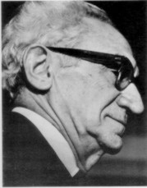
At the Instrument
Society of America
1971

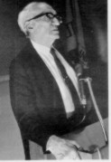
At the Instrument
Society of America,
ca. 1971

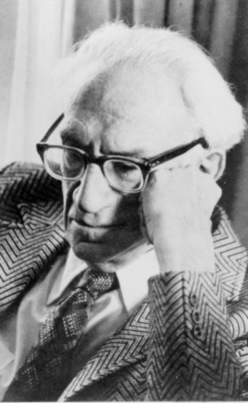
Photo by Fima Noveck
ca. 1974

THE VELIKOVSKY LECTURES

A - C |  | 1950 - 1954
D - K |  | 1955 - 1959
L - O |  | 1960 - 1964
P - R |  | 1965 - 1969
S - Z |  | 1970 - 1979

SEE: http://www.varchive.org/lec/index.htm

THE VELIKOVSKY CORRESPONDENCE
If you have corresponded with Immanuel Velikovsky on any topic of historical or scientific significance and would like this correspondence to be included in this archive, please send to the editors complete, unedited texts as an e-mail attachment in html or standard word-processor format. Or simply fax the letters to our Idaho number: (208) 730-3332.

A - D |  | 1920 - 1929
E - H |  | 1930 - 1939
I - L |  | 1940 - 1949
M - P |  | 1950 - 1959
Q - U |  | 1960 - 1969
V - Z |  | 1970 - 1980

SEE: http://www.varchive.org/cor/index.htm

VELIKOVSKY
BONDS OF THE PAST
A Movie by Henry Zemel
This documentary was first telecast on February 22, 1972 by the Canadian Broadcasting Corporation. This online version in Windows Media Player format is divided into 12 parts, which can be watched by clicking on the still frames. It is also viewable in RealPlayer format.
Reproduced with the kind permission of the author

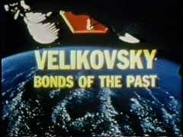 | 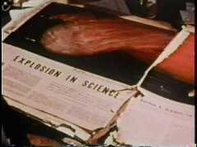 | 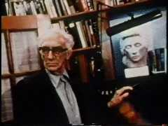
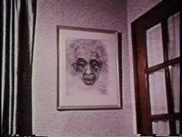 | 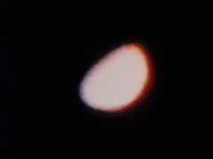 | 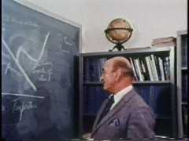
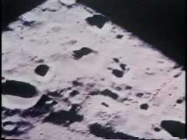 | 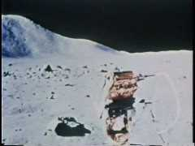 | 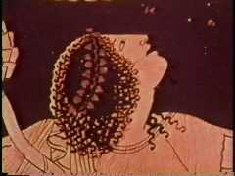
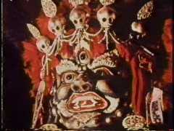 | 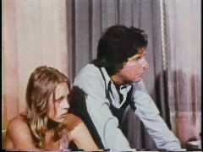 | 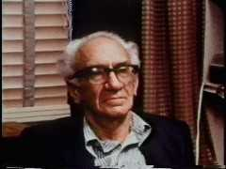

SEE: http://www.varchive.org/bonds/bonds.htm

END

