**Is The Moon Hollow - 2014**

Have you ever stopped to think about our moon? Evidence describes an alternative story for its origin. Get ready for this one.

“What in blazes is our Moon doing way out there? It’s too far out to be a true satellite of Earth  , it is too big to have been captured by the Earth. The chances of such a capture having been effected and the Moon then having taken up a nearly circular orbit about the Earth are too small to make such an eventuality credible. . . . But, then, if the Moon is neither a true satellite of the Earth nor a captured one, what is it?” –Isaac Asimov, *Asimov on Astronomy*,” Doubleday, 1974; Mercury Press 1963; also quoted in Don Wilson’s book, *Our Mysterious Spaceship Moon* (1975).

The Moon is the eye in the sky to the inhabitants of Earth. It provides us with the natural tidal cycles which are said to maintain the equilibrium of all species on the planet. Peculiarly, certain phases of the Moon cycle are even known to affect our moods and emotions. Most will likely never question the existence or makeup of the Moon as it does its usual routine of lighting up the night sky and circling the planet, however many scientists are not convinced that the narrative of its origin is as ‘solid’ as we are lead to believe. Much controversy exists around the origin and makeup of the Moon today, and one of the largest arguments surrounding the satellite is the solidity (or lack thereof) of its center and the process by which we got our Moon in the first place.

Currently there are around 5 widely discussed theories of Moon formation. They are as follows:

1.)    **Capture** - This theory proposes that the Moon was captured by the gravitational pull of the Earth. The one main problem is the capture mechanism. A close encounter with Earth typically results in either collision or altered trajectories. This hypothesis has difficulty explaining the essentially identical oxygen isotope ratios of the two worlds.

 2.)    **Fission** – This theory states that during a time when the Earth was forming and was still molten, the spinning of the planet projected out material which became our moon today. The Pacific Ocean was supposedly the area where the Moon came from, however this was debunked considering the immaturity of the ocean floor crust and the knowing that the moon formed much longer ago.

 3.)    **Accretion** – This hypothesis states that the Earth and the Moon formed together as a double system from the primordial accretion disk of the Solar System. The problem with this hypothesis is that it does not explain the angular momentum of the Earth-Moon system or why the Moon has a relatively small iron core compared to the Earth (25% of its radius compared to 50% for the Earth).

 4.)    **Georeactor Explosion** – A more radical alternative hypothesis, published in 2010, proposes that the Moon may have been formed from the explosion of a georeactor located along the core-mantle boundary at the equatorial plane of the rapidly rotating Earth.

 5.)    **The Giant Impact Theory** – This was the most commonly accepted theory up until recently. This theory suggests that long ago a planetary body the size of Mars crashed into Earth expelling a large piece of mass into space which became our Moon. While this hypothesis explains many aspects of the Earth-Moon system, there are still a few unresolved problems facing it, such as the Moon’s volatile elements not being as depleted as expected from such an energetic impact. Another issue is Lunar and Earth isotope comparisons. In 2011, the most precise measurement yet of the isotopic signatures of lunar rocks was published. Surprisingly, the Apollo lunar samples carried an isotopic signature identical to Earth rocks, but different from other Solar system bodies. Since most of the material that went into orbit to form the Moon was thought to come from Theia (the name scientists gave to the impactor), this observation was unexpected. In 2007, researchers from Caltech showed that the likelihood of Theia having an identical isotopic signature as the Earth was very small (<1 percent). Published in 2012, an analysis of titanium isotopes in Apollo lunar samples showed that the Moon has the same composition as the Earth which conflicts with the moon forming far from Earth’s orbit. [3]

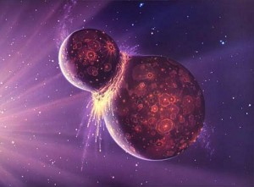

The Giant Impact Theory no longer suffices for explaining the formation of our moon.

Unfortunately none of the previous theories provide the answers to the big questions surrounding the Moon’s origins. What’s apparent however is the number of strange facts about the Moon which conjure up many ‘hmms’ about its existence. Let’s take a look at some of them:

**1. Moon’s Age:**The Moon is far older than previously expected, maybe even older than the Earth or the Sun. The oldest age for the Earth is estimated to be 4.6 billion years old; Moon rocks were dated at 5.3 billion years old, and the dust upon which they were resting was at least another billion years older. Some argue that the Moon may seem older only because its surface never renews itself, whereas the Earth may have rocks that old but have since been recycled through the natural resurfacing of the planet. [4]

**2. Rock’s Origin:** The chemical composition of the dust upon which the rocks sat differed remarkably from the rocks themselves, contrary to accepted theories that the dust resulted from weathering and breakup of the rocks themselves. The rocks had to have come from somewhere else. [5]

**3. Heavier Elements on Surface:** Normal planetary composition results in heavier elements in the core and lighter materials at the surface; not so with the Moon. Don Wilson writes in his book *Our Mysterious Spaceship Moon*,

“The abundance of refractory elements like titanium in the surface areas is so pronounced that several geologists proposed the refractory compounds were brought to the Moon’s surface in great quantity in some unknown way. They don’t know how, but that it was done cannot be questioned.”

**4. Water Vapor:** On March 7, 1971, lunar instruments placed by the astronauts recorded a vapor cloud of water passing across the surface of the Moon. The cloud lasted 14 hours and covered an area of about 100 square miles. [1]

**5. Magnetic Rocks:** Moon rocks were magnetized. This is odd because there is no magnetic field on the Moon itself. This could not have originated from a “close call” with Earth—such an encounter would have ripped the Moon apart. There have been many theories that aim to explain this magnetism however they all still sit as theories.

**6. Seismic Activity:** Hundreds of “moonquakes” are recorded each year that cannot be attributed to meteor strikes. In November, 1958, Soviet astronomer **Nikolay A. Kozyrev** of the Crimean Astrophysical Observatory photographed a gaseous eruption of the Moon near the crater Alphonsus. He also detected a reddish glow that lasted for about an hour. In 1963, astronomers at the Lowell Observatory also saw reddish glows on the crests of ridges in the Aristarchus region. These observations have proved to be precisely identical and periodical, repeating themselves as the Moon moves closer to the Earth. These are probably not natural phenomena.

**7. Hollow Moon:** The Moon’s mean density is 3.34 gm/cm3 (3.34 times an equal volume of water) whereas the Earth’s is 5.5. What does this mean? In 1962, NASA scientist **Dr. Gordon MacDonald** stated,

“If the astronomical data are reduced, it is found that the data require that the interior of the Moon is more like a hollow than a homogeneous sphere.”

Nobel chemist **Dr. Harold Urey** suggested the Moon’s reduced density is because of large areas inside the Moon where there is “simply a cavity.”

MIT’s **Dr. Sean C. Solomon** wrote,

“The Lunar Orbiter experiments vastly improved our knowledge of the Moon’s gravitational field… indicating the frightening possibility that the Moon might be hollow.”

In **Carl Sagan**’**s** treatise, Intelligent Life in the Universe, the famous astronomer stated, “A natural satellite cannot be a hollow object.”

Therefore, the Moon may not be a “natural” satellite at all.

**8. Moon Echoes:** On November 20, 1969, the Apollo 12 crew jettisoned the lunar module ascent stage causing it to crash onto the Moon. The LM’s impact (about 40 miles from the Apollo 12 landing site) created an artificial moonquake with startling characteristics—the Moon reverberated like a bell for more than an hour.

This phenomenon was repeated with Apollo 13 (intentionally commanding the third stage to impact the Moon), with even more startling results. Seismic instruments recorded that the reverberations lasted for three hours and twenty minutes and traveled to a depth of twenty-five miles, leading to the conclusion that the Moon has an unusually light—or even no—core. To put it into perspective, when the Earth experiences a large earthquake, the reverberations from the quake usually only last minutes due to the density of the planet.

**9. Moon’s Origin:** Before the astronauts’ Moon rocks conclusively disproved the theory, the Moon was believed to have originated when a chunk of Earth broke off eons ago. Another theory was that the Moon was created from leftover “space dust” remaining after the Earth was created. Analysis of the composition of moon rocks disproved this theory also.

Another popular theory is that the Moon was somehow “captured” by the Earth’s gravitational attraction. But no evidence exists to support this theory. Isaac Asimov, stated,

“It’s too big to have been captured by the Earth. The chances of such a capture having been affected and the Moon then having taken up nearly circular orbit around our Earth are too small to make such an eventuality credible.”

**10. Weird Orbit:** Our Moon is the only Moon in the solar system that has a stationary, near-perfect circular orbit (although it is still elliptical). Stranger still, the Moon’s center of mass is about 6000 feet closer to the Earth than its geometric center (which should cause wobbling), but the Moon’s bulge is on the far side of the Moon, away from the Earth. It seems that “something” must have put the moon in orbit with its precise altitude, course, and speed.

**11. Moon Diameter:** How does one explain the “coincidence” that the Moon is just the right distance, coupled with just the right diameter, to completely cover the sun during an eclipse? Again, Isaac Asimov responds,

“There is no astronomical reason why the moon and the sun should fit so well. It is the sheerest of coincidences, and only the Earth among all the planets is blessed in this fashion.”

(Henry Kroll, author of *Cosmological Ice Ages,* discusses the Moon’s arrival in orbit around the Earth)

**The Moon in Mythology**

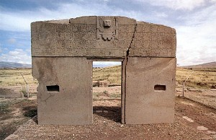

An ancient calendar located in the Courtyard of Kalasasaya in Bolivia tells of a time when our moon wasn’t there.

Theories about the moon actually date back thousands of years as various cultures and civilizations discussed the story of how it came to be where it resides today.

Greek authors **Aristotle** and **Plutarch**, and Roman authors **Apollonius Rhodius** and **Ovid** all wrote of a group of people called the Proselenes who lived in the central mountainous area of Greece called Arcadia. The *Proselenes* claimed title to this area because their forebears were there “before there was a moon in the heavens.” [6]

This claim is substantiated by symbols on the wall of the Courtyard of Kalasasaya, near the city of Tiahuanaco, Bolivia, which record that the moon came into orbit around the Earth between 11,500 and 13, 000 years ago, long before recorded history.

~~~

Zulu Shaman Credo Mutwa said that Zulu legends believe the Moon to be hollow and the home of the Python or Chitauri, or as David Icke calls them the “Reptilians”, a race of intelligent extraterrestrials. The legend states the Moon was brought here hundreds of generations ago by two brothers, Wowane and Mpanku, who were the leaders of these Reptilian extraterrestrials.

These two were known as the water brothers and they both had scaly skin like a fish. This tale is very similar to the Mesopotamia and Sumerian accounts about the two chief leader brothers Enlil and Enki, (Lords of the Earth). Credo continues telling the Zulu legends of how Wowane and Mpanku stole the Moon in the form of an egg from the “Great Fire Dragon,” and emptied out the yolk until it was hollow. Then they “rolled” the Moon across the sky to the Earth which brought about cataclysmic events on this planet that ended the “Golden Age” of the past. [7]

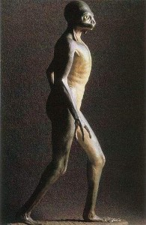

African Zulu legends tell of an extra-terrestrial race called the Chitauri who hollowed out a moon and brought it to Earth to use as a hub to oversee the control of the human race. This legend fits well into the theory of the reptilian-human hybrids which are thought to run our world today.

Credo Mutwa claims that the Earth was very different then it is now before the Moon had arrived. There weren’t any seasons and the planet was perpetually engulfed by a canopy of water vapor. People did not feel the strong glare of the Sun that we do now, and they could only see it through a watery mist. The Earth was once a beautiful place, a lovely place, lush and green with giant Redwoods, Violets and Ferns with a gentle drizzle and mist. The water canopy fell to the Earth as a cataclysm of rain when the Moon was put into place in the Earth’s orbit. This is symbolized in the Bible when it rains for 40 days and 40 nights.

The arrival of the Moon and the Reptilians changed everything on Earth. It modified the Earth’s rotation and angle. The earth turned over on its axis as we are upside down, as the legend says, and brought more powerful tidal systems that once had been much calmer. Women did not menstruate before the Moon arrived.

Zulus and other native African accounts say the Moon was built far, far, away to keep an eye on people, and as a vehicle to travel the Universe. Credo says that the Reptilians “Giant Mother-ship” is the Moon and that’s where they escaped to during the cataclysms of the “Great Flood,” which they had caused by manipulating the Moon and creating other cosmic events.

**Could It Be True?**

Outrageous as the spacecraft Moon theory might first appear, consider how this model reconciles all the mysteries of the Moon. It explains why the Moon gives evidence of being older than the Earth and perhaps even our solar system and why there are three distinct layers within the Moon**,** with the densest materials on the outside layer, as one would expect of the “hull” of a spacecraft would be. It could also explain why no sign of water has been found on the Moon’s surface, yet there is evidence it exists deep inside. This theory also would explain the strange maria and mascons, perhaps the remnants of the machinery used to hollow out the Moon. The idea of an artificial satellite could explain the odd, rhythmic “moon quakes” as artificial constructs reacting the same way during periods of stress from the Earth’s pull. And artificial equipment beneath the Moon’s surface might be the source of the gas clouds that have been observed.

A scientist called Irwin I. Shapiro who works at the Harvard Smithsonian Center for astrophysics said, “Looking at all the anomaly’s and unanswered questions about the Moon**,** the best explanation for the Moon is observational error, it doesn’t exist” Irwin I. Shapiro is a respected figure in astrophysics, his research includes using gravitational lenses to assess the age of the universe.

**Strange Anomalies on the Moon**

The following strange structures and happenings further propagate the mystery surrounding the moon:

**1. Ages of Flashes:** Aristarchus, Plato, Eratosthenes, Biela, Rabbi Levi, and Posidonius all reported anomalous lights on the moon. NASA, one year before the first lunar landing, reported 570+ lights and flashes were observed on the moon from 1540 to 1967. [9]

**2. Operation Moon Blink:** NASA’s *Operation Moon Blink* detected 28 lunar events in a relatively short period of time. [8]

**3. The Shard:** The Shard, an *obelisk-shaped object* that towers 1½ miles from the Ukert area of the moon’s surface, was discovered by Orbiter 3 in 1968. **Dr. Bruce Cornet**, who studied the amazing photographs, stated,

“No known natural process can explain such a structure.” [10]

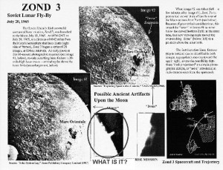

Photograph taken by the Lunar Orbiter conjure up some questions about unknown structures found on the Moon.

**4. The Tower:** One of the most curious features ever photographed on the Lunar surface (Lunar Orbiter photograph III-84M) is an amazing spire that rises more than 5 miles from the Sinus Medii region of the lunar surface.

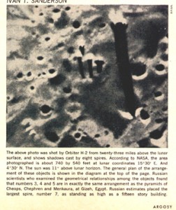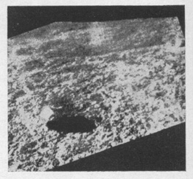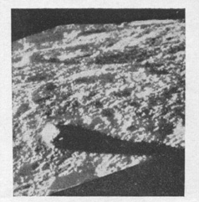  
**5. The Obelisks:** Lunar Orbiter II took several photographs in November 1966 that showed several obelisks, one of which was more than 150 feet tall.

“. . . the spires were arranged in precisely the same as the apices of the three great pyramids.”

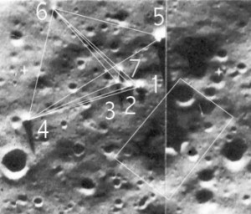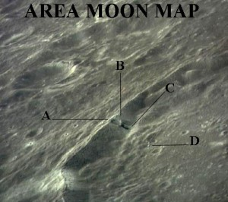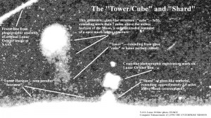

The subject of the Moon is a touchy one for many. Any suggestion of the Moon not being what we’ve been told it is usually follows with accusations of “conspiracy” and pseudo-science. Although there may be many theories that aim to debunk all aspects of this theory, there are too many factors that still don’t add up. How is it that seemingly unconnected ancient cultures have their own version of the artificial Moon myth? Why are there unexplained geometric structures on the surface of the Moon which correlate to the structures found in ancient Egypt and other primitive locations on Earth? How is it that by miraculous “chance” the Moon perfectly eclipses our Sun?

NASA is a government agency; government agencies are known to have a history of information concealment from the general public. Questioning NASA’s story isn’t ludicrous. Many speculate that NASA discovered unsettling information when they finally visited the Moon decades ago, information that would have caused a lot of commotion if leaked to the public.

Nevertheless, we are left simply curious, as no one can currently complete the narrative of the Moon’s origin. We encourage you to think outside of the box in this regard, as history and mainstream science provide only a limited perspective on the matter. Perhaps George Lucas was on to something after all…

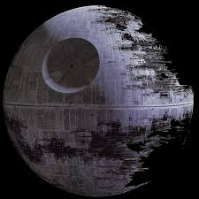

1.)    <http://news.google.com/newspapers?nid=1817&dat=19711016&id=TQ4fAAAAIBAJ&sjid=I5wEAAAAIBAJ&pg=6760,3106296> (water vapour clouds detected on moon)

2.)    <http://humansarefree.com/2013/12/who-parked-moon-in-perfect-circular.html>

3.)    <http://physicsworld.com/cws/article/news/2012/mar/26/further-doubts-cast-over-lunar-formation-models> (Theia/Moon/Earth Isotopes)

4.)    Bennett, M., Percy, D. (2001). *Dark Moon: Apollo and the Whistle-blowers*. (p. 269). Adventures Unlimited Press.

5.)    <http://ngm.nationalgeographic.com/1969/12/moon-landing/moon-rock-text> (moon rock differs from Earth rock)

6.)    <http://www.halexandria.org/dward200.htm> (Proselenes)

7.)    <http://www.youtube.com/watch?v=2Da5Keq7HSg> (Icke discusses Credo Mutwa and Hollow Moon Theory)

8.)    <http://ntrs.nasa.gov/archive/nasa/casi.ntrs.nasa.gov/19660030253_1966030253.pdf> (project moon blink)

9.)    <http://www.bibliotecapleyades.net/luna/lunarevents/NASA_R-277_1700s.htm> (copy of NASA’s publication *Chronological Catalog of Reported Lunar Events*)

10.) <http://tieba.baidu.com/p/17046300> (Dr. Bruce Cornet’s letter describing strange anomalies on the moon)

11.) <http://www.astrosurf.com/lunascan/argosy_cuspids.htm>

12.) <http://doowansnewsandevents.wordpress.com/2013/11/14/the-moon/>

13.) <http://waitingforthehollowmoon.blogspot.ca/>

=========================================================================================================================================================