**Stanley Kubrick Confesses To Faking The Moon Landings**

Posted on December 10, 2015 by [Sean Adl-Tabatabai](http://yournewswire.com/author/cyrus/) in [News](http://yournewswire.com/category/news/), [US](http://yournewswire.com/category/news/us/) // [19 Comments](http://yournewswire.com/stanley-kubrick-confesses-to-faking-the-moon-landings/#disqus_thread)

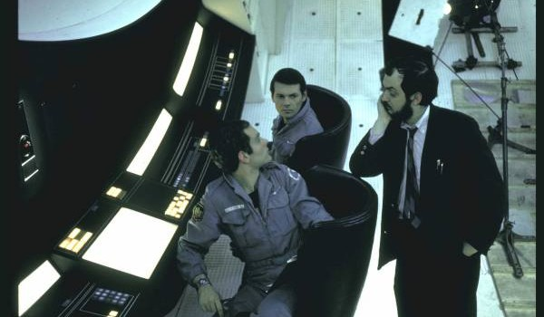

**A stunning new video has emerged 15 years after Stanley Kubrick’s death in which Kubrick admits that the NASA moon landings were faked.**

Filmmaker T. Patrick Murray interviewed Kubrick three days before his death in March 1999. He was forced to sign an 88-page NDA to keep the contents of the interview a secret for 15 years.

Below is a transcript from the interview with Stanley Kubrick, in which the 2001 Space Odyssey Director admits on camera that, “*the moon landings ALL were faked , and that I was the person who filmed it*.”

We have included a leaked rough cut of the film below the transcript as well as two unedited raw videos of the interview with Kubrick below that:

K: I’m so preoccupied. With my work, innovation, risk-taking, regrets…  
T: Why are you giving this interview?  
K: Because, it started to get to me after awhile. Well, this is difficult, because it is the first time I’ve talked about it. (sighs)  
T: Sure, take all the time you need.  
K: I’ve always been conflicted by it, but not consciously until years later. I was just blown away by the chance, the opportunity, the challenge of making this, this production, and I went into this like it was a regular film, like another regular film of mine, not thinking too much about uh the long term effects of what it would mean to society if it was ever discovered.  
T: What are you talking about? I’m dying to know what you’re talking about.  
K: Well, a confession of sorts. A movie I made, that nobody is aware of – even though they’ve seen it.  
T: A movie you made, no one knows you made? Is that what you said?  
K: That’s right. Is that intriguing? Do I have you intrigued?  
K: I perpetrated a huge fraud on the American public, which I am now about to detail, involving the United States government and NASA, that the moon landings were faked, that the moon landings ALL were faked , and that I was the person who filmed it.  
T: Ok. (laughs) What are you talking…You’re serious. Ok.  
K: I’m serious. Dead serious.  
K: Yes, it was fake.  
T: Ok. Wait. Wait…  
T: I don’t want this to be an R-rated film, but seriously, what the blank, but seriously…  
T: I, I, I worked almost eight months to secure this once in a lifetime interview that almost no else could ever get, and instead of talking about his sixteen films that I’ve endured since I was a child…That we didn’t land on the moon, you’re saying?  
K: No, we didn’t.  
K: It was not real.  
T: The moon landings were fake?  
K: A, a, a.. fictional moon landing. A fantasy. It was not real.  
K: Don’t you think it’s important for people to know the truth?  
T: The moon landing in ’69, which was two years before my birth…  
K: Is total fiction.  
T: Total fiction.  
T: Is that?…So, that’s the 15 year thing. So that’s makes sense now. That’s why I can’t release it for 15 years now, that makes total sense now.  
T: Did we…we didn’t land on the moon you’re saying?  
K: No, we didn’t.  
T: Why are you telling me?  
K: A, a, a, a massive fraud. An unparalleled fraud perpetrated against them. They SHOULD know.  
K: Nixon want to uh, they were planning, yeah, he want to fake this, this moon landing…  
T: Are you contending that people DON’T want to know the truth about the world, reality, the moon landings…?  
K: The government, knowing this, takes advantage of it by perpetrating fraud after fraud after fraud.  
T: How did you end up giving in? Being complicit with this fraud?  
K: I didn’t want to do it.  
T: This is NOT where I thought this interview was going!  
K: With my help, with my, with my aid, and it is, it is bothering me.  
T: I only have this certain amount of time with you. And I’ll talk about whatever you want, but…  
T: You’re not…This isn’t some type of joke, or…  
K: No. No, it’s not.  
T: Or a film within a film thing…  
K: Not joking. NOPE.  
T: Okay.  
K: The conspiracy theorists were right, on this occasion.  
T: I don’t know what to ask you first.  
K: I thought it was wrong, I just…I didn’t believe in perpetrating a fraud like that.  
T: But you did.  
K: It also undermined my artistic integrity to do that.  
T: Ok, but you ended up saying yes. Why?  
K: Well, yes, but because basically I was bribed. To put it bluntly, that’s what it was. It was just a plain fucking bribe.  
T: Why are you telling me?  
K:A, a, a, massive fraud. An unparalleled fraud perpetrated against them. They SHOULD know! Don’t you think it’s important for people to know the truth?  
T: Why did they have to fake it? Why? Why would they ever need to do something like that? Why would the government ever want or need to do…  
K: It’s no secret that NASA always wanted to fulfill this Kennedy prophecy.  
T: Take it from the beginning…  
T: I gotta be honest, this is where he (Kubrick) got me. I mean, when I actually put myself in his position, when I actually imagine that he was telling the truth, and that he was presented with this opportunity and if in the one in a billion chance that I lived his life and I was presented with the same opportunity, what would I do?  
T: Yeah, he wanted his approval points up and he thought nothing could do it better than this.  
T: What a conflict. I mean, gosh, I can’t imagine being presented with that opportunity. On one hand, I’d really would want to do it, but then I’d probably say I’m committing a crime, and lying…  
T: It depends, but my guess would be…no, if you’re good, but you would do it.  
K: Spielberg, (inaudible) Scorsese, even Woody Allen. There isn’t one of them who wouldn’t do this.  
T: I gotta admit: I’d do it. I’d do it too.  
T: But they dangled all this power and all this flattery on you, essentially?  
K: Yeah, it got to me after awhile. You can listen to so much of that stuff before you start to believe it.  
T: They just said you were the greatest and stuff?  
K: Yeah, yeah – and I agreed with them.  
K: Why are you telling the world? Why does the world need to know that the moon landings aren’t real and you faked them?  
K: Which I consider to be my masterpiece.  
T: And you can’t take credit, or even talk about…  
K: Well, I am now..  
T: Right, so you’ll be dead. In ten years, or 15…  
K: Right, ten or 15 something like that.  
T: So, you can’t talk to Roger Ebert about it. Does that frustrate you?  
T: Why did they have to fake it? Why would they have to do that?  
K: Because it is impossible to get there.  
T: Ok, back up, back up, back up….