Mars: Our Sleeping Neighbour

David Pratt

http://ourworld.compuserve.com/homepages/dp5/mars.htm

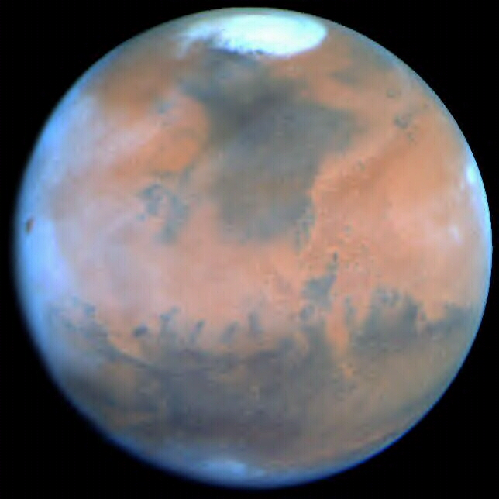

What does theosophy say about Mars?
'Mars . . . has ended its third round. We of the Earth are in our fourth; Venus is in its seventh and last; and Mercury is just beginning its seventh.' (Fundamentals of the Esoteric Philosophy, 208)
'. . . the earth as compared with Mars is, essentially, a grosser planet; and in evolution, also, it stands at a lower or more material point of its own planetary cycle than does Mars in its planetary cycle. . . . Therefore, Mars is more ethereal than the earth . . .' (Fountain-Source of Occultism, 326-7)
'As for the planet Mars, its physical sphere is younger than the earth, but presently it is in obscuration. It is more than merely "asleep," for the great bulk of its living entities have moved on to higher globes of the planetary chain of Mars. However, certain beings were left there when its globe D went into obscuration. These are the shishtas, "remainders," i.e. those who serve as the seeds of life on any planet, until the returning life-wave in the next globe-manvantara shall find these bodies waiting and ready for their use. At present, the vital essences of the Mars planetary chain have left its physical globe D, having ended their third round thereon, and have gone to its other globes.' (Fountain-Source, 332; see also Fundamentals, 207-10)
'Any globe can be either in partial or complete obscuration. It is in complete obscuration when there is no actively evolving Life-wave on it. This is rather rare, but happens frequently enough when compared with the immense ages of a Chain-manvantara. . . . Such is the case with the planet Mars at the present time.' (Dialogues of G. de Purucker, 2:357-8, 264)
The present manvantara of the earth-chain began about 2 billion years ago, and will last for a total of 4.32 billion years. (Secret Doctrine, 2:68-70)
'There is a mystery with regard to Mars, and that is why H.P.B. in a certain passage [SD 1:575] on the seven sacred planets mentions only four (Saturn, Jupiter, Mercury, and Venus), and merely hints at three more. Like the sun and the moon which are substitutes for two secret planets, Mars -- to a certain extent -- is in the same category.' (Fountain-Source, 332; see also Fundamentals, 209-10, 349, 526)
Mars represents the principle of kâma or desire (which has a higher aspect as well as a lower). The spiritual rector of Mars builds and oversees globe F (the sixth globe), and also globe F', of the earth-chain. It will also govern the destiny of the sixth root-race. (Fundamentals, 548, 586-7; Fountain-Source, 151-2, 323)
'. . . the planet Mars is built by its particular group of seven or twelve planetary chains, itself being the eighth of its ogdoad; and our earth chain is one of these.' (Fountain-Source, 324)
'. . . such great adept astronomers were the Scientists of the earliest races of the Aryan stock, that they seem to have known far more about the races of Mars and Venus than the modern Anthropologist knows of those of the early stages of the Earth.' (Secret Doctrine, 2:699)
'. . . Mars is now in obscuration. This means that the body of the planet is, as it were, sleeping in space, as it rolls about the sun and has no inhabitants on it such as we.' (Echoes of the Orient, 2:411)
'The inhabitants of [the sacred planets] resemble each other very closely because they belong more or less to the same evolutionary life-wave. This does not mean that the inhabitants of Jupiter, or of Mars, or of Mercury, or of Venus, if any at present, have human bodies proportioned exactly as our human bodies are, or that they are formed of flesh as our human bodies are. On the contrary, the inhabitants of these planets, whatever and whoever they may be, have bodies different from ours but approximating to ours somewhat.' (Questions We All Ask, 1:250-1)
Third round on earth: '[Man] has now a perfectly concrete or compacted body, at first the form of a giant-ape, and more intelligent, or rather cunning, than spiritual. For, on the downward arc, he has now reached a point where his primordial spirituality is eclipsed and overshadowed by nascent human mentality. In the last half of the Third Round his gigantic stature decreases, and his body improves in texture, and he becomes a more rational being, though still more an ape than a Deva. . . . (All this is almost exactly repeated in the third Root-Race of the Fourth Round.)' (Secret Doctrine, 1:188-9). '[We became selfconscious human beings] towards the end of the globe manvantara when the mânasic faculty began to manifest as best it could in Third Round conditions.' (Studies in Occult Philosophy, 615; see also 287)
'. . . every globe of a planetary chain is surrounded during its globe manvantara with a thick veil of meteoric dust, most of it very fine, some of it, however, consisting of more or less large bodies.' (Fountain-Source, 336) 'Mars has at present none or very little of such a protecting veil, simply because its life-energies have gone to another globe of the Martian planetary system -- the Martian planetary chain -- and the attractive magnetic force which holds together such a veil therefore is largely absent. But Venus and Mercury, for instance, have, as we have, such a protecting veil, although much thinner in Mercury's case than in that of Venus, because Mercury is just emerging from obscuration, and it is what the astronomers see when they look at those planets through their telescopes, when they see the "clouds," and note that they cannot see the face of the planet itself.' (Fundamentals, 340; see also Studies, 294-5) 'When the life-waves begin to come into Mars again, as they will before many millions of years have passed, Mars also will begin again to be re-covered with what scientists call heavy clouds, which are really veils of meteoric dust.' (Studies, 320)
'MARS WITH TWO MOONS NOT HIS OWN [SD 1:165]. This is taken from the letter by a Master who, replying to the query as to why Mercury and Venus have no satellites, says: "It is because Mars has two to which he has no right and -- for other reasons." That is, we infer that Mars absorbed these moons or dragged them off into his orbit at some time enormously distant and still keeps them. They cannot therefore stand to him in the same relation as our moon does to us. One of the "other reasons" may be that, Venus being in her 7th round, all vestiges of old moons have been sublimated and absorbed into her atmosphere.' (Echoes, 2:217)
'. . . the planet Mars has two satellites, Phobos and Deimos. Phobos is not a moon; but Deimos is a true moon, but not of Mars. Phobos is a capture, as we may say, by Mars.' (Fundamentals, 526) '. . . the true moon of Mars has not disappeared yet. Mars is a much younger planet than the Earth is . . .' (Dialogues, 2:170)
A.P. Sinnett (and later Besant and Leadbeater) wrongly argued that Mars and Mercury were globes C and E respectively of the earth-chain. The correct teaching is that Mars and Mercury, like the earth, are separate planetary chains -- each consists of 7 (or 12) globes, of which only the lowest (globe D) is visible to us. See Fundamentals, 208-9, 518-21, 538-40, 587; Fountain-Source, 320, 635; The Mahatma Letters, Appendix, 489-93.
'G. de P. -- . . . the planet from which we came before we came to Earth on the Outer Round . . . was the planet Venus; and the planet to which we shall next go on the Outer Round is the planet Mercury.' (Dialogues, 1:21)
'Student -- I gathered from what was said at the last meeting that the last planet we were on was Venus. Then where does the Moon come in? We are supposed to come from the Moon.
'G. de P. -- Well, I was referring to the Outer Rounds when I spoke of the planet Venus. The Moon, of course, is the parent of the Earth. You see, I have explained that there are two kinds of Rounds: the Outer Rounds and the Inner Rounds. The Outer Rounds are they which the life-hosts follow in passing from one solar planet -- from one planet of the solar family to another planet of the solar family, such as from Venus to Earth, from Earth to Mercury, or from Jupiter to Venus, or again from Mercury to Mars. . . . The Inner Rounds are the Rounds pursued by the life-hosts in passing from globe to globe of any one planetary chain . . . And it is just on this point that Mrs. Besant's non-understanding of the difference between the Outer and the Inner Rounds made her make the mistake that she did in saying that we came to Earth from the planet Mars.' (Dialogues, 1:72-3)

What do scientists say?
Mars, like the earth, is 4.6 billion years old, having formed from the same primordial solar nebula. Its two tiny moons are probably captured asteroids. Mars is less dense than the earth. It has a weak magnetic field, a very thin atmosphere (mainly carbon dioxide), and a harsh, arid environment. It has dormant volcanoes, and the southern hemisphere in particular is heavily cratered. The Mars Pathfinder mission has led to the unexpected discovery that Martian rocks are much more similar to those on earth than to those on the moon.
There is abundant evidence that Mars was once geologically active, and had a thicker (possibly oxygen-rich) atmosphere, a warmer climate, and large quantities of running water. The dominant view at present is that this period ended billions rather than millions of years ago. Similarly, most craters are usually estimated to be billions of years old. However, the lack of extensive surface erosion indicates that they could be far younger. Although they are normally regarded as impact craters, the material surrounding them seems to have flowed out like mud, suggesting that many may have been produced by internal forces. [1]
The general opinion is that Mars is completely barren of life today, but may have supported primitive plant and animal life early in its history. Some scientists believe such lifeforms may still exist today, beneath the surface and even on the surface [2]. A group of scientists is investigating what appear to be large artefacts on the surface of Mars, including a carved, humanoid face in the Cydonia region, and various pyramidal and other structures [3]. A few of these researchers think that such objects could be the remains of an extinct indigenous civilization on Mars [4].

References:
[1] W.R. Corliss (comp.), The Moon and The Planets, Sourcebook Project, 1985, pp. 214-5, 218.
[2] Ibid., pp. 210-12; W.R. Corliss (comp.), Science Frontiers, Sourcebook Project, 1994, pp. 64-5; Barry E. DiGregorio, with Dr G.V. Levin & Dr P.A. Straat, Mars: The Living Planet, Frog, 1997.
[3] Stanley V. McDaniel & M.R. Paxson (eds.), The Case for the Face: Scientists examine the evidence for alien artifacts on Mars, Adventures Unlimited Press, 1998; Mark J. Carlotto, 'Evidence in Support of the Hypothesis that Certain Objects on Mars are Artificial in Origin', Journal of Scientific Exploration, vol. 11, 1997, pp. 123-45; Mark J. Carlotto, The Martian Enigmas: A Closer Look, North Atlantic Books, 1997; M.J. Carlotto, H.W. Crater, J.L. Erjavec, & S.V. McDaniel, 'Reponse to Geomorphology of Selected Massifs on the Plains of Cydonia, Mars by David Pieri', Journal of Scientific Exploration, vol. 13, 1999, pp. 413-9.
[4] J.E. Brandenburg, V. DiPietro, G. Molenaar, 'The Cydonian Hypothesis', Journal of Scientific Exploration, vol. 5, 1991, pp. 1-25.

Last revised: October 1999. Originally published in Fohat, Fall 1997.

