Richard Clark Hoagland 1945-
http://en.wikipedia.org/wiki/Richard_C._Hoagland
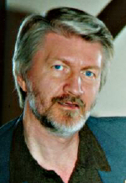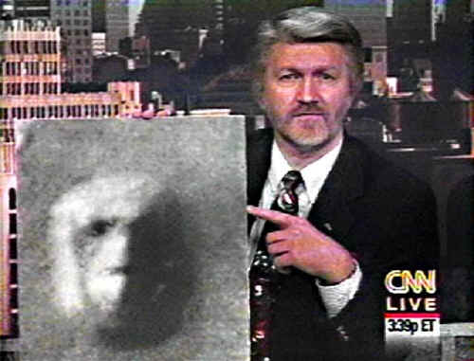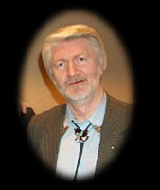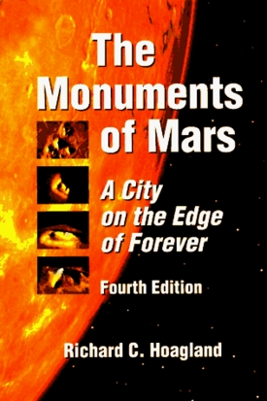

Richard C. Hoagland (born April 25, 1945) is a proponent of theories on astronomical topics, as well as a number of conspiracy theories connected to the space program. His major focus is on previous advanced civilizations in the solar system, in particular on Mars and the Moon. His theories are not supported by mainstream astronomers.

Contents
- 1 Career
- 2 Theories
- 3 Controversies
- 4 "Enterprise Mission" website
- 5 References
- 6 External links

Career
Hoagland claims to have served as a "Curator of Astronomy & Space Science" [3] at the "Springfield Museum of Science", located at The Quadrangle in Springfield, Massachusetts, and as a science adviser to Walter Cronkite and CBS News during the Apollo program. [4]
Hoagland also claims to have co-produced [5] with WTIC (AM) a Peabody Award-nominated radio program, "A Night of Encounter", covering the July 14, 1965, Mariner 4 flyby of the planet Mars. However, the official Peabody Awards entry form (51-65R) lists only Charles Renaud as the producer of the program.^{[1]} WTIC announcer Dick Bertel hosted the program and interviewed Hoagland, and the program also featured a conversation between Hoagland and astronomer Dr. Robert S. Richardson, Associate Director of the Griffith Observatory. ^{[2]}

Theories
Hoagland has made numerous claims about the existence of extraterrestrial life (or intelligence, at some point), which he believes is supported by the presence of the so-called Face on Mars. He claims that the face was part of a city built on Cydonia Planitia by extraterrestrial intelligences. The "city" apparently consists of very large pyramids and mounds arranged in a geometrical pattern, with the ratios between measured angles roughly equaling mathematical constants like pi, e, the square root of two, and the golden section.
Hoagland has appeared on CNN, the BBC, UFO Evidence & Conspiracy, Mysteries in Space, and is a frequent guest on Coast to Coast AM, often interviewed by George Noory.
Some of his better-known theories include:
- The Face on Mars is an artificial construct [6]
- There is a Martian City at Cydonia [7]
- (Adapted with acknowledgement from Tom Van Flandern) Mars was once the moon of a larger planet, that then exploded, leaving Mars isolated. [8]
- The advanced civilisation on Mars had prior warning of the cataclysm and so escaped via migration to planet Earth, eventually adapting to the environment and becoming the present human race.
- Numerous rocks surrounding the landing sites of the Mars Exploration Rovers are in fact pieces of Martian machinery. [9]
- Rocks on Mars containing biological fossils were purposely destroyed by NASA's rover. [10]
- The true color of Mars is salmon red with patches of greenish plant life and a light blue sky. [11]
- Hyperdimensional physics [12]
- The United States government has covered up the presence of extraterrestrials [13] [14] [15] [16]
- The many historical failures of Mars-bound spacecraft were due to deliberate sabotage by a 'cabal' of powerful people who were desperate to conceal the 'truth' of Martian civilisation.
- The Space Agency murdered the Apollo 1 astronauts [17]
- The Saturnian moon Iapetus is an artificial world. [18]
- The Galileo spacecraft, which burnt up in Jupiter's atmosphere, caused a mysterious black spot due to its nuclear payload [19]
- NASA Missions to Mars are a "well documented interest of the Bush family". [20][21]
- The Face on Mars is an indication of a Human/Feline hybrid design found in ancient Earth civilization, and knowledge of its existence is being suppressed by NASA. [22].
- NASA is also suppressing knowledge of an ancient civilization on the Moon. The advanced technology of this civilization is "lying around on the Moon's surface." [23] [24]
[25]
- Additionally, that NASA denies there are large semi-transparent structures constructed of glass on the lunar surface discovered during the Apollo missions. [26]
- The Arecibo message was intentionally altered by author Carl Sagan. [27]
- The 9/11 attacks were part of a Masonic conspiracy. [28][29]
- Federal agencies such as FEMA, NASA, and the US government are linked to Freemasonry. [30][31][32][33]
- That the Old Navy Stores are tied in with secret societies and coverups. Hoagland stated this on a Coast to Coast AM show one evening.^{[3][4]}

Controversies
Hoagland's claims and theories are not without controversy:
- The claim that Hoagland is most famous - or infamous - for is that of the Face on Mars that appears in a Viking Orbiter image taken of the Cydonia region on Mars. This discovery was made independently by two computer engineers named Vincent DiPietro and Gregory Molenaar, at the time working at NASA's Goddard Space Flight Center, while searching through NASA archives. They discovered two images misfiled, in Viking frames 35A72 and 70A13. At the time the images were acquired back in 1976, Viking chief scientist Gerry Soffen dismissed the "face" image 35A72 as "a trick of light and shadow" which he said, "disappeared several hours later." In fact, DiPietro and Molenaar discovered the second "face" image 70A13, which was acquired 35 Viking orbits later and at a different "sun-angle" than the 35A72 image, thereby indicating that there might have been more to the story. DiPietro and Molenaar asserted that there was more detail in the 70A13 frame than the original 35A72 image. Subsequently, DiPietro and Molenaar developed the "Starburst Pixel Interleaving Technique", or SPIT, which allowed for far greater resolution than the original images provided. This technique was verified by DiPietro and Molenaar using several Landsat images. Hoagland claimed at the time that this 'face' was actually half hominid (left side) and half feline (right side) using computer enhancements of the original Viking imagery. Also, he claims that this is evidence that an advanced civilization existed on Mars, and that NASA is suppressing the evidence for reasons explained in a Brookings Institution Report titled Proposed Studies on the Implications of Peaceful Space Activities for Human Affairs[34], specifically on page 216 of the report which stated that any evidence of extraterrestrial life found in the solar system should be withheld from the public because it was believed such information would destabilise society. In 1997, the Mars Global Surveyor probe sent back high resolution images of the Cydonia region [35] that provided evidence that the 'face' is nothing more than an irregular shaped mountain. While the new images did not fully disprove his claim, Hoagland contends these images were deliberately downgraded (run through multiple filters that degraded the original image) in quality to give a "catbox" appearance in order to hide what is really on Mars. Even when, on 21 Sept 2006, several new 3D views [36] , [37] derived from the high-resolution stereo camera on the European Space Agency's Mars Express orbiter were released, Hoagland was unconvinced. "Science is not about what you can see. It's about what you can measure", he remarked. (NOTE: Hoagland has no training in science).
- Hoagland claims to be responsible for the theory concerning the presence of life in the subsurface water on Jupiter's moon Europa [38], a claim which is disputed by Ralph Greenberg, a professor of Mathematics at the University of Washington [39] [40]. The theory, however, has neither been proven nor disproven because, to date, there have been no NASA or European Space Agency missions to Europa to investigate the theory.
- Hoagland's extension of Tom Van Flandern's theory of an exploding Mars companion -- to a Martian civilisation fleeing the catastrophe and inter-speciating with the human race is devoid of supporting evidence and not in line with proper scientific method. Scientists maintain that scientific investigation must adhere to the scientific method, a process for evaluating empirical knowledge that explains observable events in nature as results of natural causes, rejecting supernatural notions.
- The claim that the Galileo Probe caused a "mysterious black spot" has since been debunked by both NASA and several independent astronomers. There is photographic proof that similar "black spots" were present in imagery of Jupiter for several years prior to Hoagland's "discovery". ^{[5]} ^{[6]}
- Finally, Hoagland has claimed a close friendship with legendary CBS news anchor Walter Cronkite. While Hoagland was a minor fact-checking assistant to Cronkite during the Apollo Missions, Cronkite has specifically distanced himself from Hoagland. ^{[citation needed]} According to his daughter, Kathy Cronkite, during an on-the-air radio morning show on KLBJ-FM in 1994 where hosts Dale Dudley and Bob Fonseca were discussing Hoagland's claims, Kathy was very frank in relating her father's wishes that Hoagland would "quit referring to [her father] ever again as long as he keeps acting like a kook". ^{[citation needed]}
- Hoagland is a frequent guest on - and scientific advisor to - Coast to Coast AM, making numerous appearances during recent years. He has more airtime than other guests on the show. He regularly promotes his events and educational materials to the Coast to Coast audience during his guest appearances. The show also permits Hoagland to solicit cash from the radio audience and this is not a courtesy extended to other guests. His organisation is not a public company and therefore disposition of cash raised in this way is not available for audit by any independent authority.
- Hoagland was awarded an "International Angstrom Medal for Excellence in Science" in 1993. [41]. However, this was an unauthorized and unofficial award, given to Hoagland without the permission of the Royal Swedish Academy of Sciences or Uppsala University. According to skeptical researcher Phil Plait, Lars-Jonas Angstrom himself has said "Obviously a mistake was made in awarding the medal to Mr Hoagland." [42]

"Enterprise Mission" website
This site has material relating to Mars, including photos that show the Face, anomalous features that Hoagland sees as buildings, and the like. Other matters covered on the website are NASA-related conspiracies, theories of hyperdimensional physics, UFOs and/or alien related matters, the solar system, and data concerning Jupiter's satellite Europa.

References
- ^ The entry form is held at the Hargrett Rare Book and Manuscript Library at the University of Georgia Libraries in Athens, Georgia, submitted by Paul W. Morency, President of Broadcast-Plaza, Inc.
- ^ Associated Press. "Laser Beam Transmits Radio Broadcast", The Day, 1965-7-15.
- ^ [1]
- ^ [2]
- ^ PIA01496: Jovian Dark Spot. Retrieved on 2006-06-28.
- ^ Phil Plait. Bad Astronomy: Misconceptions: Coast to Coast AM. Retrieved on 2006-06-28.

External links
- Official website
- Richard Hoagland at Coast-to-Coast AM
- Phil Plait debunking Richard Hoagland's theories
- Borgus.com spoof of Hoagland and Art Bell
================================================================================================================================
END

