Stephen William Hawking 1942-
http://en.wikipedia.org/wiki/Stephen_Hawking
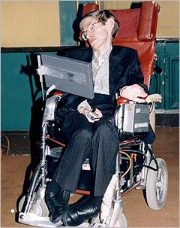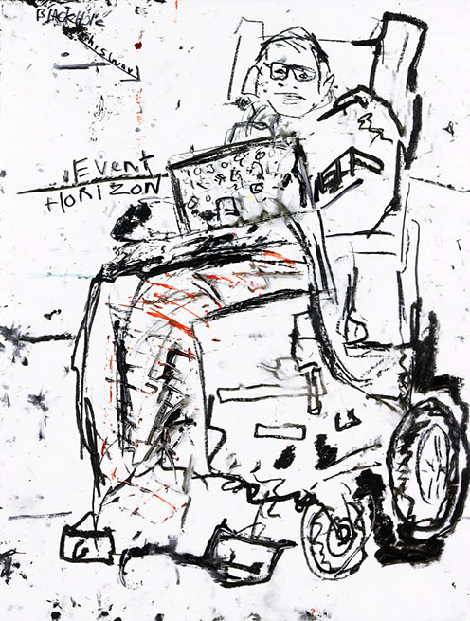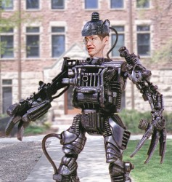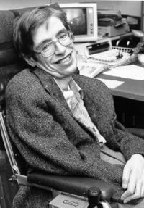
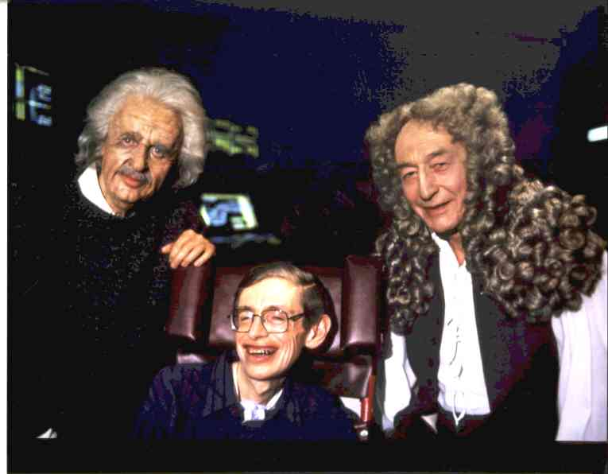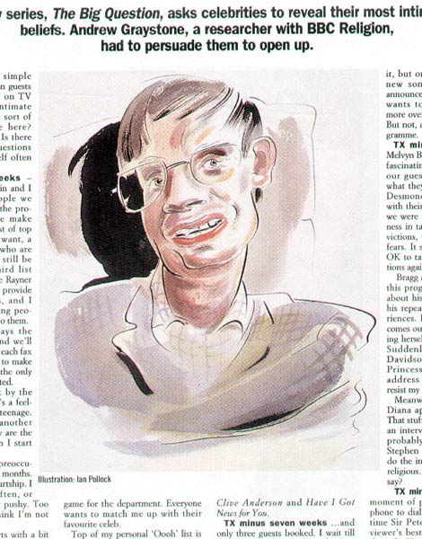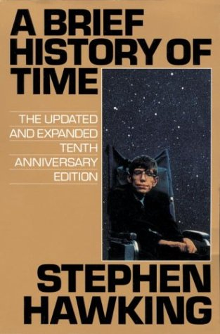

Stephen William Hawking, CH, CBE, FRS, FRSA, (born 8 January 1942) is a British theoretical physicist. Hawking is the Lucasian Professor of Mathematics at the University of Cambridge, and a Fellow of Gonville and Caius College, Cambridge. He is known for his contributions to the fields of cosmology and quantum gravity, especially in the context of black holes, and his popular works in which he discusses his own theories and cosmology in general. These include the runaway popular science bestseller A Brief History of Time, which stayed on the British Sunday Times bestseller list for a record-breaking 237 weeks.^{[1]}
His scientific contributions to date have included providing, with Roger Penrose, theorems regarding singularities in the framework of general relativity, and the theoretical discovery that black holes emit radiation, which is today known as Hawking radiation (or sometimes as Bekenstein-Hawking radiation).^{[2]} His scientific career spans more than forty years and his books and public appearances have made him an academic celebrity and world-renowned theoretical physicist. He is an Honorary Fellow of the Society of Arts.^{[3]}

Contents
- 1 Biography
- 2 Research fields
- 3 Losing an old bet
- 4 Illness
- 5 Computer
- 6 Distinctions
- 7 Comments on the future of earth and humanity
- 8 Selected publications
  - 8.1 Technical
  - 8.2 Popular
  - 8.3 Films and series
- 9 Awards
- 10 Media Appearances
- 11 See also
- 12 Notes and references
- 13 External links

Biography
Stephen William Hawking was born on January 8, 1942 to Frank Hawking, a research biologist, and Isobel Hawking. He had two younger sisters, Philippa and Mary, and an adopted brother, Edward.^{[4]} Though Hawking's parents had their home in North London, they relocated to Oxford while Isobel was pregnant with Stephen, desiring a safer location for the birth of their first child (London was under attack at the time by the Luftwaffe).^{[citation needed]} After Hawking was born, the family moved back to London, where his father headed the division of parasitology at the National Institute for Medical Research.^{[4]}
In 1950, Hawking and his family moved to St Albans in Hertfordshire where, from the age of 11, he attended St Albans School, where he was a good but not exceptional student.^{[4]} He maintains his connection with the school, giving his name to one of the four houses and to an extra-curricular science lecture series. He has visited to deliver one of the lectures and has also granted a lengthy interview to pupils working on the school magazine, the Albanian.
He was always interested in science.^{[4]} He enrolled at University College, Oxford with the intent of studying mathematics, but after his first year was persuaded by his father to switch to physics. His interests during this time were in thermodynamics, relativity, and quantum mechanics. His physics tutor, Robert Berman, later said in the New York Times Magazine, "It was only necessary for him to know that something could be done, and he could do it without looking to see how other people did it. ... He didn't have very many books, and he didn't take notes. Of course, his mind was completely different from all of his contemporaries."^{[4]} He was passing with his fellow students, but his unimpressive study habits gave him a final examination score on the borderline between first and second class honours, making an "oral examination" necessary. Berman said of the oral examination, "And of course the examiners then were intelligent enough to realise they were talking to someone far more clever than most of themselves."^{[4]}
After receiving his B.A. degree at Oxford University in 1962, he stayed to study astronomy, deciding to leave when he found that studying sunspots, which was all the observatory was equipped for, didn't appeal to him and that he was more interested in theory than in observation.^{[4]} He left Oxford for Trinity Hall, Cambridge, where he engaged in the study of theoretical astronomy and cosmology.
Almost as soon as he arrived at Cambridge, he started developing symptoms of Amyotrophic Lateral Sclerosis, a type of motor neuron disease which would cost him the loss of almost all neuromuscular control. During his first two years at Cambridge, he did not distinguish himself, but, after the disease had stabilised and with the help of his doctoral tutor, Dennis William Sciama, he returned to working on his Ph.D..^{[4]} Stephen revealed that he did not see much point in obtaining a doctorate if he was to die soon. Hawking later said that the real turning point was his 1965 marriage to Jane Wilde, a language student.^{[4]}
Jane Wilde, Hawking's first wife, with whom he had three children, cared for him until 1991 when the couple separated, reportedly due to the pressures of fame and his increasing disability. Hawking married his nurse Elaine Mason in 1995. (Elaine Mason's first husband, David Mason, had designed the first version of Hawking's talking computer). In October 2006, the Hawkings filed for divorce.^{[5]}
In 1999, Jane Hawking published a memoir, Music to Move the Stars, detailing her own long-term relationship with a family friend whom she later married. Hawking's daughter Lucy Hawking is a novelist. Their son Robert Hawking emigrated to the United States, married, and has one child, George Edward Hawking.
Hawking was elected as one of the youngest Fellows of the Royal Society in 1974, was created a Commander of the Order of the British Empire in 1982, and became a Companion of Honour in 1989. Prof. Hawking is a member of the Board of Sponsors of The Bulletin of the Atomic Scientists.
At the celebration of his 65th birthday on January 8, 2007, Hawking announced he plans for a zero-gravity flight in 2007 to prepare for a sub-orbital space flight in 2009 on Virgin Galactic's space service. Billionaire Richard Branson pledged to pay all expenses for the flight, costing an estimated $200,000.^{[6]}

Research fields
Hawking's principal fields of research are theoretical cosmology and quantum gravity.
In the late 1960s, he and his Cambridge friend and colleague, Roger Penrose, applied a new, complex mathematical model they had created from Albert Einstein's general theory of relativity. This led, in 1970, to Hawking proving the first of many singularity theorems; such theorems provide a set of sufficient conditions for the existence of a singularity in space-time. This work showed that, far from being mathematical curiosities which appear only in special cases, singularities are a fairly generic feature of general relativity.^{[7]}
He supplied a mathematical proof, along with Brandon Carter, W. Israel and D. Robinson, of John Wheeler’s "No-Hair Theorem" — namely, that any black hole is fully described by the three properties of mass, angular momentum, and electric charge.
Hawking also suggested that, upon analysis of gamma ray emissions, after the Big Bang, primordial or mini black holes were formed. With Bardeen and Carter, he proposed the four laws of black hole mechanics, drawing an analogy with thermodynamics. In 1974, he calculated that black holes should thermally create and emit subatomic particles, known as Hawking radiation, until they exhaust their energy and evaporate.^{[8]}
In collaboration with Jim Hartle, Hawking developed a model in which the Universe had no boundary in space-time, replacing the initial singularity of the classical Big Bang models with a region akin to the North pole; while one cannot travel North of the North pole, there is no boundary there. While originally the no-boundary proposal predicted a closed Universe, discussions with Neil Turok led to the realisation that the no-boundary proposal is consistent with a Universe which is not closed also.
Among Hawking's many other scientific investigations, included are the study of: quantum cosmology, cosmic inflation, helium production in anisotropic Big Bang universes, large N cosmology, the density matrix of the universe, topology and structure of the universe, baby universes, Yang-Mills instantons and the S matrix; anti de Sitter space, quantum entanglement and entropy; the nature of space and time, including the arrow of time; spacetime foam, string theory, supergravity, Euclidean quantum gravity, the gravitational Hamiltonian; Brans-Dicke and Hoyle-Narlikar theories of gravitation; gravitational radiation, and wormholes.

Losing an old bet
Main article: Thorne-Hawking-Preskill bet
Hawking was in the news in July 2004 for presenting a new theory about black holes which goes against his own long-held belief about their behavior, thus losing a bet he made with Kip Thorne and John Preskill of Caltech. Classically, it can be shown that information crossing the event horizon of a black hole is lost to our universe, and that thus all black holes are identical beyond their mass, electrical charge and angular velocity (the "no hair theorem"). The problem with this theorem is that it implies the black hole will emit the same radiation regardless of what goes into it, and as a consequence that if a pure quantum state is thrown into a black hole, an "ordinary" mixed state will be returned. This runs counter to the rules of quantum mechanics and is known as the black hole information paradox.
Hawking had earlier speculated that the singularity at the centre of a black hole could form a bridge to a "baby universe" into which the lost information could pass; such theories have been very popular in science fiction. But according to Hawking's new idea, presented at the 17th International Conference on General Relativity and Gravitation, on 21 July 2004 in Dublin, Ireland, black holes eventually transmit, in a garbled form, information about all matter they swallow:
The Euclidean path integral over all topologically trivial metrics can be done by time slicing and so is unitary when analytically continued to the Lorentzian. On the other hand, the path integral over all topologically non-trivial metrics is asymptotically independent of the initial state. Thus the total path integral is unitary and information is not lost in the formation and evaporation of black holes. The way the information gets out seems to be that a true event horizon never forms, just an apparent horizon.^{[9]}
Having concluded that information is conserved, Hawking conceded his bet in Preskill's favour, awarding him Total Baseball, The Ultimate Baseball Encyclopedia. Thorne, however, remained unconvinced of Hawking's proof and declined to contribute to the award.^{[10]}
Another older bet — about the existence of black holes — was described by Hawking as an "insurance policy" of sorts. To quote from his book, A Brief History of Time:
“ This was a form of insurance policy for me. I have done a lot of work on black holes, and it would all be wasted if it turned out that black holes do not exist. But in that case, I would have the consolation of winning my bet, which would win me four years of the magazine Private Eye. If black holes do exist, Kip will get one year of Penthouse. When we made the bet in 1975, we were 80% certain that Cygnus was a black hole. By now, I would say that we are about 95% certain, but the bet has yet to be settled. ”
—Stephen Hawking, A Brief History of Time (1988)^{[1]}
According to the updated 10th anniversary edition of A Brief History of Time, Hawking has conceded the bet "to the outrage of Kip's liberated wife" due to subsequent observational data in favor of black holes.

Illness
Hawking is severely disabled by amyotrophic lateral sclerosis, or ALS (a type of motor neuron disease.); this condition is commonly known in the United States as Lou Gehrig's Disease.
When he was young, he enjoyed riding horses and playing with the other children. At Oxford, he coxed a rowing team, which, he stated, helped relieve his immense boredom at the university. Symptoms of the disorder first appeared while he was enrolled at Cambridge. He lost balance and fell downstairs, hitting his head. Worried of losing his genius, he took the Mensa International test to verify that his intellectual abilities were intact. Diagnosis came when Hawking was 21, shortly before his first marriage, and doctors said he would not survive more than two or three years.
He gradually lost the use of his arms, legs, and voice, and is now almost completely paralyzed. The computer system attached to his wheelchair is operated by Hawking via an infra-red 'blink switch' clipped onto his glasses. By scrunching his right cheek up, he is able to talk, compose speeches, research papers, browse the World Wide Web, and write e-mails. The system also uses radio transmission to provide control over doors in his home and office.
During a visit to the research centre CERN in Geneva in 1985, Hawking contracted pneumonia, which in his condition was life-threatening. It resulted in acute difficulty of breathing, which could only be overcome through a tracheotomy by which Stephen Hawking lost his natural speech ability. He has since used an electronic voice synthesizer to communicate. The voice synthesizer, which has an American accent, is of a model that is no longer produced. Asked why he has still kept it after so many years, Hawking mentioned that he has not heard a voice he likes better and because he identifies with it. Hawking is said to be looking for a replacement since, other than being obsolete, the synthesizer, a DECtalk DTC01 is now considered large and fragile but as of present, finding a software alternative has been difficult. During a lecture in Hong Kong in June 2006, he joked that if he got a new one with a French accent, his wife would divorce him.
When Hawking (then using a wheelchair and unable to dress himself) and his wife were first living together, they received no outside assistance other than from physics students who helped in exchange for extra attention with their work. As his condition worsened, Hawking needed a team of nurses to provide round-the-clock care. He also needed a wheelchair for mobility.
Despite his disease, he describes himself as "lucky" — not only has the slow progress of his disease provided time to make influential discoveries, it has also afforded time to have, in his own words, "a very attractive family".^{[11]} When Jane was asked why she decided to marry a man with a 3-year life expectancy, she responded: "These were the days of atomic gloom and doom, so we all had a rather short life expectancy."

Computer
Hawking receives a new computer every 18-24 months donated by Intel. The most recent computer was donated in April of 2005 and is based on the Centrino chipset. It consists of two pieces, a rear chassis which houses 3 160Whr batteries and various external peripherals, and a front chassis, which houses a Tablet-PC and the speakers which project his hardware-synthesized voice. The two chassis are connected via a custom-designed umbilical cable which allows power and electrical signals to travel back and forth. Hawking's computer can run for up to 16 hours without needing a recharge.
The computer utilizes a wireless data card that runs on mobile phone networks. This allows Hawking to check his email and browse the web while away from a wireless LAN network. Hawking can also make and receive voice phone calls via a mobile phone with an external microphone in front of his computer speakers.

Distinctions
- Hawking’s belief that the average person should have access to his work led him to write a series of popular science books in addition to his academic work. The first of these, A Brief History of Time, was published on April 1, 1988 by Hawking, his family and friends, and some leading physicists. It became a documentary in 1991. [1] It surprisingly became a best-seller and was followed by The Universe in a Nutshell (2001). Both books have remained highly popular all over the world. A collection of essays titled Black Holes and Baby Universes (1993) was also popular. He has now written a new book, A Briefer History of Time (2005) that aims to update his earlier works and make them accessible to a wider audience. He has recently announced that he plans to write a children's book focusing on science that has been described to be "like Harry Potter, but without the magic."^{[12]}
- Hawking is also known for his wit; he is famous for his oft-made statement, "When I hear of Schrödinger's cat, I reach for my pistol." This was a deliberately ironic paraphrase of the phrase "Whenever I hear the word culture... I release the safety-catch of my Browning", from the play Schlageter (Act 1, Scene 1) by German playwright and Nazi Poet Laureate, Hanns Johst. His wit has both entertained the non-specialist public and helped them to understand complex questions. Asked in October 2005 on the British daytime chat show Richard & Judy, to explain his assertion that the question "What came before the Big Bang?" was meaningless, he compared it to asking "What lies north of the north pole?"
- Hawking is an active supporter of various causes. He appeared on a political broadcast for the United Kingdom's Labour Party, and actively supports the children's charity SOS Children's Villages UK.^{[13]}

Comments on the future of earth and humanity
Hawking has made several comments suggesting that the human race may become extinct within the next thousand years. "unless we spread into space ... [as] there are too many accidents that can befall life on a single planet."[2] In the third week of June 2006, Stephen Hawking spoke in China and made the statement that humans might have already damaged the atmosphere and inadvertently reconnected the planet Earth with her dead neighbors.^{[citation needed]}
The China Daily asked Hawking about the environment, and he responded that he was "very worried about global warming." He said he was afraid that Earth "might end up like Venus, at 250 degrees Celsius and raining sulphuric acid."^{[14]} In the light of this discussion Hawking asked an open question on Yahoo Answers "How can the human race survive the next hundred years?" and received well over 25,000 responses. The validity of the question was confirmed by Hawking himself and the Yahoo Answers staff.[3]
In an ABC News interview in August 2006, Hawking explained, "The danger is that global warming may become self-sustaining, if it has not done so already. The melting of the Arctic and Antarctic ice caps reduces the fraction of solar energy reflected back into space, and so increases the temperature further. Climate change may kill off the Amazon and other rain forests, and so eliminate one of the main ways in which carbon dioxide is removed from the atmosphere. The rise in sea temperature may trigger the release of large quantities of methane, trapped as hydrates on the ocean floor. Both these phenomena would increase the greenhouse effect, and so further global warming. We have to reverse global warming urgently, if we still can."
Hawking has also warned of the continued danger posed by nuclear weapons to human survival, saying that "Since Hiroshima and Nagasaki, no nuclear weapons have been used in war, though the world has come uncomfortably close to disaster on more than one occasion," and that "But for good luck, we would all be dead." Hawking concluded that "We foresee great perils if governments and society do not take action now to render nuclear weapons obsolete and prevent further climate change." Professor Hawking has expressed his opposition to plans to replace the Trident nuclear weapons system by the UK government, stating that "Nuclear war remains the greatest danger to the survival of the human race. To replace Trident would make it more difficult to get arms reduction. It would also be a waste of money because there are no circumstances in which we would use it independently."^{[15]}

Selected publications

Technical
- The Large Scale Structure of Spacetime with George Ellis, 1973 ISBN 0521099064
- The Large, the Small, and the Human Mind, (with Abner Shimony, Nancy Cartwright, and Roger Penrose), Cambridge University Press, 1997, ISBN 0-521-56330-5 (hardback), ISBN 0-521-65538-2 (paperback), Canto edition: ISBN 0-521-78572-3
- Information Loss in Black Holes, Cambridge University Press, 2005
- God Created the Integers: The Mathematical Breakthroughs That Changed History, Running Press, 2005 ISBN 0762419229

Popular
- A Brief History of Time, (Bantam Press 1988) ISBN 055305340X
- Black Holes and Baby Universes and Other Essays, (Bantam Books 1993) ISBN 0553374117
- The Universe in a Nutshell, (Bantam Press 2001) ISBN 055380202X
- On The Shoulders of Giants. The Great Works of Physics and Astronomy, (Running Press 2002) ISBN 076241698X
- A Briefer History of Time, (Bantam Books 2005) ISBN 0553804367
Footnote: On Hawking's website, he denounces the unauthorized publication of The Theory of Everything and asks consumers to be aware that he was not involved in its creation.

Films and series
- A Brief History of Time (film)
- Stephen Hawking's Universe
Full lists of Hawking's publications are available on his website.[4]

Awards
- 1975 Eddington Medal
- 1976 Hughes Medal of the Royal Society
- 1979 Albert Einstein Medal
- 1982 Order of the British Empire (Commander)
- 1985 Gold Medal of the Royal Astronomical Society
- 1986 Member of the Pontifical Academy of Sciences
- 1988 Wolf Prize in Physics
- 1989 Prince of Asturias Awards in Concord
- 1989 Companion of Honour
- 1999 [5] Julius Edgar Lilienfeld Prize of the American Physical Society
- 2003 Michelson Morley Award of Case Western Reserve University
- 2006 Copley Medal of the Royal Society[6]

Media Appearances
Main article: Stephen Hawking in popular culture
Hawking has appeared as himself on many television shows. For example, he has played himself on a Red Dwarf anniversary special, played a hologram of himself on an episode of Star Trek: The Next Generation, appeared in a skit on Late Night with Conan O'Brien, and appeared on the Discovery Channel special Alien Planet.^{[16]}
He has also "played" himself in three episodes of The Simpsons, one episode of Futurama, two episodes of Family Guy, and one episode of The Fairly Odd Parents. His name is mentioned in the song "White & Nerdy" by "Weird Al" Yankovic. His actual synthesizer voice was used on parts of the Pink Floyd song "Keep Talking" from the 1994 album The Division Bell.

See also
- Gravitational singularity
- Kip S. Thorne
- Roger Penrose
- Space colonization

Notes and references
- ^ ª ^{b} Hawking, Stephen (1988). A Brief History of Time. Bantam Books. ISBN 0-553-38016-8.
- ^ Particle creation by black holes,Comm. Math. Phys. 43, no. 3 (1975), 199–220.
- ^ Honorary Fellows of the Society of Arts. Retrieved on March 25, 2007.
- ^ ª ^{b} ^{c} ^{d} ^{e} ^{f} ^{g} ^{h} ^{i} (1984) Current Biography, 1984. New York: The H. W. Wilson Co..
- ^ "Hawking and second wife agree to divorce", Telegraph.co.uk, 2007-01-09. Retrieved on March 18, 2007.
- ^ "Stephen Hawking plans to see space", Telegraph.co.uk, 2007-01-09. Retrieved on March 18, 2007.
- ^ Hawking, SW; R Penrose (Jan. 27, 1970). "The Singularities of Gravitational Collapse and Cosmology". Proceedings of the Royal Society of London. Series A, Mathematical and Physical Sciences 314 (1519): 529-548. Retrieved on 2007-03-23.
- ^ Hawking, SW (1974). "Black Hole Explosions". Nature 248 (1): 30-31. Retrieved on 2007-03-23.
- ^ GR Conference website: summary of Hawking's talk
- ^ Preskill, John. On Hawking’s Concession 24 July 2004.
- ^ My experience with ALS. Hawking, Stephen. Retrieved on March 3, 2007.
- ^ Man must conquer other planets to survive, says Hawking. Daily Mail (13 June 2006). Retrieved on November 28, 2006.
- ^ SOS Children's Villages - Our Friends. Retrieved on May 6, 2006.
- ^ Stephen Hawking: Earth Could Become Like Venus
- ^ Not in Our Name: Campaign Launched against Trident.
- ^ Stephen Hawking. IMdB. Retrieved on March 18, 2007.
- Boslough, John (1985). Stephen Hawking's Universe. New York: Avon Books. ISBN 0-380-70763-2. A layman's guide to Stephen Hawking.
- Ferguson, Kitty (1991). Stephen Hawking: Quest For A Theory of Everything. Franklin Watts. ISBN 0-553-29895-X.
- Morris, Errol (Director). (1991) A Brief History of Time [Documentary]. Triton Pictures.
- Hawking, S. W. & Ellis, G. F. R. (1973). The Large Scale Structure of Space-time. Cambridge: Cambridge University Press. ISBN 0-521-09906-4. . Highly influential in the field.
- Hawking, S. W. & Israel, W. (1979). General relativity: an Einstein centenary survey. New York: Cambridge University Press. ISBN 0-521-22285-0. . A much cited centennial survey.
- Misner, Charles; Thorne, Kip S. & Wheeler, John Archibald (1973). Gravitation. San Francisco: W. H. Freeman. ISBN 0-7167-0344-0. ; see Box 34.3 for a short biography. (This famous book is the first modern textbook on general relativity, and shows that even in the early seventies, Hawking was already regarded as an unusually intriguing personality by his colleagues.)

External links
- Stephen Hawking's website
  - An overview of Hawking's communication system
  - An overview of Hawking's physical disability
- Stephen Hawking at the Notable Names Database
- Hawking's Students at the Mathematical Genealogy Project.
- Hawking celebrates own brief history, 7 January 2002, BBC
- Black holes turned "inside out", 22 July 2004, BBC
- An audio interview with Stephen Hawking (MP3 format) from Hour 25
- Return of the time lord, Interview about "A Brief History of Time", 27 September 2005, The Guardian.
- "Leaping the Abyss", interview in Reason by Gregory Benford
- Stephen Hawking touches on God and science - Physicist says Pope John Paul told scientists not to study universe’s origins msnbc.com 15 June 2006
- Stephen Hawking - discussion of two views of the universe Video
  - Press Release from the Catholic League on misquote of Pope by Hawking
- Transcript of Stephan Hawking's lecture "The Origin Of The Universe" in the Hebrew University In Jerusalem, December 14th, 2006
- Stephen Hawking at the Mathematics Genealogy Project
- O'Connor, John J..; Edmund F. Robertson "Stephen Hawking". MacTutor History of Mathematics archive.
Honorary Titles Preceded by
Sir James Lighthill Lucasian Professor at Cambridge University
1980–Present Succeeded by
Incumbent

==================================================================================================================================

