Jean-Claude Pecker
Fred Hoyle and the
Mythical Big Bang
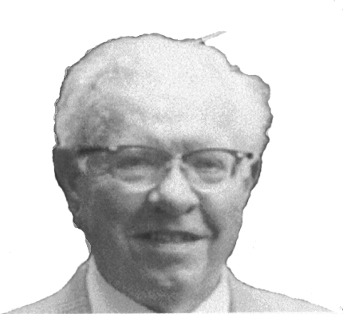
Fred Hoyle
http://www.humanist.org.nz/Docs/BigBang.html

In this article, written exclusively for New Zealand Humanist, Jean-Claude Pecker discusses:
Fred Hoyle and the origins of the Universe.
Sir Fred Hoyle died at the age of 86, on Monday August the 20th, at Bournemouth, UK, where he had retired several years ago. He was, no doubt, still the young man he has ever been, active, creative, unconventional, multi-talented, interested by everything, deeply sensitive, exceptionally imaginative, and strongly uncompromising.
Born on June 24th, 1915, he displayed very early an obvious taste for the "mysteries" of the Universe, for its beauties, and for astronomy. At the age of 13, he is said to have observed the sky every possible night,with a small telescope. Later, after his Doctorate Thesis on Quantum Electrodynamics, defended at Cambridge in 1939, as a student of Allen Smailes and Paul Diracand later, disgusted by the military applications of nuclear physics, he turned towards astrophysics, then influenced by his friend Raymond Lyttleton. He became Plumian Professor of Astronomy And Experimental Philosophy at Cambridge in 1958, until 1972. He kept very close relations with foreign universities and observatories. He worked at the Mount Wilson and Palomar Observatories (although he was essentially a theoretician), at Cal-Tech, and also at Cornell University where he was professor at large from 1972 until 1978, and kept very close working relations with astronomers all over the world, Fritz Zwicky, Halton Christian (Chip) Arp, William (Willi) Fowler, Geoffrey and Margaret Burbidge, in the USA, N. Chandra Wickramasinghe, Jayant V. Narlikar, in India, and in the UK, not to speak of his earlier Cambridge accomplices, Thomas Gold, Sir Hermann Bondi, and of course Lyttleton.
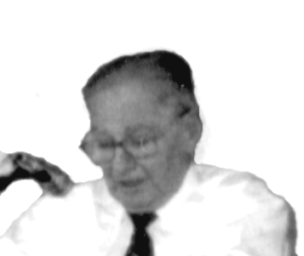
Jean Claude Pecker
Fred missed by an inch the Nobel Prize, which was granted to Willi Fowler for their common accomplishments described in the famous paper BBFH (Burbidge, Burbidge, Fowler, Hoyle), in which they established correctly the bases for the nucleosynthesis of elements in the hot heart of a star. He received however many awards, including the 1970 Kalinga Prize from UNESCO for scientific popularisation, the 1997 Crafoord Prize of the Swedish Academy of Sciences (created for disciplines not covered by the Nobel prize), the Gold medal of the RAS, the ADION medal of the Nice Observatory (to quote one which I know well), and several others. The Queen knighted him in 1972.
Sir Fred Hoyle was much more than a skilled astronomer and physicist. He was a writer, he was a composer, he was, in a way, a philosopher (although I doubt whether he would have himself accepted this qualification). "Nothing human was foreign to him", to plagiarise the Latin author Terentius. As a composer, he wrote several operas. As a science-fiction writer, he was the author of the celebrate d Black Cloud (1957), of A for Andromeda (1962), and also of Ossian’s Ride, October the First Is Too Late, Fifth Planet, Element 79.... – novels in which he displays an acute sense for the problems thatcan be linked with extraterrestrial intelligence. In them, he shows also his splendid use of smiling irony, making fun out of some of his colleagues, American, British, and others, all eminent astronomers, with a somewhat crude (but may I say probably well deserved?) cruelty!....
In the field of astrophysics, he has touched every domain. He proposed a theory for the formation of the Sun as a double star, he studied the nucleosynthesis of chemical elements, he discussed at length the propagation of gravitation, he devised a way for life to have appeared on Earth through the pollution of our planet by some comet coming from the circum-stellar space, very far away. And here I shorten the list very much!....He was certainly one of the most creative scientists of the 20th century.
-:-:-:-::-:-:-:-
One of Hoyle’s main and last concerns was the evolution of the Universe. From the beginning, Fred was opposed to the Big Bang. But here I must relocate his personal points of view at their place and time, and remind the reader of the bitter dispute which has existed in the scientific and philosophical circles for about 2500 years. The firststep of this opposition between the "pro’s" and the "con’s" was the opposition between Aristotle and Plato. Whenever Plato represented his Universe as having been created by God, by a "demiourgos", a Creator, Aristotle found no reason to believe that the World had a determined origin: it has to be eternal, and it has always been there. In other words, the World was for him "non-generated, non-created".
Of course, during many centuries, the Creation of the World, in the Christian realm, has been admitted as a dogma. At the time of the great naturalists of the 18th and 19th century, until Lamarck and Darwin, it became obvious for geological and palaeontological arguments that the Creation could not have been a seven-day affair that occurred some 6000 years ago. Time scales were obviously inadequate and had necessarily to be very much extended – to millions, and now to milliards (thousands of millions) of years. One could only attribute to the Creation, as described in the Scriptures, a symbolic signification.
At that time, observation could not answer this question. But the 20th century witnessed many important advances. Albert Einstein, in 1916, extended the Newtonian laws of gravitation to what we call the General Relativity Theory (perhaps a badly chosen name that gave to many people the idea that everything is relative, that nothing is truer than anything else...; which is obviously a completely irrationalist point of view!). Indeed, General Relativity (GR) produced a set of complicated equations of which the solution is, in particular, the rate of the variation of the density with time in the Universe. But the equations of GR had an infinity of solutions depending upon the choice of some parameters that then escaped measurement. Einstein himself, in 1917, decided that the equations had to be completed by a "cosmological" term, in order for the solution to be that of an Aristotelian Universe, in equilibrium, eternal, non-created. This "steady-state" Universe of Einstein was indeed an interesting solution. But again, like in the case of the old concepts of the Universe proposed during Antiquity, the Middle Age, the Renaissance, and modern times, no observational evidence could be given in favour of that steady-state Einstein Universe!...But the many improvements of astronomical instrumentation in the beginning of the 20th century changed the cosmological scenery, making cosmology an observational science.
Galaxies are families of stars; they contain often hundreds of milliards (thousands of millions) of stars; and there are millions of known galaxies in the Universe, probably some orders of magnitude more...Our Sun is one star belonging to one galaxy, our Galaxy, the Milky Way...During the period 1910-1920, Vesto Slipher measured characteristics of the observable spectrum of relatively close-by galaxies, such as the shift of spectral lines towards the red part of the spectrum, the so-called "red-shift". Admitting that the red-shift, because of the well-known Doppler effect is a measurement of a velocity away from us of the light-source, and using his data, Slipher was able to show that these galaxies are receding from us with a measurable apparent velocity. In the years 1920-1930, Edwin Hubble derived methods to determine the distance of galaxies; his students and the students of their students have improved these methods. Having at our disposal the very deep surveys of very distant galaxies now made possible by the use of very large telescopes (the American Keck, or the European VLT in Chile), and of space telescopes (the Hubble telescope), we can explore the Universe to enormous depths, which means also to the remotest times in the past. With the light that covers 300,000 km in one second, we know now how to measure the velocity of recession and the distances of many many galaxies, located at milliards of light-years! Hubble and co-workers, comparing the two sets of data they found discovered that the velocity of recession was proportional to the distance. Assuming the former is indeed a "real velocity", and not an appearance of the spectrum due to some other effect, this means that the Universe, at the present time, is expanding, at least in its observed part. This expansion is fast: about 75 miles per second for a distance of one million "parsecs" (i.e. about 3.26 million light years).
Georges-Henri Lemaître and the primeval atom
Georges-Henri Lemaître was originally a civil engineer but entered a seminary after World War I and became a priest (ordained in 1923), astronomer, and cosmologist. He was a rising member of the catholic hierarchy and was soon to become the director of the Pontifical Academy of Science when he put forward for the first time, at a meeting of the British Association for the Evolution of the Universe in 1931, his ideas for the concept of the "primeval atom", the first version of the Big Bang that he sometimes called the "fireworks theory". He argued that an infinite universe was impossible on logical grounds and that just as the universe is finite in space it must be finite in time as well! As a consequence of this belief, which conformed to his religious beliefs, he accepted only those solutions to the General Relativity equations that indicated a beginning in time and a closed space and rejected all solutions that indicated no beginning for the universe and an infinite size! He suggested that the entire universe began with a single primeval atom with zero radius that expanded explosively splitting into atoms the size of galaxies, then into atoms the size of suns, and so on down to the particles that exist today. IBM
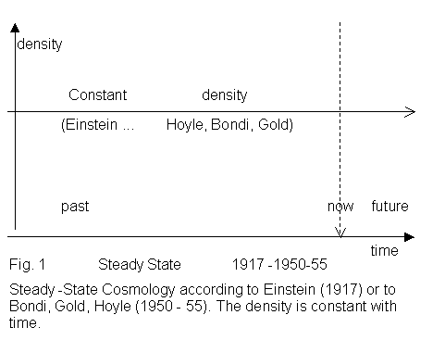
The apparent existence of the expansion led theoreticians like Aleksandr Friedman, in the USSR, and the Cannon Georges Lemaître, in Belgium, to solve the GR equations in a different way to Einstein, rejecting any idea of a "steady-state Universe". They reached models that were compatible with the observed expansion, which they admitted as real, and with the GR equations. And their main characteristic was a "singular" point, some 12-15 milliards of years in the past (with modern estimations of the observed data), a singular point at which time the density of the Universe was infinitely large.
George Gamow, and his colleagues Alpher and Herman, in the years 1945-54, suggested the idea that at such a very high density, the temperature must also be extremely high. During the fast initial expansion after ...Creation, the density decreases fast, as does the temperature. When the temperature becomes low enough, very quickly indeed, the mixture of elements created by the nucleosynthesis processes at very high temperatures, is, in a way, frozen-in (like in the process of the temper of steel, a process well-known to the metallurgists). So Gamow calculated the chemical elementary composition of the Universe from these considerations. He predicted also that the original temperature of the Universe, at the time of the freezing-in of the chemical elements, could be observed through the diffuse and diluted radiation present now in the Universe around us; this temperature could be equated to a small number of degrees Celsius in the absolute Kelvin scale of temperatures. That was a (rather imprecise!) prediction of a cosmic temperature, very low of course, but observable in the radio-astronomical domain, – the so-called "cosmic background radiation".
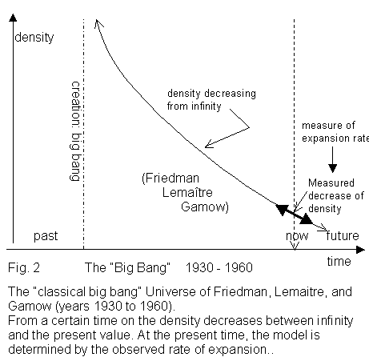
At that time, and we are back to Fred Hoyle, Fred considered this theory as a fantastic phantasm, probably for similar philosophical reasons to those which led Einstein to propose his own steady-state Universe in 1917. By derision, he coined the expression "big bang". You know: "Those crazy guys, and their crazy big bang!"...(not verbatim, of course ...but probably not far from it!). The expression made indeed the fortune of the theory. At that time, in 1951 and 1952, Pope Pius the XIIth expressed his conviction that the "Big Bang" was indeed a splendid solution, and he said it in more or less that way: "the "Big Bang" is nothing else but the "fiat lux"...!". I remember that in August 1952, the International Astronomical Union wasm eeting in Rome. On Sunday, we had a reception held by the pope at Castel Gondolfo, his summer residence. Some of us did not want to listen to the pope’s homily, and instead, took each other for a walk under the pleasant shadows of the olive trees, on the hills of the castle.... Four of us walked together, Dick Thomas (now deceased), Fred Hoyle, Évry Schatzman, and myself. We reconstructed the World in our own way... We were all beginners in astrophysics; Fred was the older. It was a few exciting hours, which I shall never forget.
But Hoyle would not stop at just a discussion under the olive trees. Together with Tommy Gold, and Herman Bondi, in Cambridge, they proposed a new theory for a Steady-State Universe, with constant density, illimited in the past as in the future, never created. The expansion was however real: but a continuous creation of matter was regularly replacing the matter gone away in the expansion. The model did not predict any residual temperature, any cosmic background radiation of the sky, as did Gamow.
In 1964, ten years after the predictions of Gamow, Arno Penzias and Robert Wilson discovered, almost without looking for it, the existence of that cosmic background radiation, at a value of 2.7 degrees Kelvin. This brought the proof that Gamow was right. Penzias and Wilson got the Nobel Prize. The Big Bang theory was now on the air, triumphant, and convincing. It accounted simply for the expansion, as measured, for the background radiation of about 3° Kelvin, as observed, and of the actual composition of the Universe (at the expense of some new calculations of nucleosynthesis, using better data than Gamow, and knowing that, in the stars, the chemical composition, except for the light elements, Hydrogen, Helium, Lithium..., is mainly built by the nucleosynthesis processes, during the stellar evolution, as described by BBFH, quoted above, – and not at some earlier phase).
Pope Pius XII and the Big Bang
In 1951, Pope Pius XII asserted that the Big Bang supported the long-standing and accepted doctrine of creation ex nihilo – creation from nothing – that was originally proposedby Tertullian in the 3rd century and developed to greater extremes by St. Augustine in the 4th century. Tertullian was a dualist who argued that as God was wholly good and divine as well as eternal and infinite he must have created the material world, that he considered evil and imperfect and therefore finite with a beginning and an end, from nothing, as he could not have created it from the perfection that existed before. In an address to the Pontifical Academy of Sciences Pius XII wrote: "In fact, it seems that present day science, with one sweeping step back across millions of centuries, has succeeded in bearing witness to that primordial ‘Fiat lux’ [let there be light] uttered at the moment when, along with matter, there burst forth from nothing a sea of light and radiation, while the particles of the chemical elements split and formed into millions of galaxies … Hence, creation took place in time, therefore, there is a Creator, therefore, God exists!" John Paul II has however shown more caution – in an address to the same group in 1988 he warned against "making uncritical and overhasty use for apologetic purposes of such recent theories as that of the Big Bang in cosmology." Despite this caution religious apologists have continued to push the Big Bang theory at the expense of other possibilities. IBM
-:-:-:-:-:-:-:-
But several authors were indeed not satisfied by that state of affairs. In the first place, the so-called cosmic background radiation had been actually predicted (much before Gamow!) by several scientists, Guillaume, Hertz, Regener, and even Eddington, on the basis of a steady-state Universe in equilibrium for an infinite duration. And predicted by them (in particular Eddington) with a better accuracy than Gamow! Another group, Zwicky, Findlay-Freundlich, and Max Born, in the early fifties, predicted the almost correct value of the temperature of the background radiation on a very different basis. They refused the reality of the expansion; they assumed that the "apparent" velocity was indeed the spectroscopic result of some interaction of the light coming from distant sources with the matter, or even the empty space, crossed by the light rays in their long travel. They thought of a "light-space" interaction, and they reached a rather good value for the cosmic background temperature. So the main argument for the big bang to have become the Big Bang, was really not any more valid. Unfortunately, most of the cosmologists refused to accept those arguments, and stuck to the Big Bang, a new dogma, unquestionable....They quickly found, as everyone else, its defects. So they repaired it. It is not any more a "simple" Big Bang. It is a scarred Big Bang, bristling with strange prostheses, such as the "inflation", occurring 10 ⁻⁴³ seconds after the bang, the bang itself occurring in an already existing (no Creation is any more imposed!) quantum Universe of which we know nothing,– such as the "grand unification" of elementary forces, an unification which is possible, but which has not been shown as being necessary, –such as the "super-symmetry (SUSY)", occurring before the grand unification, a phenomenon which is necessary in a way, but which is not based on any experimental result, – such as the theory of elementary particles, which is a fascinating exercise, looking like the numerological and geometrical phantasies of the ancient Pythagoreans. As said very convincingly by the Swedish Nobel Laureate Hannés Alfvén, "the big bang is a wonderful myth, like the creation of the World in seven days, or the cosmic egg of the Chinese tradition"(this quotation is done by pure memory, – hence not literal).
"To try to write a grand cosmical drama leads necessarily to myth.To try to let knowledge substitute ignorance in increasingly larger regions of space and time is science."
Hannes Alfvén.
So what is the solution? Is it this repaired Big bang, now without its singular point? Or is it some other solution?
For some time, Jean-Pierre Vigier and I, and some co-authors, have advocated a solution similar to that of Zwicky, assuming that the velocity of galaxies are apparent velocities and that the spectrum characteristics which led Slipher and followers to measure it are indeed instead the result of some still unknown interaction between light and space. I still think there may be some large amount of truth in these views, but, unfortunately, no laboratory experiment is really convincing, the observations conducted in the vicinity of our Sun are going in that direction, but with a very insufficient accuracy. The existence, demonstrated by Halton (Chip) Arp of "abnormal" red shifts, therefore of apparent velocities much larger than the true velocities and certainly not real, detected in the spectrum of "active" galaxies, has supported our point of view without any doubt. Unfortunately, in spite of hundreds of good and convincing cases, Arp was not successful in convincing the establishment that he was right.
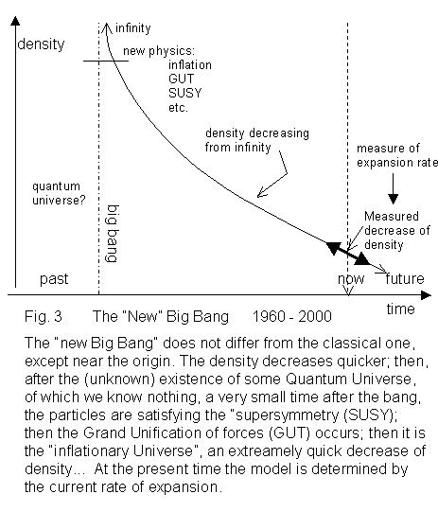
Another very promising and convincing view (which accepts Arp’s data) is that of Fred Hoyle and of his co-authors, now Geoffrey Burbidge, and Jayant Narlikar. They have published the elements of a "Quasi Steady-State Cosmology" (QSSC), which indeed appears as a very satisfactory solution, accounting well for the observed data, and obeying the laws of General Relativity. In the QSSC, there is an infinite number of oscillations between states of high density, – not as high as implied in the big bang! – and of low density, – not as low as implied by the future state of the Universe, according to the big bang theories. There is an alternance of periods of real expansion and of real contraction. At times of high densities, the chemical elements are formed and the cosmological background radiation too, during the expanding phase. One accounts easily, quantitatively, for the present composition of the Universe in elementary chemical elements, for the background temperature, for the expansion rate. One accounts for many other things as well, such as the hierarchical (or fractal) distribution of matter in the Universe. In this model, young matter is created in nuclei of active galaxies; and the light emitted by these nuclei is highly red shifted. This process is still not entirely convincing. But altogether, the QSSC theory holds water much better than does the Big bang. One may note that the authors propose several tests that are actually quite feasible in a not too distant future with the progress of deep field surveys of the sky.
Is it the end of the debate? Of course not. I have not spoken as yet of several bona fide cosmologies. Some (Segal and co-workers) imply a 5 dimensional space with two different times; some others think of complicated topological description of the geometry of the Universe. Some others want to account for the asymmetry of the Universe (our Universe is indeed made of matter; and antimatter is present only in large accelerators...) by astute geometries; again they propose testable proofs; and they seem to be quite correct in their findings. Other scientists speak of a multitude of small bangs, out of which we observe only one, in our vicinity; others propose that our Universe is not alone, sometimes connected, sometimes not, with other Universes. Etc. ..... Let us note that these theories are not necessarily completely contradictory either with the big bang models, or with the QSSC. Syncretic views are still possible. ...
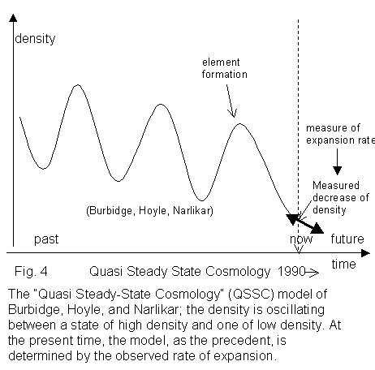
There are several questions that no model answers,– yet. For example, Einstein himself was not able to solve the GR equations in any other way than by assuming the so-called "cosmological principle" according to which the Universe is, at any point, at any time, isotropic, and homogeneous. The obvious astronomical experience shows that this is a complete illusion.? The density goes from 10¹³ grams per cubiccentimetre in the heart of the neutron stars to 10⁻²⁹ grams per cubic centimetre in the interstellar galactic space. Homogeneous? Absurd!...Still no one knows how to solve the equations when one wants to get rid of this principle of convenience!... The observations themselves are not giving all that should be necessary to reconstruct a good kinematical description of the Universe. One knows the radial velocities (away from us, or towards us); no one knows any transverse velocity (velocity in the direction perpendicular to the line of sight), even for close-by galaxies!....
So there is still much doubt, much work ahead of us. The big bang theories are there. So is the QSSC. So are others. For the time being, the big bang Cosmology is adopted by a large majority of scientists. But nobody can say that this will be true tomorrow. Actually, we are here on the margins of progressing science. Let us consider the physical world, the physical truth, as a gigantic ocean. It is full of admitted truth, which will stay as such, without endeavouring any major change in the coming times. At the margins, the waves, going up the dunes, going down on the marshes...There, there is some truth of course, as there is only one truth. But we still do not know precisely what it is. We know only that its search has to be done by some rational way, by a strict methodology, by several mathematical tools, by a good knowledge of physics. Some decades from now, the waves will cover and uncover other unknown parts of the world of knowledge; and by then, we shall know the solution to the problem (perhaps); but we shall face some more difficult problems, such as the one of the origin of life, probably. Science is always progressing at the margins, where there are some very natural hesitations. But the progress will continue; and the truth that is acquired will stay acquired. The aim of science is to learn, progressively, the unique and unambiguous truths that rule the natural world – and to discover the beauty of that unique truth.

Born in 1923, Jean-Claude Pecker is a leading scientist, author and rationalist in France is a member of the Academy of Humanism and an Honorary Associate of Rationalist International. He was Professor at Collège d’ France from 1964 to 1988 and Director of Institute of Astrophysics from 1972 to 1979. At present he is the General Secretary of International Astronomical Union and Secretary of the International Academy of Humanism. He has authored several books and hundreds of papers on astronomy, astrophysics, cosmology, human rights, pseudo-sciences, science & society and history of astronomy. Selected books: Le Ciel (1959), Astrophysique Générale (w. Schatzman 1959), Astronomie Expérimentale (1969), Les Laboratoires Spatiaux (1969), 1971, Papa, dis-moi, qu’est-ce que c’est que l’Astronomie (1971), Clefs pour l’Astronomie (1981), Sous l’Étoile Soleil (1984), Astronomie Flammartion (Dir.1986), Pour comprendre l’Univers (w.Delsemme & Reeves 1988), L’avenir du Soleil (1990), Le Promeneur du Soleil (1992), Le Soleil est une étoile (1992), 1999, Understanding the Heavens (1999). Honours and awards: Cmdr Légion d’honneur, Gd. Officer Ordre Nat. Mérite, Cmdr Palmes Acad.; Prizes: Forthuny (Ac.Sc.Paris), Manley-Bendall, Stroobant (Ac.Roy.Belgium), Jean Perrin (Soc.Fr.Phys.), Lodén (Astr.Soc. Uppsala, Sweden), Trois-Physiciens, Union Rationaliste, and others; Medals: Silver CNRS, Janssen (Soc.Astron.Fr.), Janssen (Soc.Fr. Photogr.), ADION medal and others.

