Fred Hoyle 1915-2001
http://en.wikipedia.org/wiki/Fred_Hoyle
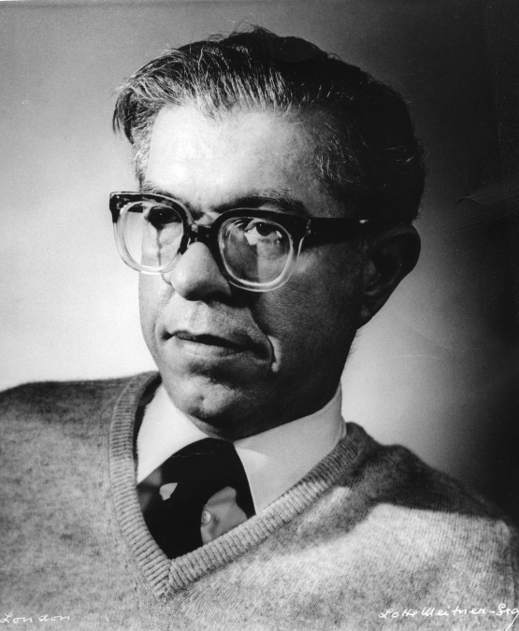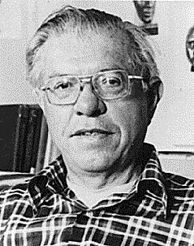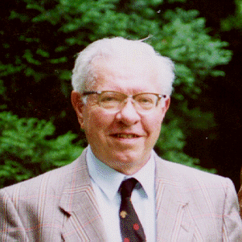

Sir Fred Hoyle (June 24, 1915 in Bingley, Yorkshire – August 20, 2001 in Bournemouth, England) was a British astronomer, notable for a number of his theories that run counter to current astronomical opinion, and a writer of science fiction, including a number of books co-authored by his son Geoffrey Hoyle. He spent most of his working life at the Institute of Astronomy at Cambridge, and was director of the institute for a number of years.

Contents
- 1 Contribution to cosmogony
- 2 Rejection of the big bang
- 3 Media appearances and scientific honours
- 4 Rejection of chemical evolution
- 5 Other controversies
- 6 Honours
- 7 Fiction works
- 8 Non-fiction works
- 9 Further reading
- 10 References
- 11 External links

Contribution to cosmogony
An early paper of his made an interesting use of the Anthropic Principle. In trying to work out the routes of stellar nucleosynthesis, he observed that one particular nuclear reaction, the Triple-alpha process, which generated carbon, would require the carbon nucleus to have a very specific energy for it to work. The large amount of carbon in the universe, which makes it possible for carbon-based lifeforms (e.g. humans) to exist, demonstrated that this nuclear reaction must work. Based on this notion, he made a prediction of the energy levels in the carbon nucleus that was later borne out by experiment.
However, those energy levels, while needed in order to produce carbon in large quantities, were statistically very unlikely. Hoyle later wrote:
Would you not say to yourself, "Some super-calculating intellect must have designed the properties of the carbon atom, otherwise the chance of my finding such an atom through the blind forces of nature would be utterly minuscule." Of course you would . . . A common sense interpretation of the facts suggests that a superintellect has monkeyed with physics, as well as with chemistry and biology, and that there are no blind forces worth speaking about in nature. The numbers one calculates from the facts seem to me so overwhelming as to put this conclusion almost beyond question.^{[1]}
An atheist, Hoyle said that this suggestion of guiding hand lead him to be "greatly shaken"^{[2]}. Scientists who advocate the intelligent design hypothesis sometimes cite Hoyle's work in this area to support the claim that the universe was fine tuned in order to allow intelligent life to be possible.
His co-worker William Alfred Fowler eventually won the Nobel Prize for Physics in 1983 (with Subramanyan Chandrasekhar), but for some reason Hoyle’s original contribution was overlooked, and many were surprised that such a notable astronomer missed out. Fowler himself in an autobiographical sketch affirmed Hoyle’s pioneering efforts:
The concept of nucleosynthesis in stars was first established by Hoyle in 1946. This provided a way to explain the existence of elements heavier than helium in the universe, basically by showing that critical elements such as carbon could be generated in stars and then incorporated in other stars and planets when that star "dies". The new stars formed now start off with these heavier elements and even heavier elements are formed from them. Hoyle theorized that other rarer elements could be explained by supernovas, the giant explosions which occasionally occur throughout the universe, whose temperatures and pressures would be required to create such elements.

[] Rejection of the big bang
While having no argument with Edwin Hubble's discovery that the universe was expanding, Hoyle disagreed on its interpretation. An atheist, he found the idea that the universe had a beginning to be philosophically troubling, as many argue that a beginning implies a cause, and thus a creator (see kalam cosmological argument) ^{[3]}. Instead, Hoyle, along with Thomas Gold and Hermann Bondi (with whom he had worked on radar in World War II), argued for the universe being in a "steady state". The theory tried to explain how the universe could be eternal and essentially unchanging while still having the galaxies we observe moving away from each other. The theory hinged on the creation of matter between galaxies over time, so that even though galaxies get further apart, new ones that develop between them fill the space they leave. The resulting universe is in a "steady state" in the same manner that a flowing river is - the individual water molecules are moving away but the overall river remains the same.
The theory was the only serious alternative to the Big Bang which agreed with key observations of the day, namely Hubble's red shift observations, and Hoyle was a strong critic of the Big Bang. Ironically, he is the one responsible for coining the term "Big Bang" in a BBC radio programme, The Nature of Things while criticising the theory; the text was published in 1950.
Hoyle, unlike Gold and Bondi, offered an explanation for the appearance of new matter by postulating the existence of what he dubbed the "creation field", or just the "C-field", which had negative pressure in order to be consistent with the conservation of energy and drive the expansion of the universe. These features of the C-field anticipated the later development of cosmic inflation. They jointly argued that continuous creation was no more inexplicable than the appearance of the entire universe from nothing, although it had to be done on a regular basis. In the end, mounting observational evidence convinced most cosmologists that the steady state model was incorrect and that the Big Bang was the theory that agreed best with observations, although Hoyle clung to his theory, mostly through criticizing the accuracy of astronomers' observations. In 1993, in an attempt to explain some of the evidence against the steady state theory, he presented a modified version called "quasi-steady state cosmology" (QSS), but the theory did not capture a significant audience.
The evidence that resulted in the Big Bang's victory over the steady state model, at least in the minds of most cosmologists, included the discovery of the cosmic microwave background radiation, the distribution of "young galaxies" and quasars throughout the Universe, a more consistent age estimate of the universe and most recently the observations of the COBE satellite, which showed that crucial disturbances in the early universe allowed for the creation of galaxies.

[] Media appearances and scientific honours
Hoyle appeared in a series of radio talks on astronomy for the BBC in the 1950s; these were collected in the book The Nature of the Universe, and he went on to write a number of other popular science books. He wrote some science fiction; most interesting is The Black Cloud in which it transpires that most intelligent life in the universe takes the form of interstellar gas clouds, who are surprised that intelligent life can form on planets, and a television series A for Andromeda. In 1957 he was elected a Fellow of the Royal Society, and he was knighted in 1972. He was jointly awarded the Crafoord Prize by the Royal Swedish Academy of Sciences which is comparable to a Nobel Prize and could be seen as amends for his being overlooked for the Nobel earlier.

[] Rejection of chemical evolution
In his later years, Hoyle became a staunch critic of theories of chemical evolution to explain the naturalistic Origin of life. With Chandra Wickramasinghe, Hoyle promoted the theory that life evolved in space, spreading through the universe via panspermia, and that evolution on earth is driven by a steady influx of viruses arriving via comets.
In his 1981/4 book Evolution from Space (co-authored with Chandra Wickramasinghe), he calculated that the chance of obtaining the required set of enzymes for even the simplest living cell was one in 10^{40,000}. Since the number of atoms in the known universe is infinitesimally tiny by comparison (10⁸⁰), he argued that even a whole universe full of primordial soup wouldn’t have a chance. He claimed:
The notion that not only the biopolymer but the operating program of a living cell could be arrived at by chance in a primordial organic soup here on the Earth is evidently nonsense of a high order.
Hoyle compared the random emergence of even the simplest cell to the likelihood that "a tornado sweeping through a junk-yard might assemble a Boeing 747 from the materials therein." Hoyle also compared the chance of obtaining even a single functioning protein by chance combination of amino acids to a solar system full of blind men solving Rubik's Cube simultaneously. [1]
These analogies have been rejected by biologists as a straw man argument. Richard Dawkins, for example, wrote in The Blind Watchmaker:
If he'd said 'chance' instead of 'natural selection' he'd have been right. Indeed, I regretted having to expose him as one of the many toilers under the profound misapprehension that natural selection is chance.
Dawkins seems though to have missed the point. Hoyle never rejected the workings of natural selection. But he noted that Darwinian theory requires that natural selection work on random mutations; and his point was that random mutation has an infinitesimal chance of producing anything workable for nature to select from.
The evolution of complex systems can occur by means of a ladder of stratified stability. The Nobel Prize-winning chemist Manfred Eigen (beginning in 1971 with an influential theoretical paper^{[citation needed]}) and his collaborators have considered in some detail how a genetic code could get going.

[] Other controversies
Further occasions on which Hoyle aroused controversy included his questioning the authenticity of fossil Archaeopteryx and his condemnation of the failure to include Jocelyn Bell in the Nobel Prize award recognising the development of radio interferometry and its role in the discovery of pulsars. Hoyle played an important role in determining the nature of the pulsing radio signals (from the pulsar), but was also excluded from the prize. Hoyle had a famous heated argument with Martin Ryle of the Cavendish Radio Astronomy Group about Hoyle's Steady State Universe which somewhat restricted collaboration between the Cavendish Radio Astronomy Group and the Institute of Astronomy during the 1960s.

[] Honours
Awards
- Gold Medal of the Royal Astronomical Society (1968)
- Bruce Medal (1970)
- Henry Norris Russell Lectureship (1971)
- Royal Medal (1974)
- Klumpke-Roberts Award of the Astronomical Society of the Pacific (1977)
- Crafoord Prize from the Royal Swedish Academy of Sciences, with Edwin Salpeter (1997)
Named after him
- Asteroid 8077 Hoyle

[] Fiction works
- The Black Cloud, 1957
- Ossian's Ride, 1959
- A for Andromeda, 1962
- Fifth Planet, 1963 (co-authored with Geoffrey Hoyle)
- Andromeda Breakthrough, 1965 (co-authored with John Elliott)
- October the First Is Too Late, 1966
- Element 79, 1967
- Rockets in Ursa Major, 1969 (co-authored with Geoffrey Hoyle)
- Seven Steps to the Sun, 1970 (co-authored with Geoffrey Hoyle)
- The Inferno, 10/1973 (co-authored with Geoffrey Hoyle)
- The Molecule Men and the Monster of Loch Ness, 1973 (co-authored with Geoffrey Hoyle)
- Into Deepest Space, 1974 (co-authored with Geoffrey Hoyle)
- The Incandescent Ones, 1977 (co-authored with Geoffrey Hoyle)
- The Westminster Disaster, 10/1978 (co-authored with Geoffrey Hoyle)
- Comet Halley, 11/1985

[] Non-fiction works
- Nicolaus Copernicus, Heinemann Educational Books Ltd., London, p. 78, 1973
- Astronomy and Cosmology: A Modern Course, 1975, ISBN 0-7167-0351-3
- Energy or Extinction? The case for nuclear energy, 1977, Heinemann Educational Books Limited, ISBN 0-435-54430-6. In this provocative book Hoyle establishes the dependence of Western civilisation on energy consumption and predicts that nuclear fission as a source of energy is essential for its survival.
- The Intelligent Universe, 1983
- Evolution from Space: A Theory of Cosmic Creationism, 1984, ISBN 0-671-49263-2
- Burbidge, E.M., Burbidge, G.R., Fowler, W.A. and Hoyle, F., Synthesis of the Elements in Stars, Revs. Mod. Physics 29:547–650, 1957, the famous B²FH paper after their initials, for which Hoyle is most famous among professional cosmologists.
- Hoyle, F., The big bang in astronomy, New Scientist 92(1280):527, November 19, 1981.
- Arp, H.C., Burbidge, G., Hoyle, F., Narlikar, J.V. and Wickramasinghe, N.C., The extragalactic universe: an alternative view, Nature 346:807–812, August 30, 1990.
- Home Is Where the Wind Blows: Chapters from a Cosmologist's Life (autobiography) Oxford University Press 1994, ISBN 0-19-850060-2
- Fred Hoyle, Mathematics of Evolution, (1987) University College Cardiff Press, (1999) Acorn Enterprises LLC., ISBN 0-9669934-0-3

[] Further reading
- Alan P. Lightman and Roberta Brawer, Origins: the lives and worlds of modern cosmologists, Harvard University Press, 1990. A collection of interviews, mostly with the generation (or two) of cosmologists after Hoyle, but also including an interview with Hoyle himself. Several interviewees testify to Hoyle's influence in popularizing astronomy and cosmology.
- Dennis Overbye, Lonely Hearts of the Cosmos: the scientific quest for the secret of the Universe, HarperCollins 1991, Back Bay 1999 (with new afterword). Very well-written (reads like a novel) biography-based account of modern cosmology. Complementary to Origins.
- Simon Mitton, Conflict in the Cosmos: Fred Hoyle's Life in Science, Joseph Henry Press, 2005, ISBN 0-309-09313-9 or, Fred Hoyle: a life in science, Aurum Press, 2005, ISBN 1-85410-961-8
- Douglas Gough, or, The Scientific Legacy of Fred Hoyle, Cambridge University Press, 2005, ISBN 0-521-82448-6
- Chandra Wickramasinghe, A Journey with Fred Hoyle: The Search for Cosmic Life, World Scientific Publishing, 2005, ISBN 981-238-912-1
- Jane Gregory, Fred Hoyle's Universe, Oxford University Press, 2005, ISBN 0-19-850791-7

[] References
- Ferguson, Kitty (1991). Stephen Hawking: Quest For A Theory of Everything. Franklin Watts. ISBN 0-553-29895-X.
- ^ Fred Hoyle, "The Universe: Past and Present Reflections." Engineering and Science, November, 1981. p 8-12
- ^ Gregg Easterbrook. Was Life Begun by Chance? Not a Chance. Beliefnet.com Accessed Sept. 22, 2006
- ^ Quentin Smith, A Big Bang Cosmological Argument For God's Nonexistence. Faith and Philosophy. April 1992 (Volume 9, No. 2, pp. 217-237

[] External links
- Obituary by Sir Martin Rees, Physics Today
- Obituary in The Guardian
==================================================================================================================================
END

