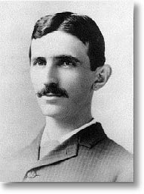
To the Smithsonian or Bust:
The Scientific Legacy of Nikola Tesla
by Zara Herskovits
http://www.yale.edu/scimag/Archives/Vol71/tesla.html

According to legend, the inventor who revolutionized electrical technology came into this world precisely at midnight as the sky was illuminated by a powerful lightning storm. From these prophetic beginnings, Nikola Tesla has since plunged into relative obscurity. Modern society has benefited greatly from the contributions of Tesla. Amongst his 111 patents, Tesla designed the first practical methods for generating alternating current, which has enabled the long-distance transmission of electricity. He created the "Tesla coil," a popular device for demonstrating high frequency and high voltage phenomena. He designed new electric lighting systems and incandescent lamps. Tesla also revolutionized the field of radio communications with his four-circuit transmitter/receiver and novel designs for intensifying and transforming signals. (v)
Yale University celebrated Tesla's accomplishments during his lifetime by awarding him an honorary Master's degree in 1894. Over a century later, Tesla is again being honored by Yale, with a bronze sculpture that graces the basement entryway of the Becton Engineering and Applied Science Center. The bust was presented to the University by John W. Wagner, a third grade teacher from Ann Arbor, Michigan, who initiated and coordinated a letter writing campaign to fund the sculpture. Mr. Wagner's students practiced their penmanship composing over one hundred letters to solicit donations from citizens and corporation leaders throughout the world. (v)
The man and his machines
Nikola Tesla was born between July 9 and 10, 1856, in the village of Smiljan, near the border of the Austro-Hungarian Empire. The inventor's father, Milutin Tesla, was sent to an Army officers' school, and later rebelled to become a cleric of the Serbian Orthodox Church. Milutin spoke several languages fluently, was a talented mathematician, and wrote socially progressive editorials published in the local newspapers. Nikola's mother, Djouka Mandic, was an expert needleworker who spent most of her time working around the family farm and caring for her five children. Although she was illiterate, Djouka had a photographic memory and was able to quote entire volumes of European poetry and Biblical passages. She also invented tools around the house and would spin her own thread from plants that she had grown. Nikola Tesla credited his mother for many of his own abilities, believing that he had inherited her industriousness and inventiveness. (ii)
At the ripe old age of five, Tesla invented his first motor. This device was powered by sixteen hapless insects who were glued to the propellers. However, a local boy who enjoyed eating live June bugs quickly put a stop to this promising field of research. The June bug power project was abandoned when the young inventor began throwing up. (ii,vii)
As a child, Tesla enjoyed writing poetry and getting into trouble around the family farm. In one household misadventure, he was attacked by the gander, a powerful barnyard enemy. Young Tesla was also in the habit of riding the family cow as if it were a pony, and once fell from its back. This incident was not nearly as disastrous as his attempt to glide from the barnyard roof with a parasol. The youthful scientist nearly drowned on several occasions, most notably when he fell headlong into a large vat of milk and was almost boiled alive.(ii,vii)
Milutin insisted that Nikola Tesla should join the ministry, despite his son's interest in engineering. In 1874, Tesla fell ill with cholera and was bedridden for nine months. At this point, Tesla struck an unusual bargain with his father, suggesting that he might regain his health if allowed to pursue engineering. His father ultimately consented and urged Tesla to spend the next year recovering in the mountains so that he could avoid the compulsory military draft before matriculating at a university. Some of Tesla's more obscure inventions, such as a method for rapid travel that would necessitate the construction of a stationary elevated ring encircling the earth like a donut, were created during this period of rehabilitation.(ii)
When Nikola entered the Polytechnic School in Graz, he studied 20 hours a day, reading and memorizing works by Descartes, Goethe, Spencer, and Shakespeare. Although he earned straight A+ grades during his first semester and was able to speak nine languages, Tesla never graduated from the Austrian Polytechnic School. By his third year, Tesla was gambling heavily and was not granted an extension when he was unprepared for his final exams. He continued his studies at the University of Prague until forced to support himself financially. In 1881, Tesla was hired by the Hungarian government as a draftsman and designer for the Engineering Department at the Central Telegraph Office, and he used his own salary to further his experiments. Tesla began working on the problem of how to harness alternating current during his years in college and persisted for many years before conceptualizing a solution.(ii,vii)
During these early years of his career, Tesla invented an amplifier to enhance transmission signals in the induction-triggered carbon disk speaker of the telephone, an improvement he designed while working for the American telephone exchange in Budapest. During this period, Tesla also designed reversible clothing, a disastrous experiment conducted when he did not have enough money to purchase a new suit. Tesla did not patent either of these inventions.(ii)
In 1882, Tesla was hired by the Continental Edison Company in Paris to troubleshoot their mechanical and electrical problems.ii, He built the first alternating current motor in the closet of a secret mechanical shop, and was mortified when wealthy investors didn't immediately share his enthusiasm over this revolutionary device. Tesla became interested by the promise of greater opportunities in the United States, so he secured a job redesigning dynamos for the Edison Light Company in New York.(ii)
Nikola Tesla arrived in America in 1884 carrying four cents in his pocket and a few valued possessions - a packet of poems, articles, and calculations of unsolvable integrals. During his first year, Tesla redesigned twenty-four types of standard machines for Edison's company, working from 10:30 a.m. until 5 a.m. the next morning for successive days throughout the week , His manager had promised a bonus of $50,000 for this work; however, this agreement was never put in writing. When Tesla demanded payment upon completion of the tasks, he was told, "You are still a Parisian. When you become a full-fledged American, you will appreciate an American joke."ii Tesla was not amused, and promptly resigned his position.(x)
During the following year, Tesla began patenting his own innovations and formed the Tesla Electric Light & Manufacturing Company. Despite Tesla's success in designing a municipal arc lighting system, investors forced the inventor to leave his own company in 1886, leaving Tesla bankrupt with only a decoratively engraved stock certificate. Tesla was understandably insulted, and with no other means of supporting himself, was forced to spend the winter digging ditches. Fortunately, his engineering prowess impressed the construction foreman, who introduced Tesla to a different enclave of engineers and financiers. With the aid of these new contacts, Tesla secured the monetary backing to build his own laboratory for designing alternating current machinery. He was finally able to build working models and begin patenting his motors, generators, transformers and systems for utilizing electric power. George Westinghouse saw great potential in Tesla's ideas and purchased his alternating current patents, bringing the inventor to Pittsburgh to develop his motors for commercial use.(vii,ix)
The war between Edison's direct current (DC) scheme and Tesla's alternating current (AC) system became increasingly galvanized during the 1880s, due to the significant capital invested in developing new methods of powering the nation's growing industrial sector. Edison initially attempted to protect his commercial interests by lobbying the New York state government to limit electrical current to 800 Volts, which would render the competing system of alternating current illegal. When Westinghouse countered this political maneuver with a threat of direct litigation, Edison switched tactics and began a propaganda war to sway public opinion against alternating current. He initiated mass demonstrations in which animals were electrocuted by alternating current, and arranged to power the electric chair in New York's Auburn State prison with an alternating current generator in order to brand AC as "the executioner's current."vii,viii Westinghouse responded by publicly citing facts and statistics to promote the safety of alternating current, encouraging other respected scientists to assist in these educational efforts.vii Westinghouse gained an advantage in this battle for public opinion when he underbid Edison and secured the contract to supply the Chicago World's Fair of 1893, the first World's Fair to be powered by electricity. Introducing alternating current in this international forum was an ingenious means of gaining acceptance for alternating current technology. The success of AC at the Chicago World's Fair impressed the International Niagara Commission and Westinghouse was awarded a contract to build the first generators at Niagara Falls using Tesla's polyphase system. The Niagara Falls hydroelectric plant not only provided energy for lighting homes, running trolley cars and replacing steam engines, but also fueled the new electrometallurgical and electrochemical industries, ushering in the age of modern electrical power.viii,ix
During the 1890s, Tesla developed the apparatus and circuits used for wireless communication. In addition to designing circuitry, he had the foresight to conceptualize how this technology might be applied as a means of communicating world news and other messages. When Guglielmo Marconi, who is often cited as the inventor of radio, publicly demonstrated signal transmission across the Atlantic in 1901, Tesla sarcastically remarked, "Let him continue. He is using seventeen of my patents."viii, The issue of intellectual property in the field of radio worked its way through the courts for decades. In 1943, nearly six months after Tesla's death, the Supreme Court declared Marconi's patent invalid because the wireless technology it described was predated by the work of Sir Oliver Lodge, John Stone, and Nikola Tesla.iii
Tesla also invented an oscillation transformer with its primary and secondary coils tuned to resonance, which allowed currents of high voltage and high frequency to be produced. This device, called the "Tesla Coil," became part of the standard equipment in nearly every college physics laboratory throughout Europe and America. Tesla's original purpose in designing this apparatus was to develop a more efficient electric light, which he believed would be accomplished by passing high frequency currents through a gas-filled tube. Over the next decade, he designed over fifty variations of this coil, systematically modifying the configuration, insulators, and windings to maximize efficiency. In 1899, Tesla relocated to Colorado Springs and built an enormous coil to experiment with a novel method of transmitting wireless power.ix The El Paso Electric Company agreed to provide Tesla's new facility with free electrical power, a promise they likely regretted when his oscillation transformer produced 135 foot bolts of manmade lightning and short-circuited the entire town of Colorado Springs.ii
Tesla also became interested in the design of automated and remote control devices, a field that he termed "telautomatics." In 1897, he built two radio-controlled model boats that could be steered and made to fire explosives from a distance. One of the prototype models employed intricate control features such as a system to prevent interference and a loop antenna so the vessel could operate beneath water. Tesla foresaw the utility of these innovations as powerful weapons that could be of interest to the U.S. Navy.ix
Tesla was filled with a boundless energy throughout his life and was described by friends as "a vegetarian that doesn't know how to vegetate."ii He continued working on problems throughout the night, sleeping between the hours 5:30 a.m. and 10:30 a.m. even at the age of 75.xi
Tesla spent his later years alone living in various New York hotels and feeding the pigeons of New York City. When maids at the St. Regis hotel complained about Tesla's companions, the four pigeons nesting in the desk of his hotel room, Tesla moved.xi Although he could have become wealthy from his inventions, Tesla was not interested in financial matters. He once remarked to his close friend and biographer Kenneth Swezey, "I will never have any money unless I get it in amounts so large that I cannot get rid of it except by throwing it out the window!"ix,xiii
Toward the end of Tesla's life, the inventor's experimental concepts became increasingly fantastic. On his seventy-eighth birthday, Tesla described a new "death beam" apparatus that could destroy 10,000 planes from a distance of 250 miles and defeat armies of millions via the transmission of concentrated particle beams. He envisioned using this death beam to create an invisible defensive wall to protect national borders. Tesla stated that this work was based on entirely new principles of physics, but refused to explain any of the theories, insisting that experts would have to trust him.
In 1937, Tesla was hit by a taxi and refused medical treatment, stubbornly maintaining that if he kept moving after the accident, it would prevent his blood from clotting. He never fully recovered from this incident and became increasingly reclusive in his final years, rarely leaving his room in the Hotel New Yorker. In 1943, at the age of 86, Nikola Tesla died in his sleep, bequeathing a legacy of innovation that has immeasurably advanced the progress of humankind. After his death, the Federal Bureau of Investigations, the Office of Alien Property, and the War Department impounded Tesla's papers on advanced weapons systems, and much of this information has yet to be released.ii
The Man and the Mystery
Considering the profound influence of Nikola Tesla's inventions on modern society, it is mysterious that Tesla is not as recognized as some of his contemporaries. John Wagner, the school teacher from Ann Arbor, Michigan, who mobilized his third grade classes to raise thousands of dollars in funds to create the commemorative bronze bust of Tesla, attributes this to "a deliberate assault on factual history" propagated by institutions such as the Smithsonian museum.vi This observation was corroborated by the testimony of Senator Carl Levin, who remarked in an address to then-president George H.W. Bush:
Nikola Tesla has not been granted his proper place in history. In the Smithsonian Institution, for example, Mr. Edison's inventions are justifiably well represented. However, although the museum has included Mr. Tesla's alternating current generators in their exhibit, no mention is made of Mr. Tesla. In fact the generator is included as part of the Edison exhibit.
Mr. Wagner notes that Edison's bust is not only situated near Tesla's first AC motor/generator, but also "Tesla's U.S. patent number appeared on the motor/generator, [and] ... the display was arranged in such a way as to give credit to Edison."vi He writes that the Tesla exhibit, a small glass show-case containing some of his personal artifacts in a darkened hallway near the men's room, was only created due to recent congressional pressure.(vi,xiv)
According to Mr. Wagner, Nikola Tesla has also been omitted from the Smithsonian museum's educational texts, despite his numerous contributions to modern electrical technology. The Smithsonian Book of Invention describes innovators such as Charles Goodyear and Thomas Edison in addition to popular culture figures such as Archie Bunker and Colonel Sanders, but fails to even mention Nikola Tesla. Smithsonian's Visual Timeline of Inventions is not significantly better, detailing inventions such as the Rubik's cube, the electric toothbrush, and the pop-up toaster, but failing to list the AC motor. Further, this book credits the invention of radio to Guglielmo Marconi, despite the Supreme Court ruling in favor of Tesla's patents. On his web page, Wagner accuses the Smithsonian of presenting "distorted history," suggesting that the electrical innovations of Edison are held above those of Tesla due to contributions from the Edison foundation to the Smithsonian.(vi)
It is not inconceivable that a national institution like the Smithsonian Museum could be subject to such corporate pressures, since such private sector involvement has gained increasing prominence at the museum. Corporations are now allowed to display their logos at exhibit entrances and are occasionally granted floor space for exhibitions. While Michael Heyman, the current Smithsonian secretary, denies that sponsors can dictate the content of an exhibit, some curators have complained off the record that content for a recent Spirit of America exhibition was imposed on them. According to another report, corporate sponsors were directly involved in the planning, execution and marketing of the Ocean Planet exhibit that was opened in 1995. Further research would be necessary to determine whether similar factors influence how the museum has historically presented the work of Edison and Tesla.
Mr. Wagner initiated the letter writing campaign to restore Nikola Tesla to his rightful place in the historical record. When his class attempted to donate the statue of Tesla to the Smithsonian Museum, their offer was rejected. This bust recently found a home at Yale University, one of the first institutions to honor Tesla for his work. Nikola Tesla was born into the world during an electrical storm, and left our generation with the scientific legacy of an electrical revolution.(xiv)
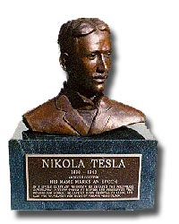
In memoriam Nikola Tesla: The inscription underneath his bust reads: "In a single burst of invention he created the polyphase alternating current system of motors and generators that powers our world. He gave us every essential of radio, and laid the foundation for much of today’s technology."
REFERENCES
i) Waters HB. Nikola Tesla, Giant of Electricity. New York: Crowell, 1961.
ii) Seifer MJ. Wizard: The Life and Times of Nikola Tesla Biography of a Genius. New Jersey: Carol Publishing Group, 1996.
iii) Glenn J (editor). The Complete Patents of Nikola Tesla. New York: Barnes and Noble Books, 1994.
iv) Martin TC. Inventions, Researches and Writings of Nikola Tesla. Hollywood, CA: Angriff Press: 1981.
v) Efforts of Schoolchildren Bring Honor to Inventor who Helped 'Power Our World' Yale Bulletin and Calendar. April 1997; 25(33). Available at: http://www.yale.edu/opa/ybc/v25.n33.news.05.html Accessed April 25, 2002.
vi) Wagner J. Nikola Tesla 1856-1943 Forgotten American Scientist. Available at: http://www.concentric.net/~Jwwagner/ Accessed: April 25, 2002.
vii) Cheney M. Tesla: Man Out of Time. New Jersey: Prentice-Hall, Inc., 1981.
viii) Hall SS. Tesla: a scientific saint, wizard or carnival sideman? Smithsonian. June 1986; 71: 120-131 Available at: Biography Resource Center, New York Public Library.
ix) Swezey KM. Nikola Tesla. Science. May 16, 1958; 128(3307):1147-1159.
x) Tesla N (edited by Ben Johnston). My Inventions: The Autobiography of Nikola Tesla. Williston, Vermont: Hart Brothers, 1982.
xi) Tesla at 75. Time Magazine. July 20, 1931;18(3): 27-30.
xii) Tesla, at 78, Bares New 'Death-Beam' The New York Times. July 11, 1934; col. 1, p18.
xiii)Nikola Tesla Dies; Prolific Inventor." The New York Times. January 8, 1943; col. 1, p19.
xiv) The Congressional Record. Tuesday July 10, 1990; 136(86): H4455-H4456 and S9311-S9312.
xv) Zengerle J. The New Republic. October 20, 1997; 217(16):18-19.
xvi) Hansen L. Profile: Ethical debate surrounding museums receiving gifts and donations from corporations and sponsors. All Things Considered (NPR) February 5, 2002. Available at: Newspaper Source Database, New York Public Library.
xvii) Jackson RL. Smithsonian Flows With Corporate Tide." Los Angeles Times. June 6, 1995; col. A1, p5.

Title: The Man Who Invented The Twentieth Century
http://www.viper69.freeserve.co.uk/blackstar/rev-0052.html
Author/Artist: Robert Lomas
Publisher: Headline
Media: Book
Reviewer: Pan
This pop-biography of Nikola Tesla - 'forgotten genius of electricity' - aims to remind us of one of the modern world's great inventors. Contrary to what the author believes, Tesla has not been forgotten by everybody but electrical engineers. Tesla's name also has a special places in the hearts of conspiracy theorists and alternative historians everywhere.
Tesla's long and eventful life had enough material to furnish a dozen conspiracy theories. A vastly intelligent and idealistic man, he was ripped off again and again by the likes of Thomas Edison, George Westinghouse and JP Morgan. Tesla was the inventor who made AC current the basis of the modern electricity supply industry, who invented radio years before Marconi, who perfected the steam turbine and more. The mysteries of the profit motive, however, failed him.
He dreamed of supplying free power for all, without the need for expensive sub-stations, pylons, transformers and cables and all of the other equipment now in use. In his experiments he had shown that it was possible to harness the earth's electro-magnetic field to transmit AC power through the atmosphere. Suitable receiving equipment could be used to capture this transmitted power in the home. The promise really was of free electrical power for all.
Of course this scheme attracted the attention of the American electricity supply industry, already an extremely powerful force thanks to the work Tesla had done in making AC power a practical proposition - in the process of making them powerful he had, of course, been ripped off mercilessly. If Tesla's free power scheme took off then over-night the investment of men like Edison, Westinghouse and the capitalists headed by Morgan, would have been rendered worthless. So, once more exploiting Tesla's complete lack of business acumen, they bought his patents then starved him of funds so that he'd have no way of completing his work.
Portrayed in the popular press of as the archetypal 'wacky' inventor, it was easy to let him rant and rave in public, ensuring that eventually few people would take him seriously. In time he lapsed into obscurity, and when he died in 1943 his body lay undisturbed for two days. Penniless and alone, he died an almost forgotten figure.
The US government did not forget him. On his death the FBI impounded all his writings, afraid that they contained countless secrets of military value - including a 'death ray' that eventually was used as the basis of Reagan's 'star wars' project.
Tesla's inventions and his theories were so far ahead of their time as to have been viewed as little more than science fiction. But he was right on most things, and even when he disagreed with Einstein about a theory of gravity it seems that Tesla was closer to the truth than Einstein.
The dream of free and universal power is still just a dream. There's no money in it, that's the bottom line.
Despite the interesting story to be told, it has to be said that this isn't the definitive Tesla biography that I had hoped for. The writing is repetitive and conveys little of the excitement of Tesla's life and his inventions. The science has been stripped to a bare minimum and the patronising tone means that the book reads like it was written for a bunch of pre-teens. Far from risking alienating his readers by going into too much scientific detail, Robert Lomas has gone to the other extreme and risks alienating readers by adopting a patronising and simplistic tone at times.
Hopefully, however, the book will serve to rekindle interest in Tesla, and so may result in a more detailed biography at some point in the future.

Welcome to the Tesla Memorial Society of New York
http://www.teslasociety.com/
This website contains important documents and photos about Nikola Tesla, Albert Einstein, Michael Pupin, Mileva Maric (Einstein's wife), Stanford White (Tesla's friend), Dr. George Papanicolaou, and Robert Underwood Johnson (Click on the names for more information). This website is our contribution to science, history and the memory of those geniuses.
Who's Tesla?

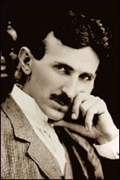
Nikola Tesla (1856-1943) was the genius who lit the world, whose discoveries in the field of alternating polyphase current electricity advanced the United States and the rest of the world into the modern industrial era.
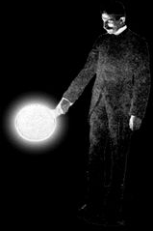
Nikola Tesla had 700 patents in the US and Europe. Tesla's discoveries include the Tesla Coil, fluorescent light, wireless transmission of electrical energy, radio, remote control, discovery of cosmic radio waves and use of ionosphere for scientific purposes.
Nikola Tesla was a New Yorker, who lived and worked in New York City almost 60 years and died at Hotel New Yorker, in Manhattan, on January 7, 1943.
We here at the Tesla Memorial Society of New York want the world to know of Tesla. Tesla's impact on our civilization is tremendous, and his memory should be kept alive.
In 1917, Tesla was awarded the Edison Medal, the most coveted electrical prize in the United States.
Nikola Tesla's name has been honored with an International Unit of Magnetic Flux Density called "Tesla".
The United States Postal Service honored Tesla with a commemorative stamp in 1983.
Tesla was inducted into the Inventor's Hall of Fame in 1975.
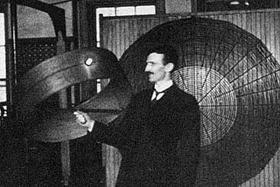
The Nikola Tesla Award is one of the most distinguished honors presented by the Institute of Electrical Engineers. The award has been given annually since 1976.
The Nikola Tesla Award is presented annually since 1968, at the Area Power Conference, Duluth, Minnesota. The award is furnished by Siemens Westinghouse Power Corporation.
The Nikola Tesla Statue is located on Goat Island to honor the man whose inventions were incorporated into the Niagara Falls Power Station in 1896. Tesla is known as the inventor of the polyphase alternating current.
The Nikola Tesla Corner Sign located at the intersection of 40th Street and 6th Avenue in Manhattan, is a constant reminder to all New Yorkers of the greatness of this genius.
Many of the new technologies in the world today, are based on Tesla's ideas. Tesla spent 50 years of his life to find a way for interplanetary communications, especially with Mars. He is the first scientist in the world to use the Ionosphere for scientific purposes (The Ionosphere is the upper part the atmosphere under constant bombardment of solar energy, which breaks down molecules into ions causing an ionized shield of our atmosphere, very important for radio communications).
Nikola Tesla is a unifying force for the people of the Balkans, and the people of the previous Austro-Hungary Empire (an area of Europe devoted to science and progress). Every child in the Balkans knows about Tesla.
The Tesla Memorial Society of New York is proposing that Tesla's birthday, July 10th, be proclaimed by the United Nations "Nikola Tesla Day". This day will signify a day of science, cosmos explorations, and brotherhood among nations and religions around the world.
We are asking all Tesla admirers and all governments around the world to support the idea of "Nikola Tesla Day".

Lost Tesla Papers about the "Death Rays"
- Click here for Nikola Tesla interview in the New York Time about the "Death Rays"

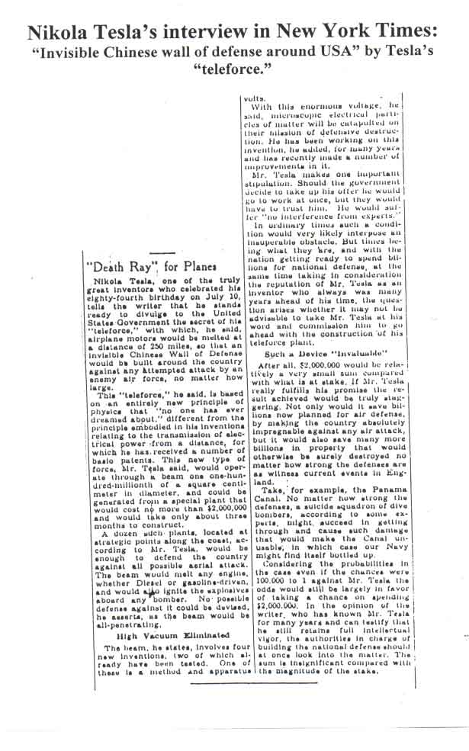
Nikola Tesla died on January 7th, 1943 in Hotel New Yorker, in Manhattan, in room 3327 on the 33rd floor of the hotel. Immediately after Tesla’s death, Tesla scientific papers vanished from his hotel room in Hotel New Yorker. Tesla papers were never found. Tesla papers contained scientific data and information about “Death Rays”, which could be used for military purposes.
In 1947 the Military Intelligence service identified the writings about the particle-beam contained in Tesla’s scientific papers as “extremely important.” Military intelligence services of the USA, Germany and USSR were vitally interested in Tesla’s “Death Rays”.
The current beam-weapon program is originated from Tesla’s “Death Rays” idea.
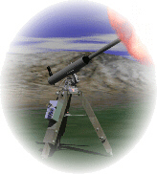
Tesla claimed of having invented a “death ray” capable of destroying 10,000 enemy airplanes at a distance of 250 miles (400 kilometers).
On July 23, 1934 Time Magazine wrote an article about Tesla’s Ray:
“Last week Dr. Tesla announced a combination of four inventions which would make war unthinkable.
Nucleus of the idea is a death ray-a concentrated beam of sub-microscopic particles flying at velocities approaching that of light. The beam, according to Tesla, would drop an army in its tracks, bring down squadrons of airplanes 250 miles away. Inventor Tesla would discharge the ray by means of 1) a device to nullify the impeding effect of the atmosphere on the particles 2)a method for setting up high potential 3) a process for amplifying that potential to 50,000.000 volts; 4) creation of “a tremendous electrical repelling force.”

Tesla “Death Rays” are laser beams
Laser beams are special sorts of electro-magnetic waves, a special sort of light.
The white light or daily light is a mixture of different length of waves. White light is a mixture of many colors which can be separated. Red light has long waves whereas blue light has short waves.
The waves making up a laser beam are quite different. Not only are all the waves the same length, but they are lined up so that the tops (peaks) of the waves coincide with each other.
Laser beams can be concentrated into a tiny point. They have tremendous energy.
Laser beams can produce enough heat to turn a metal into a vapor! They are accurate cutting tools that can even cut diamond, the hardest substance known to man. Laser beams are powerful enough to cut through metal in military operations, a laser beam can be bounced off a target such as an enemy airplane or ship to determine its distance and speed. Laser gyroscopes (guidance devices) are being develop to direct bombs and artillery shells to their target.
Today, laser beams are used also in medicine: for microsurgery, in delicate brain surgery and for coagulation of bleeding vessels into the eye structure of retina. They are also used to treat detached retina. The laser “knife” is completely steril and seals small blood vessels as it cuts, minimizing tissue bleeding.

Dr. Nikola Tesla
Monday 22nd November 1999
altered July 2000
http://www.rocknroll.force9.co.uk/science/tesla.htm

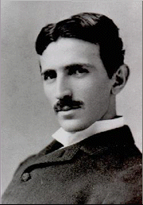
Dr. Nikola Tesla, was a Serb,
born in Croatia in the Balkans in 1857 and lived until 1943
He was one of the greatest innovators and pioneers of the modern age, However his achievements are largely forgotten by the public at large, he isn't as well known as Marconi or Edison, who he worked with. A great many myths have come to light about the man in recent years, as with a mysterious tale as his is, it is ripe for such treatment.
A. C. Electric Power
His most celebrated achievements are in the field of electricity in the 1880's, when in his 30's, where he first proposed A. C. ( alternating current ), which meant that electricity could be used commercially for power distribution. He also perfected the A. C. motor. Which is much smaller than the D. C. motor of the same power, and synchronous, which means it runs at a fixed speed.
The transmission of electrical power is fundamental to modern life. It could not be done feasibly, using Direct Current ( D. C. ) because the current loss would be too large. But before the advent of A. C. the only way to get domestic electrical power would have been Battery cells, or a massive, and noisy dynamo ( with engine ! )
He invented everything from step up and down transformers, rectifiers ( to convert a. c. back to d. c. ), A. C. Generators, The electrical condenser ( now called a capacitor ), High frequency generators, and such a great deal of work on electrical coil devices, and magnetics, that we use the unit Tesla for the S. I. unit for magnetic flux density. His invention of the Tesla Coil, which uses an air core, and a secondary winding that is tuned to the resonant frequency of the first, is used in the petrol engine, to generate the spark plug's very high voltage spark.
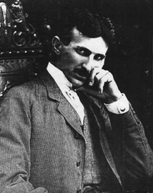
The Great Radio Controversy
He invented Wireless radio, but Guglielmo Marconi was given the credit until June 1943, when The U. S. Supreme Court finally settled the matter, after 16 months of investigating patent records and scientific publications, and declared that Nikola Tesla was the true inventor of modern radio technology. This was known as the Great Radio Controversy. Unfortunately, most school children are still taught that it was Marconi, which shows how simple it is for us to regurgitate uncorroborated legends, without checking on the up to date facts.
The Flying Machine
Later in the 1890's he turned his attention to motive power, he was attempting to make an electric vehicle that would enable the first powered flight possible, but he was beaten to this goal by the internal combustion petrol engine. However after this disappointment, he switched his thinking to viscosity and fluids, to see if he could improve the approach of mechanical engines like the petrol engines.
He came up with a simple device that could be used as an engine or turbine, which is now known as The Tesla Engine. This was installed in the first hydro electric power station, at Niagara falls. Dr. Tesla produced a scientific paper in September 1911 announcing the discovery to the technical world. Later he modified his design to be used in many different applications, including - a very efficient motor engine, a fluid flow gauge, an air conditioning unit and a water pump.
Patent
Over 42 years, until he was 71, he was granted over a hundred patents with the U. S. patent office. After this time, it is said that he was a consultant with the U. S. government, during this time was when some perculiar/controversial experiments were alleged to have been carried out.
Myth or Mystery ?
Famously, the Hollywood movie, " The Philadelphia Experiment ", dealt with the so called " black project ", The Philadelphia Project. This is alleged to have been dealt with all manor of bizarre concepts including Teleportation and Time Travel, but the myth and mystery has been propagated for so long, that it has become a favorite among conspiracy theorists, and it is difficult to know what it was really about. However it is known that Dr. Tesla's equipment and concepts were used, perhaps only to try to demonstrate electrical power supply and transmission through air to a remote place, or vehicle, a concept which he was known to be interested in.
A Pauper's Grave
Sadly, all too many brilliant people die alone and destitute, often unrecognized for their genius until years later. Nicola Tesla died Jan 1943, he was lonely and penniless in a New York hotel room. The United States Alien Property Office seized all his notes and papers. It's funny how real life never ends like a Hollywood Film.

Dr. Nicola Tesla's notes and papers are now housed in in the Nicola Tesla Museum in Belgrade, Yugoslavia.

Dr. Nikola Tesla
A Man Out Of Time

