Tesla healing devices rediscovered. Own a hundred year old marvel
Clive de Carle clive@clivedecarle.com The Secret Health Club
Date: 15 September 2021
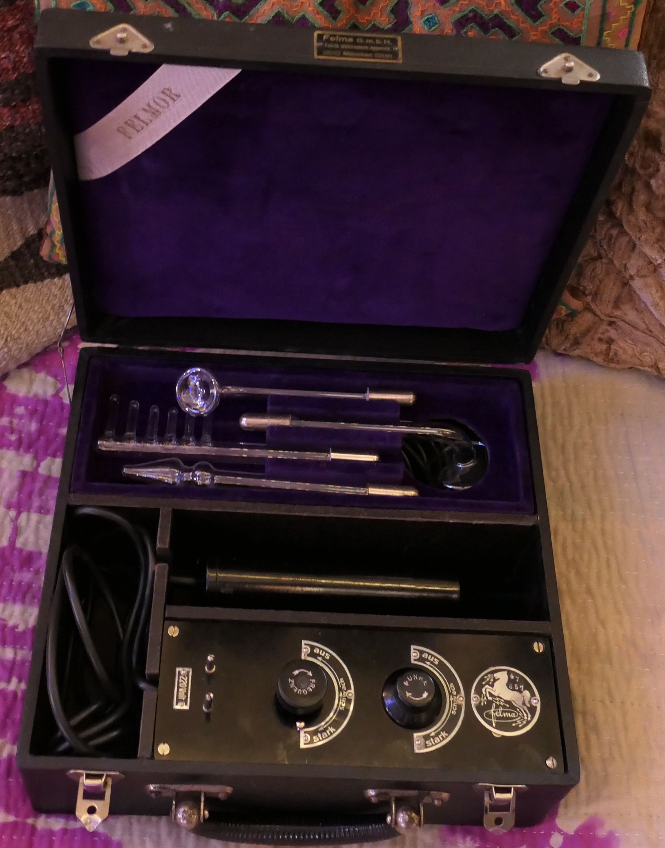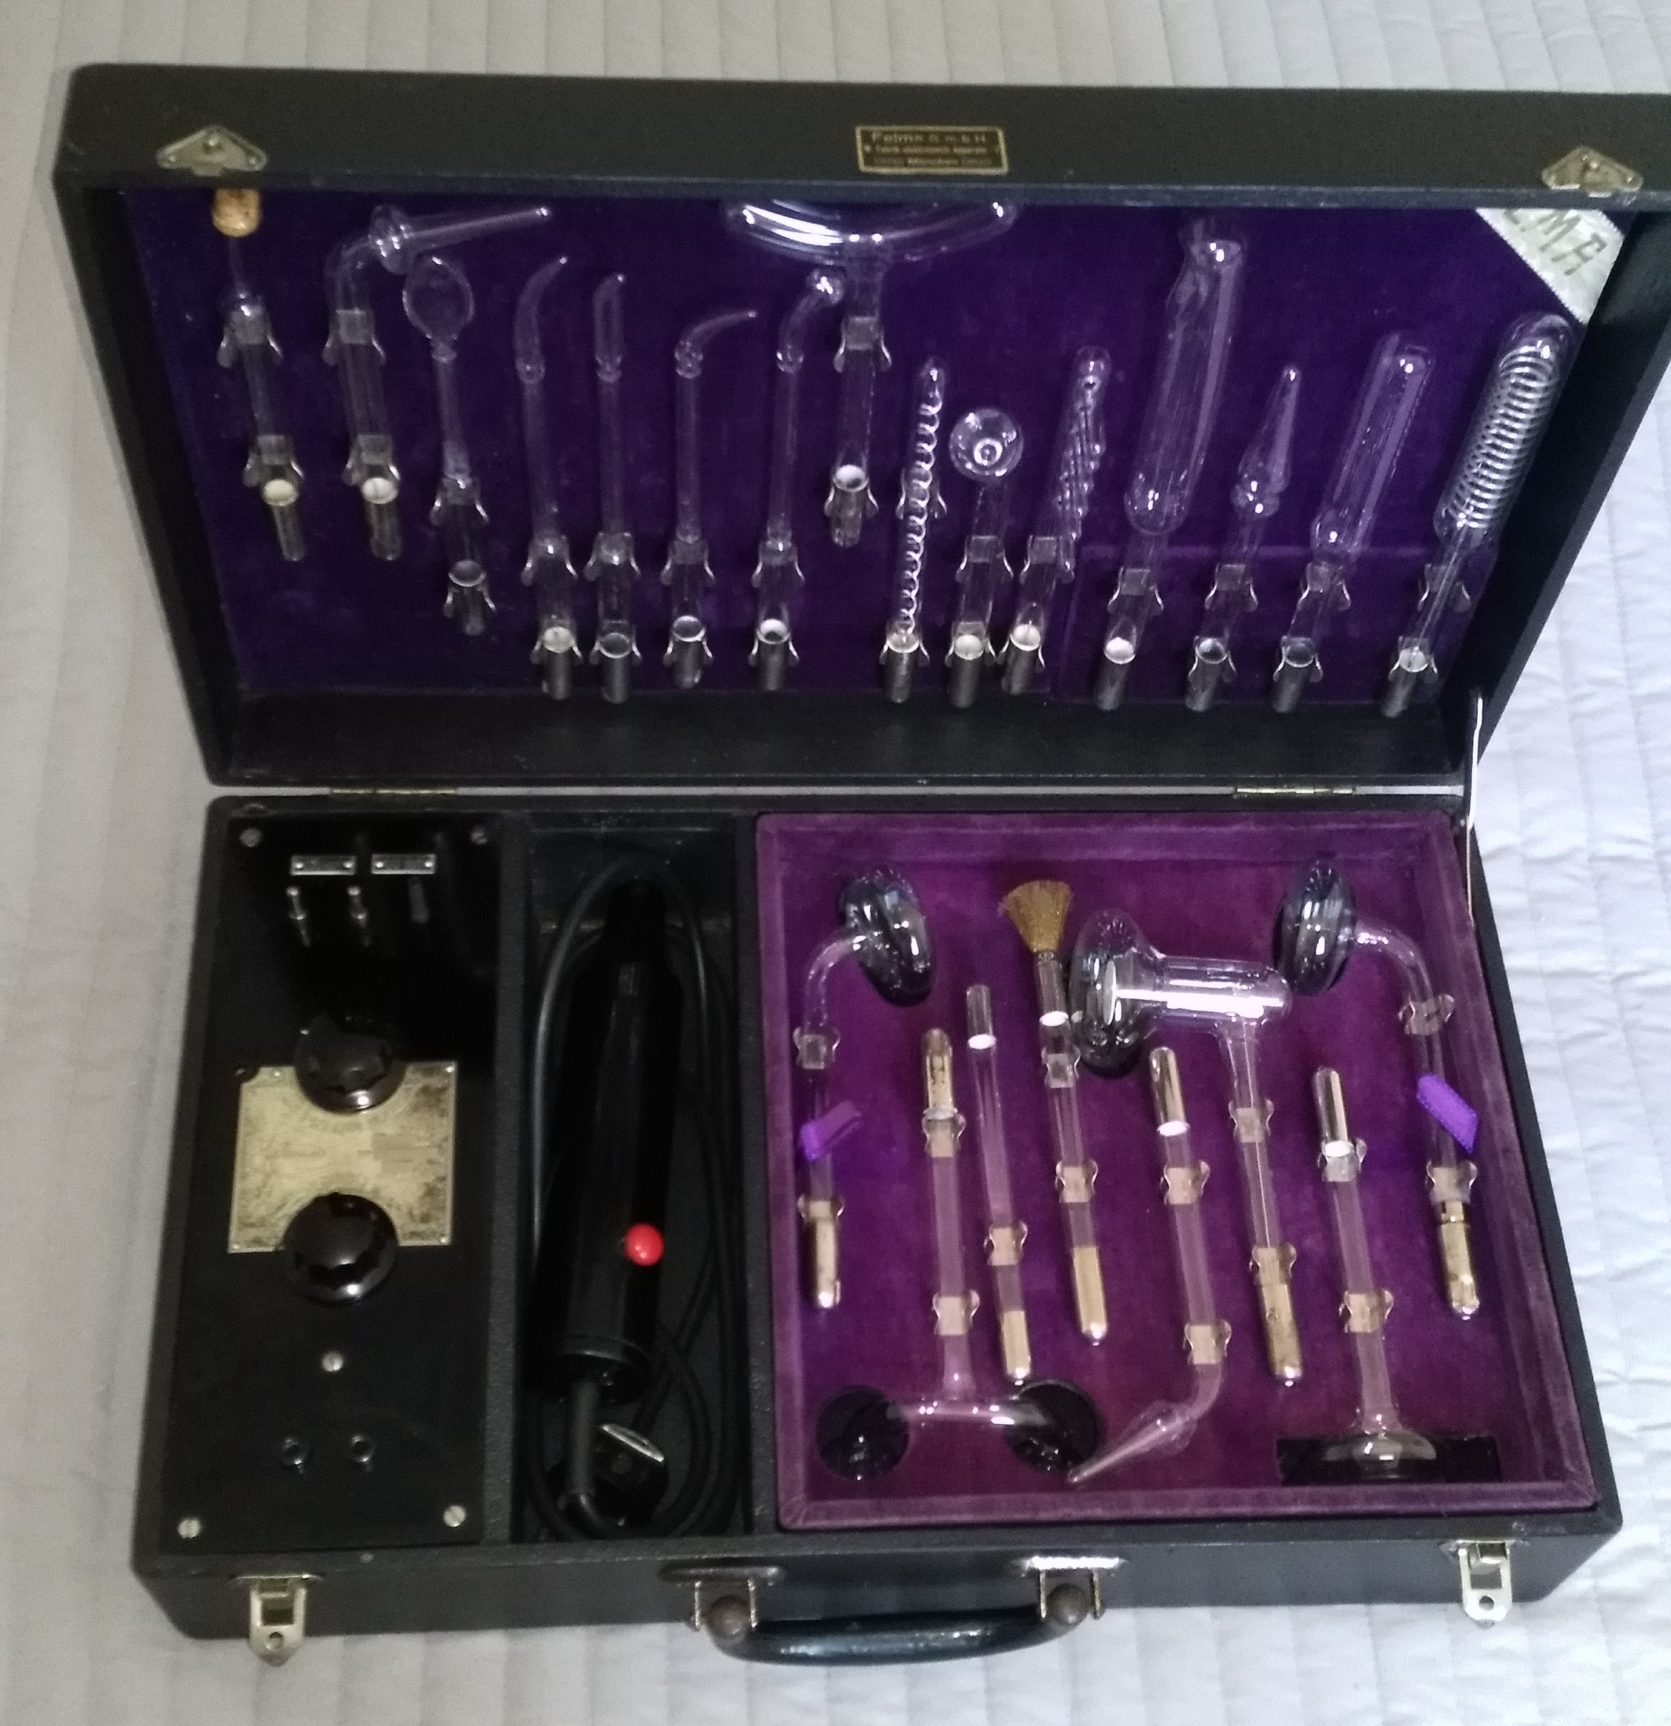

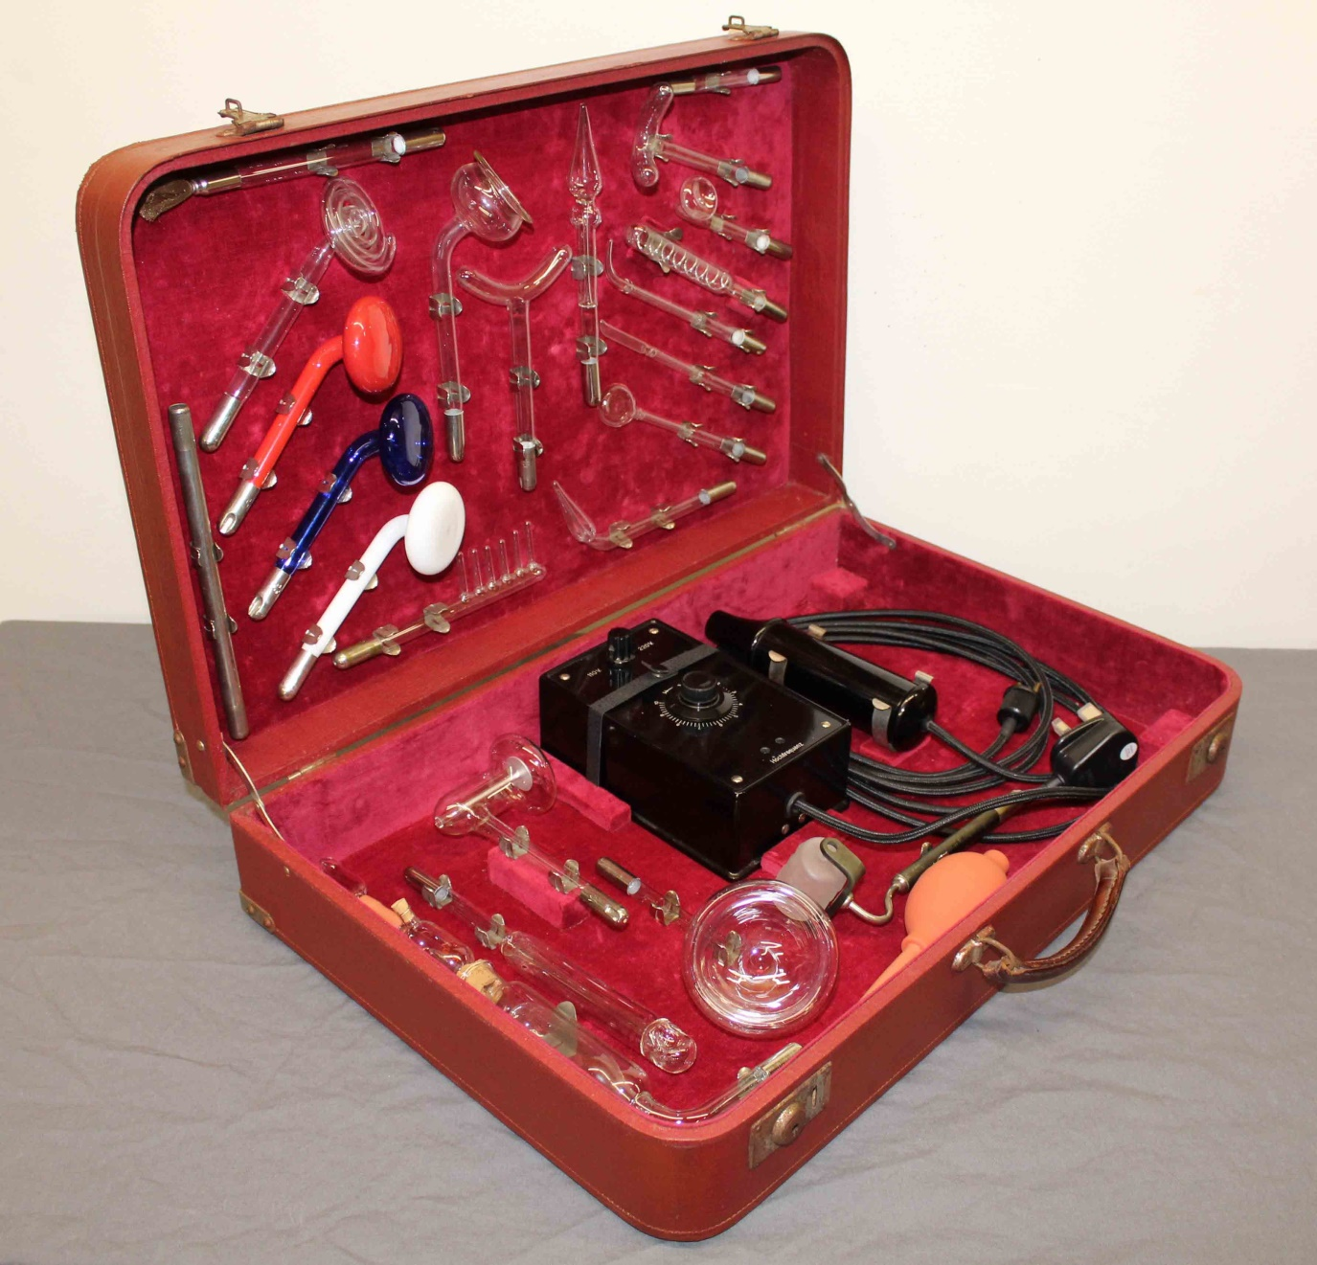

I am writing to a select few people who likely already know about the Tesla devices that I am passionate about.
I have just got a some ultra rare sets back from the restorers including some really serious units for practitioners.
They range from £1000 ($1400) to £8,000 for the ultra rare high end ones.
Nicola Tesla invented the high frequency healing device in 1891.
Designed to be used by professionals or at home to remedy just about any ailment imaginable, these devices power up the body with energy at a cellular level with photons and electrons, thus increasing the body’s ability to self repair.
By the turn of the last century this technology was being hailed as a health marvel.
I was introduced to Tesla devices some 20 years ago by a medical doctor that I worked with at that time. I saw incredible results, as you can see in one of the Tesla videos on the Secret Health Club site, where 34 people in a row experience significant pain reduction or come out of pain completely in around 5 minutes each. Of all the healing devices available today, if I could only own one device, no matter what the price, it would be original Tesla technology.
Dentists used the famous ‘cocaine’ electrode and other electrodes specially designed for the mouth and gums. Hairdressers used them for hair regrowth and they rapidly became very popular for home use on both people and animals.
The devices are electro-mechanical, utilising resonating Tesla coils to create plasma within noble gas filled electrodes.
As you can imagine this technology was hated by the doctors and pharmaceutical companies of the day who saw them as rivals to their growing monopoly. By the 1930’s they had sufficiently pressured the US government to ban their manufacture in the US entirely.
Having collected these wonderful devices
over the years I currently have a limited
number of sets available, all in original
condition, fully electrically and mechanically restored with original hand blown glass..
Ideal for health practitioners or those keen to help people with their health, these amazing devices need to be used and demonstrated to help wean people off their addiction to a belief in the allopathic paradigm.
They come as small, medium or large sets and every set comes with membership of the teslatechclub.com with it’s zoom meetings, an ever growing body of period literature including instruction books as pdf’s, detailed reports from Dr’s using the devices 100 + years ago and a detailed instructional video.
Like vehicles, back in the day one could buy a Mini or a Rolls Royce and everything in between. Over the years I have learned how to spot the great sets and avoid the unreliable ones, the irreparable ones and the death traps. Most importantly I have found out who can actually repair and tune them correctly and safely and those that just claim that they can.
I can be as happy using an inexpensive set in many cases as I am using an expensive set however the expensive ones have many advantages such as: power, durability, usability, overall build quality, glass quality, the ability to change frequencies, a timer, a broad range of the most useful and effective electrodes and a host of other design features, favoured by the serious user. Examples would be the various dental electrodes, electrodes for the eyes, ears, nose, throat, thyroid and much more. Many professionals choose the largest, most durable sets with the widest power band while many also want the truly historic, museum quality sets for their beauty and rarity. It is important to note that this Tesla coil technology cannot be properly replicated using modern electronics.
Let me know if you would like to buy a set.
Best wishes Clive

===========================================================

