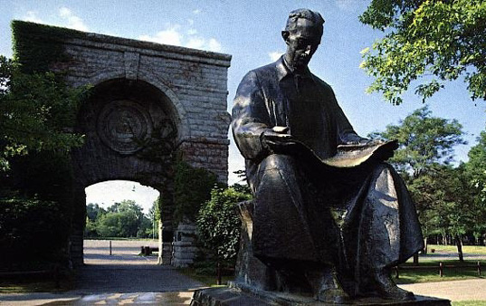
TRIBUTE TO NIKOLA TESLA
by
William C. Wysock, Tesla Technology Research
Nicola Tesla, the inventor and true "Father of Radio" and
other technologies that are now cornerstones of our modern world
http://www.bptec.com/Tesla.htm
Throughout history, academia have honored those pioneers and discoverers that have brought mankind out of darkness and into light. The list of famous physists, scientists, engineers and inventors is long. Many of the units of electrical measurement quantity and expression come from the founding fathers who first postulated and discovered physical phenomena in electricity and magnetism. Volta, Ampere, Faraday, Hertz, Maxwell, Newton, Watt and Weber, are amoung the names that have been synonymous with standard units of electrical and magnetic measure, since their respective times of discovery and contribution.
One name that has been added to this exhaulted roster, only in recent times, is that of Dr. Nikola Tesla. Tesla's numerous contributions to the discovery, understanding, and development in the electrical art during the period dubbed "The Golden Age of Discovery," cannot be overstated. From the practical development of alternating current generation and distribution and the understanding of the rotating magnetic field to the discovery of terrestrial electrical standing waves and the introduction of wireless, radio, remote control, computers, wireless power generation and distribution techniques, to directed partical beam weapons and beyond. No single individual in the sciences has had a more profound impact on or in our modern world, that we take for granted today.
It is fitting, then, that the august body of the Conference Generale des Poids et Mesures, the group responsible for developing SI (International System of Units,) would establish the special name of Tesla and the symbol T, to represent a new International Standard Unit for Magnetic flux density. Whereas Weber, (Wb,) remains honored as the SI unit for magnetic flux, the SI unit for magnetic flux density, (T,) has posthumously been accorded to Tesla. Modern technology such as MRI and NMR, rely on this unit of measure as an integral part of equipment performance and specification.
The author of this tribute, William "Bill" Wysock , is an associate of Tesla Technology Research, an icon in the world of Tesla and high voltage science.

